Supporting Information

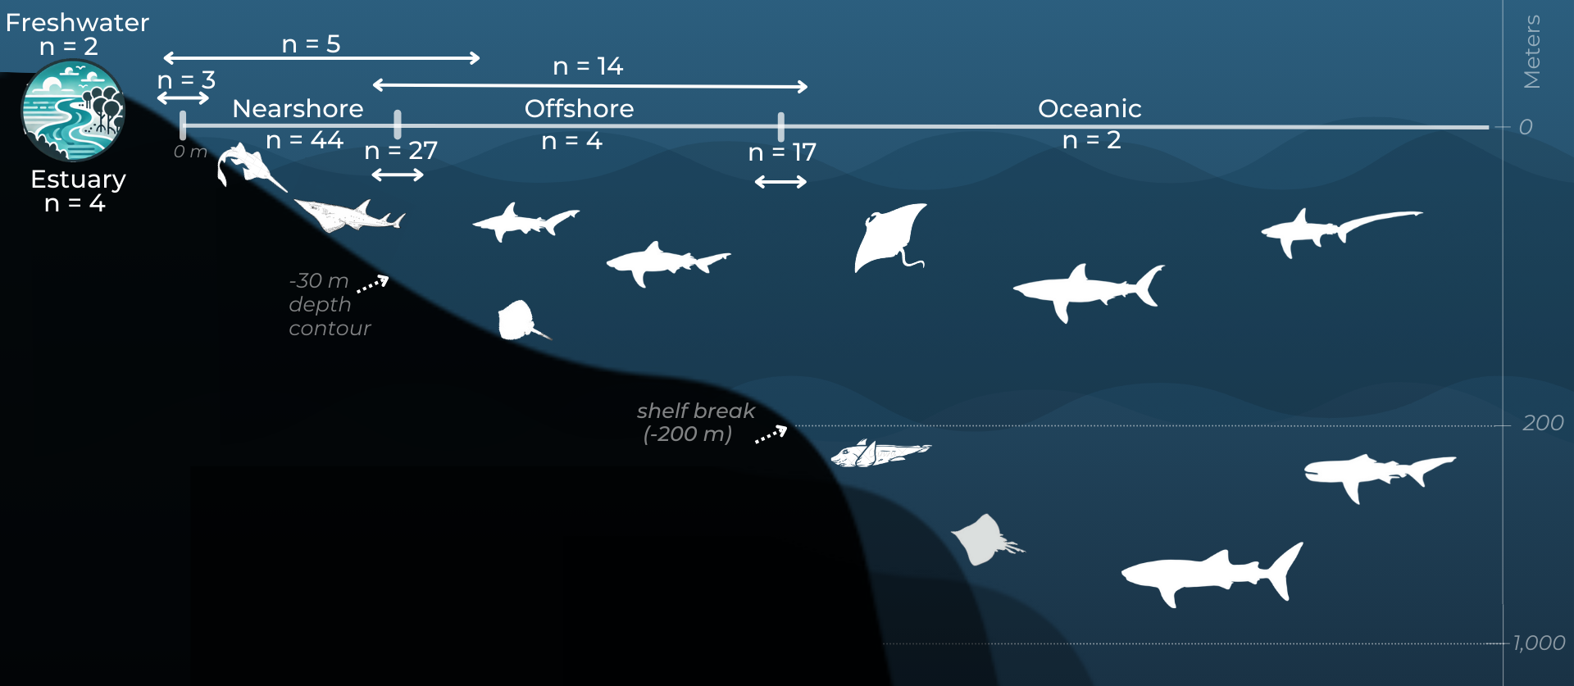
Figure S1. Number of Important Shark and Ray Areas (ISRAs) identified by aquatic systems (i.e., freshwater, estuary, and marine). The freshwater system includes the inland waters of Southeast Asia in which obligate freshwater and euryhaline generalist species occur (Grant et al. 2019). The estuarine system includes tidally influenced waters that are partially enclosed, connected to the sea, and regularly diluted by freshwater runoff, extending seaward to the mouth of the estuary (NOAA 2012). The marine system is divided into three zones: nearshore (from the coast to 30 m depth), offshore (from 30 m depth to the continental shelf break at ~200 m depth), and oceanic (beyond the shelf break to the deep ocean) (NOAA 2012). Horizontal bidirectional arrows (↔) represent ISRAs that were in more than one system or zone (e.g., 27 ISRAs were located in both nearshore and offshore zones). Depths not to scale.

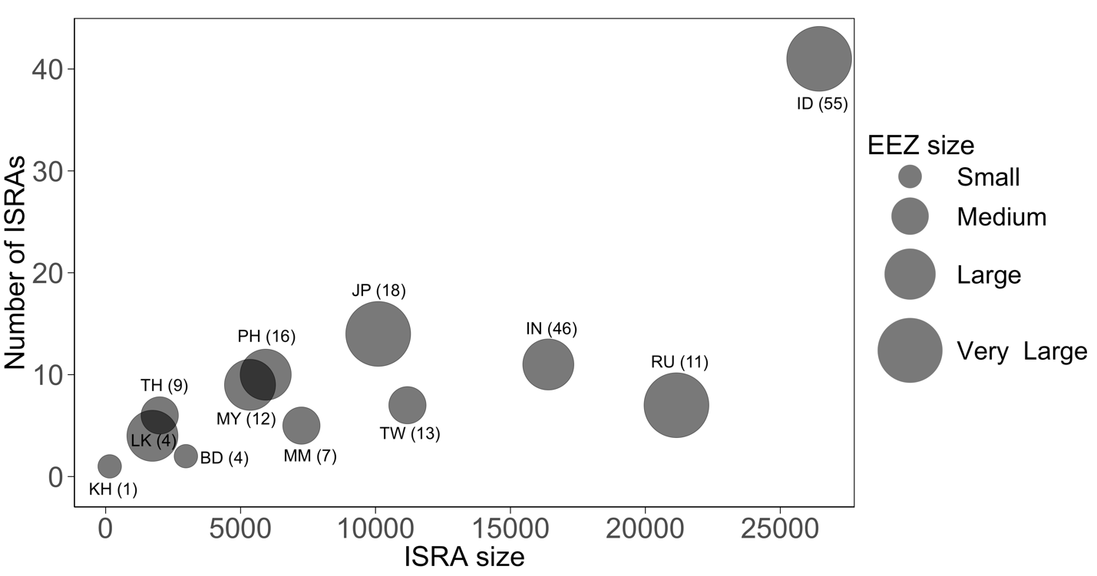
Figure S2. Bubble chart depicting the relationship between the number of Important Shark and Ray Areas (ISRAs) and their area across jurisdictions in Asia (excluding C4 – Movement Areas). Bubble size indicates the extent of each jurisdiction's Exclusive Economic Zone (EEZ): Small (<150,000 km²), Medium (150,000–500,000 km²), Large (500,000–2,000,000 km²), Very Large (>2,000,000 km²). The number of Qualifying Species is displayed next to each jurisdiction label. For India and the Russian Federation, only the EEZ within the ISRA Asia region was included. Jurisdictions are labelled using their standardized two-letter jurisdiction codes: BD, Bangladesh; KH, Cambodia; TW, Chinese Taipei; IN, India; ID, Indonesia; JP, Japan; LK, Sri Lanka; MM, Myanmar; MY, Malaysia; PH, The Philippines; RU, Russian Federation; TH, Thailand.

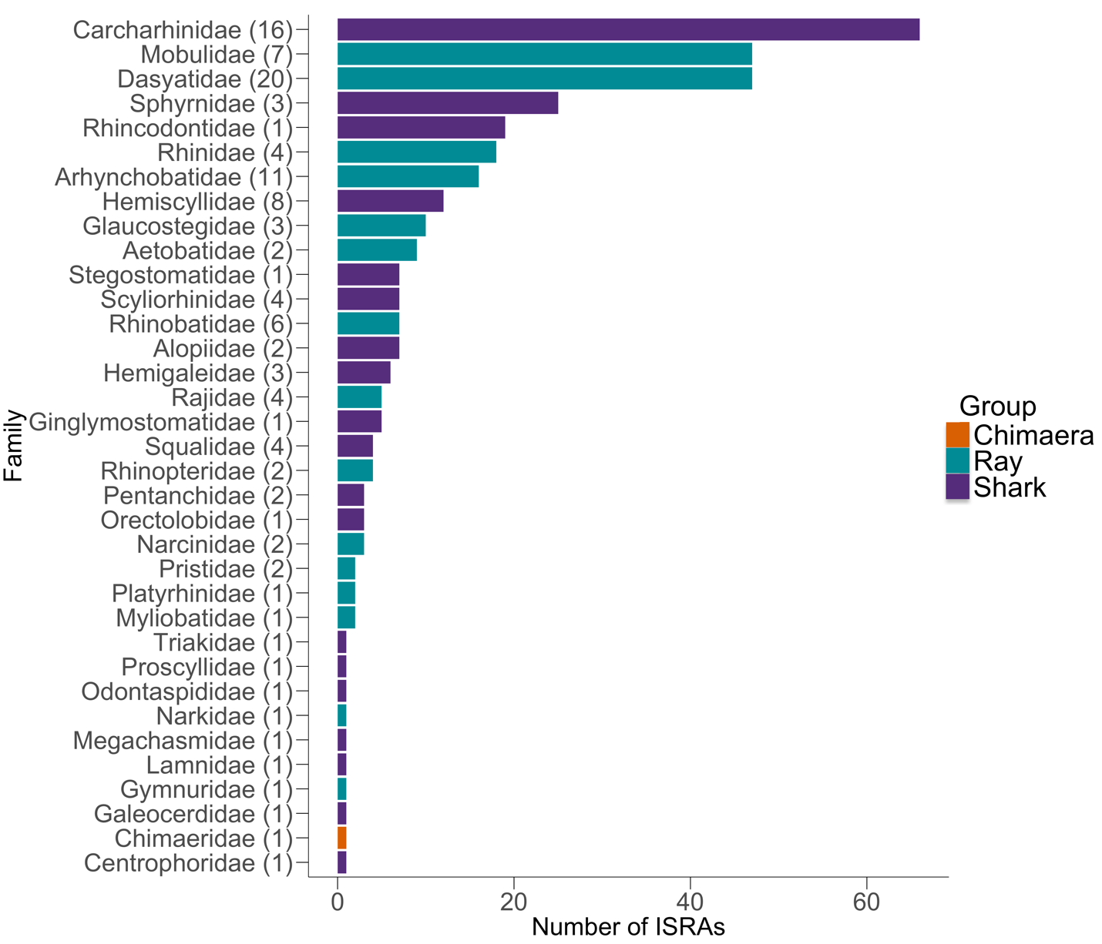
Figure S3. Chondrichthyan families represented by Qualifying Species within Important Shark and Ray Areas (ISRAs) in Asia. Numbers in parentheses indicate the number of Qualifying Species in each family. The ordering of the families is based on the number of ISRAs.

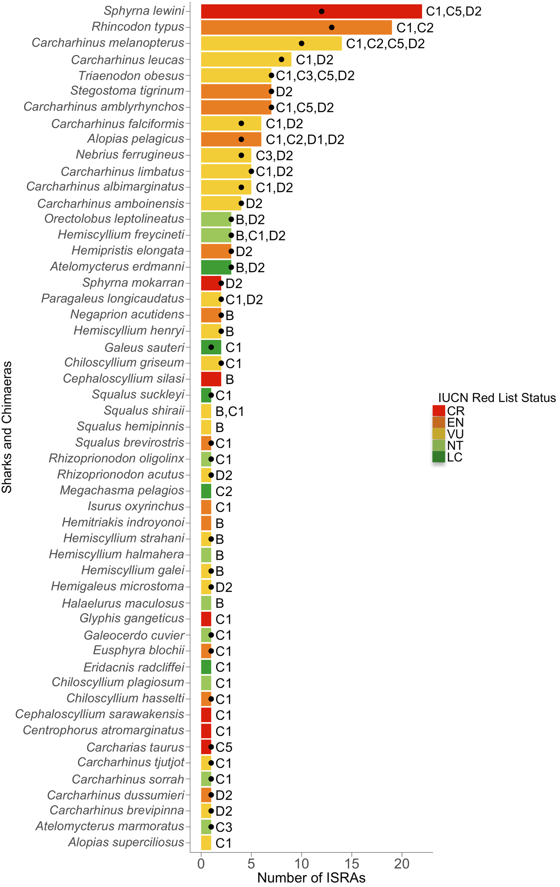
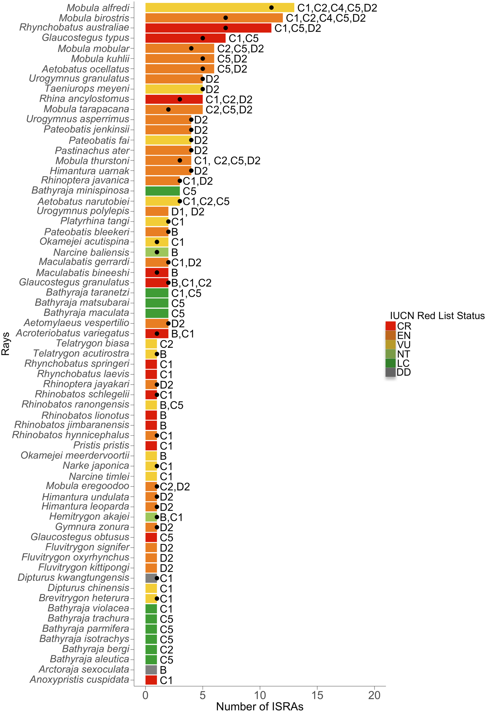
Figure S4.The number of Important Shark and Ray Areas (ISRA) in the Asia region by each Qualifying Species for (A) sharks and chimaeras, and (B) rays. The dots represent the number of ISRAs that overlap with marine protected areas (the actual extent of spatial overlap varies from 1–100%, with most ISRAs intersecting only partially with MPAs). Letters and numbers next to the bar represent the ISRA Criteria: Range Restricted (Criterion B); Life-History (Criterion C; Reproductive Areas [C1], Feeding Areas [C2], Resting Areas [C3], Movement [C4], or Undefined Aggregations [C5]); and Special Attributes (Criterion D; Distinctiveness [D1; related to distinct biological, behavioral, or ecological characteristics] and Diversity [D2; species richness]). IUCN Red List categories: CR, Critically Endangered; EN, Endangered; VU, Vulnerable; NT, Near Threatened; LC, Least Concern; DD, Data Deficient.

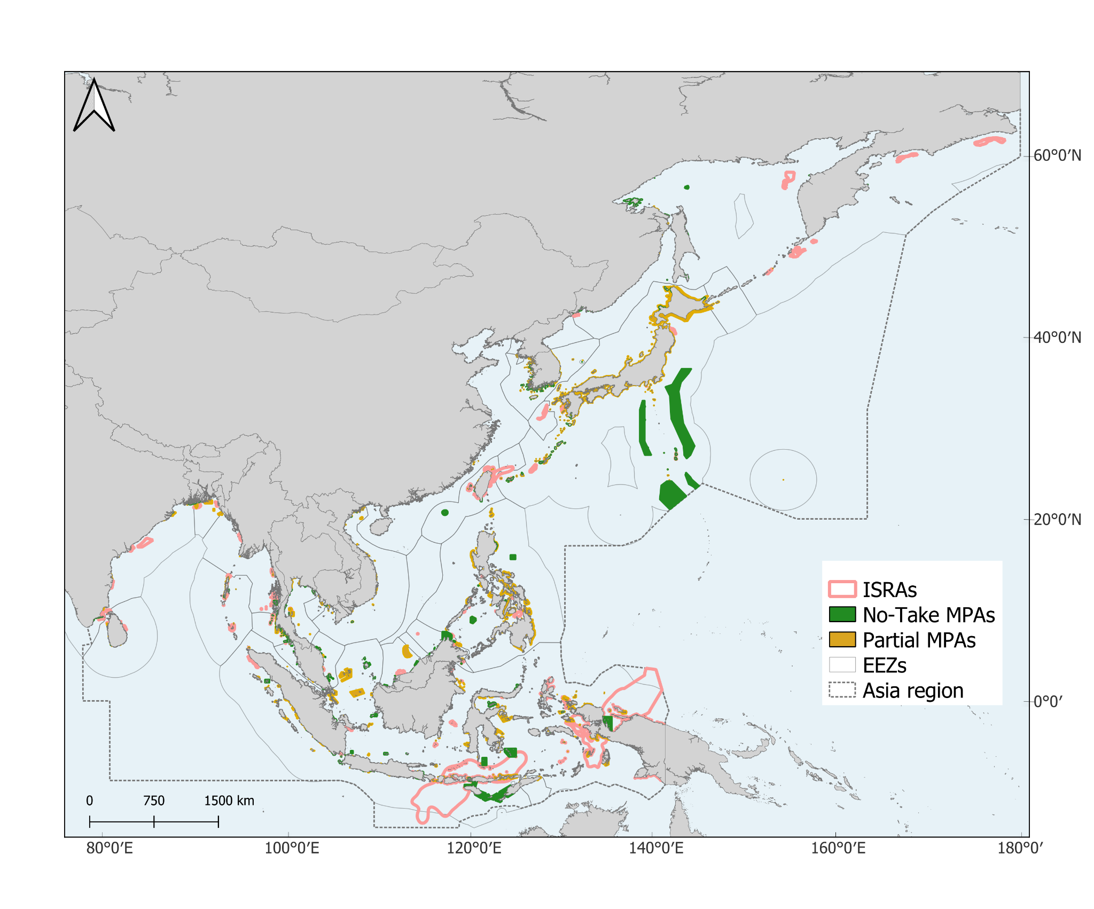
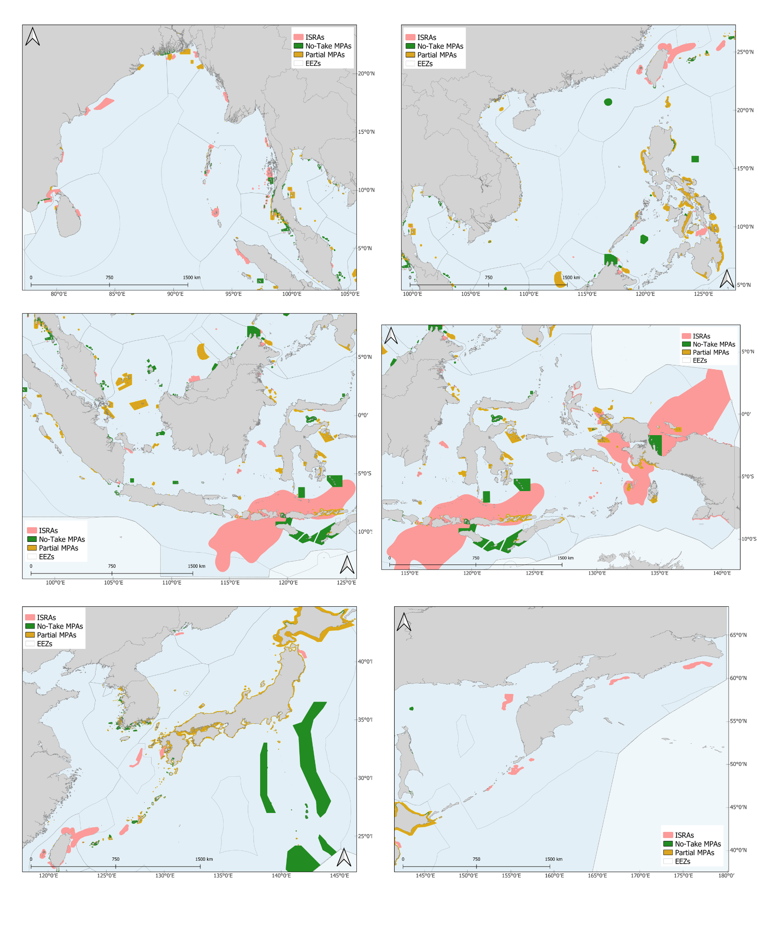
Figure S5. Marine protected areas (no-take MPA and partial MPA) and Important Shark and Ray Areas (ISRAs) in the Asia region. MPAs of China were not included as spatial data is not available. Spatial layers of MPAs were retrieved from the World Database on Protected Areas (WDPA) (UNEP-WCMC and IUCN 2025) in March 2025. Democratic People's Republic of Korea does not report MPA spatial data to the WDPA.

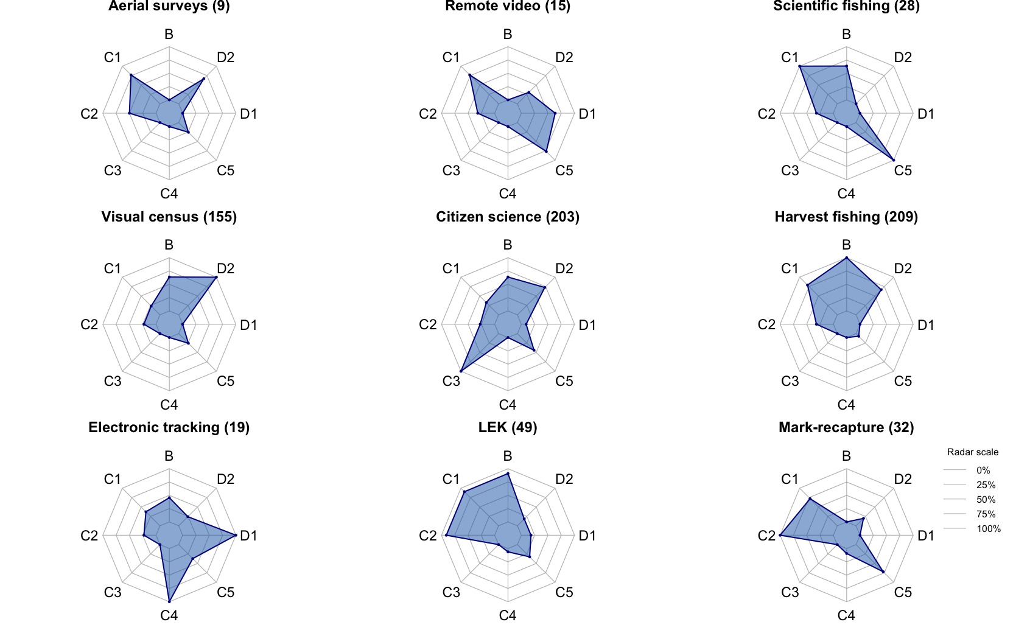
Figure S6. Research methods used to collect data that supported the delineation of Important Shark and Ray Areas (ISRAs) in the Asia region according to ISRA Criteria. See Table 1 for definitions of research methods. Range Restricted (Criterion B); Life-History (Criterion C; Reproductive Areas [C1], Feeding Areas [C2], Resting Areas [C3], Movement [C4], or Undefined Aggregations [C5]); and Special Attributes (Criterion D; Distinctiveness [D1; related to distinct biological, behavioral, or ecological characteristics] and Diversity [D2; species richness]). LEK, local ecological knowledge. Numbers in parentheses indicate the number of times the method was used.

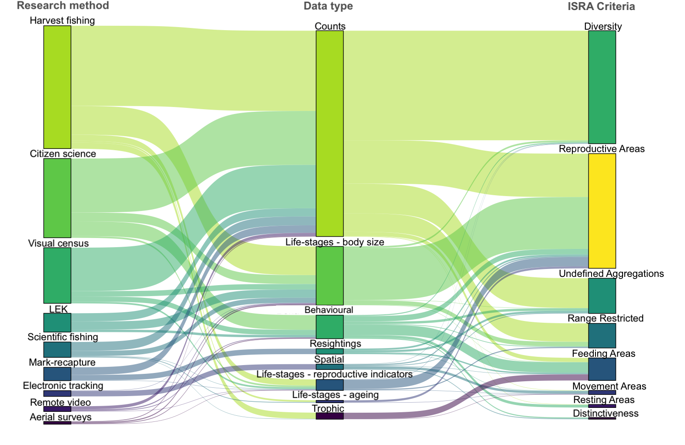
Figure S7. Flow diagram showing the relationship between research methods, data types, and ISRA Criteria used to identify Important Shark and Ray Areas (ISRAs) in the Asia region. ISRA Criteria: Range Restricted – Criterion B (B); Life-History – Criterion C: Reproductive Areas (C1), Feeding Areas (C2), Resting Areas (C3), Movement Areas (C4), or Undefined Aggregations (C5); Special Attributes – Criterion D: Distinctiveness (D1; related to distinct biological, behavioral, or ecological characteristics) and Diversity (D2; species richness). See the methods section for ISRA Criteria definitions. See Table 1 for definitions of research methods and data types. LEK, Local ecological knowledge. Each node is at the ‘criteria x species’ level.

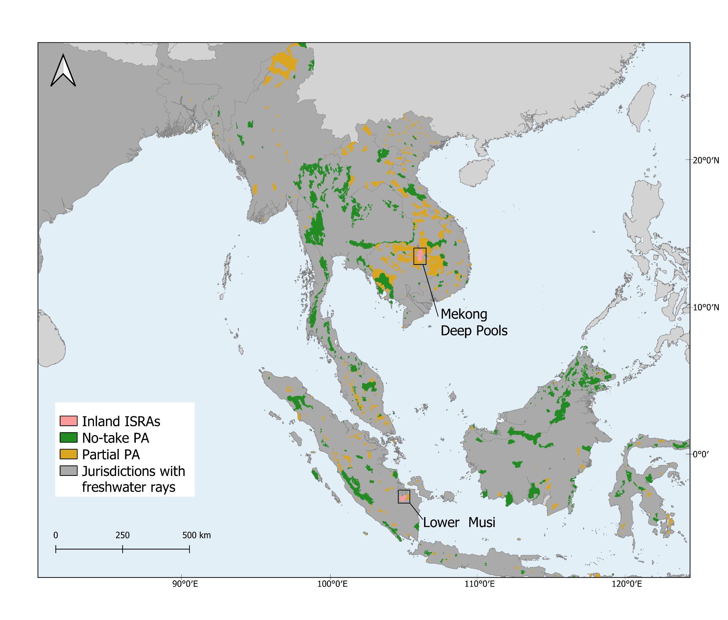

Figure S8. Inland protected areas (no-take PA and partial PA) and freshwater Important Shark and Ray Areas (ISRAs) in the Asia region. Freshwater rays include obligate freshwater species (Fluvitrygon spp. whiprays) and two euryhaline generalists, Giant Freshwater Whipray (Urogymnus polylepis) and Bull Shark (Carcharhinus leucas). Inland protected areas of India were not included as spatial data were unavailable. Spatial layers of inland protected areas were retrieved from the World Database on Protected Areas (WDPA) (UNEP-WCMC and IUCN 2025) in March 2025. India does not report spatial data to the WDPA.

Table S1. Important Shark and Ray Areas (ISRAs) in the Asia region. Percentage represents the proportion of each ISRA from the total area covered by all ISRAs (1,079,537 km²).

Table S2. Species for which IUCN Red List of Threatened Species (IUCN 2025) range maps were not available due to insufficient distribution data.
Species
Akheilos suwartanai
Apristurus sibogae
Arctoraja sexoculata
Bathyraja panthera
Cephaloscyllium formosanum
Dipturus amphispinus
Dipturus kwangtungensis
Dipturus wuhanlingi
Fenestraja sibogae
Glaucostegus younholeei
Gollum suluensis
Okamejei mengae
Pastinachus stellurostris
Scyliorhinus garmani
Sinobatis stenosoma
Squaliolus laticaudus
Squatina legnota
Tetronarce californica
Urolophus kaianus

Table S3. Maximum and threshold values for chondrichthyan species richness within individual 0.01° grid cells across Asia, derived from species richness maps. Threshold values correspond to 30% (or 85th percentile) and 80% (or 99th percentile) of the maximum richness, used to identify areas of high and exceptionally high species richness.
Diversity Dimensions | Maximum richness | High richness threshold (30%) | Exceptionally high richness threshold (80%)
Chondrichthyan species richness | 103 | 31 | 82
Range-restricted species richness | 12 | 4 | 10

Table S4. Marine protected areas and their category (no-take or partial) in the Asia region by jurisdiction.

