Supplementary material 3. Assessment of threats faced by listed and unlisted Brazilian primate species

We also presented the threats related to landscape attributes, considering the biomes in which the listed primates occur and their IUCN threat categories, in order to compile a diagnosis of this group of species that can facilitate future conservation actions (Figure 1_Supplementary Material 3).
The 13 listed species have a large variation in the range size, e.g., Leontopithecus caissara has the smallest range, with less than 1000 km², and Alouatta guariba has the largest range, with over 900,000 km² (Figure 1_Supplementary Material 3).
Sapajus xanthosternos and Callicebus barbarabrownae - species with a predominant distribution in the Caatinga - are classified as Critically Endangered and have, to date, the lowest habitat availability of all primates ever listed. They occupy the most fragmented landscapes (with less than 30% habitat coverage), with more than 20% road coverage within their geographic distributions (Figure 1_Supplementary Material 3). The Amazonian species presented the greatest habitat availability and the lowest proportion of fragmented landscapes within their range when compared to species in other biomes (Figure 3). However, they have the highest proportion of habitat loss, with Saguinus bicolor standing out with a proportion of urbanized areas like the species in the Atlantic Forest (Figure 1_Supplementary Material 3). The Atlantic Forest species Leontopithecus chrysopygus, listed only once in 2000, has the lowest habitat availability, distributed in more fragmented landscapes (with <30% habitats) when compared to its congeners, although Leontopithecus rosalia occupies landscapes with a higher proportion of roads (like Sapajus flavius ​​in magnitude) (Figure 1_Supplementary Material 3).

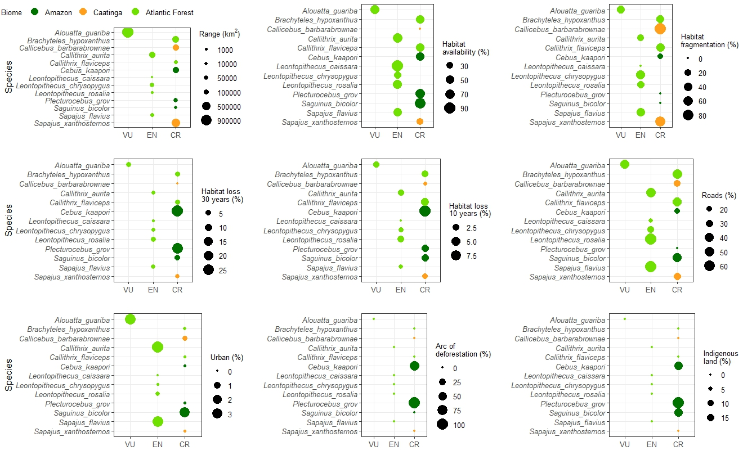
Figure 1_Supplementary Material 3. Diagnosis of the landscape attributes of Brazilian primates listed in the Top 25 lists from 2000 to 2022. The circles' colors represent the biomes with greater overlap in the species' range

Among the listed species, Callicebus barbarabrownae occupies more fragmented landscapes, and Sapajus flavius, which has a higher proportion of roads (Figure 2_Supplementary Material 3, PC1, with negative scores on axis 1). Cebus kaapori and Plecturocebus grovesi stood out among the listed species due to the greater overlap with the deforestation arc (Figure 2_Supplementary Material 3, PC1, with positive scores on axis 1). Cebus kaapori showed greater habitat loss in the Amazon (Figure 2_Supplementary Material 3, PC2, with positive scores on axis 2). Leontopithecus caissara and Saguinus bicolor stand out due to the greater availability of habitat (Figure 2_Supplementary Material 3, PC2, with negative scores on axis 2).
Among the unlisted species, the Amazonian species are grouped together, although Mico rondoni, Ateles marginatus, Alouatta discolor, Chiropotes satanas, and Chiropotes utahickae stand out due to the greater R9_1 overlap of their distributions with the deforestation arc (Figure 3_Supplementary Material 3, with positive scores on axis 1). The Caatinga and Atlantic Forest species are grouped together, mainly Callicebus coimbrai and Alouatta ululata, with the highest proportion of roads and fragmented areas (Figure 3_Supplementary Material 3, with negative scores on axis 1), characteristics that also group the only Cerrado species, Sapajus cay. On axis 2, Chiropotes satanas appears among the species with the greatest habitat loss (positive scores), and Cacajao melanocephalus and Alouatta belzebuth have the greatest habitat availability and overlap with indigenous lands (negative scores) (Figure 3_Supplementary Material 3).

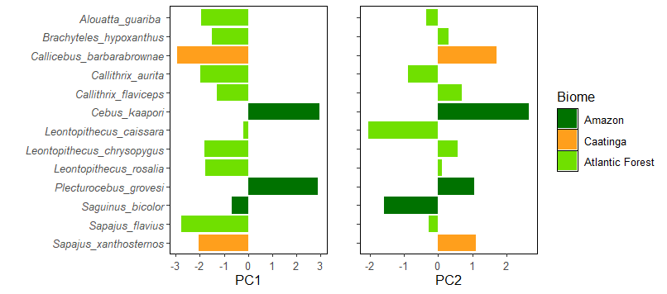
Figure 2_Supplementary Material 3. Variation of scores along the first two axes of the Principal Component Analysis indicates which Brazilian species listed in the top 25 are grouped according to the association with each axis (PC1 and PC2)

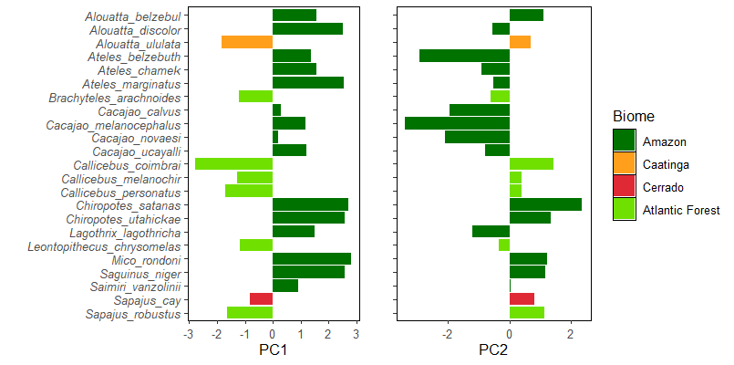
Figure 3_Supplementary Material 3. Variation of scores along the first two axes of the Principal Component Analysis, indicating how the unlisted species are grouped according to the association with each axis (PC1 and PC2)

