Supplementary material 4. Amount of habitat available in each biome analyzed for the periods related to the editions of Primates in Peril

The primate habitat layer was generated based on land use and land cover mapping with a spatial resolution of 30 m, which belongs to collection 9 of the MapBiomas initiative (MapBiomas 2024) for the years corresponding to the Primates in peril publications from 2000 to 2022, obtained every two years, plus one year before the first edition, i.e. 1998, 2000, 2002, 2004, 2006, 2008, 2010, 2012, 2014, 2016, 2018, 2020 and 2022. The classes considered as primate habitats were converted into presence or absence (forest, savannah with a height greater than 5 m, mangrove, and floodplain forest), based on the original land use and land cover map (MapBiomas 2024).
To obtain the habitat proportion in each biome, we corrected the savanna habitats of the Caatinga and Cerrado biomes to include only forests >5m height representing primate habitats, based on forest height mapping (Potapov et al. 2021), also described in detail in Matte et al. (2024). We corrected the savannah habitat type that represents primate habitats in these biomes because this formation/vegetation type is far more prevalent there (Matte et al. 2024).
We generated a Boolean image from the forest height raster (Potapov et al. 2021) and assigned the value “1” to pixels with a height greater than five meters and “0” to the remaining pixels with lower values. At the same time, we extracted only the savanna from the habitat layer for each period of the MapBiomas analysed (from 1998 to 2022) (Souza Jr. et al. 2020; MapBiomas 2024) and multiplied the result by the Boolean image of forest height. We then replaced the savanna areas >5m height on the map with all habitat types to obtain only the savanna habitat areas over five meters on the final habitat map.
The proportion of available habitat for each biome was calculated using a 100 x 100 km grid, cut out according to the biome boundaries. The habitat coverage of each 100 km landscape was extracted, weighted by landscape area, and finally, the proportion of available habitat in each landscape comprising the biome was obtained (Figure 1 of Supplementary material 4). The Amazon has 785 landscapes within it, the Caatinga has 282 landscapes, the Cerrado 956, and the Atlantic Forest 1,097 landscapes. To highlight habitat gains and losses in each biome, we show the average proportion of available habitat and other descriptive statistics calculated based on all 100 km landscapes of each biome for the period from 1998 to 2022 can be analyzed in Table 1 of this Supplementary Material 4.

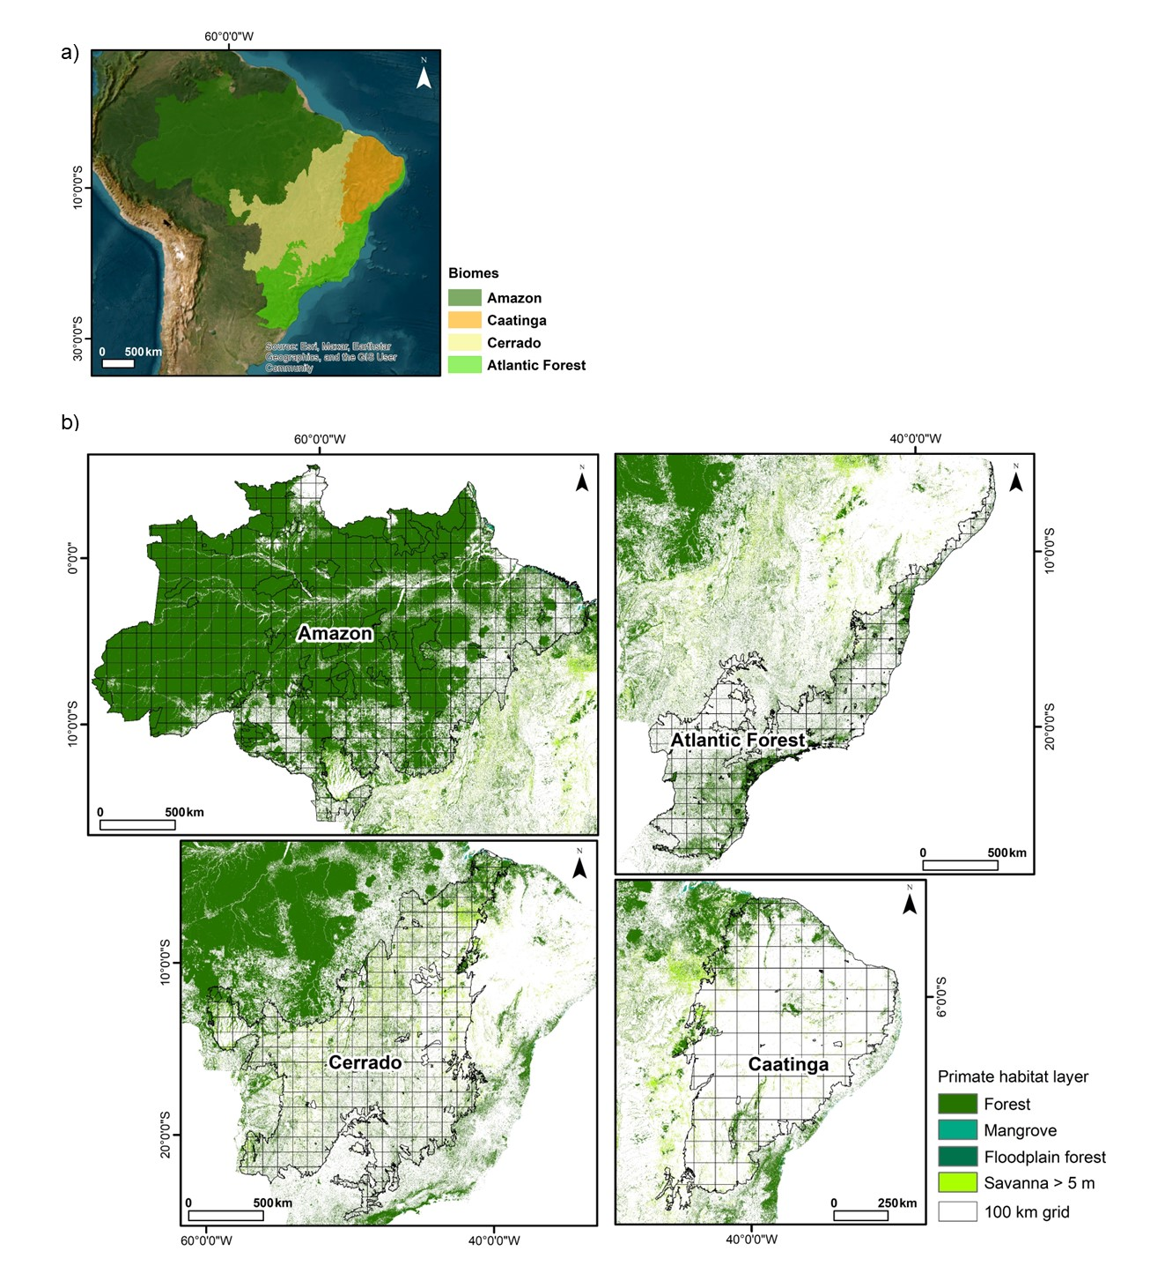
Figure 1 of the Supplementary material 4. Location of the biomes under study Amazon, Caatinga, Cerrado and Atlantic Forest (a). Methodology used to extract the proportion of habitat available for each biome using a 100 x 100 km grid, cut out according to the biome boundaries (b). The primate habitat layer corresponds to the coverage of forest formations, savannahs over 5 m high, mangroves and floodplain forest within each 100 km landscape. This proportion was extracted after adding up the number of pixels for each type of habitat, weighting them by their area and, finally, obtaining the proportion of habitat available in each landscape that makes up the biome. The example of habitat coverage refers to the year 2018 (MapBiomas, 2024)

Table 1 of the Supplementary Material 4. Changes in the average proportion of available habitat (AP), standard deviation (SD), standard error (SE), and coefficient of variation (CV) of available habitat for each biome from 1998 to 2022, obtained by considering landscapes within 100 km of each biome's boundaries.
Year | AP_Amazon | SD_Amazon | SE_Amazon | CV_Amazon
1998 | 58.54 | 41.91 | 1.50 | 71.59
2000 | 58.09 | 41.91 | 1.50 | 72.16
2002 | 57.51 | 41.85 | 1.49 | 72.78
2004 | 56.75 | 41.72 | 1.49 | 73.52
2006 | 56.27 | 41.63 | 1.49 | 73.97
2008 | 55.93 | 41.59 | 1.48 | 74.36
2010 | 55.79 | 41.57 | 1.48 | 74.52
2012 | 55.69 | 41.55 | 1.48 | 74.61
2014 | 55.55 | 41.51 | 1.48 | 74.72
2016 | 55.28 | 41.43 | 1.48 | 74.95
2018 | 55.05 | 41.38 | 1.48 | 75.17
2020 | 54.71 | 41.26 | 1.47 | 75.41
2022 | 54.09 | 41.13 | 1.47 | 76.03
Year | AP_Caatinga | SD_Caatinga | SE_Caatinga | CV_Caatinga
1998 | 6.23 | 14.64 | 0.87 | 235.08
2000 | 6.30 | 14.82 | 0.88 | 235.12
2002 | 6.18 | 14.64 | 0.87 | 237.04
2004 | 6.15 | 14.59 | 0.87 | 237.16
2006 | 6.15 | 14.58 | 0.87 | 237.00
2008 | 6.27 | 14.74 | 0.88 | 235.08
2010 | 6.25 | 14.69 | 0.87 | 235.16
2012 | 6.20 | 14.61 | 0.87 | 235.61
2014 | 6.19 | 14.61 | 0.87 | 236.04
2016 | 6.29 | 14.68 | 0.87 | 233.38
2018 | 6.30 | 14.72 | 0.88 | 233.58
2020 | 6.26 | 14.67 | 0.87 | 234.28
2022 | 6.20 | 14.48 | 0.86 | 233.57
Year | AP_Cerrado | SD_Cerrado | SE_Cerrado | CV_Cerrado
1998 | 2.46 | 5.91 | 0.19 | 240.08
2000 | 2.44 | 5.86 | 0.19 | 240.06
2002 | 2.40 | 5.72 | 0.18 | 237.89
2004 | 2.38 | 5.68 | 0.18 | 238.68
2006 | 2.37 | 5.67 | 0.18 | 238.90
2008 | 2.37 | 5.68 | 0.18 | 239.88
2010 | 2.36 | 5.69 | 0.18 | 240.69
2012 | 2.35 | 5.68 | 0.18 | 241.09
2014 | 2.32 | 5.64 | 0.18 | 242.60
2016 | 2.30 | 5.61 | 0.18 | 243.50
2018 | 2.29 | 5.59 | 0.18 | 243.83
2020 | 2.27 | 5.56 | 0.18 | 244.52
2022 | 2.22 | 5.51 | 0.18 | 248.01
Year | AP_Atlantic_Forest | SD_Atlantic_Forest | SE_Atlantic_Forest | CV_Atlantic_Forest
1998 | 21.93 | 32.92 | 0.99 | 150.10
2000 | 22.05 | 33.04 | 1.00 | 149.83
2002 | 22.17 | 33.18 | 1.00 | 149.66
2004 | 22.37 | 33.36 | 1.01 | 149.08
2006 | 22.48 | 33.46 | 1.01 | 148.87
2008 | 22.59 | 33.55 | 1.01 | 148.53
2010 | 22.70 | 33.64 | 1.02 | 148.19
2012 | 22.78 | 33.70 | 1.02 | 147.98
2014 | 22.78 | 33.76 | 1.02 | 148.17
2016 | 22.85 | 33.84 | 1.02 | 148.10
2018 | 22.94 | 33.90 | 1.02 | 147.78
2020 | 23.06 | 34.01 | 1.03 | 147.47
2022 | 23.16 | 34.13 | 1.03 | 147.34

References
Matte, A. L., Buss, G., Fialho, M., Becker, F. G., Jerusalinsky, L., de Lacerda, J. C., Santos, P.J.P., Bezerra, B. (2024). How do landscape and life history traits contribute to the threat context of Brazilian primates?. Anim. Conserv., 27, 267-280.
MapBiomas (2024). Coleção 9 da série anual de Mapas de Cobertura e Uso da Terra do Brasil, acessado em 17/07/2025 através do link: https://brasil.mapbiomas.org/colecoes-mapbiomas/
Potapov, P., Li, X., Hernandez-Serna, A., Tyukavina, A., Hansen, M.C., Kommareddy, A., Pickens, A., Turubanova, S., Tang, H., Silva, C.E., Armstom, J., Dubayah, R., Blair, J.B., Hofton, M. (2020). Mapping global forest canopy height through integration of GEDI and landsat data. Remote Sens. Environ., 253, 112165.
Souza, C. M., Jr., Z. Shimbo, J., Rosa, M. R., Parente, L. L., A. Alencar, A., Rudorff, B. F. T., Hasenack, H., Matsumoto, M., G. Ferreira, L., Souza-Filho, P. W. M., de Oliveira, S. W., Rocha, W. F., Fonseca, A. V., Marques, C. B., Diniz, C. G., Costa, D., Monteiro, D., Rosa, E. R., Vélez-Martin, E., ... Azevedo, T. (2020). Reconstructing three decades of land use and land cover changes in Brazilian biomes with Landsat archive and earth engine. Remote Sens. 12, 2735.

