DEFORESTATION AROUND SUBTROPICAL STREAMS DRIVES TAXONOMIC AND FUNCTIONAL NESTEDNESS OF AQUATIC INSECT COMMUNITIES
Lívia Serezani¹*, Caroline de Mello Correia², Adriano Sanches Melo³, Victor S. Saito⁴, Tadeu Siqueira^{5,6} & Danielle Katharine Petsch^{7,8}

Supplementary Information

Land use in the sampled region
To evaluate the history of deforestation and land-use changes in the sampled region, we used the MapBiomas platform to obtain land-use and land-cover maps for the 30 years preceding sampling (1985–2015). The data indicate that deforestation in the region occurred relatively early, with pasturelands and forest plantations dominating the landscape during the 1980s and 1990s. From the 2000s onward, an expansion of agricultural and urban areas can be observed. In the year of sampling (2015), the landscape appeared to be mainly composed of pastures, agricultural areas, and forest plantations, with relatively few urbanized areas. Furthermore, the most preserved areas are largely located within the boundaries of protected areas, namely Intervales State Park and Carlos Botelho State Park. However, over time, the buffer zones surrounding these protected areas have become increasingly occupied by human land-use activities.

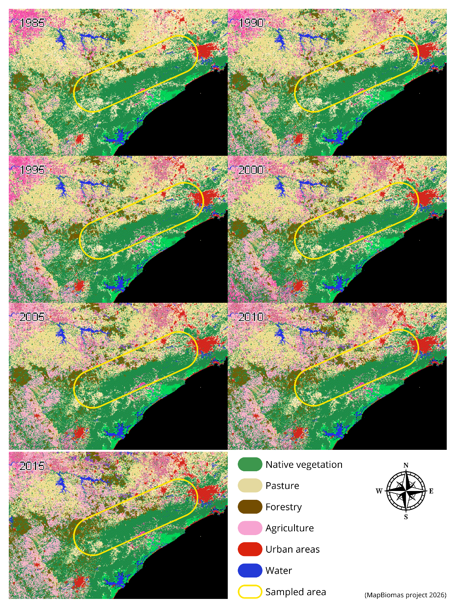
Figure S1: Land-use and land-cover history of the sampled area (1985–2015), obtained from the MapBiomas Project (http://mapbiomas.org). The images show land cover in the southeastern region of São Paulo state, including native forest (green), pasture (beige), forest plantations (brown), agriculture (purple), urban areas (red), and water bodies (blue). The yellow outline indicates the area where the sampling points are located.

Table S1: Results of the generalized linear models testing the effect of native vegetation cover on genus occurrence. β corresponds to the estimated coefficient of the predictor (% native vegetation), and p to the significance value of the test. Only genera occurring in at least five streams were included in the analyses.
Order | Genera | β | p value
Ephemeroptera | Americabaetis | 1.098 | 0.273
Ephemeroptera | Baetodes | 3.076 | 0.001*
Ephemeroptera | Caenis | 0.008 | 0.994
Ephemeroptera | Callibaetis | -0.452 | 0.661
Ephemeroptera | Campylocia | 1.638 | 0.074
Ephemeroptera | Cloeodes | -0.768 | 0.303
Ephemeroptera | Farrodes | 0.969 | 0.229
Ephemeroptera | Hagenulopsis | 1.627 | 0.209
Ephemeroptera | Hylister | 4.207 | 0.000*
Ephemeroptera | Massartella | -0.306 | 0.695
Ephemeroptera | Thraulodes | 2.229 | 0.085
Ephemeroptera | Traverhyphes | 1.549 | 0.046*
Ephemeroptera | Tricorythodes | 2.008 | 0.275
Ephemeroptera | Tricorythopsis | 1.830 | 0.048*
Ephemeroptera | Ulmeritoides | -6.365 | 0.023*
Ephemeroptera | Zelusia | 0.464 | 0.672
Plecoptera | Anacroneuria | 2.873 | 0.000*
Plecoptera | Gripopteryx | 1.573 | 0.071
Plecoptera | Kempnyia | 2.296 | 0.025*
Plecoptera | Macrogynoplax | 5.759 | 0.003*
Trichoptera | Atopsyche | 1.217 | 0.111
Trichoptera | Austrotinodes | 1.606 | 0.037*
Trichoptera | Blepharopus | -0.566 | 0.500
Trichoptera | Cernotina | 0.505 | 0.681
Trichoptera | Chimarra | 1.252 | 0.137
Trichoptera | Cyrnellus | 0.144 | 0.902
Trichoptera | Helicopsyche | 2.488 | 0.015*
Trichoptera | Leptonema | 1.881 | 0.015*
Trichoptera | Marilia | 1.312 | 0.351*
Trichoptera | Mortoniella | 0.942 | 0.521
Trichoptera | Nectopsyche | 1.849 | 0.037*
Trichoptera | Neotrichia | -0.457 | 0.606
Trichoptera | Oecetis | 1.892 | 0.171
Trichoptera | Phylloicus | 1.482 | 0.057
Trichoptera | Polyplectropus | 0.291 | 0.830
Trichoptera | Protoptila | -0.274 | 0.870
Trichoptera | Smicridea | 0.681 | 0.445
Trichoptera | Triplectides | 1.349 | 0.183
Odonata | Argia | -1.047 | 0.178
Odonata | Cacoides | 2.899 | 0.070
Odonata | Dythemis | 0.748 | 0.315
Odonata | Heliocharis | 1.137 | 0.443
Odonata | Hetaerina | 2.215 | 0.043*
Odonata | Heteragrion | 0.011 | 0.988
Odonata | Progomphus | 1.917 | 0.039*
Megaloptera | Corydalus | 1.777 | 0.140
Coleoptera | Austrolimnius | 2.368 | 0.011*
Coleoptera | Cylloepus | 1.188 | 0.141
Coleoptera | Heterelmis | 2.047 | 0.046*
Coleoptera | Hexacylloepus | 1.100 | 0.145
Coleoptera | Huleechius | 3.408 | 0.025*
Coleoptera | Macrelmis | 2.482 | 0.004*
Coleoptera | Microcylloepus | 2.057 | 0.022*
Coleoptera | Neoelmis | 1.794 | 0.020*
Coleoptera | Phanocerus | 2.707 | 0.004*
Coleoptera | Psephenus | 1.122 | 0.190
Coleoptera | Xenelmis | 1.568 | 0.050

