Online Resource 1

Title: Not all forest edges are the same: agricultural edges have the greatest impacts on ant-mediated seed dispersal of temperate forest myrmecochores

Journal: Biodiversity and Conservation

Farrell, C.A. ^{a,d,e}, Churchill, A.C. ^{a,b}, Mei, X. ^{c}, Zhu, W. ª, Prior, K.M. ª

ª Binghamton University, Department of Biological Sciences, Binghamton, NY, United States
^{b} Binghamton University, Environmental Studies Program, Binghamton, NY, United States
^{c} Binghamton University, Department of Earth Sciences, Binghamton, NY, United States
^{d} Current: Hobart and William Smith Colleges, Geneva, NY, United States
^{e} Corresponding author: Catherine A. Farrell (catherinefarrell123@gmail.com)

Text S1 Supplementary Methods: Soil Processing
Within a few days of collection (stored at 4 °C), soil samples were processed through a sieve with 4 mm openings. Soil moisture was measured by taking the wet weight and placing subsamples in a drying oven at 60 °C. After at least 48 hours, the oven was raised to 105 °C for 2 hours, and then the subsamples were removed and placed in a desiccator for 30 mins before weighing the dry weight, which was subtracted from the wet weight to record the moisture in the sample. This is a more precise way to measure soil moisture than the probe measurements taken in the field. To measure soil organic matter (SOM), subsamples were placed directly into a muffle furnace (550 °C) for 4 hours and weighed a final time after cooling to determine the weight of SOM lost from ignition. A subset of the remaining soil was homogenized using a ball-mill and was analyzed for total carbon (C) and nitrogen (N) using a ThermoFisher Isotope Ratio Mass Spectrometer (model Delta V Advantage, Bremen, Germany) at the Cornell University Stable Isotope Laboratory (COIL).

Supplementary Tables and Figures
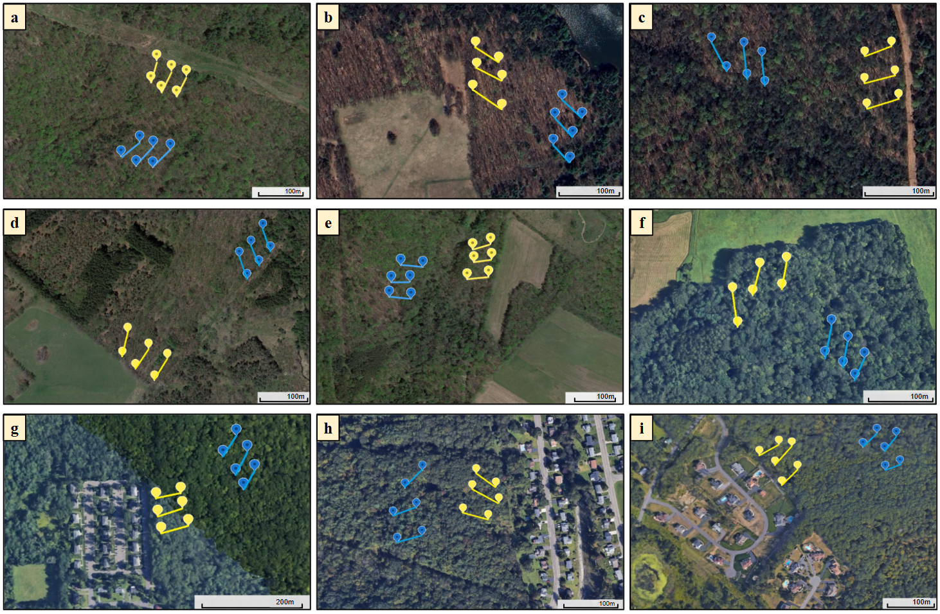
Fig. S1 Aerial images of sites in three surrounding landscape (SL) categories: (a-c) low-maintenance SL, (d-f) agricultural SL, and (g-i) residential SL. Transect placement is represented with yellow pins and lines for edge transects, and blue pins and lines for interior transects. A scale bar (100 or 200 m) is present in the bottom right corner of each site image. These images were taken from Google Earth and were all taken within the last 13 years. The associated site information and transect coordinates are in Table S1

Table S1 Descriptions of sites (A-I), transect placement, and myrmecochores observed at each site (E= frequency within edge plots; I= frequency within interior plots). Forest patch area was estimated (to the nearest whole acre) by measurements on Google Earth. SL descriptions are based on visual observations in the field and on aerial images (Fig. S1). Permission was granted by landowners to collect data from each site
 | Forest Name | Description of SL | Forest Patch Area (acres) | Landowner | Edge Transect Coordinates (start) | Interior Transect Coordinates (start) | Myrmecochores Found in Plots | Myrmecochores Found Outside Plots
A | LN- Lackawanna State Park (south) | Low maintenance- pipeline | 132 | Pennsylvania Department of Natural Resources | 41.5526,  -75.7104; 41.5526,  -75.7101; 41.5525,  -75.7097 | 41.5510,  -75.7101; 41.5511,  -75.7105; 41.5512,  -75.7109 | Viola sp. (E=3), Uvularia sessilifolia (I=2) | Viola sp.
B | AT- Aqua Terra Wilderness Area | Low maintenance- isolated section of an old field | 592 | Broome County | 42.0324,  -75.9455;  42.0320,  -75.9454;  42.0316, -75.9455 | 42.0307,  -75.9438; 42.0312,  -75.9438; 42.0315,  -75.9437 | Uvularia sessilifolia (I=1) | Trillium sp.
C | JP- Jones Park | Low maintenance- powerline clearing | 1,276 | Town of Vestal | 42.0111,  -75.9743; 42.0104,  -75.9741; 42.0107,  -75.9742 | 42.0105,  -75.9764; 42.0106,  -75.9766; 42.0107,  -75.9770 | Viola sp. (E=5, I=22), Trillium sp. (E= 1, I=5) | Viola sp., Trillium sp., Uvularia sessilifolia, Hepatica sp., Asarum canadense
D | FSP- Florence Shelly Wetlands Preserve | Agriculture- pasture | 1,144 | The Nature Conservancy | 41.8845,  -75.5156; 41.8847,  -75.5160; 41.8850,  -75.5163 | 41.8872,  -75.5129; 41.8869,  -75.5132; 41.8867,  -75.5135 | Viola sp. (I=8) | Viola sp.
E | LA- Lackawanna State Park (east) | Agriculture- crops | 147 | Pennsylvania Department of Natural Resources | 41.5700,  -75.7008; 41.5703, -75.7007; 41.5707, -75.7007 | 41.5695,  -75.7030; 41.5698,  -75.7030; 41.5702,  -75.7026 | Viola sp. (I=17) | Viola sp., Hepatica sp., Uvularia sessilifolia
F | FC- Fall Creek North | Agriculture- pasture | 93 | Cornell Botanical Gardens | 42.4586,  -76.4513; 42.4589,  -76.4507; 42.4590,  -76.4502 | 42.4576,  -76.4488; 42.4578,  -76.4491; 42.4581,  -76.4494 |  | Viola sp., Trillium sp., Uvularia sessilifolia
G | SW- Sapsucker Woods | Residential- apartment complex | 128 | Cornell Lab of Ornithology | 42.4769,  -76.4567; 42.4766,  -76.4567;  42.4762,  -76.4566 | 42.4771,  -76.4547;  42.4773,  -76.4548; 42.4777,  -76.4551 | Viola sp. (I=2), Trillium sp. (I=1) | Viola sp., Trillium grandiflorum, Erythronium americanum
H | NP- Binghamton University Nature Preserve | Residential- suburban | 283 | Binghamton University | 42.0795,  -75.9606; 42.0798,  -75.9604;  42.0800,  -75.9605 | 42.0803,  -75.9621; 42.0797,  -75.9622; 42.0792,  -75.9621 | Viola sp. (I=2) | Viola sp.
I | FS- Frances Slocum State Park | Residential- low-density suburban | 270 | Pennsylvania Department of Natural Resources | 41.3354,  -75.9087; 41.3359,  -75.9089;  41.3361,  -75.9091 | 41.3358,  -75.9060; 41.3363,  -75.9065; 41.3366,  -75.9062 | Viola sp. (I=2), Uvularia sessilifolia (E=2, I=8) | Viola sp., Trillium sp., Hepatica americana, Uvularia sessilifolia

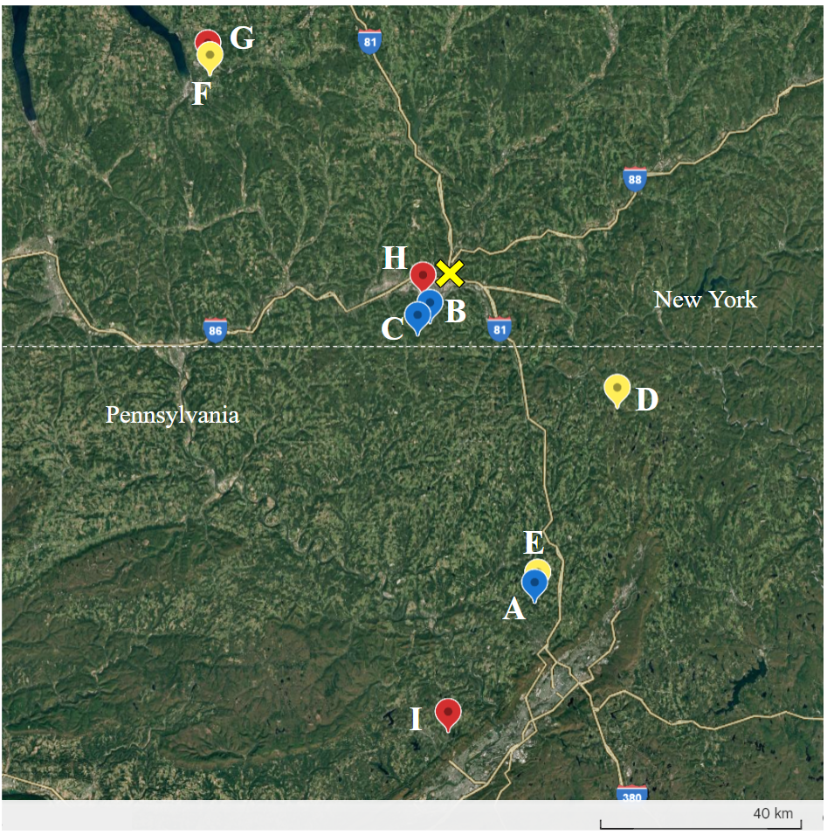

Fig. S2 Map demonstrating site (n = 9) distribution across New York and Pennsylvania. The yellow “X” represents Binghamton, NY. Sites are indicated by colored pins and letters associated with the site list above (Table S1). Yellow pins represent agricultural SL sites, red pins represent residential SL sites, and blue pins represent low-maintenance SL sites. There is a scale bar on the bottom showing 40 kilometers (km)
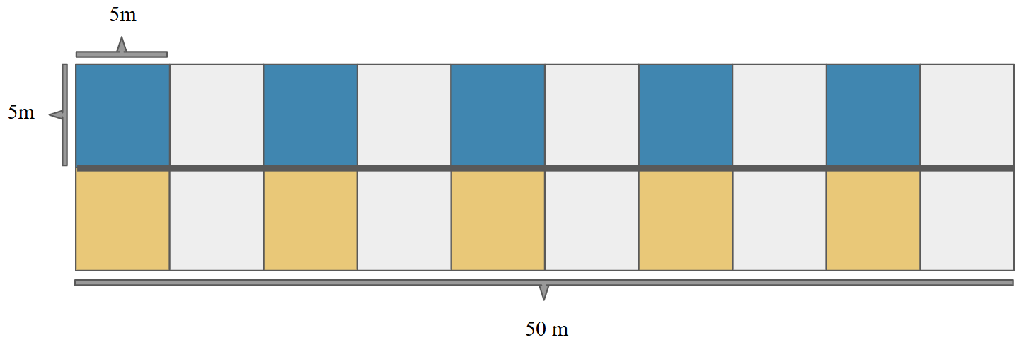
Fig. S3 A diagram of the transect structure, 50 m long and including 5, 25 m² plots along both sides. The blue plots (Type 2; along the top) were used to sample forest invertebrates and soil variables, and to measure seed dispersal and damage. The yellow plots (Type 1; along the bottom) were used to sample vegetation and ant habitat variables by placing 1 m² quadrats in each corner and averaging the four measurements per plot together, as well as taking some measurements at the plot level
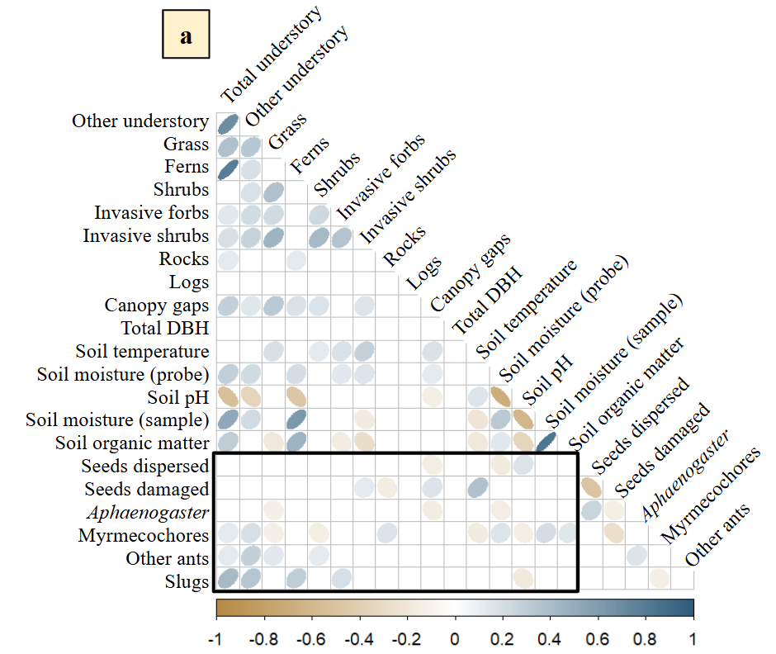
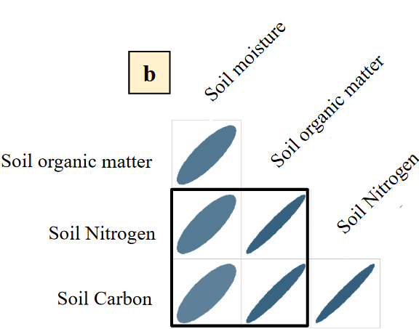

Fig. S4 Correlation plots with data from all sites and sampling locations: a. correlations between vegetation, invertebrate habitat, soil abiotic, and myrmecochory variables, and b. correlations between lab-measured soil variables. The black-outlined boxes emphasize relationships between environmental and myrmecochory variables, and soil organic matter (SOM) and nutrients, respectively. The positively sloped ellipses (blue) represent significant positive correlations between variables, the negatively sloped ellipses (orange) represent significant negative correlations, and the darker ellipses represent stronger correlations (shown in the scale bar on the bottom). Of the 16 environmental variables included, 13 correlated with myrmecochory variables to be included in PCAs (see Fig. S6)

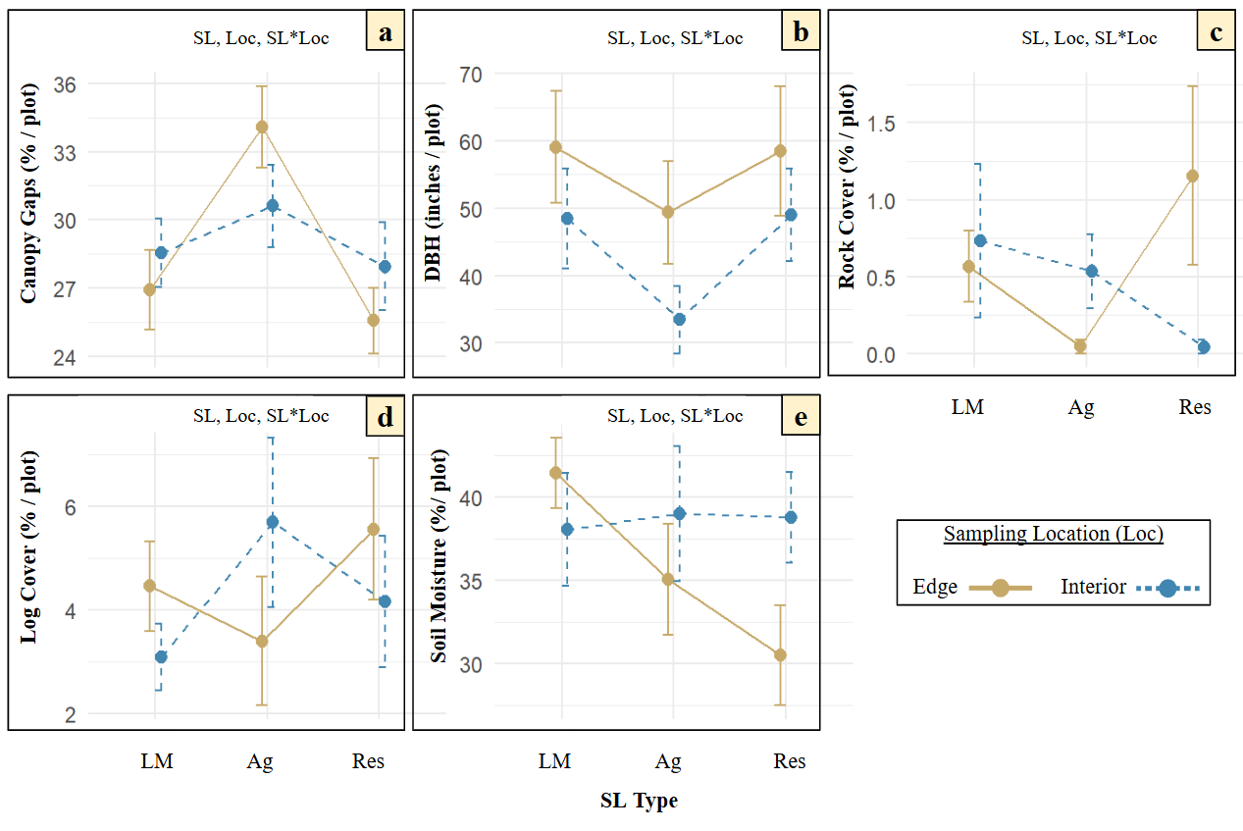
Fig. S5 Interaction plots for environmental variables: a. canopy openness, b. DBH of trees (>10 cm), c. rock cover, d. log cover, and e. percent soil moisture (probe). All values are means ± S.E. The SL types (low-maintenance (LM), agricultural, and residential) are along the x-axis and the location is denoted by color: edge (yellow) and interior (blue) sampling locations. ‘a’, ‘b’ and ‘e’ are measurements taken once at the plot level and ‘c’ and ‘d’ are measurements averaged together from quadrats. Significant factors are indicated with bold letters: ‘SL’ for surrounding landscape type, ‘Loc’ for sampling location, and ‘SL*Loc’ for the interaction (surrounding landscape x sampling location). The associated p-values are recorded above (Table S2)

Table S2 Measured variables and statistical models or tests used in models, test statistics (F stat, chi-square (Chisq), or G stat), and p-values for predictors of surrounding landscape (SL) type, sampling location, and interaction term (surrounding landscape * sampling location). GLMMs have specified distributions (dist.). Some variables were log-transformed before running LMEs. Each model or test has a different test statistic type reported. Bolded p-vales and variables represent significance
Variable | Measurement Type | Type of Model,  or Test | Factors | d.f. | F stat †, Chisq ‡, or  G stat § | P-value
Myrmecochores | Occurrence in plots | G-test § | SL Type | 2 | 1.919 | 0.383
Myrmecochores | Occurrence in plots | G-test § | Sampling Location | 1 | 23.062 | <0.001
Aphaenogaster | Abundance | GLMM, negative binomial dist. ‡ | SL Type | 2, 256 | 1.336 | 0.512
Aphaenogaster | Abundance | GLMM, negative binomial dist. ‡ | Sampling Location | 1, 256 | 7.864 | 0.005
Aphaenogaster | Abundance | GLMM, negative binomial dist. ‡ | Interaction | 2, 256 | 4.009 | 0.135
Slugs | Abundance | GLMM, negative binomial dist. ‡ | SL Type | 2, 256 | 2.676 | 0.262
Slugs | Abundance | GLMM, negative binomial dist. ‡ | Sampling Location | 1, 256 | 29.374 | <0.001
Slugs | Abundance | GLMM, negative binomial dist. ‡ | Interaction | 2, 256 | 25.752 | <0.001
Other ants | Abundance | GLMM, negative binomial dist. ‡ | SL Type | 2, 256 | 5.338 | 0.069
Other ants | Abundance | GLMM, negative binomial dist. ‡ | Sampling Location | 1, 256 | 18.953 | <0.001
Other ants | Abundance | GLMM, negative binomial dist. ‡ | Interaction | 2, 256 | 25.547 | <0.001
Seed dispersal | Number out of 8 | GLMM (zero inflated), truncated Poisson dist. ‡ | SL Type | 2, 250 | 0.534 | 0.766
Seed dispersal | Number out of 8 | GLMM (zero inflated), truncated Poisson dist. ‡ | Sampling Location | 1, 250 | 0.772 | 0.380
Seed dispersal | Number out of 8 | GLMM (zero inflated), truncated Poisson dist. ‡ | Interaction | 2, 250 | 2.912 | 0.233
Seed damage | Number out of 8 | GLMM (zero inflated), truncated Poisson dist. ‡ | SL Type | 2, 250 | 1.729 | 0.421
Seed damage | Number out of 8 | GLMM (zero inflated), truncated Poisson dist. ‡ | Sampling Location | 1, 250 | 0.015 | 0.902
Seed damage | Number out of 8 | GLMM (zero inflated), truncated Poisson dist. ‡ | Interaction | 2, 250 | 0.211 | 0.90
Total understory cover * | Average % cover of quadrats | LME † | SL Type | 2, 6 | 1.932 | 0.225
Total understory cover * | Average % cover of quadrats | LME † | Sampling Location | 1, 252 | 0.230 | 0.632
Total understory cover * | Average % cover of quadrats | LME † | Interaction | 2, 252 | 6.560 | 0.002
Other understory cover (forbs, tree seedlings) * | Average % cover of quadrats | LME † | SL Type | 2, 6 | 4.041 | 0.077
Other understory cover (forbs, tree seedlings) * | Average % cover of quadrats | LME † | Sampling Location | 1, 252 | 0.008 | 0.929
Other understory cover (forbs, tree seedlings) * | Average % cover of quadrats | LME † | Interaction | 2, 252 | 11.000 | <0.001
Grass cover | Average % cover of quadrats | GLMM, beta dist. ‡ | SL Type | 2, 256 | 12.010 | 0.002
Grass cover | Average % cover of quadrats | GLMM, beta dist. ‡ | Sampling Location | 1, 256 | 28.491 | <0.001
Grass cover | Average % cover of quadrats | GLMM, beta dist. ‡ | Interaction | 2, 256 | 11.868 | 0.003
Fern cover | Average % cover of quadrats | GLMM, beta dist. ‡ | SL Type | 2, 256 | 0.236 | 0.889
Fern cover | Average % cover of quadrats | GLMM, beta dist. ‡ | Sampling Location | 1, 256 | 18.924 | <0.001
Fern cover | Average % cover of quadrats | GLMM, beta dist. ‡ | Interaction | 2, 256 | 14.804 | 0.001
Shrub cover * | Average % cover of quadrats | LME † | SL Type | 2, 6 | 8.704 | 0.017
Shrub cover * | Average % cover of quadrats | LME † | Sampling Location | 1, 252 | 21.185 | <0.001
Shrub cover * | Average % cover of quadrats | LME † | Interaction | 2, 252 | 4.824 | 0.009
Invasive forbs | Occurrence in plots | G-test § | SL Type | 2 | 23.187 | <0.001
Invasive forbs | Occurrence in plots | G-test § | Sampling Location | 1 | 2.582 | 0.108
Invasive shrubs | Occurrence in plots | G-test § | SL Type | 2 | 31.730 | <0.001
Invasive shrubs | Occurrence in plots | G-test § | Sampling Location | 1 | 14.048 | <0.001
Canopy openness | % cover of plot | LME † | SL Type | 2, 6 | 0.485 | 0.638
Canopy openness | % cover of plot | LME † | Sampling Location | 1, 252 | 0.033 | 0.855
Canopy openness | % cover of plot | LME † | Interaction | 2, 252 | 2.744 | 0.066
Tree DBH | Total inches in plot | GLMM, gamma dist. ‡ | SL Type | 2, 256 | 0.281 | 0.869
Tree DBH | Total inches in plot | GLMM, gamma dist. ‡ | Sampling Location | 1, 256 | 1.057 | 0.304
Tree DBH | Total inches in plot | GLMM, gamma dist. ‡ | Interaction | 2, 256 | 0.190 | 0.909
Rock cover | Average % cover of quadrats | GLMM, beta dist. ‡ | SL Type | 2, 256 | 1.879 | 0.391
Rock cover | Average % cover of quadrats | GLMM, beta dist. ‡ | Sampling Location | 1, 256 | 0.548 | 0.459
Rock cover | Average % cover of quadrats | GLMM, beta dist. ‡ | Interaction | 2, 256 | 2.085 | 0.353
Log cover | Average % cover of quadrats | GLMM, beta dist. ‡ | SL Type | 2, 256 | 2.251 | 0.325
Log cover | Average % cover of quadrats | GLMM, beta dist. ‡ | Sampling Location | 1, 256 | 0.093 | 0.760
Log cover | Average % cover of quadrats | GLMM, beta dist. ‡ | Interaction | 2, 256 | 1.502 | 0.472
Soil temperature | Degrees C | LME † | SL Type | 2, 6 | 0.214 | 0.814
Soil temperature | Degrees C | LME † | Sampling Location | 1, 252 | 1.478 | 0.225
Soil temperature | Degrees C | LME † | Interaction | 2, 252 | 2.704 | 0.069
Soil moisture (probe) | % in plots | LME † | SL Type | 2, 6 | 0.106 | 0.901
Soil moisture (probe) | % in plots | LME † | Sampling Location | 1, 252 | 2.167 | 0.142
Soil moisture (probe) | % in plots | LME † | Interaction | 2, 252 | 2.356 | 0.097
Soil pH | pH | LME † | SL Type | 2, 6 | 0.351 | 0.718
Soil pH | pH | LME † | Sampling Location | 1, 252 | 7.102 | 0.008
Soil pH | pH | LME † | Interaction | 2, 252 | 0.833 | 0.436
Soil moisture (sample) | g*g-1 | LME † | SL Type | 2, 6 | 0.058 | 0.945
Soil moisture (sample) | g*g-1 | LME † | Sampling Location | 1, 252 | 26.853 | <0.001
Soil moisture (sample) | g*g-1 | LME † | Interaction | 2, 252 | 17.075 | <0.001
Soil organic matter | g*g-1 | GLMM, beta dist. ‡ | SL Type | 2, 256 | 3.754 | 0.153
Soil organic matter | g*g-1 | GLMM, beta dist. ‡ | Sampling Location | 1, 256 | 12.697 | <0.001
Soil organic matter | g*g-1 | GLMM, beta dist. ‡ | Interaction | 2, 256 | 20.077 | <0.001
Soil C | % of transect sample | LME † | SL Type | 2, 6 | 0.127 | 0.883
Soil C | % of transect sample | LME † | Sampling Location | 1, 219 | 2.221 | 0.138
Soil C | % of transect sample | LME † | Interaction | 2, 219 | 24.815 | <0.001
Soil N | % of transect sample | LME † | SL Type | 2, 6 | 0.088 | 0.917
Soil N | % of transect sample | LME † | Sampling Location | 1, 219 | 1.192 | 0.276
Soil N | % of transect sample | LME † | Interaction | 2, 219 | 21.141 | <0.001
*Log-transformed variable before running model
†F-stat reported
‡Chi-squared reported
§G-stat reported

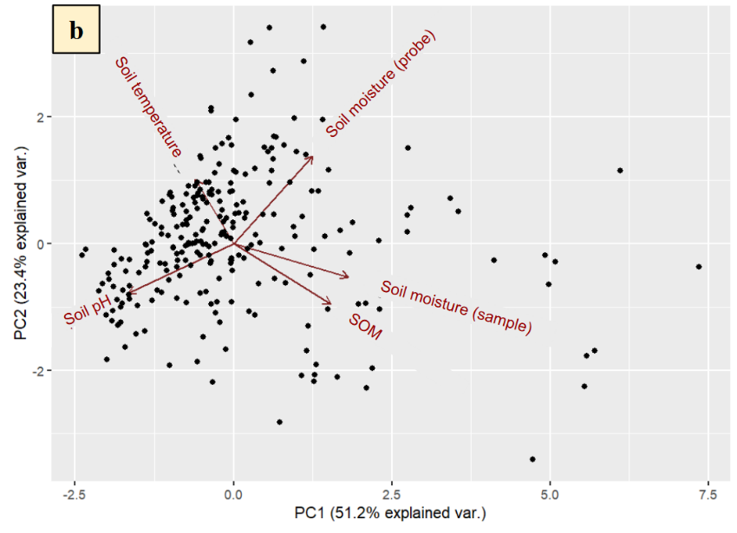
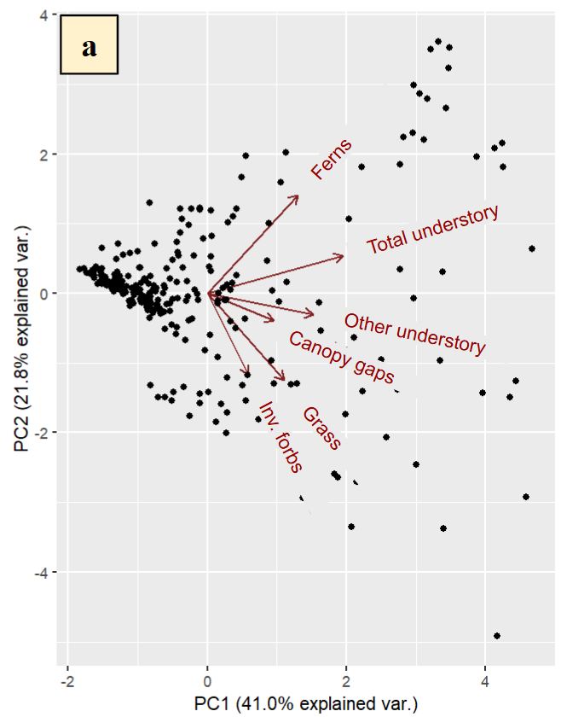

Fig. S6 Principal component analyses for: a) vegetation variables with VegPC1 explaining 41.0% of site variation, and VegPC2 21.8%; and b) soil variables with SoilPC1 explaining 51.2% site variation, and SoilPC2 explained 23.4%. The points represent plots. Arrows represent environmental variables and the strength of their contributions to the PC values on either axis, with longer arrows contributing more to the associated axis value. Since invasive forbs and shrubs were strongly correlated, we only included invasive forbs in vegetation PCA. For the soil PCA, we did not include soil carbon (C) or nitrogen (N) because they were strongly correlated with SOM, and SOM mostly consists of C and N and reflects soil C:N ratios (Sievers & Holtz, 1926). VegPC1, VegPC2 and SoilPC1 were used in path analysis

Table S3 A list of loading values associated with the vegetation PCA (a) and the soil PCA (b) depicted in Fig. S6. Bold loadings are the greatest contributors to the PC value and are noted in the path analysis (Fig. 4)
PCA | Variable | PC1 loading | PC2 loading
a | Total understory | 0.954 | 0.267
a | Other understory | 0.745 | -0.148
a | Grass | 0.538 | -0.610
a | Fern | 0.635 | 0.691
a | Inv. forb | 0.287 | -0.574
a | canopy gaps | 0.467 | -0.194
b | Moisture (sample) | 0.903 | -0.262
b | SOM | 0.764 | -0.477
b | Moisture (probe) | 0.623 | 0.685
b | Temperature | -0.300 | 0.501
b | pH | -0.827 | -0.392

Table S4 Statistics associated with the path analysis (Fig. 4). Predictor and response variables are listed for all direct relationships tested within the path analysis and covariances are also described. Path components are bold when the p-value is significant, and coefficients demonstrate stronger relationships when closer to |1|
Predictor | Response | Path type | P-value | Coefficient (β)
vegPC1/soilPC1 | vegPC1/soilPC1 | covariance | 0.000 | 0.416
vegPC1 | Slugs | direct | 0.000 | 0.464
vegPC1 | myrmecochores | direct | 0.689 | 0.026
vegPC1 | Aphaenogaster | direct | 0.676 | 0.028
vegPC2/soilPC1 | vegPC2/soilPC1 | covariance | 0.000 | 0.432
vegPC2 | Slugs | direct | 0.068 | 0.115
vegPC2 | Myrmecochores | direct | 0.187 | 0.087
vegPC2 | Aphaenogaster | direct | 0.000 | 0.280
soilPC1 | Slugs | direct | 0.063 | -0.129
soilPC1 | Myrmecochores | direct | 0.034 | 0.154
soilPC1 | Aphaenogaster | direct | 0.004 | -0.211
Aphaenogaster | Dispersal | direct | 0.000 | 0.193
Slugs | Damage | direct | 0.104 | 0.087
Dispersal | Myrmecochores | direct | 0.857 | -0.012
Damage | Myrmecochores | direct | 0.000 | -0.260
Dispersal/Damage | Dispersal/Damage | covariance | 0.000 | -0.491

