Supplementary Information 2
For “Biogeography, sex, and body mass shape the fungal diet of an endangered mycophagous mammal”.

This Supplementary Information contains results for all community composition analysis performed on presence-absence OTU data. Analyses were carried out as described in the main paper, and summarised below.

Summary of analyses performed
Beta diversity analyses were performed on presence-absence OTU matrices using Raup-Crick distances after removal of outlier samples. Differences in fungal community composition was tested between sites, long-footed potoroo sub-populations, seasons, topography, and mass and sex of long-footed potoroos, with Permutational Multivariate Analysis of Variance (PERMANOVA) using the ‘adonis2’ function in the package vegan. Fungal genera indicative of differences between group were identified the ‘indicspecies’ function from the indicspecies package. To assess how spatial, seasonal and climatic variables structured fungal community composition in scats, distance-based redundancy analysis (db-RDA) was conducted using ‘capscale’ in vegan.
Where topographic variables explained variation in fungal community composition, we assessed the response of each fungal taxon to these variables using used Generalised Linear Latent Variable models from gllvm (Niku et al., 2025).

Table of Contents
Table | Page
Figure S2.1 | 3
Table S2.1 | 3
Table S2.2 | 4
Table S2.3 | 5
Table S2.4 | 6-7
Table S2.5 | 8
Figure S2.2 | 8
Table S2.6 | 9
Table S2.7 | 10
Table S2.8 | 11
Figure S2.3 | 11

Results

Spatial and seasonal patterns in long-footed potoroo diet
Based on relative abundance data, ECM and truffle-like ECM community composition of long-footed potoroo scats differed significantly between long-footed potoroo sub-populations, sites nested within sub-population, season, and the interaction between season and site, across all sites between 1993-1995. NMDS stress was high however for both the ECM (stress = 0.226) and truffle-like ECM (stress = 0.196) fungal communities (Table S2.1, Fig S2.1), indicating that results should be interpreted with caution. For both fungal communities, site explained the greatest amount of variation, followed by season. Group dispersion differed significantly between sites (p = 0.001) but not between sub-population (p ≤ 0.221) for ECM communities, and did not differ significantly between sites (p ≤ 0.713) or sub-population (p ≤ 0.614) for truffle-like ECM fungal communities. Pairwise analysis of between-site differences indicated that the ECM and truffle-like ECM fungal communities were significantly different between three pairs of sites (Table S2.2).
ECM fungal community composition in LFP scats at Bellbird differed according to Topographic Wetness Index (TWI) (R² = 0.087, p ≤ 0.032) and northness (R² = 0.083, p ≤ 0.037), but not eastness or slope; and truffle-like ECM fungal communities differed in response to eastness ((R² = 0.023, p ≤ 0.026), but not northness, slope or TWI, in the PERMANOVA models. The truffle-like ECM and total ECM fungi Generalised Linear Latent Variable Models (GLLVM), that include these respective variables, were however not significantly better than the null model. The divergent responses between the distance-based PERMANOVA and model-based GLLVM analyses suggests that the influence of the environmental variables was likely due to the response of a few highly abundant and variable fungi species (Table S2.3, S2.4) and this response was not consistent or predictable across the community.

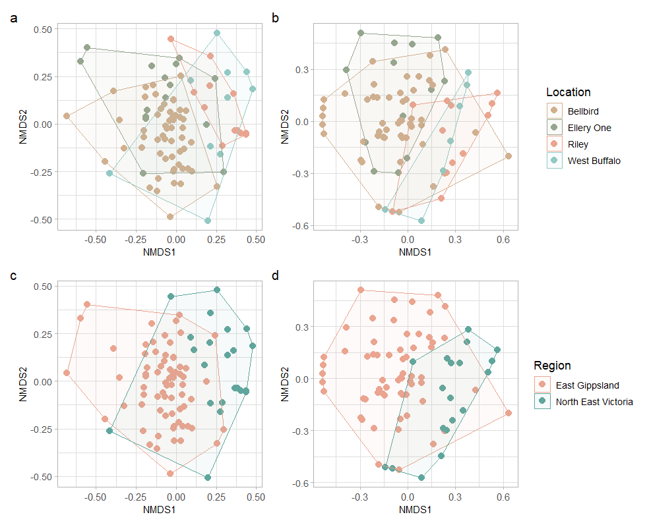
Figure S2.1. NMDS ordination of fungal communities in scat samples collected between 1993-1995, using presence-absence OTU data with Raup-Crick dissimilarity index. Ordination of fungal community composition, a) for all ECM by location; b) truffle-like ECM by location; c) all ECM by region; d) truffle-like ECM by region.

Table S2.1. PERMANOVA estimates for the ECM and truffle-like ECM community in scat samples collected at all sites between 1993-1995. All predictors are significant (p < 0.05).
Variable | DF | R² | P value
Distance matrix | ECM community
Site | 3 | 0.391 | 0.001
Season | 3 | 0.277 | 0.001
Distance matrix | Truffle-like ECM community
Site | 3 | 0.317 | 0.001
Season | 3 | 0.118 | 0.001

Table S2.2. Pairwise PERMANOVA between locations using Raup-Crick dissimilarity index dissimilarity index for fungal communities between sites. Significant results (p < 0.05) in bold.
 | All ECM |  | Truffle-like ECM
Site pair | R2 | p.adj | R2 | p.adj
Bellbird vs Riley | 0.402 | 0.006 | 0.241 | 0.006
Bellbird vs West Buffalo | 0.129 | 0.084 | 0.146 | 0.012
Bellbird vs Ellery One | 0.395 | 0.006 | 0.143 | 0.012
Riley vs West Buffalo | -0.088 | 1 | 0.024 | 1
Riley vs Ellery One | 0.513 | 0.006 | 0.467 | 0.006
West Buffalo vs Ellery One | 0.222 | 0.054 | 0.312 | 0.060

Table S2.3. Generalised Linear Latent Variable Model estimates for truffle-like ECM fungal OTUs in response the topographic variable of eastness at Bellbird between 1993-2016. Significant results (p < 0.05) in bold.
Taxon | Estimate (SD) | p value
Descomyces_albus_OTU1034 | -0.234 (0.214) | 0.275
Austrogautieria_sp_OTU115 | -0.102 (0.117) | 0.381
Mesophellia_sp_OTU1188 | -0.611 (0.413) | 0.139
Rossbeevera_pachydermis_OTU120 | 0.296 (0.132) | 0.025
Hysterangium_sp_OTU125 | -0.13 (0.136) | 0.339
Austrogautieria_costata_OTU1289 | 0.071 (0.328) | 0.828
Thaxterogaster_dulcamarus_OTU1634 | 0.062 (0.331) | 0.852
Thaxterogaster_caesibulga_OTU167 | -0.345 (0.165) | 0.037
Descomyces_sp_OTU1693 | 0.341 (0.282) | 0.227
Dingleya_geometrica_OTU1758 | -0.119 (0.301) | 0.692
Thaxterogaster_sp_OTU1980 | -1.475 (1.926) | 0.444
Octaviania_tasmanica_OTU238 | 0.077 (0.124) | 0.533
Mesophellia_sp_OTU26 | -0.167 (0.114) | 0.143
Labyrinthomyces_sp_OTU2855 | 0.41 (0.395) | 0.299
Thaxterogaster_sp_OTU2891 | -0.028 (0.476) | 0.954
Rossbeevera_sp_OTU2968 | -0.166 (0.516) | 0.747
Hysterangium_sp_OTU307 | 0.069 (0.14) | 0.620
Gymnomyces_sp_OTU3458 | -0.204 (0.533) | 0.702
Zelleromyces_dendriticus_OTU362 | 0.012 (0.216) | 0.957
Thaxterogaster_sp_OTU4225 | 2.629 (5.275) | 0.618
Thaxterogaster_austrovaginatus_OTU4513 | -21.743 (34.073) | 0.523
Mesophellia_sp_OTU4648 | 0.447 (0.572) | 0.435
Hysterangium_sp_OTU562 | 91.877 (985.946) | 0.926
Thaxterogaster_australis_OTU609 | -0.023 (0.346) | 0.946
Elaphomyces_sp_OTU610 | -0.008 (0.238) | 0.972
Arcangeliella_claridgei_OTU67 | 0.057 (0.131) | 0.661
Thaxterogaster_sp_OTU686 | 0.283 (0.191) | 0.137
Thaxterogaster_sp_OTU692 | 0.177 (0.222) | 0.426
Mesophellia_sp_OTU726 | 0.188 (0.236) | 0.424
Hysterangium_sp_OTU738 | 1.014 (1.437) | 0.480
Thaxterogaster_chalybeus_OTU75 | 0.037 (0.139) | 0.791
Hydnoplicata_convoluta_OTU766 | -0.014 (0.21) | 0.948
Elaphomyces_sp_OTU77 | 0.03 (0.3) | 0.919
Hysterangium_sp_OTU81 | -0.121 (0.12) | 0.315
Thaxterogaster_austrosaginus_OTU869 | 0.057 (0.332) | 0.864
Hysterangium_sp_OTU876 | 0.149 (0.195) | 0.443
Labyrinthomyces_sp_OTU945 | 0.216 (0.228) | 0.344
Hysterangium_sp_OTU984 | 0.376 (0.325) | 0.246

Table S2.4. Generalised Linear Latent Variable Model estimates for ECM fungal OTUs in response the topographic variables of Topographic Wetness Index (TWI) and northness at Bellbird between 1993-2016. Significant results (p < 0.05) in bold.

 | Response to TWI |  | Response to northness
Taxon | Estimate (SD) | p value | Estimate (SD) | p value
Descomyces_albus_OTU1034 | -0.197 (0.183) | 0.281 | -0.139 (0.376) | 0.712
Austrogautieria_sp_OTU115 | -0.06 (0.093) | 0.521 | 0.408 (0.233) | 0.081
Mesophellia_sp_OTU1188 | 0.159 (0.173) | 0.357 | -0.074 (0.526) | 0.889
Rossbeevera_pachydermis_OTU120 | 0.004 (0.099) | 0.967 | -0.009 (0.25) | 0.972
Hysterangium_sp_OTU125 | -0.025 (0.108) | 0.816 | 0.003 (0.261) | 0.991
Austrogautieria_costata_OTU1289 | -0.531 (0.506) | 0.295 | 0.067 (0.662) | 0.919
Thaxterogaster_dulcamarus_OTU1634 | -0.46 (0.492) | 0.35 | -0.005 (0.678) | 0.995
Thaxterogaster_caesibulga_OTU167 | 0.02 (0.124) | 0.869 | 0.31 (0.293) | 0.29
Descomyces_sp_OTU1693 | 0.04 (0.181) | 0.827 | -1.085 (0.777) | 0.163
Dingleya_geometrica_OTU1758 | 0.146 (0.206) | 0.479 | 0.476 (0.583) | 0.414
Thaxterogaster_sp_OTU1980 | 0.094 (0.284) | 0.741 | 0.644 (0.621) | 0.3
Octaviania_tasmanica_OTU238 | 0.026 (0.096) | 0.786 | -0.022 (0.244) | 0.927
Mesophellia_sp_OTU26 | -0.046 (0.086) | 0.597 | 0.049 (0.22) | 0.826
Labyrinthomyces_sp_OTU2855 | 0.048 (0.227) | 0.833 | -1.076 (1.064) | 0.312
Thaxterogaster_sp_OTU2891 | 0.111 (0.366) | 0.761 | -8.856 (11.827) | 0.454
Rossbeevera_sp_OTU2968 | -55.681 (0.053) | < 0.0001 | -94.1 (0.329) | < 0.0001
Hysterangium_sp_OTU307 | -0.003 (0.109) | 0.98 | -0.505 (0.294) | 0.086
Gymnomyces_sp_OTU3458 | -0.121 (0.462) | 0.794 | -2.212 (2.285) | 0.333
Zelleromyces_dendriticus_OTU362 | 0.146 (0.155) | 0.348 | 0.253 (0.44) | 0.565
Thaxterogaster_sp_OTU4225 | -0.621 (0.781) | 0.426 | -0.504 (1.158) | 0.664
Thaxterogaster_austrovaginatus_OTU4513 | 0.065 (0.386) | 0.866 | 0.626 (0.829) | 0.45
Mesophellia_sp_OTU4648 | -0.537 (0.912) | 0.556 | -2.7 (2.679) | 0.314
Hysterangium_sp_OTU562 | -48.169 (8.393) | < 0.0001 | 5.01 (363.076) | 0.989
Thaxterogaster_australis_OTU609 | -0.361 (0.441) | 0.414 | -0.267 (0.722) | 0.712
Elaphomyces_sp_OTU610 | -1.814 (0.858) | 0.034 | -0.048 (0.59) | 0.935
Arcangeliella_claridgei_OTU67 | 0.09 (0.098) | 0.361 | -0.273 (0.265) | 0.302
Thaxterogaster_sp_OTU686 | 0.111 (0.137) | 0.418 | 0.041 (0.402) | 0.918
Thaxterogaster_sp_OTU692 | 0.216 (0.153) | 0.158 | -0.36 (0.509) | 0.479
Mesophellia_sp_OTU726 | -0.143 (0.211) | 0.498 | -0.274 (0.435) | 0.528
Hysterangium_sp_OTU738 | -1.798 (2.905) | 0.536 | 1.992 (1.642) | 0.225
Thaxterogaster_chalybeus_OTU75 | 0.112 (0.107) | 0.292 | 0.074 (0.275) | 0.787
Hydnoplicata_convoluta_OTU766 | -0.211 (0.212) | 0.318 | 0.272 (0.359) | 0.448
Elaphomyces_sp_OTU77 | 0.137 (0.206) | 0.507 | 0.519 (0.502) | 0.301
Hysterangium_sp_OTU81 | -0.049 (0.09) | 0.591 | -0.208 (0.232) | 0.371
Thaxterogaster_austrosaginus_OTU869 | -1.663 (1.656) | 0.315 | 1.11 (0.732) | 0.13
Hysterangium_sp_OTU876 | -0.024 (0.149) | 0.872 | -0.991 (0.513) | 0.053
Labyrinthomyces_sp_OTU945 | 0.151 (0.152) | 0.319 | -0.124 (0.513) | 0.809
Hysterangium_sp_OTU984 | 0.122 (0.187) | 0.515 | -1.423 (1.019) | 0.163

There was a significant effect of distance decay for both ECM and truffe-like ECM fungal communities in East Gippsland, indicating that long-footed potoroo diets in this population are structured by geographic distance. Mantel correlations were not significant for fungal communities in Northeast Victoria, indicating communities in long-footed potoroo diets between sites are no more different than what would be expected by chance. In East Gippsland, mantel correlations were stronger for ECM (mantel correlation for first distance class = 0.324, p (corrected) ≤ 0.001; second distance class = -0.324, p (corrected) ≤ 0.002) compared to truffle-like ECM (mantel correlation for first distance class = 0.172, p (corrected) ≤ 0.003; second distance class = -0.172, p (corrected) ≤ 0.006) communities.
Dispersion in ECM communities differed significantly between seasons (p ≤ 0.027), but it did not differ for truffle-like ECM communities. Pairwise analysis of seasonal differences indicated that the ECM communities were significantly different between all season pairings except Autumn and Summer, and Autumn and Winter (Table S2.5). For truffle-like ECM fungi, communities were only significantly different between Summer and Winter (Table S2.5). Indicator species analysis revealed that Arcangeliella (stat = 0.461, p ≤ 0.001), Hydnoplicata (stat = 0.372, p ≤ 0.025), and Labyrinthomyces (stat = 0.332, p ≤ 0.037) were all associated with scats collected in Winter, Thaxterogaster (stat = 0.413, p ≤ 0.001) was associated with the grouping of Winter and Spring, and Mesophellia was associated with Spring (stat = 0.303, p ≤ 0.036)
The db-RDA identified three variables that best explained variation in truffle-like ECM and ECM fungal communities in long-footed potoroo scats from sites between 1993-1995 (Fig S2.2). For truffle-like ECM fungal communities, Site explained the greatest variation (sum of squares = 2.802, p= 0.001), followed by Season (sum of squares = 2.669, p ≤ 0.001), and average minimum temperature of the past quarter (sum of squares = 1.051, p ≤ 0.004). Together, these variables explained 23.68% of variation within the fungal community. For the total ECM community, Site also explained the greatest variation (sum of squares = 1.005, p ≤ 0.003), followed by Season (sum of squares = 1.005, p ≤ 0.003), and average temperature of the past week (sum of squares = 0.309, p ≤ 0.029). Together, these variables explained 21.3 % of variation within the fungal community.
Indicator species analysis identified truffle-like ECM genera that were indicative of differences between sites and sub-populations (Table S2.6).

Table S2.5. Pairwise PERMANOVA between seasons using Raup-Crick dissimilarity index for fungal communities in LFP scat samples collected at all sites between 1993-1995. Significant results (p < 0.05) in bold.
 | All ECM |  | Truffle-like ECM
Site pair | R2 | p.adj | R2 | p.adj
Autumn vs Spring | 0.365 | 0.006 | 0.012 | 1
Autumn vs Summer | 0.113 | 0.288 | 0.044 | 1
Autumn vs Winter | 0.130 | 0.630 | 0.001 | 1
Spring vs Summer | 0.288 | 0.006 | 0.130 | 0.072
Spring vs Winter | 0.227 | 0.024 | 0.112 | 0.174
Summer vs Winter | 0.280 | 0.012 | 0.177 | 0.018

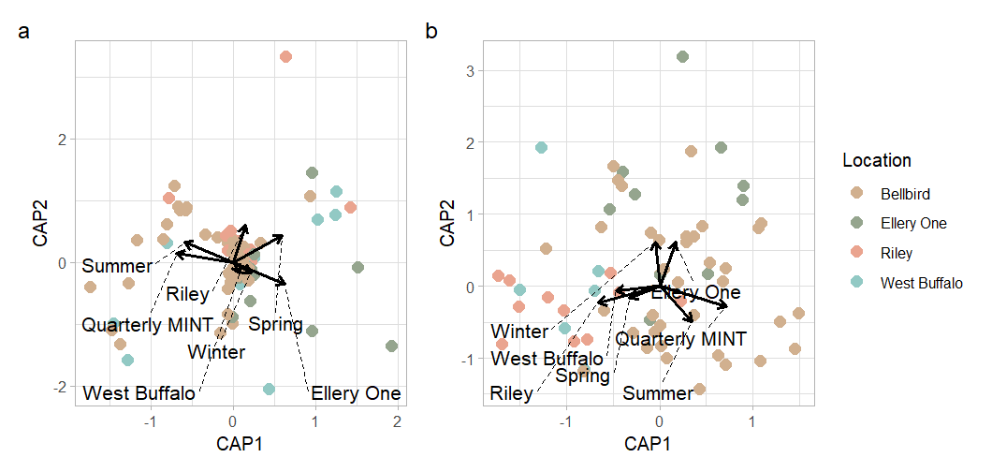
Figure S2.2. Db-RDA with climatic variables that best explain variation in a) ECM and b) truffle-like ECM fungal communities in scat samples collected at all sites between 1993-1995, using Raup-Crick dissimilarity index.

Table S2.6. Indicator truffle-like ECM genera of scat samples collected at all sites between 1993-1995 using presence-absence OTU data. All indicator taxa listed are significantly associated with their site group (p < 0.05).
Site/group | Genera associated with grouping | stat | P value
Between sites
Bellbird | Austrogautieria | 0.459 | 0.001
West Buffalo | Elaphomyces | 0.374 | 0.021
Bellbird + Ellery One | Arcangeliella | 0.334 | 0.012
Riley + West Buffalo | Rossbeevera | 0.359 | 0.007
Riley + West Buffalo | Malajczukia | 0.342 | 0.027
Between regions
East Gippsland | Austrogautieria | 0.456 | 0.001
East Gippsland | Arcangeliella | 0.334 | 0.008
Northeast Victoria | Malajczukia | 0.342 | 0.001
Northeast Victoria | Rossbeevera | 0.359 | 0.001
Northeast Victoria | Elaphomyces | 0.317 | 0.009

Fungal diets of long-footed potoroos between two adjacent sites
Fungal communities in long-footed potoroo scats also differed between two of the more intensively sampled sites in East Gippsland, Bellbird and Watchmaker, between 1998 and 2005. Season explained the greatest variation in ECM communities between these sites (PERMANOVA: R² = 0.399, p ≤ 0.001), followed by Site (R² = 0.244, p ≤ 0.001). Season also the greatest variation in truffle-like ECM communities between these sites PERMANOVA: R² = 0.155, p ≤ 0.001), followed by Site (R² = 0.054, p ≤ 0.002), and there was no interaction between Site and Season. NMDS stress was high for both ECM (stress = 0.251) and truffle-like ECM (stress = 0.197) fungal communities indicating that results should be interpreted with caution. Dispersion for samples at Bellbird were significantly lower than those at Watchmaker for the total ECM community (p ≤ 0.001) but did not differ between sites for truffle-like ECM community (p ≤ 0.86). Pairwise analysis of seasonal differences indicated that the ECM communities were significantly different between all season pairings for ECM fungi except Autumn and Summer, and between all pairings except between Spring and Winter and between Spring and Autumn for truffle-like ECM fungi (Table S2.7). Group dispersion was significantly different between seasons for all ECM fungi (p.adj ≤ 0.002) and truffle-like ECM fungi (p.adj ≤ 0.005).
A distance-based redundancy analysis (db-RDA) was conducted to further investigate the role of season and site in shaping the community composition of fungal communities between Watchmaker and Bellbird (Fig S2.3). For ECM fungal communities, the variables that best explained community variation were Season, Location, quarterly minimum temperature, quarterly precipitation, and monthly AHMI, which explained 16.32% of variation; for truffle-like ECM communities, Season, Location, quarterly minimum temperature, and annual minimum temperature explained 15.12% of variation.
Indicator species analysis found that two genera, Austrogautieria and Elaphomyces, were important in driving differences in truffle-like ECM fungal communities between the sites. Austrogautieria was associated with Bellbird (stat = 0.211, p ≤ 0.027), and Elaphomyces was associated with Watchmaker (stat = 0.393, p ≤ 0.001).

Long-footed potoroo fungal diet varies with individual traits
Using trait data (i.e. body mass and sex) recorded from trapped long-footed potoroos at Watchmaker between 1998 and 2005, we found that body mass significantly correlated with fungal community composition in long-footed potoroo scats at Watchmaker for truffle-like ECM but not for the total ECM fungal community (Fig S2.4). For truffle-like ECM fungal communities, season contributed more to explaining community variation between long-footed potoroo scats than did mass (Season: R² = 0.274, p ≤ 0.003; Mass: R² = 0.126, p ≤ 0.007). NMDS stress was moderate for both the ECM (stress = 0.194) and truffle-like ECM (stress = 0.153) fungal communities. No truffle-like ECM genera were indicative of differences between LFP mass classes. Truffle-like ECM and total ECM fungal community composition did not differ between male and female LFPs.

Table S2.7. Pairwise PERMANOVA between seasons using Raup-Crick dissimilarity index for fungal communities in LFP scat samples collected at Watchmaker and Bellbird between 1998 – 2005. Significant results (p < 0.05) in bold.
 | All ECM |  | Truffle-like ECM
Site pair | R2 | p.adj | R2 | p.adj
Summer vs Autumn | 0.224 | 0.078 | 0.164 | 0.030
Summer vs Winter | 0.496 | 0.006 | 0.172 | 0.006
Summer vs Spring | 0.345 | 0.006 | 0.126 | 0.012
Autumn vs Winter | 0.451 | 0.006 | 0.159 | 0.006
Autumn vs Spring | 0.286 | 0.006 | 0.095 | 0.060
Winter vs Spring | 0.144 | 0.030 | -0.010 | 1

Table S2.8. DB-RDA model statistics for variables that best explain variation in fungal communities, using Raup-Crick dissimilarity index. All results are significant (p < 0.05).
 | All ECM |  | Truffle-like ECM
Site pair | SumOfSqs | P | SumOfSqs | P
Season | 0.700 | 0.001 | 2.174 | 0.006
Location | 0.715 | 0.001 | 1.888 | 0.001
Monthly AHMI | 0.288 | 0.03
Quarterly Precipitation | 0.279 | 0.034
Quarterly MINT | 0.369 | 0.001 | 0.899 | 0.016
Annual MINT |  |  | 1.445 | 0.001

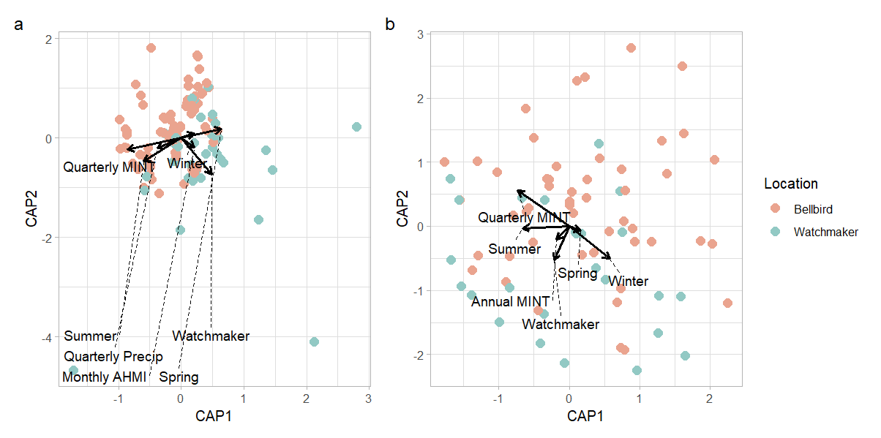
Figure S2.3. db-RDA with climatic variables that best explain variation in a) ECM and b) truffle-like ECM fungal communities in scat samples collected at Watchmaker and Bellbird between 1998-2005.

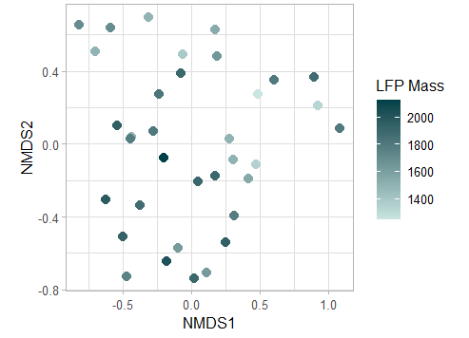
Figure S2.4. NMDS ordination of truffle-like ECM fungal communities in LFP scats at Watchmaker, visualized with respect to LFP body mass (grams).

