Supplementary Information 1
For “Biogeography, sex, and body mass shape the fungal diet of an endangered mycophagous mammal”

Table of Contents
Item | Page
Supplementary Table S1.1 | 2
Supplementary Table S1.2 | 3
Supplementary Figure S1.1 | 3
Supplementary Figure S1.2 | 4
Supplementary Figure S1.3 | 5
Supplementary Table S1.3 | 5
Supplementary Figure S1.4 | 5
Supplementary Table S1.4 | 6
Supplementary Figure S1.5 | 6
Supplementary Table S1.5 | 7
Supplementary Figure S1.6 | 7
Supplementary Figure S1.7 | 8
Supplementary Table S1.6 | 8
Supplementary Table S1.7 | 9
Supplementary Table S1.8 | 9
Supplementary Figure S1.8 | 9
Supplementary Figure S1.9 | 10
Supplementary Table S1.9 | 10

Table S1.1. Site characteristics. Bellbird and Watchmaker are located in the East Gippsland sub-population, and the remaining sites are within the Northeast Victoria sub-population. * = Tree species at Watchmaker were derived from dominant tree species within the modelled Ecological Vegetation Class (The State of Victoria, Department of Energy, Environment and Climate Action (DEECA), 2018) for that site (East Gippsland Lowlands Bioregion – Lowland Forest).
Site name | Elevation (m.a.s.l) | Aspect (degrees) | Slope (degrees) | Annual precipitation (mm)  (Fick & Hijmans, 2017) | Mean annual temperature (°C) (Fick & Hijmans, 2017) | Annual Heat Moisture Index (AHMI) | Dominant tree species (Green et al., 1999) | Last logging activity within 1km radius of study location, prior to 2016
Bellbird | 183.7 | 223.8 | 9.8 | 1211 | 14.1 | 19.9 | Eucalyptus sieberi | 1970s (DJPR and DEECA, 2023)
Watchmaker | 238.1 | 144.9 | 3.3 | 1211 | 14.1 | 19.9 | * Eucalyptus sieberi, E. globoidea, E. consideniana | 2003 (DJPR and DEECA, 2023)
Ellery One | 314.8 | 152.4 | 4.9 | 1086 | 13.6 | 21.7 | E. obliqua with E. cypellocarpa, E. muellerana and E. croajingolensis | Logging recent to 1999 (Green et al., 1999)
Riley | 902.5 | 71.6 | 11.1 | 1076 | 10.6 | 19.1 | E. obliqua, E. mannifera, E. radiata and E. viminalis | No history of logging (DJPR and DEECA, 2023; Green et al.,1999)
West Buffalo | 910.9 | 225.8 | 7.5 | 1119 | 11.2 | 18.9 | E. obliqua and E. cypellocarpa | 1995 (DJPR and DEECA, 2023)

Table S1.2. The time range, location, and number of long-footed potoroo scat samples used in each analysis.
Analysis | Time frame | Sites (number of samples per site)
Spatial and seasonal analysis of fungi in long-footed potoroo scats | 1993 – 1995 | Bellbird (57) Ellery One (20), Riley (13), West Buffalo (11)
Fungi in long-footed potoroo scats between two adjacent sites (a)  - Full dataset | 1998 – 2005 | Watchmaker (43) and Bellbird (121)
Fungi in long-footed potoroo scats between two adjacent sites (b)  - Sub-sampled dataset: same number of samples at each site for each year and season combination | 1998 – 2005 | Watchmaker (26) and Bellbird (26); see Figure S1.1 for distribution of samples across season and year
Sex and mass-based differences in fungi in long-footed potoroo scats | 1998 – 2005 | Watchmaker (42)
Analysis of fungi in long-footed potoroo scats across a topographical gradient | 1993 – 2016 | Bellbird (247)

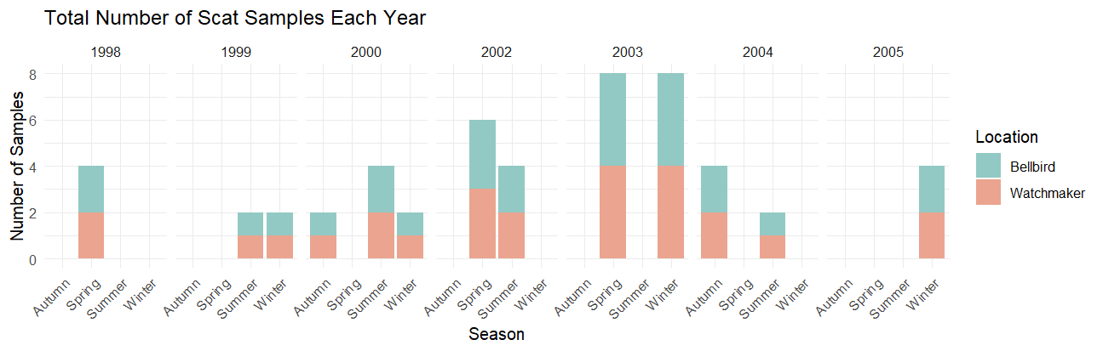
Figure S1.1. Sample distribution for analysis of fungal communities in potoroo scats at Watchmaker and Bellbird, with an equal number of samples at each site for each year and season combination
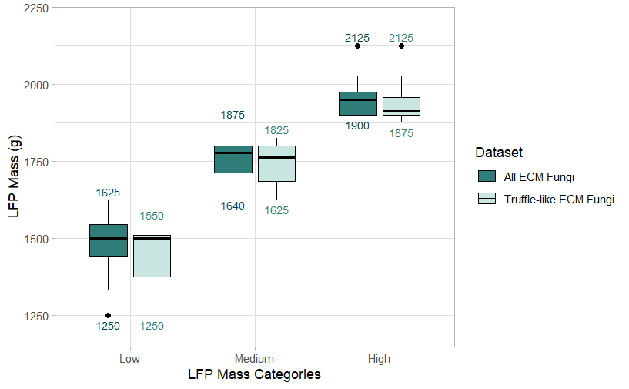Figure S1.2. Grouping of samples into low, medium and high LFP mass categories. Group maximum and minimum is denoted above and below each box, respectively.

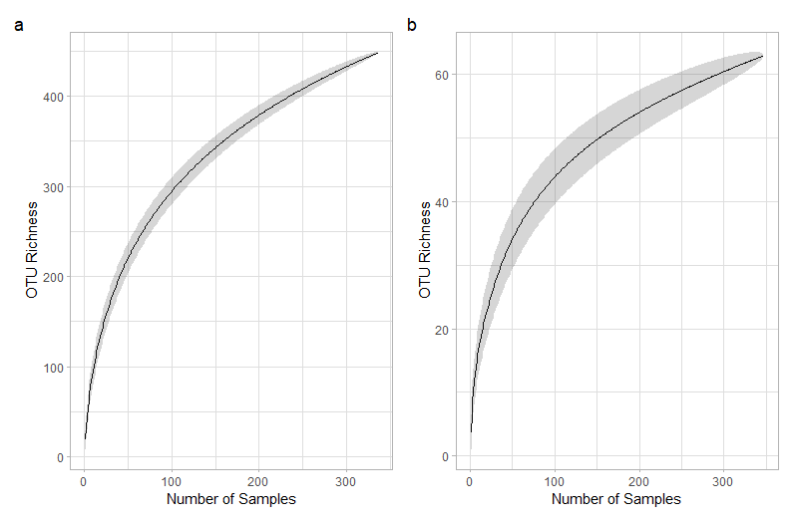
Figure S1.3. Species accumulation curve for a) all ECM OTUs (n = 336), and B) truffle-like ECM OTUs (n = 310). Shaded area represents the standard deviation from random permutations of data.
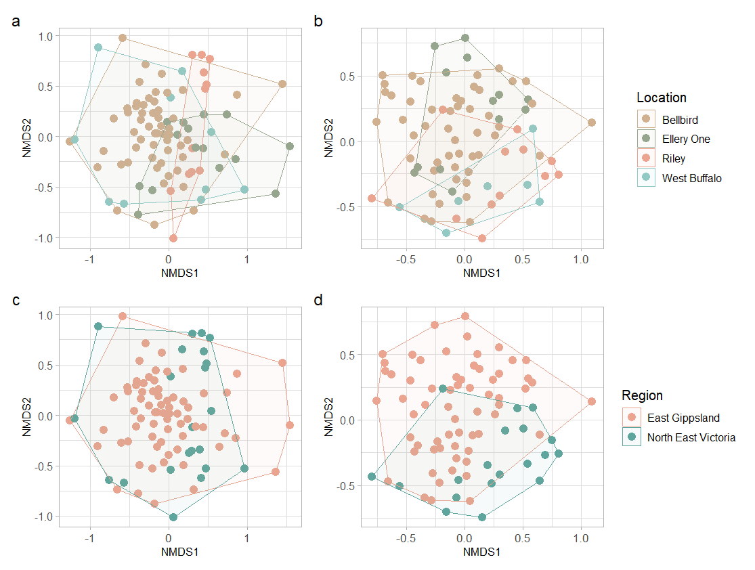

Figure S1.4. NMDS ordination of fungal communities in scat samples collected between 1993-1995. Ordination of fungal community composition, a) for all ECM by location; b) truffle-like ECM by location; c) all ECM by region; d) truffle-like ECM by region.

Table S1.3. Pairwise PERMANOVA between locations using Bray-Curtis dissimilarity index for fungal communities between sites. Significant results (p < 0.05) in bold.
 | All ECM |  | Truffle-like ECM
Site pair | R2 | p.adj | R2 | p.adj
Bellbird vs Riley | 0.077 | 0.006 | 0.043 | 0.006
Bellbird vs West Buffalo | 0.034 | 0.036 | 0.031 | 0.21
Bellbird vs Ellery One | 0.055 | 0.006 | 0.033 | 0.132
Riley vs West Buffalo | 0.085 | 0.162 | 0.062 | 1
Riley vs Ellery One | 0.138 | 0.006 | 0.117 | 0.006
West Buffalo vs Ellery One | 0.067 | 0.096 | 0.094 | 0.264

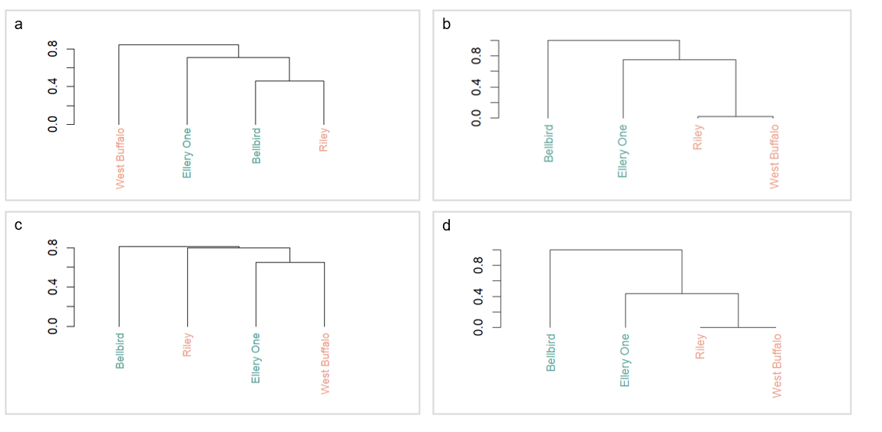
Figure S1.5. Hierarchical cluster analysis for OTUs at sites in East Gippsland (blue colour) and Northeast Victoria (orange colour) for truffle-like ECM relative abundance (a) and presence-absence (b), and ECM fungi relative abundance (c) and presence-absence (d).

Table S1.4. Pairwise PERMANOVA between seasons using Bray-Curtis dissimilarity index for fungal communities in LFP scat samples collected at all sites between 1993-1995. Significant results (p < 0.05) in bold.
 | All ECM |  | Truffle-like ECM
Site pair | R2 | p.adj | R2 | p.adj
Autumn vs Spring | 0.060 | 0.006 | 0.031 | 1
Autumn vs Summer | 0.044 | 0.252 | 0.037 | 1
Autumn vs Winter | 0.052 | 0.066 | 0.059 | 0.132
Spring vs Summer | 0.071 | 0.006 | 0.060 | 0.012
Spring vs Winter | 0.056 | 0.006 | 0.057 | 0.018
Summer vs Winter | 0.095 | 0.006 | 0.089 | 0.006

Table S1.5. Indicator truffle-like ECM genera of scat samples collected at all sites between 1993-1995. All indicator taxa listed are significantly associated with their site group (p < 0.05).
Site/group | Genera associated with grouping | stat | P value
Between sites
Bellbird | Austrogautieria | 0.525 | 0.001
Ellery One | Dingleya | 0.45 | 0.008
Riley + West Buffalo | Descomyces | 0.467 | 0.003
Riley + West Buffalo | Malajczukia | 0.467 | 0.010
Riley + West Buffalo | Rossbeevera | 0.373 | 0.004
 | Elaphomyces | 0.331 | 0.025
Bellbird + Ellery One + Puggaree | Arcangeliella | 0.321 | 0.027
Between regions
East Gippsland | Austrogautieria | 0.473 | 0.001
East Gippsland | Arcangeliella | 0.328 | 0.002
Northeast Victoria | Malajczukia | 0.467 | 0.001
Northeast Victoria | Descomyces | 0.467 | 0.002
Northeast Victoria | Rossbeevera | 0.373 | 0.001
Northeast Victoria | Elaphomyces | 0.331 | 0.003

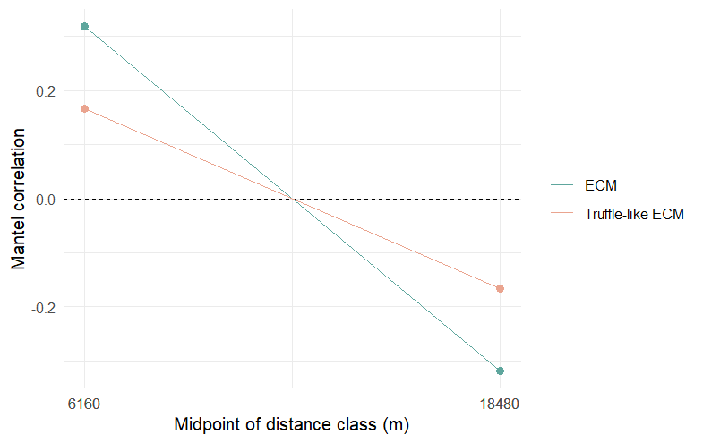
Figure S1.6. Mantel correlations for fungal communities in East Gippsland. Both correlations are significant (p ≤ 0.05).

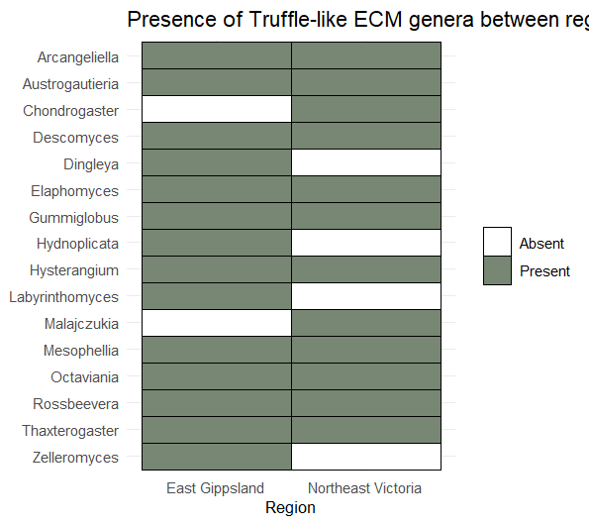
Figure S1.7. Presence of all truffle-like fungal genera in LFP diets between East Gippsland and Northeast Victoria for all sites between 1993 – 1995.

Table S1.6. PERMANOVA estimates for the sub-sampled (same number of samples for each site in each year and season combination) ECM and truffle-like ECM community datasets at Watchmaker and Bellbird between 1998 – 2005. All predictors are significant (p < 0.05).
Variable | DF | R² | P value
Distance matrix | Truffle-like ECM community
Site | 1 | 0.078 | 0.035
Season | 3 | 0.038 | 0.012
Distance matrix | ECM community
Site | 1 | 0.048 | 0.001
Season | 3 | 0.093 | 0.001
Site:Season | 3 | 0.057 | 0.033

Table S1.7. Pairwise PERMANOVA between seasons using Bray-Curtis dissimilarity index for fungal communities in LFP scat samples collected at Watchmaker and Bellbird between 1998 – 2005. Significant results (p < 0.05) in bold.
 | All ECM |  | Truffle-like ECM
Site pair | R2 | p.adj | R2 | p.adj
Summer vs Autumn | 0.047 | 1 | 0.030 | 0.324
Summer vs Winter | 0.077 | 0.006 | 0.061 | 0.006
Summer vs Spring | 0.061 | 0.024 | 0.034 | 0.042
Autumn vs Winter | 0.059 | 0.306 | 0.038 | 0.012
Autumn vs Spring | 0.050 | 1 | 0.038 | 0.042
Winter vs Spring | 0.045 | 0.078 | 0.027 | 0.036

Table S1.8. DB-RDA model statistics for variables that best explain variation in fungal communities, using Bray-Curtis dissimilarity index. All results are significant (p < 0.05).
 | All ECM |  | Truffle-like ECM
Site pair | SumofSqs | P | SumofSqs | P
Season | 2.769 | 0.001 | 2.330 | 0.001
Location | 2.153 | 0.001 | 1.127 | 0.003
Monthly AHMI | 0.650 | 0.020
Quarterly Precipitation | 0.853 | 0.002
Quarterly MINT | 0.890 | 0.001 | 0.767 | 0.014
Annual MINT |  |  | 0.909 | 0.009

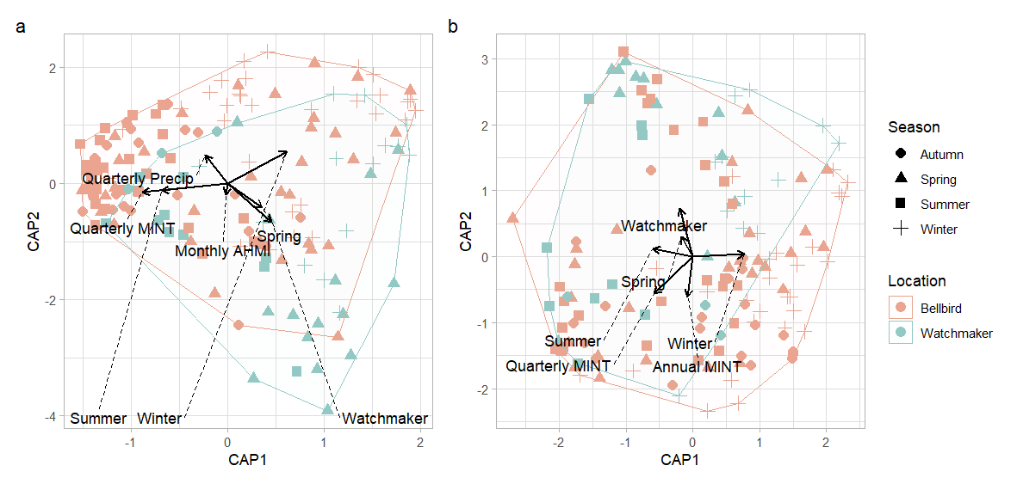Figure S1.8. db-RDA with climatic variables that best explain variation in a) ECM and b) truffle-like ECM fungal communities in scat samples collected at Watchmaker and Bellbird between 1998-2005.
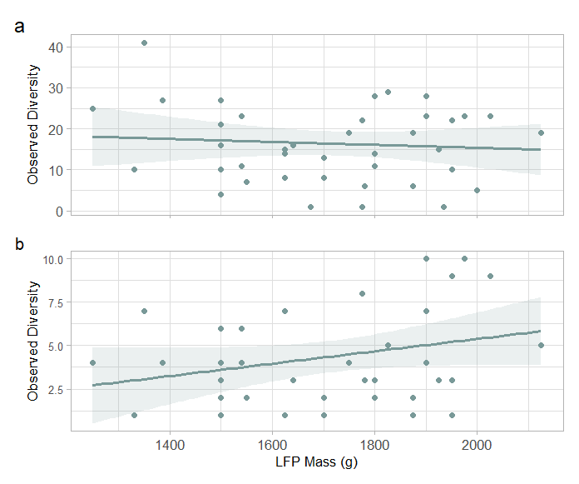
Figure S1.9. Relationship between LFP mass and diversity of a) ECM fungi and b) truffle-like ECM fungi in scats.

Table S1.9. PERMANOVA estimates for the ECM and truffle-like ECM community in scat samples collected at Watchmaker. Significant predictors (p < 0.05) are in bold.
Variable | DF | R² | P value
Distance matrix | ECM community
Sex | 1 | 0.039 | 0.01
Mass | 1 | 0.050 | 0.002
Season | 3 | 0.144 | 0.001
Distance matrix | Truffle-like ECM community
Sex | 1 | 0.031 | 0.204
Mass | 1 | 0.054 | 0.007
Season | 3 | 0.143 | 0.001

References
Fick, S. E., & Hijmans, R. J. (2017). WorldClim 2: New 1km spatial resolution climate surfaces for global land areas. International Journal of Climatology, 37(12), 4302–4315.
The State of Victoria, Department of Energy, Environment and Climate Action (DEECA). (2018). Native Vegetation—Modelled 2005 Ecological Vegetation Classes (with Bioregional Conservation Status) [Spatial Data; SHP]. https://datashare.maps.vic.gov.au/search?md=a502df15-7b90-5e96-b1a0-ba29e95558b2
The State of Victoria, Department of Jobs, Precincts and Regions (DJPR) and Department of Energy, Environment and Climate Action (DEECA). (2023). Logging history overlay of most recent harvesting activities [Spatial Data; SHP]. https://datashare.maps.vic.gov.au/search?q=uuid%3D3a367d37-6dfe-5d66-ba7a-3d8f864cb417

