Supplementry Table S 1: The statistical data for the RE-HPLC calibration curve for ATO, CIP and FLX*

 | FLX | CIP | ATO
Linear regression | 0.9994 | 0.99952 | 0.99874
Slope | -0.00222 | -0.00107 | -0.00141
Intercept | 107.99427 | -6.01958 | -1.26531
Response Std error | 2.4973 | 0.85987 | 0.28634
LOD | 0.24 | 0.216 | 0.42
LOQ | 0.74 | 0.66 | 0.89
Range (µg/mL) | 1-15 | 1-15 | 1-15
Recovery Range | 96.37% | 111.5% | 104.9%

*The matrix effect (<5%) was determined using the biotic sample.

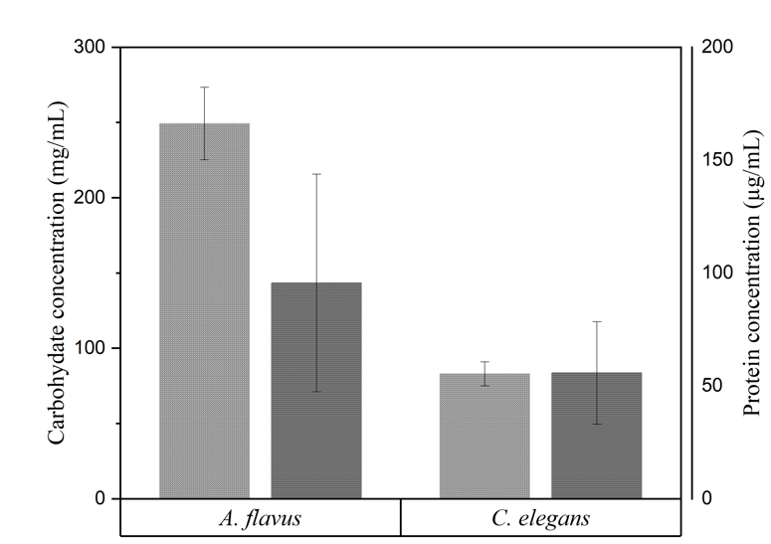
Supplementry Figure S 2: Extracellular matrix (ECM) concentrations for A. flavus and C. elegans carbohydrate () and protein ().

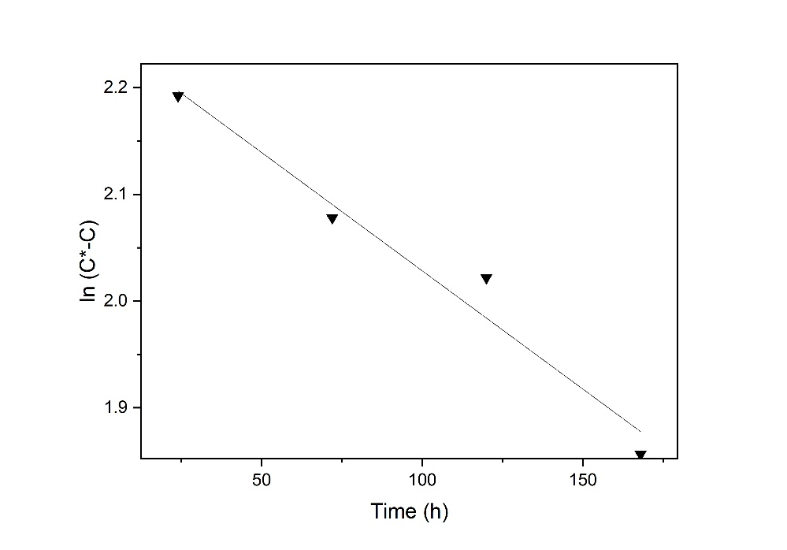
Supplementry Figure S 3: The elimination rate of FLX. Initial concentration (C*) concentration (C).The kinetic rate fit the pseudo first order as ln (C*-C) plotted against time got the highest linear regression value (R²).

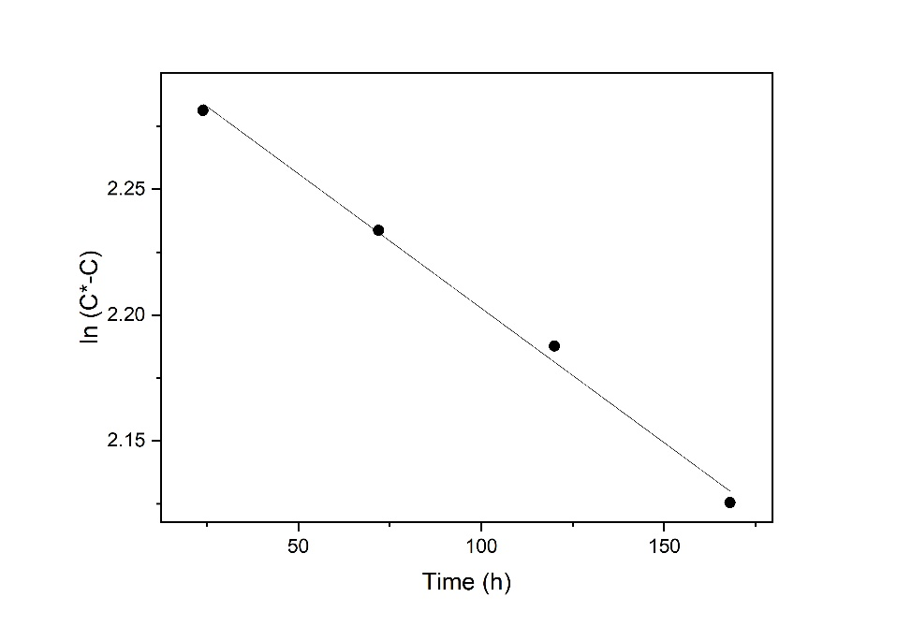
Supplementry Figure S 4: The elimination rate of CIP. Initial concentration (C*) concentration (C).The kinetic rate fit the pseudo first order as ln (C*-C) plotted against time got the highest linear regression value (R²).

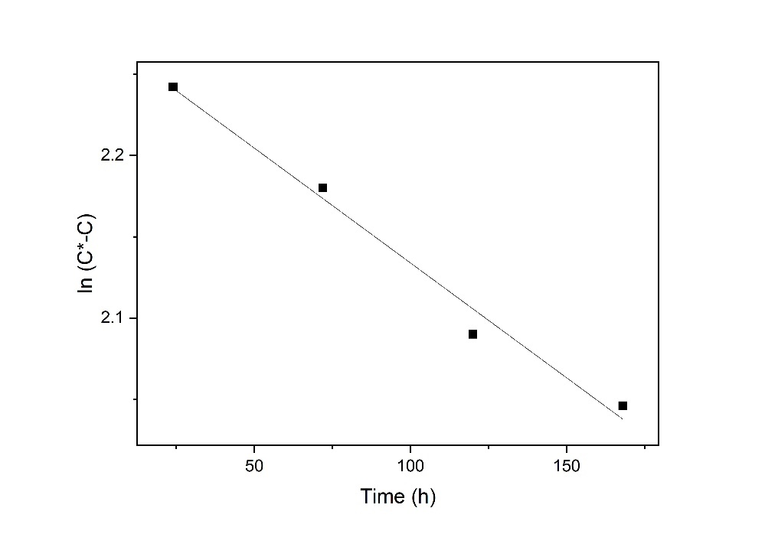
Supplementry Figure S 5: The elimination rate of ATO. Initial concentration (C*) concentration (C).The kinetic rate fit the pseudo first order as ln (C*-C) plotted against time got the highest linear regression value (R²).

