Additional References for Supporting Information
Bathurst JC, Birkinshaw SJ, Cisneros F et al (2011) Forest impact on floods due to extreme rainfall and snowmelt in four Latin American environments 2: Model analysis. J Hydrol 400:292-304
Clark, KL, Nadkarni NM, Schaefer D et al (1998) Atmospheric deposition and net retention of ions by the canopy in a tropical montane forest, Monteverde, Costa Rica. J Trop Ecol 14:27-45
Cleveland CC, Townsend AR, Schimel DS et al (1999) Global patterns of terrestrial biological nitrogen (N₂) fixation in natural systems. Glob Biogeochem Cycles 13:623-645
Da Rocha RP, Morales CA, Cuadra SV et al (2009) Precipitation diurnal cycle and summer climatology assessment over South America: An evaluation of Regional Climate Model version 3 simulations. J Geophys Res 114:D10108
Houser JN, Mulholland PJ, Maloney KO (2006) Upland Disturbance Affects Headwater Stream Nutrients and Suspended Sediments during Baseflow and Stormflow. J Environ Qual 35:352-365
Larsen MC, and Webb RMT (2009) Potential effects of runoff, fluvial sediment, and nutrient discharges on the coral reefs of Puerto Rico. J Coastal Res 25:189-208
Loescher HW, Gholz HL, Jacobs JM et al (2005) Energy dynamics and modeled evapotranspiration from a wet tropical forest in Costa Rica. J Hydrol 315:274-294
Maréchal JC, Varma MRR, Riotte J et al (2009) Indirect and direct recharges in a tropical forested watershed: Mule Hole, India. J Hydrol 364:272-284
Rollebeck R, Anhuf D (2007) Characteristics of the water and energy balance in Amazonian lowland rainforest in Venezuela and the impact of the ENSO cycle. J Hdrol 337:377-390
Ruiz L, Varma MRR, Kumar MSM et al (2010) Water balance modeling in a tropical watershed under deciduous forest (Mule Hole, India): regolith matric storage buffers the groundwater recharge process. J Hydrol 380:460-472
Silva JSO, Bustamante MMdC, Markewitz D et al (2011) Effects of land cover on chemical characteristics of streams in the Cerrado region of Brazil. Biogeochem 105:75-88
Sumner DM, Jacobs JM (2005) Utility of Penman-Monteith, Priestley-Taylor, reference evapotranspiration, and pan evaporation methods to estimate pasture evapotranspiration. J Hydrol 308:81-104
Wei X, Liu S, Zhou G et al (2005) Hydrological processes in major types of Chinese forest. Hydrol Process 19:63-75
Williams MR, Melack JM (1997) Solute export from forested and partially deforested catchments in the central Amazon. Biogeochem 38:67-102
Zhiheng L., Yiping Z., Wang S et al (2010) Evapotranspiration of a tropical rain forest in Xishuangbanna, southwest China. Hydrol Proc 24:2405-2416
Table S1. Estimates of evapotranspiration (ET) from tropical watersheds. These data sources were compiled from a search using Web of Science, using key words precipitation, evapo-transpiration, tropical, nutrient concentrations.
Site | Rainfall | Actual ET | % ET | References
Venezuela | 3244 | 1492 | 46 | Table 3, in Rollenbeck and Anhuf, 2007
Brazil | 1819 | 1346 | 74 | “
Venezuela | 3664 | 1905 | 52 | “
“ | 3500 | 2065 | 59 | “
Brazil | 2209 | 1502 | 68 | “
Brazil | 2870 | 1119 | 39 | “
Brazil | 2636 | 1318 | 50 | “
Costa Rica | 1813 | 807 | 45 | Bathurst et al. 2011
Ecuador | 793 | 528 | 67 | “
Panama | 962 | 562 | 58 | “
Costa Rica | N/A | N/A | 25 | Gomez-Delgado et al. 2011
Tropical China | 1322 | 1031 | 78 | Li Zhiheng et al. 2010
India | 1090 | 900 | 83 | Ruiz et al. 2010
“ | 1235 | 1050 | 85 | Marechal et al. 2009
Guadeloupe | 4229 | 1311 | 31 | Charlier et al. 2008
Costa Rica | 2226 | 1892 | 85 | Loescher et al.2005
“ | 2624 | 2292 | 87 | “
Florida | N/A | N/A | 66 | Sumner and Jacobs 2005
China | N/A | N/A | 45 | Wei et al. 2005
Central Brazil | 1900 | 823 | 43 | Da Rocha et al. 2009
“ | 1700 | 689 | 41 | “
Argentina | 1352 | 1150 | 85 | Nosetto et al. 2005
“ | 1352 | 630 | 47 | “
Puerto Rico | 1600 | 688 | 43 | Larsen and Webb 2009

Table S2. Nitrogen loads calculated for the Panamanian watersheds, based on measured rain deposition, and extrapolation to include dry deposition (see text for methods). We show numbers with as much as five digits for the sake of allowing checks on calculations, but these estimates should be taken to be meaningful only to two digits.
 | Nitrogen load (kg N yr⁻¹) based on
Watershed | Wet deposition | Wet and dry deposition
de la Mona | 5,801 | 8,777
Grande | 59,094 | 90,929
Salmonete | 1,009 | 1,548
Chamuscado | 8,112 | 12,024
Luis | 3,616 | 5,310
Pixvae | 5,160 | 7,276
Limon | 2,351 | 3,351
Manglarito | 846 | 1,208
Figure S1. Relationship of annual rainfall and actual evapotranspiration (ET) for a variety of forested tropical sites. 1:1 line added for comparison. Data compiled from references in Table S1.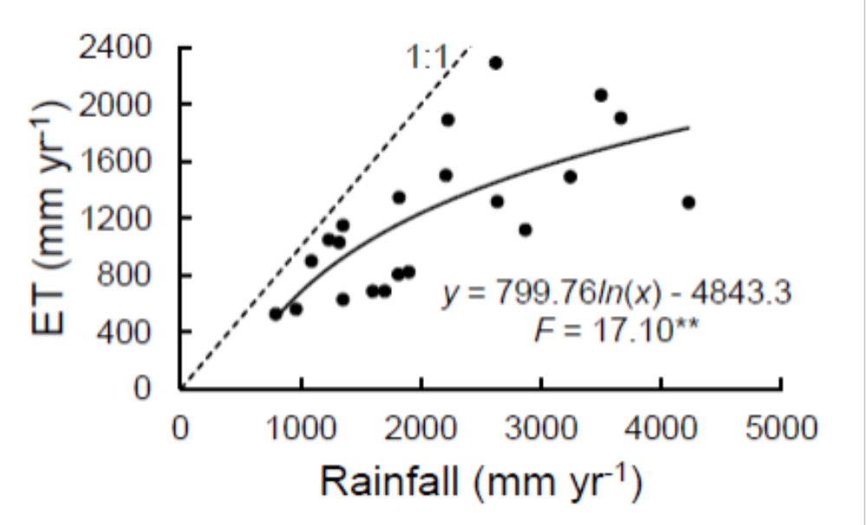
Figure S2. Rainfall for the region of this study, monthly, for 2008-2011, from the Tropical Rainfall Measuring Mission (TRMM, http://trmm.gsfc.nasa.gov).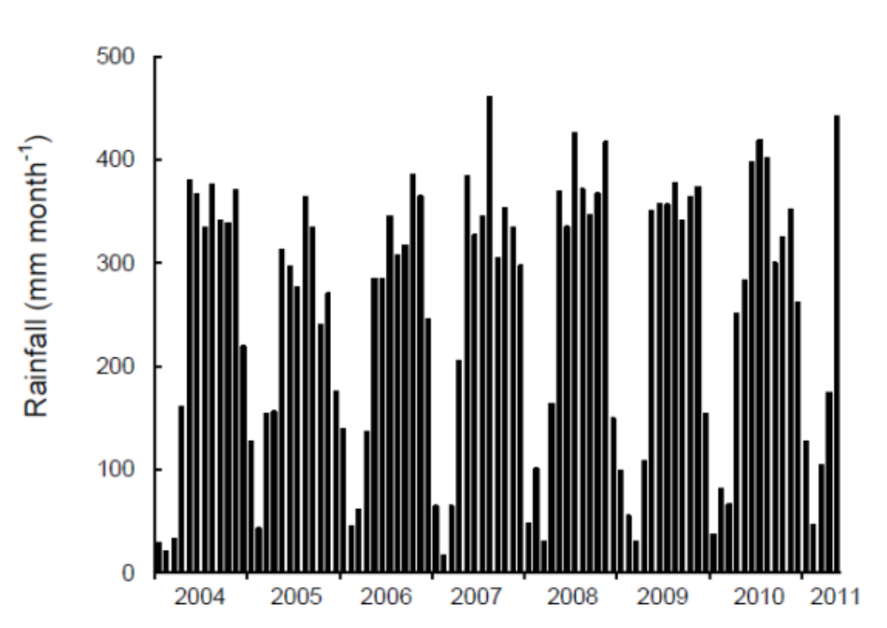
Figure S3. Percent decrease in ET associated with land cover with different degrees of conversion of forest to pastures. Data from modeling work in Li et al. (2007).