The C-N-P-S stoichiometry of soil organic matter
Edward Tipping, Cayman J Somerville, Jörg Luster
Supplementary figures

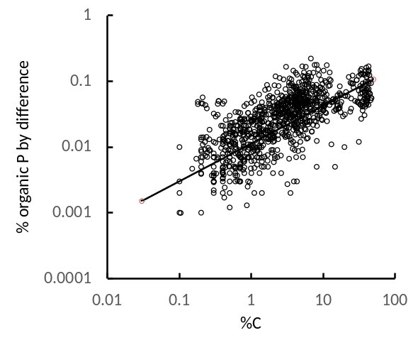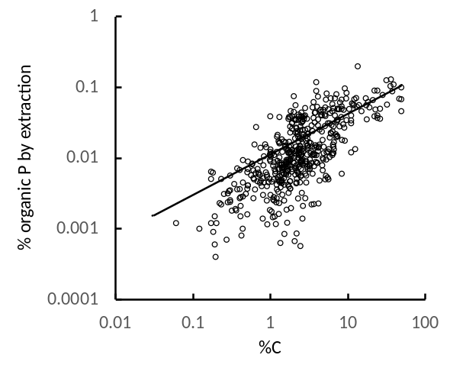
Figure S1. Relationships between soil organic phosphorus and soil organic carbon. The left-hand plot (n =946) shows results obtained by the difference between total and inorganic P, the right-hand plot (n = 504) is for results obtained by extractions with base. In each case the same power law relationship, fitted to the entire data set, is shown.

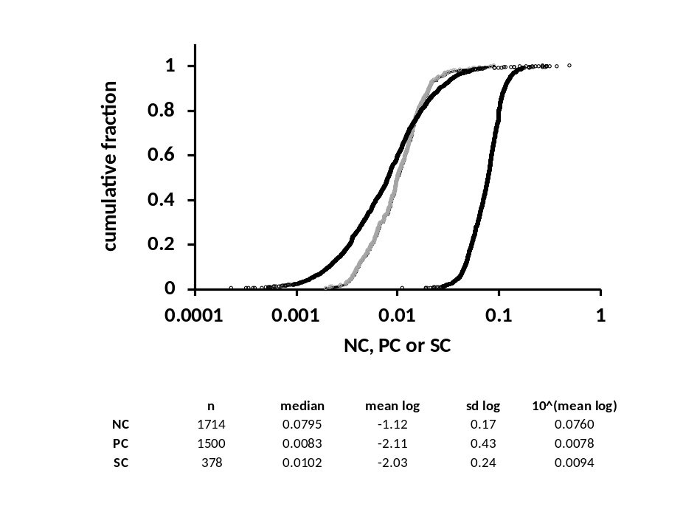
Figure S2. Log-normally distributed organic NC, PC and SC ratios for non-peat soils.

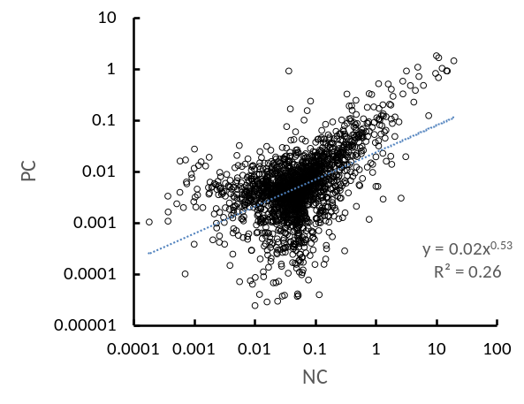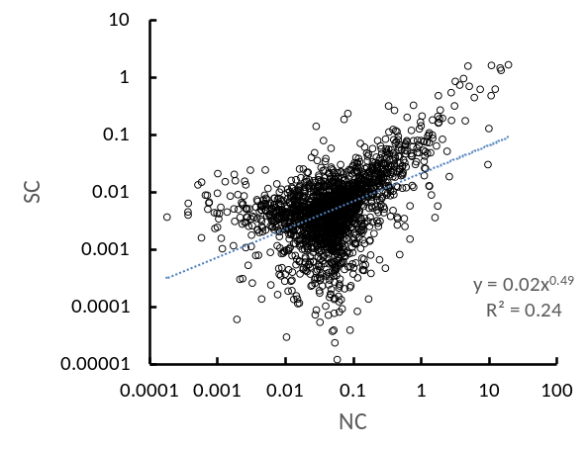

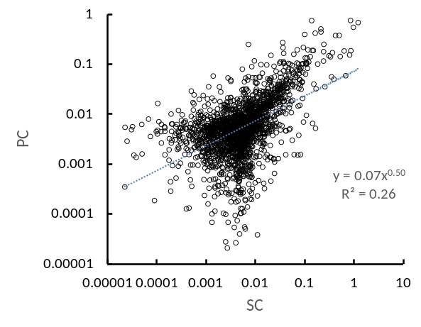
Figure S3. Spurious correlations between PC and NC, SC and NC and PC and SC, generated from randomly-chosen values within the ranges of %C, %N, %P and %S in the full data set. In each case 2000 points are plotted, and power-law fits and R² values are shown. Note that these relationships are quite different from those in Figure 2.
We repeated this 10 times with different sets of random choices, and obtained:
PC vs NC slopes in the range: 0.44 - 0.54, R² 0.21 - 0.29
SC vs NC slopes in the range: 0.48 - 0.54, R² 0.23 - 0.28
PC vs SC slopes in the range: 0.47 - 0.57, R² 0.24 - 0.31

1 %C & 35 %C 5 %C & 35 %C
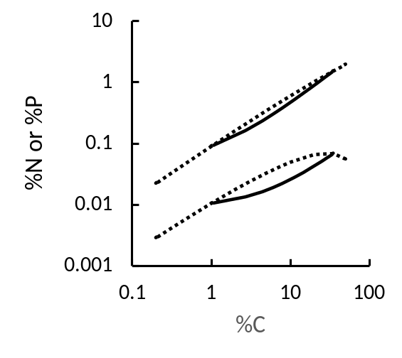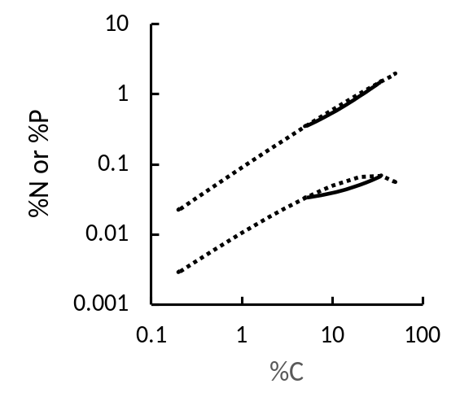
%P
%N
%P
%N
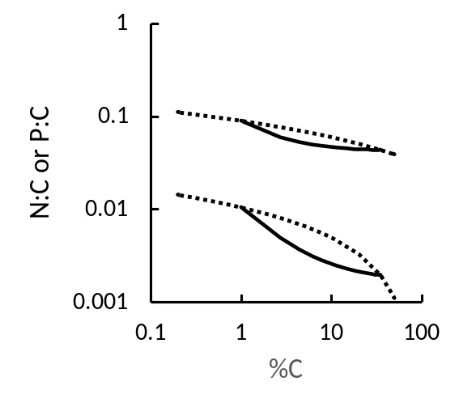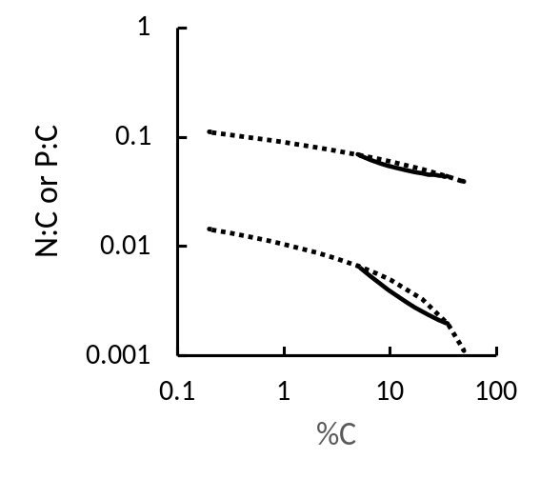
P:C
N:C
P:C
N:C
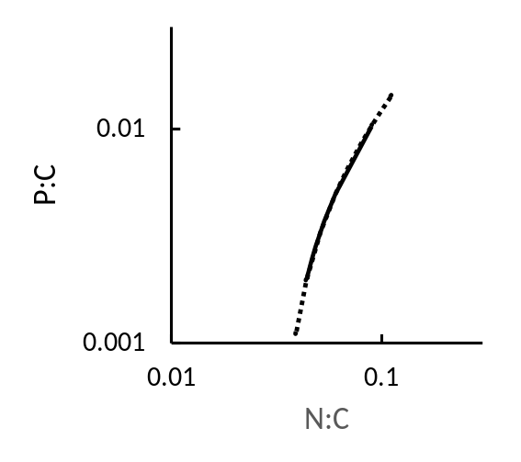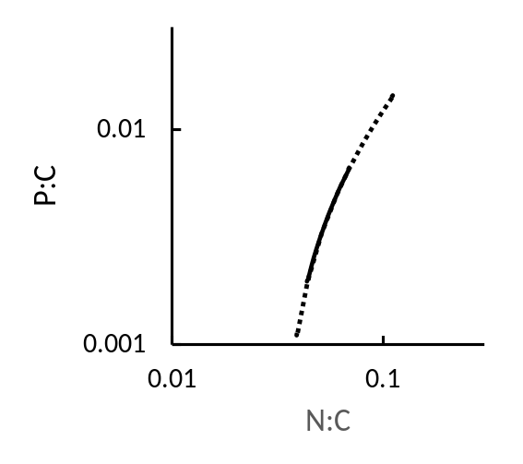
Figure S4. Simulating the effects of horizon mixing when sampling according to pre-determined depth. The dotted lines show results from the fitted mixing model. The full lines show simulated results obtained by assuming that soil samples with different %C, and therefore different NPSOM and NRSOM contents, were mixed in different proportions. The NPSOM and NRSOM end-members had the stoichiometries shown in Table 2.
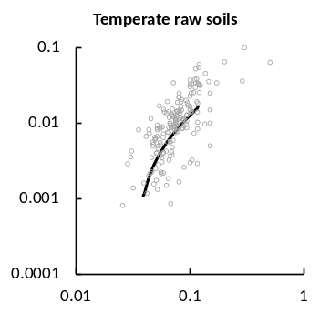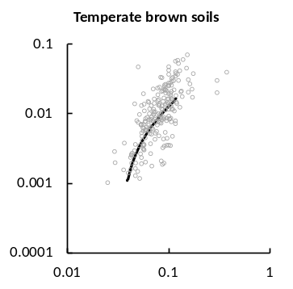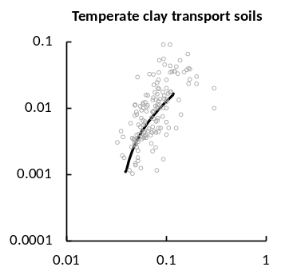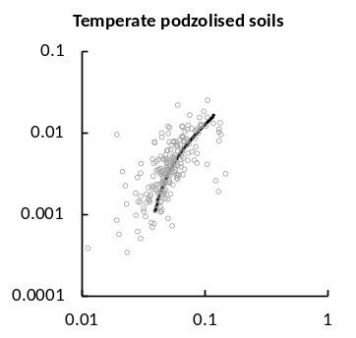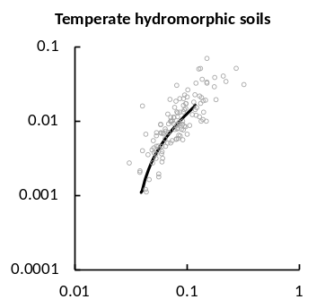
Temperate weakly-developed soils
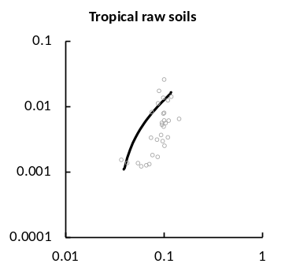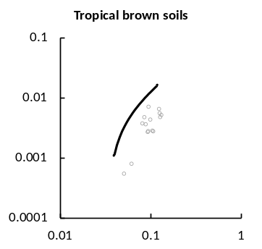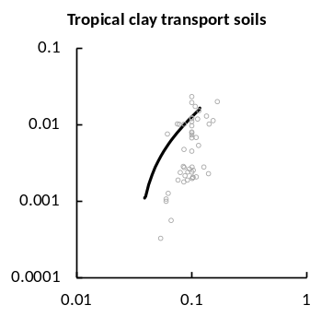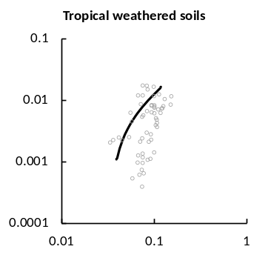

Figure S5. PC vs NC for different soil types. The line in each case is from the NPSOM-NRSOM mixing model.

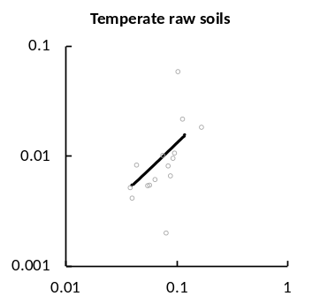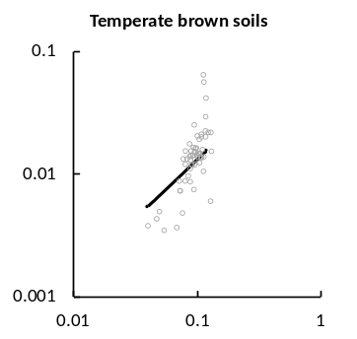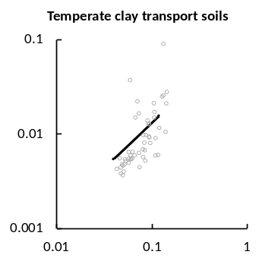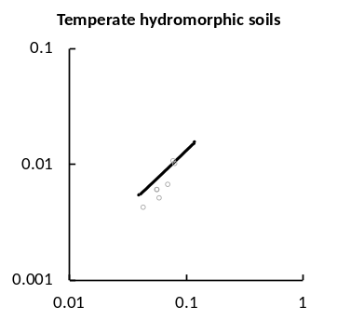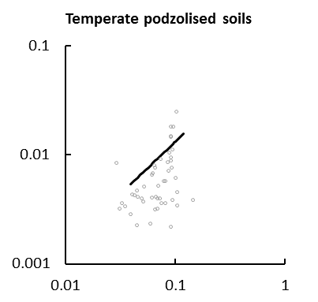
Temperate weakly-developed soils
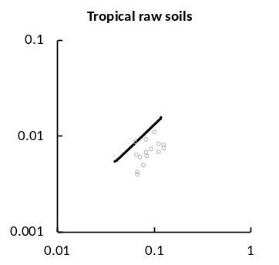
Tropical weakly-developed soils

Figure S6. SC s NC for different soil types. The line in each case is from the NPSOM-NRSOM mixing model.

