Supplementary materials

Forest fires in Canadian permafrost region: The combined effects of fire and permafrost dynamics on soil organic matter quality
Heidi Aaltonen¹, Kajar Köster¹, Egle Köster¹, Frank Berninger² , Xuan Zhou¹, Kristiina Karhu¹, Christina Biasi³, Viktor Bruckman⁴, Marjo Palviainen¹ and Jukka Pumpanen³
¹ Department of Forest Sciences, University of Helsinki, PO Box 27 FI-00014, Finland
² Department of Environmental and Biological Sciences, University of Eastern Finland, PL 111 FI-80101, Joensuu, Finland
³ Department of Environmental and Biological Sciences, University of Eastern Finland, PL 1627 FI-70211 Kuopio Finland
⁴ Commission for Interdisciplinary Ecological Studies, Austrian Academy of Sciences (ÖAW), Dr. Ignaz Seipel-Platz 2, 1010 Vienna, Austria
Corresponding author (heidi.m.aaltonen@helsinki.fi)

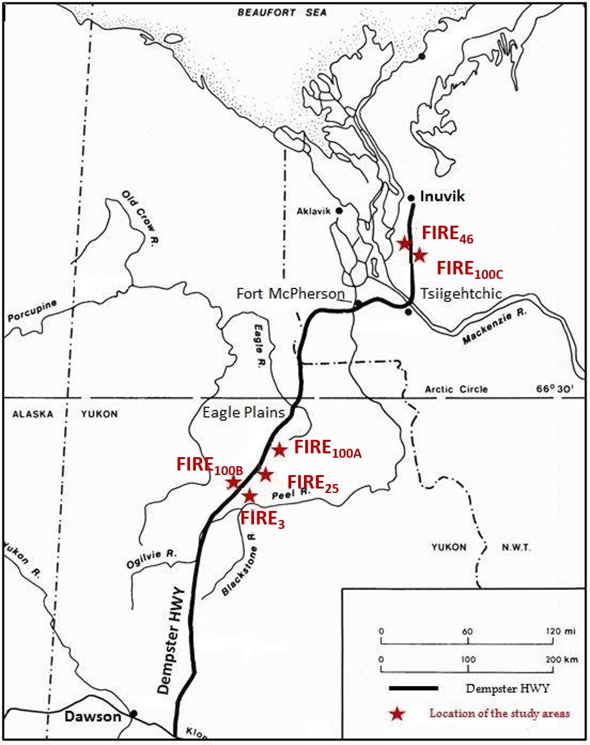
Figure S1: The locations of sampled fire areas along the Dempster Highway in the North West territories of Canada (Köster et al. 2017).
Area | Depth (cm)  (cm) | pH | ECC  (µS) | Active layer thickness (m) | Soil temperature (ºC)
FIRE₃ | 5 | 4.5 ± 0.1 | 47.8 ± 5.1 | 1.01 ± 0.09 | 7.2 ± 0.6
 | 30 | 5.2 ± 0.2 | 44.7 ± 10.2 | - | 4.0 ± 0.6
 | 50 | - | - | - | 2.5 ± 1.0
FIRE₂₅ | 5 | 4.8 ± 0.2 | 41.4 ± 6.1 | 0.88 ± 0.10 | 7.1 ± 0.4
 | 30 | 5.3 ± 0.2 | 34.7 ± 3.7 | - | 3.6 ± 0.9
 | 50 | - | - | - | 3.5 ± 0.3
FIRE₄₆ | 5 | 6.6 ± 0.2 | 122.0 ± 19.9 | 0.49 ± 0.04 | 8.9 ± 0.9
 | 30 | 7.0 ± 0.1 | 131.7 ± 10.7 | - | 2.8 ± 0.6
 | 50 | - | - | - | 1.1 ± 0.9
FIRE₁₀₀0 | 5 | 4.7 ± 0.3 | 48.1 ± 10.0 | 0.28 ± 0.01 | 6.9 ± 0.5
 | 30 | 5.6 ± 0.4 | 62.2 ± 9.7 | - | -0.1 ± 0.1
 | 50 | - | - | - | 0.0 ± 0.0
Table S1: Soil pH, electric conductivity (ECC), active layer thickness and soil temperature (at the time of sampling) for each fire area.

Table S 2: The biomasses of trees and ground vegetation and the coverage of ground vegetation in three different aged fire sites and control area. Values given are averages of plots from three sample lines with standard error following.
Site | Tree biomass (kg m⁻²) | Ground vegetation biomass (kg m⁻²) (vascular plants/moss and lichens) | Ground vegetation coverage (%) (vascular plants/moss and lichens)
FIRE₃ | - | 0.3 ± 0.1 / 0.2 ± 0.0 | 15.5 ± 3.0 / 4.0 ± 1.5
FIRE₂₅ | 0.09 ± 0.02 | 0.7 ± 0.1 / 0.7 ± 0.0 | 33.4 ± 5.5 / 66.1 ± 6.7
FIRE₄₆ | 3.50 ± 0.25 | 0.7 ± 0.1 / 0.6 ± 0.1 | 47.2 ± 6.7 / 63.2 ± 6.5
FIRE₁₀₀ | 5.24 ± 0.21 | 0.6 ± 0.1 / 1.0 ± 0.3 | 37.4 ± 5.1 / 87.4 ± 3.7

Table S3: P-values (for 5 cm depth) of multiple comparisons in each fraction between different times since fire. Fraction here means the fraction solved to water, ethanol, acid and the remaining insoluble fraction.
Comparison | Depth (cm) | Fraction | P-value
FIRE₃ vs. FIRE₂₅ | 5 | water | 0.027
FIRE₃ vs. FIRE₄₆ | 5 | water | 0.009
FIRE₃ vs. FIRE₁₀₀ | 5 | water | 0.832
FIRE₂₅ vs. FIRE₄₆ | 5 | water | 0.982
FIRE₂₅ vs. FIRE₁₀₀ | 5 | water | 0.108
FIRE₁₀₀ vs. FIRE₄₆ | 5 | water | 0.039
FIRE₃ vs. FIRE₂₅ | 5 | ethanol | 0.226
FIRE₃ vs. FIRE₄₆ | 5 | ethanol | <1e-04
FIRE₃ vs. FIRE₁₀₀ | 5 | ethanol | <1e-04
FIRE₂₅ vs. FIRE₄₆ | 5 | ethanol | <1e-04
FIRE₂₅ vs. FIRE₁₀₀ | 5 | ethanol | 1e-04
FIRE₁₀₀ vs. FIRE₄₆ | 5 | ethanol | 0.652
FIRE₃ vs. FIRE₂₅ | 5 | acid | 1.00
FIRE₃ vs. FIRE₄₆ | 5 | acid | 1.00
FIRE₃ vs. FIRE₁₀₀ | 5 | acid | 1.00
FIRE₂₅ vs. FIRE₄₆ | 5 | acid | 1.00
FIRE₂₅ vs. FIRE₁₀₀ | 5 | acid | 1.00
FIRE₁₀₀ vs. FIRE₄₆ | 5 | acid | 1.00
FIRE₃ vs. FIRE₂₅ | 5 | insoluble | 0.896
FIRE₃ vs. FIRE₄₆ | 5 | insoluble | 0.201
FIRE₃ vs. FIRE₁₀₀ | 5 | insoluble | 0.268
FIRE₂₅ vs. FIRE₄₆ | 5 | insoluble | 0.509
FIRE₂₅ vs. FIRE₁₀₀ | 5 | insoluble | 0.640
FIRE₁₀₀ vs. FIRE₄₆ | 5 | insoluble | 0.988

Table S4: P-values (for 30 cm depth) of multiple comparisons in each fraction between different times since fire. Fraction here means the fraction solved to water, ethanol, acid and the remaining insoluble fraction.
Comparison | Depth (cm) | Fraction | P-values
FIRE₃ vs. FIRE₂₅ | 30 | water | 0.765
FIRE₃ vs. FIRE₄₆ | 30 | water | <1e-04
FIRE₃ vs. FIRE₁₀₀ | 30 | water | 0.586
FIRE₂₅ vs. FIRE₄₆ | 30 | water | <1e-04
FIRE₂₅ vs. FIRE₁₀₀ | 30 | water | 1.000
FIRE₁₀₀ vs. FIRE₄₆ | 30 | water | <1e-04
FIRE₃ vs. FIRE₂₅ | 30 | ethanol | 0.705
FIRE₃ vs. FIRE₄₆ | 30 | ethanol | 0.714
FIRE₃ vs. FIRE₁₀₀ | 30 | ethanol | 0.039
FIRE₂₅ vs. FIRE₄₆ | 30 | ethanol | 0.200
FIRE₂₅ vs. FIRE₁₀₀ | 30 | ethanol | 0.005
FIRE₁₀₀ vs. FIRE₄₆ | 30 | ethanol | 0.377
FIRE₃ vs. FIRE₂₅ | 30 | acid | < 0.001
FIRE₃ vs. FIRE₄₆ | 30 | acid | < 0.001
FIRE₃ vs. FIRE₁₀₀ | 30 | acid | 0.525
FIRE₂₅ vs. FIRE₄₆ | 30 | acid | 0.003
FIRE₂₅ vs. FIRE₁₀₀ | 30 | acid | < 0.001
FIRE₁₀₀ vs. FIRE₄₆ | 30 | acid | < 0.001
FIRE₃ vs. FIRE₂₅ | 30 | insoluble | <0.001
FIRE₃ vs. FIRE₄₆ | 30 | insoluble | 0.989
FIRE₃ vs. FIRE₁₀₀ | 30 | insoluble | 0.885
FIRE₂₅ vs. FIRE₄₆ | 30 | insoluble | <0.001
FIRE₂₅ vs. FIRE₁₀₀ | 30 | insoluble | <0.001
FIRE₁₀₀ vs. FIRE₄₆ | 30 | insoluble | 0.673

Table S5: P-values (for 50 cm depth) of multiple comparisons in each fraction between different times since fire. Fraction here means the fraction solved to water, ethanol, acid and the remaining insoluble fraction.
Comparison | Depth (cm) | Fraction | P-values
FIRE₃ vs. FIRE₂₅ | 50 | water | 0.803
FIRE₃ vs. FIRE₄₆ | 50 | water | 0.818
FIRE₃ vs. FIRE₁₀₀ | 50 | water | 0.947
FIRE₂₅ vs. FIRE₄₆ | 50 | water | 0.252
FIRE₂₅ vs. FIRE₁₀₀ | 50 | water | 0.510
FIRE₁₀₀ vs. FIRE₄₆ | 50 | water | 0.996
FIRE₃ vs. FIRE₂₅ | 50 | ethanol | 0.000
FIRE₃ vs. FIRE₄₆ | 50 | ethanol | < 1e-04
FIRE₃ vs. FIRE₁₀₀ | 50 | ethanol | 1.000
FIRE₂₅ vs. FIRE₄₆ | 50 | ethanol | 0.518
FIRE₂₅ vs. FIRE₁₀₀ | 50 | ethanol | < 1e-04
FIRE₁₀₀ vs. FIRE₄₆ | 50 | ethanol | < 1e-04
FIRE₃ vs. FIRE₂₅ | 50 | acid | 0.670
FIRE₃ vs. FIRE₄₆ | 50 | acid | 0.859
FIRE₃ vs. FIRE₁₀₀ | 50 | acid | 0.999
FIRE₂₅ vs. FIRE₄₆ | 50 | acid | 0.149
FIRE₂₅ vs. FIRE₁₀₀ | 50 | acid | 0.570
FIRE₁₀₀ vs. FIRE₄₆ | 50 | acid | 0.923
FIRE₃ vs. FIRE₂₅ | 50 | insoluble | 0.881
FIRE₃ vs. FIRE₄₆ | 50 | insoluble | 0.203
FIRE₃ vs. FIRE₁₀₀ | 50 | insoluble | 0.951
FIRE₂₅ vs. FIRE₄₆ | 50 | insoluble | 0.017
FIRE₂₅ vs. FIRE₁₀₀ | 50 | insoluble | 0.556
FIRE₁₀₀ vs. FIRE₄₆ | 50 | insoluble | 0.514

Table S6: The estimated different soil organic fractions as kg m⁻² from total soil organic carbon.
Area | depth | water soluble SOM kg m⁻² | ethanol soluble SOM kg m⁻² | acid soluble SOM kg m⁻² | insoluble SOM kg m⁻²
FIRE₁₀₀ | 5 | 0.246 ± 0.08 | 0.984 ± 0.30 | 2.758 ± 0.62 | 2.314 ± 0.64
FIRE₄₆ | 5 | 0.429 ± 0.16 | 0.536 ± 0.16 | 2.804 ± 0.79 | 1.443 ± 0.34
FIRE₂₅ | 5 | 0.281 ± 0.11 | 0.231 ± 0.27 | 2.031 ± 0.78 | 1.495 ± 0.86
FIRE₃ | 5 | 0.134 ± 0.06 | 0.074 ± 0.03 | 1.569 ± 0.37 | 1.323 ± 0.32
FIRE₁₀₀ | 30 | 0.088 ± 0.05 | 0.190 ± 0.04 | 1.401 ± 0.20 | 4.716 ± 0.97
FIRE₄₆ | 30 | 1.081 ± 0.35 | 0.136 ± 0.04 | 0.442 ± 0.13 | 6.095 ± 1.62
FIRE₂₅ | 30 | 0.182 ± 0.09 | 0.088 ± 0.01 | 0.091 ± 0.01 | 9.987 ± 1.11
FIRE₃ | 30 | 0.322 ± 0.22 | 0.100 ± 0.02 | 1.390 ± 0.44 | 5.608 ± 1.24
FIRE₁₀₀ | 50 | 0.040 ± 0.01 | 0.021 ± 0.00 | 0.163 ± 0.04 | 1.092 ± 0.19
FIRE₄₆ | 50 | 0.151 ± 0.04 | 0.141 ± 0.03 | 0.819 ± 0.24 | 3.430 ± 0.71
FIRE₂₅ | 50 | 0.052 ± 0.02 | 0.074 ± 0.01 | 0.255 ± 0.06 | 2.378 ± 0.32
FIRE₃ | 50 | 0.103 ± 0.03 | 0.072 ± 0.01 | 0.533 ± 0.10 | 3.768 ± 0.21

Table S7: Parameters for the fitted models with insoluble SOM fraction as dependent variable for 5 cm soil depth. The fixed factors used are: AD (m) the is depth of the active layer, Biomass (kg m⁻²) is the total biomass of trees and ground vegetation, T (°C) is soil temperature, AD x T is the cross effect of active layer depth and soil temperature and CN (%) is the soil carbon to nitrogen-ratio.
Model 5 cm | 1 | 2 | 3 | 4
AIC value | -18.24 | -20.22 | -21.15 | -21.43
R² | 0.27 | 0.28 | 0.26 | 0.22
P-value | 0.079 | 0.043 | 0.032 | 0.029
Intercept (St.err, P-val) | 1.050 (0.323, P= 0.001) | 1.078 (0.185, P< 0.001) | 0.983 (0.155, P< 0.001) | 0.831 (0.094, P<0.001)
AD (St. err, P-val.) | -0.086 (0.417, P=0.836) | -0.130 (0.084, P=0.122) | -0.139 (0.084, P= 0.097) | -0.147 (0.084, P= 0.082)
C/N (St. err, P-val.) | -0.250 (0.193, P=0.194) | -0.248 (0.187, P=0.185) | -0.226 (0.185, P=0.221) | -
Soil T (St. err, P-val.) | -0.010 (0.043, P= 0.822) | -0.014 (0.015, P=0.111) | - | -
Biomass (St. err, P-val.) | -0.022 (0.015, P=0.122) | -0.022 (0.014, P= 0.111) | -0.027 (0.013, P=0.050) | -0.033 (0.012, P=0.007)
AD x Soil T (St. err, P-val.) | -0.006 (0.060, P=0.914) | - | - | -

Table S8: Parameters for the fitted models with insoluble SOM fraction as dependent variable for 5 cm soil depth. The fixed factors used are: AD (m) the is depth of the active layer, Biomass (kg m⁻²) is the total biomass of trees and ground vegetation, T (°C) is soil temperature, AD x T is the cross effect of active layer depth and soil temperature and CN (%) is the soil carbon to nitrogen-ratio.
Model 30 cm | 1 | 2 | 3 | 4
AIC value | -26.19 | -27.91 | -29.91 | -31.65
R² | 0.84 | 0.83 | 0.84 | 0.85
P-value | 0.155 | 0.101 | 0.052 | 0.024
Intercept (St.err, P-val) | 1.354 (0.168, P<0.001) | 1.383 (0.150, P<0.001) | 1.387 (0.134, P<0.001) | 1.425 (0.109, P<0.001)
AD (St. err, P-val.) | 0.075 (0.176, P= 0.671) | 0.002 (0.074, P=0.976) | - | -
C/N (St. err, P-val.) | -0.405 (0.266, P=0.128) | -0.400 (0.262, P=0.126) | -0.407 (0.254, P=0.109) | -0.447 (0.241, P=0.064)
Soil T (St. err, P-val.) | 0.018 (0.029, P= 0.541) | -0.006 (0.262, P= 0.650) | 0.006 (0.012, P=0.640) | -
Biomass (St. err, P-val.) | -0.019 (0.015, P=0.  213) | -0.019 (0.015, P=0.203) | -0.019 (0.014, P=0.183) | -0.009 (0.013, P=0.187)
AD x Soil T (St. err, P-val.) | -0.022 (0.047, P=0.644) | - | - | -

Table S9: Parameters for the fitted models for the fitted models with insoluble SOM fraction as dependent variable for 50 cm soil depth. The fixed factors used are: AD (m) the is depth of the active layer, Biomass (kg m⁻²) is the total biomass of trees and ground vegetation, T (°C) is soil temperature, AD x T is the cross effect of active layer depth and soil temperature and CN (%) is the soil carbon to nitrogen-ratio.
Model 50 cm | 1 | 2 | 3 | 4 | 5
AIC value | -44.10 | -44.38 | -44.58 | -46.48 | -48.13
R² | 0.19 | 0.15 | 0.10 | 0.10 | 0.10
P-value | 0.235 | 0.279 | 0.350 | 0.203 | 0.092
Intercept (St.err, P-val) | 1.502 (0.149, P<0.001) | 1.432 (0.138, P<0.001) | 1.348 (0.121, P<0.001) | 1.332 (0.106, P<0.001) | 1.297 (0.084, P<0.001)
AD (St. err, P-val.) | -0.221 (0.136, P=0.105) | -0.128 (0.112, P=0.252) | -0.015 (0.065, P=0.847) | -0.027 (0.049, P=0.579) | -
C/N (St. err, P-val.) | -0.381 (0.272, P=0.235) | -0.483 (0.260, P=0.063) | -0.414 (0.257, P=0.107) | -0.377 (0.217, P=0.083) | -0.334 (0.200, P=0.095)
Soil T (St. err, P-val.) | -0.041 (0.027, P=0.135) | -0.025 (0.024, P=0.299) | -0.005 (0.018, P=0.772) | - | -
Biomass (St. err, P-val.) | -0.015 (0.012, P=0.239) | - | - | - | -
AD x Soil T (St. err, P-val.) | 0.052 (0.031, P=0.099) | 0.034 (0.028, P=0.218) | - | - | -

Table S10: Parameter values for the linear mixed effects model with microbial C as dependent factor and size of the insoluble SOM fraction as fixed factor.

Depth (cm) | 5 | 30 | 50
R² | 0.27 | 0.97 | 0.40
P-value | 0.045 | <0.001 | 0.733
Intrecept (St.err, P-val) | 13.2 (3.655, P=0.000) | 5.065 (0.822, P<0.001) | 3.970 (7.939, P=0.617)
insoluble fraction (St. err, P-val.) | -11.9 (5.719, P=0.038) | -3.493 (0.683, P<0.001) | -2.286 (6.812, P=0.737)

Figure S2: The change (%) in the size of the insoluble SOM fraction if biomass (above ground biomass consisting of tree and ground vegetation), AD (active layer depth) or C/N ratio is changed by 10 %.

References:
Köster E, Köster K, Berninger F, et al (2017) Carbon dioxide, methane and nitrous oxide fluxes from a fire chronosequence in subarctic boreal forests of Canada. Sci Total Environ 601–602:895–905. doi: 10.1016/j.scitotenv.2017.05.246

