Supplementary statistical explanation: Our first hypothesis was directly related to testing the explanatory power of reactive inorganic soil components (Fe/Al oxyhydroxide phases and exchangeable Ca) for C concentrations (%OC) and long term stability (Δ¹⁴OC) across a pH gradient of forest and grassland soils following recent work by Kramer and Chadwick (2018), Rasmussen et al. (2018), and Rowley et al. (2018). Therefore, we began with two linear mixed models with depth, Al_{OX}, Ca_{EX}, pH, and PET/MAP, as fixed effects, site as a random effect, and %OC and Δ¹⁴OC as response variables. The random effect of site was found to be nonsignificant in both models, as determined through a comparison of AIC values between models with and without the random effect included. Therefore, we proceeded with simple multiple linear regression approaches.

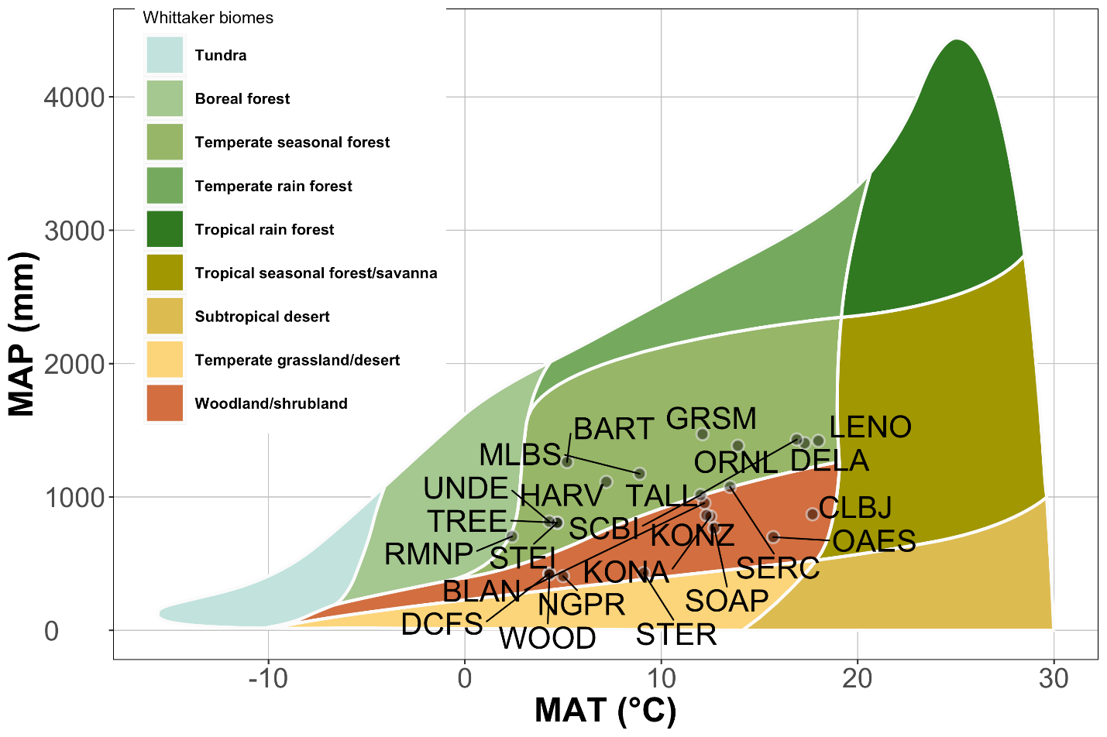
Supplementary figure 1. The 24 NEON sites included in the current study are plotted onto the Whittaker biome scheme according to mean annual temperature (MAT) and mean annual precipitation (MAP).

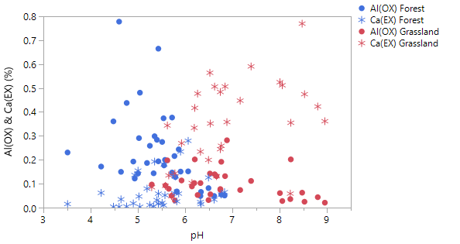

Supplementary figure 2. Data plotted by horizon illustrating the relative abundance of Al_{OX} and Ca_{EX} across the pH gradient and according to biome type.

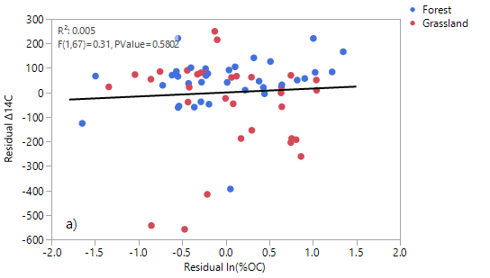
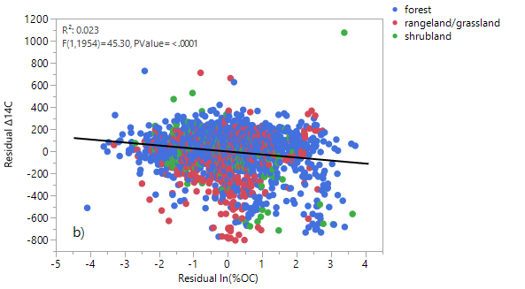

Supplementary figure 3. a) In the current study, after accounting for the influence of depth on %C and Δ¹⁴C, there was no significant relationship between %OC and Δ¹⁴OC (R² = 0.0032, p = 0.6497, n = 69). b) Data from ISRaD for forests, grasslands, and shrublands. After accounting for depth, there was a significant relationship between %OC and Δ¹⁴OC. However, the explanatory power of the correlation is very low and the relationship is actually negative (R² = 0.023, p <0.0001, n = 1956).The residuals of Δ¹⁴C come from a linear regression of Δ¹⁴C with depth. The residuals of %OC come from a linear regression of ln(%OC) with ln(depth), as these variables have a nonlinear relationship.

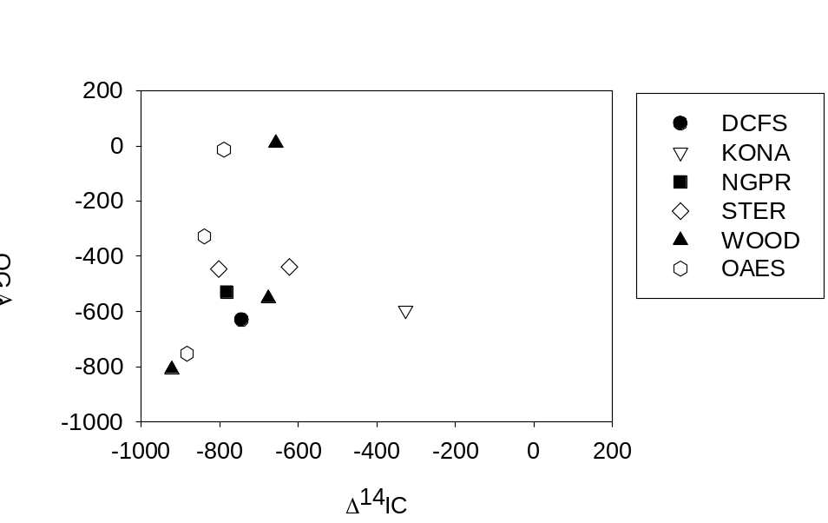
Supplementary figure 4. Δ¹⁴IC of carbonates had no relationship to Δ¹⁴OC (R² = 0.044, p = 0.6164, n = 8). Blue line represents a 1: 1 relationship.

Supplementary table 1. Extractable metal phases and their sources
Extractant | Metal | Source | References
Dithionite | Al | Al from organo-metal complexes, SRO oxyhydrides, Al from isomorphous substitution into Fe oxides | Pansu & Gautheyrou, 2006; Wagai et al., 2013
 | Fe | Fe from organo-metal complexes, SRO oxyhydroxides, crystalline Fe hydroxides | Pansu & Gautheyrou, 2006; Wagai et al., 2013
 | Mn | Reductively soluble Mn including birnessite | Jugsujinda et al., 1995
 | Si | Allophane/imogolite, Si from organo-metal complexes | Wagai et al., 2013
Oxalate | Al | Al from organo-metal complexes, SRO oxyhydrides | Pansu & Gautheyrou, 2006; Wagai et al., 2013
 | Fe | Fe from organo-metal complexes, SRO oxyhydrides | Pansu & Gautheyrou, 2006; Wagai et al., 2013
 | Mn
 | Si | Allophane/imogolite | Wagai et al., 2013
Pyrophosphate | Al | Al from organo-metal complexes | Pansu & Gautheyrou, 2006; Wagai et al., 2013
 | Fe | Fe from organo-metal complexes | Pansu & Gautheyrou, 2006; Wagai et al., 2013
 | Mn | Bioavailable Mn (MnIII) | Keiluweit et al., 2015
 | Si | Si from organo-metal complexes | Wagai et al., 2013
Ammonium acetate | Al | Exchangeable cation | Soil Survey Staff, 2014
 | Ca | Exchangeable cation | Soil Survey Staff, 2014
 | K | Exchangeable cation | Soil Survey Staff, 2014
 | Mg | Exchangeable cation | Soil Survey Staff, 2014
 | Na | Exchangeable cation | Soil Survey Staff, 2014
Potassium chloride | Al | Exchangeable cation | Soil Survey Staff, 2014
 | Fe | Exchangeable cation | Soil Survey Staff, 2014
SRO = short-range-order

Supplementary table 2. Description of SOM chemistry variables.
Variable | Source material | Description | Direction with increasing decomposition | References
C: N | Bulk soil | Values tend to decrease with increasing degree of decomposition | ↓ | Stevenson, 1994
DBE-O Chloroform | Chloroform extractable | Increasing values indicate increases in the density of C=C bonds, specifically in the chloroform-extractable fraction of OM which is the lipid-like fraction | ↓ | Koch & Dittmar, 2006, 2016; Gonsior et al., 2011
Diacid:lignin | Bulk soil | Indicator of OM degradation fresh = low,  degraded = high. | ↑ | Goñi  & Montgomery, 2000; Hatten & Goñi, 2016; Hatten, Goñi, &  Wheatcroft, 2012
Biological Index (BIX) | Water soluble | Broadly represents the autochthonous pools of DOM associated with microbial activity and/or high bioavailability. | ↑ | Parlanti et al., 2000
Fluorescence Index (FI) | Water soluble | Primarily a measure of the plant vs. microbial source of DOC, and generally correlated with aromaticity of humic-like materials. Values increase with increasing microbial nature. | ↑ | Cory  & McKnight, 2005; McKnight et al., 2001
NOSC* | Water, methanol, and chloroform extractable | Indicative of OM composition, with more negative values associated with a greater degree of reduction (lipid and fatty acid like) and more positive values indicative of a greater degree of oxidation (nucleic acid and amino acid like). | ↓ | Riedel et al., 2012
Pyrogenic C | Bulk soil | A measure of the abundance of polycyclic benzene compounds measured by BPCA. | N/A | Matosziuk  et al. 2019, 2020
δ¹³C | Bulk soil | Becomes more enriched with increasing degree of processing. | ↑ | Stevenson, 1994
*NOSC values are the mean calculated from assigned peaks. These values do not represent variation in thermodynamic degradation. Here they serve as a numeric integrator of molecular composition.

Supplementary table 3. Adjusted p-values for Spearman correlation coefficients (rho). a) Extractable metals, inorganic C, texture variables; b) climate variables; c) SOM chemistry variables
a) |  | DC(Al) | DC(Fe | DC(Mn) | DC(Si) | EX(Al) | EX(Ca) | EX(K) | EX(Mg) | EX(Na) | Inorganic C | KCl(Al) | KCl(Fe) | OX(Al) | OX(Fe) | OX(Mn) | OX(Si) | pH | PY(Al) | PY(Fe) | PY(Mn) | PY(Si) | texture - clay | texture - sand | texture - silt | texture - SSA
Δ¹⁴OC | Grasslands only | 0.624 | 0.298 | 0.417 | 0.094 | N/A | 0.260 | 0.864 | 0.287 | 0.513 | 0.001 | 0.094 | 0.213 | 0.961 | 0.583 | 0.586 | 0.192 | 0.094 | 0.378 | 0.417 | 0.192 | 0.562 | 0.417 | 0.417 | 0.287 | 0.438
 | Grasslands + Forests | 0.260 | 0.986 | 0.859 | 0.065 | 0.986 | 0.260 | 0.986 | 0.373 | 0.986 | 0.001 | 0.164 | 0.383 | 0.373 | 0.403 | 0.919 | 0.260 | 0.185 | 0.986 | 0.986 | 0.373 | 0.373 | 0.373 | 0.805 | 0.373 | 0.373
 | Forests only | 0.855 | 0.855 | 0.855 | 0.855 | 0.825 | 0.504 | 0.461 | 0.461 | 0.291 | N/A | 0.836 | 0.821 | 0.855 | 0.934 | 0.934 | 0.855 | 0.825 | 0.461 | 0.461 | 0.855 | 0.461 | 0.934 | 0.934 | 0.934 | 0.934
%OC | Grasslands only | 0.009 | 0.080 | 0.037 | <0.001 | N/A | 0.140 | 0.001 | 0.001 | 0.028 | 0.984 | 0.409 | 0.717 | 0.005 | 0.004 | 0.037 | 0.001 | 0.985 | 0.029 | 0.005 | 0.111 | 0.009 | 0.030 | 0.008 | 0.003 | 0.108
 | Grasslands + Forests | 0.001 | 0.054 | 0.123 | 0.004 | 0.123 | 0.255 | 0.008 | 0.056 | 0.169 | 0.388 | 0.667 | 0.450 | <0.001 | 0.030 | 0.054 | <0.001 | 0.632 | 0.006 | 0.004 | 0.391 | 0.030 | 0.008 | 0.004 | 0.004 | 0.208
 | Forests only | 0.001 | 0.245 | 0.888 | 0.888 | 0.042 | 0.532 | 0.614 | 0.497 | 0.741 | N/A | 0.485 | 0.717 | <0.001 | 0.043 | 0.727 | 0.043 | 0.245 | 0.158 | 0.193 | 0.971 | 0.717 | 0.717 | 0.741 | 0.717 | 0.717
b) |  | Latitude | MAP/PET | MAP | MAT | Moisture deficit | PET
Δ¹⁴OC | Grasslands only | 0.079 | 0.236 | 0.740 | 0.079 | 0.471 | 0.079
 | Grasslands + Forests | 0.289 | 0.787 | 0.294 | 0.340 | 0.991 | 0.294
 | Forests only | 0.967 | 0.116 | 0.116 | 0.967 | 0.136 | 0.688
%OC | Grasslands only | 0.026 | 0.018 | 0.685 | 0.085 | 0.007 | 0.018
 | Grasslands + Forests | 0.669 | 0.669 | 0.669 | 0.669 | 0.669 | 0.725
 | Forests only | 0.423 | 0.509 | 0.423 | 0.423 | 0.423 | 0.423
c) |  | Biological Index | C: N | DBE-O Chloroform | Diacid: lignin | Fluorescence Index | NOSC | Pyrogenic C | δ13C
Δ¹⁴OC | Grasslands only | 0.013 | 0.479 | <0.001 | 0.003 | 0.004 | 0.013 | 0.287 | 0.559
 | Grasslands + Forests | 0.647 | 0.307 | 0.001 | <0.001 | 0.001 | 0.647 | 0.261 | 0.005
 | Forests only | 0.687 | 0.346 | 0.276 | 0.276 | 0.276 | 0.886 | 0.835 | 0.835
%OC | Grasslands only | 0.629 | 0.440 | 0.989 | 0.629 | 0.810 | 0.288 | 0.063 | 0.629
 | Grasslands + Forests | 0.653 | 0.245 | 0.653 | 0.511 | 0.456 | 0.606 | 0.022 | 0.456
 | Forests only | 0.244 | 0.244 | 0.244 | 0.990 | 0.643 | 0.643 | 0.244 | 0.869

Supplementary table 4. Summary of studies extracted from ISRaD which report both extractable Fe and Al concentrations and Δ14OC.
entry_name | doi | Parent material | Vegetation | gradient | % reactive mineral phase | max value associated with highest degree of stability (%) | Mineral phase associated with stabilization | extractant | Correlated with [OC]? | Correlated with Δ14C?
kleber_2011 | 10.1111/j.1365-2486.2010.02278.x | Andesitic/basaltic ash-flow tuffs, serpentinite, sedimentary | forest, cultivated |  |  | 20.4 | pyrophosphate, dithionite | pyrophosphate, dithionite | no | no
Sollins_2009 | 10.1007/s10533-009-9359-z | Andesitic/basaltic ash-flow tuffs, serpentinite, sedimentary, glacial till | forest, cultivated |  | various | 20.4 | pyrophosphate, dithionite | pyrophosphate, dithionite | no | qualitatively
Berhe_2012 | 10.1029/2011JG001790 | chert, greenstone, sandstone | grassland | toposequence |  |  | surface area (7-35 m^2 g^-1) |  | yes | yes
Lawrence_2015 | 10.1016/j.geoderma.2015.02.005 | basalt, andesite, volcanic loess | grassland | chronosequence |  |  | surface area |  | yes | yes
Masiello, 2004 | 10.1029/2004GB002219 | arkosic sandstone, siltstone, and shale | grassland | chronosequence | 0.05-1.35 | 1.28 | Fe+Al(py) | pyrophosphate | yes | yes
Khomo_2017 | 10.5194/soil-3-17-2017 | granite, nephelinite, gabbro | savanna | lithoclimosequence | 0-5.5 | 5.5 | crystalline FeOOH | Fed-Feo | yes | qualitatively
Heckman_2010 | 10.5281/zenodo.1486081 | basalt, rhyolite, granite, dolostone | temperate forest | lithosequence | 0.4-3.1 | 3.1 | crystalline Fe, organo-Fe | Fed-Feo, pyrophosphate | yes | qualitatively
Rasmussen_2005 | 10.2136/sssaj2005.0040 | andesite, granite | temperate forest | lithosequence | 0.2-2.7 | 1.07 | Al(OX) | oxalate | yes | qualitatively
Rasmussen_2018 | 10.3390/soilsystems2030041 | granite, basalt, andesite | temperate forest | lithosequence | 0.08-0.692 | 0.69 | Fe (ox) | oxalate | yes | yes
Trumbore_1996 | 10.1126/science.272.5260.393 | granodiorite | temperate forest | elevation | 0.06-6.6 (ox), 0.01-0.27 (py) | n/a | Al and Fe from py and ox | pyrophosphate, oxalate | no | no
Giardina_2014 | 10.1038/NCLIMATE2322 | volanic (lava) | tropical forest | climosequence | 0-9 | 9 | Al(ox) | oxalate |  | yes
Guillet_1988 | 10.1016/0031-0182(88)90111-3 | volcanic | tropical forest | climo/toposequence | 0.01-5 | 5 | Al(ox) and Si(ox) | oxalate | qualitatively | qualitatively
Torn_1997 | 10.1038/38260 | volcanic | tropical forest | chronosequence | 5-74 | 55 | allophane, imogolite, ferrilhydrite | ammonium oxalate | yes | yes
Gentsch_2018 | 10.1111/gcb.14316 | not listed | tundra |  | 0.02-2 | 2 | "metals" | oxalate | qualitatively | qualitatively
Caner_2003 | 10.1016/S0016-7061(03)00127-7 | laterized surface |  |  |  |  |  |  | no | no

Supplementary table 5. Relative abundance of soil parent materials, expressed as % area of conterminous US, % of sites included in this study (n = 24), and % of published studies that report both selective dissolution and bulk Δ¹⁴OC data in ISRaD (n = 15).
 | % area | % sites | % studies
Parent material class | USGS | This study | Published studies
Alluvial/Colluvial | 28 | 33 | 0
Eolian | 7 | 0 | 0
Glacial till/outwash | 21 | 33 | 0
Lacustrine/playa | 1 | 0 | 0
Sandstone | 23 | 17 | 13
Limestone/calcareous | 6 | 4 | 0
Residuum, unspecified | 2 | 0 | 7
igneous/metamorphic | 12 | 13 | 7
volcanic (basalt, andesite, rhyolite) | 1 | 0 | 73

