Supporting Information
The fate of calcium in temperate forest soils – A Ca K-edge XANES study

Jörg Prietzel¹*, Wantana Klysubun², Luis Carlos Colocho Hurtarte¹

¹Chair of Soil Science, Center of Life and Food Sciences Weihenstephan, Technical University München, Emil-Ramann-Str. 2, 85354 Freising, Germany

²Synchrotron Light Research Institute, 111 Moo 6 University Avenue, Muang District, Nakhon Ratchasima 30000, Thailand

*Corresponding author
Email: prietzel@wzw.tum.de

Table S1: Important properties of the investigated Rendzic Leptosols.
Horizon |  | Depth  [cm] |  |  | pH  KCl |  |  | C_{org} | C_{inorg} |  | Ca_{tot} | Ca_{exch} | Mg_{tot} | P_{tot} | Fe_{d}* |  | Fe_{o} | Al_{o}* |  | CEC | Base saturation
 |  |  |  |  |  |  | ------------------------------- mg g⁻¹ ---------------------------- |  |  |  |  |  |  |  |  |  |  |  |  | mmol IE kg⁻¹ | %
 | Rendzic Leptosol TUTTLINGEN
L |  | 3 |  | 5.6 |  | 483 |  |  | 0 |  | 21 |  | 1.3 | 0.92 | 0.7 |  |  |  | 0.5
Of |  | 5 |  | 6.1 |  | 350 |  |  | 0 |  | 20 | 10.3 | 2.0 | 1.1 | 5.6 |  |  |  | 8.8 | 560 | 98
Ah1 |  | 11-18 |  | 6.1 |  | 101 |  |  | 0.2 |  | 11 | 8.7 | 5.8 | 0.76 | 25 | 3.7 |  |  | 5.1 | 444 | 99
Ah2 |  | 25-29 |  | 6.4 |  | 77 |  |  | 0.1 |  | 21 | 8.2 | 6.5 | 0.70 | 28 | 2.8 |  |  | 5.4 | 439 | 100
BwAh |  | 29-36 |  | 7.0 |  | 36 |  |  | 3.7 |  | 22 | 7.8 | 6.5 | 0.72 | 27 | 2.5 |  |  | 5.2 | 412 | 100
C1 |  | 36-42 |  | 7.3 |  | 20 |  |  | 17 |  | 53 | 5.8 | 6.1 | 0.68 | 24 | 2.0 |  |  | 4.8 | 294 | 100
C2 |  | 42+60 |  | 7.4 |  | 20 |  |  | 25 |  | 70 | 4.9 | 5.9 | 0.69 | 21 | 1.7 |  |  | 4.1 | 249 | 100
 | Rendzic Leptosol WELLHEIM
L |  | 2 |  |  |  | 480 |  |  | 0 |  | 15.2 |  | 2.5 | 0.26 | 0.27 |  |  |  | 0.18
Ah |  | 0-10 |  | 6.1 |  | 130 |  |  |  | 6.0 | 22 | 8.0 | 11 | 1.3 | 46 | 1.6 |  |  | 3.3 | 558 | 100
CAh |  | 10-30 |  | 6.5 |  | 117 |  |  |  | 8.7 | 26 | 7.4 | 13 | 1.3 | 49 | 1.5 |  |  | 3.1 | 508 | 100
C |  | 30+ |  | 7.3 |  | 16 |  |  |  | 115 | 234 | 0.63 | 107 | 0.18 | 0.41 | 0.0 |  |  | 0.0 | 62 | 100
 | Rendzic Leptosol ACHENPASS
L |  | 2-0 |  |  |  | 472 |  |  | 0 |  | 16 |  | 2.4 | 0.43 | 0.14 |  |  |  | 0.12
Ah |  | 0-7 |  | 7.4 |  | 82 |  |  | 35 |  | 105 | ND | 4.6 | 0.58 | 15 | 1.3 |  |  | 3.0 | 508 | 100
CAh |  | 7-19 |  | 7.6 |  | 49 |  |  | 32 |  | 103 | ND | 5.0 | 0.68 | 19 | 1.3 |  |  | 3.7 | 245 | 100
C |  | 19+ |  | 7.6 |  | 30 |  |  | 50 |  | 142 | ND | 4.6 | 0.67 | 16 | 0.9 |  |  | 3.0 | 171 | 100
 | Rendzic Leptosol MANGFALL MTS.
L |  | 2 |  | 5.1 |  | 485 |  |  | 0 |  | 16 |  | 1.9 | 0.49 | 0.29 |  |  |  | 0.28
Of |  | 3 |  | 4.9 |  | 426 |  |  | 0 |  | 15 | 14 | 2.7 | 0.68 | 0.98 |  |  |  | 1.4 | 1019 | 99
Oh |  | 10 |  | 6.1 |  | 422 |  |  | 0 |  | 41 | 16 | 19 | 1.0 | 4.5 |  |  |  | 8.0 | 1239 | 97
Ah |  | 0-9 |  | 6.8 |  | 223 |  |  | 21 |  | 119 | 12 | 69 | 1.2 | 16 | 3.7 |  |  | 6.0 | 897 | 98
CAh |  | 9-20 |  | 7.4 |  | 104 |  |  | 50 |  | 177 | 4.2 | 110 | 0.85 | 16 | 2.5 |  |  | 4.2 | 317 | 96
*L, Of,Oh horizons: Fe_{tot}, Al_{tot}
Table S2: Important properties of the investigated Eutric Cambisols.
Horizon |  | Depth  [cm] |  |  | pH  KCl |  |  |  | C_{org} |  | C_{inorg} |  |  | Ca_{tot} |  | Ca_{exch} |  | Mg_{tot} |  | P_{tot} |  | Fe_{d}* |  |  | Fe_{o} |  | Al_{o}* |  | CEC |  | Base saturation  %
 |  |  |  |  |  |  |  | ------------------------------- mg g⁻¹ ---------------------------- |  |  |  |  |  |  |  |  |  |  |  |  |  |  |  |  |  |  |  |  | mmol IE kg⁻¹
 | Eutric Cambisol TUTTLINGEN
LOf |  | 2 |  |  | 5.3 |  | 336 |  |  |  | 0 |  |  | 9.1 |  | 9.1 |  | 2.0 |  | 0.72 |  | 17 |  |  |  |  |  | 24 | 1017 |  | 52
Ah |  | 0-5 |  |  | 4.8 |  | 75 |  |  |  | 0 |  |  | 5.1 |  | 4.0 |  | 3.3 |  | 0.69 |  | 34 |  | 2.3 |  |  |  | 20 | 362 |  | 60
AhBw |  | 5-16 |  |  | 4.8 |  | 48 |  |  |  | 0 |  |  | 3.4 |  | 3.1 |  | 3.7 |  | 0.65 |  | 35 |  | 2.3 |  |  |  | 2.2 | 338 |  | 49
BwAh |  | 16-36 |  |  | 5.6 |  | 15 |  |  |  | 0 |  |  | 4.2 |  | 4.1 |  | 4.1 |  | 0.57 |  | 37 |  | 1.9 |  |  |  | 2.1 | 319 |  | 67
Bw |  | 36-52 |  |  | 6.5 |  | 8.6 |  |  |  | 0 |  |  | 6.8 |  | 5.6 |  | 4.4 |  | 0.48 |  | 38 |  | 0.9 |  |  |  | 1.9 | 316 |  | 90
CB |  | 52-80 |  |  |  |  | 8.2 |  |  |  | 40 |  |  | 135 |  | 8.1 |  | 2.7 |  | 0.47 |  | 46 |  | 0.4 |  |  |  | 0.9 | 255 |  | 100
 | Eutric Cambisol WELLHEIM
L |  | 2 |  |  |  |  | 473 |  |  |  | 0 |  |  | 18 |  |  |  | 1.3 |  | 0.32 |  | 0.10 |  |  |  |  |  | 0.09
Ah |  | 0-5 |  |  | 3.7 |  | 31 |  |  |  | 0 |  |  | 2.2 |  | 1.1 |  | 2.0 |  | 0.41 |  | 16 |  | 1.0 |  |  |  | 1.3 | 89 |  | 74
Bw |  | 5-10 |  |  | 4.3 |  | 14 |  |  |  | 0 |  |  | 2.2 |  | 1.1 |  | 2.2 |  | 0.34 |  | 16 |  | 1.0 |  |  |  | 1.3 | 82 |  | 83
II Bw |  | 10-30 |  |  | 4.2 |  | 9.1 |  |  |  | 0.3 |  |  | 3.5 |  | 2.5 |  | 2.8 |  | 0.43 |  | 26 |  | 0.9 |  |  |  | 1.5 | 139 |  | 96
CBw |  | 30-50 |  |  | 6.9 |  | 11 |  |  |  | 1.6 |  |  | 8.5 |  | (5.3) |  | 3.9 |  | 0.58 |  | 46 |  | 1.1 |  |  |  | 1.9 | 277 |  | 100
 | Eutric Cambisol ACHENPASS
L |  | 2 |  |  |  |  |  |  |  | 482 |  | 0 |  |  | 16 |  |  |  | 2.3 |  | 0.32 |  | 0.35 |  |  |  |  | 0.50
Ah |  | 0-4 |  |  |  | 7.2 |  |  |  | 106 |  | 15 |  |  | 38 |  | 5.2 |  | 27 |  | 0.74 |  | 16.8 |  |  | 4.7 |  | 3.6 | 408 | 100
BwAh |  | 4-13 |  |  |  | 7.1 |  |  |  | 68 |  | 3.3 |  |  | 17 |  | 4.5 |  | 18 |  | 0.78 |  | 20.7 |  |  | 6.4 |  | 4.8 | 370 | 100
Bw |  | 13-26 |  |  |  | 7.2 |  |  |  | 38 |  |  | 3.3 |  | 13 |  | 4.4 |  | 18 |  | 0.69 |  | 22.5 |  |  | 6.0 |  | 4.9 | 395 | 100
CBw |  | 26-43 |  |  |  | 7.8 |  |  |  | 26 |  |  | 83 |  | 158 |  | 1.8 |  | 102 |  | 0.30 |  | 7.1 |  |  | 1.2 |  | 1.4 | 197 | 100
C(Bw) |  | 43-95 |  |  |  | 7.9 |  |  |  | 17 |  |  | 98 |  | 170 |  | 1.3 |  | 110 |  | 0.28 |  | 5.1 |  |  | 1.0 |  | 1.1 | 161 | 100
 | Eutric Cambisol MANGFALL MTS.
L |  | 2 |  |  |  | 5.6 |  |  |  | 509 |  | 0 |  |  | 17 |  |  |  | 3.4 |  | 0.39 |  | 1.1 |  |  |  |  | 1.8
Of |  | 8 |  |  |  | 5.7 |  |  |  | 496 |  | 0 |  |  | 20 |  | 12 |  | 5.8 |  | 0.70 |  | 4.4 |  |  |  |  | 7.9 | 901 | 100
Oh |  | 4 |  |  |  | 6.2 |  |  |  | 411 |  | 0 |  |  | 24 |  | 14 |  | 10 |  | 0.70 |  | 11 |  |  |  |  | 20.4 | 1065 | 99
Ah1 |  | 0-9 |  |  |  | 6.7 |  |  |  | 243 |  | 3.9 |  |  | 33 |  | 15 |  | 19 |  | 0.66 |  | 16 |  |  | 6.7 |  | 5.9 | 1074 | 99
Ah2 |  | 15-22 |  |  |  | 6.8 |  |  |  | 134 |  | 2.2 |  |  | 24 |  | 13 |  | 19 |  | 0.51 |  | 23 |  |  | 9.9 |  | 7.5 | 921 | 100
Bw |  | 22-37 |  |  |  | 6.6 |  |  |  | 67 |  | 1.0 |  |  | 15 |  | 9.1 |  | 19 |  | 0.34 |  | 28 |  |  | 10.9 |  | 7.5 | 668 | 100
Table S3: Important properties of the investigated Rockic Histosols on calcareous bedrock and Dystric Cambisols on silicate bedrock.
Horizon |  | Depth |  | pH | C_{org} | C_{inorg} | Ca_{tot} | Ca_{exch} | Mg_{tot} | P_{tot} | Fe_{d}* | Fe_{o} | Al_{o}* | CEC | Base saturation  %
 |  | [cm] |  | KCl | ------------------------------- mg g⁻¹ ----------------------------- |  |  |  |  |  |  |  |  | mmol IE kg⁻¹
 | Rockic Histosol MANGFALL MTS
L |  | 1 |  |  | 478 | 0 | 16
Of |  | 4 |  | 3.2 | 474 | 0 | 13 | 5.4 | 2.2 |  | 0.8 |  | 1.3 | 417 | 98
Oh1 |  | 10 |  | 2.9 | 474 | 0 | 7 | 5.8 | 2.4 |  | 1.7 |  | 2.9 | 495 | 97
Oh2 |  | 10 |  | 3.2 | 472 | 0 | 11 | 7.1 | 2.4 | 0.49 | 1.7 |  | 3.1 | 550 | 99
Oh3 |  | 10 |  | 5.3 | 465 | 0 | 36 | 11.2 | 15 | 0.53 | 6.5 |  | 27 | 935 | 100
 | Rockic Histosol WETTERSTEIN
L |  | 1 |  | 4.8 | 464 | 0 | 8.4 |  | 0.09 | 0.6 | 0.4 |  | 0.6
Of |  | 4 |  | 4.3 | 455 | 0 | 8.7 |  | 0.08 | 0.58 | 2.0 |  | 3.3
Oh1 |  | 10 |  | 5.8 | 342 | 0 | 32 | 21 | 0.16 | 0.69 | 10.1 |  | 17 | 1098 | 100
Oh2 |  | 15 |  | 6.3 | 339 | 0 | 37 | 21 | 0.11 | 0.16 | 9.2 |  | 16 | 1049 | 100
Oh3 |  | 20 |  | 6.5 | 332 | 0 | 37 | 21 | 0.10 | 0.86 | 9.1 |  | 17 | 1119 | 100
Oh4 |  | 5 |  | 6.8 | 207 |  | 44 | 22 | 0.32 | 0.10 | 23 |  | 37 | 935 | 100
 | Dystric Cambisol BAD BRÜCKENAU
L |  | 3 |  | 5.0 | 506 | 0 | 9.8 | 4.6 | 1.1 | 0.83 | 1.0 |  | 1.4 | 417 | 97
Of |  | 12 |  | 4.7 | 482 | 0 | 8.8 | 6.1 | 1.5 | 1.3 | 6.0 |  | 5.0 | 543 | 79
Ah |  | 7-14 |  | 3.6 | 97 | 0 | 6.7 | 2.9 | 1.5 | 2.9 | 37 | 35 | 12 | 260 | 10
BwAh |  | 23-33 |  | 4.0 | 50 | 0 | 13 | 3.0 | 2.3 | 2.5 | 33 | 30 | 14 | 206 | 15
Bw1 |  | 51-62 |  | 4.1 | 26 | 0 | 13 | 5.0 | 1.8 | 1.8 | 27 | 19 | 11 | 143 | 33
Bw2 |  | 75-93 |  | 4.2 | 11 | 0 | 14 | 1.9 | 1.8 | 1.7 | 23 | 13 | 8.4 | 148 | 45
 | Dystric Cambisol STEINACH
LOf |  | 3 |  | 3.7 | 347 | 0 | 11 | 6.1 | 0.9 | 1.5 | 16 |  | 14 | 474 | 89
Ah |  | 0-5 |  | 3.4 | 99 | 0 | 25 | 1.7 | 1.8 | 3.0 | 23 | 14 | 7.9 | 241 | 60
Bw1 |  | 5-30 |  | 3.7 | 44 | 0 | 31 | 1.4 | 1.8 | 2.7 | 21 | 13 | 8.6 | 216 | 59
Bw2 |  | 30-50 |  | 4.0 | 13 | 0 | 52 | 2.0 | 1.6 | 2.5 | 18 | 6.3 | 6.6 | 215 | 84
Bw3 |  | 50-70 |  | 4.0 | 6.1 | 0 | 64 | 3.0 | 1.4 | 2.8 | 9.8 | 3.1 | 4.6 | 296 | 94
CBw |  | 70-100+ |  | 4.2 | 5.0 | 0 | 65 | 2.2 | 1.3 | 2.8 | 9.2 | 2.6 | 5.9 | 228 | 97

Figure S1: Detailed comparison of Ca K-edge XANES spectra obtained for different Ca silicate minerals with potential relevance in soils and for Ca adsorbed to the clay mineral (CM) montmorillonite.

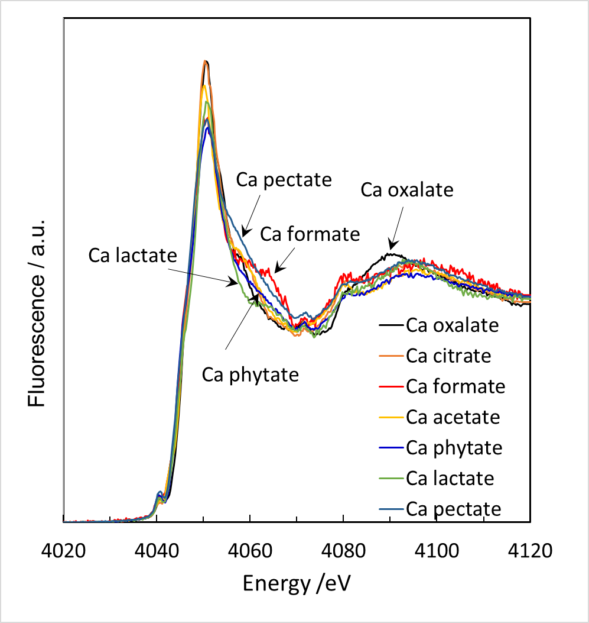
Figure S2: Detailed comparison of Ca K-edge XANES spectra obtained for different organic Ca compounds with potential relevance in soils.

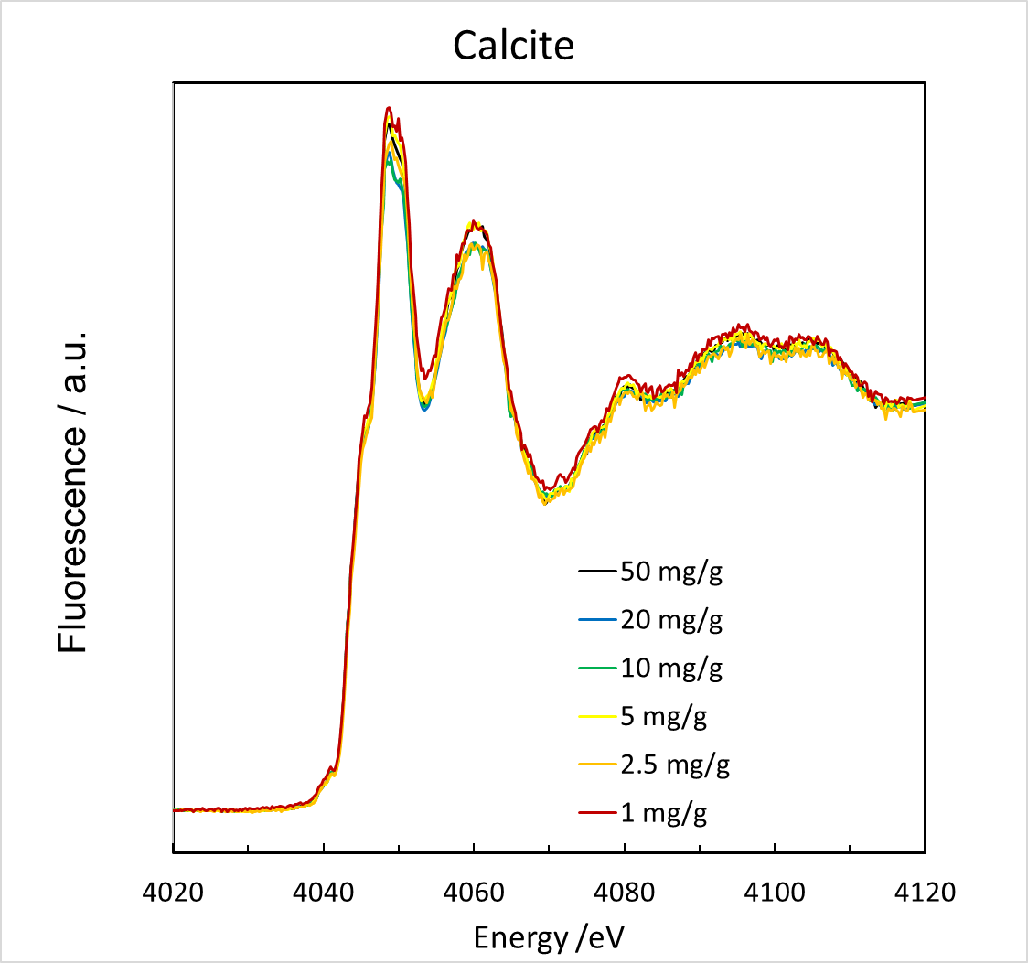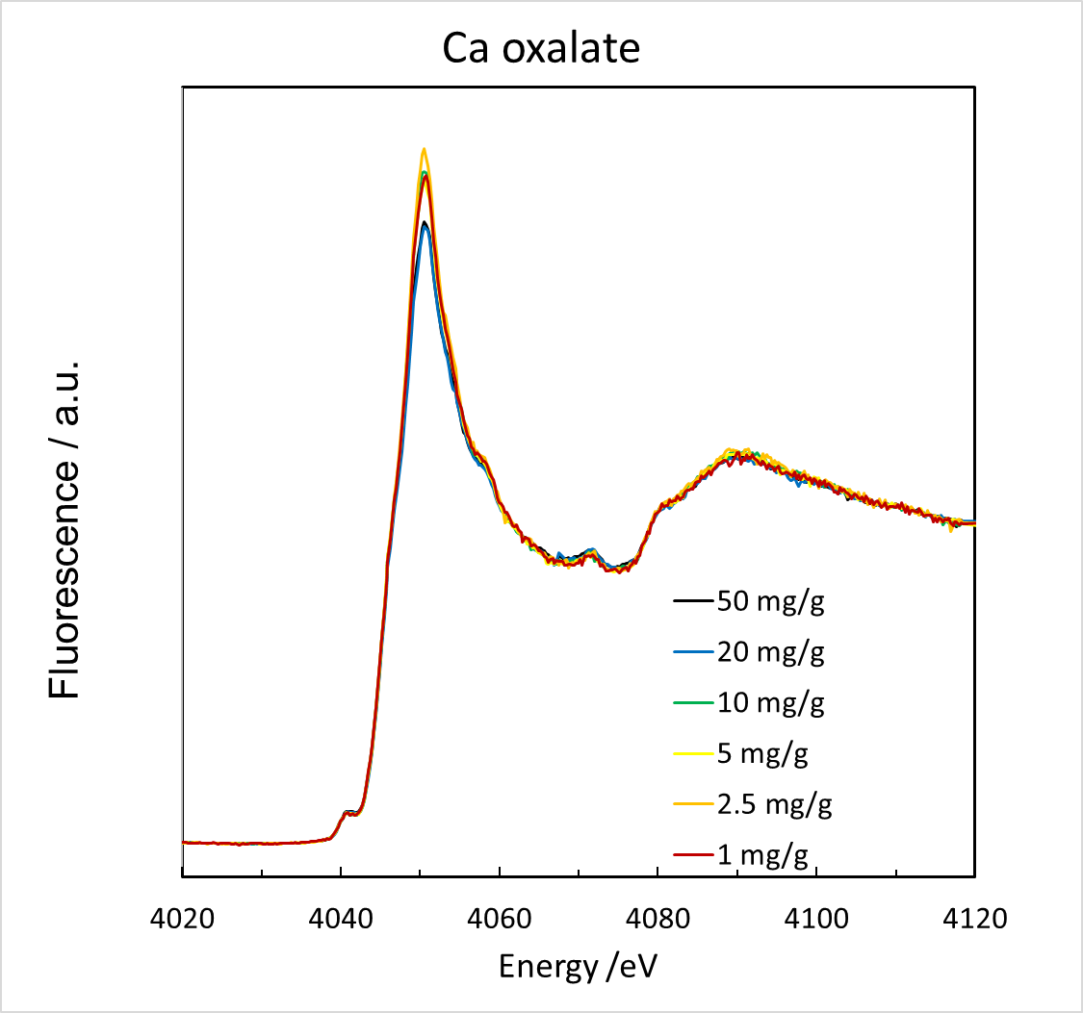
Figure S3: Ca K-edge XANES spectra of calcite (left panel), and Ca oxalate (right panel) after dilution to different Ca concentrations with fine ground quartz

