Long-term litter type treatments alter soil carbon composition but not microbial carbon utilization in a mixed pine-oak forest
Xiaowei Guo · Zhongkui Luo · Osbert Jianxin Sun
X.W. Guo · O.J. Sun ()
School of Ecology and Nature Conservation, Beijing Forestry University, Beijing 100083, China.
E-mail: sunjianx@bjfu.edu.cn
Z.K. Luo
College of Environmental and Resource Sciences, Zhejiang University, Zhejiang, 310058, China.
Table S1 Effects of litter treatment (L) and nitrogen addition (N) on soil water content (SWC), soil temperature, and various components of organic carbon. Values are means ± standard errors (SE). Significant differences are denoted by different letters at p < 0.05. SWC, soil mass water content; fDOC, the proportion of DOC; Macro-C, the soil organic carbon in the 250-2000 μm soil aggregates; LOC, labile organic carbon; ROC, recalcitrant organic carbon; MR, microbial respiration. N₀, 0 g·N·m^{–2}·yr^{–1}; N_{5,} 5 g·N·m^{–2}·yr^{–1}; N₁₀, 10 g·N·m^{–2}·yr^{–1}; all applied as urea. L_{con}, natural soil conditions; L_{nil}, complete removal of aboveground litter; L_{woody}, placement of fine woody litter; L_{leaf}, placement of leaf litter; L_{mix}, placement of mixed leaf and fine woody litter.
Treatments | SWC  %  0-20 cm | Temperature  ℃  0-20 cm | fDOC  %  0-5 cm | fDOC  %  10-20 cm | Macro-C  g·kg-1  10-20 cm | LOC  g·kg-1  10-20 cm | ROC  g·kg-1  10-20 cm | MR  mg·kg-1·day-1  0-5 cm
Lmix | 60.2±3.0 a | 17.3±1.1 c | 29.0±4.0 a | 42.6±4.1 | 18.3±1.1 | 6.2±0.4 a | 53.5±3.9 a | 34.2±2.6 a
Lleaf | 54.5±3.5 ab | 17.3±0.1 c | 29.1±4.4 a | 36.2±3.9 | 18.5±1.5 | 6.1±0.3 ab | 52.5±4.4 a | 35.7±1.8 a
Lwoody | 53.3±2.8 ab | 17.7±0.1 b | 21.3±2.6 b | 29.6±3.6 | 16.6±1.5 | 4.9±0.2 c | 41.0±2.0 b | 29.0±1.9 b
Lnil | 47.5±2.3 b | 18.1±0.2 a | 22.8±2.3 ab | 33.9±4.0 | 15.5±1.2 | 5.4±0.3 bc | 45.4±3.2 ab | 25.5±1.5 b
Lcon | 47.6±6.0 b | 17.6±0.2 bc | 22.0±4.8 ab | 25.5±3.1 | 17.3±1.3 | 5.6±0.1 abc | 48.1±3.1 ab | 27.3±1.7 b
N0 | 49.7±2.4 | 17.7±0.1 | 23.5±2.6 | 31.9±3.2 | 16.7±1.2 ab | 5.5±0.2 | 47.1±3.1 | 27.5±1.5 b
N5 | 58.1±2.9 | 17.4±0.1 | 24.2±2.7 | 38.8±3.5 | 19.2±0.9 a | 5.6±0.2 | 47.7±2.5 | 31.9±1.7 a
N10 | 53.4±2.3 | 17.7±0.1 | 28.5±3.3 | 34.4±3.0 | 15.9±1.0 b | 5.9±0.3 | 49.7±3.1 | 33.9±2.0 a
Litter (L) | p < 0.05 | p < 0.001 | p < 0.05 | p = 0.08 | p = 0.26 | p < 0.01 | p < 0.01 | p < 0.001
Nitrogen (N) | p = 0.08 | p = 0.07 | p = 0.14 | p = 0.41 | p < 0.05 | p = 0.37 | p = 0.72 | p < 0.01
L * N | p = 0.77 | p = 0.40 | p < 0.05 | p < 0.05 | p < 0.05 | p < 0.05 | p < 0.05 | p < 0.05

Fig. S1 Effect sizes with 95% confidence interval of litter manipulation and nitrogen addition on various components and classifications of soil organic carbon in 0–5 cm soil layer. The red color illustrates the effects of litter treatment, and the blue color illustrates the effects of nitrogen addition, respectively. TOC, total soil organic carbon; DOC, dissolved organic carbon; MacroC, macro-aggregate carbon fraction; MicroC, micro-aggregate carbon fraction; MineralC, fraction of mineral-bond carbon; LOC, labile organic carbon fraction; IOC, intermediate organic carbon fraction; ROC, recalcitrant organic carbon fraction; MBC, microbial biomass carbon. L_{con}, natural soil conditions; L_{nil}, complete removal of aboveground litter; L_{woody}, placement of fine woody litter; L_{leaf}, placement of leaf litter; L_{mix}, placement of mixed leaf and fine woody litter. N₀, 0 g·N·m^{–2}·yr^{–1}; N_{5,} 5 g·N·m^{–2}·yr^{–1}; N₁₀, 10 g·N·m^{–2}·yr^{–1}; all applied as urea.
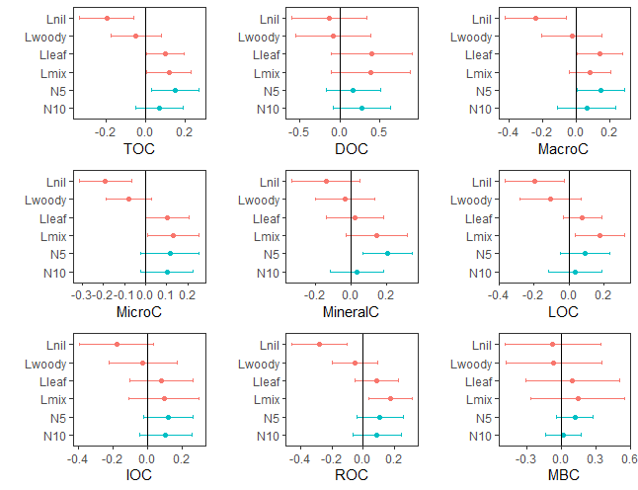

Fig. S2 Effect sizes with 95% confidence interval of litter manipulation and nitrogen addition on various components and classifications of soil organic carbon in 5–10 cm soil layer. The red color illustrates the effects of litter treatment, and the blue color illustrates the effects of nitrogen addition, respectively. TOC, total soil organic carbon; DOC, dissolved organic carbon; MacroC, macro-aggregate carbon fraction; MicroC, micro-aggregate carbon fraction; MineralC, fraction of mineral-bond carbon; LOC, labile organic carbon fraction; IOC, intermediate organic carbon fraction; ROC, recalcitrant organic carbon fraction; MBC, microbial biomass carbon. L_{con}, natural soil conditions; L_{nil}, complete removal of aboveground litter; L_{woody}, placement of fine woody litter; L_{leaf}, placement of leaf litter; L_{mix}, placement of mixed leaf and fine woody litter. N₀, 0 g·N·m^{–2}·yr^{–1}; N_{5,} 5 g·N·m^{–2}·yr^{–1}; N₁₀, 10 g·N·m^{–2}·yr^{–1}; all applied as urea.
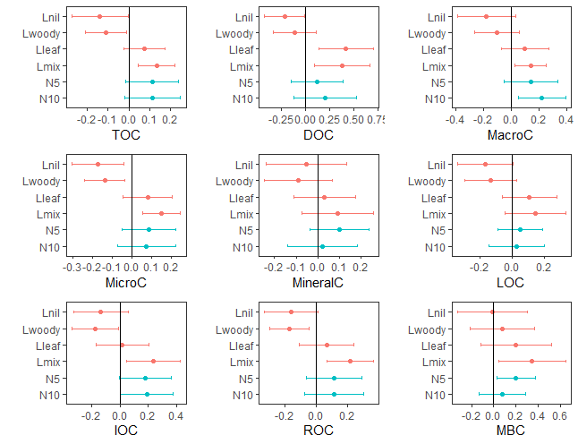
Fig. S3 Effect sizes with 95% confidence interval of litter manipulation and nitrogen addition on various components and classifications of soil organic carbon in 10–20 cm soil layer. The red color illustrates the effects of litter treatment, and the blue color illustrates the effects of nitrogen addition, respectively. TOC, total soil organic carbon; DOC, dissolved organic carbon; MacroC, macro-aggregate carbon fraction; MicroC, micro-aggregate carbon fraction; MineralC, fraction of mineral-bond carbon; LOC, labile organic carbon fraction; IOC, intermediate organic carbon fraction; ROC, recalcitrant organic carbon fraction; MBC, microbial biomass carbon. L_{con}, natural soil conditions; L_{nil}, complete removal of aboveground litter; L_{woody}, placement of fine woody litter; L_{leaf}, placement of leaf litter; L_{mix}, placement of mixed leaf and fine woody litter. N₀, 0 g·N·m^{–2}·yr^{–1}; N_{5,} 5 g·N·m^{–2}·yr^{–1}; N₁₀, 10 g·N·m^{–2}·yr^{–1}; all applied as urea.
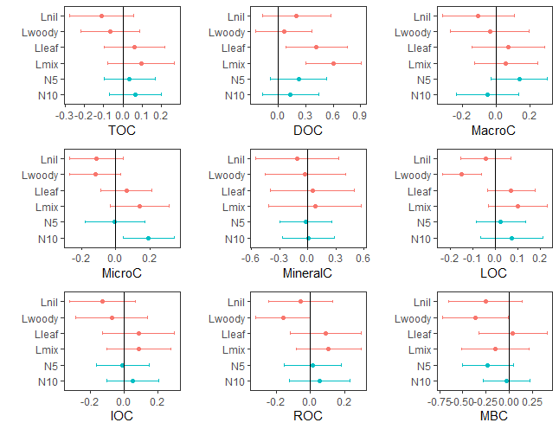
Fig. S4 Effect sizes with 95% confidence interval of litter manipulation and nitrogen addition on selective soil microbial properties in 0-5 cm soil layer. The red color illustrates the effects of litter treatment, and the blue color illustrates the effects of nitrogen addition, respectively. MR, microbial respiration; CUE_{C:N}, carbon use efficiency; qCO₂, microbial metabolic quotient; BG, β-1,4-glucosidase; NAG, β-1,4-N-acetyl-glucosaminidase; BG:NAG, the ratio to BG to NAG. L_{con}, natural soil conditions; L_{nil}, complete removal of aboveground litter; L_{woody}, placement of fine woody litter; L_{leaf}, placement of leaf litter; L_{mix}, placement of mixed leaf and fine woody litter. N₀, 0 g·N·m^{–2}·yr^{–1}; N_{5,} 5 g·N·m^{–2}·yr^{–1}; N₁₀, 10 g·N·m^{–2}·yr^{–1}; all applied as urea.
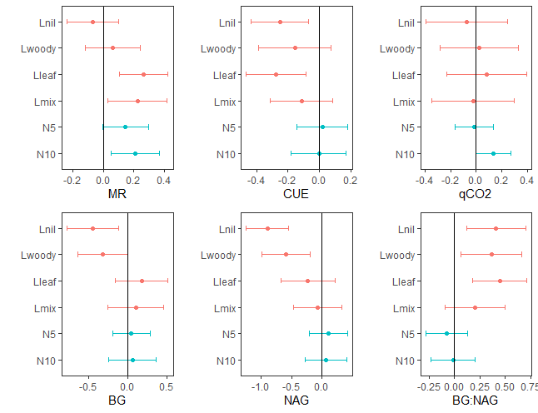
Fig. Effect sizes with 95% confidence interval of litter manipulation and nitrogen addition on selective soil microbial properties in 5-10 cm soil layer. The red color illustrates the effects of litter treatment, and the blue color illustrates the effects of nitrogen addition, respectively. MR, microbial respiration; CUE_{C:N}, carbon use efficiency; qCO₂, microbial metabolic quotient; BG, β-1,4-glucosidase; NAG, β-1,4-N-acetyl-glucosaminidase; BG:NAG, the ratio to BG to NAG. L_{con}, natural soil conditions; L_{nil}, complete removal of aboveground litter; L_{woody}, placement of fine woody litter; L_{leaf}, placement of leaf litter; L_{mix}, placement of mixed leaf and fine woody litter. N₀, 0 g·N·m^{–2}·yr^{–1}; N_{5,} 5 g·N·m^{–2}·yr^{–1}; N₁₀, 10 g·N·m^{–2}·yr^{–1}; all applied as urea.
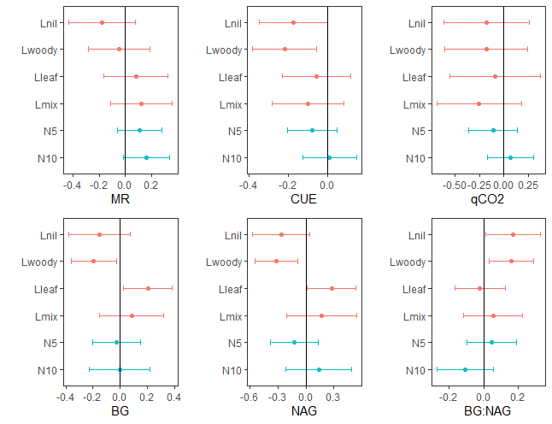
Fig. S6 Effect sizes with 95% confidence interval of litter manipulation and nitrogen addition on selective soil microbial properties in 10-20 cm soil layer. The red color illustrates the effects of litter treatment, and the blue color illustrates the effects of nitrogen addition, respectively. MR, microbial respiration; CUE_{C:N}, carbon use efficiency; qCO₂, microbial metabolic quotient; BG, β-1,4-glucosidase; NAG, β-1,4-N-acetyl-glucosaminidase; BG:NAG, the ratio to BG to NAG. L_{con}, natural soil conditions; L_{nil}, complete removal of aboveground litter; L_{woody}, placement of fine woody litter; L_{leaf}, placement of leaf litter; L_{mix}, placement of mixed leaf and fine woody litter. N₀, 0 g·N·m^{–2}·yr^{–1}; N_{5,} 5 g·N·m^{–2}·yr^{–1}; N₁₀, 10 g·N·m^{–2}·yr^{–1}; all applied as urea.
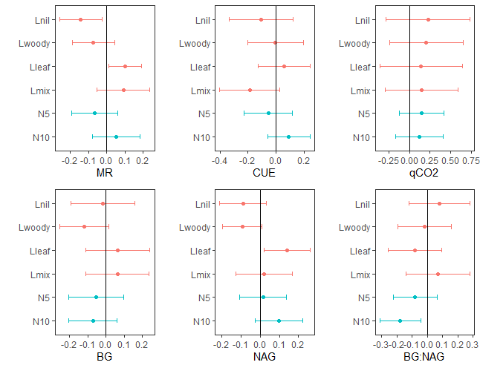
Fig. S7 Effects of litter treatment on the proportion of various physical and chemical soil organic carbon fractions in 0–5, 5–10 and 10–20 cm soil layers. fMacro-C, the proportion of OC in the 250-2000 μm soil aggregates; fMicro-C, the proportion of OC in the 53-250 μm soil aggregates; fMineral-C, the proportion of OC in the < 53 μm soil aggregates. fLOC, the proportion of labile organic carbon; fIOC, the proportion of intermediate organic carbon; fROC, the proportion of recalcitrant organic carbon. Error bars show one standard error. Different letters above the bar for the same soil layer indicate significant difference among treatments (p < 0.05).
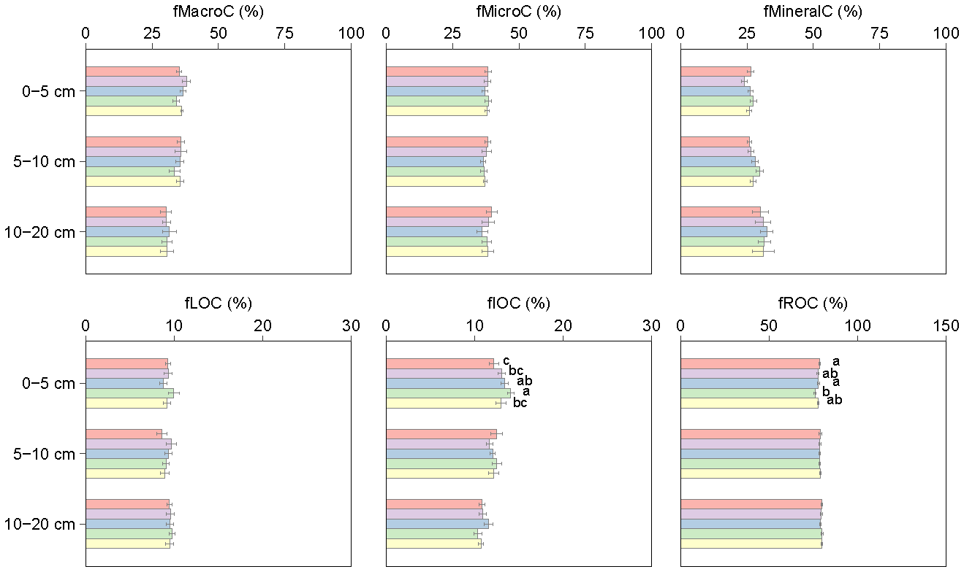

Fig. S8 Effects of nitrogen addition on the proportion of various physical and chemical soil organic carbon fractions in 0–5, 5–10 and 10–20 cm soil layers. fMacro-C, the proportion of OC in the 250-2000 μm soil aggregates; fMicro-C, the proportion of OC in the 53-250 μm soil aggregates; fMineral-C, the proportion of OC in the < 53 μm soil aggregates. fLOC, the proportion of labile organic carbon; fIOC, the proportion of intermediate organic carbon; fROC, the proportion of recalcitrant organic carbon. Error bars show one standard error. Different letters above the bar for the same soil layer indicate significant difference among treatments (p < 0.05)
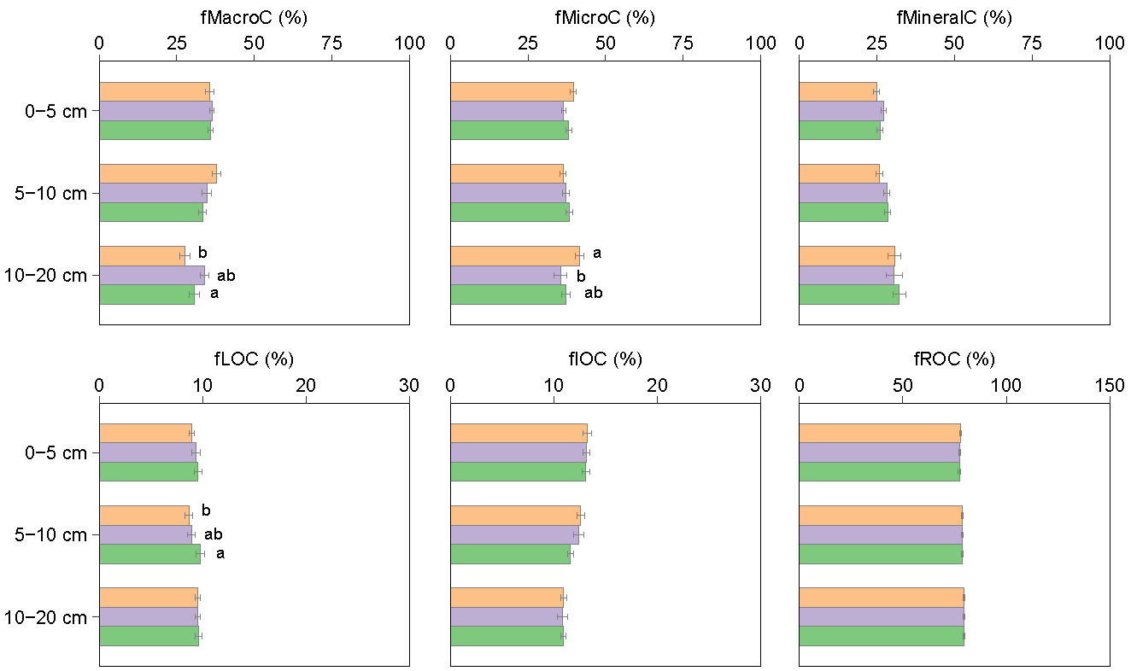

Fig. S9 Redundancy analysis (RDA) of microbial characteristics (red vectors) (i.e., MBC, MR, CUE_{C:N}, qCO₂) as impacted by soil carbon and nitrogen properties including the assessed physical and chemical SOC fractions (blue vectors) in the (a) 0-5 cm, (b) 5-10 cm and (c) 10-20 cm soil layers. The length and angle of arrows indicate the importance of the assessed soil carbon and nitrogen properties in explaining soil microbial characteristics. TN, total nitrogen; DON, dissolved organic nitrogen

