Supplementary Information: “Effectiveness of phosphorus control under extreme heatwaves: implications for sediment nutrient releases and greenhouse gas emissions”
Qing Zhan^{1,*}, Cleo N. Stratmann^{1, 2, 3}, Harm G. van der Geest⁴, Annelies J. Veraart⁵, Kristof Brenzinger^{6, 7}, Miquel Lurling², Lisette N. de Senerpont Domis^{1, 2}

¹ Department of Aquatic Ecology, Netherlands Institute of Ecology (NIOO-KNAW), P.O. Box 50, 6708 PB Wageningen, The Netherlands
² Department of Aquatic Ecology and Water Quality Management, Wageningen University, P.O. Box 47, 6708 PB Wageningen, The Netherlands
³ Leesu, Ecole des Ponts ParisTech, Université Paris-Est Créteil, 6-8 avenue Blaise Pascal, 77455 Marne-la-Vallée Cedex 2, France
⁴ Department of Freshwater and Marine Ecology, Institute for Biodiversity and Ecosystem Dynamics, University of Amsterdam. P.O. Box 94240, 1090 GE Amsterdam, The Netherlands
⁵ Department of Aquatic Ecology and Environmental Biology, Institute for Water and Wetland Research, Radboud University, P.O. Box 9010, 6500 GL Nijmegen, the Netherlands
⁶ Department of Microbial Ecology, Netherlands Institute of Ecology (NIOO-KNAW), P.O. Box 50, 6708 PB Wageningen, The Netherlands
⁷ Department of Animal Ecology and Tropical Biology, Biocenter, University of Würzburg, Am Hubland, 97074 Würzburg, Germany

*Corresponding author. E-mail: Q.Zhan@nioo.knaw.nl (Q. Zhan)
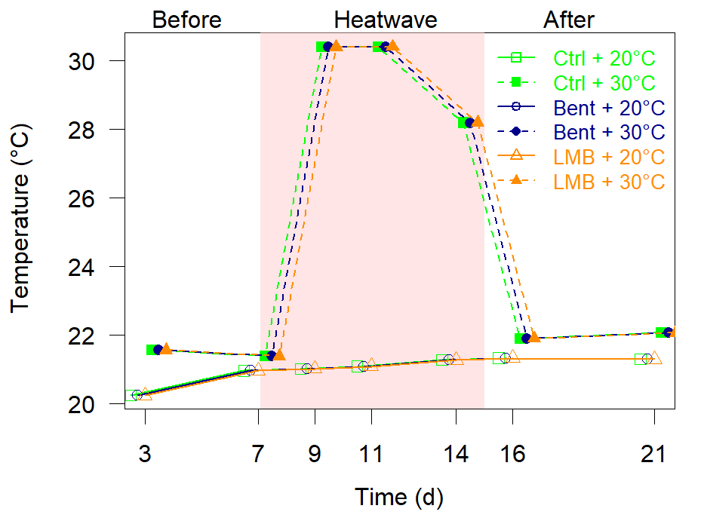
Figure S1. The dynamics of water temperature in each treatment.
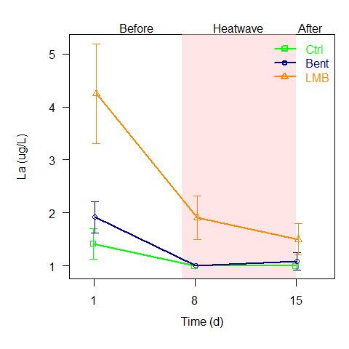  (a) | 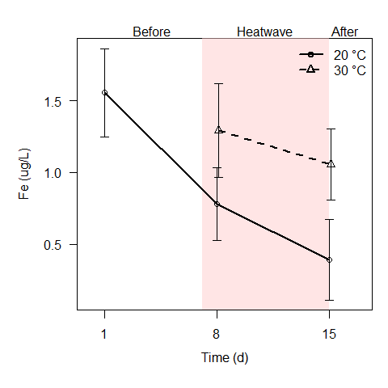  (b)
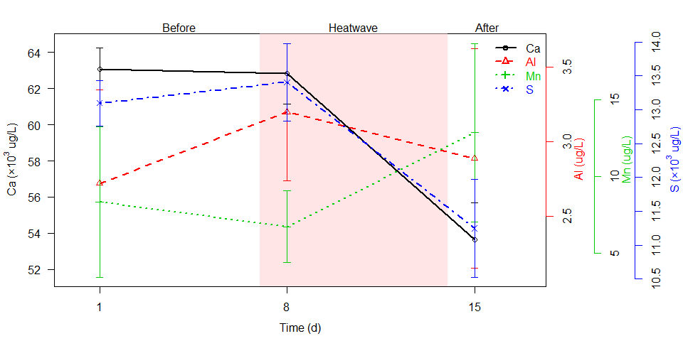
(c)
Figure S2. The filterable metal concentrations.
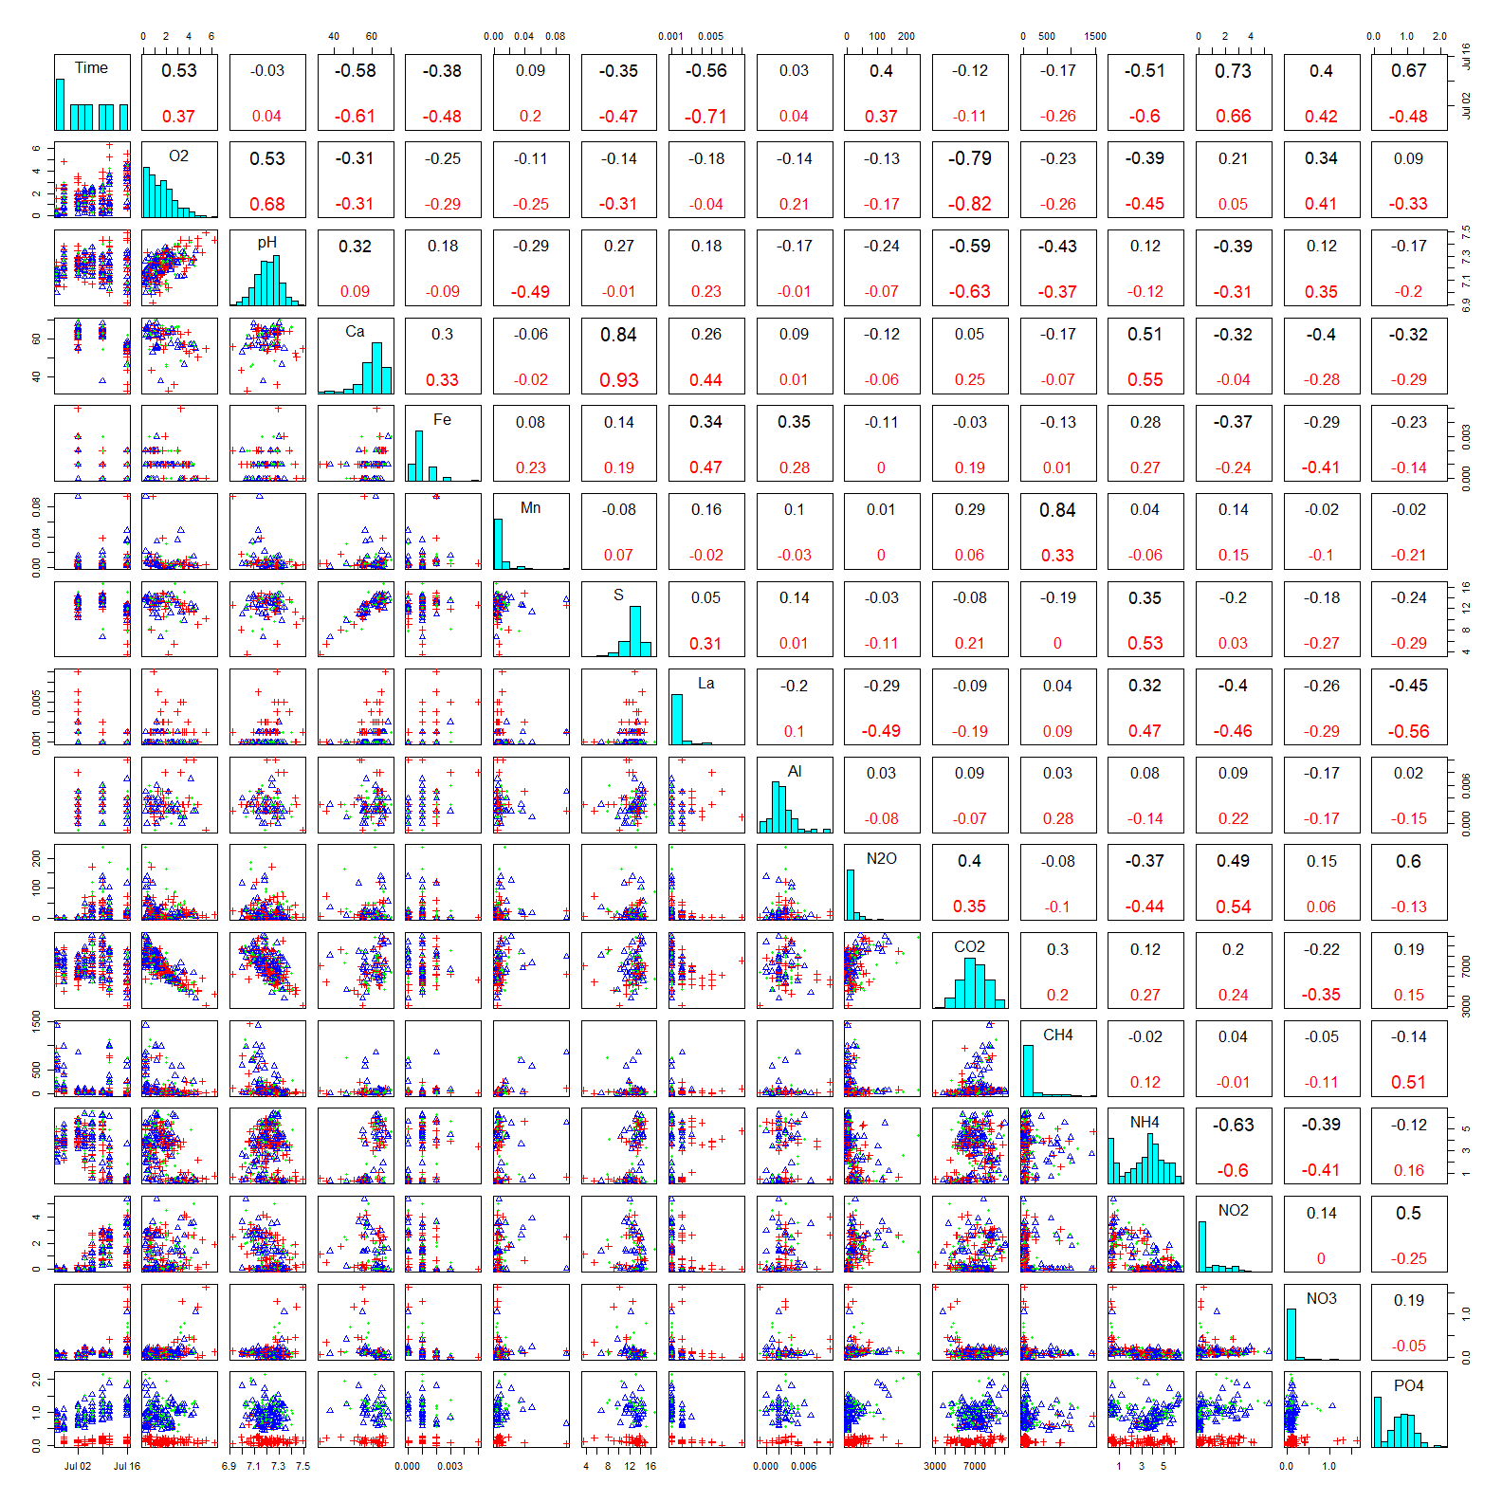
Figure S3. Correlation matrix for all measured variables. The lower panels illustrate the scatter points between each two variables: the green dots represent control (‘Ctrl’) treatments, the blue dots represent bentonite (‘Bent’) treatments, and the red dots represent Phoslock® (‘LMB’) treatments. The diagonal panels illustrate the histograms of each variable. The upper panels illustrate the Pearson correlation coefficients between each two variables: the black numbers represent non-LMB (Ctrl/Bent) treatments, the red numbers represent the LMB treatments.

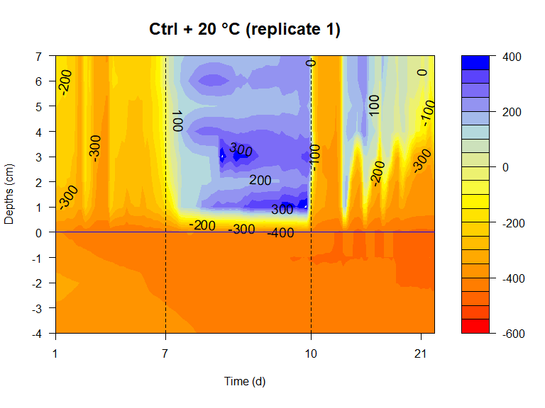 | 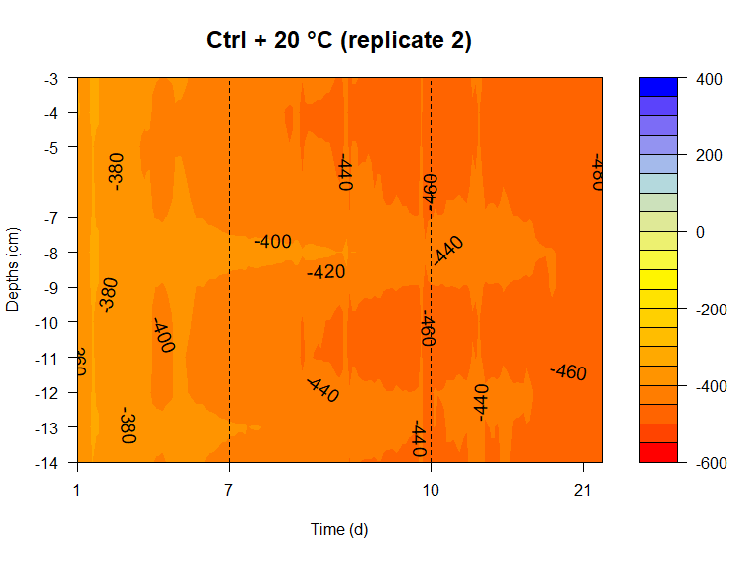
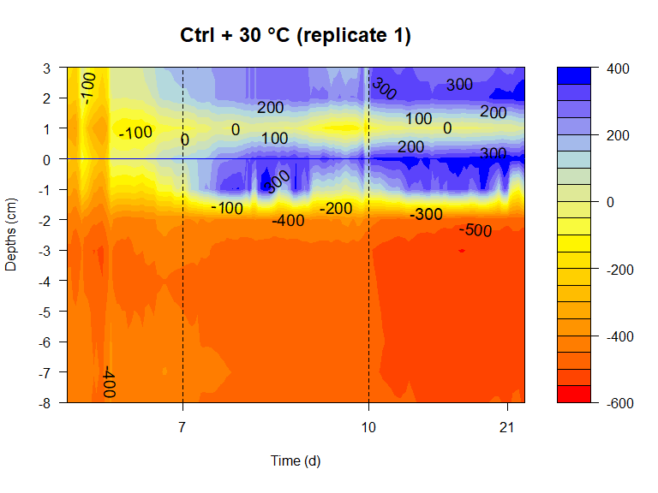 | 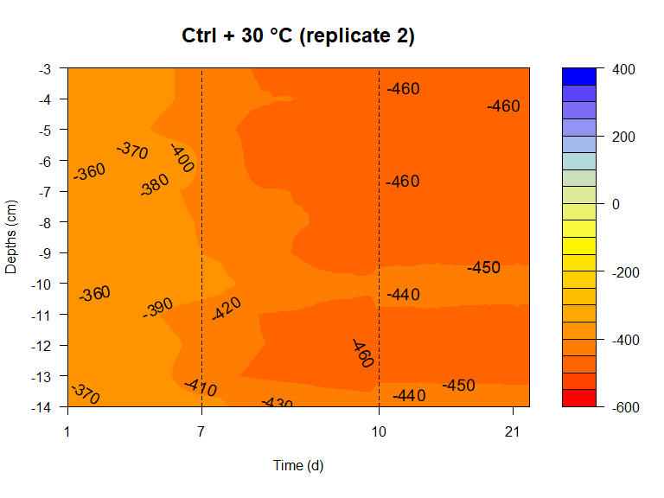
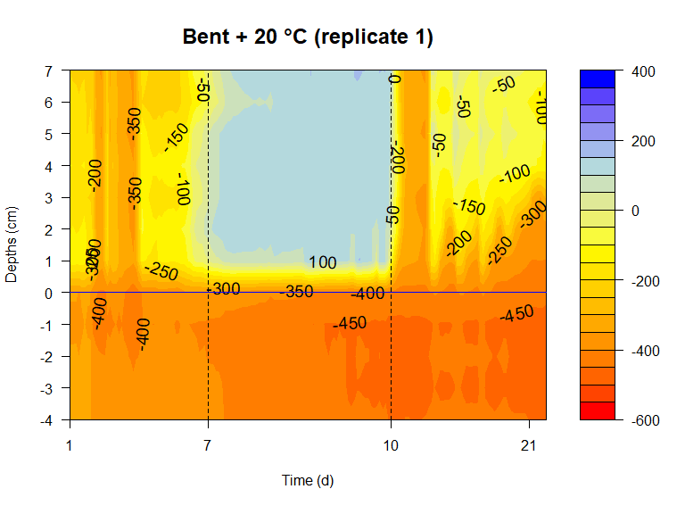 | 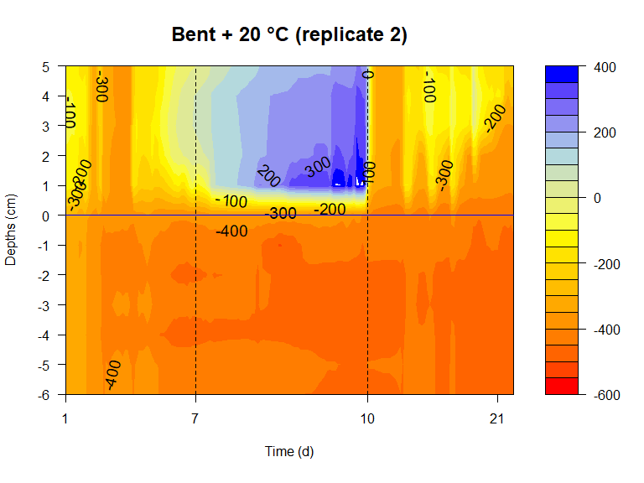
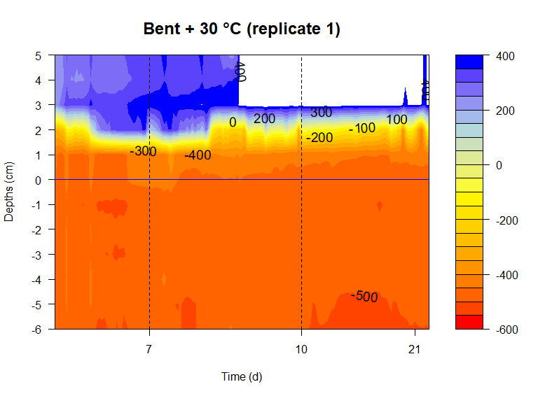 | 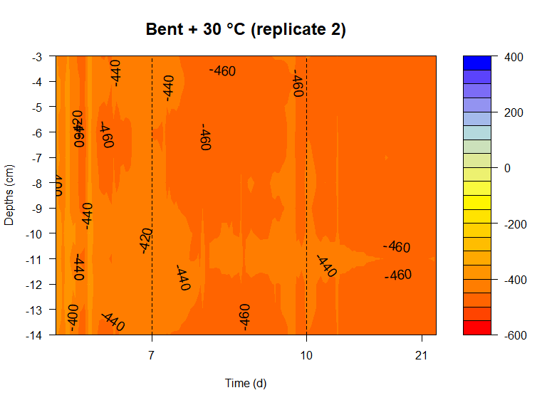
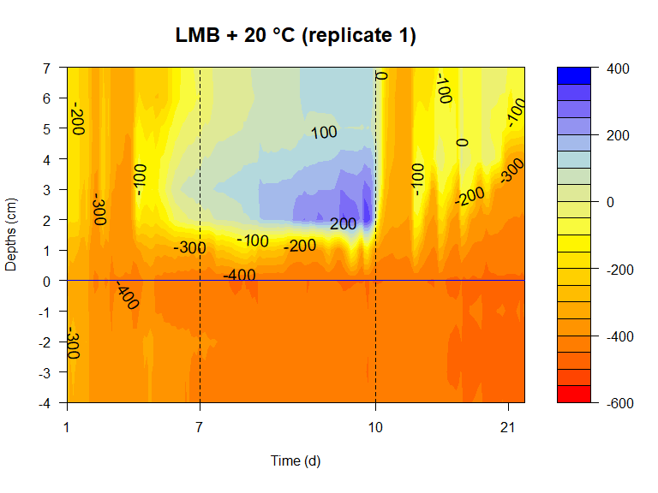 | 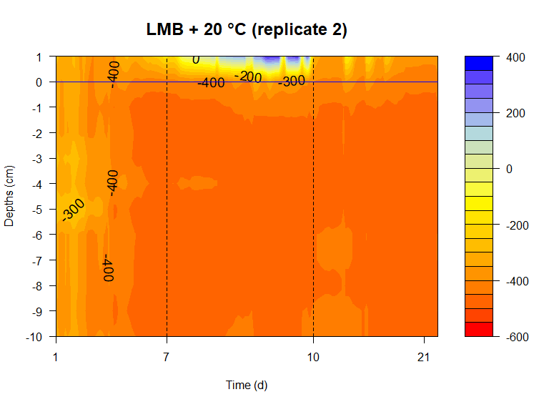
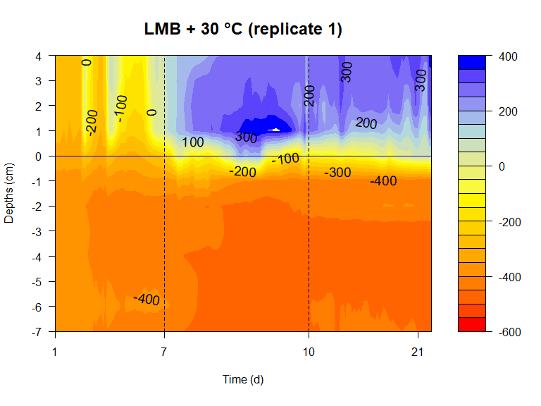 | 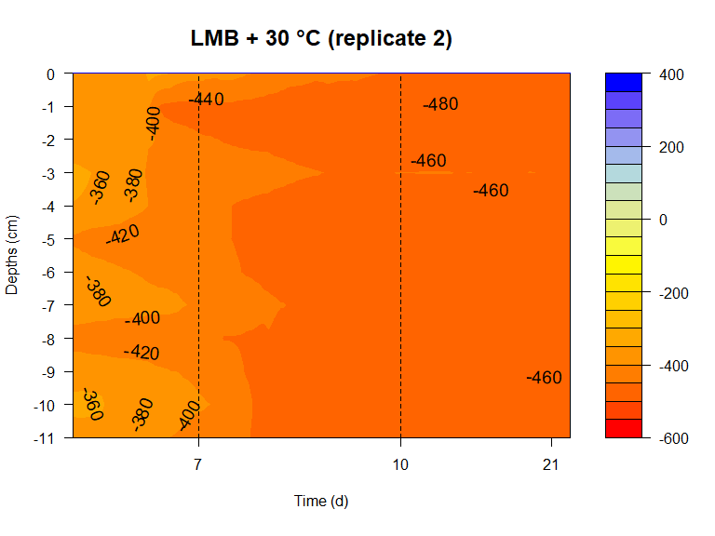
Figure S4. Contour plot of redox potentials at different depths in each core. Horizontal dashed line represents sediment water interface (SWI). Differences of measured depths related to SWI result from different insertion depths of the redox probe sensors in the sediment. The two vertical dashed lines represents the start and end of the second week (heatwave simulation) of the experiment. The head titles indicate heatwave and P-treatments (Ctrl, Bent and LMB) with two replicates for each treatment.

