Supplementary Information
Table S1 Linear combination fitting of the EXAFS region for soil samples, together with the estimated standard deviation (ESD) derived from the variance calculated in the covariance matrix and the residuals of the fit. Lower residuals represent a better data fit for the model.
 | SRFA | ESD | Ferrihydrite | ESD | Biotite | ESD | Goethite | ESD | Hematite | ESD | Residuals
Forest 35 organic | 0.079 | 0.021 | 0.252 | 0.048 | 0.134 | 0.018 | 0.329 | 0.032 | 0.275 | 0.013 | 0.3510
Forest 61 organic | 0.251 | 0.019 | 0.259 | 0.042 | 0.067 | 0.016 | 0.201 | 0.028 | 0.298 | 0.012 | 0.2744
Forest 90 organic | 0.124 | 0.029 | 0.309 | 0.064 | 0.272 | 0.024 | 0.273 | 0.043 | 0.189 | 0.018 | 0.6281
Forest 35 upper | 0.110 | 0.018 | 0.340 | 0.039 | 0.059 | 0.015 | 0.284 | 0.027 | 0.226 | 0.011 | 0.2416
Forest 61 upper | 0.076 | 0.016 | 0.193 | 0.035 | 0.049 | 0.013 | 0.394 | 0.024 | 0.255 | 0.010 | 0.1898
Forest 90 upper | 0.097 | 0.016 | 0.219 | 0.036 | 0.105 | 0.013 | 0.315 | 0.024 | 0.336 | 0.010 | 0.1969
Forest 35 lower | 0.033 | 0.020 | 0.275 | 0.044 | 0.104 | 0.017 | 0.339 | 0.030 | 0.216 | 0.012 | 0.3029
Forest 61 lower | 0.027 | 0.019 | 0.321 | 0.043 | 0.043 | 0.012 | 0.363 | 0.029 | 0.251 | 0.012 | 0.2862
Forest 90 lower | 0.080 | 0.019 | 0.266 | 0.041 | 0.057 | 0.016 | 0.285 | 0.028 | 0.293 | 0.011 | 0.2545
Field 35 upper | 0.036 | 0.015 | 0.265 | 0.033 | 0.132 | 0.012 | 0.285 | 0.022 | 0.241 | 0.009 | 0.1664
Field 61 upper | 0.076 | 0.016 | 0.298 | 0.035 | 0.143 | 0.013 | 0.221 | 0.024 | 0.195 | 0.010 | 0.1905
Field 90 upper | 0.030 | 0.018 | 0.292 | 0.041 | 0.077 | 0.015 | 0.332 | 0.028 | 0.292 | 0.012 | 0.2591
Field 35 lower | 0.050 | 0.014 | 0.255 | 0.031 | 0.095 | 0.012 | 0.294 | 0.021 | 0.304 | 0.009 | 0.1517
Field 61 lower | - | - | 0.162 | 0.032 | 0.177 | 0.014 | 0.287 | 0.026 | 0.257 | 0.010 | 0.2319
Field 90 lower | 0.042 | 0.015 | 0.296 | 0.033 | 0.108 | 0.013 | 0.304 | 0.022 | 0.296 | 0.009 | 0.1697
The residual, $\frac{{(Io-Ic)}^{2}}{N}$, represents the sum of squares difference between observed ($Io$) and calculated intensities ($Ic$) over $N$ data points.

Table S2 Explained variance and standard regression coefficients using all predicting variables, for Fe and DOC in different experimental plots and soil depths
 |  |  | Explained variance | Standard regression coefficients
 |  |  | Explained variance | Age | Depth | Fe | DOC | pH | Al | Mn | Si | K | Mg | Ca | Na | Cl | NO₃ | SO₄ | cond.
Fe | All |  | 62% (2) | 0.13 | -0.23 | - | 0.49 | -0.11 | 0.11 | -0.05 | 0.04 | 0.03 | -0.08 | -0.07 | -0.04 | -0.07 | -0.05 | 0.00 | -0.00
Fe | Control |  | 77% (2) | - | -0.12 | - | 0.43 | 0.19 | 0.23 | 0.07 | 0.06 | 0.15 | -0.04 | -0.09 | 0.12 | 0.00 | 0.08 | 0.01 | -0.01
Fe | Forest | all | 67% (2) | 0.10 | -0.24 | - | 0.43 | -0.18 | 0.07 | -0.02 | 0.01 | -0.06 | -0.08 | -0.06 | -0.05 | -0.07 | -0.11 | 0.03 | -0.02
Fe | Forest | shallow | 67% (2) | 0.22 | - | - | 0.42 | -0.14 | 0.18 | -0.01 | 0.02 | -0.10 | -0.05 | -0.12 | 0.00 | -0.02 | -0.11 | 0.10 | 0.00
Fe | Forest | deep | 66% (3) | -0.29 | - | - | 0.75 | -0.53 | -0.23 | 0.16 | -0.02 | -0.21 | -0.09 | 0.05 | 0.03 | -0.28 | -0.11 | 0.08 | -0.12
DOC | All |  | 72% (2) | 0.11 | -0.22 | 0.51 | - | 0.00 | 0.22 | -0.11 | 0.09 | 0.13 | -0.09 | -0.10 | -0.00 | -0.04 | -0.11 | 0.04 | 0.01
DOC | Control |  | 81% (2) | - | -0.08 | 0.43 | - | 0.17 | 0.23 | -0.08 | 0.10 | 0.14 | -0.07 | -0.09 | 0.19 | -0.02 | -0.11 | 0.01 | 0.01
DOC | Forest | all | 81% (3) | 0.17 | -0.25 | 0.51 | - | -0.14 | 0.22 | -0.05 | 0.04 | -0.03 | -0.05 | 0.02 | 0.01 | -0.06 | -0.04 | 0.19 | 0.02
DOC | Forest | shallow | 79% (2) | 0.21 | - | 0.44 | - | -0.16 | 0.20 | -0.08 | 0.06 | -0.06 | -0.06 | -0.06 | 0.01 | -0.04 | -0.08 | 0.30 | 0.01
DOC | Forest | deep | 69% (2) | 0.32 | - | 0.46 | - | -0.07 | 0.37 | -0.03 | 0.04 | 0.07 | -0.02 | 0.04 | 0.12 | -0.05 | 0.08 | 0.12 | -0.04
pH | All |  | 72% (3) | -0.68 | 0.03 | -0.12 | 0.09 | - | -0.02 | -0.14 | 0.10 | 0.25 | 0.00 | -0.11 | 0.02 | -0.04 | -0.15 | -0.01 | -0.09
pH | Control |  | 45% (2) | - | -0.01 | 0.20 | 0.18 | - | -0.00 | -0.15 | -0.07 | 0.06 | -0.04 | -0.13 | 0.00 | -0.06 | -0.14 | -0.04 | -0.05
pH | Forest | all | 58% (2) | -0.22 | 0.20 | -0.19 | -0.21 | - | -0.05 | 0.01 | -0.05 | -0.05 | -0.01 | 0.00 | -0.01 | -0.04 | 0.05 | 0.21 | -0.11
pH | Forest | shallow | 52% (2) | -0.41 | - | -0.17 | -0.21 | - | 0.05 | -0.01 | -0.06 | -0.05 | 0.00 | 0.06 | -0.02 | -0.06 | 0.03 | 0.17 | -0.15
pH | Forest | deep | 68% (2) | -0.22 | - | -0.28 | -0.09 | - | -0.15 | 0.09 | 0.01 | 0.02 | -0.11 | -0.02 | -0.03 | -0.14 | 0.07 | 0.36 | -0.17
“All” includes all experimental plots, “Control” only includes non-forested plots and “Forest” represents forested plots and is further divided by depth, where separate analysis are done on the shallow and deep lysimeter water samples. Numbers in brackets under explained variance show the optimal number of components for each model, as determined by cross-validation.

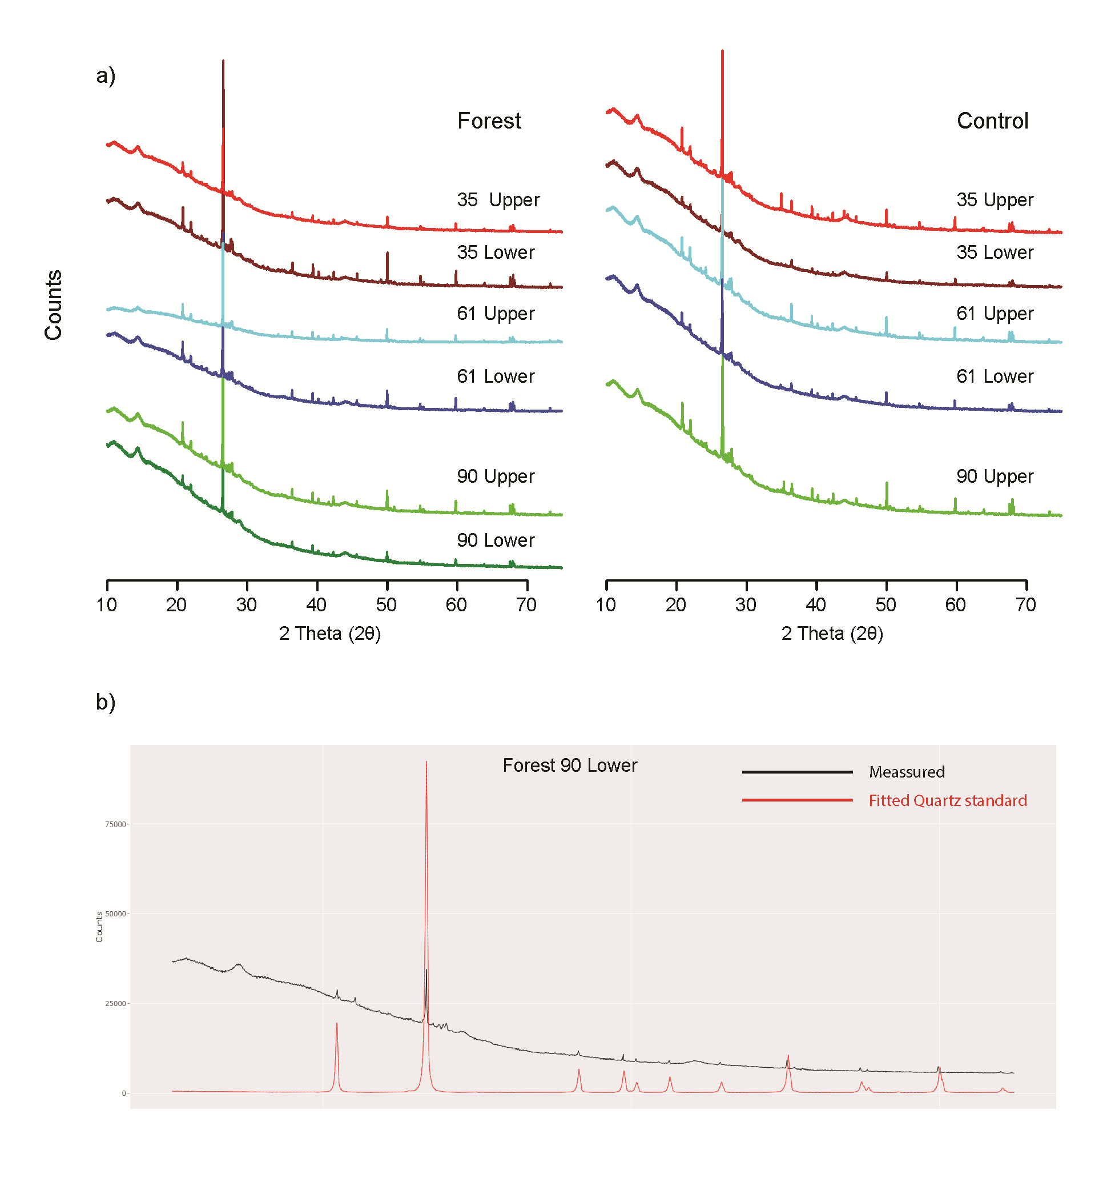
Fig. S1 X-ray diffraction spectra for soil samples. a) Comparison of forest and control plot soil form different depths. b) Comparison of the 90-year old lower mineral soil sample and a quartz standard

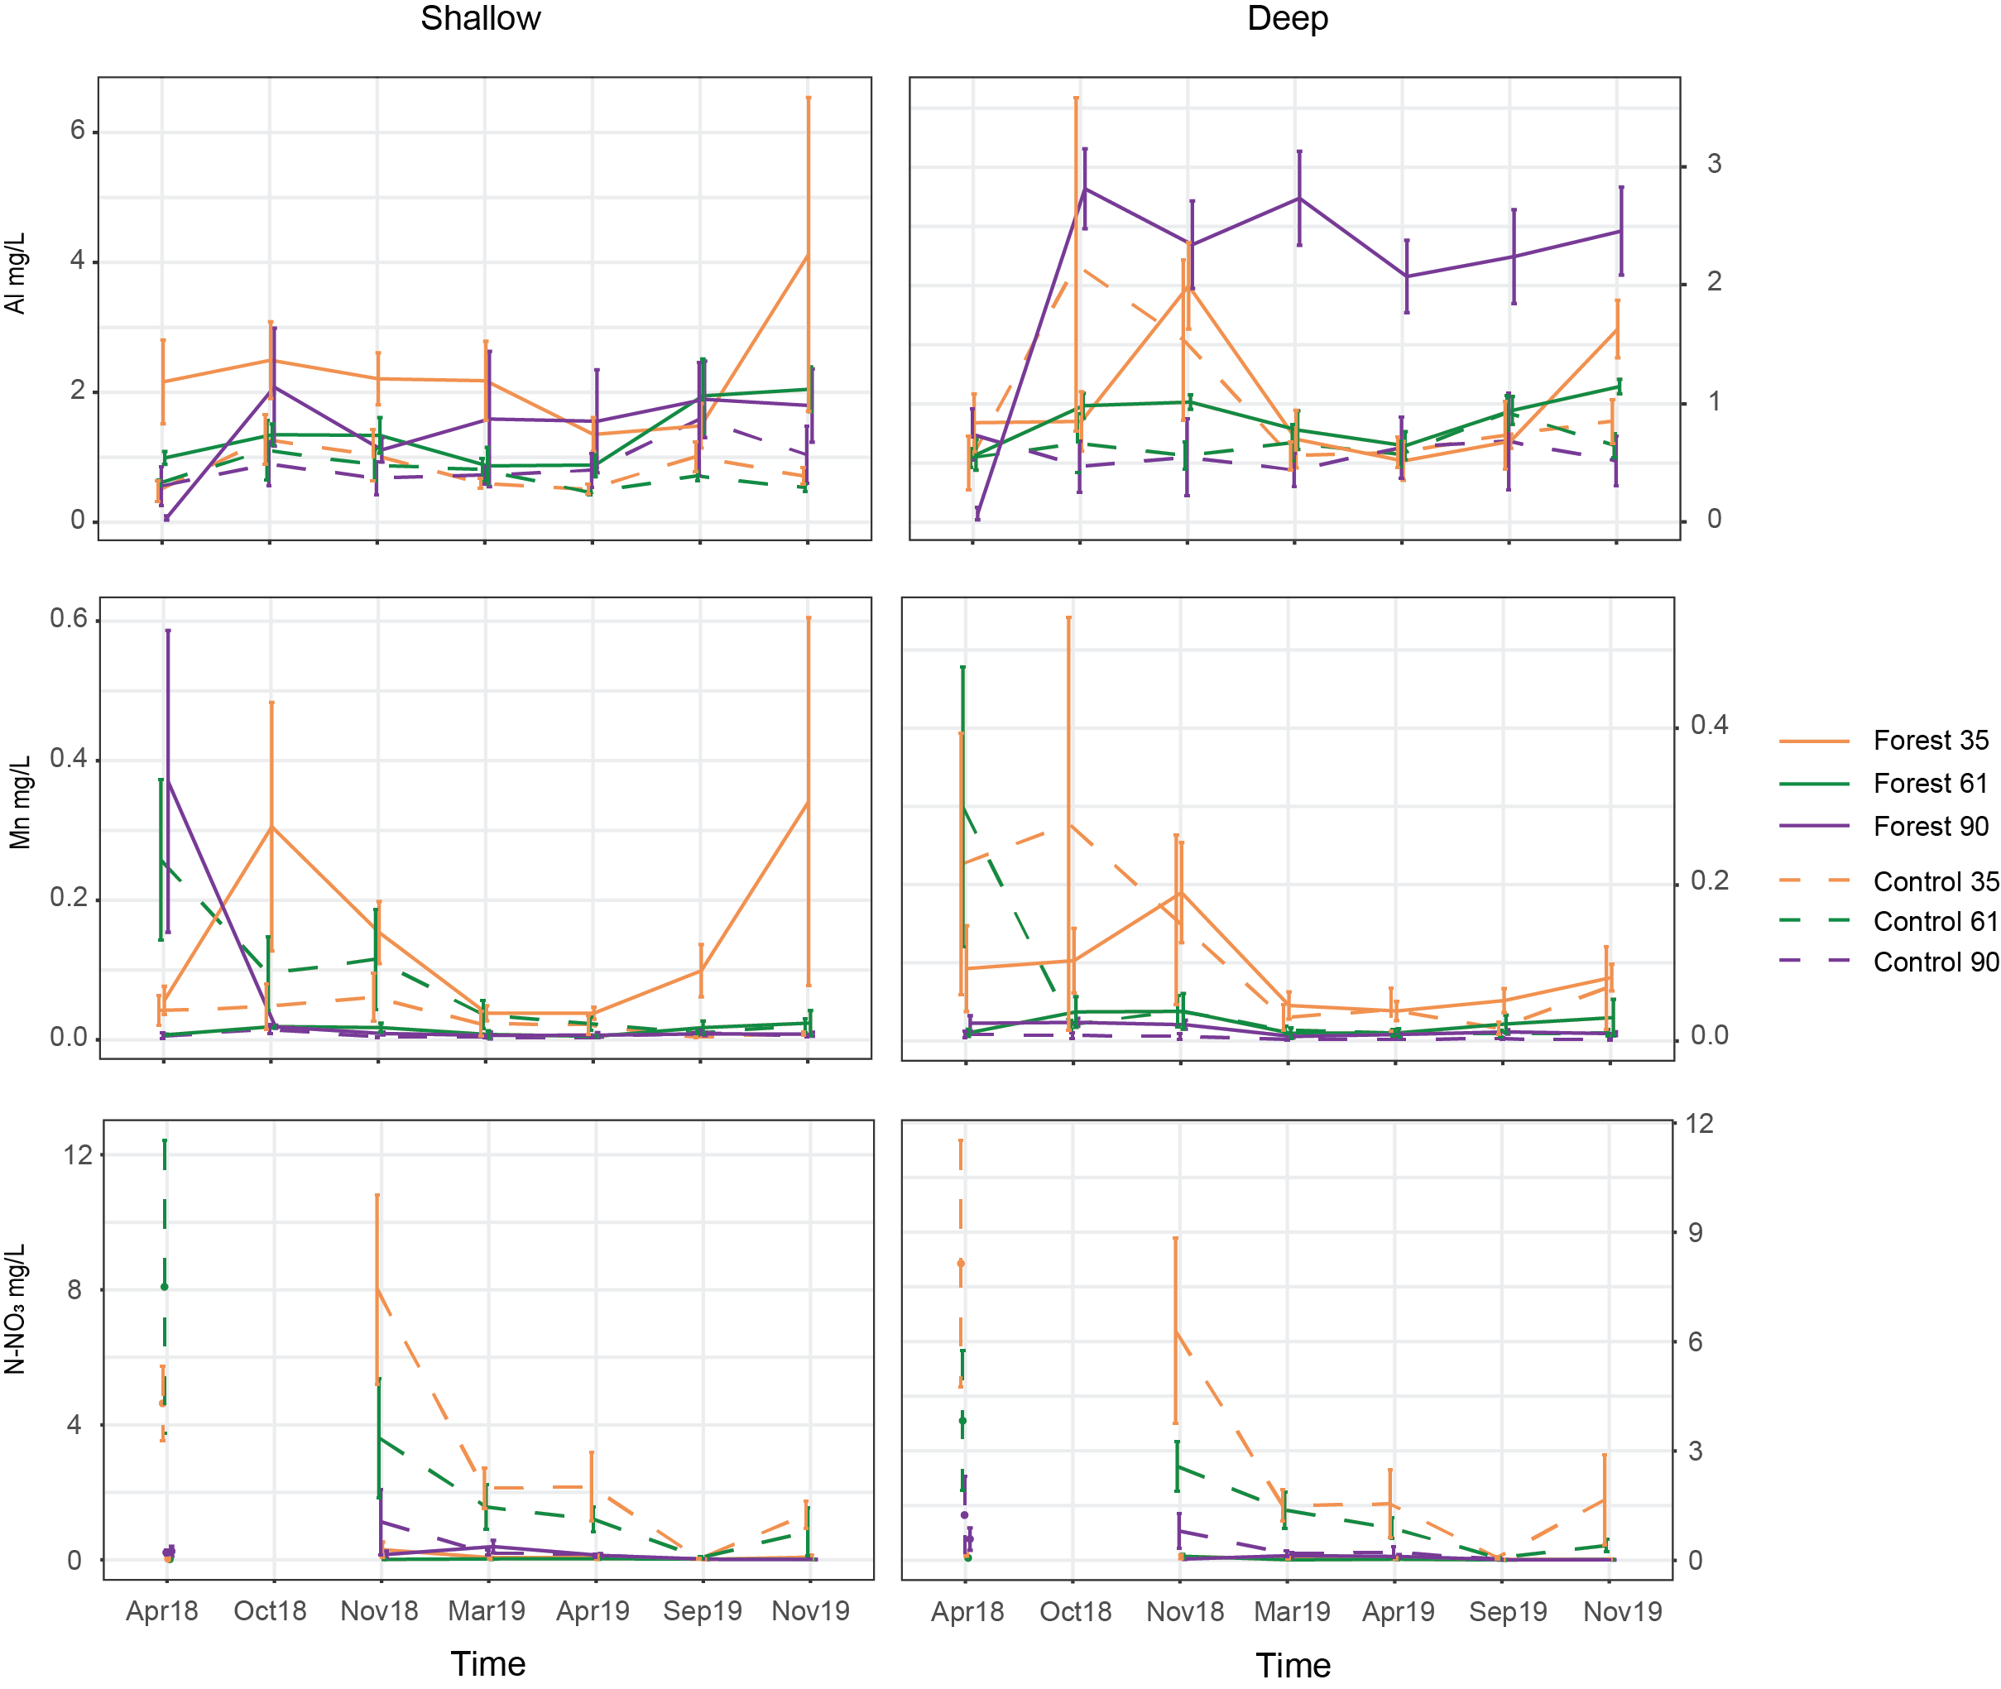Fig. S2 Al, Mn, and N-NO₃ concentrations in soil-water from the shallow (left) and deep (right) lysimeters over time. Error bars represent SE and are slightly shifted along the x-axis for better visualization.

Table S3 EXAFS shell-by-shell fitting of soil samples.
Plot | Path | R (Å) | CN | σ² (Å²) | ΔE₀ (eV)
Forest 35  organic | Fe-O | 2.00 | 5.9 | 0.0139 | 3.1
Forest 35  organic | Fe-Fe | 3.04 | 2.7 | 0.0100 | 3.1
Forest 35  organic | Fe-Fe | 3.38 | 2.4 | 0.0100 | 3.1
Forest 35  organic | Fe-C | 2.88 | 1.3 | 0.0075 | 3.1
Forest 35  organic | Fe-C-O# | 4.04 | 2.7 | 0.0150 | 3.1
Forest 61  organic | Fe-O | 2.00 | 5.8 | 0.0113 | 2.4
Forest 61  organic | Fe-Fe | 3.03 | 2.3 | 0.0100 | 2.4
Forest 61  organic | Fe-Fe | 3.36 | 2.2 | 0.0100 | 2.4
Forest 61  organic | Fe-C | 2.88 | 2.4 | 0.0075 | 2.4
Forest 61  organic | Fe-C-O# | 4.11 | 4.8 | 0.0150 | 2.4
Forest 90  organic | Fe-O | 2.02 | 5.9 | 0.0115 | 2.4
Forest 90  organic | Fe-Fe | 3.05 | 2.0 | 0.0100 | 2.4
Forest 90  organic | Fe-Fe | 3.41 | 2.1 | 0.0100 | 2.4
Forest 90  organic | Fe-C | 2.92 | 3.3 | 0.0075 | 2.4
Forest 90  organic | Fe-C-O# | 4.30 | 6.5 | 0.0150 | 2.4
Forest 35  upper | Fe-O | 2.00 | 5.6 | 0.0149 | 3.3
Forest 35  upper | Fe-Fe | 3.04 | 2.4 | 0.0100 | 3.3
Forest 35  upper | Fe-Fe | 3.39 | 2.2 | 0.0100 | 3.3
Forest 35  upper | Fe-C | 2.88 | 1.4 | 0.0075 | 3.3
Forest 35  upper | Fe-C-O# | 4.06 | 2.9 | 0.0150 | 3.3
Forest 61  upper | Fe-O | 1.99 | 5.7 | 0.0148 | 3.3
Forest 61  upper | Fe-Fe | 3.04 | 2.4 | 0.0100 | 3.3
Forest 61  upper | Fe-Fe | 3.40 | 2.5 | 0.0100 | 3.3
Forest 61  upper | Fe-C | 2.89 | 1.8 | 0.0075 | 3.3
Forest 61  upper | Fe-C-O# | 4.06 | 3.7 | 0.0150 | 3.3
Forest 90  upper | Fe-O | 2.00 | 6.1 | 0.0158 | 2.8
Forest 90  upper | Fe-Fe | 3.01 | 2.7 | 0.0100 | 2.8
Forest 90  upper | Fe-Fe | 3.38 | 1.6 | 0.0100 | 2.8
Forest 90  upper | Fe-C | 2.80 | 0.6 | 0.0075 | 2.8
Forest 90  upper | Fe-C-O# | 4.12 | 1.3 | 0.0150 | 2.8
Forest 35  lower | Fe-O | 2.00 | 5.7 | 0.0133 | 3.1
Forest 35  lower | Fe-Fe | 3.04 | 2.5 | 0.0100 | 3.1
Forest 35  lower | Fe-Fe | 3.38 | 2.0 | 0.0100 | 3.1
Forest 35  lower | Fe-C | 2.89 | 1.3 | 0.0075 | 3.1
Forest 35  lower | Fe-C-O# | 4.13 | 2.7 | 0.0150 | 3.1
Forest 61  lower | Fe-O | 2.00 | 5.2 | 0.0129 | 3.1
Forest 61  lower | Fe-Fe | 3.03 | 2.4 | 0.0100 | 3.1
Forest 61  lower | Fe-Fe | 3.38 | 2.5 | 0.0100 | 3.1
Forest 61  lower | Fe-C | 2.91 | 1.4 | 0.0075 | 3.1
Forest 61  lower | Fe-C-O# | 4.09 | 2.8 | 0.0150 | 3.1
Table continues on next page.
Plot | Path | R (Å) | CN | σ² (Å²) | ΔE₀ (eV)
Forest 90  lower | Fe-O | 2.00 | 5.7 | 0.0131 | 3.2
Forest 90  lower | Fe-Fe | 3.04 | 2.4 | 0.0100 | 3.2
Forest 90  lower | Fe-Fe | 3.38 | 2.7 | 0.0100 | 3.2
Forest 90  lower | Fe-C | 2.90 | 2.6 | 0.0750 | 3.2
Forest 90  lower | Fe-C-O# | 4.01 | 5.2 | 0.0150 | 3.2
Field 35  upper | Fe-O | 2.00 | 5.4 | 0.0140 | 3.1
Field 35  upper | Fe-Fe | 3.03 | 2.4 | 0.0100 | 3.1
Field 35  upper | Fe-Fe | 3.38 | 2.3 | 0.0100 | 3.1
Field 35  upper | Fe-C | 2.89 | 1.7 | 0.0075 | 3.1
Field 35  upper | Fe-C-O# | 4.03 | 3.4 | 0.0150 | 3.1
Field 61  upper | Fe-O | 2.02 | 5.6 | 0.0143 | 3.4
Field 61  upper | Fe-Fe | 3.03 | 2.1 | 0.0100 | 3.4
Field 61  upper | Fe-Fe | 3.40 | 2.0 | 0.0100 | 3.4
Field 61  upper | Fe-C | 2.92 | 1.6 | 0.0075 | 3.4
Field 61  upper | Fe-C-O# | 4.01 | 3.1 | 0.0150 | 3.4
Field 90  upper | Fe-O | 2.00 | 5.9 | 0.0146 | 3.2
Field 90  upper | Fe-Fe | 3.03 | 2.5 | 0.0100 | 3.2
Field 90  upper | Fe-Fe | 3.38 | 2.2 | 0.0100 | 3.2
Field 90  upper | Fe-C | 2.89 | 1.8 | 0.0750 | 3.2
Field 90  upper | Fe-C-O# | 4.05 | 3.5 | 0.0150 | 3.2
Field 35  lower | Fe-O | 2.01 | 5.3 | 0.0146 | 3.1
Field 35  lower | Fe-Fe | 3.04 | 2.3 | 0.0100 | 3.1
Field 35  lower | Fe-Fe | 3.39 | 2.1 | 0.0100 | 3.1
Field 35  lower | Fe-C | 2.89 | 1.8 | 0.0075 | 3.1
Field 35  lower | Fe-C-O# | 4.04 | 3.5 | 0.0150 | 3.1
Field 61  lower | Fe-O | 2.01 | 5.3 | 0.0140 | 2.8
Field 61  lower | Fe-Fe | 3.04 | 2.2 | 0.0100 | 2.8
Field 61  lower | Fe-Fe | 3.39 | 1.3 | 0.0100 | 2.8
Field 61  lower | Fe-C | 2.86 | 1.2 | 0.0075 | 2.8
Field 61  lower | Fe-C-O# | 4.04 | 2.3 | 0.0150 | 2.8
Field 90  lower | Fe-O | 2.00 | 5.4 | 0.0135 | 3.7
Field 90  lower | Fe-Fe | 3.05 | 2.7 | 0.0100 | 3.7
Field 90  lower | Fe-Fe | 3.38 | 2.7 | 0.0100 | 3.7
Field 90  lower | Fe-C | 2.90 | 2.0 | 0.0075 | 3.7
Field 90  lower | Fe-C-O# | 4.02 | 4.0 | 0.0150 | 3.7
R(Å): interatomic distances; CN: Coordination numbers; σ²(Å² ): Debye−Waller factors; ΔE₀ (eV): threshold energy shifts. $S_{0}^{2}$ = 0.8.

Table S4 EXAFS shell-by-shell fitting for soil solution (lysimeter) samples.
Plot | Path | R (Å) | CN | σ² (Å²) | ΔE₀ (eV)
Forest 90  shallow | Fe-O | 2.01 | 5.9 | 0.0088 | 2.2
Forest 90  shallow | Fe-C | 2.90 | 1.8 | 0.0056 | 2.2
Forest 90  shallow | Fe-C-O# | 4.25 | 3.5 | 0.0112 | 2.2
Forest 61  deep | Fe-O | 2.01 | 5.8 | 0.0094 | 2.6
Forest 61  deep | Fe-C | 2.90 | 1.7 | 0.0056 | 2.6
Forest 61  deep | Fe-C-O# | 4.17 | 3.3 | 0.0112 | 2.6
Forest 90  deep | Fe-O | 2.02 | 6.2 | 0.0116 | 2.3
Forest 90  deep | Fe-C | 2.87 | 0.5 | 0.0056 | 2.3
Forest 90  deep | Fe-C-O# | 4.24 | 1.0 | 0.0112 | 2.3
Control 35  deep | Fe-O | 2.00 | 5.5 | 0.0069 | 1.6
Control 35  deep | Fe-C | 2.87 | 2.0 | 0.0056 | 1.6
Control 35  deep | Fe-C-O# | 4.24 | 4.0 | 0.0112 | 1.6
Control 61  deep | Fe-O | 2.00 | 5.7 | 0.0079 | 2.1
Control 61  deep | Fe-C | 2.90 | 2.0 | 0.0056 | 2.1
Control 61  deep | Fe-C-O# | 4.25 | 3.0 | 0.0112 | 2.1
Control 90  deep | Fe-O | 2.00 | 5.9 | 0.0098 | 1.9
Control 90  deep | Fe-C | 3.02 | 1.8 | 0.0056 | 1.9
Control 90  deep | Fe-C-O# | 4.25 | 3.6 | 0.0112 | 1.9
R(Å): interatomic distances; CN: Coordination numbers; σ²(Å² ): Debye−Waller factors; ΔE₀ (eV): threshold energy shifts. $S_{0}^{2}$ =1.0.
CN: Coordination numbers; R(Å): interatomic distances; σ²(Å² ): Debye−Waller factors; ΔE₀ (eV): threshold energy shifts. S₀²=1.048.
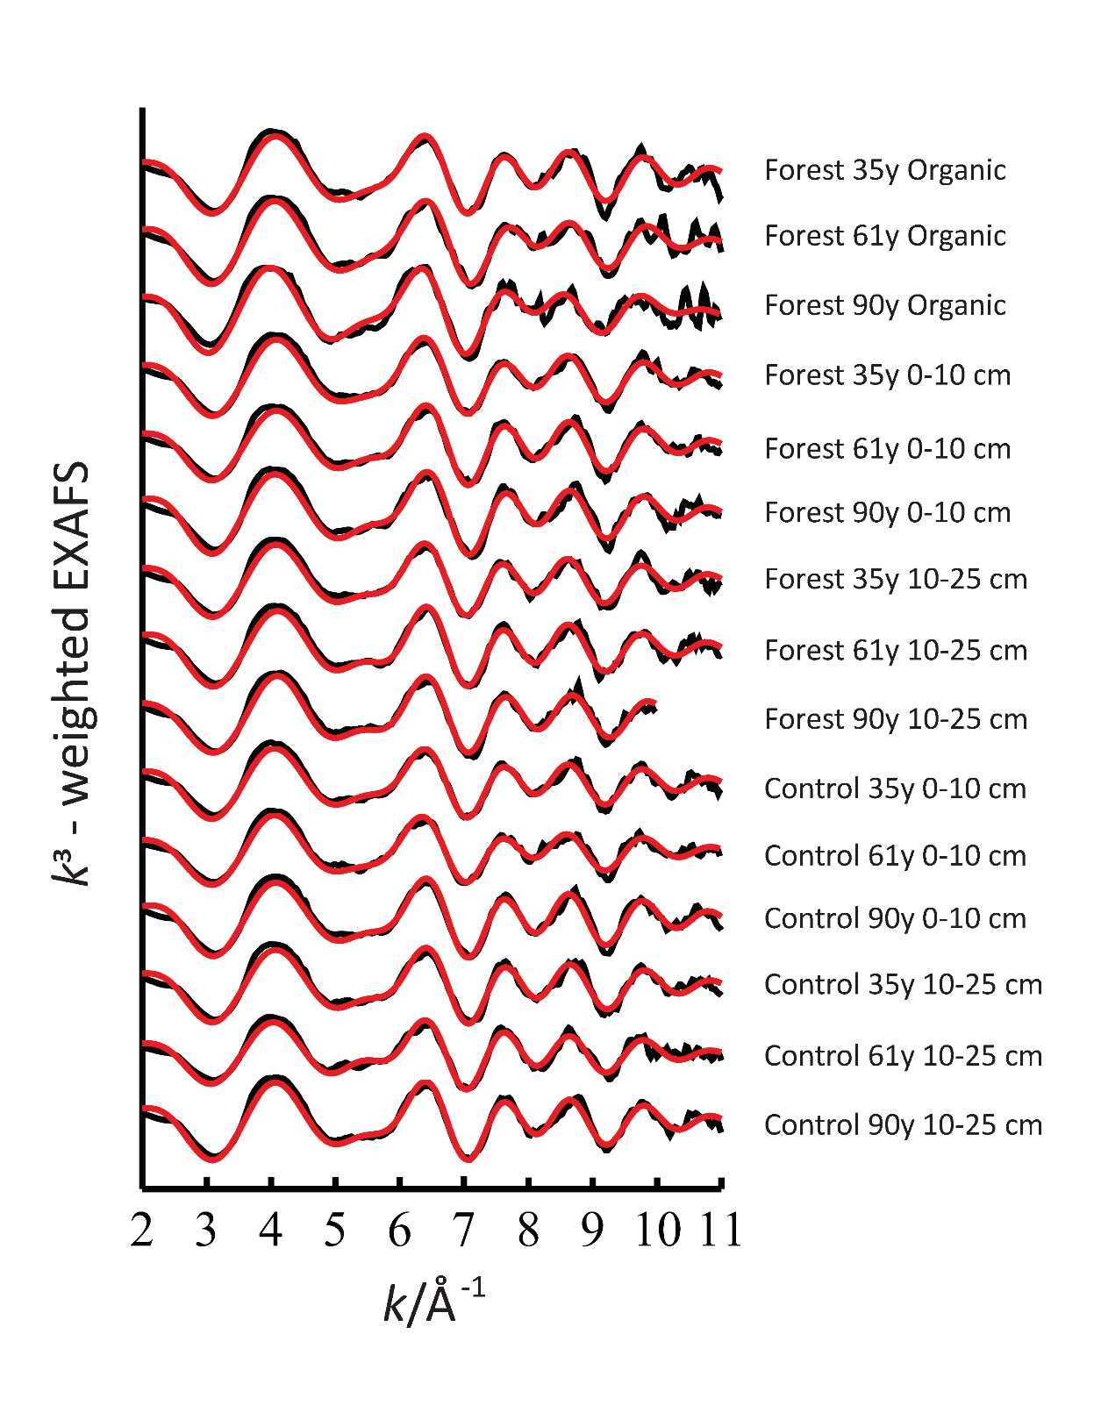
Fig. S3 EXAFS shell-by-shell fitting of soil samples. Red lines represent fitted data

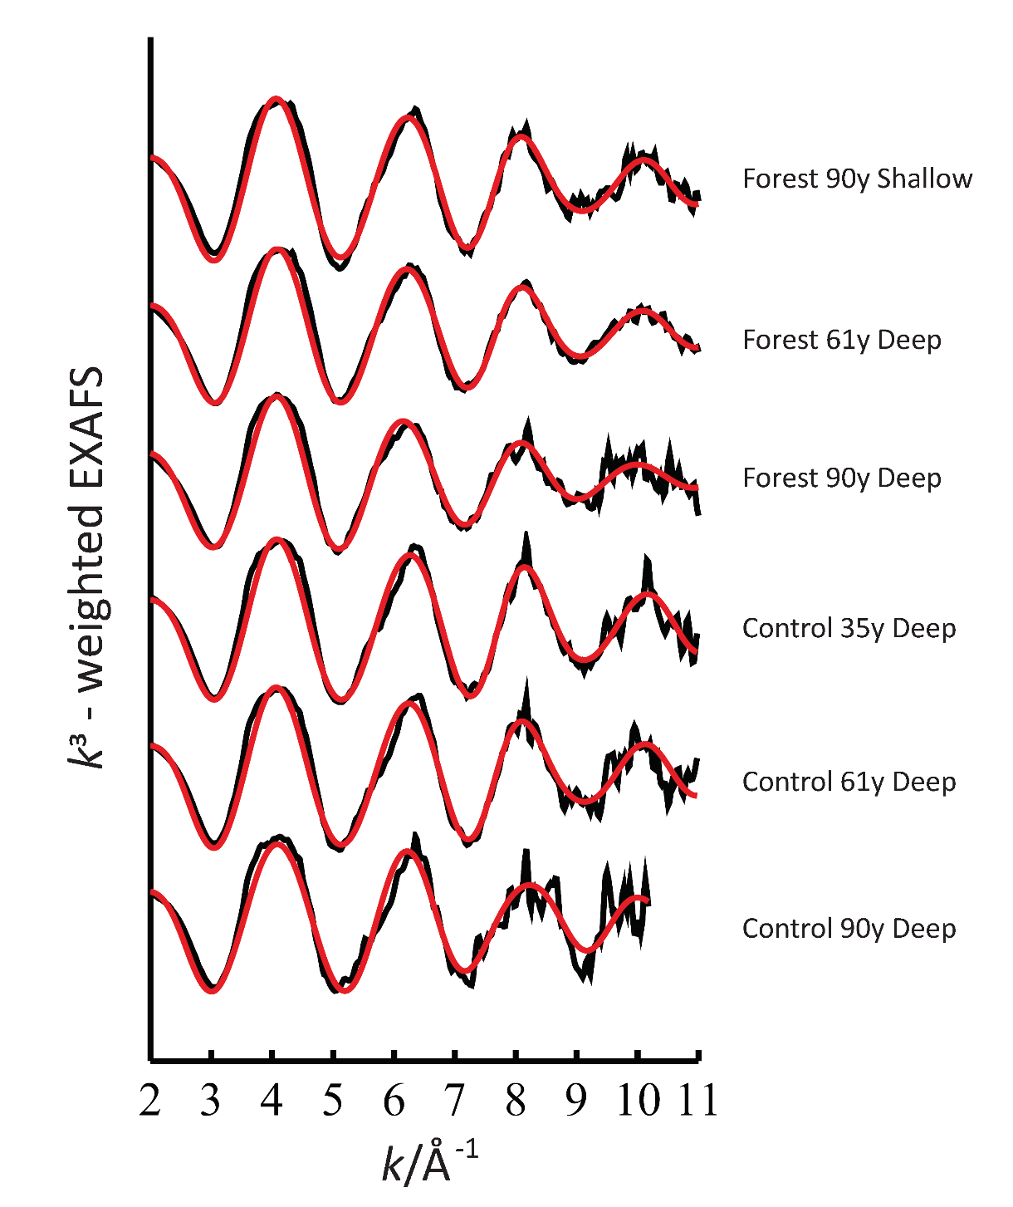
Fig. S4 EXAFS shell-by-shell fitting of soil solution (lysimeter) samples. Red lines represent fitted data

Fig. S5 Integrated pre-edge centroid position and intensity, for control soil, forest soil and soil solution samples. The centroid position indicates that all samples were dominated by Fe(III) and the intensity suggests Fe was six-coordinate.

