Tracing carbon and nitrogen microbial assimilation in suspended particles in freshwaters

Leonardo Mena-Rivera^{1,2}, Charlotte E.M. Lloyd¹, Michaela K. Reay¹, Tim Goodall³, Daniel S. Read³, Penny J. Johnes⁴, Richard P. Evershed¹

¹Organic Geochemistry Unit, School of Chemistry, University of Bristol, Cantock’s Close, Bristol BS8 1TS, UK
²School of Chemistry, Universidad Nacional, Heredia 86-3000, Costa Rica
³UK Centre for Ecology & Hydrology (UKCEH), Wallingford, Oxfordshire OX10 8BB, UK
⁴School of Geographical Sciences, University of Bristol, University Road, Bristol BS8 1SS, UK

Supplementary information
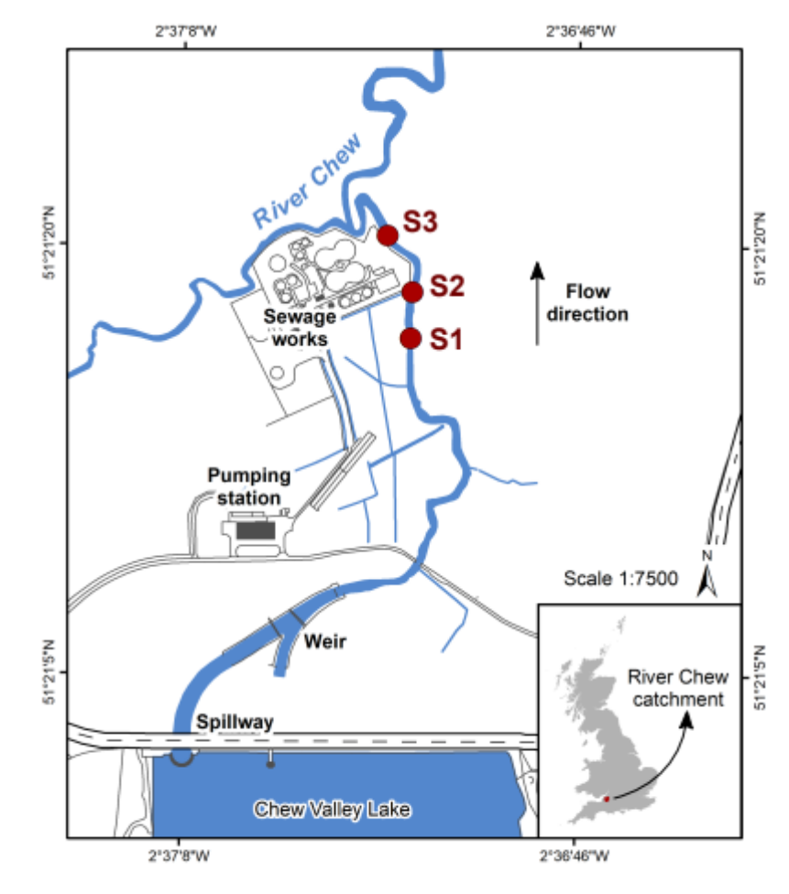
Fig. S1 Sampling sites in the River Chew, Somerset, UK.

Table S1 Natural abundance isotopic composition of individual proteinaceous AAs in suspended particles in the River Chew, Somerset, UK.

Amino acid | $δ^{15}$N |  |  | $δ^{13}$C
Amino acid | S1 | S2 | S3 | S1 | S2 | S3
Ala | 12.133 | 17.599 | 19.551 | -27.181 | -26.976 | -28.758
Gly | 8.080 | 11.755 | 12.985 | -22.454 | -21.988 | -22.529
Val | 16.352 | 21.484 | 20.717 | -32.883 | -33.269 | -34.576
Leu | 10.679 | 14.559 | 17.032 | -28.838 | -30.841 | -28.909
Thr | 7.019 | 9.715 | 11.053 | -19.557 | -20.279 | -21.755
Ser | 4.037 | 7.971 | 9.991 | -18.040 | -18.134 | -20.114
Pro | 13.291 | 17.618 | 17.838 | -25.250 | -25.905 | -25.854
Asx | 10.674 | 15.445 | 17.887 | -21.617 | -22.542 | -25.057
Glx | 13.386 | 18.759 | 20.854 | -22.935 | -23.250 | -24.322
Hyp | 12.981 | 11.869 | 12.422 | -24.302 | -24.937 | -25.441
Phe | 10.262 | 14.943 | 12.245 | -31.966 | -32.564 | -32.635
Lys | 6.096 | 10.193 | 12.668 | -25.756 | -26.535 | -26.937
Tyr | 8.235 | 14.055 | 15.296 | -31.388 | -32.302 | -31.752

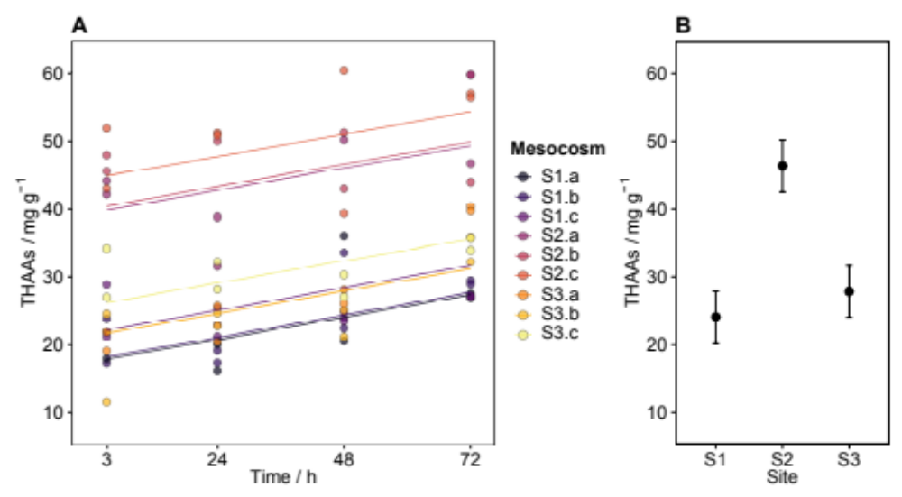
Fig. S2 Concentration of THAAs over time during the SIP experiment (A) for the different treatments: ¹³C,¹⁵N-Glu (a), ¹⁵N-NO₃⁻ (b), and controls (c). Estimated marginal means of the concentration of THAAs per site (B); error bars show 95% confidence levels.

Table S2 Assimilation rates (V, h⁻¹ x 10³) of ¹³C and ¹⁵N into individual proteinaceous AAs after 3 h of incubation.

Amino acid | ¹³C-Glu |  |  | ¹⁵N-Glu |  |  | ¹⁵N-NO₃⁻
Amino acid | S1 | S2 | S3 | S1 | S2 | S3 | S1 | S2 | S3
Ala | 0.615 | 0.653 | 0.772 | 1.001 | 0.954 | 1.125 | 0.084 | 0.315 | 0.155
Asx | 0.850 | 0.789 | 0.952 | 1.337 | 1.304 | 1.571 | 0.160 | 0.517 | 0.093
Glx | - | - | - | - | - | - | 0.220 | 0.633 | 0.185
Gly | 0.194 | 0.185 | 0.209 | 0.509 | 0.528 | 0.566 | 0.046 | 0.107 | -0.036
Hyp | 0.005 | 0.016 | 0.026 | - | - | - | - | - | -
Leu | 0.276 | 0.245 | 0.166 | 0.284 | 0.293 | 0.212 | 0.148 | 0.485 | -0.396
Lys | 0.943 | 0.715 | 1.318 | 1.497 | 1.301 | 1.750 | 0.214 | 0.481 | -0.099
Phe | 0.375 | 0.303 | 0.394 | 1.214 | 1.371 | 1.248 | 0.233 | 0.749 | 0.435
Pro | 0.794 | 0.720 | 0.797 | 0.824 | 0.803 | 0.955 | 0.033 | -0.014 | -0.171
Ser | 0.404 | 0.341 | 0.492 | 0.598 | 0.529 | 0.638 | 0.096 | 0.298 | -0.056
Thr | 0.465 | 0.400 | 0.500 | 0.924 | 0.899 | 1.032 | 0.089 | 0.223 | 0.117
Tyr | 0.128 | 0.133 | 0.224 | - | - | - | - | - | -
Val | 0.432 | 0.416 | 0.418 | 0.662 | 0.798 | 0.678 | -0.035 | -0.315 | -0.869
Asx: aspartic acid + asparagine; Glx: glutamic acid + glutamine. Assimilation rates for Glx were excluded for the ¹³C,¹⁵N-Glu treatment.

Table S3 Transport rates (ρ, nmol g⁻¹ h⁻¹) of ¹³C and ¹⁵N into individual proteinaceous AAs after 3 h of incubation.

Amino acid | ¹³C-Glu |  |  | ¹⁵N-Glu |  |  | ¹⁵N-NO₃⁻
Amino acid | S1 | S2 | S3 | S1 | S2 | S3 | S1 | S2 | S3
Ala | 36.617 | 92.586 | 45.236 | 19.569 | 45.076 | 21.997 | 2.040 | 17.666 | 3.492
Asx | 72.090 | 176.533 | 74.919 | 28.349 | 72.901 | 30.924 | 3.511 | 26.908 | 0.654
Glx | - | - | - | - | - | - | 3.730 | 29.151 | 1.754
Gly | 9.842 | 21.124 | 11.568 | 12.919 | 30.131 | 15.667 | 1.710 | 9.434 | -1.956
Hyp | 0.039 | 0.322 | 0.224 | - | - | - | - | - | -
Leu | 46.345 | 48.572 | 35.006 | 7.927 | 9.680 | 7.486 | 2.524 | 11.102 | -16.606
Lys | 30.144 | 43.685 | 35.286 | 16.167 | 27.064 | 14.265 | 1.597 | 4.582 | -0.236
Phe | 14.095 | 25.967 | 14.357 | 5.068 | 13.060 | 4.980 | 0.622 | 5.462 | 1.242
Pro | 33.136 | 69.390 | 34.340 | 6.873 | 15.498 | 8.224 | 0.333 | -0.294 | -1.959
Ser | 19.874 | 42.429 | 23.759 | 9.820 | 21.962 | 10.328 | 1.974 | 14.980 | -0.617
Thr | 23.700 | 54.001 | 25.667 | 11.850 | 30.322 | 13.196 | 1.348 | 8.034 | 0.158
Tyr | 1.854 | 1.592 | 1.940 | - | - | - | - | - | -
Val | 18.412 | 36.964 | 20.922 | 5.634 | 14.173 | 6.791 | -0.385 | -7.810 | -11.262
Asx: aspartic acid + asparagine; Glx: glutamic acid + glutamine. Transport rates for Glx were excluded for the ¹³C,¹⁵N-Glu treatment.

