Production of dissolved carbon and alkalinity during macroalgal wrack degradation on beaches: A mesocosm experiment with implications for blue carbon

Anita K. Perkins^{1,2,3}, Isaac R. Santos^{2,4}, Andrew L. Rose^{1,3}, Kai G. Schulz^{1,3}, Hans-Peter Grossart^{5,6}, Bradley D. Eyre¹, Brendan P. Kelaher², Joanne M. Oakes¹

¹ Centre for Coastal Biogeochemistry, Faculty of Science and Engineering, Southern Cross University, Lismore, NSW, Australia
² National Marine Science Centre, Faculty of Science and Engineering, Southern Cross University, Coffs Harbour, NSW, Australia
³ Southern Cross Geoscience, Faculty of Science and Engineering, Southern Cross University, Lismore, NSW, Australia
⁴Department of Marine Sciences, University of Gothenburg, Göteborg, Sweden
⁵Leibniz Institute for Freshwater Ecology and Inland Fisheries (IGB), Experimental Limnology, Neuglobsow, Germany
⁶University of Potsdam, Institute of Biochemistry and Biology, Potsdam, Germany
Corresponding author:
joanne.oakes@scu.edu.au

Supplementary Information (SI)
Results

Table S1 Daily mass balance results at a sediment depth of 100 cm from the calculations using 200g E. radiata. All units are in mmol. The organic carbon content of the sand decreased by 129 mmol C by the end of the 60 day study. *The parameters highlighted grey had similar values regardless of whether mass balance calculations were based on concentrations at 100 cm sediment depth, or average concentrations for the entire sediment column. **Output C refers to the sum of measured C outputs (DOC, DIC, CO_{2Emission} and CH_{4Emission}). ***Proc C refers to the difference between input and output C (daily input of C minus the sum of measured output of DOC, DIC, CO_{2Emission} and CH_{4Emission}).
Days | Loss % | Daily input C | Daily input C SE | DOC | DOC SE | DIC | DIC SE | CO₂ Em | CO₂ Em SE | CH₄ Em | CH₄ Em SE | Output C* | Output C SE | Proc. C**
0.5 | 0.92 | 696 | 122.3 | 0.2 | 0.04 | 2.0 | 0.3 | 0.03 | -0.15 | 0.000 | 0.000 | 2 | 0.4 | 693
1 | 0.76 | 756 | 10.0 | 329 | 334 | 1.1 | 1.1 | 0.06 | 0.1 | 0.000 | 0.000 | 330 | 336 | 425
3 | 0.70 | 334 | -44.7 | 1457 | 1430 | 30 | 6.0 | 1.65 | 0.83 | 0.000 | 0.000 | 1489 | 1437 | -1155
6 | 0.62 | 516 | -34.4 | 225 | 140 | 83 | 10 | 19.23 | 2.08 | 0.002 | 0.002 | 327 | 152 | 189
10 | 0.61 | 2.40 | -9.1 | 217 | 8.9 | 114 | 15 | 22.68 | 1.49 | 0.003 | 0.005 | 354 | 25 | -351
20 | 0.52 | 577 | -1.6 | 536 | 38 | 245 | 40 | 0.96 | 0.98 | 0.000 | 0.005 | 782 | 79 | -205
30 | 0.41 | 669 | 51.6 | 47 | 24 | 186 | 44 | 22.65 | 23.38 | 0.015 | 0.020 | 256 | 92 | 413
45 | 0.29 | 672 | -49.1 | 36 | 6.4 | 378 | 79 | 47.21 | 58.16 | 0.122 | 0.142 | 461 | 143 | 211
60 | 0.19 | 636 | 15.0 | 32 | 11 | 475 | 243 | 42.40 | 47.70 | 0.126 | 0.268 | 550 | 301 | 86
Sum |  | 4856 | 60 | 2880 | 1992 | 1514 | 437 | 156.87 | 134.58 | 0.268 | 0.442 | 4551 | 2565 | 305

Table S2 Daily mass balance results using average depth from the calculations using 200g E. radiata. All units are in mmol. The sand had less organic content by -129 mmol C by the end of the 60 days. *The parameters highlighted grey had similar values regardless of whether mass balance calculations were based on concentrations at 100 cm sediment depth, or average concentrations for the entire sediment column.**Output C refers to the sum of measured C (DOC, DIC, CO_{2Emission} and CH_{4Emission}). ***Proc C refers to the difference between input and output C (daily input of C minus the sum of measured output of DOC, DIC, CO_{2Emission} and CH_{4Emission}).
Days | Loss % | Daily input C | Daily input C SE | DOC | DOC SE | DIC | DIC SE | CO₂ Em | CO₂ Em SE | CH₄ Em | CH₄ Em SE | Output C* | Output C SE | Proc. C**
0.5 | 0.92 | 696 | 122.3 | 223 | 149 | 1 | 0.09 | 0.03 | -0.15 | 0.000 | 0.000 | 224 | 149 | 471
1 | 0.76 | 756 | 10.0 | 416 | 212 | 1 | 0.22 | 0.06 | 0.1 | 0.000 | 0.000 | 417 | 213 | 339
3 | 0.70 | 334 | -44.7 | 961 | 290 | 13 | 1.37 | 1.65 | 0.83 | 0.000 | 0.000 | 978 | 297 | -645
6 | 0.62 | 516 | -34.4 | 324 | 117 | 27 | 2.48 | 19.23 | 2.08 | 0.002 | 0.002 | 361 | 135 | 155
10 | 0.61 | 2.40 | -9.1 | 229 | 103 | 36 | 5.6 | 22.68 | 1.49 | 0.003 | 0.005 | 272 | 131 | -270
20 | 0.52 | 577 | -1.6 | 484 | 62 | 97 | 22.0 | 0.96 | 0.98 | 0.000 | 0.005 | 586 | 111 | -9
30 | 0.41 | 669 | 51.6 | 58 | 16 | 52 | 19.3 | 22.65 | 23.38 | 0.015 | 0.020 | 227 | 179 | 442
45 | 0.29 | 672 | -49.1 | 63 | 32 | 161 | 38.7 | 47.21 | 58.16 | 0.122 | 0.142 | 515 | 506 | 157
60 | 0.19 | 636 | 15.0 | 74 | 59 | 207 | 99.0 | 42.40 | 47.70 | 0.126 | 0.268 | 520 | 832 | 116
Sum |  | 4856 | 60 | 2832 | 1038 | 594 | 189 | 156.87 | 134.58 | 0.268 | 0.442 | 4100 | 2553 | 756

Table S3 Daily mass balance results from 200g E. radiata calculated for concentrations of alkalinity, NH₄⁺ and PO₄⁺ at a depth of 100 cm or average across the entire sediment column (0-100cm). All units are mmol.
 | 100 cm depth |  |  |  |  |  |  | Average depth
Days | Loss % | TA | TA SE | NH₄⁺ | NH₄⁺ SE | PO₄⁺ | PO₄⁺ SE | TA | TA SE | NH₄⁺ | NH₄⁺ SE | PO₄⁺ | PO₄⁺ SE
0 | 0.92 | 1.7 | 0.03 | 0.00 | 0.00 | 0.00 | 0.00 | 1.0 | 0.03 | 0.11 | 0.03 | 0.04 | 0.01
1 | 0.76 | -0.5 | 0.4 | 0.24 | 0.27 | 0.00 | 0.00 | 0.4 | 0.3 | 0.18 | 0.07 | 0.05 | 0.01
3 | 0.70 | 73 | 24 | 0.96 | 1.10 | 0.03 | 0.02 | 24.7 | 5.2 | 0.32 | 0.16 | 0.09 | 0.02
6 | 0.62 | 205 | 65 | 0.03 | 0.01 | 0.03 | 0.01 | 63 | 10.6 | 0.03 | 0.01 | 0.08 | 0.02
10 | 0.61 | 212 | 47 | 0.30 | 0.26 | 0.00 | 0.00 | 70 | 8.0 | 0.14 | 0.09 | 0.07 | 0.01
20 | 0.52 | 303 | 41 | 0.90 | 0.74 | 0.07 | 0.02 | 127 | 14.3 | 0.45 | 0.27 | 0.14 | 0.02
30 | 0.41 | 213 | 33 | 0.40 | 0.16 | 0.36 | 0.03 | 72 | 12.4 | 0.31 | 0.06 | 0.26 | 0.02
45 | 0.29 | 335 | 38 | 1.85 | 0.82 | 1.08 | 0.07 | 138 | 32 | 1.11 | 0.41 | 0.32 | 0.03
60 | 0.19 | 276 | 65 | 7.70 | 2.76 | 0.42 | 0.17 | 149 | 96 | 8.27 | 4.52 | 0.22 | 0.09
Sum |  | 1618 | 314 | 12.40 | 6.11 | 2.00 | 0.33 | 645 | 179 | 10.92 | 5.61 | 1.27 | 0.21

Table S4 t-test results between treatment vs control for each variable, with 95% significance level. Concentrations that were significant are highlighted in grey.
Variable | Mean + SD Ecklonia | Mean + SD Control | t Statistic | DF | Probability>(t)
DIC | 7.7 ± 3.8 | 2.2 ± 0.2 | 9.48 | 44 | 3.33 × 10⁻¹²
DOC | 74 ± 171 | 0.4 ± 0.3 | 2.89 | 44 | 5.98 × 10⁻³
Sediment CO₂ | 6.7 ± 4.5 | 0.6 ± 0.1 | 9.02 | 44 | 1.46 × 10⁻¹¹
Sediment CH₄ | 1.3 × 10⁻³ ± 9.9 × 10⁻⁴ | 8.6 × 10⁻⁴ ± 6.7 × 10⁻⁵ | 2.95 | 44 | 0.005
TA | 9683 ± 5999 | 2317 ±68 | 8.20 | 44 | 2.05 × 10⁻¹⁰
NH₄ | 1321 ± 2438 | 1.6 ± 3.9 | 3.63 | 44 | 7.26 × 10⁻⁴
PO₄ | 1179 ± 3055 | 31 ± 38 | 2.55 | 44 | 1.44 × 10⁻²
DO | 29 ± 30 | 91 ± 5 | -13.8 | 44 | 1.36 × 10⁻¹⁷
pH | 7.3 ± 0.5 | 8.2 ± 0.2 | -12.9 | 44 | 1.54 × 10⁻¹⁶
CO₂ Emission | 2.7 ± 4.2 | 0.01 ± 0.03 | 3.7 | 33 | 7.7 × 10⁻⁴
CH₄ Emission | 1.67 × 10⁻⁴ ± 1.8 × 10⁻³ | 8.1 × 10⁻⁷ ± 1.3 × 10⁻⁵ | 0.6 | 33 | 0.6

Table S5 Comparisons of models for the mass decay function. These allowed us to determine if the degradation has one, two or three phases. The models compared Akaike’s Information Criterion (AIC) test results and Bayesian Information Criterion (BIC) test results. Models selected the lower AIC, or BIC values.
 | AIC value | BIC value
Degradation in 1 phase | -37.6 | -44.4
Degradation in 2 phase | -42.1 | -68.3
Degradation in 3 phase | 77.9 | -63.7

Fig S1 Average concentration changes (in relation to the control) in DO (% saturation) and pH throughout the 60 days in the four mesocosms across sediment depths.
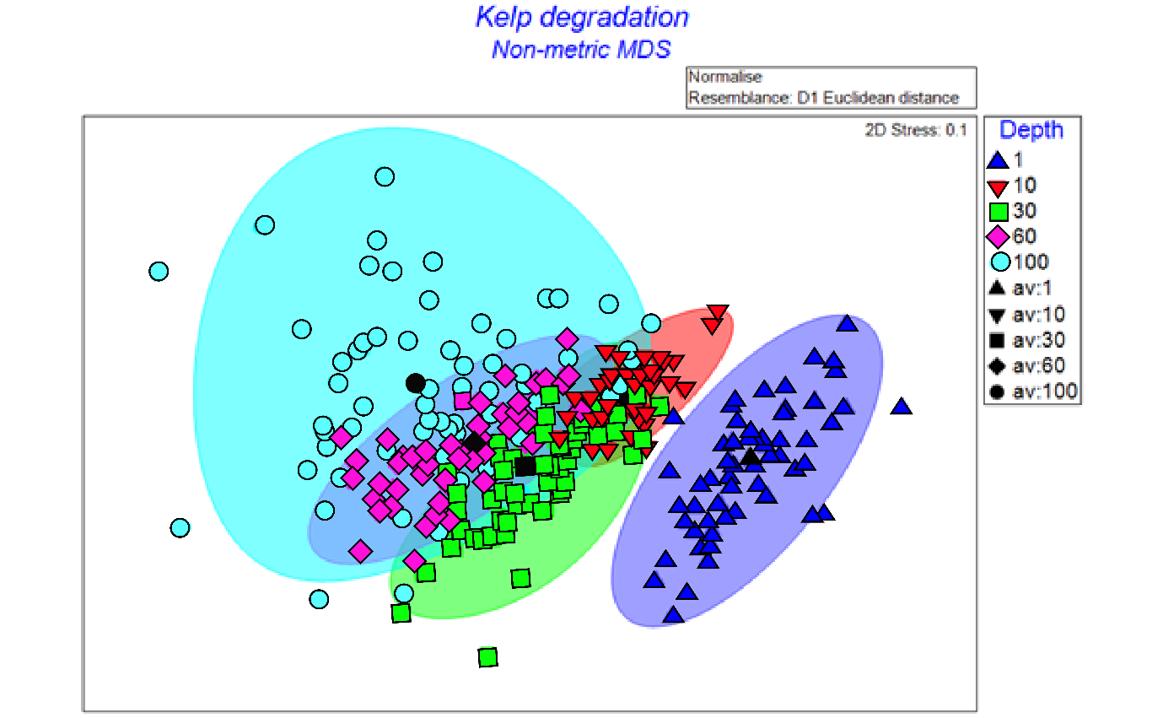
Fig S2 Non metric multidimensional scaling (nMDS) of all combined and normalised C-components across the different depths using all four replicates. The shaded regions represent the different depth clusters as determined by the algorithm of the software. Black symbols are the average of all components at each depth.

