Supplementary material to:
Extracellular enzyme activities in tropical soils are driven by seasonal litter input
Biogeochemistry

Karst J. Schaap^{1, 2} (ORCID 0000-0003-1627-9029), Lucia Fuchslueger³ (ORCID 0000-0002-9615-4439), Carlos Alberto Quesada², Florian Hofhansl⁴ (ORCID 0000-0003-0073-0946), Oscar Valverde-Barrantes⁵ (ORCID 0000-0002-7327-7647), Plínio B. Camargo⁶, Marcel R. Hoosbeek¹ (ORCID 0000-0003-0617-0089)

Corresponding author: Karst J. Schaap, karstsch@gmail.com
1: Soil Chemistry, Wageningen University, P.O. Box 47, 6700AA Wageningen, The Netherlands
2: CODAM, National Institute of Amazonian Research (INPA), Av. André Araújo 2936, Petrópolis, CEP 69067-375, Manaus, Brazil
3: Centre of Microbiology and Environmental Systems Science, Div. Terrestrial Ecosystem Research, University of Vienna, Althanstrasse 14, 1090 Vienna, Austria
4: Biodiversity and Natural Resources Program, International Institute for Applied Systems Analysis (IIASA), Schlossplatz 1, A-2361 Laxenburg, Austria
5: Institute of Environment, Department of Biological Sciences, Florida International University, Miami, FL 33199 USA
6: CENA, University of São Paulo, Piracicaba, Brazil

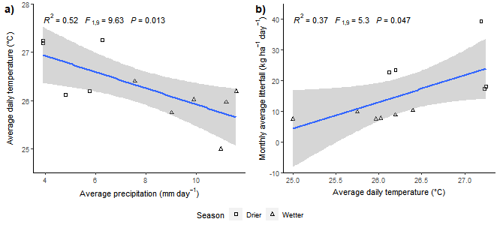
Figure S1: The relation between a) average temperature and average precipitation, and b) the relation between average temperature and average litterfall.
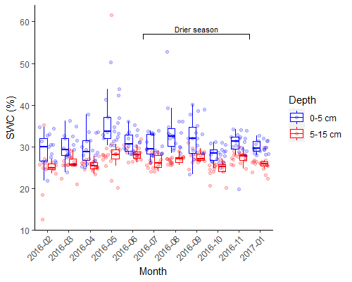
Figure S2: Gravimetric soil water contents (SWC) during the sampling period. Boxplots showing the median, the lower and upper hinges correspond to the first and third quartiles.

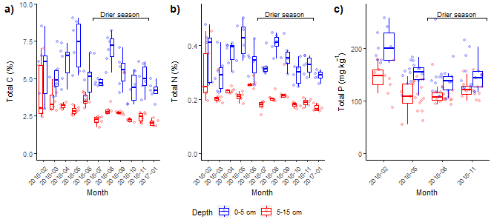 Figure S3: Soil nutrient data for the respective sampling dates. Total C and total N in mass percent of dry soil. Boxplots showing the median, the lower and upper hinges correspond to the first and third quartiles.

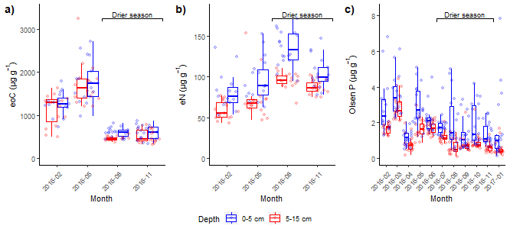
Figure S4: eoC, eN and Olsen P in µg g⁻¹ dry soil. Boxplots showing the median, the lower and upper hinges correspond to the first and third quartiles.

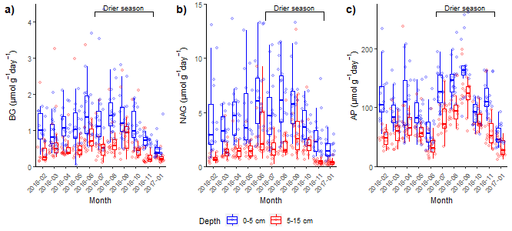Figure S5: C, N and P related extracellular enzyme activities (BG, NAG and AP per gram dry soil) from February 2016 till January 2017. Boxplots showing the median, the lower and upper hinges correspond to the first and third quartiles.

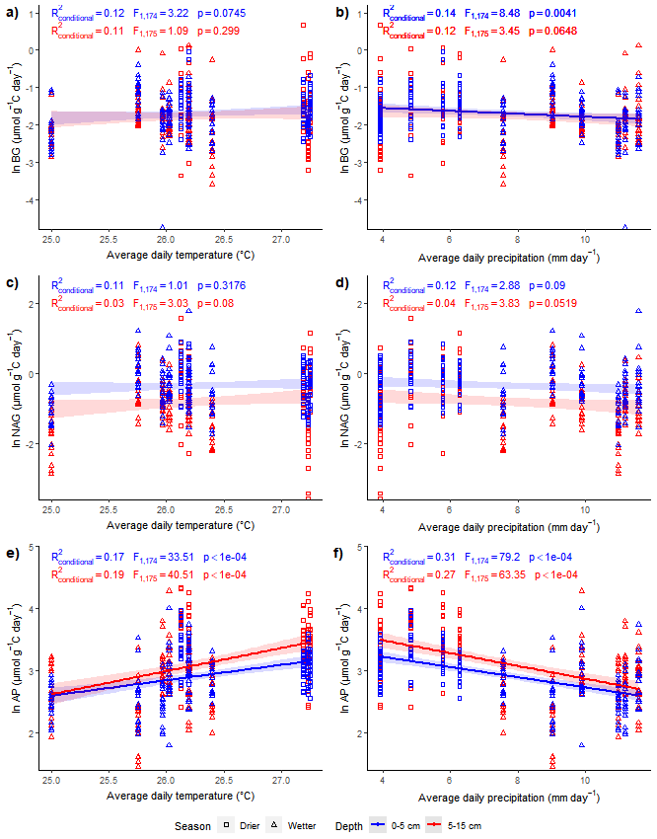
Figure S6: Relation between average enzyme activities and temperature and precipitation. Regression line only shown for significant relationships

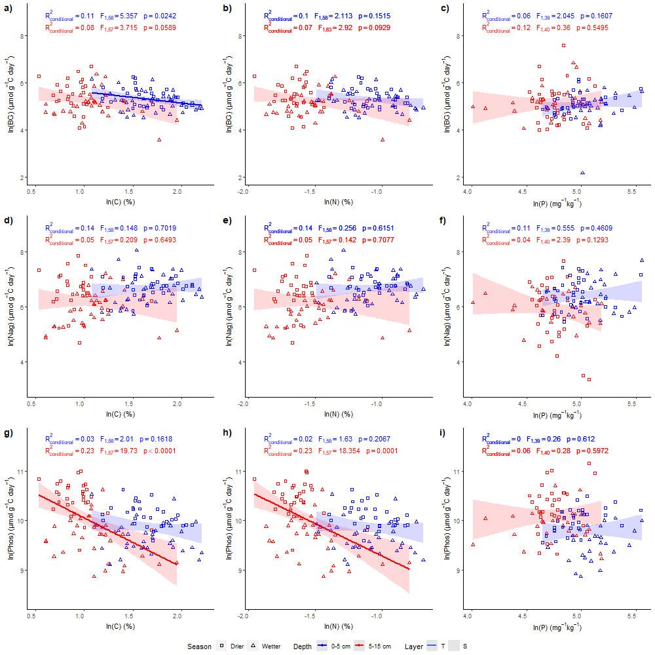
Figure S7: Relations between EE and total soil nutrients at 0–5 cm and 5–15 cm. Conditional R², F and p values for linear mixed effect models with sampling location as a random effect. a, b, and c β-glucosidase as related to C, N and P; d, e and f N-acetyl glucosamidase as related to C, N and P; g, h, and i Phosphatase as related to C, N and P
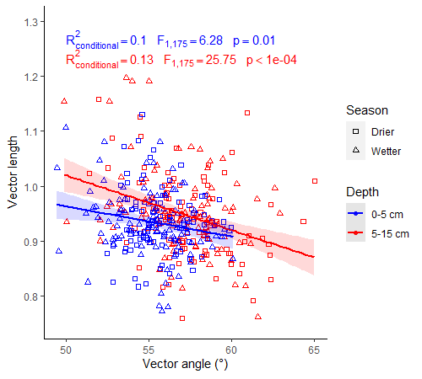
Figure S8: Relation between enzyme vector length (unitless) and vector angle (°)

Table S1: Proportional enzyme activities as calculated according to Moorhead (2016). All means ± SE.
 | Month | n | Proportional BG:AP | Proportional BG:NAG
0-5 cm | 2016-02 | 15 | 0.514 ± 0.003 | 0.770 ± 0.004
0-5 cm | 2016-03 | 18 | 0.527 ± 0.003 | 0.761 ± 0.003
0-5 cm | 2016-04 | 18 | 0.526 ± 0.002 | 0.753 ± 0.002
0-5 cm | 2016-05 | 18 | 0.515 ± 0.004 | 0.735 ± 0.006
0-5 cm | 2016-06 | 18 | 0.600 ± 0.003 | 0.771 ± 0.002
0-5 cm | 2016-07 | 18 | 0.537 ± 0.003 | 0.777 ± 0.004
0-5 cm | 2016-08 | 18 | 0.531 ± 0.002 | 0.765 ± 0.003
0-5 cm | 2016-09 | 18 | 0.527 ± 0.002 | 0.763 ± 0.002
0-5 cm | 2016-10 | 18 | 0.550 ± 0.002 | 0.781 ± 0.003
0-5 cm | 2016-11 | 18 | 0.494 ± 0.001 | 0.776 ± 0.002
0-5 cm | 2017-01 | 17 | 0.501 ± 0.003 | 0.764 ± 0.004
5-15 cm | 2016-02 | 15 | 0.485 ± 0.005 | 0.789 ± 0.005
5-15 cm | 2016-03 | 18 | 0.527 ± 0.003 | 0.801 ± 0.003
5-15 cm | 2016-04 | 18 | 0.498 ± 0.002 | 0.783 ± 0.002
5-15 cm | 2016-05 | 18 | 0.518 ± 0.003 | 0.783 ± 0.004
5-15 cm | 2016-06 | 18 | 0.590 ± 0.003 | 0.789 ± 0.003
5-15 cm | 2016-07 | 18 | 0.512 ± 0.003 | 0.787 ± 0.003
5-15 cm | 2016-08 | 18 | 0.527 ± 0.004 | 0.804 ± 0.004
5-15 cm | 2016-09 | 18 | 0.525 ± 0.003 | 0.790 ± 0.003
5-15 cm | 2016-10 | 17 | 0.516 ± 0.003 | 0.766 ± 0.003
5-15 cm | 2016-11 | 18 | 0.457 ± 0.003 | 0.818 ± 0.004
5-15 cm | 2017-01 | 18 | 0.494 ± 0.002 | 0.836 ± 0.002

