Table S1 Statistical test results for agricultural soil (n=4). Shown are the effects of temperature (temp), and acclimation (cooling time) as well as the interactive effects of the three factors. Statistically significant effects are indicated by bold F-values and p-values. Visualizations of the data can be seen in Figures 1.
 | Agricultural soil |  |  |  |  |  | Forest soil
 | temp |  | cooling time |  | temp x cooling time |  | temp |  | cooling time |  | temp x cooling time
 | F-value | p-value | F-value | p-value | F-value | p-value | F-value | p-value | F-value | p-value | F-value | p-value
MBC (mg C g⁻¹ SOC) | 0.341 | 0.570 | 47.19 | <0.001 | 1.828 | 0.201 | 6.154 | 0.035 | 4.539 | 0.062 | 0.599 | 0.459
microbial respiration (µg C h⁻¹ g⁻¹ SOC) | 676.8 | <0.001 | 56.66 | <0.001 | 40.24 | 0.0001 | 785.7 | <0.001 | 46.65 | 0.0001 | 1.676 | 0.228
microbial growth (µg C h⁻¹ g⁻¹ SOC) | 74.64 | <0.001 | 9.985 | 0.008 | 0.018 | 0.846 | 131.8 | <0.001 | 6.222 | 0.030 | 0.012 | 0.916
CUE | 0.203 | 0.663 | 12.69 | 0.006 | 20.54 | 0.001 | 5.484 | 0.047 | 0.060 | 0.813 | 0.006 | 0.806

Table S2 Table 2 Response ratios to cooling for the measured parameters and effects of the site (agricultural or forest, n=4), glucose addition (+C), and acclimation (cooling time) as well as the respective interactive effects on the RR. Statistically significant effects are indicated in bold F- values and p-values in the respective column.
 |  |  | microbial respiration | microbial growth | CUE | label respiration | label in mic. biomass | label in PLFA
agricultural |  | H2O 42 h | 3.30 ± 0.25 | 2.74 ± 0.35 | 0.89 ± 0.04
agricultural |  | +C 42 h | 2.32 ± 0.12 | 4.76 ± 0.40 | 1.72 ± 0.15 | 1.41 ± 0.05 | 0.78 ± 0.05 | 1.51 ± 0.20
agricultural |  | H2O 186 h | 2.61 ± 0.19 | 5.92 ± 0.94 | 1.72 ± 0.25
agricultural |  | +C 186 h | 1.75 ± 0.06 | 2.75 ± 0.41 | 1.43 ± 0.21 | 1.36 ± 0.02 | 0.97 ± 0.10 | 1.42 ± 0.20
forest |  | H2O 42 h | 3.28 ± 0.04 | 4.26 ± 0.59 | 1.18 ± 0.11
forest |  | +C 42 h | 2.60 ± 0.13 | 8.56 ± 1.36 | 2.70 ± 0.53 | 1.20 ± 0.05 | 1.04 ± 0.14 | 1.6 ± 0.13
forest |  | H2O 186 h | 2.79 ± 0.12 | 3.43 ± 0.16 | 1.11 ± 0.05
forest |  | +C 186 h | 2.47 ± 0.09 | 2.59 ± 0.18 | 1.04 ± 0.07 | 1.34 ± 0.02 | 0.98 ± 0.14 | 1.19 ± 0.28
 | Site | F-value | 3.199 | 1.536 | 0.006 | 5.659 | 1.010 | 0.026
 |  | p-value | 0.124 | 0.228 | 0.941 | 0.055 | 0.335 | 0.875
 | +C | F-value | 59.01 | 0.187 | 10.22
 |  | p-value | <0.001 | 0.670 | 0.004
 | cooling time | F-value | 26.46 | 7.767 | 2.193 | 0.843 | 0.242 | 1.040
 |  | p-value | <0.001 | 0.011 | 0.152 | 0.394 | 0.632 | 0.330
 | Site x +C | F-value | 5.188 | 2.051 | 0.544
 |  | p-value | 0.035 | 0.166 | 0.468
 | Site x cooling time | F-value | 2.948 | 14.28 | 15.58 | 4.109 | 0.911 | 0.494
 |  | p-value | 0.103 | 0.001 | <0.001 | 0.089 | 0.359 | 0.497
 | +C x cooling time | F-value | 1.734 | 30.24 | 21.94
 |  | p-value | 0.204 | <0.001 | <0.001
 | Site x +C x cooling time | F-value | 0.445 | 0.614 | 0.009
 |  | p-value | 0.513 | 0.441 | 0.925

Table S2 Statistical test results for agricultural soil (n=4). Shown are the effects of glucose addition (+C), temperature (temp), and acclimation (cooling time) as well as the interactive effects of the three factors. Statistically significant effects are indicated by bold F-values and p-values. Visualizations of the data can be seen in Figures 2, 4 and S1.
 | +C |  | temp |  | Cooling time |  | +C x temp |  | +C x cooling time |  | temp x cooling time |  | +C x temp x cooling time
 | F-value | p-value | F-value | p-value | F-value | p-value | F-value | p-value | F-value | p-value | F-value | p-value | F-value | p-value
MBC (mg C g⁻¹ SOC) | 0.433 | 0.5181 | 13.97 | 0.001 | 90.90 | <0.001 | 0.992 | 0.331 | 2.556 | 0.126 | 0.944 | 0.343 | 1.530 | 0.230
total PLFA content (µmol C g⁻¹ SOC) | 11.77 | 0.002 | 0.326 | 0.577 | 0.001 | 0.974 | 0.002 | 0.961 | 0.004 | 0.948 | 0.005 | 0.943 | 0.216 | 0.647
microbial respiration (µg C h⁻¹ g⁻¹ SOC) | 0.623 | 0.438 | 238.0 | <0.001 | 9.126 | 0.006 | 0.666 | 0.423 | 21.02 | 0.0001 | 0.174 | 0.681 | 24.0 | 0.0001
microbial growth (µg C h⁻¹ g⁻¹ SOC) | 2.090 | 0.162 | 141.4 | <0.001 | 8.199 | 0.009 | 1.204 | 0.284 | 4.075 | 0.055 | 2.511 | 0.127 | 3.466 | 0.076
CUE | 87.94 | <.001 | 14.68 | 0.001 | 3.780 | 0.064 | 8.829 | 0.007 | 7.302 | 0.012 | 4.489 | 0.045 | 14.37 | <.001
label derived respiration (µg C h⁻¹ g⁻¹ SOC) |  |  | 33.15 | 0.001 | 2.972 | 0.113 |  |  |  |  | 0.307 | 0.591
label incorporation in microbial biomass (µg C h⁻¹ g⁻¹ SOC) |  |  | 2.237 | 0.163 | 29.79 | 0.0002 |  |  |  |  | 0.014 | 0.907
label incorporation in PLFA (µg C h⁻¹ g⁻¹ SOC) |  |  | 6.293 | 0.029 | 0.008 | 0.9283 |  |  |  |  | 0.0002 | 0.988
label allocation to bacterial PLFAs (% of uptake) |  |  | 0.310 | 0.587 | 0.710 | 0.416 |  |  |  |  | 0.090 | 0.772
label allocation to fungal PLFAs (% of uptake) |  |  | 12.36 | 0.008 | 3.414 | 0.102 |  |  |  |  | 0.355 | 0.568
label allocation to unsaturated PLFAs (% of uptake) |  |  | 44.44 | <.001 | 3.167 | 0.113 |  |  |  |  | 0.484 | 0.506

Table S3 Statistical test results for forest soil (n=4). Shown are the effects of glucose addition (+C), temperature (temp), and acclimation (cooling time) as well as the interactive effects of the three factors. Statistically significant effects are indicated by bold F-values and p-values. Visualizations of the data can be seen in Figures 2, 4 and S1.
 | +C |  | temp |  | cooling time |  | +C x temp |  | +C x cooling time |  | temp x cooling time |  | +C x temp x cooling time
 | F-value | p-value | F-value | p-value | F-value | p-value | F-value | p-value | F-value | p-value | F-value | p-value | F-value | p-value
MBC C (g C g⁻¹ SOC) | 8.893 | 0.007 | 5.480 | 0.028 | 19.09 | 0.0002 | 0.020 | 0.889 | 5.011 | 0.035 | 1.102 | 0.304 | 0.076 | 0.785
total PLFA content (µmol C g⁻¹ SOC) | 0.095 | 0.761 | 1.407 | 0.249 | 26.24 | 0.0001 | 0.658 | 0.427 | 1.457 | 0.242 | 0.0006 | 0.981 | 0.149 | 0.703
microbial respiration (µg C h⁻¹ g⁻¹ SOC) | 120.5 | <.0001 | 804.1 | <.0001 | 40.79 | <.0001 | 6.965 | 0.015 | 1.507 | 0.233 | 7.638 | 0.012 | 4.015 | 0.058
microbial growth (µg C h⁻¹ g⁻¹ SOC) | 15.27 | 0.0006 | 349.2 | <.0001 | 1.319 | 0.263 | 1.527 | 0.229 | 23.163 | 0.0001 | 10.58 | 0.004 | 9.223 | 0.006
CUE | 24.64 | <.001 | 25.17 | <.001 | 12.27 | 0.002 | 0.995 | 0.330 | 12.74 | 0.002 | 7.147 | 0.015 | 9.509 | 0.006
label derived respiration (µg C h⁻¹ g⁻¹ SOC) |  |  | 30.26 | 0.0004 | 3.338 | 0.101 |  |  |  |  | 8.868 | 0.016
label incorporation in microbial biomass (µg C h⁻¹ g⁻¹ SOC) |  |  | 1.036 | 0.329 | 1.359 | 0.266 |  |  |  |  | 0.099 | 0.758
label incorporation in PLFA (µg C h⁻¹ g⁻¹ SOC) |  |  | 2.026 | 0.192 | 6.680 | 0.032 |  |  |  |  | 1.591 | 0.243
label allocation to bacterial PLFAs (% of uptake) |  |  | 16.15 | 0.002 | 7.298 | 0.021 |  |  |  |  | 2.048 | 0.180
label allocation to fungal PLFAs (% of uptake) |  |  | 0.477 | 0.509 | 24.75 | 0.001 |  |  |  |  | 12.55 | 0.008
label allocation to unsaturated PLFAs (% of uptake) |  |  | 73.56 | <.001 | 11.47 | 0.006 |  |  |  |  | 10.72 | 0.007

Table S4 Results of Permutational Multivariate Analysis of Variance Using Distance Matrices to determine difference in PLFA-based microbial communities between sites as well as to determine effects of glucose addition (+C), temperature (temp), and acclimation (cooling time) as well as the interactive effects of the three factors. Statistically significant effects are indicated by bold R² and p-values. Visualizations of the data can be seen in Figure 3.
 |  |  | agricultural soil |  | forest soil
 | R² | p-value | R² | p-value | R² | p-value
Site | 0.752 | 0.001
+C |  |  | 0.200 | 0.001 | 0.037 | 0.355
temp |  |  | 0.010 | 0.851 | 0.027 | 0.531
cooling time |  |  | 0.810 | 0.018 | 0.054 | 0.177
+C x temp |  |  | 0.060 | 0.067 | 0.045 | 0.260
+C x cooling time |  |  | 0.014 | 0.742 | 0.031 | 0.460
temp x cooling time |  |  | 0.024 | 0.439 | 0.020 | 0.680
+C x temp x cooling time |  |  | 0.608 | 0.979 | -0.009 | 1.000

 | agricultural soil |  |  |  |  |  |  |  |  | Forest soil
 | 1°C +C 42 h | 1°C 42 h | 11°C +C 42 h | 11°C 42 h | 1°C +C 186 h | 1°C 186 h | 11°C +C 186 h | 11°C 186 h |  | 1°C +C 42 h | 1°C 42 h | 11°C +C 42 h | 11°C 42 h | 1°C +C 186 h | 1°C 186 h | 11°C +C 186 h | 11°C 186 h
Total soil C (mg C g⁻¹ dry soil) | 9.748 ± 0.494 | 8.944 ± 0.143 | 9.248 ± 0.435 | 8.864 ± 0.185 | 6.408 ± 1.852 | 8.642 ± 0.138 | 8.777 ± 0.273 | 8.871 ± 0.186 |  | 40.53 ± 2.089 | 44.80 ± 4.204 | 45.21 ± 3.62 | 45.64 ± 2.048 | 40.540 ± 2.829 | 47.55 ± 2.84 | 38.97 ± 3.361 | 46.05 ± 2.984
microbial biomass C (µg C g⁻¹ dry soil) | 37.94 ± 2.715 | 38.28 ± 1.901 | 44.69 ± 0.491 | 45.15 ± 3.372 | 56.91 ± 2.956 | 60.60 ± 2.237 | 69.95 ± 6.491 | 59.17 ± 3.889 |  | 254.9 ± 16.95 | 263.9 ± 19.09 | 293.0 ± 21.40 | 294.3 ± 23.93 | 312.3 ± 25.47 | 301.0 ± 23.11 | 334.6 ± 22.07 | 333.1 ± 22.73
total PLFA (nmol C g⁻¹ dry soil) | 282.1 ± 6.146 | 180.1 ± 68.28 | 280.5 ± 29.54 | 145.3 ± 38.77 | 311.2 ± 33.21 | 162.8 ± 17.21 | 257.1 ± 56.62 | 158.5 ± 8.299 |  | 1873 ± 236.0 | 2533 ± 593.8 | 2010 ± 142.9 | 1975 ± 186.5 | 1414 ± 104.3 | 1175 ± 88.31 | 1325 ± 321.0 | 1048 ± 157.1
bacterial PLFA (nmol C g⁻¹ dry soil | 95.42 ± 2.043 | 68.56 ± 24.61 | 101.0 ± 11.39 | 52.90 ± 14.13 | 103.5 ± 12.89 | 58.13 ± 6.245 | 94.42 ± 21.31 | 56.80 ± 3.727 |  | 385.1 ± 46.31 | 538.1 ± 132.4 | 409.9 ± 28.49 | 415.7 ± 36.73 | 291.3 ± 28.67 | 241.6 ± 17.45 | 265.6 ± 63.86 | 216.5 ± 31.51
fungal PLFA (nmol C g⁻¹ dry soil | 38.05 ± 1.229 | 25.86 ± 9.517 | 39.61 ± 3.778 | 21.55 ± 5.476 | 45.50 ± 5.043 | 24.51 ± 2.449 | 36.39 ± 6.889 | 24.84 ± 1.148 |  | 399.2 ± 44.48 | 530.9 ± 98.11 | 437.6 ± 25.15 | 412.6 ± 25.80 | 290.1 ± 35.66 | 262.0 ± 26.91 | 278.4 ± 68.80 | 221.7 ± 28.30
saturated PLFA (nmol C g⁻¹ dry soil | 138.9 ± 2.520 | 85.11 ± 32.47 | 140.7 ± 15.01 | 68.62 ± 17.60 | 157.1 ± 15.90 | 77.69 ± 8.459 | 126.8 ± 29.41 | 73.51 ± 3.953 |  | 603.7 ± 69.54 | 815.0 ± 198.1 | 649.2 ± 46.45 | 655.6 ± 69.52 | 471.1 ± 36.26 | 371.7 ± 32.3 | 428.4 ± 105.5 | 327.8 ± 48.18
unsaturated PLFA (nmol C g⁻¹ dry soil | 143.2 ± 7.314 | 95.00 ± 35.83 | 139.8 ± 14.57 | 76.68 ± 21.20 | 154.1 ± 17.64 | 85.12 ± 8.840 | 130.3 ± 28.03 | 84.98 ± 4.539 |  | 1269.1 ± 167.8 | 1718 ± 395.8 | 1361 ± 97.31 | 1320 ± 117.7 | 943.1 ± 68.98 | 803.6 ± 56.27 | 896.5 ± 215.9 | 720.4 ± 109.5
Fungi:bacteria | 0.400 ± 0.021 | 0.368 ± 0.011 | 0.396 ± 0.011 | 0.415 ± 0.011 | 0.443 ± 0.018 | 0.424 ± 0.020 | 0.401 ± 0.051 | 0.441 ± 0.023 |  | 1.041 ± 0.026 | 1.031 ± 0.049 | 1.076 ± 0.045 | 1.003 ± 0.032 | 0.992 ± 0.040 | 1.076 ± 0.031 | 1.040 ± 0.033 | 1.033 ± 0.035
microbial respiration (ng C h⁻¹ g⁻¹ dry soil) | 69.37 ± 4.076 | 37.19 ± 2.837 | 159.5 ± 5.949 | 119.9 ± 2.149 | 71.49 ± 1.658 | 32.96 ± 2.303 | 124.8 ± 1.719 | 84.47 ± 2.955 |  | 448.9 ± 13.30 | 298.1 ± 20.99 | 1174 ± 85.78 | 975.2 ± 58.89 | 363.0 ± 18.48 | 257.2 ± 19.52 | 896.1 ± 48.90 | 712.4 ± 47.40
microbial growth (ng C h⁻¹ g⁻¹ dry soil) | 16.30 ± 0.963 | 33.83 ± 4.982 | 76.41 ± 4.796 | 87.98 ± 7.694 | 22.58 ± 3.828 | 12.28 ± 1.199 | 55.82 ± 4.822 | 68.59 ± 6.824 |  | 65.51 ± 11.60 | 134.7 ± 3.698 | 499.4 ± 43.05 | 569.9 ± 75.08 | 162.9 ± 13.42 | 111.8 ± 14.36 | 415.9 ± 31.85 | 421.4 ± 23.46
CUE | 0.191 ± 0.008 | 0.470 ± 0.017 | 0.324 ± 0.018 | 0.420 ± 0.023 | 0.236 ± 0.036 | 0.274 ± 0.029 | 0.307 ± 0.019 | 0.444 ± 0.02 |  | 0.124 ± 0.018 | 0.315 ± 0.021 | 0.298 ± 0.011 | 0.364 ± 0.023 | 0.309 ± 0.019 | 0.303 ± 0.034 | 0.316 ± 0.012 | 0.378 ± 0.014
label derived respiration (ng C h⁻¹ g⁻¹ dry soil) | 16.42 ± 0.553 |  | 23.11 ± 0.670 |  | 17.27 ± 0.283 |  | 23.47 ± 0.265 |  |  | 83.35 ± 4.521 |  | 101.1 ± 10.04 |  | 67.00 ± 4.761 |  | 89.55 ± 4.698
label in EOC (µg C g⁻¹ dry soil) | 0.625 ± 0.088 |  | 0.265 ± 0.016 |  | 0.123 ± 0.027 |  | 0.489 ± 0.106 |  |  | 7.150 ± 0.875 |  | 5.041 ± 0.722 |  | 0.345 ± 0.038 |  | 7.116 ± 1.617
label incorporation in microbial biomass (ng C h⁻¹ g⁻¹ dry soil) | 75.57 ± 4.939 |  | 58.29 ± 1.274 |  | 89.89 ± 7.486 |  | 84.56 ± 2.358 |  |  | 222.6 ± 9.137 |  | 229.4 ± 28.91 |  | 255.1 ± 28.03 |  | 248.7 ± 40.79
label incorporation in PLFA (ng C h⁻¹ g⁻¹ dry soil) | 28.04 ± 1.318 |  | 41.52 ± 4.677 |  | 28.84 ± 4.839 |  | 40.84 ± 9.231 |  |  | 95.57 ± 13.93 |  | 149.7 ± 17.78 |  | 85.66 ± 30.13 |  | 78.71 ± 29.61
label allocation to bacterial PLFAs (% of uptake) | 29.42 ± 0.541 |  | 29.58 ± 0.282 |  | 28.33 ± 1.135 |  | 29.04 ± 0.915 |  |  | 23.91 ± 0.091 |  | 20.41 ± 0.678 |  | 24.64 ± 0.898 |  | 22.96 ± 0.323
label allocation to fungal PLFAs (% of uptake) | 27.69 ± 1.005 |  | 26.84 ± 0.574 |  | 29.83 ± 1.036 |  | 27.87 ± 1.702 |  |  | 18.67 ± 0.93 |  | 22.67 ± 2.317 |  | 16.83 ± 2.034 |  | 15.14 ± 1.061
label allocation to saturated PLFAs (% of uptake) | 28.13 ± 0.782 |  | 32.72 ± 0.753 |  | 30.37 ± 0.92 |  | 33.95 ± 1.997 |  |  | 24.35 ± 0.626 |  | 28.43 ± 0.816 |  | 24.23 ± 0.446 |  | 33.38 ± 0.594
label allocation to unsaturated PLFAs (% of uptake) | 71.87 ± 0.782 |  | 67.28 ± 0.753 |  | 69.63 ± 0.92 |  | 66.05 ± 1.997 |  |  | 75.65 ± 0.626 |  | 71.57 ± 0.816 |  | 75.77 ± 0.446 |  | 66.62 ± 0.594
Table S4: Mean values and standard errors of measured parameters.

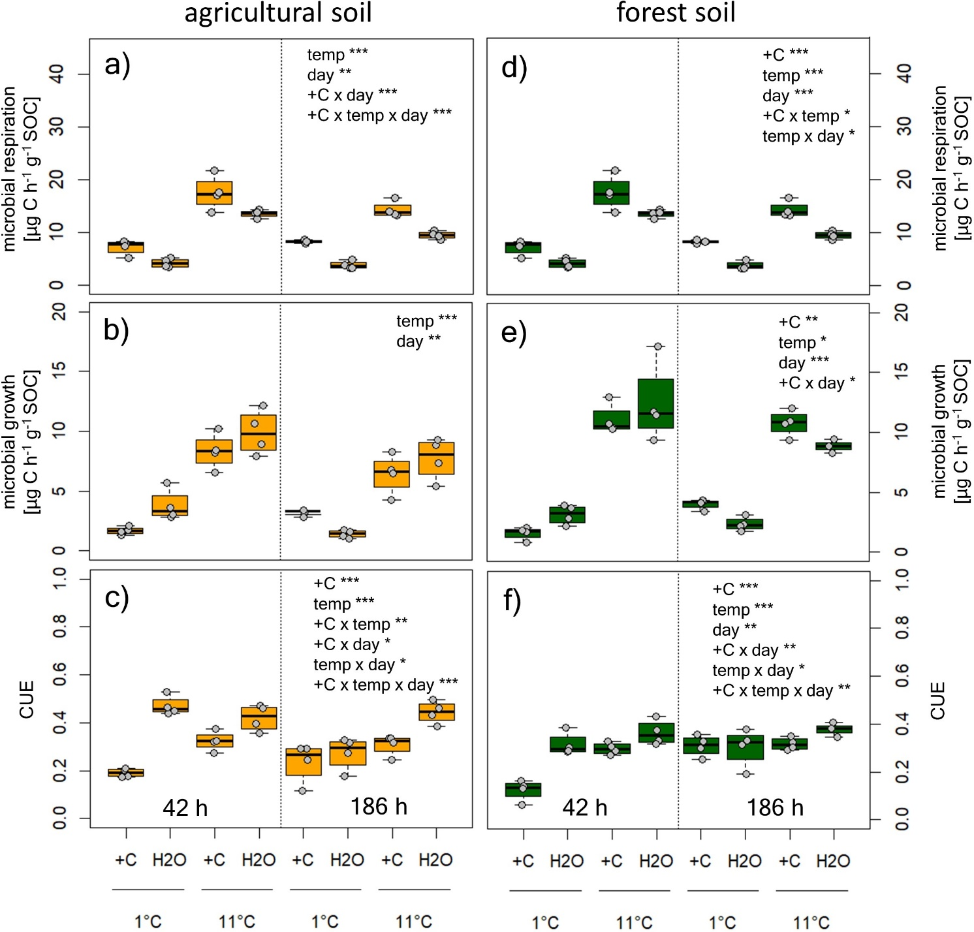
Figure S1: Microbial Respiration, growth (both calculated per g SOC), and carbon use efficiency of agricultural soil (a-c) and forest soil (d-f) in response to glucose (+C) or water addition (H2O) at different temperatures (1 °C and 11 °C) during immediate cooling (42 h) and after acclimation to the temperatures (186 h). Statistics accompanying this figure can be found in Table S2 and Table S3.

