Supplementary Information for the paper

Soil nitrous oxide and methane fluxes from a land-use change transition of primary forest to oil palm in an Indonesian peatland

Erin Swails, Julia Drewer, Jodie Hartill, Louis-Pierre Comeau, Louis V. Verchot, Kristell A. Hergoualc’h

S1. Diel variation in fluxes

S1.1. Materials and methods
Three diel variation studies of gas fluxes were undertaken; one in the degraded drained forest site (DF) (18-19th of April 2012) and two in the oil palm plantation site (OP) (20-21st April 2012, 4-5th February 2013 on days 2 and 3 following the second fertilizer application). Flux measurements were conducted every 2 hours over a 24-hour period starting at 09:00 on the first day of the experiments. In the DF measurements were collected from 4 randomly selected chambers, and in the OP from 3 chambers in the FZ and 3 in the NFZ. The same chambers were measured during the two experiments in the OP. Water table depth, soil temperature, air temperature and air pressure were recorded concurrently with flux measurements.

S1.2 Results
No diel trends were obvious in N₂O or CH₄ fluxes during the experiments in the DF or OP sites, and diel fluctuations apparent in air temperature were more muted for soil temperature (Figure S1). Temporal variation in fluxes observed throughout the 24-hour period were the same order of magnitude of spatial variation between the individual chambers at the site (Table S1).

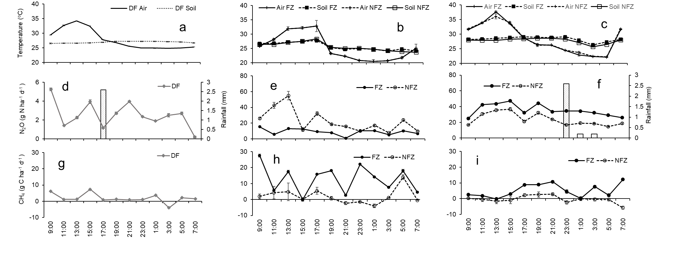Figure S1. Bi-hourly mean air and soil temperatures (a, b, c) and N₂O (d, e, f) and CH₄ (g, ha, i) fluxes measured during a 24-hour period at the degraded forest (DF) (a, d, g) and at the oil palm plantation (OP) sites in 2012 (b, e, h) and 2013 (c, f, i). Daily rainfall (bars) is shown on the right axis in (d, e, f). Temperatures and fluxes are presented per microtopography in the OP (FZ = Fertilized Zone, NFZ = Non-Fertilized Zone). The soil microtopography in the DF was homogeneous. Error bars are standard errors of the means (DF, n = 4; FZ, n = 3; NFZ, n = 3). There was no rainfall during the measurement period in 2012 in the OP.

Table S1. Temporal and spatial coefficients of variation (CV) of bi-hourly N₂O and CH₄ fluxes during the diel studies in the degraded forest (DF) and oil palm plantation (OP) sites including microtopography in the OP (FZ, fertilized zone; NFZ, non-fertilized zone) as spatial effect. The soil microtopography in DF was homogeneous.
 |  |  | N₂O |  | CH₄
LU | Diel study | Spatial position | CV _{temporal} | CV _{spatial} | CV _{temporal} | CV _{spatial}
DF | 1 | Site-scale | 54% | 34% | 147% | 93%
OP | 2 | FZ | 45% | 81% | 67% | 74%
OP | 2 | NFZ | 65% | 122% | 233% | 236%
OP | 3 | FZ | 27% | 88% | 85% | 90%
OP | 3 | NFZ | 34% | 85% | 642% | 239%
CV _{temporal} was calculated based on the mean bi-hourly fluxes per site or microtopography; CV _{spatial} was computed based on the mean per chamber.

S2. Fluxes of CH₄ and N₂O from water surface in drainage canals

S2.1 Materials and methods

Monthly fluxes of N₂O and CH₄ from drainage canals in the oil palm plantation (OP) were measured from March 2012 through March 2013. The main drainage canal where the sampling took place was always flooded, while the secondary and tertiary canals were only flooded after rainfall. Two polyvinyl chloride (PVC) chambers (diameter = 0.27 m and height < 0.3 m) were each placed in inflatable tubes secured to an access bridge using two anchor points and placed on the surface of the water in the canal, creating an airtight seal. As for determination of soil GHG fluxes, the PVC chamber lids included a port for gas sampling and a vent. Samples were collected in pre-evacuated 40-ml glass vials at 0, 10, 20 and 30 minutes after closing the chamber. The samples were analyzed within 15 days by the Center for International Forestry in Jambi on a Shimadzu 14A gas chromatograph equipped with an electron capture detector for N₂O and a flame ionisation detector for CH₄ (Loftfield et al. 1997). N₂O and CH₄ fluxes were calculated from the rate of change in concentration of the analyte in the chamber headspace, determined by linear regression based on the four gas samples (Verchot et al. 1999, 2000). Annual fluxes were computed by annualizing the average of all fluxes instead of cumulating monthly averages given the limited number of spatial replicates.

S2.2 Results

Monthly drainage canal fluxes of N₂O and CH₄, water depth, and precipitation are presented in Figure S3. N₂O fluxes were generally less than 20 g N ha⁻¹ d⁻¹ while CH₄ fluxes were more variable ranging from -5 ± 1 to 138 ± 28 g C ha⁻¹ d⁻¹. Fluxes of N₂O and CH₄ tended to increase with increasing canal water depth and monthly precipitation in January – March 2013, but there were no relationships among GHG fluxes, water depth, and precipitation over the measurement period. GHG fluxes were also unrelated to water temperature. Average N₂O and CH₄ fluxes over the observation period were, respectively, 2.3 ± 2.2 g N ha⁻¹ d⁻¹ and 33.6 ± 14.7 g C ha⁻¹ d^{­1} i.e. 0.8 ± 0.8 kg N ha⁻¹ y⁻¹ and 12.3 ± 5.4 kg C ha⁻¹ y⁻¹.

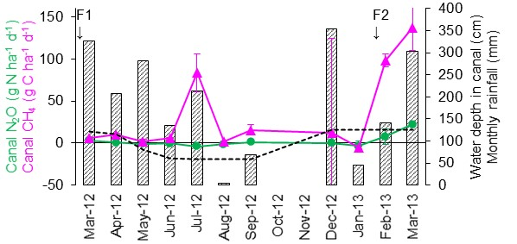
Figure S2. Monthly fluxes of N₂O (green circles) and CH₄ (pink triangles) from the main drainage canal in the oil palm plantation site (OP) (left axis). The water depth in the main canal (dashed line) and monthly rainfall (bars) are shown on the right axis. The arrows indicate the two fertilization events in the OP. Error bars represent the standard errors of the monthly mean (n = 2).

S3. Litterfall

S3.1. Materials and methods
Monthly litterfall in the PF and DF was measured from April 2012 to March 2013 (Comeau et al. 2016). The litter was collected in twenty litterfall traps (0.5 m²) randomly placed in both forests. After collection, the litter was oven-dried at 70°C for 48 hours, sorted into its major components (branches and leaves) and weighed. The N concentration of dried samples was analysed using the Kjeldahl method (Hesse 1971) from 3 replicates per litter component and site. Annual litterfall rates (in dry matter and N units) were computed by summing monthly litterfall over the 12-month monitoring period.

S3.2. Results
The N content in litterfall was homogeneous among litter components and forest sites (Table S3) and amounted to 1.0 ± 0.1% on average. Monthly litterfall rates varied with no distinct seasonal pattern and were high in the dry month of August 2012 for both forests (Figure S3).

Table S3. Mean and standard error C.I. (n = 3) of N concentration in main litterfall components for the primary forest (PF) and degraded forest (DF).

Site | Leaves N (%) | Branches N (%)
PF | 1.1 ± 0.1 | 0.9 ± 0.1
DF | 1.1 ± 0.1 | 1.0 ± 0.3

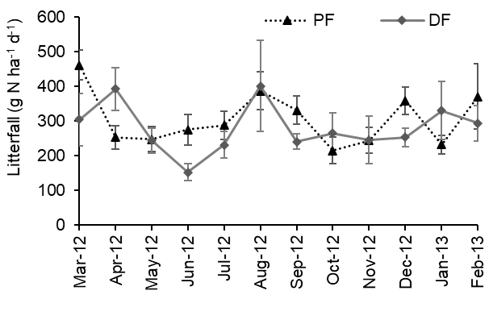
Figure S3. Monthly litterfall rate (g N ha⁻¹ d⁻¹) in both forest sites (PF = primary forest, DF = degraded forest). No litterfall was collected in the oil palm plantation where fronds were cut during harvests. Error bars represent the standard errors of the means.

S4. Supplementary results on rainfall, water table level, and soil water-filled pore space

Monthly variation in precipitation, water table depth and soil water-filled pore space (WFPS) are displayed in Figure S4. Average annual cumulative rainfall for the years 2011-13 was 1,780 mm which was 27% less than the long-term annual mean record of 2,466 mm (Siderius 2004). A brief dry season (monthly precipitation < 100 mm) was apparent in August – September 2012 at all sites (Figure S4a, c), but additional dry months occurred in the DF and OP sites (November 2011 – January 2012 and January 2013), and in the PF site (January 2012, March 2013). The water table depth level tended to follow the rainfall trend in PF, with less variation in drained sites (Figure S4a, c, e). The WFPS did not follow the rainfall pattern and month-to-month variation was high except at the DF site (Figure S4b, d, f).

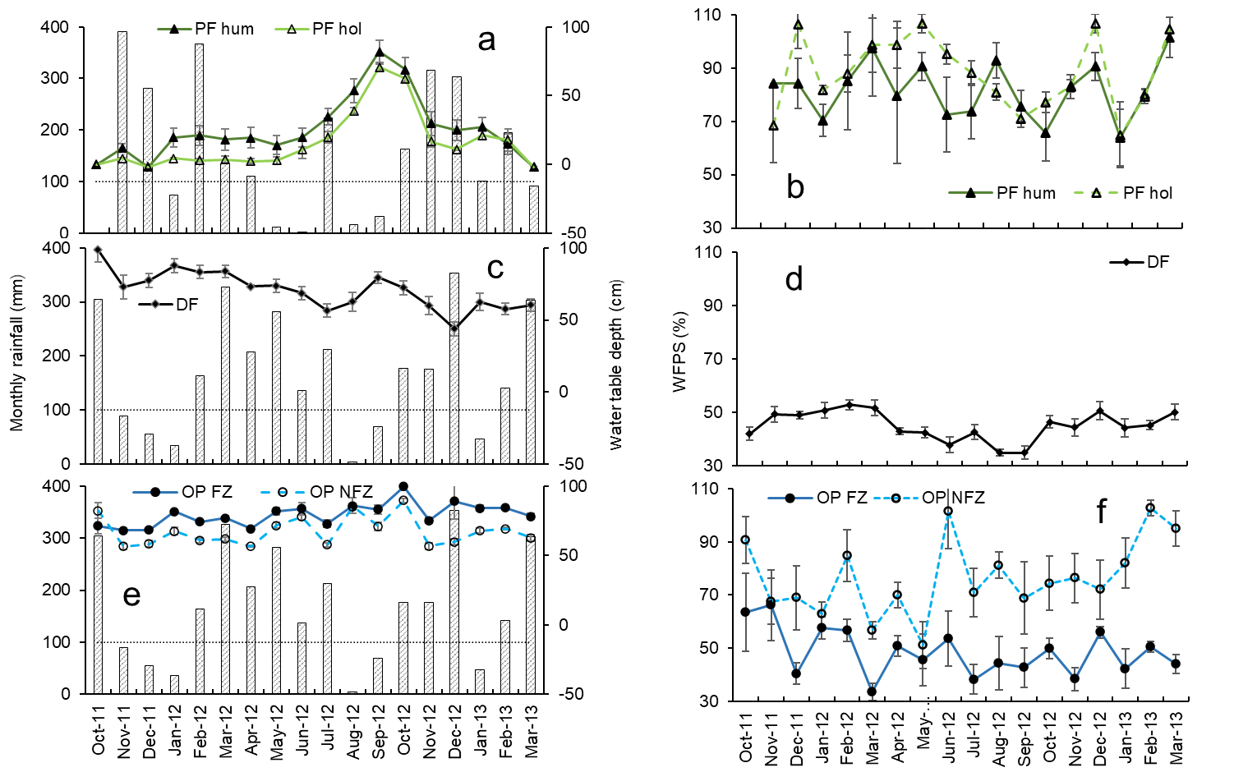
Figure S4. Monthly rainfall and monthly mean water table depth (a, c, e) and soil water-filled pore space (WFPS) (b, d, f) in the primary forest (PF) (a, b), degraded forest (DF) (c, d), and oil palm plantation (OP) (e, f) sites. Water table level and WFPS are presented per microtopography in the PF (hum = hummock, hol = hollow) and in the OP (FZ = Fertilized Zone, NFZ = Non-Fertilized Zone). The soil microtopography in the DF was homogeneous. Rainfall was measured at weather stations in the PF (a) and at the mid-point between the DF and the OP (c, d). Error bars represent the standard errors of the monthly means (hum, n = 4; hol, n = 6, DF, n = 10; FZ, n = 5; NFZ, n = 5).

S5. Supplementary results on soil and air temperature

The monthly average air temperature varied month to month in the three sites while soil temperature tended to be steady during the measurement period (Figure S5).

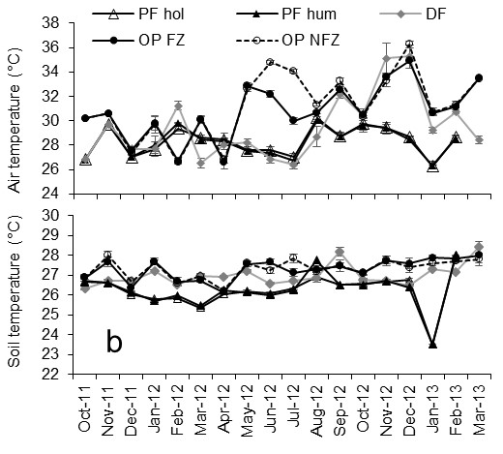
Figure S5 Monthly mean air (a) and soil (b) temperature in the primary forest (PF), degraded forest (DF), and oil palm plantation (OP) sites presented per microtopography in the PF (hum = hummock, hol = hollow) and in the OP (FZ = Fertilized Zone, NFZ = Non-Fertilized Zone). The soil microtopography in the DF was homogeneous. Error bars represent the standard errors of the monthly mean (hum, n = 4; hol, n = 6, DF, n = 10; FZ, n = 5; NFZ, n = 5).
References
Comeau, LP, Hergoualc'h, K, Hartill, J, et al (2016) How do the heterotrophic and the total soil respiration of an oil palm plantation on peat respond to nitrogen fertilizer application?. Geoderma 268: 41-51.
Hesse, PR, 1971. A textbook of soil chemical analyses.
Loftfield, N, Flessa, H, Augustin, J, Beese, F (1997). Automated gas chromatographic system for rapid analysis of the atmospheric trace gases methane, carbon dioxide, and nitrous oxide. Journal of Environmental Quality 26: 560-564.
Siderius, C (2004) A Hydrological Model of the Air Hitam Laut Watershed and the Impact of Various Land Use Scenarios. Wageningen University Report. Wageningen, The Netherlands: Wageningen University.
Verchot, LV, Davidson, EA, Cattânio, H et al (1999) Land use change and biogeochemical controls of nitrogen oxide emissions from soils in eastern Amazonia. Global Biogeochemical Cycles 13: 31-46.
Verchot, LV, Davidson, EA, Cattanio, JH, Ackerman, IL (2000) Land use change and biogeochemical controls on methane fluxes in soils of eastern Amazon. Ecosystems 3: 41-56.

