Supplementary materials

1. Figures

Figure S1

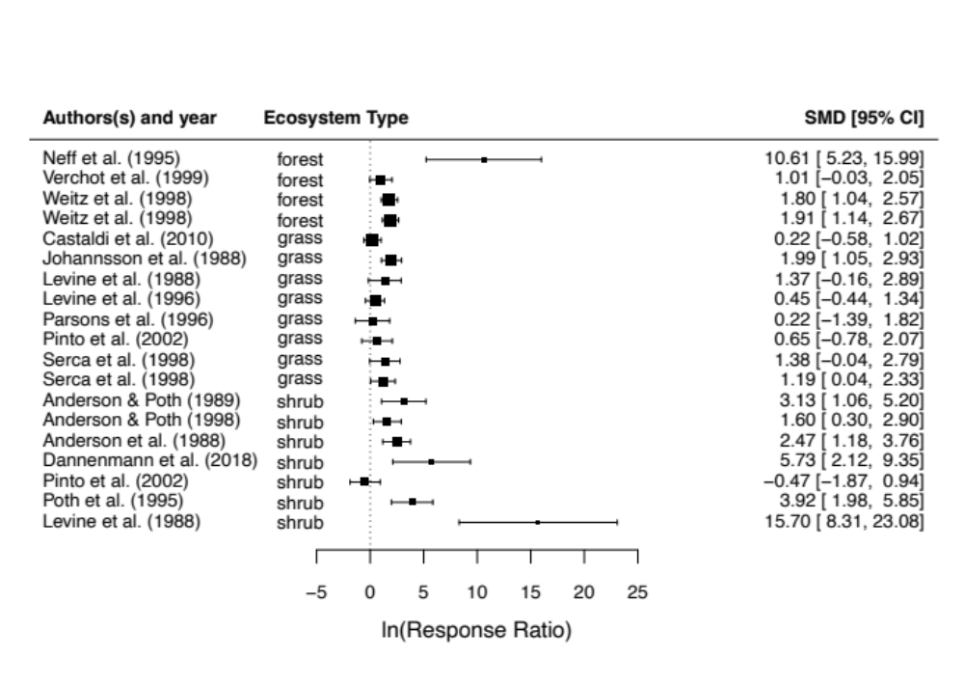

Fig. S1. Studies that measured soil NO emissions up to 1 year post-fire with accompanying effect size (SMD) and variance (95% CI). Note that some studies measured more than one site or ecosystem type.

Figure S2

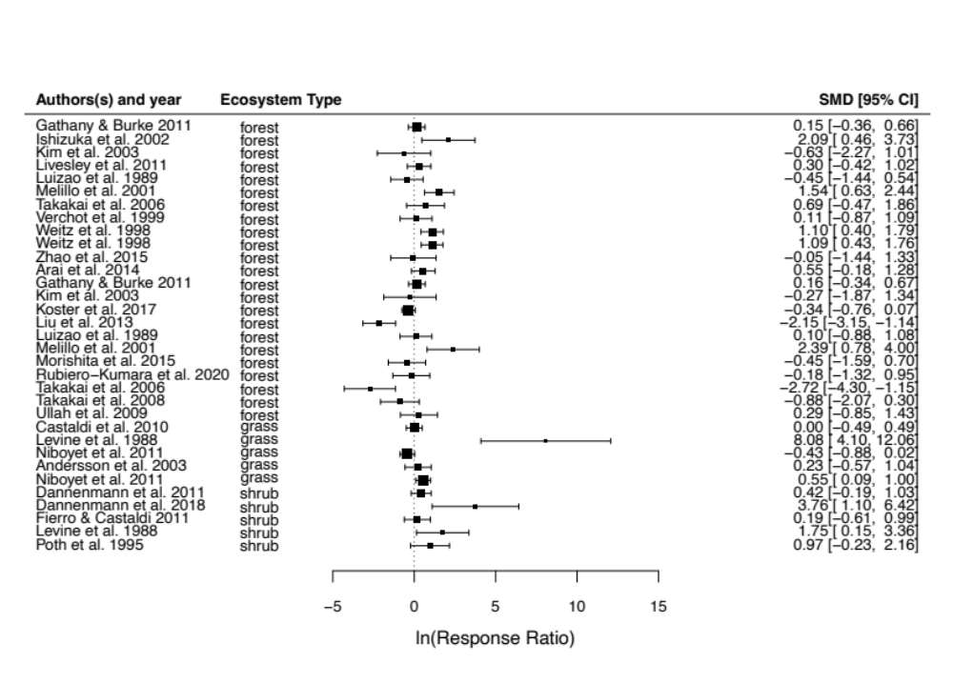

Fig. S2. Studies that measured soil N₂O emissions, including >1 year post-fire with accompanying effect size (SMD) and variance (95% CI). Note that some studies measured more than one site or ecosystem type.

2. Supplementary files

Table S1. See accompanying CSV file with extracted mean fluxes of NO and N₂O in burned and unburned sites, standard deviations/ variance metrics (where SD = standard deviation, SE = Standard error, and CI = confidence interval), and sample sizes used for meta-analytical statistics in fig. 2 and fig. 3. Note prior to our analysis all measurements of variance were converted to standard deviations.

