Supplemental Information for Hot spots and hot moments of greenhouse gas emissions in agricultural peatlands
Tyler L. Anthony¹*, Whendee L. Silver¹
¹Department of Environmental Science, Policy and Management, University of California Berkeley, CA
*Corresponding author: Tyler L. Anthony, Department of Environmental Science, Policy, and Management, University of California Berkeley, 130 Mulford Hall, Berkeley, CA 94720, USA (t.anthony@berkeley.edu)

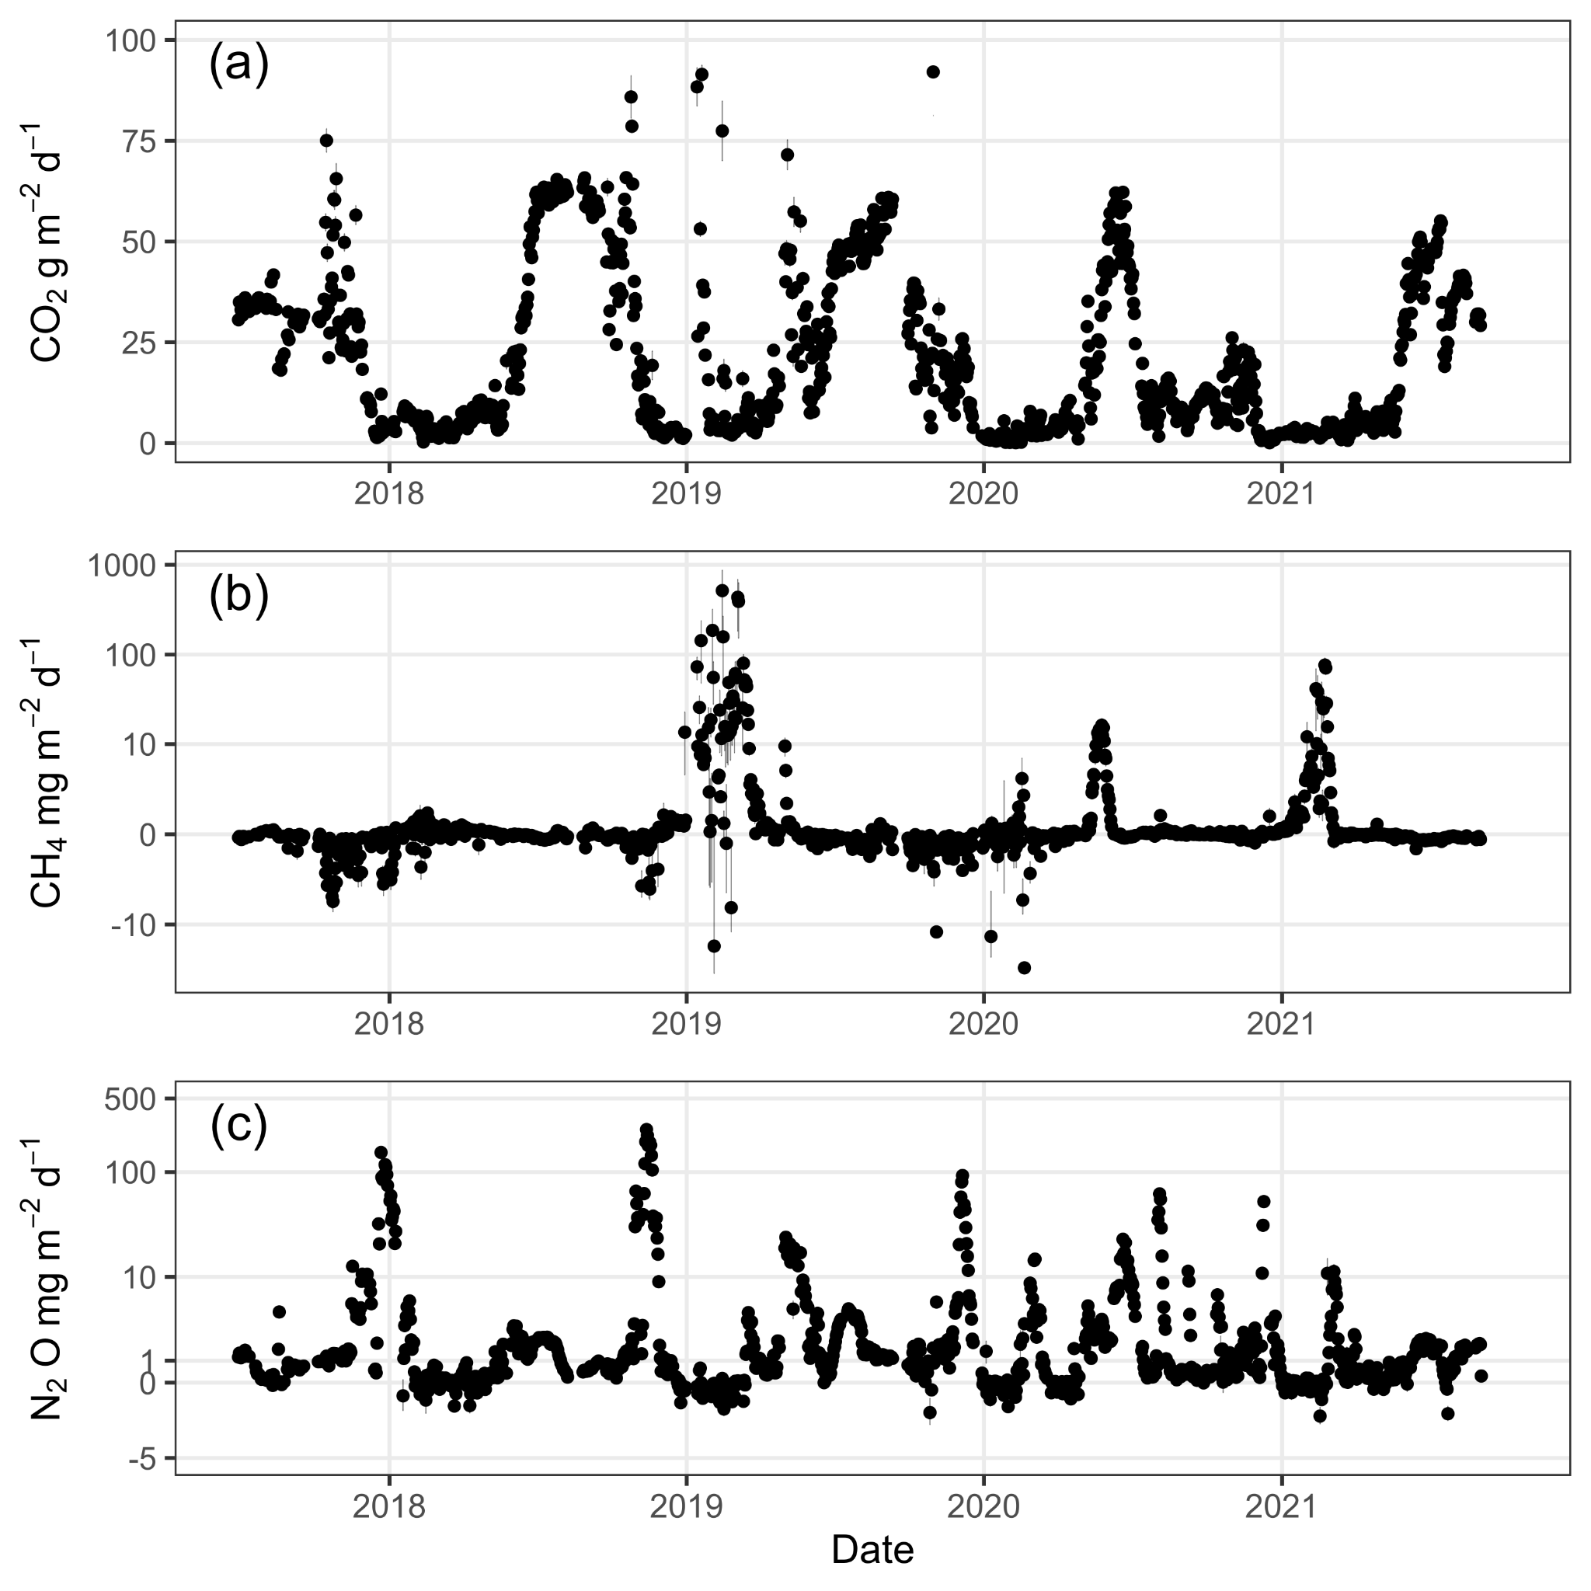
Figure S1. Daily mean (± standard error) (a) CO₂ (g CO₂ m⁻² d⁻¹), (b) CH₄ (mg CH₄ m⁻² d⁻¹), and (c) N₂O (mg N₂O m⁻² d⁻¹) fluxes from an annual corn agricultural peatland from July 2017 through June 2021. Black circles are daily mean flux measurements with black error bars representing daily standard error. Both (b) CH₄ and (c) N₂O use a pseudo-log scale to highlight net consumption and daily flux variability.

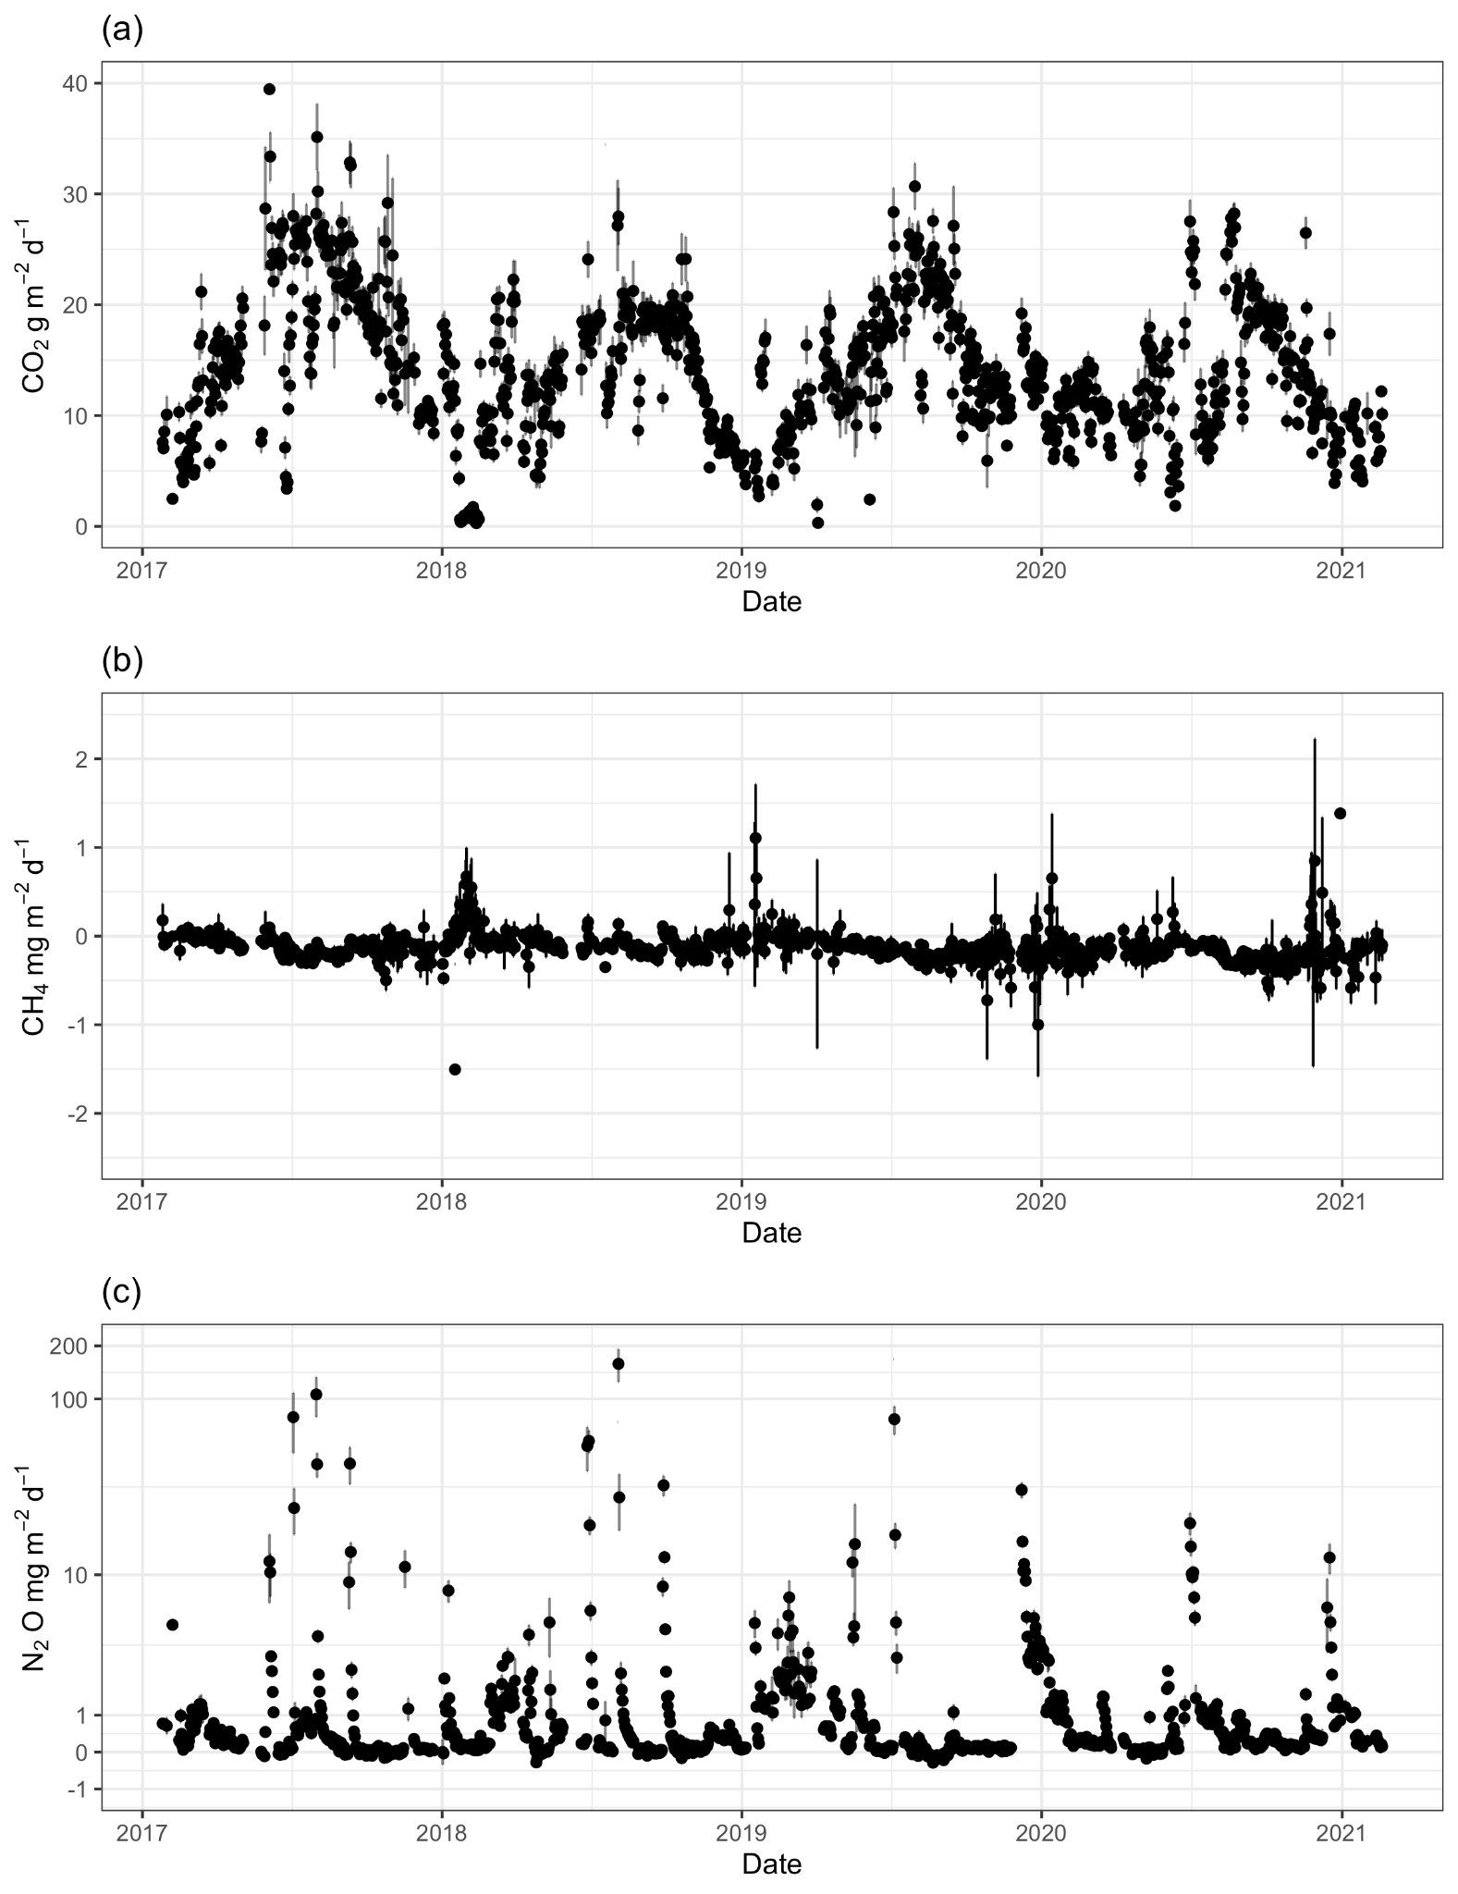
Figure S2. Daily mean (± standard error) (a) CO₂ (g CO₂ m⁻² d⁻¹), (b) CH₄ (mg CH₄ m⁻² d⁻¹), and (c) N₂O (mg N₂O m⁻² d⁻¹) fluxes from a perennial alfalfa agricultural peatland February 2017 through January 2021. Black circles are daily mean flux measurements with black error bars representing daily standard error. (c) N₂O uses a pseudo-log scale to highlight net consumption and daily flux variability.

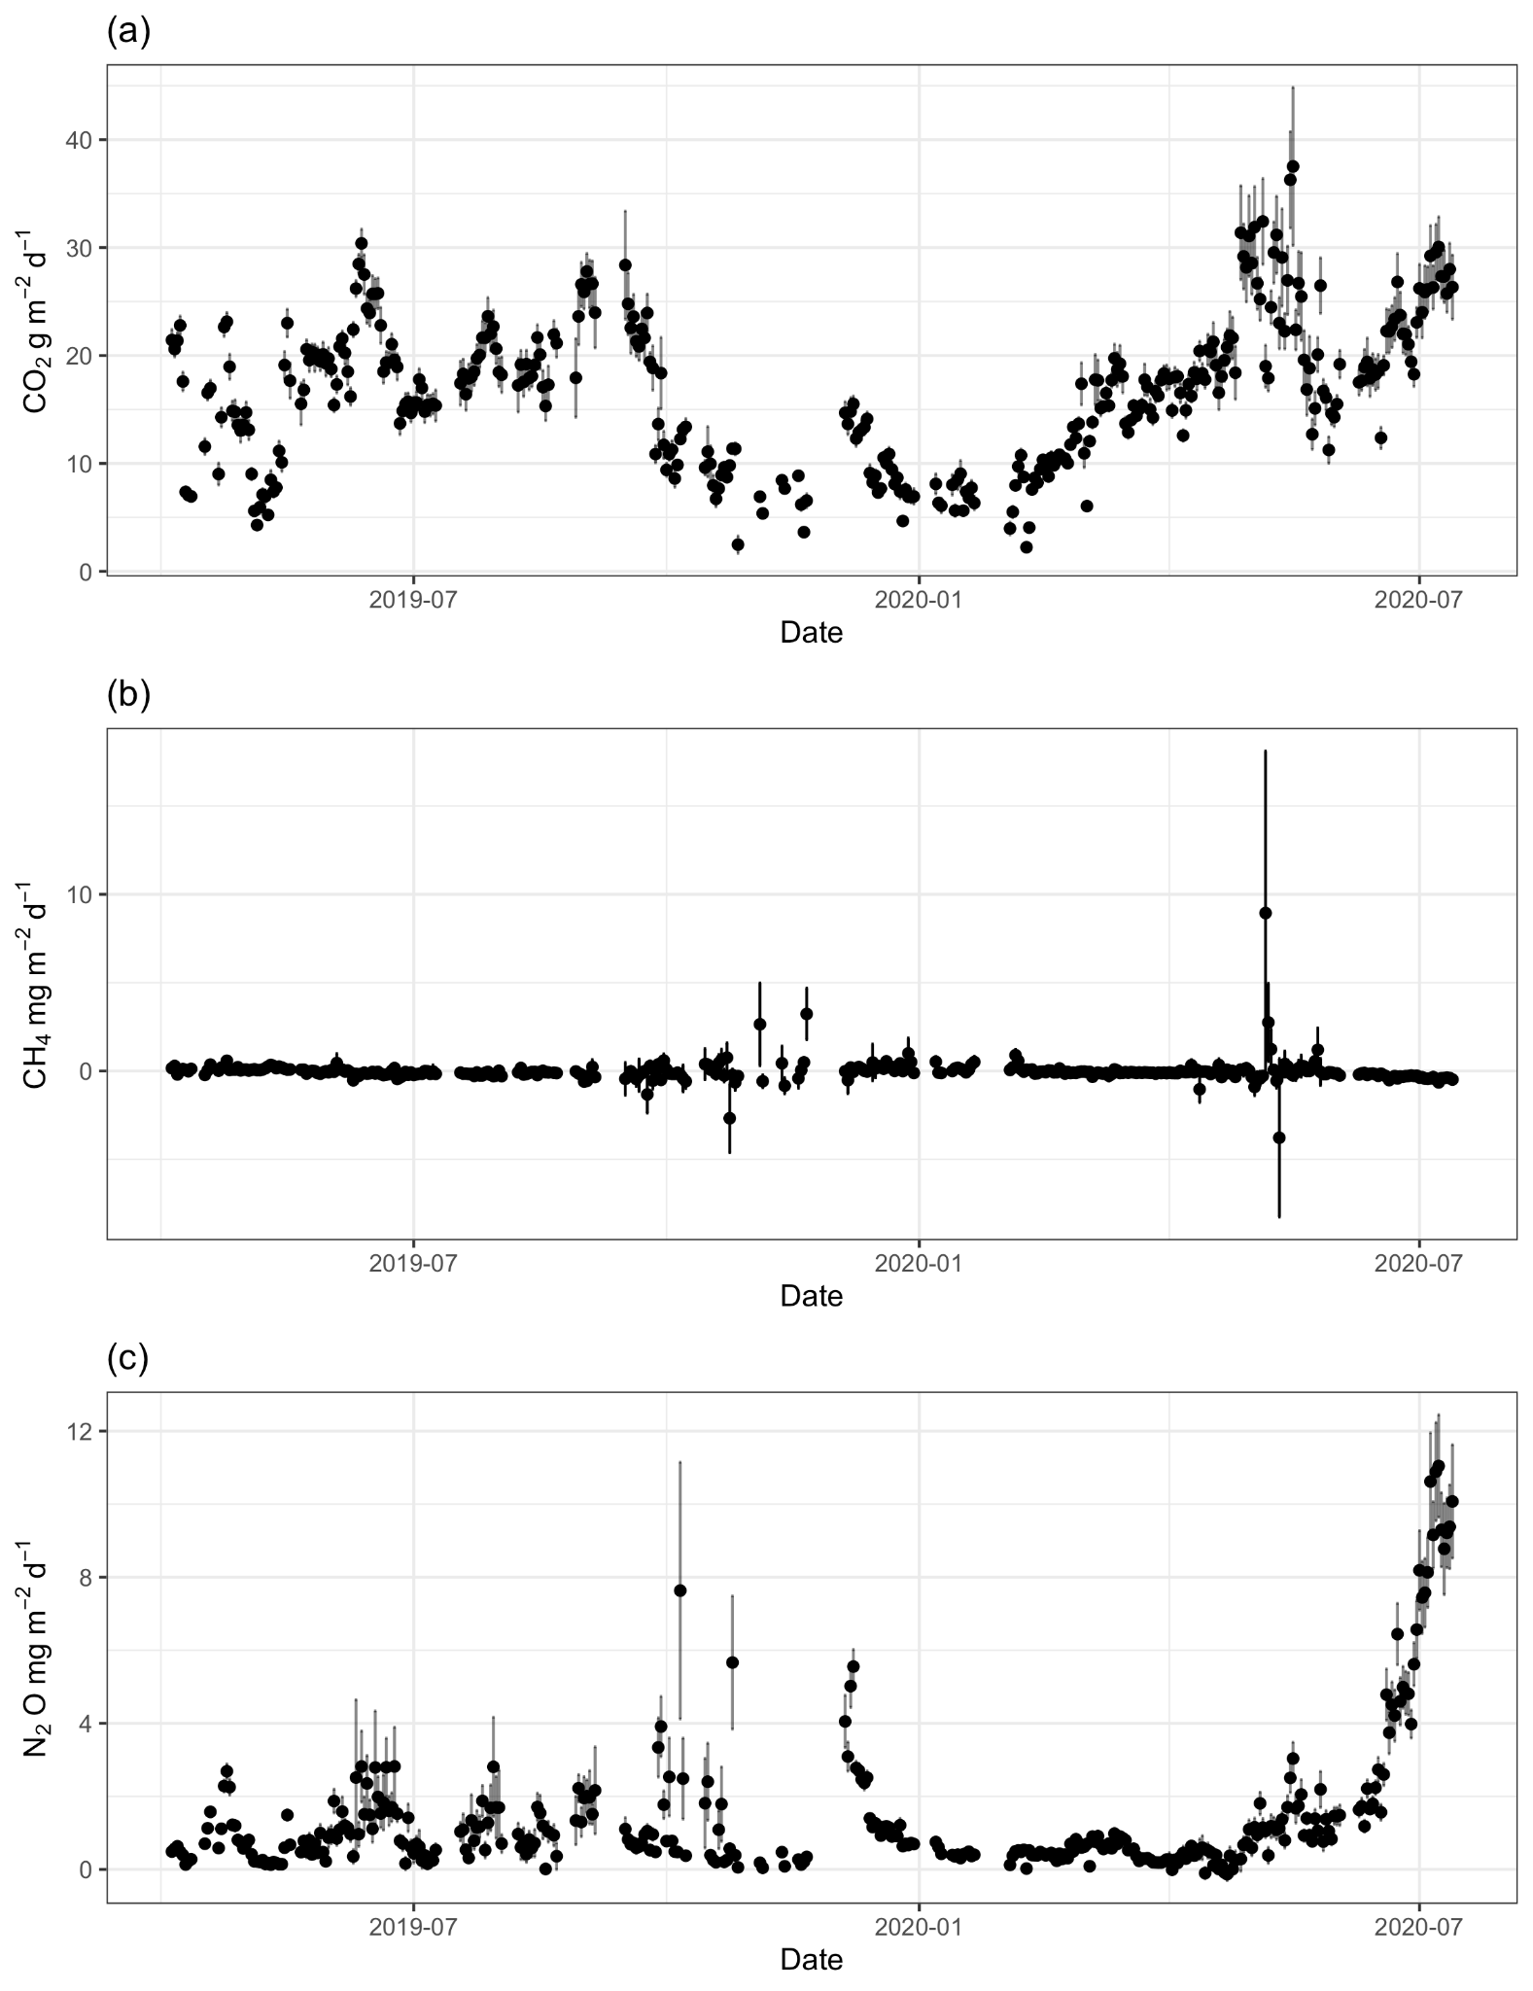
Figure S3. Daily mean (± standard error) (a) CO₂ (g CO₂ m⁻² d⁻¹), (b) CH₄ (mg CH₄ m⁻² d⁻¹), and (c) N₂O (mg N₂O m⁻² d⁻¹) fluxes from a grazed pasture agricultural peatland April 2019 through July 2020. Black circles are daily mean flux measurements with black error bars representing daily standard error.
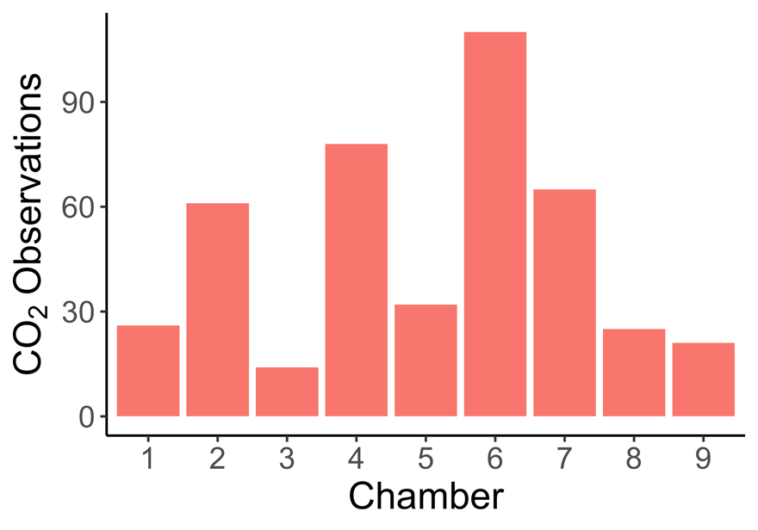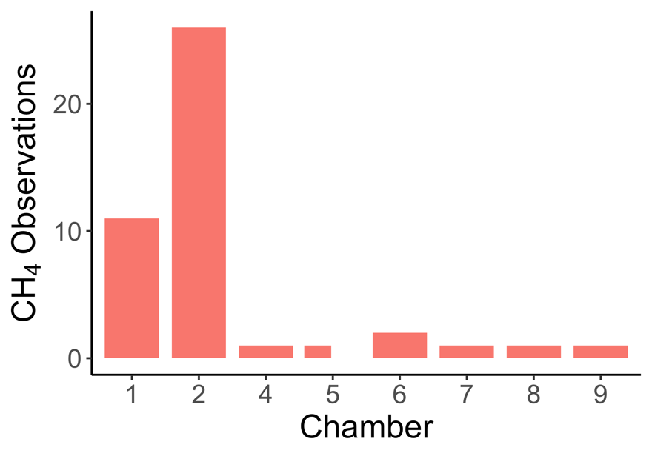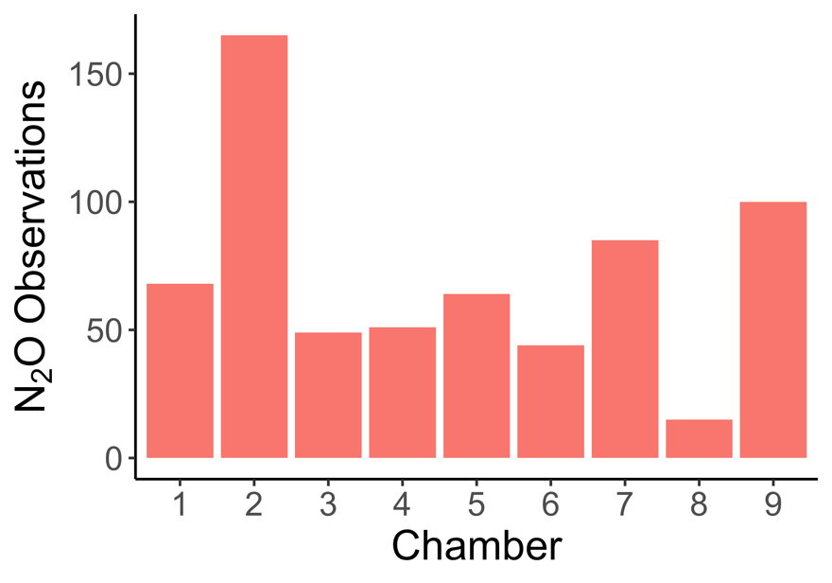
Figure S4. Total number of (top) carbon dioxide (CO₂), (middle) methane (CH₄), and (bottom) nitrous oxide (N₂O) hot moment observations by chamber from an annual corn agricultural peatland.

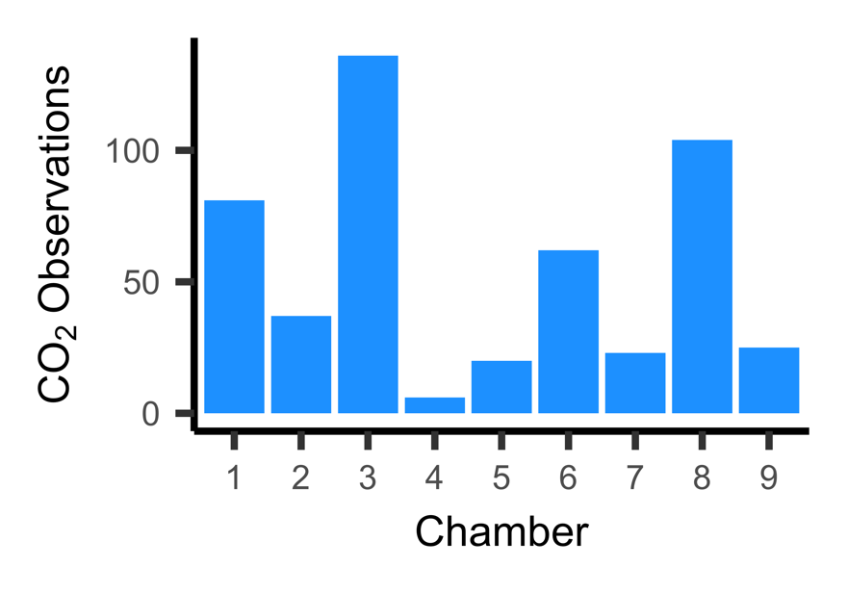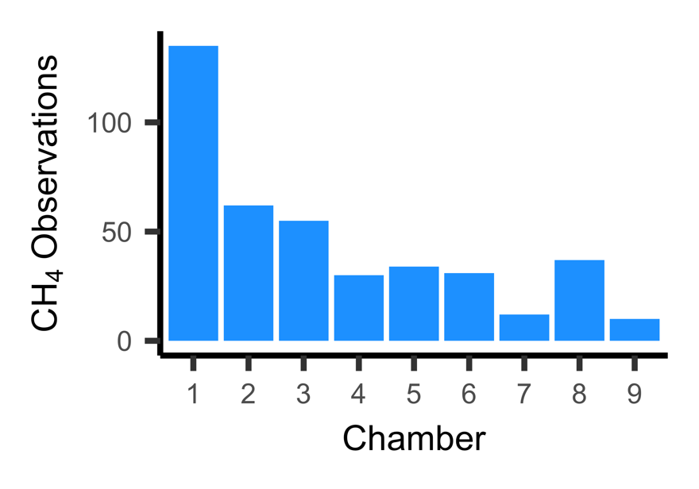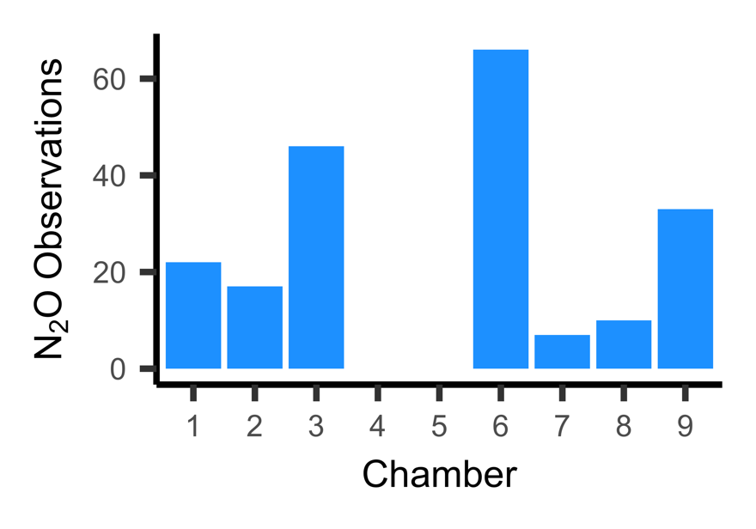

Figure S5. Total number of (top) carbon dioxide (CO₂), (middle) methane (CH₄), and (bottom) nitrous oxide (N₂O) hot moment observations by chamber from a perennial alfalfa agricultural peatland.

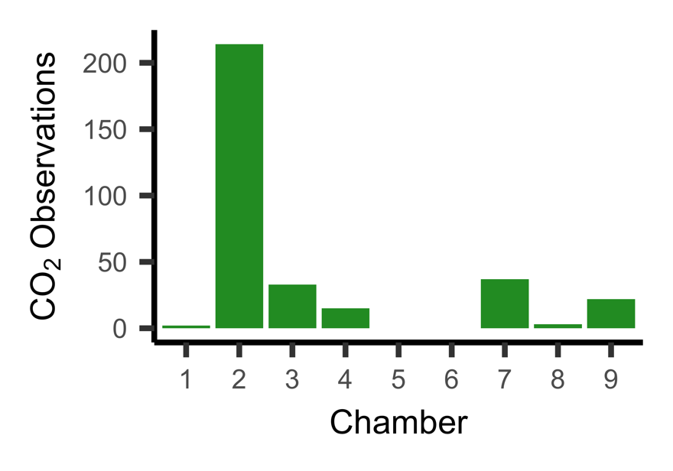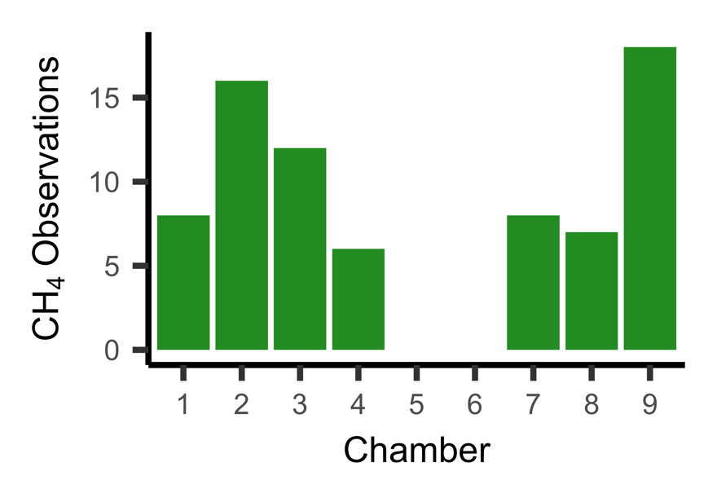
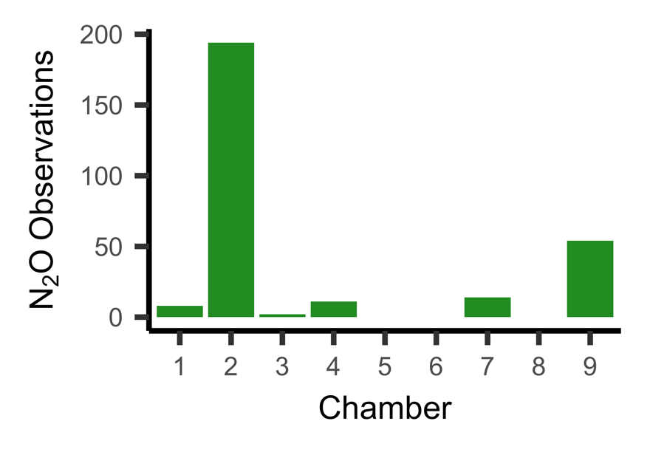
Figure S6. Total number of (top) carbon dioxide (CO₂), (middle) methane (CH₄), and (bottom) nitrous oxide (N₂O) hot moment observations by chamber from a grazed pasture alfalfa agricultural peatland.

