Appendix S1

Soil Nitrogen Cycling in Forests Invaded by the Shrub Rosa multiflora: Importance of Soil Moisture and Invasion Density

Biogeochemistry

Authors: Eric R. Moore^{1*} ORCiD: 0000-0003-2727-7029
Richard V. Pouyat^{1,2}
Tara L.E. Trammell¹ ORCiD: 0000-0002-5215-4947

Affiliations:
¹Dept. of Plant and Soil Sciences, University of Delaware, Newark, DE 19716, USA
²USDA Forest Service, Northern Research Station, NRS-08, Newark, DE 19716, USA
*Corresponding author: Eric Moore
Email: ermoore@udel.edu

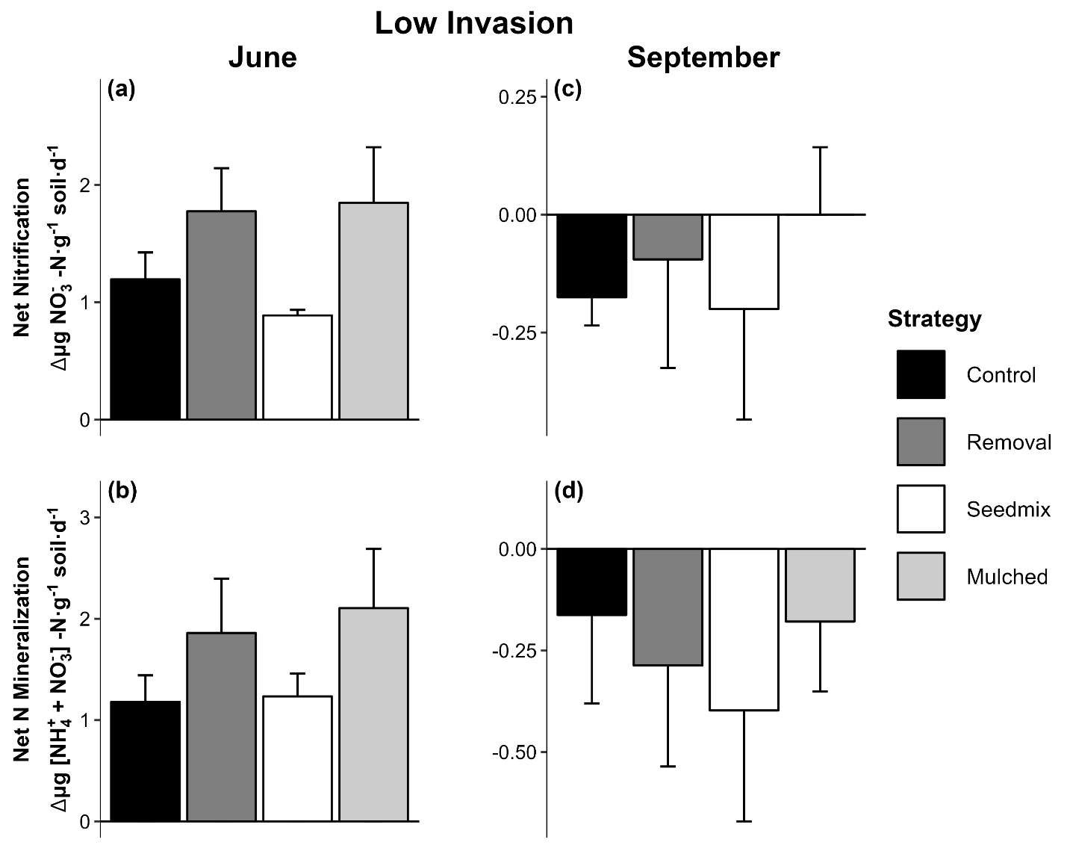

Figure S1 – Mean net change (± 1 SE) in potential net nitrification and net N-mineralization rates during the early (June) and late (September) growing season in control and treatment plots at the Low Invasion site following invasive plant removal in 2018. No differences were observed between the groups (P > 0.10).

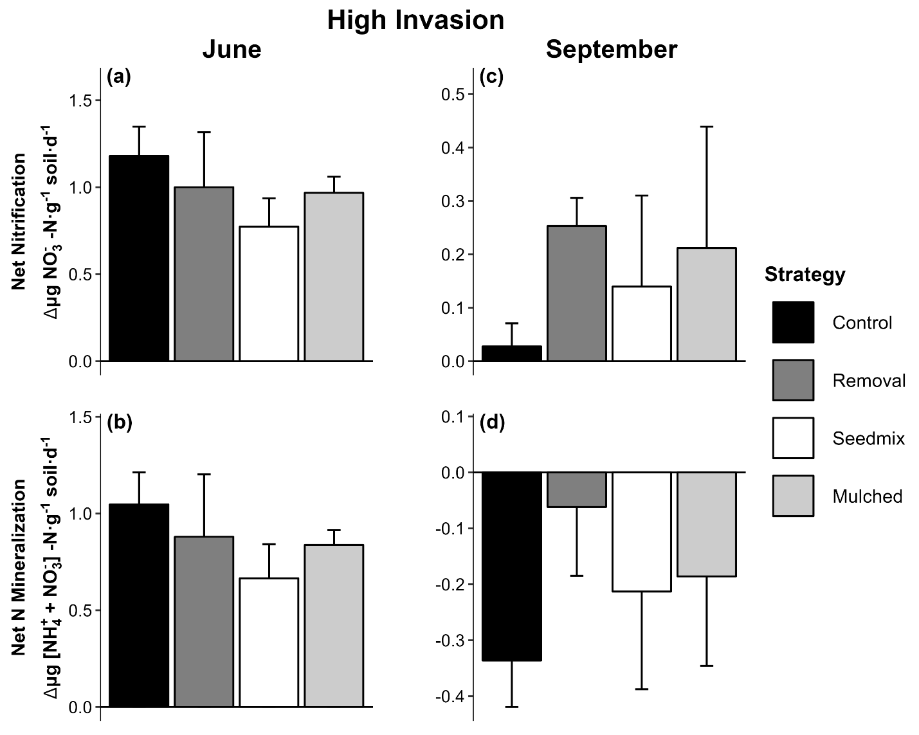

Figure S2 – Mean net change (± 1 SE) in potential net nitrification and net N-mineralization rates during the early (June) and late (September) growing season in control and treatment plots at the High Invasion site following invasive plant removal in 2018. No differences were observed between the groups (P > 0.10).

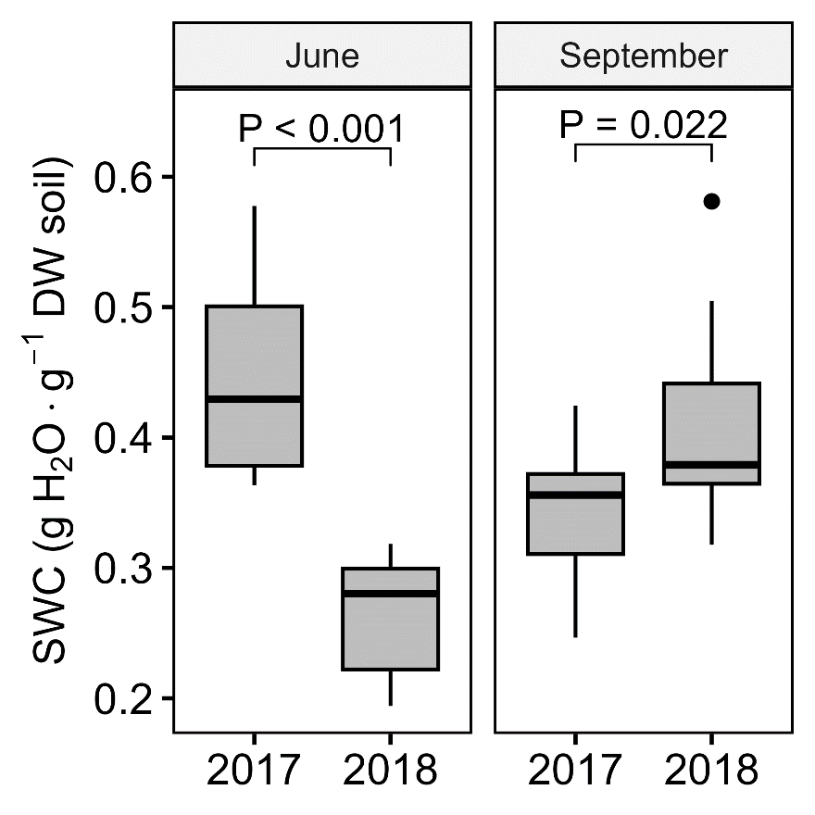

Figure S3 – Mean (± 1 SE) Soil Water Content (SWC) for all Control plots during the early (June) and late (September) growing season, pooled across sites (n = 9 plots season⁻¹ year⁻¹).

Table S1 – Results of one-way ANOVA and Tukey-Kramer post-hoc analysis comparing soil N cycling metrics across the Low, Medium, and High Invasion forest sites in 2017, prior to invasive plant removal. F- and P-values are reported for the omnibus test; adjusted P-values are reported for each pairwise comparison. Bold indicates significant* differences (P < 0.05) between groups.
Month | Metric | F | P | Comparison | adjusted P
June | Nitrification | 12.151 | < 0.001 | Low-Medium | < 0.001
 |  |  |  | Low-High | 0.009
 |  |  |  | Medium-High | 0.226
 | N mineralization | 9.238 | < 0.001 | Low-Medium | < 0.001
 |  |  |  | Low-High | 0.007
 |  |  |  | Medium-High | 0.714
September | Nitrification | 10.274 | < 0.001 | Low-Medium | < 0.001
 |  |  |  | Low-High | 0.021
 |  |  |  | Medium-High | 0.239
 | N mineralization | 3.007 | 0.063* | Low-Medium* | 0.060*
 |  |  |  | Low-High | 0.212
 |  |  |  | Medium-High | 0.794
*Indicates a trend toward significant differences.

Table S2 – Means (± 1 SE) of potential net ammonification in June and September 2017. Letters indicate significant* differences (P < 0.05) between sites in each month and N cycling metric
Month | Invasion | Ammonification
Month | Invasion | µg NH₄⁺ -N produced g⁻¹ DW soil
June | Low | -0.10 (0.09)
 | Medium | -0.10 (0.06)
 | High | 0.03 (0.01)
September | Low | 0.24 (0.03)^{A}
 | Medium | 0.41 (0.06)^{B}
 | High | 0.32 (0.02)^{AB}

Table S3 – Mean net change (± 1 SE) in potential net nitrification and net N-mineralization rates across management strategies for June and September, following invasive plant removal in 2018. Letters indicate trends toward significant differences (P < 0.10) between groups.
Month | Invasion | Strategy | Nitrification | N Mineralization
Month | Invasion | Strategy | µg ${NO}_{3}^{-}$-N produced  g⁻¹ DW soil d⁻¹ | µg [${NO}_{3}^{-}$ + ${NH}_{4}^{+}$]-N produced  g⁻¹ DW soil d⁻¹
June | Low | Control | 1.20 (0.23) | 1.18 (0.26)
 |  | Removal | 1.78 (0.37) | 1.86 (0.53)
 |  | Seedmix | 0.89 (0.05) | 1.23 (0.23)
 |  | Mulched | 1.85 (0.47) | 2.11 (0.58)
 | Medium | Control | 0.58 (0.07) ^{A} | 0.96 (0.30)
 |  | Removal | 0.54 (0.05) ^{AB} | 1.02 (0.30)
 |  | Seedmix | 0.21 (0.09) ^{B} | 0.49 (0.12)
 |  | Mulched | 0.20 (0.12) ^{B} | 0.61 (0.08)
 | High | Control | 1.18 (0.17) | 1.05 (0.17)
 |  | Removal | 1.00 (0.32) | 0.88 (0.32)
 |  | Seedmix | 0.77 (0.16) | 0.67 (0.18)
 |  | Mulched | 0.97 (0.09) | 0.84 (0.08)
September | Low | Control | -0.18 (0.06) | -0.16 (0.22)
 |  | Removal | -0.09 (0.23) | -0.29 (0.25)
 |  | Seedmix | -0.20 (0.23) | -0.40 (0.27)
 |  | Mulched | 0.00 (0.14) | -0.18 (0.17)
 | Medium | Control | -0.04 (0.01) | -0.17 (0.05)
 |  | Removal | 0.02 (0.14) | -0.31 (0.10)
 |  | Seedmix | -0.17 (0.12) | -0.20 (0.05)
 |  | Mulched | -0.07 (0.06) | -0.24 (0.13)
 | High | Control | 0.03 (0.04) | -0.34 (0.08)
 |  | Removal | 0.25 (0.05) | -0.06 (0.12)
 |  | Seedmix | 0.14 (0.17) | -0.21 (0.17)
 |  | Mulched | 0.21 (0.23) | -0.19 (0.16)

