Soil C:N:P stoichiometric signatures of grasslands differ between tropical and warm temperate climatic zones
Biogeochemistry
Hernández-Romero, Ángel Héctor^{1,2}*, Perroni, Yareni; Sánchez Velásquez, Lázaro Rafael, Martínez-Hernández, Sergio; Ávila-Bello, Carlos Héctor; Xu, Xiaofeng; Zhang, Lihua
*Corresponding author: hechernandez@uv.mx
^{1*}Instituto de Biotecnología y Ecología Aplicada, Universidad Veracruzana, Av. Culturas Veracruzanas 101, Col. Emiliano Zapata, Xalapa, Veracruz, Mexico. CP 91090.
²Centro de Estudios Interdisciplinarios en Agrobiodiversidad, Universidad Veracruzana, Carr. Costera del Golfo Km 220, Acayucan, Veracruz, Mexico, CP 96000.

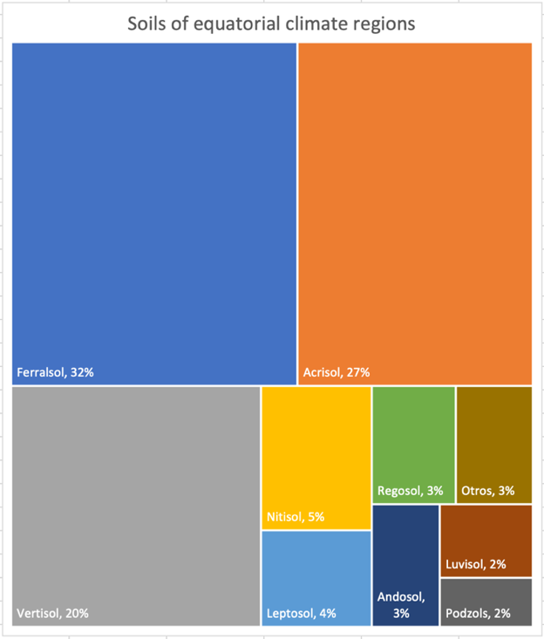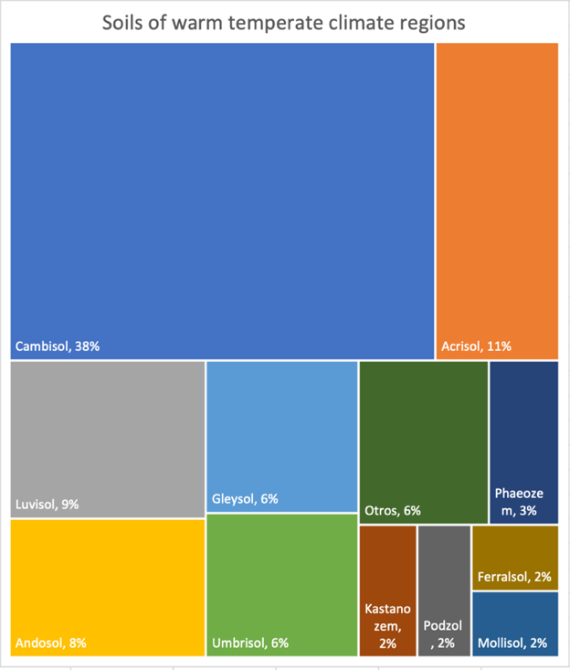

Supplementary Appendix 2. Main soil types, according to the World Reference Base (IUSS, 2015), for equatorial or humid tropical (A) and warm temperate (C) regions.

