Supplements

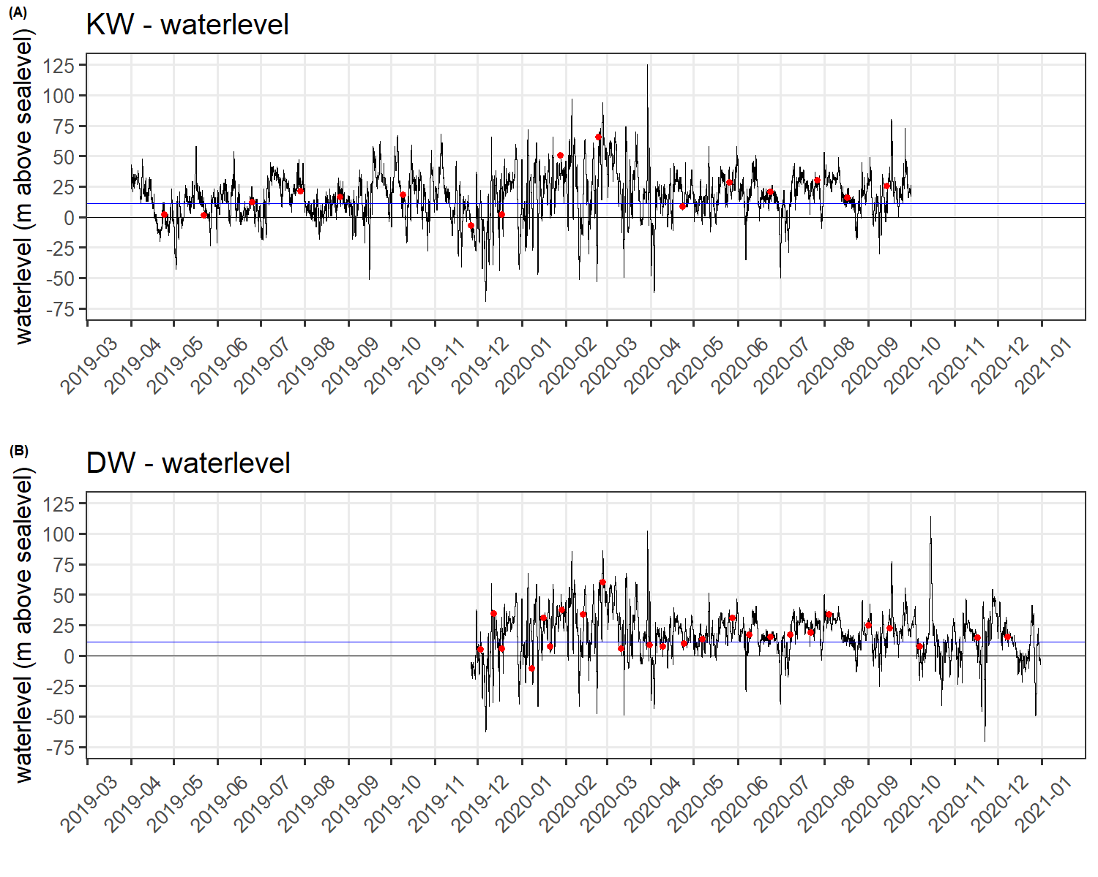
Supplementary Figure S1: Time series of water-level data (m above sea level) for (A) KW and (B) DW. The blue horizontal lines represent the long-term mean water level, and the red dots the respective sampling dates

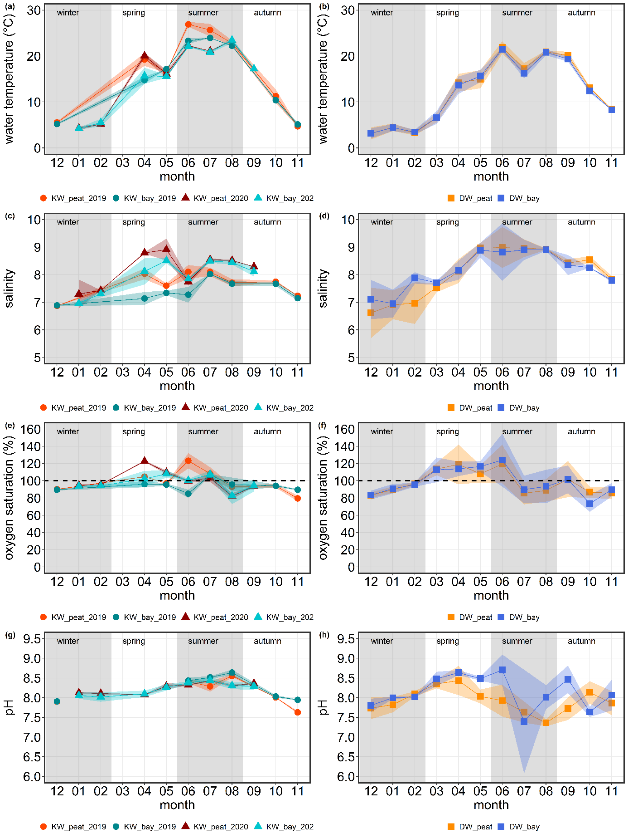
Supplementary Figure S2: Monthly mean (± SD) surface water temperatures (a and b), salinities (c and d), oxygen saturation (in %, e and f,) and pH (g and h) in the respective peatland and bay areas of Karrendorf (KW) and Drammendorf (DW)
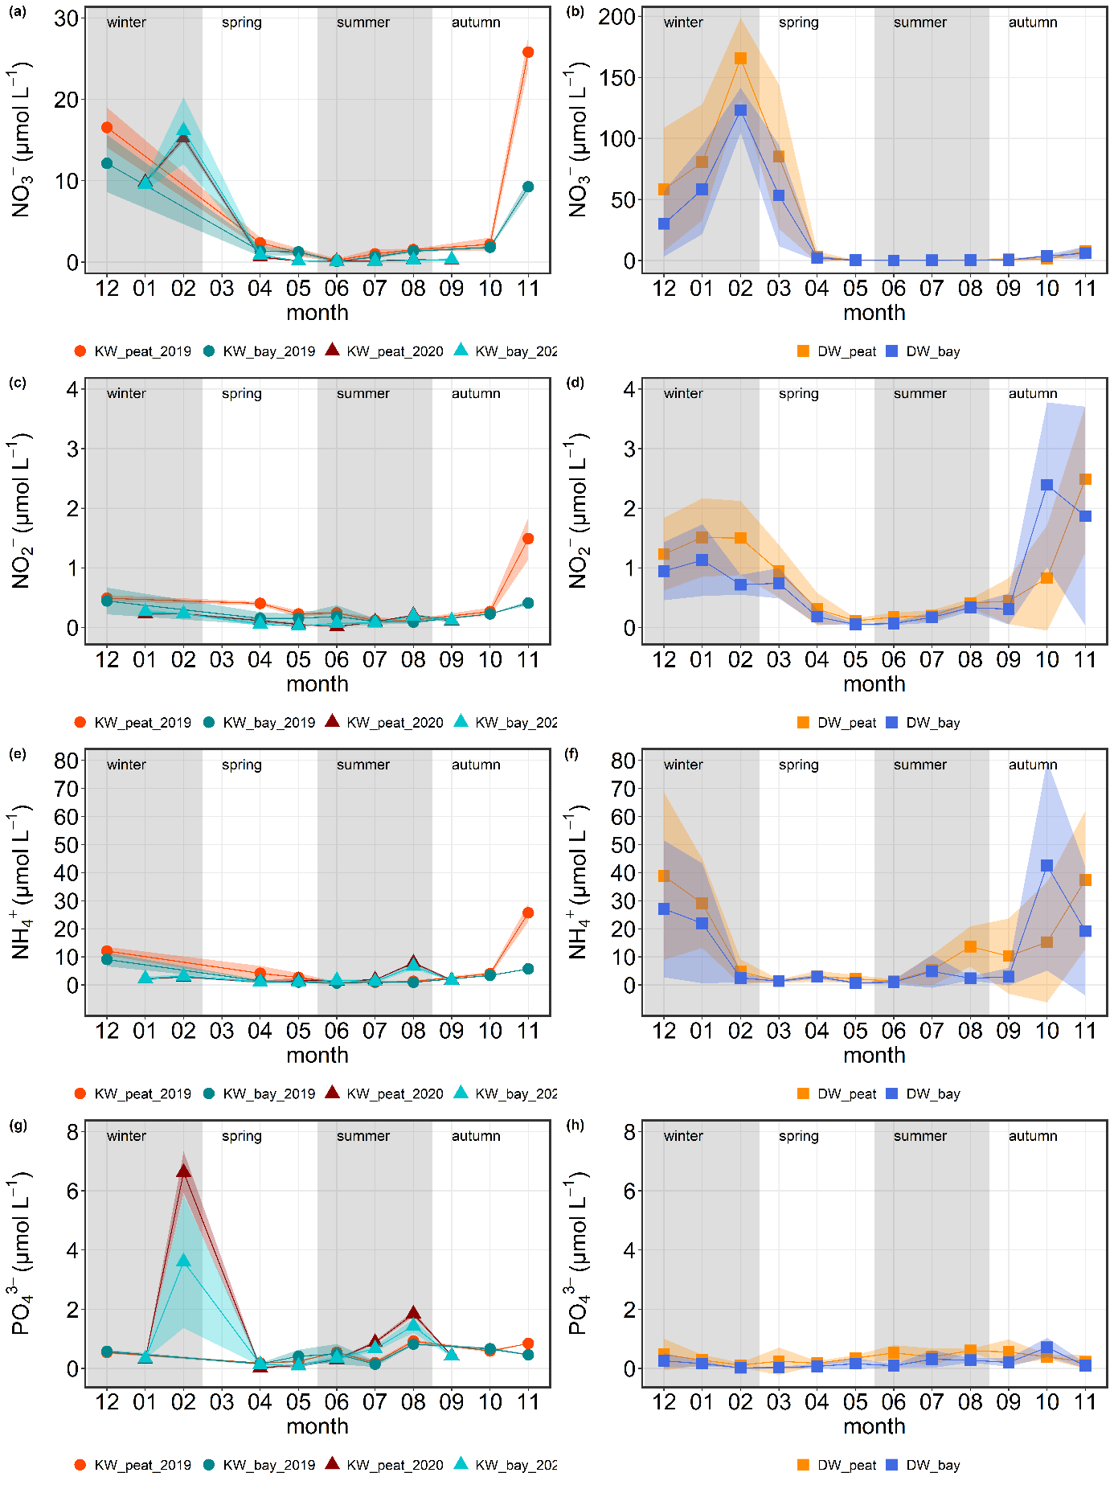
Supplementary Figure S3: Monthly mean (± SD) surface water concentrations of NO₃– (a and b), NO₂– (c and d), NH₄⁺ (e and f), and PO₄^{3–} (g and h) in the respective peatland (“peat”) and bay (“bay”) areas of Karrendorf (KW) and Drammendorf (DW). Note the different scales on the y-axes of the NO₃– plots

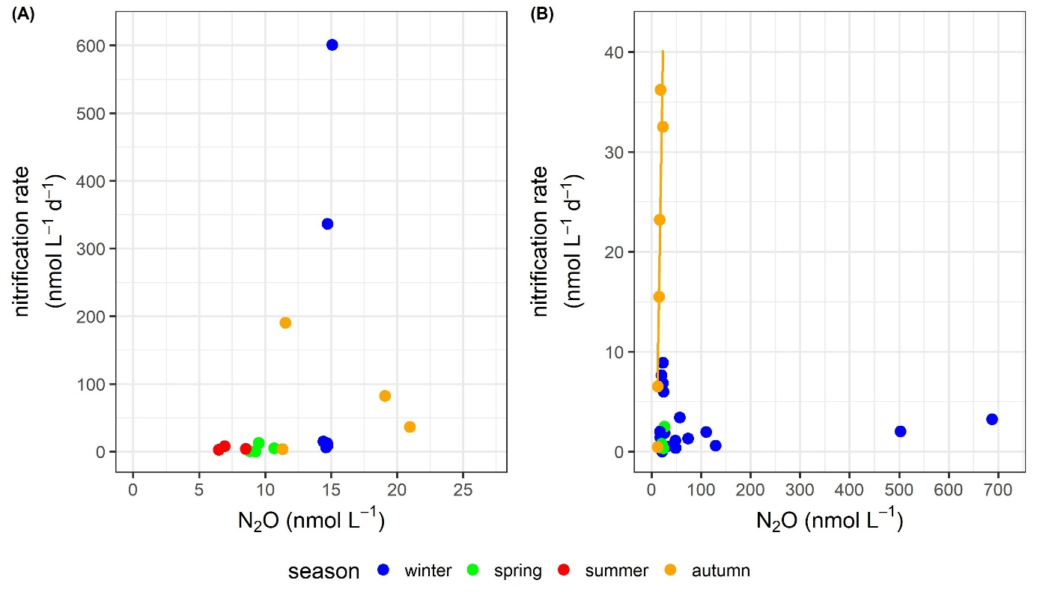
Supplementary Figure S4: Correlation plots of N₂O concentrations and nitrification rates of (A) KW and (B) DW for each season. The yellow regression line for data from DW indicates a significant correlation in autumn (see Chapter 3.3.2)

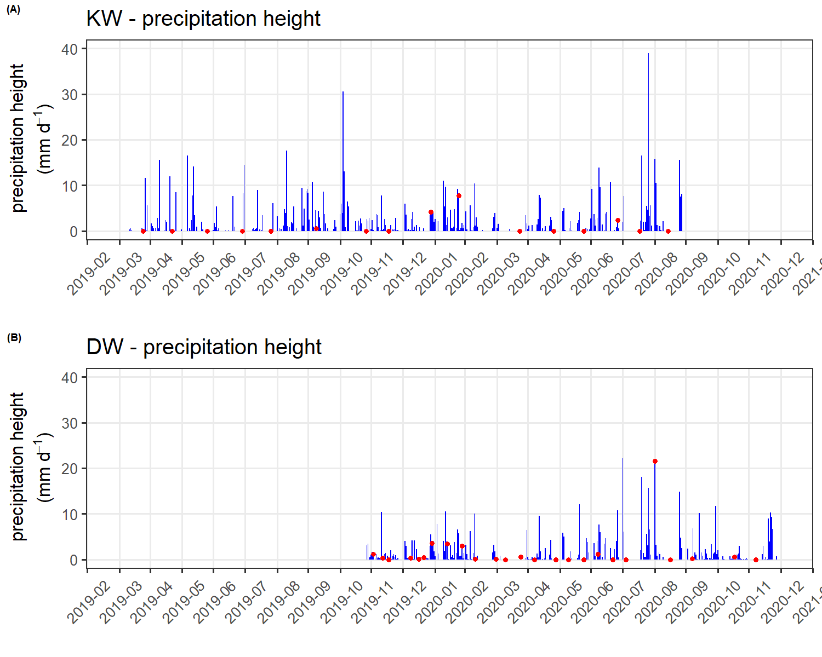
Supplementary Figure S5: Time series of precipitation height data (mm d⁻¹) for (A) KW and (B) DW. The red dots indicate the respective sampling dates

Supplementary Table S1: Sampling dates at KW (Karrendorfer Wiesen) and DW (Drammendorfer Wiesen) listed for all seasons
Study site | Season
Study site | Winter | Spring | Summer | Autumn
KW | 18.12.2019  28.01.2020  24.02.2020 | 24.04.2019  22.05.2019  23.04.2020  26.05.2020 | 25.06.2019  29.07.2019  26.08.2019  24.06.2020  27.07.2020  17.08.2020 | 09.10.2019  26.11.2019  14.09.2020
DW | 03.12.2020  12.12.2020  18.12.2020  08.01.2020  16.01.2020  21.01.2020  29.01.2020  13.02.2020  27.02.2020  08.12.2020 | 11.03.2020  31.03.2020  09.04.2020  24.04.2020  07.05.2020  28.05.2020 | 09.06.2020  24.06.2020  08.07.2020  22.07.2020  04.08.2020 | 01.09.2020  16.09.2020  07.10.2020  17.11.2020

Supplementary Table S2: Statistical results of seasonal comparisons of the two study sites (KW = Karrendorfer Wiesen, DW = Drammendorfer Wiesen) for all seasons and variables. The data were analyzed in a two-way ANOVA using the factors “study site” and “season”. The number of observations is shown in parentheses. Significant differences (p < 0.05) are indicated in bold
 |  | Winter | P | Spring | P | Summer | P | Autumn | p
Water temperature (°C) | DW | 3.69 ± 1.18 (51) |  | 12.03 ± 4.17 (35) | < 0.001 | 19.85 ± 2.44 (30) | 0.01 | 15.33 ± 5.01 (24)
Water temperature (°C) | KW | 5.00 ± 0.61 (6) |  | 17.97 ± 1.95 (8) | < 0.001 | 23.66 ± 2.14 (12) | 0.01 | 11.05 ± 5.63 (6)
Salinity | DW | 6.81 ± 0.75 (51) |  | 8.23 ± 0.66 (35) |  | 8.96 ± 0.50 (30) | 0.001 | 8.31 ± 0.31 (24)
Salinity | KW | 7.20 ± 0.35 (6) |  | 8.33 ± 0.60 (8) |  | 8.12 ± 0.36 (12) | 0.001 | 7.76 ± 0.47 (6)
O₂  (% saturation) | DW | 87.99 ± 5.81 (51) |  | 113.59 ± 15.58 (35) |  | 99.75 ± 23.51 (30) |  | 95.02 ± 17.44 (24)
O₂  (% saturation) | KW | 93.47 ± 2.70 (6) |  | 108.56 ± 10.05 (8) |  | 101.55 ± 13.84 (12) |  | 89.05 ± 7.64 (6)
pH | DW | 7.83 ± 0.27 (46) |  | 8.27 ± 0.30 (35) |  | 7.70 ± 0.37 (30) | < 0.001 | 7.84 ± 0.33 (24)
pH | KW | 8.04 ± 0.11 (6) |  | 8.19 ± 0.13 (4) |  | 8.38 ± 0.11 (12) | < 0.001 | 8.00 ± 0.33 (6)
NO₃  (µmol L⁻¹) | DW | 89.12 ± 61.94 (51) | < 0.001 | 25.22 ± 46.03 (35) |  | 0.14 ± 0.10 (29) |  | 2.77 ± 3.56 (24)
NO₃  (µmol L⁻¹) | KW | 13.87 ± 3.36 (6) | < 0.001 | 1.08 ± 0.95 (8) |  | 0.56 ± 0.58 (12) |  | 9.41 ± 12.75 (6)
NO₂  (µmol L⁻¹) | DW | 1.40 ± 0.64 (51) | 0.001 | 0.43 ± 0.44 (35) |  | 0.23 ± 0.11 (29) |  | 1.07 ± 1.14 (24)
NO₂  (µmol L⁻¹) | KW | 0.32 ± 0.14 (6) | 0.001 | 0.20 ± 0.15 (8) |  | 0.13 ± 0.08 (12) |  | 0.62 ± 0.70 (6)
NH₄⁺ (µmol L⁻¹) | DW | 29.00 ± 25.04 (51) | 0.03 | 2.27 ± 1.55 (35) |  | 5.54 ± 6.48 (29) |  | 18.13 ± 20.92 (24)
NH₄⁺ (µmol L⁻¹) | KW | 5.69 ± 4.99 (6) | 0.03 | 2.35 ± 1.78 (8) |  | 2.38 ± 2.59 (12) |  | 10.47 ± 11.93 (6)
PO₄³⁻ (µmol L⁻¹) | DW | 0.33 ± 0.40 (51) | 0.01 | 0.26 ± 0.28 (35) |  | 0.49 ± 0.26 (29) |  | 0.44 ± 0.33 (24)
PO₄³⁻ (µmol L⁻¹) | KW | 2.49 ± 3.22 (6) | 0.01 | 0.14 ± 0.09 (8) |  | 0.78 ± 0.57 (12) |  | 0.62 ± 0.19 (6)
Chlorophyll-a (µg L⁻¹) | DW | 8.04 ± 10.51 (26) |  | 40.03 ± 26.39 (12) |  | 74.03 ± 29.01 (10) | < 0.001 | 37.73 ± 38.92 (8)
Chlorophyll-a (µg L⁻¹) | KW | 6.24 ± 4.65 (6) |  | 18.15 ± 17.34 (8) |  | 10.92 ± 6.82 (12) | < 0.001 | 6.45 ± 2.52 (6)
POC (µmol L⁻¹) | DW | 145.83 ± 109.28 (26) |  | 362.47 ± 177.77 (12) |  | 905.32 ± 238.48 (10) | < 0.001 | 353.14 ± 314.92 (8)
POC (µmol L⁻¹) | KW | 561.93 ± 830.27 (6) |  | 686.37 ± 788.39 (8) |  | 236.90 ± 156.60 (12) | < 0.001 | 321.37 ± 270.55 (6)
PON (µmol L⁻¹) | DW | 15.10 ± 9.52 (26) |  | 40.35 ± 19.41 (12) |  | 104.90 ± 26.44 (10) | < 0.001 | 44.97 ± 40.96 (8)
PON (µmol L⁻¹) | KW | 50.37 ± 79.00 (6) |  | 72.88 ± 77.92 (8) |  | 28.57 ± 16.98 (12) | < 0.001 | 31.29 ± 23.65 (6)
POC:PON (µmol µmol⁻¹) | DW | 9.85 ± 1.67 (26) |  | 8.93 ± 0.94 (12) |  | 8.69 ± 1.30 (10) |  | 8.04 ± 0.44 (8)
POC:PON (µmol µmol⁻¹) | KW | 9.59 ± 1.36 (6) |  | 8.90 ± 0.83 (8) |  | 8.05 ± 0.90 (12) |  | 9.41 ± 1.33 (6)
δ¹³C-POC  (‰) | DW | -25.99 ± 1.48 (26) |  | -26.63 ± 2.45 (12) |  | -30.32 ± 1.74 (10) | < 0.001 | -29.51 ± 2.95 (8) | < 0.001
δ¹³C-POC  (‰) | KW | -26.30 ± 1.34 (6) |  | -28.68 ± 2.07 (8) |  | -25.77 ± 2.21 (12) | < 0.001 | -24.71 ± 1.04 (6) | < 0.001
Nitrification rate  (nmol L⁻¹ d⁻¹) | DW | 2.71 ± 2.58 (20) | 0.01 | 0.88 ± 0.93 (5) |  | NA |  | 19.07 ± 14.21 (6)
Nitrification rate  (nmol L⁻¹ d⁻¹) | KW | 163.27 ± 250.96 (6) | 0.01 | 4.54 ± 5.79 (4) |  | 4.85 ± 2.66 (3) |  | 78.14 ± 81.51 (4)
N₂O  (% saturation) | DW | 455.94 ± 812.03 (52) | 0.02 | 127.13 ± 26.12 (35) |  | 76.81 ± 12.52 (30) |  | 125.88 ± 31.81 (24)
N₂O  (% saturation) | KW | 95.80 ± 3.06 (6) | 0.02 | 102.63 ± 12.90 (8) |  | 95.10 ± 12.44 (11) |  | 104.16 ± 19.81 (6)

Supplementary Table S3: Overview of the mean seasonal in- and outflow volumes (Q_{in} and Q_{out}), nutrient concentrations of the peatlands (c_{peatland}) and bays (c_{bay}) and the net nutrient transports (NNT, DIN-N, and PO₄-P) for both study sites. Data for Drammendorfer Wiesen were taken from Pönisch and Breznikar et al. (2023)
Season | Q_{in}  (m³ s^{–1}) | Q_{out}  (m³ s^{–1}) | c_{bay}  DIN-N  (kg m^{–3}) | c_{peatland}  DIN-N  (kg m^{–3}) | NNT  DIN-N (t) | c_{bay}  PO₄-P  (kg m^{–3}) | c_{peatland}  PO₄-P  (kg m^{–3}) | NNT  PO₄-P (t)
Winter | 19.4 ± 1.3 | −19.1 ± 1.3 | 249 × 10^{–6}  ± 56.6 × 10^{–6} | 278 × 10^{–6}  ± 88.5 × 10^{–6} | −3.8 ± 17.4 | 46.8 × 10^{–6}  ± 46.2 × 10^{–6} | 77.2 × 10^{–6}  ± 105 × 10^{–6} | 0.55 ± 1.52
Spring | 14.1 ± 0.8 | −14.2 ± 0.8 | 29.1 × 10^{–6}  ± 6.6 × 10^{–6} | 50.8 × 10^{–6}  ± 23.8 × 10^{–6} | −1.1 ± 4.8 | 5.6 × 10^{–6}  ± 2.8 × 10^{–6} | 4.3 × 10^{–6}  ± 2.5 × 10^{–6} | 0.03 ± 0.71
Summer | 13.2 ± 0.7 | −13.2 ± 0.7 | 43.5 × 10^{–6}  ± 16.9 × 10^{–6} | 47.6 × 10^{–6}  ± 24.4 × 10^{–6} | −0.7 ± 6.4 | 22.6 × 10^{–6}  ± 6.8 × 10^{–6} | 24.2 × 10^{–6}  ± 11.2 × 10^{–6} | −0.43 ± 2.84
Autumn | 15.3 ± 1.0 | −15.4 ± 1.0 | 107 × 10^{–6}  ± 49.0 × 10^{–6} | 287 × 10^{–6}  ± 257 × 10^{–6} | −15.9 ± 42.5 | 16.1 × 10^{–6}  ± 2.79 × 10^{–6} | 19.2 × 10^{–6}  ± 6.2 × 10⁻⁶ | −0.31 ± 1.20
Total Karrendorfer Wiesen |  |  |  |  | −21.5 ± 71.0 |  |  | −0.16 ± 6.26
Total per area (t km^{–2} yr^{–1}) |  |  |  |  | −6.1 ± 20.3 |  |  | −0.04 ± 1.79
Season | Q_{in}  (m³ s^{–1}) | Q_{out}  (m³ s^{–1}) | c_{bay}  DIN-N  (kg m⁻³) | c_{peatland}  DIN-N  (kg m⁻³) | NNT  DIN-N (t) | c_{bay}  PO₄-P  (kg m⁻³) | c_{peatland}  PO₄-P  (kg m⁻³) | NNT  PO₄-P (t)
Winter | 1.9  ± 0.1 | −1.9  ± 0.1 | 1270 × 10⁻⁶  ± 506 × 10⁻⁶ | 1840 × 10⁻⁶  ± 267 × 10⁻⁶ | −8.6 ± 9.9 | 6.5 × 10⁻⁶  ± 5.0 × 10⁻⁶ | 11.5 × 10⁻⁶  ± 3.7 × 10⁻⁶ | −0.08 ± 0.10
Spring | 1.3  ± 0.1 | −1.3  ± 0.1 | 243 × 10⁻⁶  ± 289 × 10⁻⁶ | 391 × 10⁻⁶  ± 220 × 10⁻⁶ | −1.5 ± 3.8 | 2.8 × 10⁻⁶  ± 2.8 × 10⁻⁶ | 8.1 × 10⁻⁶  ± 3.1 × 10⁻⁶ | −0.05 ± 0.04
Summer | 1.1  ± 0.1 | −1.1  ± 0.1 | 44.0 × 10⁻⁶  ± 38.2 × 10⁻⁶ | 82.7 × 10⁻⁶  ± 34.6 × 10⁻⁶ | −0.3 ± 0.5 | 6.8 × 10⁻⁶  ± 4.7 × 10⁻⁶ | 15.2 × 10⁻⁶  ± 3.1 × 10⁻⁶ | −0.07 ± 0.05
Autumn | 1.2  ± 0.1 | −1.2  ± 0.1 | 301 × 10⁻⁶  ± 218 × 10⁻⁶ | 328 × 10⁻⁶  ± 104 × 10⁻⁶ | −0.4 ± 3.2 | 8.1 × 10⁻⁶  ± 6.2 × 10⁻⁶ | 10.9 × 10⁻⁶  ± 3.7 × 10⁻⁶ | −0.04 ± 0.10
Total Drammendorfer Wiesen |  |  |  |  | −10.8 ± 17.4 |  |  | −0.24 ± 0.29
Total per area (t km^{–2} yr^{–1}) |  |  |  |  | −21.6 ± 34.8 |  |  | −0.48 ± 0.58

