Persistent and lagged effects of fire on stream solutes linked to intermittent precipitation in arid lands

Submitted to Biogeochemistry Letters

Authors: Heili Lowman*ª, Joanna Blaszczakª, Ashley Caleª, Xiaoli Dong^{b}, Stevan Earl^{c}, Julia Grabow^{d}, Nancy B. Grimm^{d}, Tamara K. Harms^{e,f}, John Melack^{g}, Ann Marie Reinhold^{h}, Betsy Summers^{i}, Alex J. Webster^{j}

* Corresponding Author: heili.lowman@duke.edu
ª Department of Natural Resources and Environmental Science, University of Nevada Reno, Reno, NV, USA
^{b} Department of Environmental Science and Policy, University of California Davis, Davis, CA, USA
^{c} Global Institute of Sustainability and Innovation, Arizona State University, Tempe, AZ, USA
^{d} School of Life Sciences, Arizona State University, Tempe, AZ, USA
^{e} Department of Biology & Wildlife and Institute of Arctic Biology, University of Alaska Fairbanks, Fairbanks, AK, USA
^{f} Department of Ecology, Evolution, and Marine Biology, University of California Santa Barbara, Santa Barbara, CA, USA
^{g} Department of Ecology, Evolution, and Marine Biology, University of California Santa Barbara, Santa Barbara, CA, USA
^{h} Gianforte School of Computing, Montana State University Bozeman, Bozeman, MT, USA
^{i} Department of Civil, Construction & Environmental Engineering, University of New Mexico, Albuquerque, NM, USA
^{j} Department of Biology, University of New Mexico, Albuquerque, NM, USA

Supplementary Information
The following document provides additional details regarding sample collection, precipitation, and discharge measurements as well as a review of past reports of fire severity and post-fire water quality studies (Supplementary Methods). It also documents published datasets used in the analyses (Supplementary Table 1). To supplement the methods in the main manuscript, we present details regarding wet meadow coverage in the monsoonal watersheds (Supplementary Table 2) and document all structures of the multivariate autoregressive state-space (MARSS) models (Supplementary Table 3). We also provide examples of observation error covariance matrices (Supplementary Tables 4 & 5), a covariate effect matrix (Supplementary Table 6), and process error covariance matrices (Supplementary Tables 7—9). In addition, we include figures of monthly precipitation observed at all study sites (Supplementary Figure 1), time series of measured specific conductance and nutrient concentrations (Supplementary Figures 2—5), and model results using a binary fire covariate in place of percent of the watershed burned (Supplementary Figure 6).

Supplementary Methods. In Santa Barbara, CA (USA), data from a total of four watersheds were assembled from published datasets courtesy of the Santa Barbara Coastal Long Term Ecological Research (SBC LTER) program (https://sbclter.msi.ucsb.edu/data/catalog/). From 2002 to 2018, water samples for stream chemistry were collected weekly during the rainy season (November - April) and every two weeks during the dry season (May - October). During storms, samples were collected hourly during the rising limb of the hydrograph and decreasing to every few hours as flow subsided. Specific conductance was measured on unfiltered samples using a conductance bridge, and all readings were corrected to 25℃. Dissolved ammonium (NH₄⁺), nitrate (NO₃–), and phosphate (PO₄^{3–}) concentrations were measured using 1.0 µm filtered samples on a Lachat Automated Ion Analyzer (Hach Company, Loveland, CO, USA) with limits of detection of 0.3 µmol L⁻¹, 0.5 µmol L⁻¹, and 0.3 µmol L⁻¹, respectively. In Mediterranean streams, 43% of NH₄⁺ observations, 87% of NO₃–, and 82% of PO₄^{3–} were greater than the analytical detection limits, and sample concentrations measured below the limit of detection were replaced with a value half the limit of detection. For additional information regarding sample collection, storage, or analyses, please refer to published SBC LTER protocols (LTER and Melack 2020). Precipitation data collected by the SBC LTER was measured on an hourly basis using a tipping bucket rain gauge and data logger to log tipping events (LTER and Melack 2019a, 2022). At sites monitored by Santa Barbara County, precipitation data is measured using a system of automated rain gauges (LTER and Melack 2019b, 2019c). Discharge data collected by the SBC LTER was collected using Solinst Model 3001 LT Leveloggers and used rating curves developed with measured stream cross-sections, roughness estimates, and the U.S. Army Corps of Engineers’ Hydrologic Engineering Center’s River Analysis System model (LTER and Melack 2019d, 2019e, 2019f, 2019g). At sites monitored by the USGS, discharge data were accessed using the dataRetrieval R package (De Cicco et al. 2021).

In Mediterranean streams, where discharge data was available, we derived monthly time series of volume-weighted nutrient concentrations. We converted nutrient concentrations to volume-weighted means to more accurately reflect mean solute concentration during each monthly interval given variation in discharge. Storm-specific volume-weighted means were first reported by Aguilera et al. (2018a). We combined storm-specific, volume-weighted means with non-storm measures of mean monthly measured concentration ($C$) and non-storm monthly discharge ($v$) to estimate monthly volume-weighted mean ($VWM$) concentrations of each solute (Williams et al. 1997):

$VWM = \frac{\sum_{i=1}^{n}{C_{i}v_{i}}}{\sum_{i =1}^{ n}{v_{i}}}$ (Equation S1)

We combined storm and non-storm data to calculate monthly volume-weighted mean NH₄⁺, NO₃–, and PO₄^{3–}concentrations (approximately 56% of records were during periods of baseflow and 44% during stormflow periods).

In Valles Caldera, NM (USA), data from three watersheds were assembled from long term datasets courtesy of the Valles Caldera National Preserve. The East Fork Jemez River (EFJ) and Rio San Antonio West (RSAW) are low-gradient, high-sinuosity, open-canopy channels within the Caldera, and they merge downstream of the Valles Caldera to form the Jemez River. Redondo Creek (RED) is a higher-gradient stream with forested canopy and is a tributary to the Rio San Antonio (downstream of RSAW). From 2005 to 2015, approximately monthly grab samples were collected at two sites (RED, RSAW), and sondes were deployed to measure specific conductance at all three sites (2005-2020 at EFJ, 2005-2018 at RED, 2018-2020 at RSAW). High-frequency measurements were collected with multiparameter sondes that have been upgraded over time, and include: ﻿Yellow Springs Instruments (YSI) 6920 (YSI/Xylem, Yellow Springs, Ohio), YSI EXO 1 and EXO 3, and In-Situ 9500 troll (In-Situ, Fort Collins, Colorado). Stream chemistry datasets are in the process of being made publicly available at https://irma.nps.gov/aqwebportal. For sites that had grab sample data available before the fire (Redondo Creek and Rio San Antonio West), pre-fire grab sample data were combined with post-fire sonde data. Sonde data alone were compiled for the remaining site (East Fork Jemez River). The conductance data were then filtered to remove unrealistic values (< 25 µS cm⁻¹) resulting in a removal of 9% of measurements and outliers greater than four standard deviation values from the site mean resulting in a removal of 0.2% of measurements. For periods during which only sonde data were available (at 15-minute resolution), weekly sonde measurements were selected for midday on Monday of each week to mimic a reasonable time at which grab samples might also be collected. We chose to subsample the sonde data measurements by randomly sampling one observation per week, rather than averaging all high-resolution measurements, to be analogous to the grab samples in the rest of the dataset. Then, grab sample and selected weekly sonde conductance data were averaged by month to match the timestep at which data was assembled for the Mediterranean streams in Santa Barbara.

To determine predominant vegetation cover types included in Table 1 of the main manuscript, we used existing sources that had delineated vegetation in the Mediterranean and monsoonal watersheds included in our analysis. For the Mediterranean streams, we referenced Table 1 in Aguilera and Melack (2018b) that presents vegetation characteristics for each of the watersheds that are part of the Santa Barbara Coastal Long Term Ecological Research program. For the monsoonal streams, we referenced Figure 2 in Muldavin et al. (2006) which assembled vegetation cover for the Valles Caldera National Preserve. Within each watershed, we report the three most common vegetation covers by area.

To determine the distance between sampling sites and fire perimeters included in Table 1 of the main manuscript, sampling sites, NHDplus stream networks, catchment boundaries, and fire polygons were mapped using the ggplot2 and ggspatial packages (Wickham 2016, Dunnington 2023). We determined the closest point along the stream network to each sampling point using the geosphere package (Hijmans 2022). Then, these corrected sampling points were examined in reference to the fire polygons. If a point fell within the fire perimeter polygon, that distance was assigned a value of 0. If a point fell outside of the fire perimeter polygon, we calculated the hydrologic distance from the corrected sampling points to the fire polygons. In order to do so, we determined where the stream network intersected the fire polygons in each watershed using the sf package (Pebesma 2018). For all intersection points, we then calculated the hydrologic distance from the corrected sampling points to the fire polygon intersection points using the riverdist package (Tyers 2024).

As noted in the main text, we chose to use percent of the watershed burned rather than fire severity due to the bias towards classifying fires as higher severity in arid regions (Gale and Carey 2022). Here, we provide additional information regarding previously reported measures of fire severity for monsoonal watersheds included in this study—

The Thompson Ridge Fire, which burned 94% of the Redondo Creek (RED) watershed, had varied fire severity; according to Sánchez et al. (2023), fire severity consisted of a mix of 11% unburned, 34% low severity, 38% moderate severity, and 16% high severity burned area on average across three different watersheds. Two fires burned the Rio San Antonio West (RSAW) and East Fork Jemez (EFJ) watersheds. The Thompson Ridge Fire, which burned approximately 8% of the RSAW watershed and 22% of the EFJ watershed, consisted of a mosaic of burn severities (Sánchez et al. 2023), as described above. The Las Conchas Fire, which burned approximately 43% of the RSAW watershed and 37% of the EFJ watershed, consisted of a mix of 15% unburned, 39% low severity, 25% moderate severity, and 20% high severity burned area (Dahm et al. 2015).

These stream chemistry data have been included in additional studies in Mediterranean and monsoonal watersheds (Dahm et al. 2015; Reale et al. 2015; Sherson et al. 2015; Aguilera and Melack 2018a, 2018b; Goodridge et al. 2018; Sánchez et al. 2023). Here, we detail how our analysis approach differs from and builds upon previous findings—

In the Mediterranean watersheds, studies of annual and storm fluxes (Aguilera and Melack 2018a) and storm event concentration-discharge relationships (Aguilera and Melack 2018b) provide descriptive information of post-fire stream solute fluxes but do not explicitly include fire characteristics as part of their modeling frameworks, in contrast to our study. One study in this region did focus on the effect of the Tea and Jesusita fires on the Rattlesnake Creek (RS02) watershed and found in-stream nitrogen concentrations returned to pre-fire concentrations approximately 17 months after the first fire (Goodridge et al. 2018). However, the Goodridge et al. (2018) analysis differed from ours in several ways: (1) their data included only storm events, whereas our data include baseflow samples as part of our monthly mean observations, (2) they assume an immediate effect of fire, whereas we investigate multiple durations of fire effects (up to 5 years post-fire), (3) the effects of fire and precipitation are intertwined in their calculation of the change in post-fire stream N export (i.e., wfe term), whereas our model structure accounts for the independent effects of fire and precipitation as well as their interaction, and (4) their analysis examined all N species together in a single watershed while we parsed the effects on separate N species in multiple watersheds, which may have different relationships to fire.

In the monsoonal watersheds, studies have focused on shorter post-fire time periods (2 months, Dahm et al. 2015; 4 months, Sherson et al. 2015), single watersheds (Reale et al. 2015), or upper regions of the Valles Caldera catchments (i.e., first order streams, Sánchez et al. 2023) which do not consider interactions with meadows in the valleys. None have considered the effects of multiple fires; Dahm et al. (2015), Reale et al. (2015), and Sherson et al. (2015) focused solely on the Las Conchas fire (2011) while Sánchez et al. (2023) focused on the Thompson Ridge fire (2013). Furthermore, the effects of fire and precipitation are only considered qualitatively in interpretation of results (Dahm et al. 2015; Sherson et al. 2015) or the effects are intertwined, similar to Goodridge et al. (2018), using a dimensionless metric of pre- to post-fire change in solute concentration (i.e., KS tests, Reale et al. 2015; $ΔX$ term, Sánchez et al. 2023). In contrast, our analysis quantifies the separate effects of fire and precipitation as well as their interaction. Our analysis compares watersheds within and across regions within the same statistical framework to facilitate their direct comparison.

References

Aguilera R, Melack JM (2018a) Relationships among nutrient and sediment fluxes, hydrological variability, fire, and land cover in coastal California catchments. Journal of Geophysical Research: Biogeosciences 123(8):2568–2589. https://doi.org/10.1029/2017JG004119
Aguilera R, Melack JM (2018b) Concentration-discharge responses to storm events in coastal California watersheds. Water Resources Research 54(1):407–424. https://doi.org/10.1002/2017WR021578
Dahm CN, Ley RIC, Reale CS, Reale JK, Van Horn DJ (2015) Extreme water quality degradation following a catastrophic forest fire. Freshwater Biology 60(12):2584–2599. https://doi.org/10.1111/fwb.12548
De Cicco LA, Lorenz D, Hirsch RM, Watkins W, Johnson M (2021) dataRetrieval: R packages for discovering and retrieving water data available from U.S. federal hydrologic web services.
Dunnington D (2023) Ggspatial: Spatial Data Framework for ggplot2. R package version 1.1.9. https://CRAN.R-project.org/package=ggspatial
Gale MG, Cary GJ (2022) What determines variation in remotely sensed fire severity? Consideration of remote sensing limitations and confounding factors. Int J Wildland Fire 31(3):291–305. https://doi.org/10.1071/WF21131
Goodridge BM, Hanan EJ, Aguilera R, Wetherley EB, Chen Y-J, D’Antonio CM, Melack JM (2018) Retention of nitrogen following wildfire in a chaparral ecosystem. Ecosystems 21(8):1608–1622. https://doi.org/10.1007/s10021-018-0243-3
Hijmans R (2022) Geosphere: Spherical Trigonometry. R package version 1.5-18. https://CRAN.R-project.org/package=geosphere
LTER SBC, Melack JM (2019a) Precipitation at Arroyo Hondo at Upper Outlaw Trail (HO202) ver 10. Environmental Data Initiative. https://doi.org/10.6073/pasta/128b6fc45f7d840a673b3c3b2f2eaa32
LTER SBC, Melack JM (2019b) SBC LTER: Land: Hydrology: Santa Barbara County Flood Control District – Precipitation at Cater Water Treatment Plant (CaterWTP229). https://doi.org/10.6073/PASTA/8E12EFBC31D84DBED0C105F8C8A2486F
LTER SBC, Melack JM (2019c) SBC LTER: Land: Hydrology: Santa Barbara County Flood Control District – Precipitation at El Deseo (ElDeseo255). https://doi.org/10.6073/PASTA/C5819A9D15A98696E65F0EFD8B45C14A
LTER SBC, Melack JM (2019d) SBC LTER: Land: Hydrology: Stream discharge and associated parameters at Arroyo Burro Creek, Cliff Drive (AB00). https://doi.org/10.6073/PASTA/66F46E14C73B5CE07EF104B91C09360B
LTER SBC, Melack JM (2019e) SBC LTER: Land: Hydrology: Stream discharge and associated parameters at Gaviota Creek, Hwy 101 South Rest Stop (GV01). https://doi.org/10.6073/PASTA/3CDF7FD60F88F0822ECFAD5A92EDF9D6
LTER SBC, Melack JM (2019f) SBC LTER: Land: Hydrology: Stream discharge and associated parameters at Arroyo Hondo Creek , Upstream Side of 101 Bridge (HO00). https://doi.org/10.6073/PASTA/85F4639AC0AC76C1EB4B3A82842CE171
LTER SBC, Melack JM (2019g) SBC LTER: Land: Hydrology: Stream discharge and associated parameters at Rattlesnake Creek, Las Canoas Rd (RS02). https://doi.org/10.6073/PASTA/00AD8507A9EED8E923867C67D907AF12
LTER SBC, Melack JM (2020) SBC LTER: Land: Stream chemistry in the Santa Barbara Coastal drainage area, 2000 -2018. https://doi.org/10.6073/PASTA/AE8784DCBA16A65AA3C8E44321B7C1BB
LTER SBC, Melack JM (2022) SBC LTER: Land: Hydrology: Precipitation at Gaviota at Las Cruces School (GV202). https://doi.org/10.6073/PASTA/9E655E16C8386E8A0CD475F9EB4A8FCD
Muldavin E, Neville P, Jackson C, Neville T (2006) A vegetation map of Valles Caldera National Preserve, New Mexico. Natural Heritage New Mexico, University of New Mexico, Albuquerque: 1–59. http://npshistory.com/publications/vall/veg-map.pdf
Pebesma E (2018) Simple Features for R: Standardized Support for Spatial Vector Data. The R Journal 10 (1), 439-446. https://doi.org/10.32614/RJ-2018-009
Reale JK, Van Horn DJ, Condon KE, Dahm CN (2015) The effects of catastrophic wildfire on water quality along a river continuum. Freshwater Science 34(4):1426–1442. https://doi.org/10.1086/684001
Sánchez RA, Meixner T, Roy T, Ferré PT, Whitaker M, Chorover J (2023) Physical and biogeochemical drivers of solute mobilization and flux through the critical zone after wildfire. Front Water 5:1148298. https://doi.org/10.3389/frwa.2023.1148298
Sherson LR, Van Horn DJ, Gomez-Velez JD, Crossey LJ, Dahm CN (2015) Nutrient dynamics in an alpine headwater stream: use of continuous water quality sensors to examine responses to wildfire and precipitation events. Hydrol Process 29(14):3193–3207. https://doi.org/10.1002/hyp.10426
Tyers M (2024) riverdist: River Network Distance Computation and Applications. R package version 0.16.3. https://CRAN.R-project.org/package=riverdist
Western Regional Climate Center (2021) Valles Caldera National Preserve Climate Stations. https://wrcc.dri.edu/vallescaldera
Wickham H (2016) ggplot2: Elegant Graphics for Data Analysis. Springer-Verlag New York.
Williams MR, Fisher TR, Melack JM (1997) Chemical composition and deposition of rain in the central Amazon, Brazil. Atmospheric Environment 31:207–217. https://doi.org/10.1016/1352-2310(96)00166-5
Supplementary Table 1 Dependent and covariate data availability used in analyses. Sites identified as in Fig. 1.

 |  |  | Data Sources
Site | Solutes Available | Time Span | Chemistry | Precipitation | Discharge
AB00 | Sp. conductance, NH₄⁺, NO₃–, PO₄^{3–} | 2002-2018 | LTER and Melack, 2020 | LTER and Melack, 2019b | LTER and Melack, 2019d
GV01 | Sp. conductance, NH₄⁺, NO₃–, PO₄^{3–} | 2002-2018 | LTER and Melack, 2020 | LTER and Melack, 2022 | LTER and Melack, 2019e
HO00 | Sp. conductance, NH₄⁺, NO₃–, PO₄^{3–} | 2002-2018 | LTER and Melack, 2020 | LTER and Melack, 2019a | LTER and Melack, 2019f
RS02 | Sp. conductance, NH₄⁺, NO₃–, PO₄^{3–} | 2002-2018 | LTER and Melack, 2020 | LTER and Melack, 2019c | LTER and Melack, 2019g
EFJ | Sp. conductance | 2005-2021 | Valles Caldera National Preserve¹ | Western Regional Climate Center, 2021 | NA
RED | Sp. conductance | 2005-2021 | Valles Caldera National Preserve¹ | Western Regional Climate Center, 2021 | NA
RSAW | Sp. conductance | 2005-2021 | Valles Caldera National Preserve¹ | Western Regional Climate Center, 2021 | NA
¹As noted in the main manuscript, data was provided by L. Crossey, C. McGibbon, and M. Albonico but is in the process of being made publicly available by the National Parks Service at https://irma.nps.gov/aqwebportal.

Supplementary Table 2 Approximate open meadow area in each watershed of the monsoonal streams in 2011 before the Las Conchas fire ignition date.

 | Total watershed area (km²) | Open meadow area (km²) | Percent open meadow (%)
EFJ | 25.6 | 2.5 | 9.8
RED | 96.0 | 36.5 | 38.0
RSAW | 147.0 | 34.2 | 23.3

Supplementary Table 3 Table describing all formulations of models run (n = 54). Most parsimonious models, as determined by Akaike Information Criteria (AICc), are denoted with an asterisk.

 | Process error covariance structure | Immediate effect window | 1-year effect window | 2-year effect window | 3-year effect window | 4-year effect window | 5-year effect window
Specific conductance | Across all 7 sites | X | X | X | X | X | X
Specific conductance | By region* | X | X | X | X | X | X
Specific conductance | No covariance | X | X | X | X | X | X
NH₄⁺ | Across all 4 sites* | X | X | X | X | X | X
NH₄⁺ | No covariance | X | X | X | X | X | X
NO₃– | Across all 4 sites* | X | X | X | X | X | X
NO₃– | No covariance | X | X | X | X | X | X
PO₄³⁻ | Across all 4 sites* | X | X | X | X | X | X
PO₄³⁻ | No covariance | X | X | X | X | X | X

Supplementary Table 4 Example observation error covariance matrix ($R$) for model structure including all seven sites with observation variance values ($σ^{2}$) constrained by region. Zero values indicate no covariance was estimated. Sites identified as in Fig. 1.

 | AB00 | GV01 | HO00 | RS02 | EFJ | RED | RSAW
AB00 | $$σ_{1}^{2}$$ | 0 | 0 | 0 | 0 | 0 | 0
GV01 | 0 | $$σ_{1}^{2}$$ | 0 | 0 | 0 | 0 | 0
HO00 | 0 | 0 | $$σ_{1}^{2}$$ | 0 | 0 | 0 | 0
RS02 | 0 | 0 | 0 | $$σ_{1}^{2}$$ | 0 | 0 | 0
EFJ | 0 | 0 | 0 | 0 | $$σ_{2}^{2}$$ | 0 | 0
RED | 0 | 0 | 0 | 0 | 0 | $$σ_{2}^{2}$$ | 0
RSAW | 0 | 0 | 0 | 0 | 0 | 0 | $$σ_{2}^{2}$$
Supplementary Table 5 Example observation error covariance matrix ($R$) for model structure including only Mediterranean streams with observation variance values ($σ^{2}$) constrained by region. Zero values indicate no covariance was estimated. Sites identified as in Fig. 1.

 | AB00 | GV01 | HO00 | RS02
AB00 | $$σ_{1}^{2}$$ | 0 | 0 | 0
GV01 | 0 | $$σ_{1}^{2}$$ | 0 | 0
HO00 | 0 | 0 | $$σ_{1}^{2}$$ | 0
RS02 | 0 | 0 | 0 | $$σ_{1}^{2}$$

Supplementary Table 6 Example effect matrix ($C$) for model structure including only Mediterranean streams examining the effects of precipitation ($β_{P}$), fire ($β_{F}$), and their interaction ($β_{PF}$). Zero values indicate no effect was estimated. Sites identified as in Fig. 1.

 | AB00 | GV01 | HO00 | RS02 | AB00 | GV01 | HO00 | RS02 | AB00 | GV01 | HO00 | RS02
AB00 | $$β_{P1}$$ | 0 | 0 | 0 | $$β_{F1}$$ | 0 | 0 | 0 | $$β_{PF1}$$ | 0 | 0 | 0
GV01 | 0 | $$β_{P2}$$ | 0 | 0 | 0 | $$β_{F2}$$ | 0 | 0 | 0 | $$β_{PF2}$$ | 0 | 0
HO00 | 0 | 0 | $$β_{P3}$$ | 0 | 0 | 0 | $$β_{F3}$$ | 0 | 0 | 0 | $$β_{PF3}$$ | 0
RS02 | 0 | 0 | 0 | $$β_{P4}$$ | 0 | 0 | 0 | $$β_{F4}$$ | 0 | 0 | 0 | $$β_{PF4}$$

Supplementary Table 7 Example process error covariance matrix ($Q$) for “stream-specific” model structure, with seven separate process variance values ($σ^{2}$). Zero values indicate no covariance was estimated. Site abbreviations are the same as in Supplementary Table 1.

 | AB00 | GV01 | HO00 | RS02 | EFJ | RED | RSAW
AB00 | $$σ_{1}^{2}$$ | 0 | 0 | 0 | 0 | 0 | 0
GV01 | 0 | $$σ_{2}^{2}$$ | 0 | 0 | 0 | 0 | 0
HO00 | 0 | 0 | $$σ_{3}^{2}$$ | 0 | 0 | 0 | 0
RS02 | 0 | 0 | 0 | $$σ_{4}^{2}$$ | 0 | 0 | 0
EFJ | 0 | 0 | 0 | 0 | $$σ_{5}^{2}$$ | 0 | 0
RED | 0 | 0 | 0 | 0 | 0 | $$σ_{6}^{2}$$ | 0
RSAW | 0 | 0 | 0 | 0 | 0 | 0 | $$σ_{7}^{2}$$
Supplementary Table 8 Example process error covariance matrix ($Q$) for “region-specific” model structure, with seven separate process variance values ($σ^{2}$) and covariance parameters ($β$) constrained by region. Zero values indicate no covariance was estimated. Site abbreviations are the same as in Supplementary Table 1.

 | AB00 | GV01 | HO00 | RS02 | EFJ | RED | RSAW
AB00 | $$σ_{1}^{2}$$ | $$β_{1-2}$$ | $$β_{1-3}$$ | $$β_{1-4}$$ | 0 | 0 | 0
GV01 | $$β_{1-2}$$ | $$σ_{2}^{2}$$ | $$β_{2-3}$$ | $$β_{2-4}$$ | 0 | 0 | 0
HO00 | $$β_{1-3}$$ | $$β_{2-3}$$ | $$σ_{3}^{2}$$ | $$β_{3-4}$$ | 0 | 0 | 0
RS02 | $$β_{1-4}$$ | $$β_{2-4}$$ | $$β_{3-4}$$ | $$σ_{4}^{2}$$ | 0 | 0 | 0
EFJ | 0 | 0 | 0 | 0 | $$σ_{5}^{2}$$ | $$β_{5-6}$$ | $$β_{5-7}$$
RED | 0 | 0 | 0 | 0 | $$β_{5-6}$$ | $$σ_{6}^{2}$$ | $$β_{6-7}$$
RSAW | 0 | 0 | 0 | 0 | $$β_{5-7}$$ | $$β_{6-7}$$ | $$σ_{7}^{2}$$

Supplementary Table 9 Example process error covariance matrix ($Q$) for “general” model structure, with seven separate process variance values ($σ^{2}$) and covariance parameters ($β$) allowed to covary across all streams. Site abbreviations are the same as in Supplementary Table 1.

 | AB00 | GV01 | HO00 | RS02 | EFJ | RED | RSAW
AB00 | $$σ_{1}^{2}$$ | $$β_{1-2}$$ | $$β_{1-3}$$ | $$β_{1-4}$$ | $$β_{1-5}$$ | $$β_{1-6}$$ | $$β_{1-7}$$
GV01 | $$β_{1-2}$$ | $$σ_{2}^{2}$$ | $$β_{2-3}$$ | $$β_{2-4}$$ | $$β_{2-5}$$ | $$β_{2-6}$$ | $$β_{2-7}$$
HO00 | $$β_{1-3}$$ | $$β_{2-3}$$ | $$σ_{3}^{2}$$ | $$β_{3-4}$$ | $$β_{3-5}$$ | $$β_{3-6}$$ | $$β_{3-7}$$
RS02 | $$β_{1-4}$$ | $$β_{2-4}$$ | $$β_{3-4}$$ | $$σ_{4}^{2}$$ | $$β_{4-5}$$ | $$β_{4-6}$$ | $$β_{4-7}$$
EFJ | $$β_{1-5}$$ | $$β_{2-5}$$ | $$β_{3-5}$$ | $$β_{4-5}$$ | $$σ_{5}^{2}$$ | $$β_{5-6}$$ | $$β_{5-7}$$
RED | $$β_{1-6}$$ | $$β_{2-6}$$ | $$β_{3-6}$$ | $$β_{4-6}$$ | $$β_{5-6}$$ | $$σ_{6}^{2}$$ | $$β_{6-7}$$
RSAW | $$β_{1-7}$$ | $$β_{2-7}$$ | $$β_{3-7}$$ | $$β_{4-7}$$ | $$β_{5-7}$$ | $$β_{6-7}$$ | $$σ_{7}^{2}$$

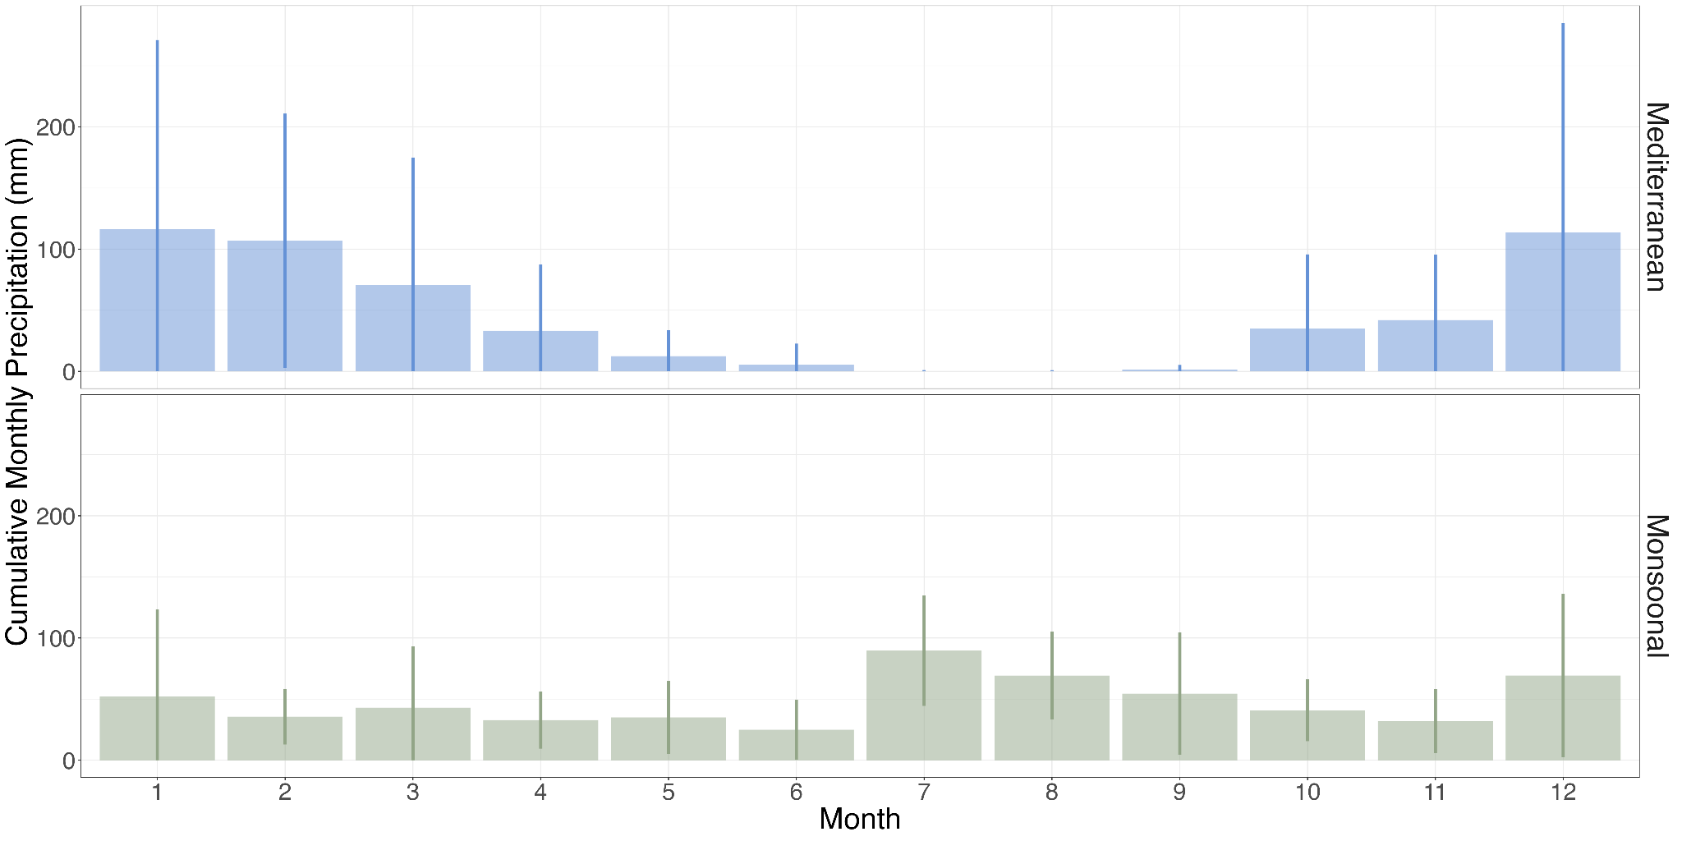

Supplementary Fig. 1 Mean cumulative monthly precipitation (mm) in Mediterranean (blue) and monsoonal streams (green). Error bars denote monthly standard deviation values.

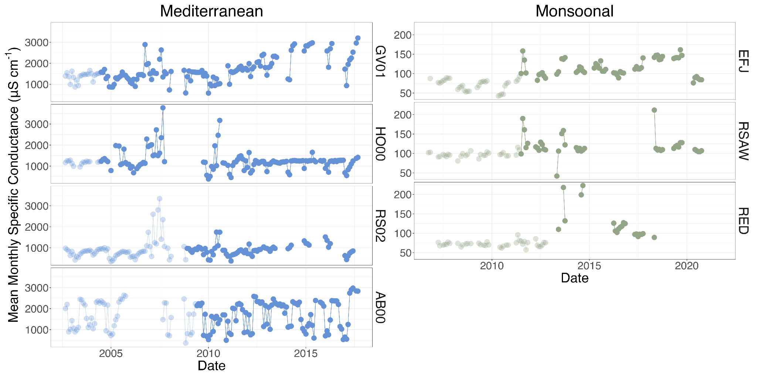
Supplementary Fig. 2 Monthly specific conductance measurements before (lightly shaded) and after (opaque) fires in Mediterranean (blue points) and monsoonal streams (green points). Sites identified as in Fig. 1. Note difference in regional scales for specific conductance, and missing points denote time periods during which samples were not collected either due to sampling stoppages or stream drying.

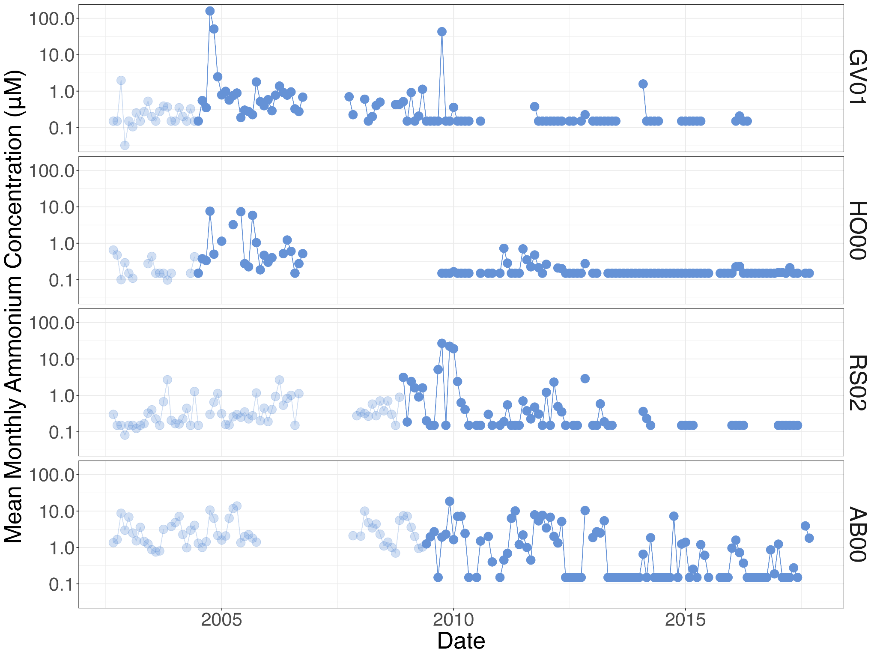

Supplementary Fig. 3 Volume-weighted mean monthly concentrations of ammonium (NH₄⁺) in Mediterranean streams. Sites identified as in Fig. 1. Pre-fire samples are denoted by lightly-shaded points, whereas post-fire samples are denoted by opaque symbols. Note log-scale for concentration.

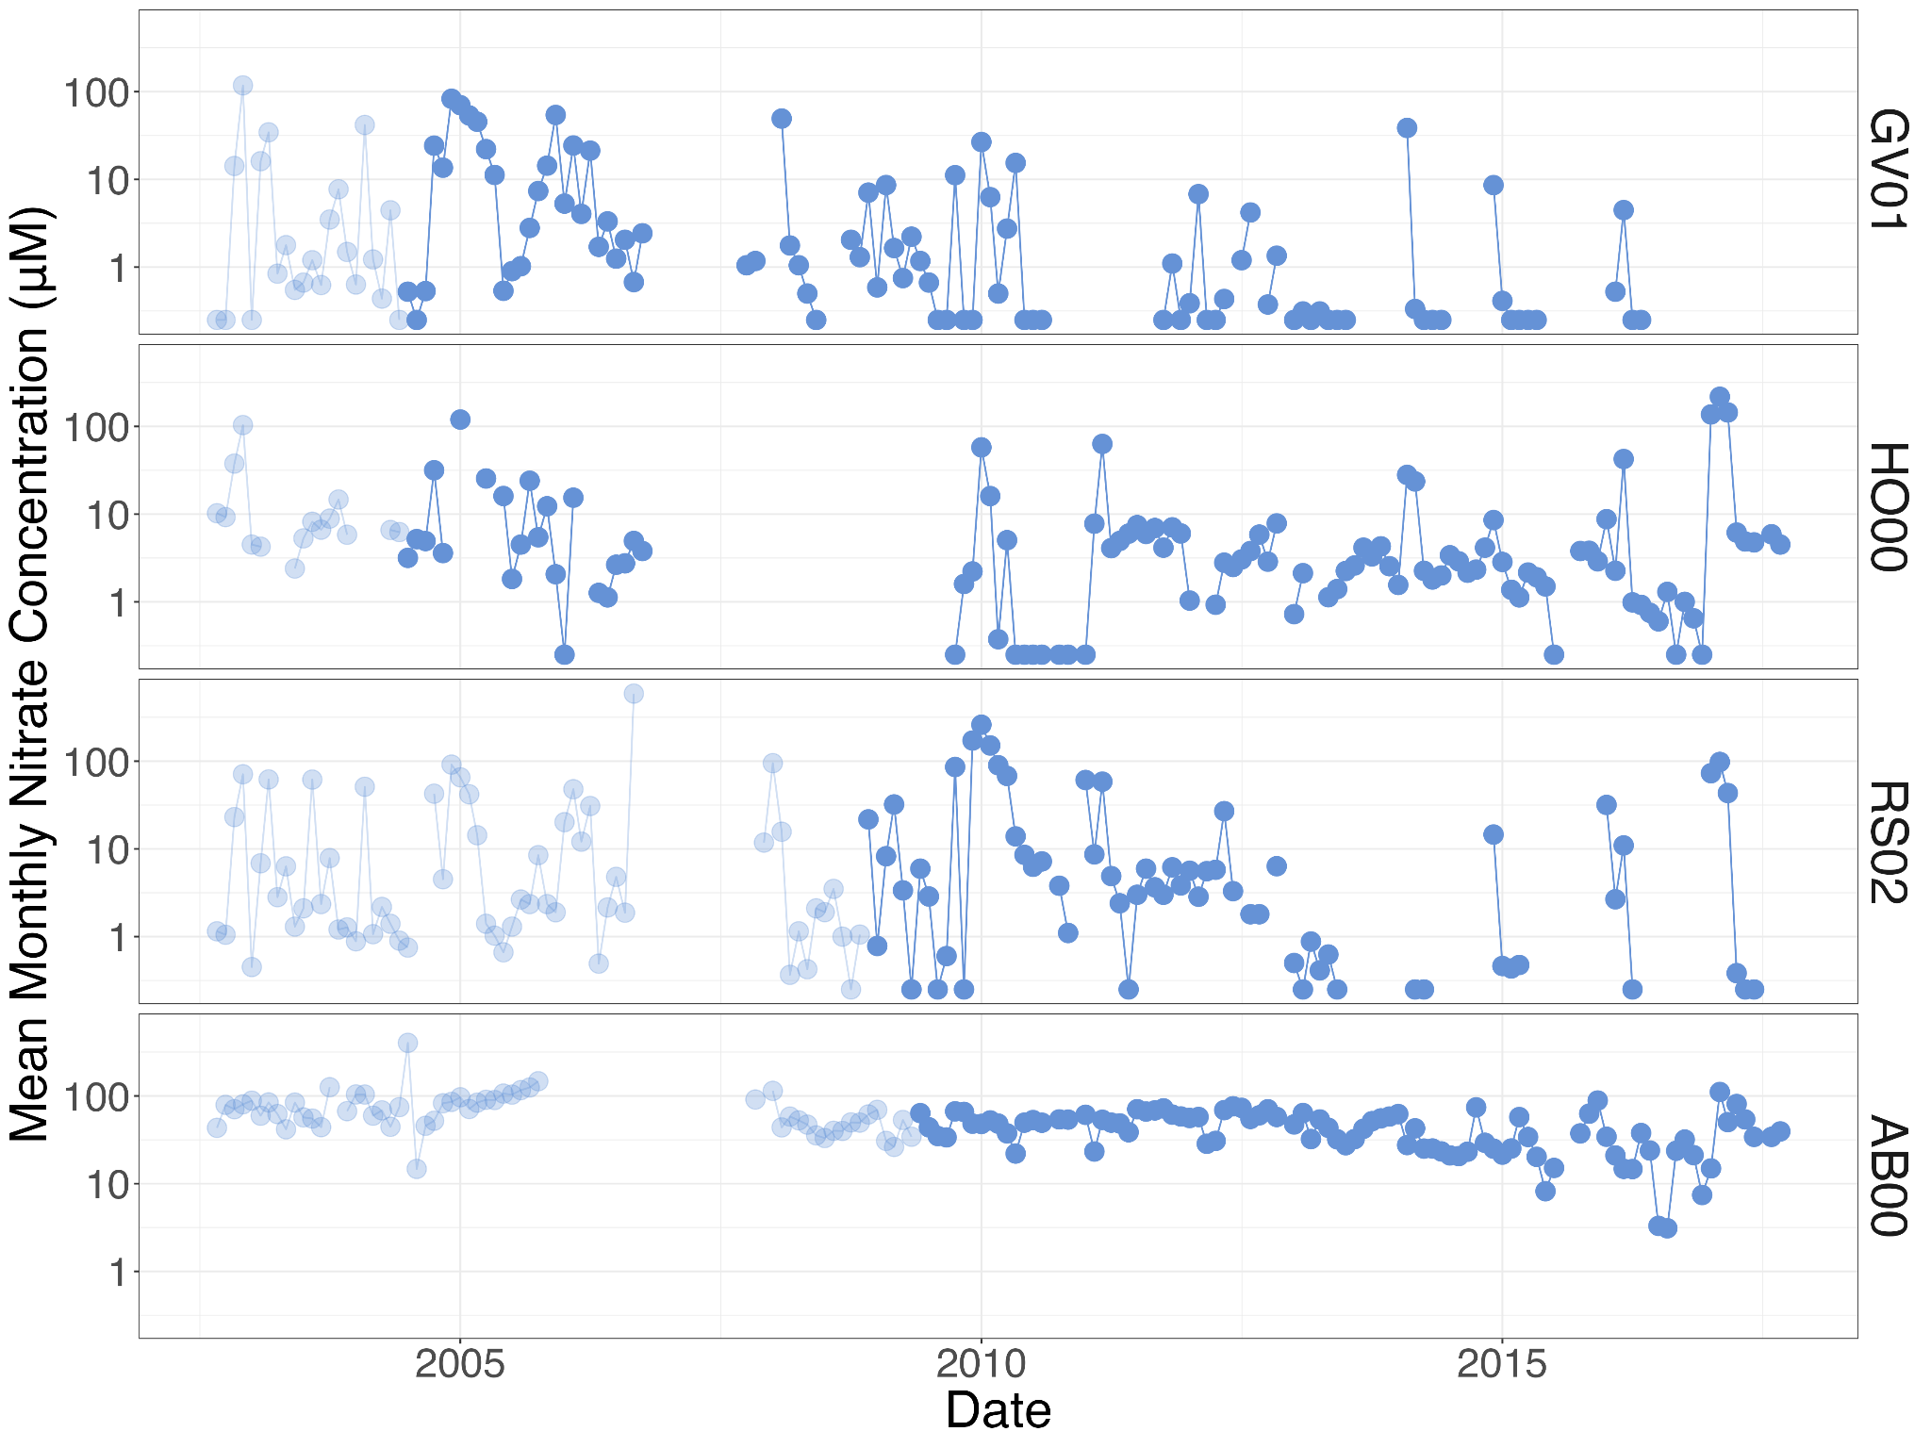

Supplementary Fig. 4 Volume-weighted mean monthly concentrations of nitrate (NO₃–) in Mediterranean streams. Sites identified as in Fig. 1. Pre-fire samples are denoted by lightly-shaded points, whereas post-fire samples are denoted by opaque symbols. Note log-scale for concentration.

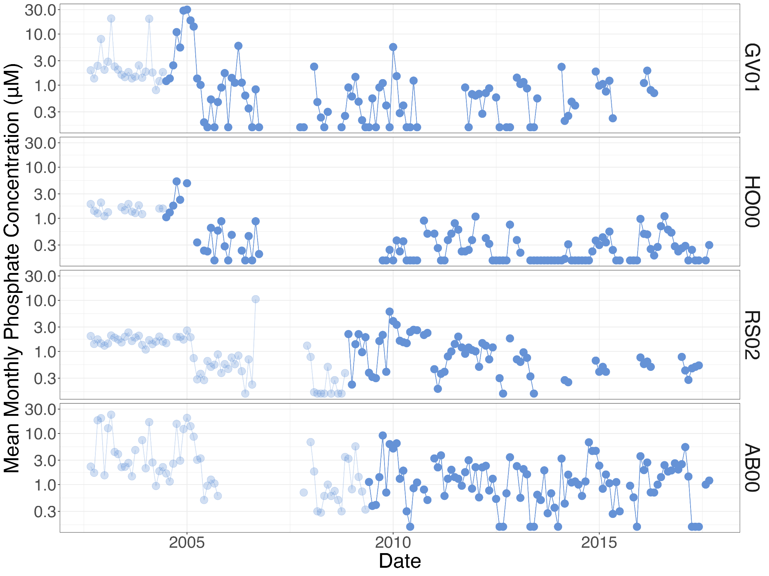

Supplementary Fig. 5 Volume-weighted mean monthly concentrations of phosphate (PO₄^{3–}) in Mediterranean streams. Sites identified as in Fig. 1. Pre-fire samples are denoted by lightly-shaded points, whereas post-fire samples are denoted by opaque symbols. Note log-scale for concentration.

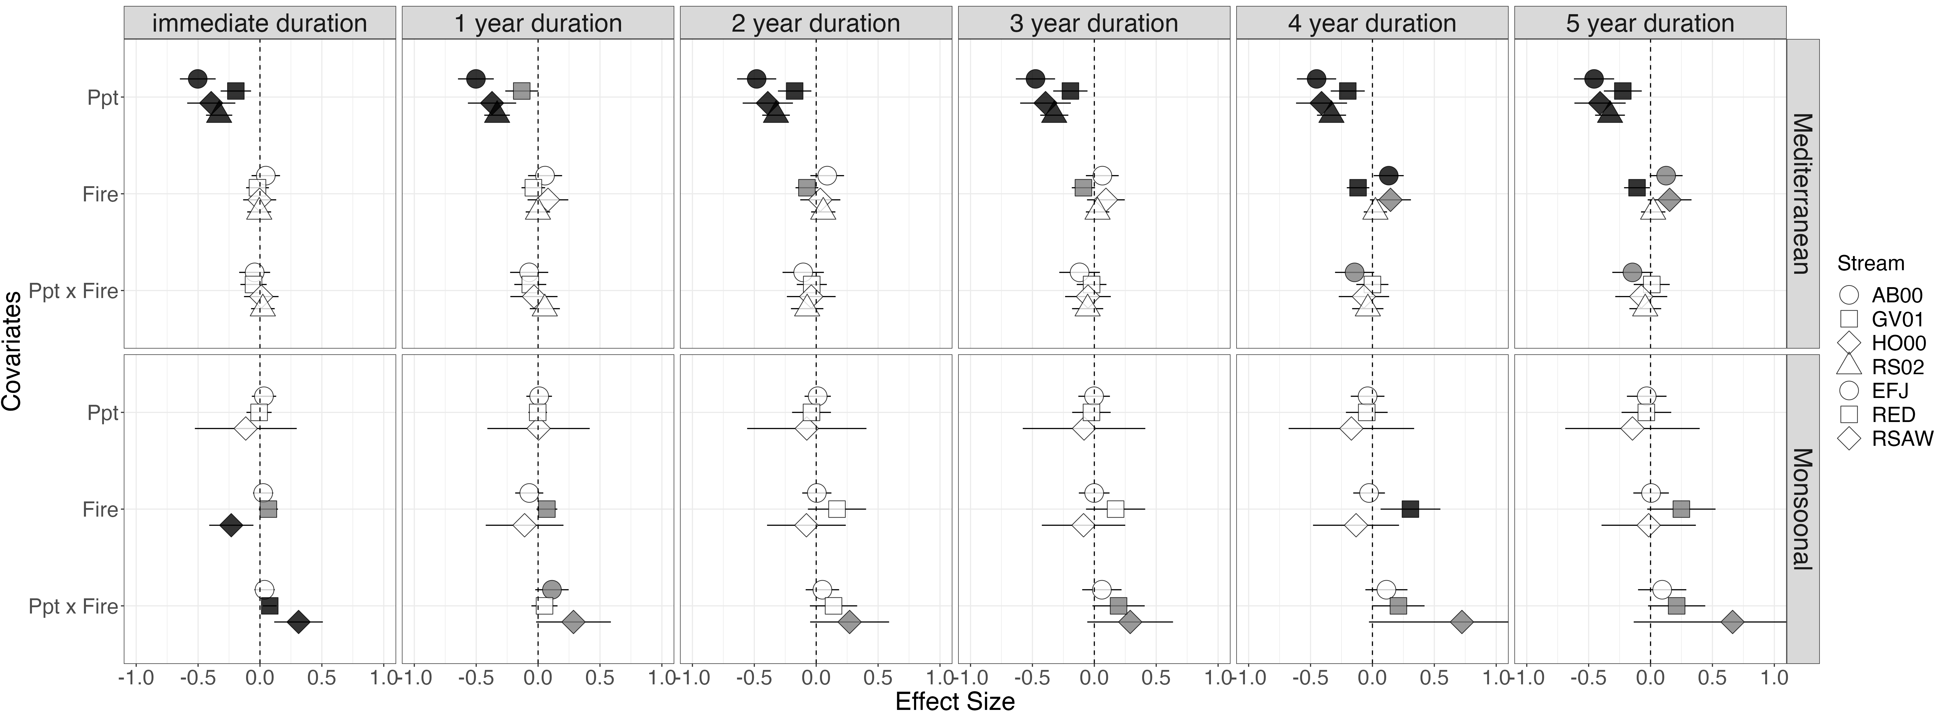

Supplementary Fig. 6 Multi-year standardized effects of precipitation (Ppt), fire (Fire), and their interaction (Ppt x Fire) on standardized, log-transformed monthly observations of specific conductance in aridland streams. Unlike in the main manuscript, the fire covariate presented in this figure is a binary variable, with 0 for unburned and 1 for burned. Sites identified as in Fig. 1. Weak effects (95% confidence intervals (CI) that do not overlap zero) are filled in gray, and strong positive and negative effects (99% CI that do not overlap zero) are filled in black. Error bars depict 99% CI.

