Supplemental Material

Seasonal patterns in riverine carbon form and export from a temperate forested watershed in Southeast Alaska

Claire Delbecq*, Jason B. Fellman, Ryan J. Bellmore, Emily J. Whitney, Eran Hood, Kevin Fitzgerald, and Jeffrey A. Falke.

*Corresponding author: cedelbecq@alaska.edu

The following Supplemental Material is available for this article:

Table S1: Concentrations and yields of the five forms of carbon.
Table S2: Invertebrate taxa present in streamwater drift samples.
Figure S1: Stage-discharge relationship for upper Montana Creek.
Figure S2: Boxplots of daily carbon yields for each month.
Figure S3: Percent contribution of invertebrate carbon to total watershed carbon export.

Table S1. Number of samples used for modeled data, range of concentrations measured with coefficient of variation, total flux for the sampling period with standard error (SE), and r² values for the model used to correlate concentration of carbon and discharge of upper Kaxdigoowu Héen. All p-values were <0.0001.

Constituent | Range of Measured Concentrations (mg/L; CV) | Total Yield kg/km²  (SE) | Model Fit
DOC (n=55) | 1.13–10.46 (0.54) | 8708 (±384) | r²=0.96
Alkalinity (n=55) | 0.69–3.00 (0.44) | 3127 (±80) | r²=0.83
POC (n=25) | 0.07–4.99 (1.99) | 992 (±229) | r²=0.93
CPOC (n=53) | 0.0007–0.5756 (1.17) | 313 (±62) | r²=0.88
Invertebrates (n=52) | 0.0018–0.079 (1.07) | 40 (±6) | r²=0.77

Table S2. Taxa present in drift samples that contributed more than one percent to terrestrial or aquatic origin biomass carbon (C) concentration (mg C/L) in Kaxdigoowu Héen, Alaska.
Terrestrial Origin Taxon | Percent contribution to Terrestrial biomass C concentration
Gastropoda (terrestrial) | 2%
Chilopoda | 2%
Collembola | 1%
Araneae | 1%
Coleoptera | 79%
Brachycera | 1%
Nematocera | 5%
Aphididae | 1%
Hymenoptera parasitoid | 7%
Lepidoptera | 1%
Aquatic Origin Taxon | Percent contribution to Aquatic biomass C concentration
Nemata | 3%
Oligochaeta | 6%
Acari | 5%
Pisces | 1%
Salmonid eggs | 4%
Ameletus | 1%
Baetis | 25%
Ephemerellidae | 2%
Heptageniidae | 18%
Leptophlebiidae | 1%
Capniidae | 1%
Chloroperlidae | 5%
Nemouridae | 2%
Limnephilidae | 4%
Rhyacophila | 3%
Amphizoa | 1%
Empididae | 1%
Muscidae | 1%
Simuliidae | 1%
Tipuloidea | 2%
Chironomidae | 11%

Figure S1. Manual measurements of stage height vs. measurements of discharge used to build the stage-discharge rating curve (Alaska Hydroscience, Juneau, AK). A stage-discharge rating curve was developing for the sampling period following Rantz et al. (1982).

Figure S2. Boxplots of daily yields for each month for: a) DOC, b) alkalinity, c) POC, d) CPOC, and e) invertebrate biomass carbon (kg C/km²/day). Note that the y-axis scale is different among figure panels. Boxes represent the inter-quartile range (IQR) with the median in bold, whiskers extend to a maximum of 1.5 times the IQR. Outliers have been excluded from this plot.

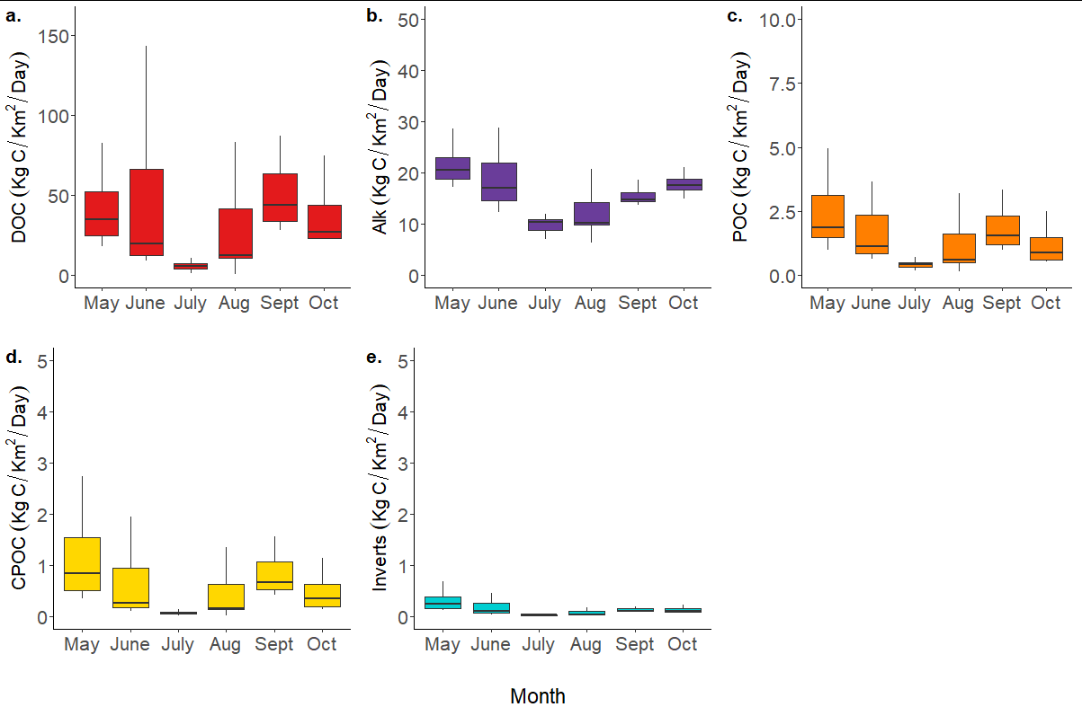

Figure S3. Percent contribution of terrestrial and aquatic origin invertebrate carbon (C) to the total watershed export of aquatic/terrestrial taxa C in Kaxdigoowu Héen, Alaska for each month and for the sampling season. Error bars represent ± standard error for each estimate, error bars that extended beyond 100% or 0% we cut off at those values.
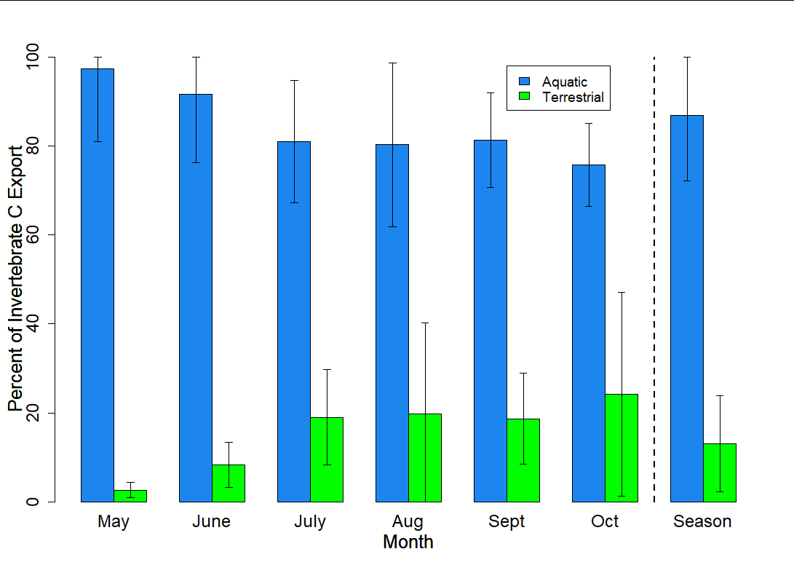

References

Rantz, SE et al. (1982) Measurement and Computation of Streamflow. Report. Vol. 1 & 2. Water Supply Paper, USGS Publications Warehouse. https://doi.org/10.3133/wsp2175.

