Journal: Biogeochemistry
Manuscript type: Research article

Black spruce boreal forest soil solution inorganic nitrogen is highly resilient to 20 years of elevated nitrogen deposition

Authors: Daniel Houle^{1,2*}, Marie Renaudin^{1,2}, Jean-David Moore³, Louis Duchesne³
¹Science and Technology Branch, Environment and Climate Change Canada, Montréal, QC, H2Y 2E7, Canada.
²Université du Québec à Montréal, Département des Sciences Biologiques, Montréal, QC, H2X 1Y4, Canada.
³ Direction de la recherche forestière, Forêt Québec, Ministère des Forêts, de la Faune et des Parcs, Québec City, QC, G1P 3W8, Canada.
*Corresponding author: Daniel Houle; daniel.houle@ec.gc.ca; (+1) 438-337-8733

Supplementary information

Table S1: Results of Mann-Kendall tests on NO₃-N, NH₄-N, and total inorganic N bulk precipitation concentrations (a) and atmospheric deposition (b) measured between 1997 and 2020 at an experimental boreal forest site.

(a) Bulk precipitation concentrations
 | Tau | P ª
NO₃-N | - 0.231 | 1.55 × 10⁻³¹ *
NH₄-N | - 0.076 | 1.24 × 10⁻⁴ *
Inorganic N | - 0.179 | 1.56 × 10⁻¹⁹ *
(b) Atmospheric deposition
 | Tau | P ª
NO₃-N | - 0.601 | 4.26 × 10⁻⁵ *
NH₄-N | - 0.362 | 0.0141 *
Inorganic N | - 0.514 | 4.69 × 10⁻⁴ *
ª *, P < 0.05.

Table S2: Results of Kruskal-Wallis tests followed by post-hoc Dunn’s tests (when applicable) showing the effects of lysimeter depth and N treatment (control: C, low N addition: LN, and high N addition: HN) on soil solution NO₃⁻ (a) and NH₄⁺ (b) concentrations measured between 2002 and 2020 at an experimental boreal forest site. Z values are reported instead of χ² when Dunn’s tests are used.

(a) NO₃⁻
 |  | df | χ² | Z | P ª
Depth | 30-60 cm | 1 | 11.14 | - | 8.45 × 10⁻⁴ *
Treatment | C-LN | 2 | - | 10.11 | 7.22 × 10⁻²⁴ *
Treatment | C-HN | 2 | - | -6.12 | 9.12 × 10⁻¹⁰ *
Treatment | HN-LN | 2 | - | 14.67 | 2.99 × 10⁻⁴⁸ *
 |  | Mean (mg.L⁻¹)
Depth | 30 cm | 0.3233
Depth | 60 cm | 0.0850
Treatment | C | 0.0307
Treatment | LN | 0.0330
Treatment | HN | 0.6977
(b) NH₄⁺
 |  | df | χ² | Z | P ª
Depth | 30-60 cm | 1 | 398.56 | - | 1.13 × 10⁻⁸⁸ *
Treatment | C-LN | 2 | - | -2.24 | 2.52 × 10⁻² *
Treatment | C-HN | 2 | - | 5.61 | 2.97 × 10⁻⁸ *
Treatment | HN-LN | 2 | - | -7.49 | 2.12 × 10⁻¹³ *
 |  | Mean (mg.L⁻¹)
Depth | 30 cm | 0.0338
Depth | 60 cm | 0.0116
Treatment | C | 0.0148
Treatment | LN | 0.0218
Treatment | HN | 0.0247
ª *, P < 0.05.

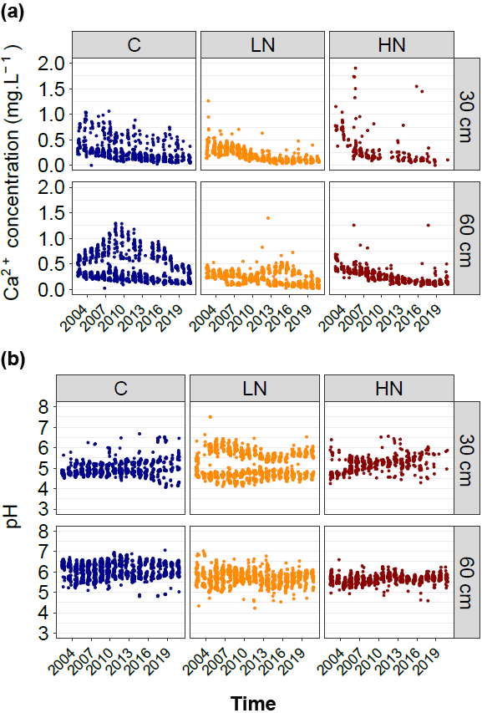
Figure S1: Temporal variations (2002-2020) of weekly measured soil solution Ca²⁺ concentration (a) and pH (b) at 30 and 60 cm depths at a Canadian experimental boreal forest submitted to three N treatments (control: C, low N addition: LN, and high N addition: HN). Point colors correspond to treatments. Observations from one of the HN treatment units were not included as a total windfall occurred in 2012 and greatly disturbed the unit’s environment.

