Supplementary material
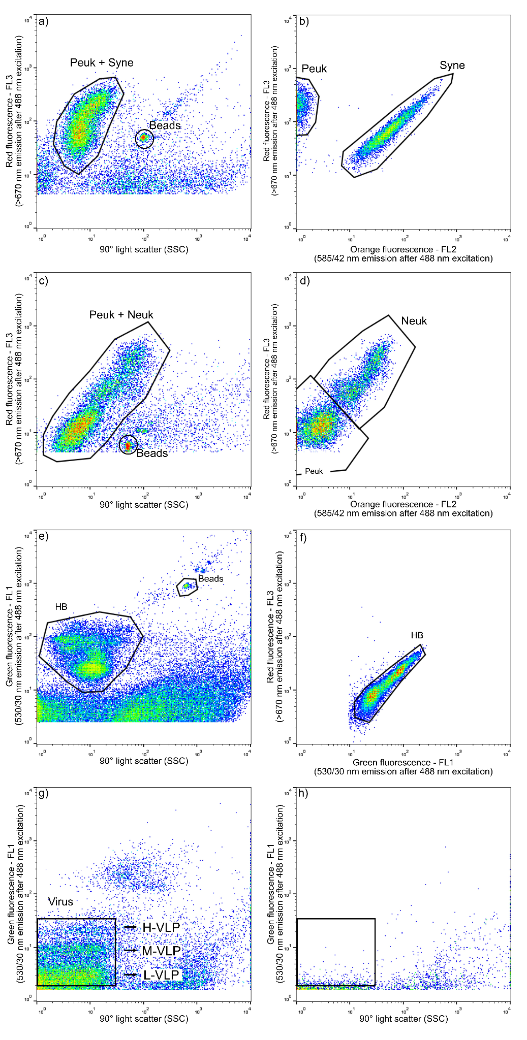
Figure S1. Examples of cytograms obtained by flow cytometry illustrating microbial population identification. (a) Picoeukaryotes (Peuk), Synechococcus (Syne) and beads distinguished by red fluorescence vs 90° light scatter (a surrogate of cell size); (b) Gated view of picoeukaryotes and Synechococcus in red vs. orange fluorescence for further characterization. (c) Picoeukaryotes, nanoeukaryotes (Neuk) and beads distinguished by red fluorescence vs 90° light scatter; (d) Gated view of picoeukaryotes and nanoeukaryotes in red vs. orange fluorescence for further characterization. (e) Heterotrophic bacteria (HB) and beads distinguished by green fluorescence vs. 90° side scatter. (f) Gated view of heterotrophic bacteria in red vs. green fluorescence. (g) Virus groups categorized by low (L-VLP), medium (M-VLP), and high (H-VLP) nucleic acid fluorescence, distinguished by their green fluorescence; (h) Corresponding virus blank.
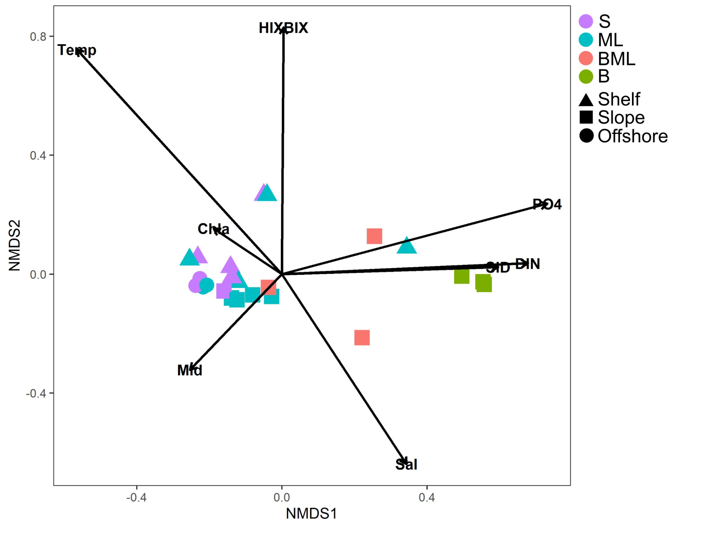
Figure S2: Non-metric multidimensional scaling (NMDS) plot using biological and environmental data. Vectors represent the direction and strength of correlation between environmental variables and NMDS coordinates. Data points are color-coded according to depth categories (S: surface, ML: mixed layer, BML: below mixed layer, B: bottom), and shape-coded by region (Shelf, Slope, and Offshore).

Table S1: Non-metric multidimensional scaling (NMDS) results using biological and environmental data. The significance of correlation is indicated by the R² value and significance levels (* p < 0.05, ** p < 0.01, *** p < 0.001).

 | R² | p
MLD | 0.1676 | 0.136
Chl-a | 0.0588 | 0.474
Temperature | 0.8901 | 0.001 | ***
Salinity | 0.5261 | 0.002 | **
FI | 0.0706 | 0.446
HIX | 0.6445 | 0.001 | ***
BIX | 0.0479 | 0.631
PO₄³⁻ | 0.5898 | 0.001 | ***
DIN | 0.4607 | 0.003 | **
SiD | 0.355 | 0.015 | *
Latitude | 0.1873 | 0.142

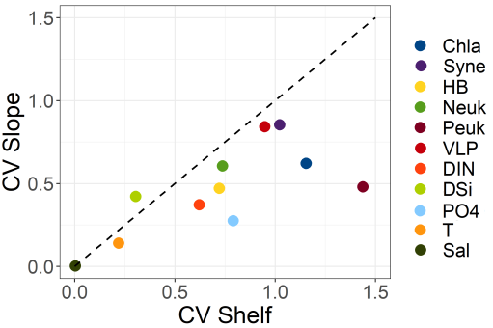
Figure S3: Natural variability for Shelf and Slope regions. Coefficient of variation (CV) for both biotic and abiotic variables, was estimated using surface and mixed layer depths.

Table S2:Values of the fluorescent components (FDOM_{B, T, A, M & C} and CDOM) in raman units (RU) and different indices proposed by Coble (1996) for the different stations and depths. St: Station; BIX: biological activity index; FI: fluorescence index; HIX: humification index; NA: data not available.
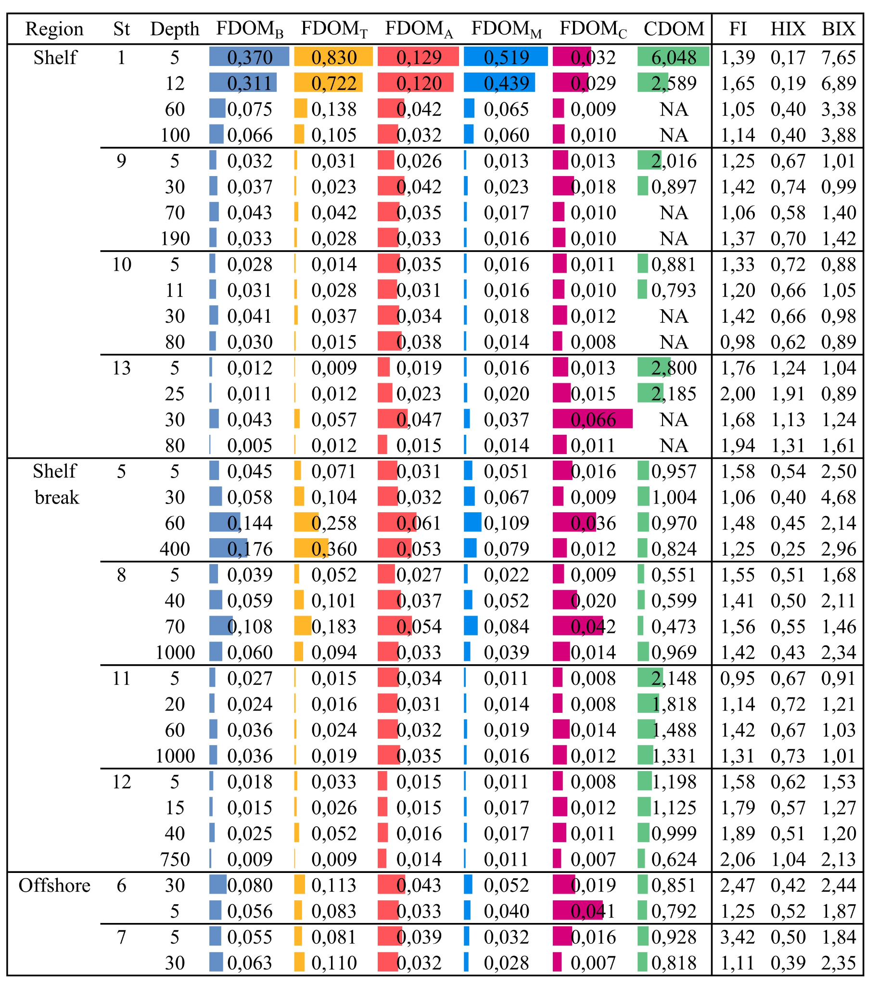
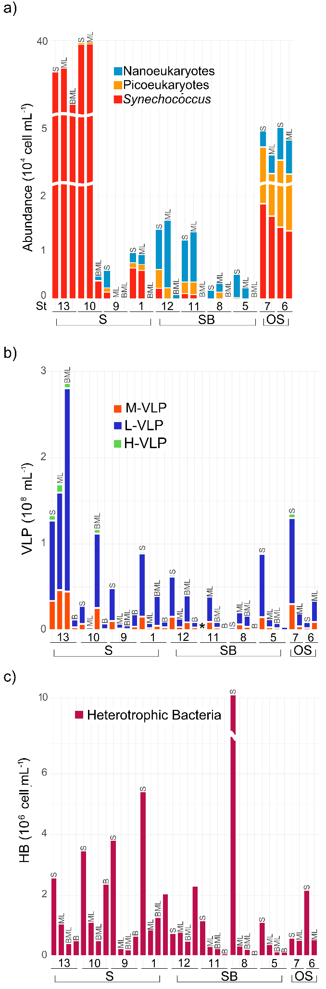
Figure S4: Cumulative bar graphs of the abundance of (a) picoeukaryotes, nanoeukaryotes, and Synechococcus (cells ml⁻¹); (b) Virus Like Particles (VLP) with low (L), medium (M), and high (H) nucleic acid fluorescence (VLP ml⁻¹); (c) Heterotrophic Bacteria (HB, cells ml⁻¹); *: data not available.

Table S3. Summary of experimental net growth (μ, d⁻¹) and mortality rates (m, d⁻¹) on total plankton (as derived from total Chl-a measurements) and discriminated by planktonic groups; HB: heterotrophic bacteria, Syne: Synechococcus, Peuk: picoeukaryotes, Neuk: nanoeukaryotes. Bacterial carbon production (BCP, µg C l⁻¹ d⁻¹) was derived from bacterial growth and mortality rates and the initial bacterial biomass. The daily proportion of specific pico/nanoeukaryotes group production consumed by microzooplankton is shown as the transformed (arctangent) value of m:μ.

 | Station |  | 𝜇 | m | BCP | Arctan (m:μ)
Shelf | 1 | HB | 0 | 0 | 0 | 0
 |  | Syne | 0.12 | 0.42 |  | 1.29
 |  | Peuk | 2.05 | 0 |  | 0
 |  | Neuk | 0.30 | 0.72 |  | 1.17
 |  | Chl-a | 0.13 | 0.67 |  | 1.38
 | 9 | HB | 0.49 | 0 | 20.71 | 0
 |  | Syne | 0 | 0 |  | 0
 |  | Peuk | 0.17 | 0 |  | 0
 |  | Neuk | 0 | 0 |  | 0
 |  | Chl-a | 1.00 | 1.34 |  | 0.93
 | 10 | HB | 0 | 0 | 0 | 0
 |  | Syne | 0 | 0 |  | 0
 |  | Peuk | 0 | 0 |  | 0
 |  | Neuk | 1.04 | 0 |  | 0
 |  | Chl-a | 0.33 | 0.97 |  | 1.24
 | 13 | HB | 0 | 0 | 0 | 0
 |  | Syne | 0.02 | 0.33 |  | 1.51
 |  | Peuk | 2.29 | 2.38 |  | 0.80
 |  | Neuk | 0 | 0 |  | 0
 |  | Chl-a | 1.27 | 1.13 |  | 0.73
Slope | 5 | HB | 0 | 0 | 0 | 0
 |  | Syne | 0 | 0 |  | 0
 |  | Peuk | 0 | 0 |  | 0
 |  | Neuk | 0 | 0 |  | 0
 |  | Chl-a | 1.06 | 0 |  | 0
 | 8 | HB | 1.32 | 0.85 | 286.32 | 0.57
 |  | Syne | 0 | 0 |  | 0
 |  | Peuk | 0 | 0 |  | 0
 |  | Neuk | 0 | 0 |  | 0
 |  | Chl-a | 0.61 | 0 |  | 0
 | 11 | HB | 1.59 | 0.74 | 24.08 | 0.44
 |  | Syne | 5.57 | 0 |  | 0
 |  | Peuk | 1.10 | 0 |  | 0
 |  | Neuk | 0 | 0.67 |  | 0
 |  | Chl-a | 1.51 | 1.30 |  | 0.71
 | 12 | HB | 0.93 | 5.65 | 1.75 | 1.41
 |  | Syne | 0 | 0 |  | 0
 |  | Peuk | 0 | 0 |  | 0
 |  | Neuk | 0 | 0 |  | 0
 |  | Chl-a | 1.03 | 0.74 |  | 0.62

