Supplementary information
Figure S1. Boxplot representing the a) Freundlich K_{f} parameter values and b) clay content by soil order.
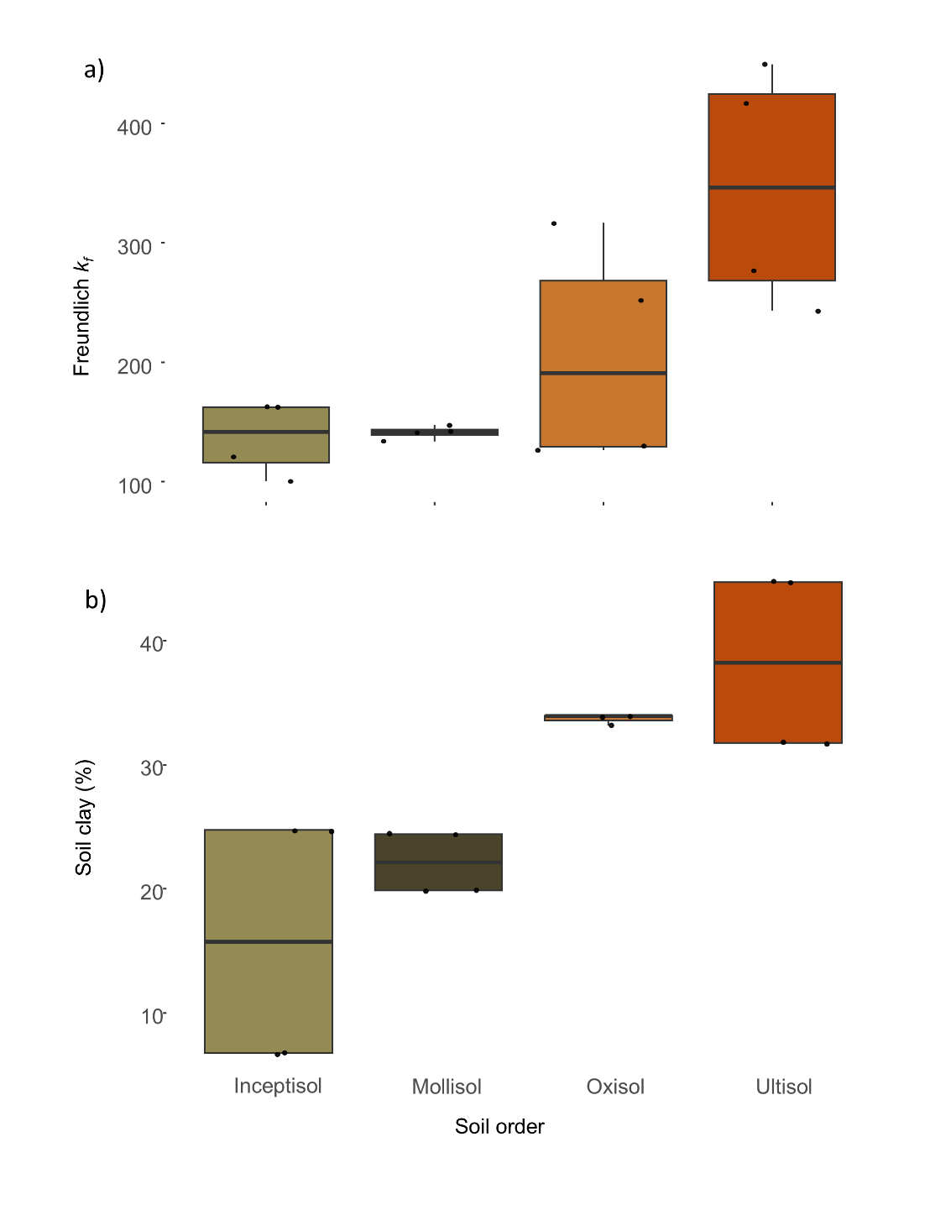

Figure S2. Percent variation of phosphorus (P) sorbed from the three different models (Freundlich in purple, Langmuir in yellow, and Temkin* in blue) and the observed sorbed P a) by soil series across all concentrations, b) by equilibrium P concentration range (P in supernatant; e.g., 0-97) across all soil series. Land use type is depicted by shape, where dots are cultivated soils and triangles are forested soils. The vertical line represents the observed sorbed P. *The Temkin model does not meet the assumption of normality of the residuals.

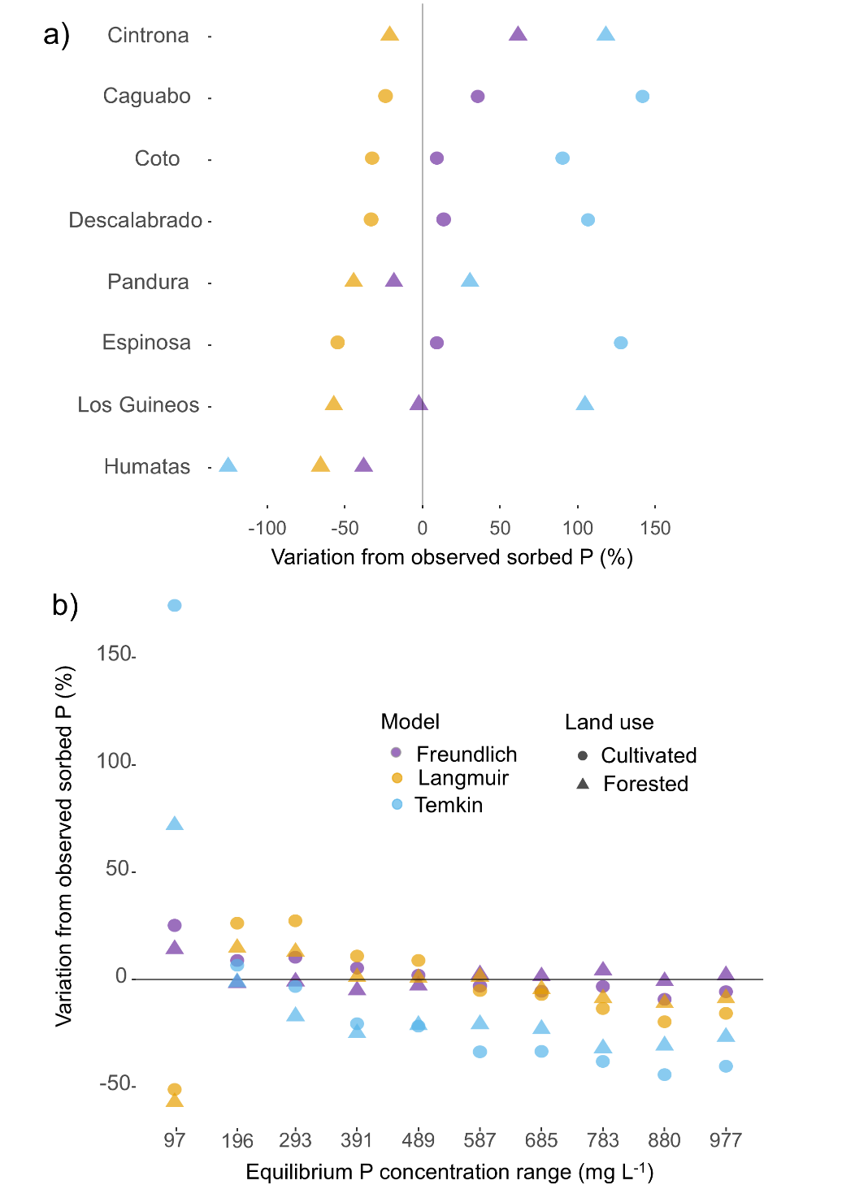
Table S1. Studies that compared best fit of soil P sorption from tropical and subtropical data using two or more different P isotherms. These studies were found through a literature search using “soil phosphorus or soil P” and “*tropic*” and “isotherm*” and “adsorption OR sorption” as TOPIC in Web of Science.

Source | Country | Biome | Ecosystem type | Soil type | Isotherms used | Soil P range | Findings
Amarh et al. 2021 | Ghana | Tropics | Uncultivated land, Cocoa farm, plantain farm | NA | Langmuir, Freundlich, Temkin | 5-45 mg P L-1 | Langmuir fitted best the data in general
Moazed et al. 2010 | Iran | Tropics | Agricultural crops | Coastal plain sands | Langmuir, Freundlich, Van Huay, Linear models | 4-70 mg P L-1 | Langmuir fitted best the data in general
Richardson and Vaithiyanathan, 1995 | USA (Everglades) | Subtropics | Freshwater wetland | Histosols | Langmuir, Freundlich, Linear models | 0-100 mg P L-1 | Freundlich best fitted the data in general
Wolde & Haile, 2015 | Ethiopia | Tropics | Agricultural crops | NA | Langmuir, Freundlich | 0-30 mg P L-1 | Freundlich fitted best the data in general
Haussin et al. 2003 | Pakistan | Tropics | Irrigated fields | NA | Langmuir, Freundlich | 0-86.4 mg P L-1 | Freundlich fitted best the data in general
Ayenew et al. 2018 | Ethiopia | Tropics | Highlands | Vertisols, Inceptisols, Ultisols | Langmuir, Freundlich | 0-32 mg P L⁻¹ | Freundlich fitted best the data in general
Tamungang et al. 2014 | Cameroon | Tropics | Unmanaged | Andisols | Freundlich, Langmuir, Temkin, Van Huay | 0-80 mg P L⁻¹ | Accuracy of fitness of data increased in the order Langmuir, Van Huay, Temkin and Freundlich
Wang and Li 2010 | USA (Florida) | Subtropics | estuary, wetland,  river, canal, marine, lake sediments | NA | Langmuir, Freundlich | 0.01-1 mmol L (0.03-31 mg P L⁻¹) | Freundlich fitted best the data in general
Getie, et al. 2021 | Ethiopia | Tropics | Plantation | Alfisols and Ultisols/Oxisols | Langmuir, Freundlich | 0.5-50 mg P L⁻¹ | Langmuir fitted best the data in general
Siradz, 2008 | Indonesia | Tropics | NA | Oxisols | Langmuir, Freundlich | 0-30 mg P L⁻¹ | Both equations described the data equally well
Lulu et al, 2022 | Ethiopia | Tropics | cropland, woodlot, grazing, garden | Mixed | Langmuir, Freundlich | 0-20 mg P L⁻¹ | Both equations described the data equally well
Wang et al. 2012 | China | Subtropics | Reservoir | NA | Langmuir, Freundlich | 0-20 mg P L⁻¹ | Both equations described the data equally well
Hadgu et al. 2014 | Ethiopia | Tropics | Highlands | Entisols, Inceptisols, Vertisols, Ultisols/Oxisols | Langmuir, Freundlich | 0-540 mg P L⁻¹ | Freundlich was better in Vertisols, Arenosols, and Nitosols. Langmuir was better in Fluvisols, and Cambisols.
Azeez & Van Averbeke, 2011 | South Africa | Tropics | cultivated | Orthic-Hutton | Langmuir, Temkin, Freundlich | 0-100 mg P L⁻¹ | Langmuir fitted best the data in general
Liang et al. 2021 | China | Subtropics | Forest | red acidic | Langmuir, Freundlich | 0-200 mg P L⁻¹ | Both equations described the data equally well
Lambano, et al. 2022 | Ethiopia | Tropics | Agricultural crops | andosols, nitisols, and vertisols | Langmuir, Freunlich | 0-50 mg P L⁻¹ | Langmuir fitted best the data in general
Yi C. et al. 2023 | China | Subtropics | Forest | red acidic | Langmuir, Freundlich | 0-200 mg P L⁻¹ | Freundlich fitted best the data in general
Brenner et al., 2018 | Mixed: Brazil, PR, CR, Panama, China, Hawaii, Kenya | Tropics and Subtropics | Forest | Mixed: Aridisol, Andisol, Inceptisol, Oxisol, Ultisol | Langmuir, Freundlich | 0-500 mg P L⁻¹ | Langmuir fitted best the data in general
Gutema et al., 2023 | Ethiopia | Tropics | Farmland | Vertisols | Langmuir, Freundlich | 0-500 mg P L⁻¹ | Freundlich fitted best the data in general
Amarakoon et al., 2019 | South Africa | Tropics |  |  | Langmuir, Freundlich | 0-300 mg P L⁻¹ | Langmuir fitted best the data in general
Guedes et al., 2015 | Brazil | Tropics | Forest | Mixed: Oxisols, Ultisols, Entisols/Inceptisols | Langmuir, Freundlich | 0-200 mg P L⁻¹ | Langmuir fitted best the data in general
Bhattacharyya et al., 2015 | India | Tropics | Farmland | NA | Langmuir, Freundlich | 0-50 ug P g⁻¹ | Langmuir fitted best the data in general
Iles et al., 2022 | Australia | Subtropics | NA | NA | Langmuir, Freundlich | 0-100 mg P L⁻¹ | Freundlich fitted best the data in general
Bera et al., 2006 | India | Tropics | Agroecological site | Alfisols | Langmuir, Freundlich | 0-80 mg P L⁻¹ | Freundlich fitted best the data in general

Table S2: Information criterion comparison of the Langmuir, Freundlich, and Temkin model by land use type and soil order. Lower AICc corresponds to better fit. Fixed effects include the two parameters of each model, and random effects include the soil series (series) and the sample ID.

Model | E¹ | AICc² | Δ AICc | Fixed | First param³ | Second param⁴ | Random | Std Dev⁵ series | Std Dev series+ID | Residual
Sub-group: Forested soils
Freundlich | 5 | 3267.95 | 0.00 | Kf+n | 294.95 | 0.31 | Kf|series/ID | 148.12 | 45.44 | 133.96
Langmuir | 5 | 3520.91 | 252.95 | Vm+k | 2159.22 | 53.89 | Vm|series/ID | 1043.25 | 302.19 | 232.35
Temkin | 5 | 3776.22 | 508.27 | Kt+B | 220.22 | 204.61 | Kt|series/ID | 372.21 | 0.15 | 365.91
Sub-group: Cultivated soils
Freundlich | 5 | 3046.55 | 0.00 | Kf+n | 130.01 | 21.40 | Kf|series/ID | 40.68 | 19.02 | 81.81
Langmuir | 5 | 3368.61 | 322.06 | Vm+k | 1707.97 | 107.76 | Vm|series/ID | 481.87 | 216.21 | 164.17
Temkin | 5 | 3616.59 | 570.04 | Kt+B | 5.94 | 139.71 | B|series/ID | 37.01 | 18.95 | 276.36
Sub-group: Inceptisols
Freundlich | 5 | 1244.99 | 0.00 | Kf+n | 108.47 | 0.38 | Kf|series/ID | 0.01 | 27.76 | 83.41
Langmuir | 5 | 1352.18 | 107.19 | Vm+k | 1413.25 | 107.47 | Vm|series/ID | 0.04 | 350.89 | 146.02
Temkin | 5 | 1470.72 | 225.73 | Kt+B | 12.90 | 102.12 | B|series/ID | 0.01 | 25.14 | 272.10
Sub-group: Mollisols
Freundlich | 5 | 1854.19 | 0.00 | Kf+n | 78.24 | 0.45 | Kf|series/ID | 4.88 | 15.18 | 65.90
Langmuir | 5 | 2023.64 | 169.45 | Vm+k | 1579.19 | 122.68 | Vm|series/ID | 0.03 | 235.12 | 120.64
Temkin | 5 | 2187.51 | 333.31 | Kt+B | 45.19 | 134.39 | B|series/ID | 53.47 | 0.05 | 381.77
Sub-group: Oxisols
Freundlich | 5 | 1816.27 | 0.00 | Kf+n | 234.41 | 0.32 | Kf|series/ID | 90.39 | 40.97 | 128.25
Langmuir | 5 | 1957.73 | 141.47 | Vm+k | 1881.07 | 59.24 | Vm|series/ID | 707.48 | 278.77 | 219.16
Temkin | 5 | 2095.34 | 279.08 | Kt+B | 57.99 | 162.54 | Kt|series/ID | 58.93 | 0.00 | 376.87
Sub-group: Ultisols
Freundlich | 5 | 1315.81 | 0.00 | Kf+n | 436.03 | 0.30 | Kf|series/ID | 110.95 | 38.97 | 130.12
Langmuir | 5 | 1474.59 | 158.78 | Vm+k | 2960.75 | 54.30 | Vm|series/ID | 739.64 | 168.00 | 298.15
Temkin | 5 | 1565.47 | 260.39 | Kt+B | 411.20 | 208.36 | Kt|series/ID | 429.64 | 0.00 | 467.79

1.Number of estimated parameters
2. Akaike Information Criterion with correction for small sample size
3. For Freundlich is K_{f}, for Langmuir is Vmax, for Temkin is K_{t}
4. For Freundlich is n, for Langmuir is Vmax, for Temkin is B
5 Standard deviation

Table S3: Information criterion comparison of the Langmuir, Freundlich, and Temkin model on the full dataset using low P concentrations in supernatant (x axis<100 mgL⁻¹). Lower AICc corresponds to better fit. Fixed effects include the two parameters of each model, and random effects include the soil series (series) and the sample ID

Model | E¹ | AICc² | Δ AICc | Fixed | First param³ | Second param⁴ | Random | Std Dev⁵ series | Std Dev series+ID | Residual
Freundlich | 5 | 4448.29 | 0.00 | Kf+n | 246.55 | 0.29 | Kf|series/ID | 150.09 | 69.08 | 85.38
Langmuir | 5 | 4734.05 | 285.77 | Vm+k | 802.08 | 4.33 | Vm|series/ID | 502.13 | 0.14 | 145.54
Temkin | 5 | 4870.12 | 421.84 | Kt+B | 1566.66 | 47.65 | B|Series/ID | 32.80 | 0.01 | 175.95

SI References
Amarakoon, I., Zvomuya, F. and Motaung, M.L. (2019) Temperature‐dependency of phosphorus sorption by Goethites and tropical soils amended with woodchip biochar. Agrosystems, geosciences & environment, 2(1), pp.1-6.
Amarh, F., Voegborlo, R.B., Essuman, E.K., Agorku, E.S., Tettey, C.O. and Kortei, N.K. (2021) Effects of soil depth and characteristics on phosphorus adsorption isotherms of different land utilization types: Phosphorus adsorption isotherms of soil. Soil and Tillage Research, 213, p.105139.
Ayenew, B., Tadesse, A.M., Kibret, K. et al. (2018) Phosphorus status and adsorption characteristics of acid soils from Cheha and Dinsho districts, southern highlands of Ethiopia. Environ Syst Res 7, 17.
Azeez, J. O., & Van Averbeke, W. (2011) Effect of Manure Types and Period of Incubation on Phosphorus-Sorption Indices of a Weathered Tropical Soil. Communications in Soil Science and Plant Analysis, 42(18), 2200–2218. https://doi.org/10.1080/00103624.2011.602452
Bera, R., Seal, A., Bhattacharyya, P., Mukhopadhyay, K. and Giri, R. (2006) Phosphate sorption desorption characteristics of some ferruginous soils of tropical region in Eastern India. Environmental geology, 51, pp.399-407.
Bhattacharyya, P., Nayak, A.K., Shahid, M., Tripathi, R., Mohanty, S., Kumar, A., Raja, R., Panda, B.B., Lal, B., Gautam, P. and Swain, C.K. (2015) Effects of 42-year long-term fertilizer management on soil phosphorus availability, fractionation, adsorption–desorption isotherm and plant uptake in flooded tropical rice. The Crop Journal, 3(5), pp.387-395.
Brenner, J., Porter, W., Phillips, J.R., Childs, J., Yang, X. and Mayes, M.A. (2018) Phosphorus sorption on tropical soils with relevance to Earth system model needs. Soil research, 57(1), pp.17-27.
Getie, A., Kiflu, A., & Meteke, G. (2021) Phosphorus sorption characteristics of luvisols and nitisols in north Ethiopian soils. Applied and Environmental Soil Science, 2021(1), 8823852. https://doi.org/10.1155/2021/8823852
Guedes, R.S., Fernandes, A.R., Souza, E.S.D. and Silva, J.R.R.E. (2015) Maximum phosphorus adsorption capacity adjusted to isotherm models in representative soils of eastern Amazon. Communications in Soil Science and Plant Analysis, 46(20), pp.2615-2627.
Gutema, D.T., Kibret, K., Robi, N.D. and Mirkena, L.W. (2023) Effect of mixed manure on selected chemical properties, and phosphorus adsorption characteristics of Vertisols in Haramaya district, eastern Ethiopia. Agrosystems, Geosciences & Environment, 6(4), p.e20448.
Hadgu, F., Gebrekidan, H., Kibret, K. and Yitaferu, B. (2014) Study of phosphorus adsorption and its relationship with soil properties, analyzed with Langmuir and Freundlich models. Agriculture, Forestry and Fisheries, 3(1), pp.40-51.
Hussain A, Ghafoor A., Anwar-Ul-Haq M., Nawaz M. (2003) Application of the Langmuir and Freundlich equations for P Adsorption Phenomenon in Saline-Sodic Soils. Int J Agric Biol 3: 349–356.
Iles, J.A., Pettit, N.E., Donn, M.J. and Grierson, P.F. (2022) Phosphorus sorption characteristics and interactions with leaf litter-derived dissolved organic matter leachate in iron-rich sediments of a sub-tropical ephemeral stream. Aquatic Sciences, 84(4), p.56.
Lambano, B.G.H., Beyene, S. and Abera, G., 2022. Phosphorus sorption characteristics as influenced by major soil units in southern Ethiopia. Journal of Plant Nutrition and Soil Science, 185(4), pp.486-494.
Liang, J., Chen, L., Liu, D., Yi, C. and Zhu, J. (2021_ Sorption and environmental risks of phosphorus in subtropical forest soils. Adsorption Science & Technology, 2021, pp.1-7.
Lulu, M., Lemma, B. and Melese, A. (2022) Phosphorous Sorption Characteristics of Soils in Smallholding Land Use in Southern Ethiopia. Applied and Environmental Soil Science.
Moazed, H., Hoseini, Y., Naseri, A.A. and Abbasi, F. (2010_ Determining Phosphorus Adsorption Isotherm in Soil and its. International Journal of Soil Science, 5(3), pp.131-139.
Richardson, C.J. and Vaithiyanathan, P. (1995) Phosphorus sorption characteristics of Everglades soils along a eutrophication gradient. Soil Science Society of America Journal, 59(6), pp.1782-1788.
Siradz, S.A. (2009) Phosphorus sorption characteristics of red soils from Lampung, west-and central Java. Journal of Tropical Soils, 14(1), pp.25-31.
Tamungang NE, Mvondo-Zé AD, Alakeh MN, et al. (2014) Phosphorus Adsorption Isotherms in
Relation to Soil Characteristics of Some Selected Volcanic Affected Soils of Foumbot in the West Region of Cameroon. Int J Soil Sci 11: 19–28.
Wolde, Z. and Haile, W. (2015) Phosphorus sorption isotherms and external phosphorus requirements of some soils of southern Ethiopia. African Crop Science Journal, 23(2), pp.89-99.
Wang Q, Li Y. (2010) Phosphorus adsorption and desorption behavior on sediments of different
origins. J Soils Sediments 10: 1159–1173.
Wang, X., Zhang, L., Zhang, H., Wu, X. and Mei, D. (2012) Phosphorus adsorption characteristics at the sediment–water interface and relationship with sediment properties in FUSHI reservoir, China. Environmental Earth Sciences, 67, pp.15-22.
Yi, C., Zhu, J., Chen, L., Huang, X., Wu, R., Zhang, H., Dai, X. and Liang, J. (2023) Speciation of Iron and Aluminum in Relation to Phosphorus Sorption and Supply Characteristics of Soil Aggregates in Subtropical Forests. Forests, 14(9), p.1804.

