Supplementary Info

Arctic willow (Salix polaris) exudation as a driver of microbial activity and soil formation in the High Arctic tundra

Journal: Biogeochemistry

Václav Tejnecký*, Petra Luláková, Hana Šantrůčková, Petra Křížová, Jiří Lehejček, Tomáš Hájek, Filip Mercl, Jiří Bárta, Karel Němeček, Ondřej Drábek
*Corresponding author: tejnecky@af.czu.cz

Detail description of willow age determination

The age of willows on each locality was determined. First, the stem was hand-sawed to obtain tap-root disc with the cross-section surface which is the part where usually the highest amount of rings of S. polaris occurs (Buchwal et al. 2013). Solution of corn starch and water was then applied on the surface to stabilize the cell walls to prevent later distortion of cellular structure (Schneider & Gärtner 2013). The 15 – 20 micrometers thick thin-sections were afterwards obtained using a sliding lab-microtome. Sodium hypochlorite was used as a bleaching agent, prior to cleaning the thin sections with water, and double-staining for 5 minutes in a 1:1 solution of Safranin and Astrablue (solution used according to (Schweingruber et al. 2013). After washing by water, the increasing ethanol concentrations were used (70%, 90%, and 98%, respectively) to dehydrate the samples. Finally, the samples were preserved by Canada balsam, embedded under a cover glass (Schweingruber et al. 2007) and dried for at least 12 hours at 60 °C. Images of microsections were taken using a digital camera (Canon EOS 650D) connected to a microscope (Olympus BX41) under x100 magnification. Photos were connected by the PTGui software (PTGui 2015) into an image of complete plant tap root cross-section. The images were analyzed visually for age determination. We used rather conservative approach of age estimation – only counting the complete and wedging rings. Thus, such count gives us the minimal age of plant rather than ultimate dating of establishment. This is, because the Arctic shrubs are known to “contain” missing rings as a result of extreme climate condition they live in Schweingruber and Poschlod (2005). For the purposes of this study we did not find necessary to apply serial sectioning developed by (Kolishchuk 1990) which can date each tree ring because we did not relate particular rings to any events.

Literature

Buchwal A, Rachlewicz G, Fonti P, Cherubini P, Gärtner H (2013) Temperature modulates intra-plant growth of Salix polaris from a high Arctic site (Svalbard). Polar Biol 36(9): 1305-1318
Kolishchuk VG (1990) Dendroclimatological study of prostrate woody plants. In: Cook ER & Kairiukstis LA (eds) Kluwer Methods of dendrochronology. Applications in the environmental sciences. Springer London.
Mercl F, Tejnecký V, Száková J, Hubová P, Tlustoš P (2017) Influence of Rhizon MOM suction cup and Triticum aestivum L. on the concentration of organic and inorganic anions in soil solution. J Soils Sediments 17(3): 820-826
PTGui (2015) New House Internet Services B.V., Rotterdam, The Netherlands. In.
Shabir GA (2003) Validation of high-performance liquid chromatography methods for pharmaceutical analysis: Understanding the differences and similarities between validation requirements of the US Food and Drug Administration, the US Pharmacopeia and the International Conference on Harmonization. Journal of Chromatography A 987(1–2): 57-66
Schneider L, Gärtner H (2013) The advantage of using a starch based non-Newtonian fluid to prepare micro sections. Dendrochronologia 31(3): 175-178
Schweingruber FH, Börner A, Schulze ED (2007) Atlas of woody plants: evolution, structure, and environmental modifications. Springer Berlin Heidelberg,
Schweingruber FH, Hellmann L, Tegel W, Braun S, Nievergelt D, Büntgen U (2013) Evaluating the wood anatomical and dendroecological potential of arctic dwarf shrub communities. In: Wood Structure in Plant Biology and Ecology. Brill. p 157-169
Schweingruber FH, Poschlod P (2005) Growth rings in herbs and shrubs: Life span,age determination and stem anatomy. Swiss Federal Research Institute WSL,

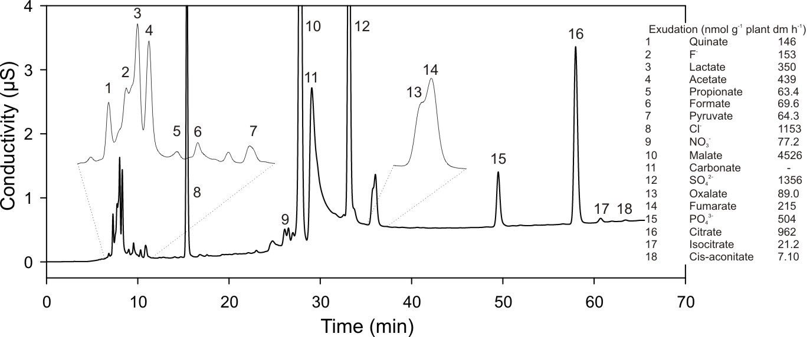
Figure S1. Example of chromatogram of exudates of Salix polaris from glacier forefield habitat. Table on the right shows name and amount of exuded LMMOA species and also inorganic anions.

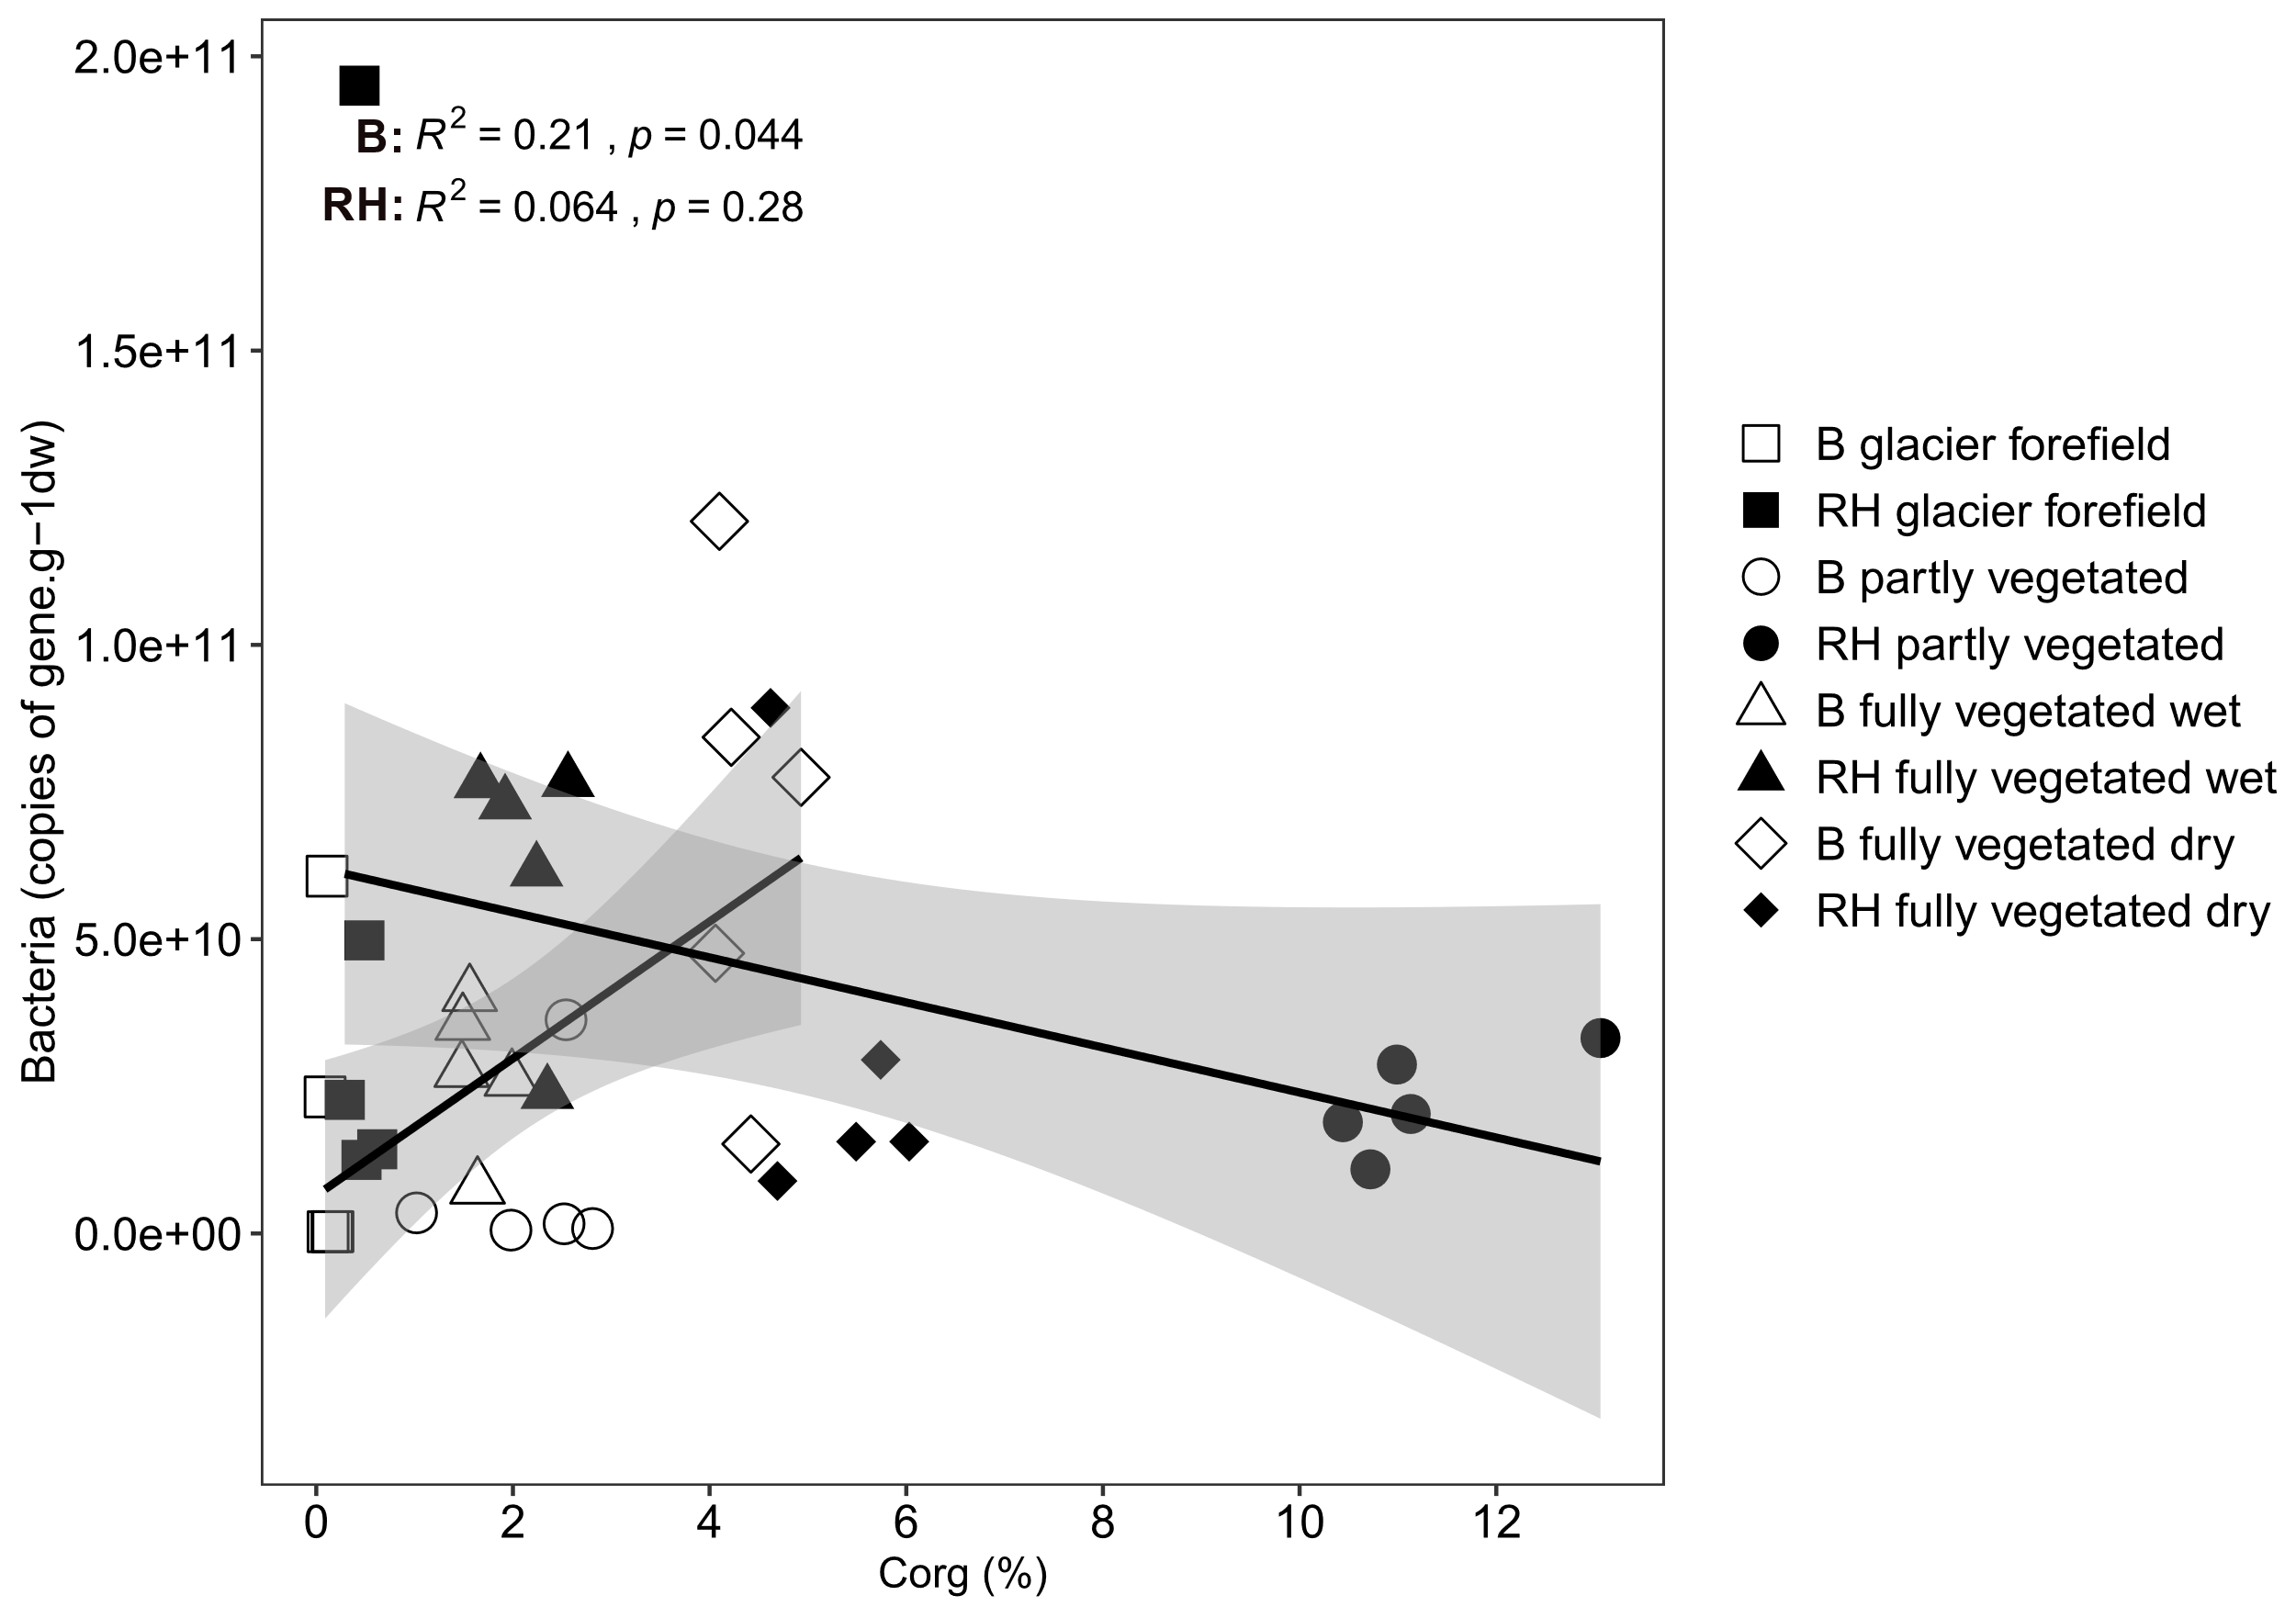
Figure S2. Correlations between soil organic C and bacterial gene copies, counted across all sites. Open symbols indicate the bulk soil (B), and closed symbols indicate rhizosphere soils (RH).
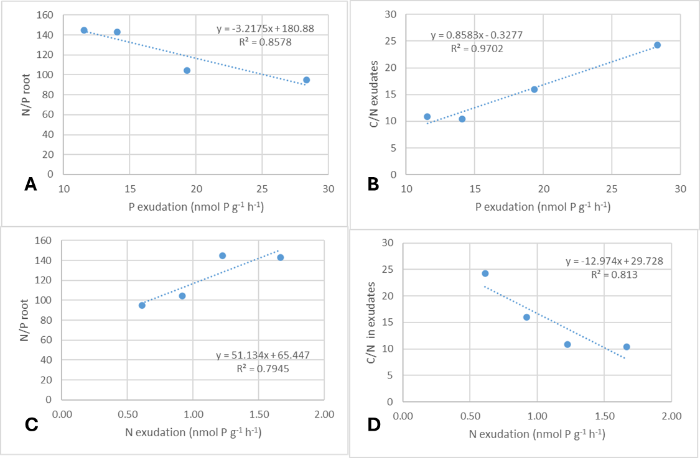
Figure S3. Correlations between P exudation and N/P roots (A) or C/N exudation (B) and between N exudation and N/P roots (C) or C/N in exudates (D). Average values from the site are given.

Table S1 Total content of Si, Al, Ca, Fe and K (in %) in bulk soils and rhizosphere effect (RE = RH soil /BS) (mean and standard deviation, n = 5). Small letters indicate difference between habitats.
 | Sit (%) |  |  | Alt (%) |  |  | Cat (%) |  |  | Fet (%) |  |  | Kt (%)
 | mean | SD | H.G. | mean | SD | H.G. | mean | SD | H.G. | mean | SD | H.G. | mean | SD | H.G.
Glacier forefield | 24.7 | 0.89 | d | 6.49 | 0.49 | c | 3.38 | 1.73 | a | 2.46 | 0.25 | c | 1.93 | 0.31 | c
Partly vegetated tundra | 11.8 | 1.02 | b | 2.74 | 0.35 | b | 6.78 | 1.09 | b | 1.49 | 0.06 | a | 0.88 | 0.04 | b
Fully vegetated dry tundra | 10.3 | 0.37 | a | 2.15 | 0.08 | a | 2.66 | 0.15 | a | 1.35 | 0.03 | a | 0.44 | 0.03 | a
Fully vegetated wet tundra | 15.4 | 0.68 | c | 2.94 | 0.22 | b | 3.15 | 0.18 | a | 1.96 | 0.12 | b | 0.56 | 0.02 | a
RE | Sit |  |  | Alt |  |  | Cat |  |  | Fet |  |  | Kt
 | mean | SD | H.G. | mean | SD | H.G. | mean | SD | H.G. | mean | SD | H.G. | mean | SD | H.G.
Glacier forefield | 0.84 | 0.05 | a | 0.80 | 0.14 | a | 1.12 | 0.52 | b | 1.00 | 0.20 | a | 1.22 | 0.34 | a
Partly vegetated tundra | 1.32 | 0.29 | b | 1.12 | 0.16 | b | 0.70 | 0.16 | a | 1.48 | 0.08 | b | 1.10 | 0.07 | a
Fully vegetated dry tundra | 1.68 | 0.26 | c | 1.54 | 0.21 | c | 1.78 | 0.13 | c | 1.74 | 0.05 | c | 1.82 | 0.13 | c
Fully vegetated wet tundra | 1.24 | 0.11 | b | 1.26 | 0.15 | b | 1.60 | 0.16 | c | 1.38 | 0.08 | b | 1.52 | 0.08 | b

Table S2 Contents of water extractable inorganic N (Nmin), cation exchange capacity (CEC, in mmol kg⁻¹) and exchangeable Ca, Mg, Fe and K (in mg kg⁻¹) and rhizosphere effect (RE = RH soil /BS) (mean and standard deviation, n = 5). Small letters indicate difference between habitats.
 | Nmin (mg kg⁻¹) |  |  | CEC (meq+ kg⁻¹) |  |  | Caex (mg kg⁻¹) |  |  | Mgex (mg kg⁻¹) |  |  | Feex (mg kg⁻¹) |  |  | Kex (mg kg⁻¹)
 | mean | SD | H.G. | mean | SD | H.G. | mean | SD | H.G. | mean | SD | H.G. | mean | SD | H.G. | mean | SD | H.G.
Glacier forefield | 2.15 | 0.47 | b | 46.1 | 25.0 | a | 741 | 459 | a | 40.4 | 10.1 | a | 34.9 | 15.9 |  | 103 | 23.4 | b
Partly vegetated tundra | 2.82 | 0.70 | b | 92.8 | 8.27 | b | 1522 | 136 | b | 155 | 27.5 | b | 35.9 | 20.5 |  | 80.6 | 10.7 | a
Fully vegetated dry tundra | 2.47 | 1.15 | b | 268 | 38.6 | c | 4814 | 741 | c | 285 | 21.7 | c | 22.2 | 12.3 |  | 98.1 | 7.02 | ab
Fully vegetated wet tundra | 0.79 | 0.38 | a | 101 | 16.6 | b | 1802 | 294 | b | 80.7 | 14.1 | b | 21.3 | 9.42 | n.s. | 88.5 | 15.5 | ab
RE | Nmin |  |  | CEC |  |  | Caex |  |  | Mgex |  |  | Feex |  |  | Kex
 | mean | SD | H.G. | mean | SD | H.G. | mean | SD | H.G. | mean | SD | H.G. | mean | SD | H.G. | mean | SD | H.G.
Glacier forefield | 0.90 | 0.81 | a | 2.16 | 0.90 | a | 1.96 | 0.73 | a | 4.52 | 3.53 | b | 0.94 | 0.84 |  | 4.20 | 2.72
Partly vegetated tundra | 0.24 | 0.13 | a | 6.48 | 2.37 | b | 6.78 | 2.64 | b | 5.94 | 1.96 | b | 0.66 | 0.54 |  | 3.84 | 2.61
Fully vegetated dry tundra | 3.34 | 1.74 | b | 1.16 | 0.36 | a | 1.12 | 0.41 | a | 1.30 | 0.46 | a | 7.52 | 15.2 |  | 1.94 | 0.86
Fully vegetated wet tundra | 5.30 | 3.06 | b | 1.20 | 0.16 | a | 1.16 | 0.17 | a | 1.32 | 0.25 | a | 2.20 | 1.57 | n.s. | 1.90 | 0.25 | n.s.
H.G. homogeneous groups; SD standard deviation; n.s. not significant difference

Table S3 Basic statistical parameters of LMMOA determined in willow (Salix polaris) exudates (µmol C L⁻¹; all 20 samples) in a microcosm experiment. Exudates were collected from 20 individual plants, five from each habitat. In one case, the amount of quinate, formate, malate and citrate from the glacier forefield and the amount of lactate from the fully vegetated wet tundra were determined as outlying values, and these values were removed from the dataset for further statistical testing.
 | Quinate | Lactate | Acetate | Propionate | Formate | Pyruvate | Malate | Oxalate | Citrate
Detection limit | 0.013 | 0.012 | 0.016 | 0.020 | 0.008 | 0.017 | 0.015 | 0.011 | 0.023
Count bellow DL | 6 | 0 | 0 | 5 | 0 | 0 | 3 | 0 | 4
Average | 0.44 | 6.67 | 3.06 | 0.23 | 2.17 | 0.31 | 9.13 | 0.29 | 2.16
Median | 0.02 | 3.83 | 1.88 | 0.06 | 0.39 | 0.08 | 0.25 | 0.11 | 0.12
Standard deviation | 1.35 | 8.41 | 3.58 | 0.65 | 6.43 | 0.62 | 34.48 | 0.50 | 7.66
Minimum | 0.007* | 1.06 | 0.75 | 0.010* | 0.14 | 0.02 | 0.007* | 0.04 | 0.011*
Maximum | 6.03 | 38.0 | 16.8 | 2.95 | 28.8 | 2.50 | 155 | 2.29 | 34.6
* ½ of detection limit

Table S4 Corelations water extractable elements and substances (H2O), exchangeable elements (ex), cation exchange capacity (CEC) and organic C (Corg) (n = 40).
 | Corg | Ca H2O | K H2O | Mg H2O | Na H2O | SO₄²⁻ H2O | Cl⁻ H2O | Ca ex | K ex | Mg ex | Na ex | CEC
Corg
Ca H2O | 0.885 |  |  |  |  |  |  | p = | 0.050 | 0.010
K H2O | 0.095 | 0.366 |  |  |  |  |  | p = | 0.010 | 0.001
Mg H2O | 0.786 | 0.911 | 0.595 |  |  |  |  | p < |  | 0.001
Na H2O | 0.030 | 0.248 | 0.870 | 0.460
SO4 2- H2O | 0.523 | 0.723 | 0.709 | 0.897 | 0.659
Cl - H2O | 0.494 | 0.737 | 0.738 | 0.826 | 0.543 | 0.805
Ca ex | 0.933 | 0.873 | 0.189 | 0.745 | 0.090 | 0.462 | 0.561
K ex | 0.226 | 0.485 | 0.972 | 0.686 | 0.849 | 0.763 | 0.809 | 0.317
Mg ex | 0.932 | 0.911 | 0.366 | 0.908 | 0.247 | 0.683 | 0.689 | 0.933 | 0.495
Na ex | -0.047 | 0.053 | 0.608 | 0.242 | 0.788 | 0.418 | 0.379 | -0.016 | 0.615 | 0.101
CEC | 0.938 | 0.888 | 0.234 | 0.780 | 0.130 | 0.507 | 0.595 | 0.998 | 0.363 | 0.952 | 0.015

