Supplemental Information
Identifying soil N₂O sources by combining laboratory experiments with process based-models

Zhifeng Yan ^{a,b,*}, Zhaopei Chuª, Balázs Grosz ^{c}, Baoxuan Changª, Narasinha Shurpali ^{d}, Gang Liu ^{e}, Zhaolei Li ^{f}, Jinsen Zheng ^{g}, Si-liang Li ^{a,b},Klaus Butterbach-Bahl ^{h,i}
ª Institute of Surface-Earth System Science, School of Earth System Science, Tianjin University, Tianjin 300072, China
^{b} Critical Zone Observatory of Bohai Coastal Region, Tianjin Key Laboratory of Earth Critical Zone Science and Sustainable Development in Bohai Rim, Tianjin University, Tianjin 300072, China
^{c} Thünen Institute of Climate-Smart Agriculture, 38116 Braunschweig, Germany
^{d} Natural Resources Institute Finland, Halolantie 31 A, 71750 Maaninka Finland
^{e} College of Management and Economics, Tianjin University, Tianjin, 300072, China
^{f} Key Laboratory of Low-carbon Green Agriculture in Southwestern China, Ministry of Agriculture and Rural Affairs,Interdisciplinary Research Center for Agriculture Green Development in Yangtze River Basin, College of Resources and Environment, Southwest University, Chongqing, China
^{g} Crop, Livestock and Environment Division, Japan International Research Center for Agricultural Sciences, Ohwashi 1-1, Tsukuba, Ibaraki, 305-8686 Japan
^{h} Institute of Meteorology and Climate Research, Atmospheric Environmental Research, Karlsruhe Institute of Technology, Garmisch-Partenkirchen, Germany
^{i} Pioneer Center Land-CRAFT, Agroecology, Aarhus University, Aarhus C, Denmark

∗ Corresponding author:
Zhifeng Yan, Institute of Surface-Earth System Science, School of Earth System Science, Tianjin University, Tianjin 300072, China Email: yanzf17@tju.edu.cn

This Supplementary Materials provide expanded methodological details, supporting analyses, and additional tables and figures that substantiate the core findings presented in the main manuscript.

1. Calculation of NH₄⁺ and DOC concentrations
The adsorbed and dissolved NH₄⁺ are assumed to reach equilibrium and follow the Langmuir model as below (Sieczka & Koda 2016):
$$q_{NH_{4}^{+}}= \frac{q_{max}K_{L}C_{N{H_{4}}^{+}}}{1+K_{L}C_{N{H_{4}}^{+}}}$$ | (S1)
where $q_{N{H_{4}}^{+}}$ is the concentration of adsorbed NH₄⁺, $q_{max}$ is the maximum adsorption capacity of NH₄⁺, $K_{L}$ is the Langmuir constant, and $C_{N{H_{4}}^{+}}$ is the concentration of dissolved NH₄⁺. Moreover, dissolved NH₄⁺ and dissolved NH₃ are assumed to reach equilibrium as below (Maggi et al. 2008):
$$C_{NH_{3},aq}= \frac{C_{N{H_{4}}^{+}}}{{{10}^{-pH}K}_{NH_{3}-N{H_{4}}^{+}}}$$ | (S2)
where $C_{NH_{3},aq}$ is the concentration of dissolved NH_{3,} and $K_{NH_{3}-N{H_{4}}^{+}}$ is the equilibrium constant.
The exchange rate between dissolved organic carbon (DOC) and soil adsorbed organic carbon (SOC),$r_{SOC-DOC}$, was estimated as below (Yan et al. 2018):
$$r_{SOC-DOC}= \frac{{αθ(C}_{SOC}-K_{SOC}C_{DOC})}{K_{θ}+θ}$$ | (S3)
where $α$ is the mass transfer coefficient, $K_{SOC}$ is the adsorption and desorption equilibrium constant of DOC, $K_{θ}$ is the moisture constant, $C_{SOC}$ is the SOC content, and $C_{DOC}$ is the DOC concentration.

2. Calculation of nitrogen flows
During the simulations, the N flows from initial NH₄⁺ to NO₂⁻ ($F_{N}$) and from initial NO₃⁻to NO₂⁻ ($F_{D}$) can be calculated by the following equations,
$$F_{N}= \sum_{j=1}^{N_{t}}{\sum_{i=1}^{N_{z}}{r_{N{H_{4}}^{+}-{NO_{2}}^{-},i,j}V_{i}}θ_{i}∆t}$$ | (S4)
$$F_{D}= \sum_{j=1}^{N_{t}}{\sum_{i=1}^{N_{z}}{r_{N{O_{3}}^{-}-N{O_{2}}^{-},D,i,j}V_{i}}θ_{i}∆t}\frac{C_{NO3,0}{\overline{θ}V}_{0}}{C_{NO3,0}{\overline{θ}V}_{0}+\sum_{j=1}^{N_{t}}{\sum_{i=1}^{N_{z}}{r_{N{O_{2}}^{-}-N{O_{3}}^{-},i,j}V_{i}}θ_{i}∆t}∙\frac{\sum_{j=1}^{N_{t}}{\sum_{i=1}^{N_{z}}{r_{N{H_{4}}^{+}-{NO_{2}}^{-},i,j}}}}{\sum_{j=1}^{N_{t}}{\sum_{i=1}^{N_{z}}{({(r}_{N{H_{4}}^{+}-{NO_{2}}^{-},i,j}+r_{N{O_{3}}^{-}-N{O_{2}}^{-},D,i,j})}}}}$$ | (S5)
where $V_{i}$ is the volume of i^{th} voxel, $V_{0}$ is the total volume of soil, $θ_{i}$ is the moisture content of i^{th} voxel, $\overline{θ}$ is the averaged moisture, $N_{t}$ is the number of time step, $N_{z}$ is the number of numerical voxels, and $∆t$ is the time step.

3. Procedures of model parameterization
The values of $μ_{N{H_{4}}^{+}-{NO_{2}}^{-}}$, $μ_{{NO_{2}}^{-}-NO,N}$, $μ_{NO-N_{2}O,N}$, $μ_{N{O_{2}}^{-}-N{O_{3}}^{-}}$, $μ_{{{NO}_{3}}^{-}-{{NO}_{2}}^{-}}$, $μ_{{{NO}_{2}}^{-}-NO,D}$, $μ_{NO-N_{2}O,D}$, and $μ_{N_{2}O-N_{2}}$were initially determined by comparing simulated concentrations of NH₄⁺ and NO₃⁻, and N₂O production as well as its attributing ratio from denitrification ($C_{D}$) with measured ones. The value of $μ_{N{H_{4}}^{+}-{NO_{2}}^{-}}$ was determined by NH₄⁺ concentrations under different moisture conditions. The values of $μ_{N{O_{2}}^{-}-N{O_{3}}^{-}}$ and $μ_{{{NO}_{3}}^{-}-{{NO}_{2}}^{-}}$ were determined by NO₃⁻ concentrations under different moisture conditions. The values of $μ_{{NO_{2}}^{-}-NO,N}$ and $μ_{NO-N_{2}O,N}$ were mainly determined by N₂O fluxes under 40% and 60% WFPS. The values of $μ_{{{NO}_{2}}^{-}-NO,D}$ and $μ_{NO-N_{2}O,D}$ were mainly determined by N₂O fluxes under 70-90% WFPS. The value of $μ_{N_{2}O-N_{2}}$ was mainly determined by N₂O flux under 100% WFPS. Afterwards, the values of $μ_{N{O_{2}}^{-}-N{O_{3}}^{-}}$ and $μ_{{{NO}_{3}}^{-}-{{NO}_{2}}^{-}}$ were further adjusted based on the values of $C_{D}$ under different soil moisture conditions. Finally, all the parameters were optimized using Markov chain (MC) approach by allowing the parameter values to change randomly 1000 times from half to double of the initially estimated ones.

Table S1. Parameter values given by literature or assumed

Symbols | Descriptions | Values | Units | Sources and notes
$$K_{N{H_{4}}^{+}}$$ | Half-saturated concentration of NH₄⁺ | 1.71×10⁻⁴ | Mol/l | (Chang et al. 2022)
$$K_{{NO_{2}}^{-},{NO_{2}}^{-}-NO,N}$$ | Half-saturated Concentration of NO₂⁻ from NO₂⁻ to N₂O in the nitrification process | 1.00×10⁻⁵ | Mol/l | (Chang et al. 2022)
$$K_{NO,NO-N_{2}O,N}$$ | Half-saturated concentration of NO from NO to N₂O in the nitrification process | 8.33×10⁻⁴ | Mol/l | (Chang et al. 2022)
$$K_{N{O_{2}}^{-},N{O_{2}}^{-}-N{O_{3}}^{-}}$$ | Half-saturated Concentration of NO₂⁻ from NO₂⁻ to NO₃⁻ | 3.93×10⁻⁴ | Mol/l | (Chang et al. 2022)
$$K_{N{O_{3}}^{-},N{O_{3}}^{-}-N{O_{2}}^{-}}$$ | Half-saturated Concentration of NO₃⁻ from NO₃⁻ to NO₂⁻ | 8.33×10⁻⁴ | Mol/l | (Chang et al. 2022)
$$K_{N{O_{2}}^{-},N{O_{2}}^{-}-NO,D}$$ | Half-saturated concentration of NO₂⁻ from NO₂⁻ to NO in the denitrification process | 8.33×10⁻⁴ | Mol/l | (Chang et al. 2022)
$$K_{NO,NO-N_{2}O,D}$$ | Half-saturated concentration of NO from NO to N₂O in the denitrification process | 8.33×10⁻⁴ | Mol/l | (Chang et al. 2022)
$$K_{N_{2}O,N_{2}O-N_{2}}$$ | Half-saturated concentration of N₂O | 8.33×10⁻⁴ | Mol/l | (Chang et al. 2022)
$$K_{DOC,N{O_{3}}^{-}-N{O_{2}}^{-}}$$ | Half-saturated Concentration of DOC from NO₃⁻ to NO₂⁻ | 4.17×10⁻⁴ | Mol/l | (Chang et al. 2022)
$$K_{DOC,N{O_{2}}^{-}-NO,D}$$ | Half-saturated Concentration of DOC from NO₂⁻ to NO in the HD process | 4.17×10⁻⁴ | Mol/l | (Chang et al. 2022)
$$K_{DOC,NO-N_{2}O,D}$$ | Half-saturated Concentration of DOC from NO to N₂O in the HD process | 4.17×10⁻⁴ | Mol/l | (Chang et al. 2022)
$$K_{DOC,N_{2}O-N_{2}}$$ | Half-saturated Concentration of DOC from N₂O to N₂ | 8.34×10-⁴ | Mol/l | (Chang et al. 2022)
$$K_{DOC,N{O_{2}}^{-}-N{H_{4}}^{+}}$$ | Half-saturated Concentration of DOC from NO₂⁻ to NH₄⁺ | 4.17×10⁻⁴ | Mol/l | (Chang et al. 2022)
$$K_{DOC,DOC-CO_{2}}$$ | Half-saturated Concentration of DOC from DOC to CO₂ | 8.33×10⁻⁴ | Mol/l | (Chang et al. 2022)
$$K_{O_{2},N{H_{4}}^{+}-{NO_{2}}^{-}}$$ | Half-saturated Concentration of O₂ from NH₄⁺to NO₂⁻ | 1.25×10⁻⁵ | Mol/l | (Chang et al. 2022)
$$K_{O_{2},N{O_{2}}^{-}-N{O_{3}}^{-}}$$ | Half-saturated Concentration of O₂ from NO₂⁻ to NO₃⁻ | 6.88×10⁻⁵ | Mol/l | (Chang et al. 2022)
$$K_{O_{2},DOC-CO_{2}}$$ | Half-saturated Concentration of O₂ from DOC to CO₂ | 1.13×10⁻³ | Mol/l | (Chang et al. 2022)
$$I_{O_{2},N{O_{3}}^{-}-N{O_{2}}^{-},D}$$ | Inhibition constant of O₂ from NO₃⁻ to NO₂⁻ in the denitrification process | 1.49×10⁻⁴ | Mol/l | Assumed
$$I_{O_{2},N{O_{2}}^{-}-NO}$$ | Inhibition constant of O₂ from NO₂⁻ to NO | 1.49×10⁻⁴ | Mol/l | Assumed
$$I_{O_{2},NO-N_{2}O}$$ | Inhibition constant of O₂ from NO to N₂O | 1.49×10⁻⁴ | Mol/l | Assumed
$$I_{O_{2},N_{2}O-N_{2}}$$ | Inhibition constant of O₂ from N₂O to N₂ | 5.95×10⁻⁷ | Mol/l | Assumed
$$μ_{DOC-CO2}$$ | Maximum reaction rate of CO₂ from DOC | 2.80×10⁻⁴ | mol/g/s | Assumed
$$K_{NH_{3},eqi}$$ | Henry’s law constant of NH₃ | 1.46×10³ | - | (Sander 2015)
$$K_{NO,eqi}$$ | Henry’s law constant of NO | 0.047 | - | (Sander 2015)
$$K_{N_{2}O,eqi}$$ | Henry’s law constant of N₂O | 0.6 | - | (Sander 2015)
$$K_{N_{2},eqi}$$ | Henry’s law constant of N₂ | 0.016 | - | (Sander 2015)
$$K_{O_{2},eqi}$$ | Henry’s law constant of O₂ | 0.032 | - | (Sander 2015)
$$K_{CO_{2},eqi}$$ | Henry’s law constant of CO₂ | 0.82 | - | (Sander 2015)
$$K_{NH_{3}-N{H_{4}}^{+}}$$ | Equilibrium constant between NH₄ and NH₃ | 1.00×10^{9.24} | - | (Maggi et al. 2008)
$$D_{NH_{3},0}$$ | Diffusion coefficient of gaseous NH₃ in air | 2.28×10⁻⁵ | m²/s | (Spiller 1989)
$$D_{NO,0}$$ | Diffusion coefficient of gaseous NO in air | 2.11×10⁻⁵ | m²/s | (Massman 1998)
$$D_{N_{2}O,0}$$ | Diffusion coefficient of gaseous N₂O in air | 1.68×10⁻⁵ | m²/s | (Massman 1998)
$$D_{N_{2},0}$$ | Diffusion coefficient of gaseous N₂ in air | 2.12×10⁻⁵ | m²/s | (Cadogan et al. 2014)
$$D_{O_{2},0}$$ | Diffusion coefficient of gaseous O₂ in air | 2.10×10⁻⁵ | m²/s | (Weast 1997)
$$D_{CO_{2},0}$$ | Diffusion coefficient of gaseous CO₂ in air | 1.92×10⁻⁵ | m²/s | (Weast 1997)
$$q_{max}$$ | Maximum adsorption capacity of NH₄⁺ | 5.00×10⁻⁶ | Mole/l | (Sieczka & Koda 2016)
$$K_{L}$$ | Langmuir constant of NH₄⁺ | 7.20×10³ | l/Mole | (Sieczka & Koda 2016)
$$α$$ | Mass transfer coefficient of SOC desorption | 2.00×10⁻⁶ | 1/s | (Yan et al. 2018)
$$K_{SOC}$$ | Adsorption/desorption equilibrium constant between SOC and DOC | 0.039 | l/g | (Yan et al. 2018)
$$K_{θ}$$ | Moisture constant | 0.10 | m³/m | (Yan et al. 2018)
$$X_{HET,0}$$ | Initial biomass concentration of heterotroph | 5.3×10⁻³ | g/l | (Maggi et al. 2008)
$$X_{AOB,0}$$ | Initial biomass concentration of ammonia-oxidizing bacteria | 2.57×10⁻² | g/l | (Maggi et al. 2008)
$$X_{NOB,0}$$ | Initial biomass concentration of nitrite-oxidizing bacteria | 5.0×10⁻⁴ | g/l | (Maggi et al. 2008)
$$X_{DEN,0}$$ | Initial biomass concentration of denitrifiers | 6.0×10⁻³ | g/l | (Maggi et al. 2008)
$$ρ_{b}$$ | Bulk density of incubated soil | 1.0×10³ | kg/m³ | (Wang et al. 2023)
$h_{soil}$ | Depth of incubated soil | 8×10⁻³ | m | (Wang et al. 2023)
$V_{0}$ | Total volume of incubated soil | 2×10⁻⁵ | m³ | (Wang et al. 2023)
$$m_{a}$$ | cementation exponent for dissolved species | 1.5 | - | (Hamamoto et al. 2010)
$$m_{g}$$ | cementation exponent for gaseous species | 1.5 | - | (Hamamoto et al. 2010)
$$n_{a}$$ | saturation exponent for dissolved species | 2.5 | - | (Hamamoto et al. 2010)
$$n_{g}$$ | saturation exponent for gaseous species | 2.5 | - | (Hamamoto et al. 2010)

Table S2. Parameter values determined by Markov chain (MC) optimization
Symbols | Descriptions | Units | Well-mixed model | PBM-T-NF model
$$μ_{N{H_{4}}^{+}-{NO_{2}}^{-}}$$ | Maximum reaction rate of NO₂⁻ from NH₄⁺ | mol/g/s | 8.63×10⁻⁶ | 8.72×10⁻⁶
$$μ_{{NO_{2}}^{-}-NO,N}$$ | Maximum reaction rate of NO from NO₂⁻ in the nitrification process | mol/g/s | 8.84×10⁻⁸ | 6.11×10⁻⁸
$$μ_{NO-N_{2}O,N}$$ | Maximum reaction rate of N₂O from NO in the nitrification process | mol/g/s | 2.10×10⁻⁴ | 3.21×10⁻⁵
$$μ_{N{O_{2}}^{-}-N{O_{3}}^{-}}$$ | Maximum reaction rate of NO₃⁻ from NO₂⁻ | mol/g/s | 5.10×10⁻³ | 5.97×10⁻²
$$μ_{N{O_{3}}^{-}-N{O_{2}}^{-}}$$ | Maximum reaction rate of NO₂⁻ from NO₃⁻ | mol/g/s | 2.47×10⁻⁵ | 2.19×10⁻⁵
$$μ_{N{O_{2}}^{-}-NO,D}$$ | Maximum reaction rate of NO from NO₂⁻ in the denitrification process | mol/g/s | 4.43×10⁻⁷ | 1.38×10⁻⁷
$$μ_{NO-N_{2}O,D}$$ | Maximum reaction rate of N₂O from NO in the denitrification process | mol/g/s | 1.80×10⁻¹ | 5.70×10⁻³
$$μ_{N_{2}O-N_{2}}$$ | Maximum reaction rate of N₂ from N₂O | mol/g/s | 1.20×10⁻⁴ | 1.22×10⁻⁵

Table S3 Initial concentrations of NH₄⁺ and NO₃ under different soil moisture contents
Soils | Concentrations  mg-N/kg-soil | 40% WFPS | 60% WFPS | 70% WFPS | 80% WFPS | 90% WFPS | 100% WFPS
LC | NH₄⁺ | 25.83 | 26.23 | 26.22 | 27.08 | 26.53 | 28.36
LC | NO₃⁻ | 125.02 | 132.37 | 127.50 | 117.76 | 107.83 | 64.91
SZ | NH₄⁺ | 24.80 | 24.19 | 24.25 | 23.99 | 23.33 | 24.33
SZ | NO₃⁻ | 100.67 | 94.83 | 94.08 | 93.42 | 80.92 | 64.92

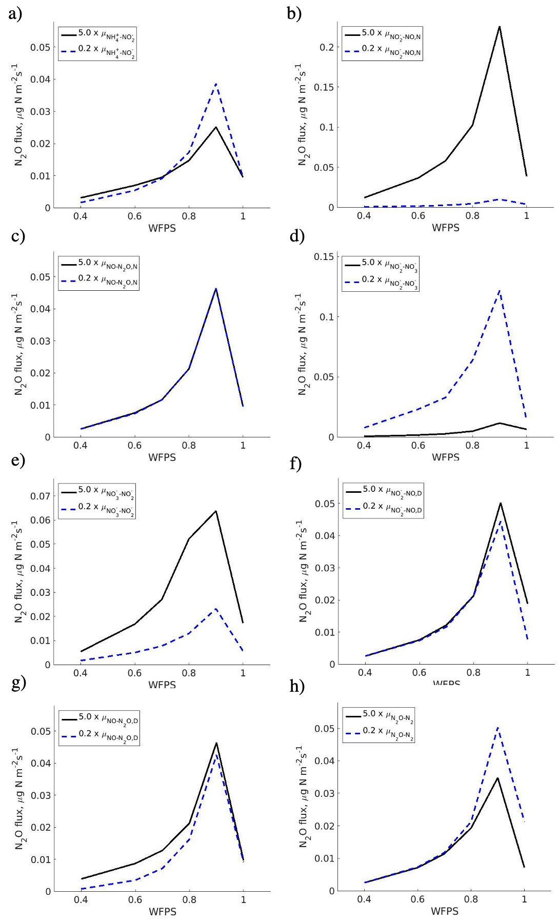
Fig. S1 Simulated N₂O fluxes by the PBM-T-NF model as (a) $μ_{N{H_{4}}^{+}-{NO_{2}}^{-}}$, (b) $μ_{{NO_{2}}^{-}-NO,N}$, (c) $μ_{NO-N_{2}O,N}$, (d) $μ_{N{O_{2}}^{-}-N{O_{3}}^{-}}$, (e) $μ_{N{O_{3}}^{-}-N{O_{2}}^{-}}$, (f) $μ_{N{O_{2}}^{-}-NO,D}$, (g) $μ_{NO-N_{2}O,D}$, or (h) $μ_{N_{2}O-N_{2}}$was increased (5.0 $×$) or decreased (0.2 $×$) by five times. LC soil was used to evaluate the effects of parameters.
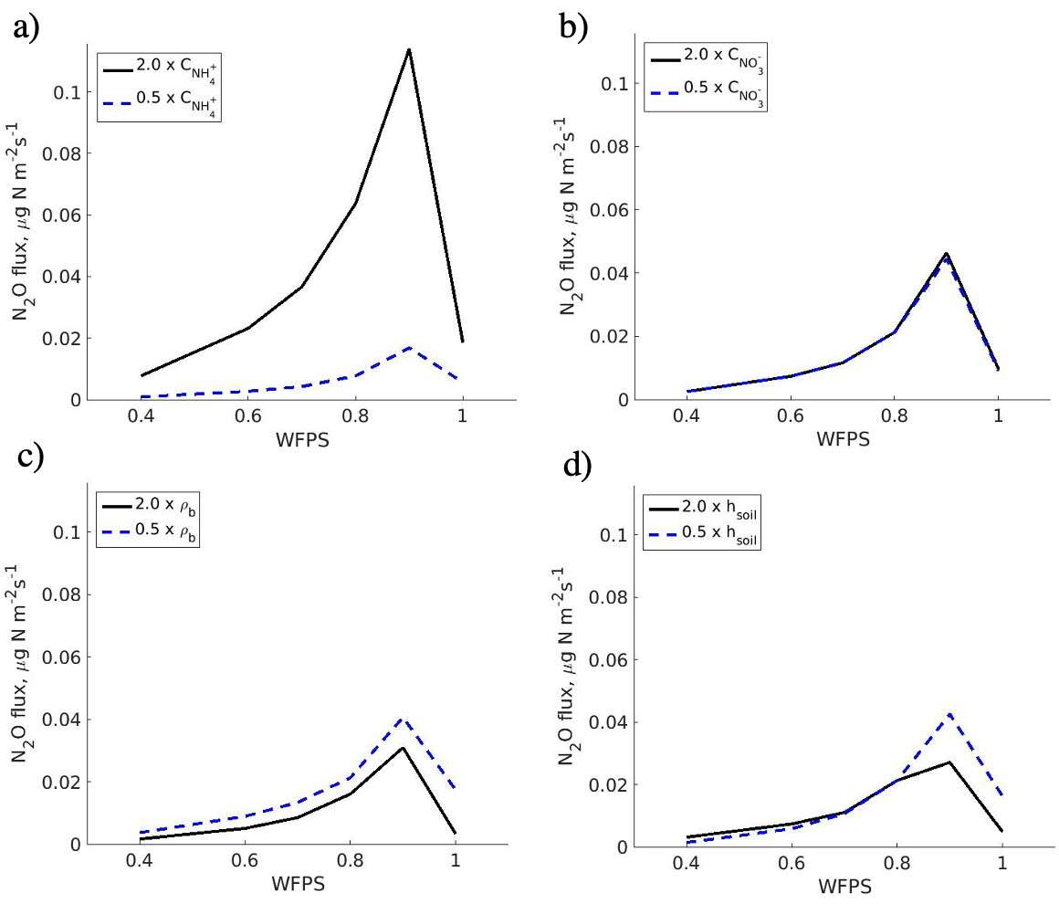
Fig. S2 Simulated N₂O fluxes by the PBM-T-NF model as (a) NH₄⁺ concentration, (b) NO₃⁻ concentration, (c) bulk density, or (d) soil depth was doubled (5.0 $×$) or halved (0.2 $×$). Virtual soil core was used in the simulations.

References
Cadogan SP, Maitland GC, Trusler JPM (2014) Diffusion Coefficients of CO2 and N2 in Water at Temperatures between 298.15 K and 423.15 K at Pressures up to 45 MPa. Journal of Chemical & Engineering Data 59(2): 519-525
Chang B, Yan Z, Ju X, Song X, Li Y, Li S, Fu P, Zhu-Barker X (2022) Quantifying biological processes producing nitrous oxide in soil using a mechanistic model. Biogeochemistry 159: 1-14
Hamamoto S, Moldrup P, Kawamoto K, Komatsu T (2010) Excluded-volume expansion of Archie's law for gas and solute diffusivities and electrical and thermal conductivities in variably saturated porous media. Water Resources Research 46(6): WR008424
Maggi F, Gu C, Riley WJ, Hornberger GM, Venterea RT, Xu T, Spycher N, Steefel C, Miller NL, Oldenburg CM (2008) A mechanistic treatment of the dominant soil nitrogen cycling processes: Model development, testing, and application. Journal of Geophysical Research Biogeosciences 113(G2): G02016
Massman WJ (1998) A review of the molecular diffusivities of H₂O, CO₂, CH₄, CO, O₃, SO₂, NH₃, N₂O, NO, and NO₂ in air, O₂ and N₂ near STP. Atmospheric Environment 32(6): 1111-1127
Sander R (2015) Compilation of Henry’s law constants (version 4.0) for water as solvent. Atmospheric Chemistry and Physics 15(8): 4399-4981
Sieczka A, Koda E (2016) Kinetic and equilibrium studies of sorption of ammonium in the soil-water environment in agricultural areas of Central Poland. Applied Sciences 6(10): 269
Spiller LL (1989) Determination of Ammonia/Air Diffusion Coefficient Using Nafion Lined Tube. 22(11-12): 2561-2573
Wang H, Yan Z, Ju X, Song X, Zhang J, Li S, Zhu-Barker X (2023) Quantifying nitrous oxide production rates from nitrification and denitrification under various moisture conditions in agricultural soils: Laboratory study and literature synthesis. Frontiers in Microbiology 13: 1110151
Weast RC (1997) CRC Handbook of Chemistry and Physics. CRC Press.
Yan Z, Bond-Lamberty B, Todd-Brown KE, Bailey VL, Li S, Liu C, Liu C (2018) A moisture function of soil heterotrophic respiration that incorporates microscale processes. Nature Communications 9(1): 2562

