Supplementary Document

Decoding the Hidden Mechanisms of Soil Carbon Cycling in Response to Climate Change

Yaxi Du¹, Jacqueline Mohan², Paul Frankson², Greta Franke¹, Zhilin Chen¹, and Debjani Sihi^{1,3*}

¹Department of Environmental Science, Emory University, Atlanta, Georgia, USA
²Odum School of Ecology, University Georgia, Athens, Georgia, USA
³Departments of Plant and Microbial Biology and Crop and Soil Sciences, N.C. Plant Sciences Initiative, North Carolina State University, Raleigh, NC, USA

*Corresponding author (email: dsihi@ncsu.edu)

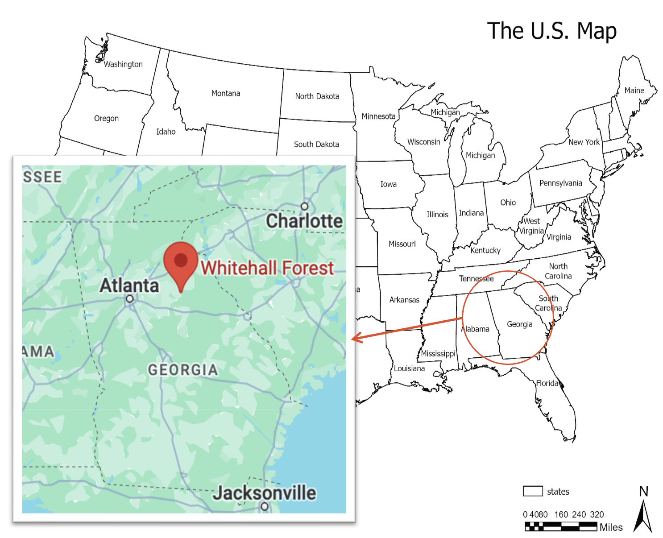
Fig. S1: U.S. map showing the study site. The soil samples were collected from a long-term warming experiment site at Whitehall Forest, Athens, GA. The map was made by using ArcGIS Pro 3.2.
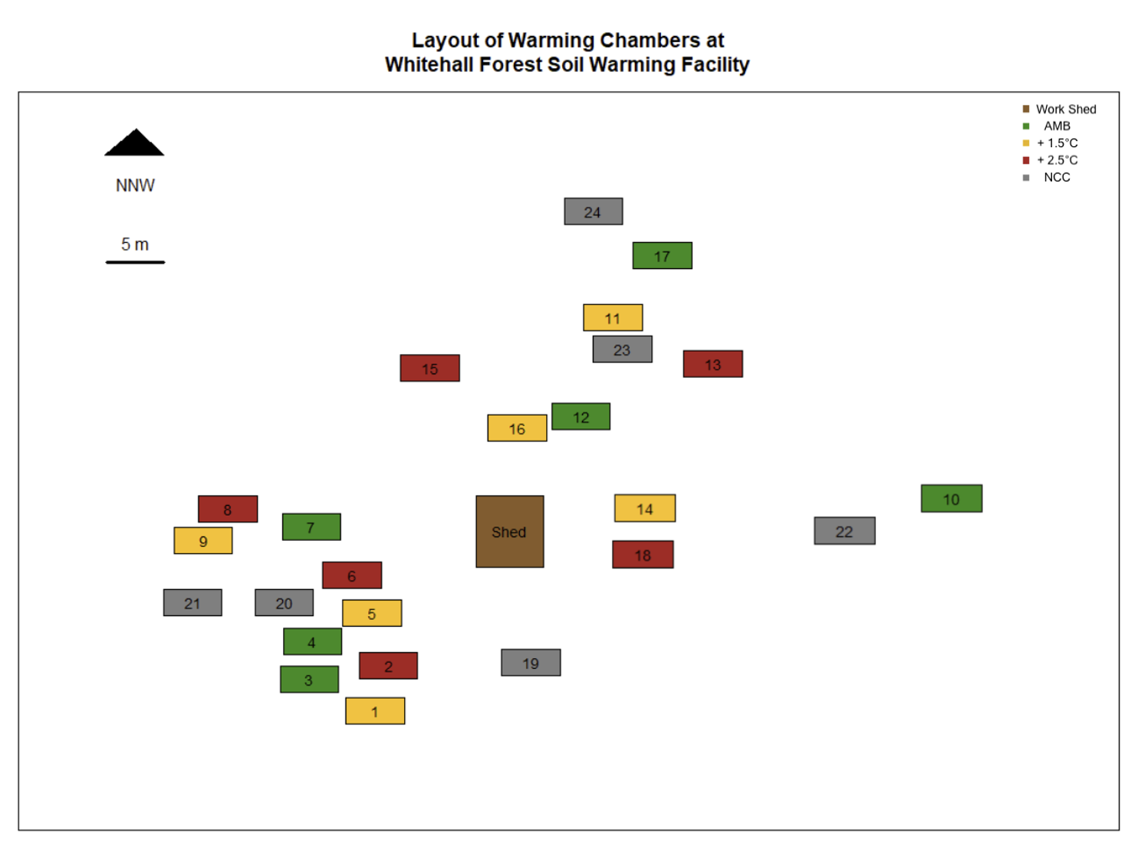
Fig. S2: A map of the Whitehall Forest soil warming experiment study site in Athens, Georgia. The numbers indicate actual plot numbers, and the colors represent the temperatures - brown represents the work shed; green represents the ambient (25°C) plots; yellow represents the 1.5°C above ambient (26.5°C) plots; red represents the 2.5°C above ambient (27.5°C) plots; gray represents the non-chambered (NCC) plots. More detailed information can be found in Table S1. Map source: Dr. Jacqueline Mohan’s Lab at the University of Georgia.

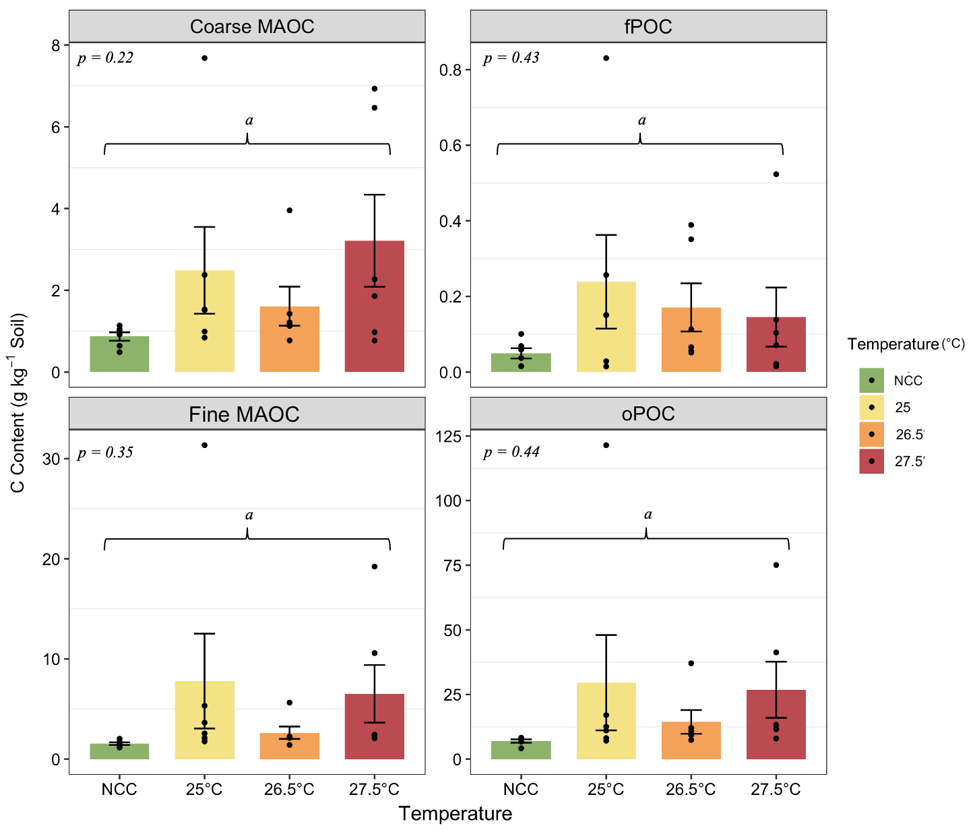
Fig. S3: Carbon content (g C kg⁻¹ soil) before-incubation in coarse mineral-associated organic carbon (MAOC), fine MAOC, free particulate organic carbon (fPOC), and occluded particulate organic carbon (oPOC) fractions at three temperature treatments (25, 26.5, and 27.5 °C) and non-chambered control (NCC). Bars represent mean values ± standard error for each temperature. The treatment differences were not significant (p>0.1). Tukey HSD letters are a for all.

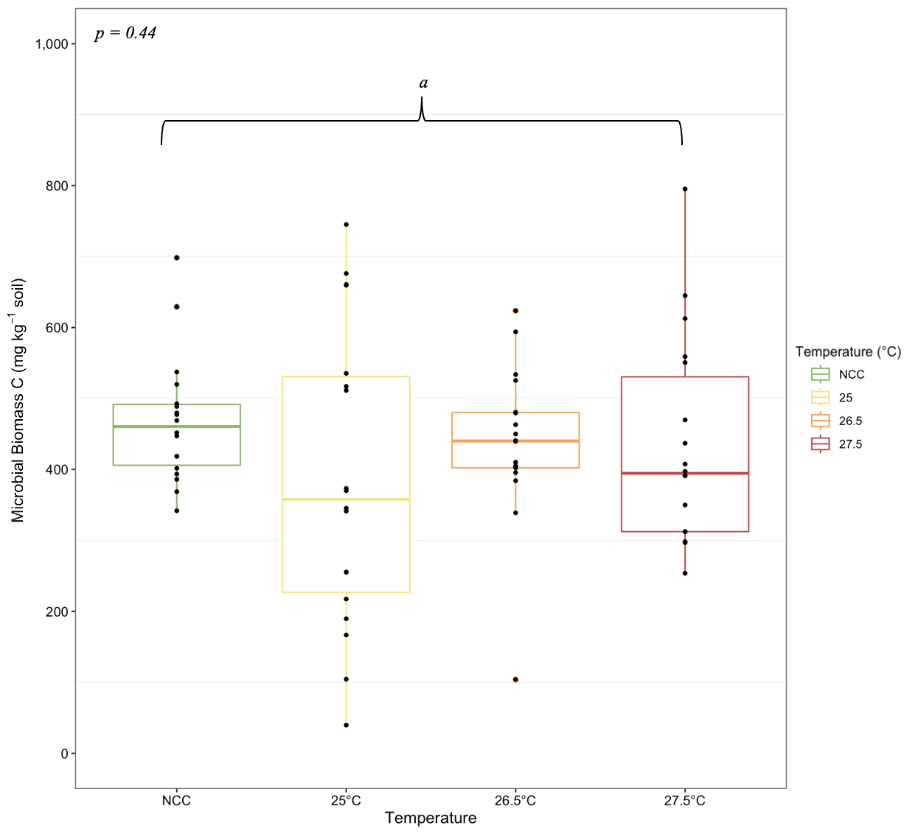
Fig. S4: Boxplots of microbial biomass carbon (mg C kg⁻¹ soil) before-incubation across three temperature treatments (25, 26.5, and 27.5 °C) and non-chambered control (NCC). Each box shows the interquartile range, the horizontal line within each box indicates the median. Bars represent mean values ± standard error for each temperature. The treatment differences were not significant (p>0.1). Tukey HSD letters are a for all.

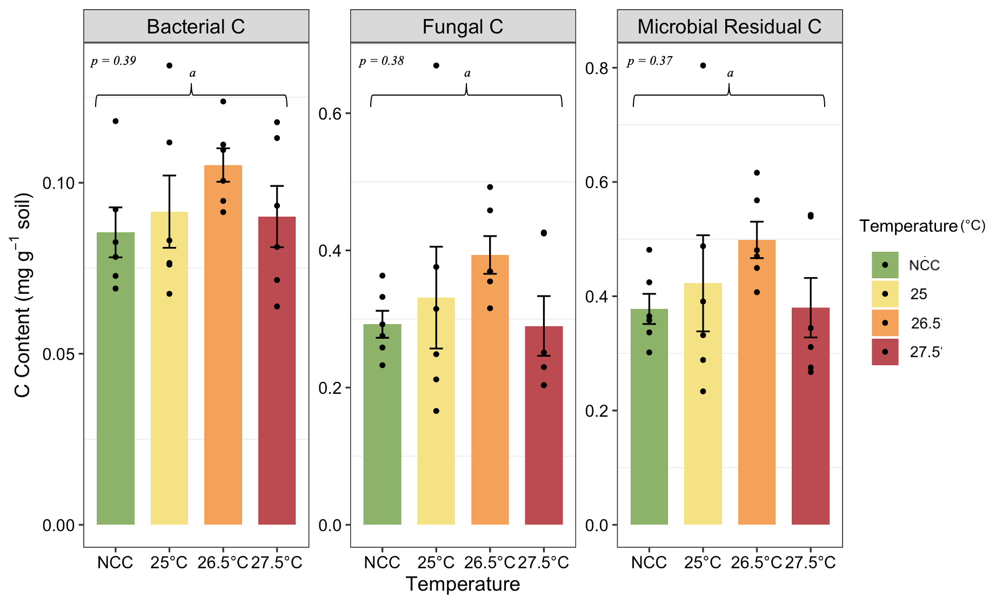
Fig. S5: Bacterial C, fungal C, and microbial residual C in soil (mg C g⁻¹ soil) before-incubation for three temperature treatments (25, 26.5, and 27.5 °C) and non-chambered control (NCC). Bars represent mean values ± standard error for each temperature. The treatment differences were not significant (p>0.1). Tukey HSD letters are a for all.

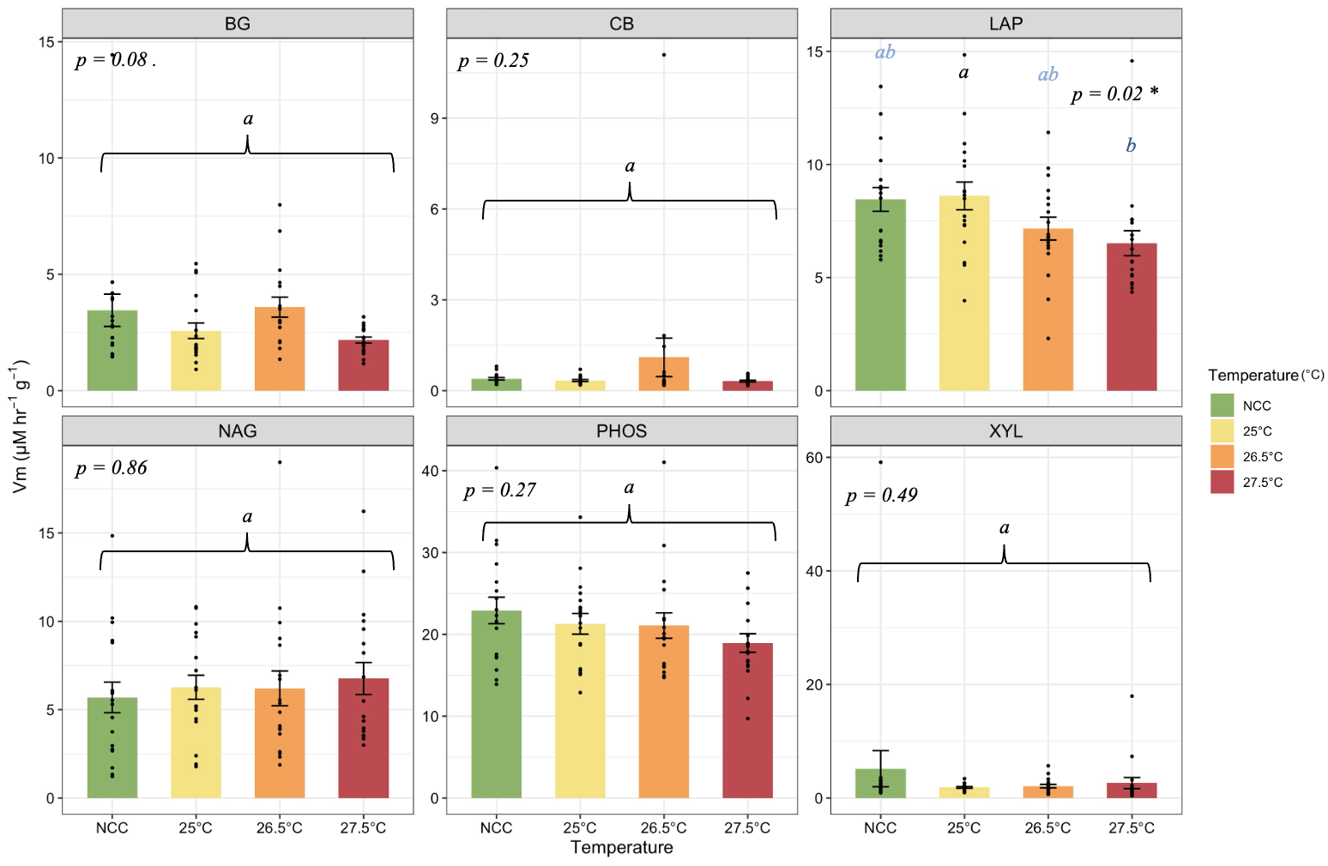
Fig. S6: Enzyme kinetic of maximum velocity (Vmax as µM hr⁻¹ g⁻¹ soil) for all six enzymes before incubation under three temperature treatments (25, 26.5, and 27.5 °C) and non-chambered control (NCC). Bars represent mean values ± standard error for each temperature. The treatment differences were not significant (p>0.1). Tukey HSD letters are a for all.

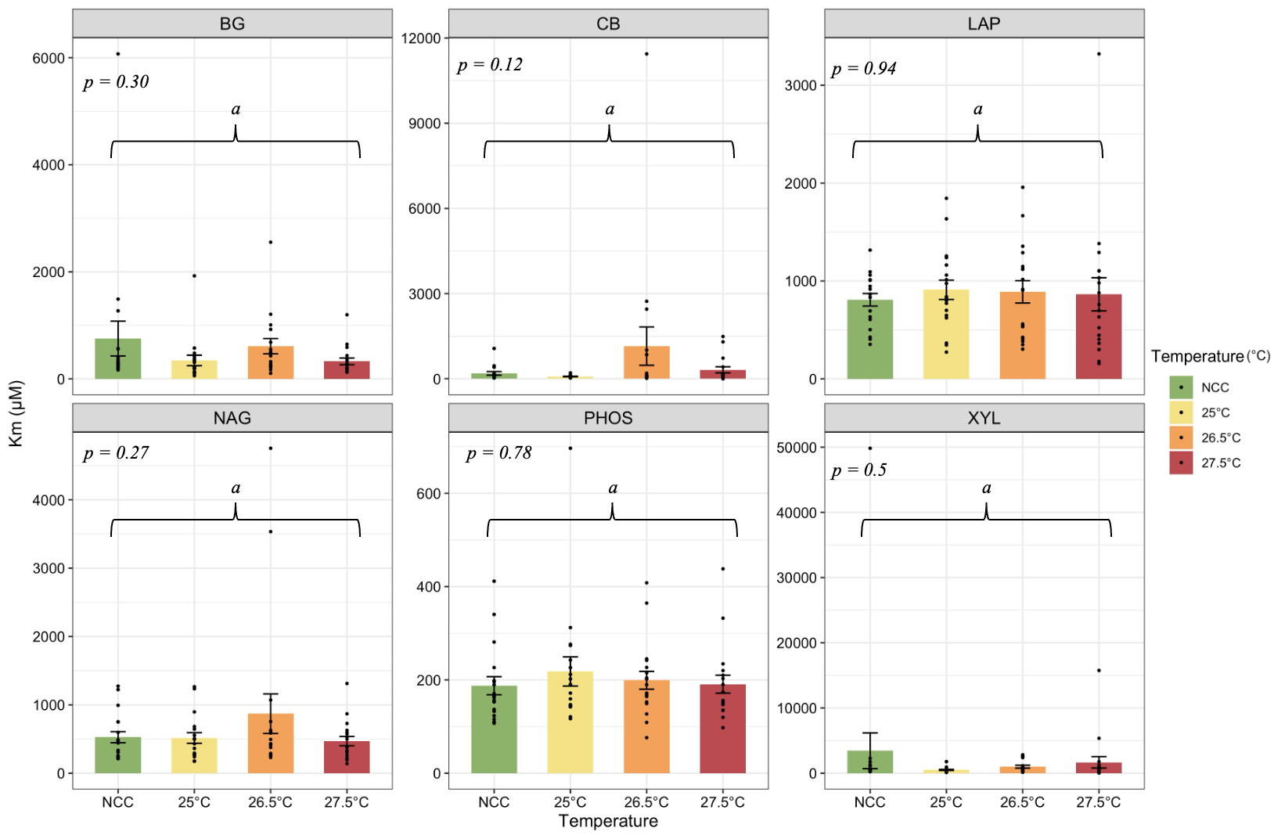
Fig. S7: The Michaelis-Menten constant (Km as µM) of enzymes, indicating substrate affinity across warming treatments before incubation under three temperature treatments (25, 26.5, and 27.5 °C) and non-chambered control (NCC). Bars represent mean values ± standard error for each temperature. The treatment differences were not significant (p>0.1). Tukey HSD letters are a for all.

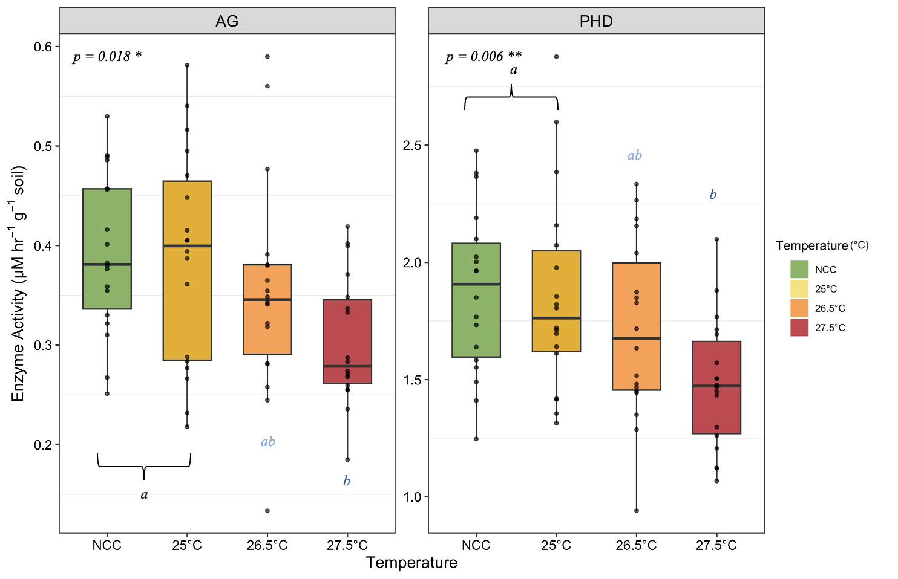
Fig. S8: Enzyme activity (µM hr⁻¹ g⁻¹ soil) for AG and PHD before incubation in response to warming treatments under three temperature treatments (25, 26.5, and 27.5 °C) and non-chambered control (NCC). Different letters above boxes denote statistically significant differences among treatment pairs, as determined by Tukey’s post hoc test. Symbols for ANOVA results: p < 0.0001 “***”, p < 0.001 “**”, p < 0.01 “*”, p < 0.1 “.”

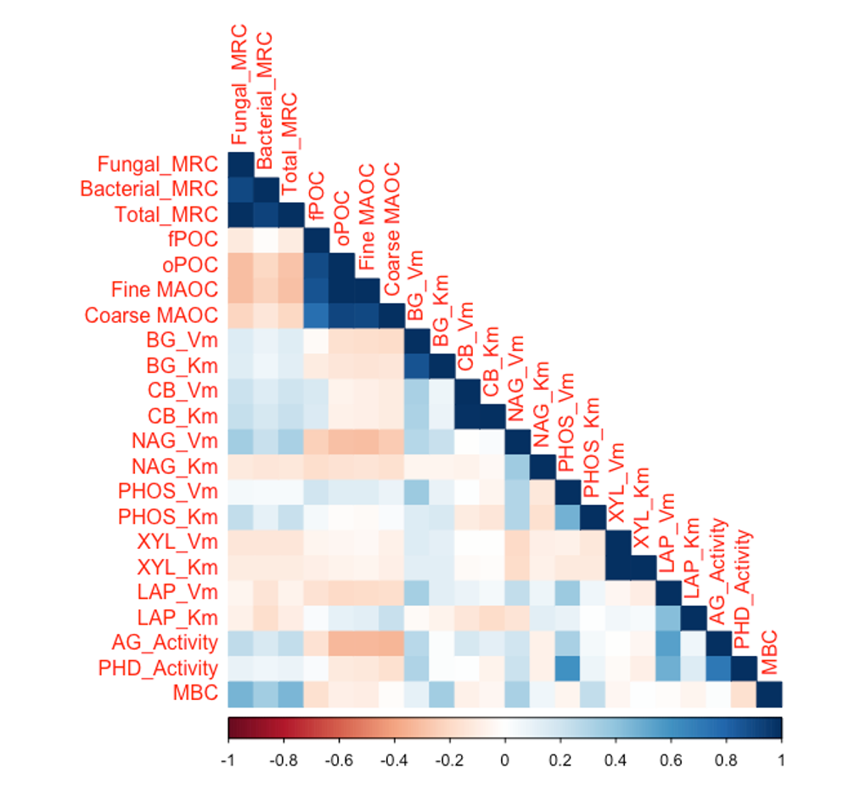
Fig. S9: Correlation matrix between measured soil properties before incubation. MRC refers to the microbial residual carbon (necromass). fPOC stands for free particulate organic carbon; oPOC stands for occluded particulate organic carbon; MAOC stands for fine mineral-associated organic carbon; C_silt stands for coarse mineral-associated organic carbon. MBC refers to microbial biomass carbon.

Table S1: detailed information for the field plots in Whitehall Forest, Athens, GA. NCC stands for non-chamber control, indicating no greenhouse plastic around the plot or buried soil warming cables, and the plots are surrounded by chicken wire. AMB (ambient control) plots have greenhouse plastic around the plot and buried soil warming cables that are not turned on. +1.5°C and +2.5°C (warming) plots have greenhouse plastic around the plot and buried soil warming cables are set to corresponding temperatures. For this study, we did not look at canopy effects, which can be a potential future direction.
Plot | Temperature | Canopy
1 | +1.5°C | Gap
2 | +2.5°C | Gap
3 | AMB | Gap
4 | AMB | Gap
5 | +1.5°C | Gap
6 | +2.5°C | Gap
7 | AMB | Gap
8 | +2.5°C | Gap
9 | +1.5°C | Gap
10 | AMB | Forest
11 | +1.5°C | Forest
12 | AMB | Forest
13 | +2.5°C | Forest
14 | +1.5°C | Forest
15 | +2.5°C | Forest
16 | +1.5°C | Forest
17 | AMB | Forest
18 | +2.5°C | Forest
19 | NCC | Gap
20 | NCC | Gap
21 | NCC | Gap
22 | NCC | Forest
23 | NCC | Forest
24 | NCC | Forest

Table S2: List of soil extracellular enzymes assayed in this study. The standard curves for each sample were determined using 7-amino-4-methylcoumann (MUC) or 4-methylumbelliferone (MUB).
Enzyme/Substrates | Abbreviation | Concentration(s) | Target element | Standard Used
4-Methylumbelliferyl β-D-glucopyranoside | BG | 100-2000 µM | Labile C | MUB
4-Methylumbelliferyl β-D-cellobioside | CB | 100-2000 µM | Labile C | MUB
4-Methylumbelliferyl N-acetyl-β-D-glucosaminide | NAG | 100-2000 µM | N (& some C) | MUB
4-Methylumbelliferyl phosphate | PHOS | 100-2000 µM | P | MUB
Phosphodiesterase | PHD | 1000 µM | P | MUB
4-Methylumbelliferyl β-D-xylopyranoside | XYL | 100-2000 µM | Stable C | MUB
4-Methylumbelliferyl α-D-glucopyranoside | AG | 1000 µM | Stable C | MUB
L-Leucine-7-amido-4-methylcoumarin hydrochloride | LAP | 100-2000 µM | N | MUC

Table S3: Detailed statistical information for path analysis. Total CO₂ is the dependent variable. The variables include Total_MRC, oPOC, fPOC, MAOC, MBC, and Substrate addition treatments. MRC stands for microbial residual C; oPOC is occluded-particulate organic C; fPOC is free-particulate organic C; MAOC is the fine mineral-associated organic C; MBC stands for microbial biomass C. A negative estimate indicates a decrease in the outcome variable with an increase in the predictor variable. In other words, a negative estimate suggests that the response variable rises while the predictor variable falls.
CO2 ~ | Estimate | Standard Error | z-value | p-value
Total_MRC | 0.01 | 0.13 | 0.10 | 0.92
oPOC | 0.36 | 0.21 | 1.73 | 0.08.
fPOC | 0.27 | 0.10 | 2.81 | 0.01*
MAOC | -0.37 | 0.21 | -1.77 | 0.08.
MBC | 0.11 | 0.11 | 1.05 | 0.29
Substrate addition treatment | 0.66 | 0.10 | 6.55 | 0.000***
Symbols: p < 0.0001 “***”, p < 0.001 “**”, p < 0.01 “*”, p < 0.1 “.”

