Supporting Information for

Using aridity as an overarching factor to advance understanding of soil organic carbon storage at the continental scale

Authors
Jocelyn M. Lavallee^{1,2}*, Michelle L. Haddix², Amy Swan³, Jamie D. Hoover⁴, M. Francesca Cotrufo^{2,3}

Affiliations
1. Environmental Defense Fund, 257 Park Ave S, New York, NY, 10010 USA.
2. Soil and Crop Sciences Department, Colorado State University, Fort Collins, CO 80523.
3. Natural Resource Ecology Laboratory, Colorado State University, Fort Collins, CO 80523.
4. RedCastle Resources, 124 South 400 East, Salt Lake City, UT 84111.
*Corresponding author: Jocelyn M. Lavallee. Email: jlavallee@edf.org

This PDF file includes:

Figs. S1 to S7
Tables S1 to S2
References

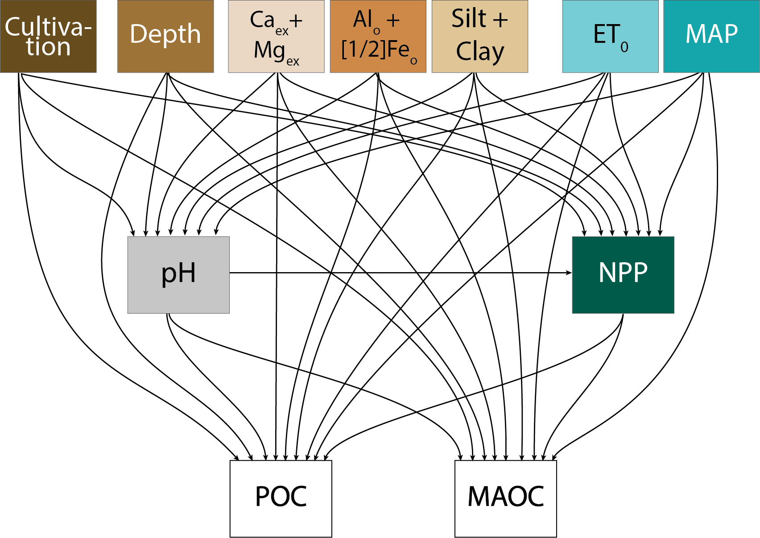
Fig. S1. A priori structural equation model, which was modified to remove silt + clay path to NPP (original hypothesis). Arrows represent hypothesized causal relationships between variables. Covariances between exogenous variables, and between POC and MAOC, are not depicted but were automatically included in the model. Abbreviations: particulate organic carbon (POC), mineral-associated organic carbon (MAOC), matrix capacity index (MCI), potential evapotranspiration (ET₀), mean annual precipitation (MAP), net primary productivity (NPP). The model structure is based on a synthesis of hypothesized relationships between climate variables, soil properties, plant productivity, and soil organic matter components (Jackson et al. 2017; Cotrufo et al. 2021; Sokol et al. 2022; Cotrufo and Lavallee 2022; Heckman et al. 2022; King et al. 2023b; Hansen et al. 2024).

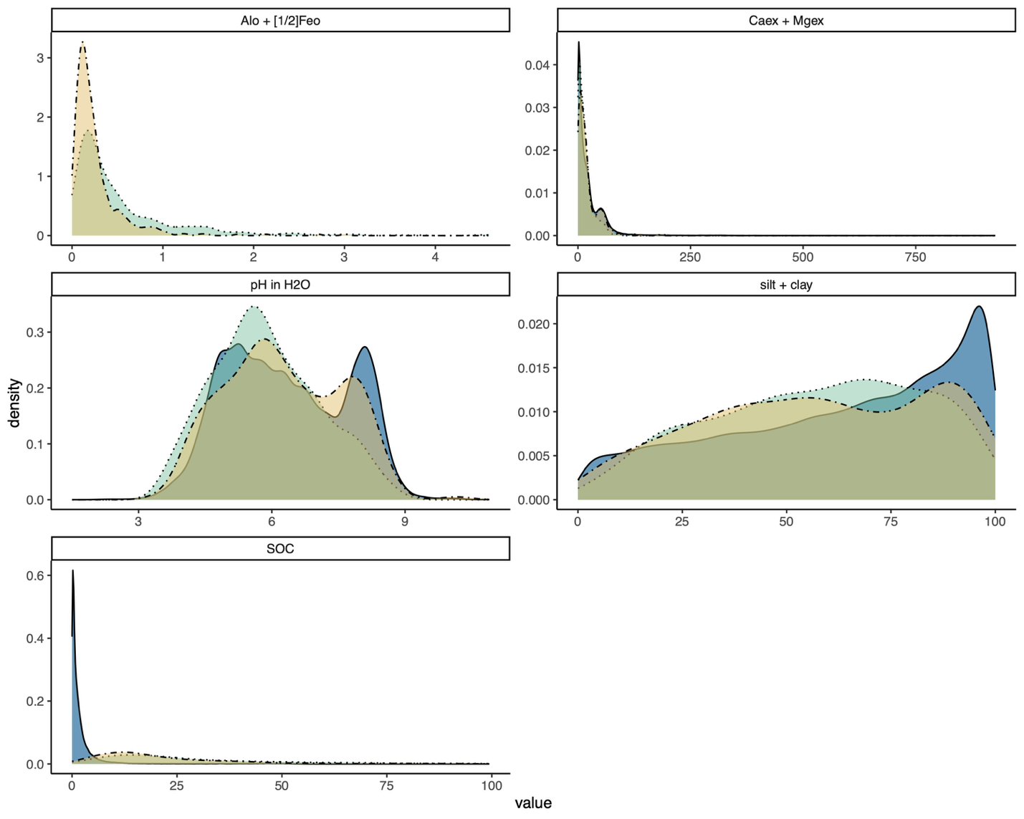

Fig. S2. Distributions of properties of selected archive samples used for soil organic matter fractionation (yellow, N = 466) and estimated using mid-infrared spectroscopy (green, N = 698) reflected the full ranges of the values in the NCSS database (blue, N = 245,605). Panels show total dithionite citrate and ammonium oxalate-extractable aluminum and iron content (Al_{o} + [1/2]Fe_{o}, upper left), NH⁴⁺ acetate extractable Ca and Mg (Caex + Mg_{ex}, upper right), pH in water (middle left), per cent silt plus clay by mass (middle right), and per cent soil organic carbon (bottom). For SOC content, only soils with values below 100 (< 10 %) are shown to match the definition of mineral soils used throughout the analysis.

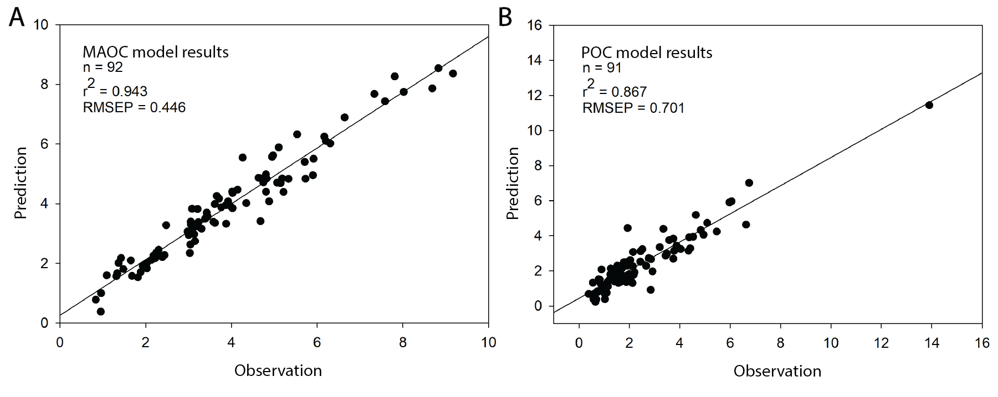
Fig. S3. Model performance for mineral-associated (MAOC; panel B) and particulate organic carbon (POC; panel A) predictions from mid-infrared (MIR) spectra for test set data. Observed and predicted MAOC and POC values are in units of mg C per g soil.

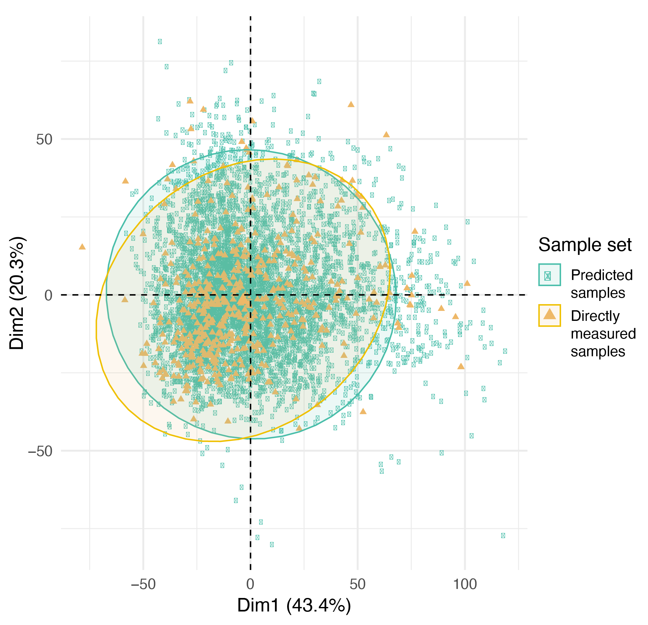
Fig. S4. The spectra of bulk soil scans of directly measured samples used to build predictive models showed good coverage of the bulk soil spectra of predicted samples. Principal components analysis of both sets of spectra is shown, with ellipses representing 95% confidence intervals for the mean position of each sample set in the two-dimensional space defined by the first two principal components. The directly measured sample set used to build models to predict POC and MAOC includes 466 samples (yellow points), while the set for which POC and MAOC were predicted from bulk soil scans include 698 samples (green points).
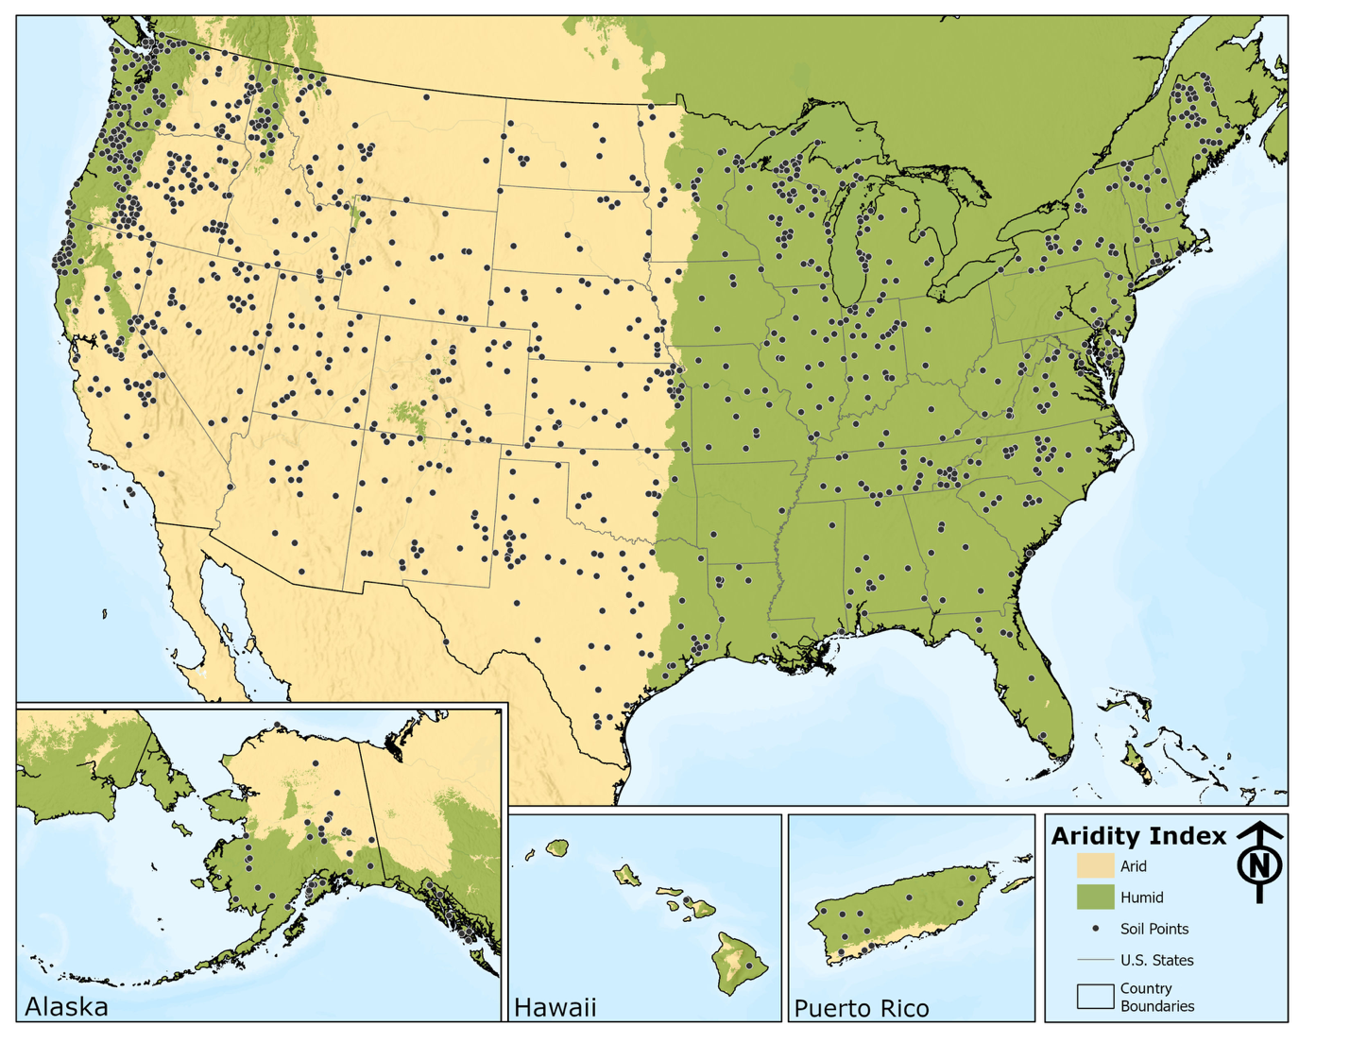
Fig. S5. Samples used in the study were well-distributed across the USA. Map of all points in the final dataset (N = 1164) with aridity index groups shown with arid systems in yellow and humid systems in green. Some points included here were omitted for various plotting and analyses due to high or low values or missing data for certain variables.

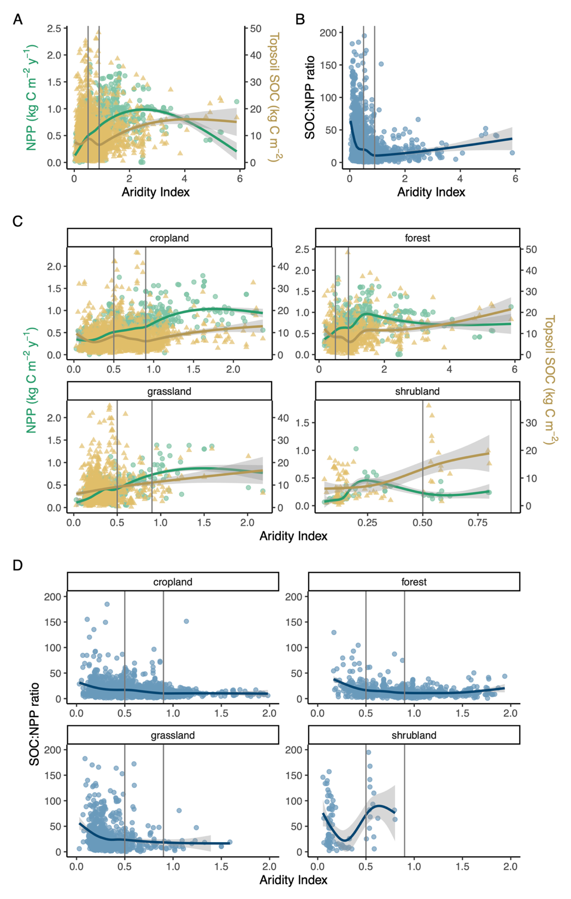

Fig. S6. Soil organic carbon (SOC) and net primary productivity (NPP) show different relationships to aridity. Panel A shows SOC (yellow) stocks and NPP (green) versus aridity index, panel B shows the SOC:NPP ratio versus aridity index for samples in the NCSS Database with available SOC concentration and bulk density data. SOC stocks are calculated to 30 cm depth (N = 4130). Lines are cubic spline GAMs to demonstrate general trends in the data (see Methods). Panels C and D show the same data separately for systems under different land cover. Land cover classifications are based on MODIS Land Cover Type (MCD12Q1) dataset using the Plant Functional Types classification for 2015 using Google Earth Engine. Land cover categories are simplified as other (water bodies, urban and built-up lands, non-vegetated lands), forest (evergreen needleleaf trees, evergreen broadleaf trees, deciduous broadleaf trees), cropland (cereal croplands, broadleaf croplands), grassland, and shrubland. Soils with Ap horizons are categorized as “previously cultivated” and included in the cropland panel. Vertical lines at AI = 0.5 and 0.9 are shown to aid visual interpretation.

Fig. S7. Changes in the proportion of SOC in MAOC [f_{MAOC}, equivalent to MAOC:(POC+MAOC)] indicate different responses of POC and MAOC to SOC:NPP ratio and aridity index, which suggest differences in controls of their accrual and decomposition. Panel A: the fraction of SOC in MAOC is negatively correlated to the SOC:NPP ratio based on simple linear regression using the ggpubr package (Kassambara, 2022). Panel B: The median proportion of SOC in MAOC (f_{MAOC}) is lower in arid and higher in humid environments, though there is large variability in f_{MAOC} values within both aridity groups (letters denote significant differences between group medians based on a Kruskal Wallis test). Panel C: f_{MAOC} is generally higher in systems with high SOC:NPP values (above the median SOC:NPP value) within land cover types. Asterisks denote significant differences (P < 0.05) between SOC:NPP group means within each land cover type based on Wilcoxon-Mann-Whitney U tests. All plots show data from 1164 topsoil samples from the National Cooperative Soil Survey archives for which POC and MAOC were directly measured or predicted using mid-infrared spectroscopy.

Table S1. Summary output for final SEM model from lavaan in R.
lavaan 0.6.17 ended normally after 260 iterations
Estimator |  | ML
Optimization method |  | NLMINB
Number of model parameters |  | 152
Number of equality constraints |  | 9
Number of observations per group: |  |  | Used | Total
Arid |  |  | 559 | 563
Humid |  |  | 596 | 601
Model Test User Model:
Test statistic |  | 3.669
Degrees of freedom |  | 11
P-value (Chi-square) |  | 0.979
Test statistic for each group:
Arid |  | 1.708
Humid |  | 1.961
Model Test Baseline Model:
Test statistic |  | 2945.3
Degrees of freedom |  | 68
P-value |  | 0
User Model versus Baseline Model:
Comparative Fit Index (CFI) |  | 1
Tucker-Lewis Index (TLI) |  | 1.016
Loglikelihood and Information Criteria:
Loglikelihood user model (H0) |  | -35736
Loglikelihood unrestricted model (H1) |  | NA
Akaike (AIC) |  |  | 71759
Bayesian (BIC) |  |  | 72481
Sample-size adjusted Bayesian (SABIC) |  |  | 72027
Root Mean Square Error of Approximation:
RMSEA |  |  | 0
90 Percent confidence interval - lower |  |  | 0
90 Percent confidence interval - upper |  |  | 0
P-value H_0: RMSEA <= 0.050 |  |  | 1
P-value H_0: RMSEA >= 0.080 |  |  | 0
Standardized Root Mean Square Residual:
SRMR |  | 0.005
Parameter Estimates:
Standard errors |  | Standard
Information |  | Expected
Information saturated (h1) model |  | Structured
Group 1 [Arid]:
Regressions:
 | Estimate | Std.Err | z-value | P(>|z|) | Std.lv | Std.all
POM_mgpg_OC ~
cly (sc.pc1) | -0.035 | 0.012 | -2.959 | 0.003 | -0.035 | -0.111
p_2 (ph.p1) | -1.483 | 0.279 | -5.307 | 0 | -1.483 | -0.204
al_ (af.pc1) | 0.745 | 0.082 | 9.035 | 0 | 0.745 | 0.323
c_m (c_mg.pc1) | 0.085 | 0.015 | 5.547 | 0 | 0.085 | 0.246
ET (et.pc1) | -0.318 | 0.07 | -4.561 | 0 | -0.318 | -0.159
pr_ (mp.pc1) | 0.035 | 0.102 | 0.346 | 0.729 | 0.035 | 0.015
NPP (npp.p1) | 0.735 | 0.179 | 4.113 | 0 | 0.735 | 0.173
hr_ (clt.pc1) | -2.715 | 0.484 | -5.607 | 0 | -2.715 | -0.151
hz_ (dpth.pc1) | -0.267 | 0.027 | -9.906 | 0 | -0.267 | -0.253
MAOM_mgpg_OC ~
cly (sc.m1) | 0.075 | 0.012 | 6.193 | 0 | 0.075 | 0.163
p_2 (ph.m1) | -2.233 | 0.461 | -4.844 | 0 | -2.233 | -0.209
al_ (af.m1) | 0.976 | 0.07 | 14.038 | 0 | 0.976 | 0.288
c_m (c_mg.m1) | 0.143 | 0.02 | 7.057 | 0 | 0.143 | 0.282
ET (et.m1) | -0.596 | 0.102 | -5.831 | 0 | -0.596 | -0.203
pr_ (mp.m1) | 0.452 | 0.131 | 3.446 | 0.001 | 0.452 | 0.133
NPP (npp.m1) | 0.89 | 0.233 | 3.822 | 0 | 0.89 | 0.143
hr_ (clt.m1) | -2.931 | 0.666 | -4.401 | 0 | -2.931 | -0.111
hz_ (dpth.m1) | -0.123 | 0.037 | -3.343 | 0.001 | -0.123 | -0.08
ph_h2o ~
ET (et.ph1) | 0.077 | 0.009 | 8.677 | 0 | 0.077 | 0.279
pr_ (mp.ph1) | -0.083 | 0.01 | -8.323 | 0 | -0.083 | -0.262
cly (sc.ph1) | -0.005 | 0.001 | -3.86 | 0 | -0.005 | -0.127
al_ (af.ph1) | -0.004 | 0.01 | -0.397 | 0.691 | -0.004 | -0.013
c_m (c_mg.ph1) | 0.024 | 0.002 | 15.111 | 0 | 0.024 | 0.505
hr_ (clt.ph1) | 0.055 | 0.072 | 0.762 | 0.446 | 0.055 | 0.022
hz_ (dpth.ph1) | 0 | 0.004 | -0.021 | 0.984 | 0 | -0.001
NPP ~
p_2 (ph.n1) | -0.325 | 0.072 | -4.516 | 0 | -0.325 | -0.189
ET (et.n1) | -0.064 | 0.019 | -3.413 | 0.001 | -0.064 | -0.136
pr_ (mp.n1) | 0.246 | 0.022 | 11.338 | 0 | 0.246 | 0.452
al_ (af.n1) | 0.008 | 0.021 | 0.38 | 0.704 | 0.008 | 0.015
c_m (c_mg.n1) | 0.013 | 0.003 | 3.926 | 0 | 0.013 | 0.159
hr_ (clt.n1) | 0.469 | 0.147 | 3.191 | 0.001 | 0.469 | 0.111
hz_ (dpth.n1) | 0.011 | 0.009 | 1.314 | 0.189 | 0.011 | 0.046
Covariances:
 | Estimate | Std.Err | z-value | P(>|z|) | Std.lv | Std.all
.POM_mgpg_OC ~~
.MAOM_mgpg_OC | 25.587 | 2.356 | 10.86 | 0 | 25.587 | 0.517
claysilt ~~
al_fe | 13.229 | 3.517 | 3.762 | 0 | 13.229 | 0.161
ca_mg | 214.24 | 25.005 | 8.568 | 0 | 214.24 | 0.389
ET | -18.14 | 4.091 | -4.434 | 0 | -18.14 | -0.191
prcp_mean | 5.281 | 3.476 | 1.519 | 0.129 | 5.281 | 0.064
horizon_ap | 2.171 | 0.455 | 4.769 | 0 | 2.171 | 0.206
hzn_bot | 8.836 | 7.619 | 1.16 | 0.246 | 8.836 | 0.049
al_fe ~~
ca_mg | -11.62 | 3.223 | -3.605 | 0 | -11.62 | -0.154
ET | -4.953 | 0.588 | -8.425 | 0 | -4.953 | -0.381
prcp_mean | 4.514 | 0.511 | 8.83 | 0 | 4.514 | 0.403
horizon_ap | -0.222 | 0.062 | -3.599 | 0 | -0.222 | -0.154
hzn_bot | 3.034 | 1.048 | 2.895 | 0.004 | 3.034 | 0.123
ca_mg ~~
ET | 23.391 | 3.818 | 6.126 | 0 | 23.391 | 0.268
prcp_mean | -19.89 | 3.293 | -6.04 | 0 | -19.89 | -0.264
horizon_ap | 1.237 | 0.412 | 2.999 | 0.003 | 1.237 | 0.128
hzn_bot | -8.67 | 6.992 | -1.24 | 0.215 | -8.67 | -0.053
ET ~~
prcp_mean | -3.048 | 0.564 | -5.405 | 0 | -3.048 | -0.235
horizon_ap | 0.079 | 0.071 | 1.114 | 0.265 | 0.079 | 0.047
hzn_bot | -5.697 | 1.228 | -4.64 | 0 | -5.697 | -0.2
prcp_mean ~~
horizon_ap | 0.017 | 0.061 | 0.283 | 0.777 | 0.017 | 0.012
hzn_bot | 4.83 | 1.059 | 4.559 | 0 | 4.83 | 0.197
horizon_ap ~~
hzn_bot | 0.418 | 0.135 | 3.1 | 0.002 | 0.418 | 0.132
Intercepts:
 | Estimate | Std.Err | z-value | P(>|z|) | Std.lv | Std.all
.POM_mgpg_OC | 23.418 | 2.228 | 10.509 | 0 | 23.418 | 3.027
.MAOM_mgpg_OC | 27.505 | 3.412 | 8.062 | 0 | 27.505 | 2.421
.ph_h2o | 5.83 | 0.206 | 28.366 | 0 | 5.83 | 5.488
.NPP | 3.789 | 0.565 | 6.71 | 0 | 3.789 | 2.079
claysilt | 57.812 | 1.036 | 55.779 | 0 | 57.812 | 2.359
al_fe | 2.851 | 0.142 | 20.121 | 0 | 2.851 | 0.851
ca_mg | 26.015 | 0.951 | 27.354 | 0 | 26.015 | 1.157
ET | 15.885 | 0.164 | 96.861 | 0 | 15.885 | 4.097
prcp_mean | 7.536 | 0.142 | 53.227 | 0 | 7.536 | 2.251
horizon_ap | 1.245 | 0.018 | 68.438 | 0 | 1.245 | 2.895
hzn_bot | 13.084 | 0.311 | 42.135 | 0 | 13.084 | 1.782
Variances:
 | Estimate | Std.Err | z-value | P(>|z|) | Std.lv | Std.all
.POM_mgpg_OC | 38.172 | 2.283 | 16.718 | 0 | 38.172 | 0.638
.MAOM_mgpg_OC | 64.135 | 3.836 | 16.718 | 0 | 64.135 | 0.497
.ph_h2o | 0.478 | 0.029 | 16.718 | 0 | 0.478 | 0.423
.NPP | 2.087 | 0.125 | 16.718 | 0 | 2.087 | 0.628
claysilt | 600.49 | 35.918 | 16.718 | 0 | 600.49 | 1
al_fe | 11.22 | 0.671 | 16.718 | 0 | 11.22 | 1
ca_mg | 505.63 | 30.244 | 16.718 | 0 | 505.63 | 1
ET | 15.035 | 0.899 | 16.718 | 0 | 15.035 | 1
prcp_mean | 11.204 | 0.67 | 16.718 | 0 | 11.204 | 1
horizon_ap | 0.185 | 0.011 | 16.718 | 0 | 0.185 | 1
hzn_bot | 53.902 | 3.224 | 16.718 | 0 | 53.902 | 1
R-Square:
 | Estimate
POM_mgpg_OC | 0.362
MAOM_mgpg_OC | 0.503
ph_h2o | 0.577
NPP | 0.372
Group 2 [Humid]:
Regressions:
 | Estimate | Std.Err | z-value | P(>|z|) | Std.lv | Std.all
POM_mgpg_OC ~
cly (sc.pc2) | -0.002 | 0.011 | -0.203 | 0.839 | -0.002 | -0.007
p_2 (ph.p1) | -1.483 | 0.279 | -5.307 | 0 | -1.483 | -0.16
al_ (af.pc2) | 0.474 | 0.054 | 8.764 | 0 | 0.474 | 0.329
c_m (c_mg.pc2) | 0.145 | 0.022 | 6.52 | 0 | 0.145 | 0.249
ET (et.1) | -0.318 | 0.07 | -4.561 | 0 | -0.318 | -0.094
pr_ (mp.pc2) | 0.142 | 0.051 | 2.797 | 0.005 | 0.142 | 0.112
NPP (npp.p2) | -0.142 | 0.138 | -1.034 | 0.301 | -0.142 | -0.037
hr_ (clt.p1) | -2.715 | 0.484 | -5.607 | 0 | -2.715 | -0.148
hz_ (dpth.p1) | -0.267 | 0.027 | -9.906 | 0 | -0.267 | -0.242
MAOM_mgpg_OC ~
cly (sc.1) | 0.075 | 0.012 | 6.193 | 0 | 0.075 | 0.145
p_2 (ph.2) | -4.003 | 0.525 | -7.62 | 0 | -4.003 | -0.272
al_ (af.1) | 0.976 | 0.07 | 14.038 | 0 | 0.976 | 0.429
c_m (c_mg.m2) | 0.309 | 0.034 | 9.213 | 0 | 0.309 | 0.336
ET (et.m2) | -0.955 | 0.155 | -6.16 | 0 | -0.955 | -0.178
pr_ (mp.m2) | 0.067 | 0.072 | 0.932 | 0.351 | 0.067 | 0.034
NPP (npp.m2) | 0.135 | 0.2 | 0.677 | 0.499 | 0.135 | 0.022
hr_ (clt.m1) | -2.931 | 0.666 | -4.401 | 0 | -2.931 | -0.101
hz_ (dpth.m1) | -0.123 | 0.037 | -3.343 | 0.001 | -0.123 | -0.071
ph_h2o ~
ET (et.p2) | 0.029 | 0.012 | 2.429 | 0.015 | 0.029 | 0.079
pr_ (mp.ph2) | -0.019 | 0.005 | -3.911 | 0 | -0.019 | -0.138
cly (sc.ph2) | 0 | 0.001 | -0.158 | 0.875 | 0 | -0.005
al_ (af.ph2) | 0.021 | 0.006 | 3.69 | 0 | 0.021 | 0.133
c_m (c_mg.ph2) | 0.03 | 0.002 | 15.149 | 0 | 0.03 | 0.482
hr_ (clt.p2) | 0.684 | 0.068 | 10.12 | 0 | 0.684 | 0.346
hz_ (dpth.p2) | 0.016 | 0.004 | 4.293 | 0 | 0.016 | 0.134
NPP ~
p_2 (ph.n1) | -0.325 | 0.072 | -4.516 | 0 | -0.325 | -0.134
ET (et.n2) | 0.146 | 0.037 | 4 | 0 | 0.146 | 0.165
pr_ (mp.n2) | 0.081 | 0.015 | 5.423 | 0 | 0.081 | 0.245
al_ (af.n2) | 0.041 | 0.017 | 2.418 | 0.016 | 0.041 | 0.11
c_m (c_mg.n2) | 0.006 | 0.006 | 1.035 | 0.3 | 0.006 | 0.042
hr_ (clt.n2) | -0.392 | 0.204 | -1.926 | 0.054 | -0.392 | -0.082
hz_ (dpth.n2) | 0.039 | 0.011 | 3.462 | 0.001 | 0.039 | 0.137
Covariances:
 | Estimate | Std.Err | z-value | P(>|z|) | Std.lv | Std.all
.POM_mgpg_OC ~~
.MAOM_mgpg_OC | 45.221 | 3.587 | 12.607 | 0 | 45.221 | 0.603
claysilt ~~
al_fe | 19.899 | 6.849 | 2.906 | 0.004 | 19.899 | 0.12
ca_mg | 140.63 | 17.755 | 7.92 | 0 | 140.63 | 0.343
ET | 5.673 | 2.888 | 1.964 | 0.049 | 5.673 | 0.081
prcp_mean | 0.852 | 7.742 | 0.11 | 0.912 | 0.852 | 0.005
horizon_ap | 3.847 | 0.555 | 6.933 | 0 | 3.847 | 0.296
hzn_bot | -8.233 | 8.886 | -0.926 | 0.354 | -8.233 | -0.038
al_fe ~~
ca_mg | 1.929 | 3.849 | 0.501 | 0.616 | 1.929 | 0.021
ET | -3.07 | 0.671 | -4.573 | 0 | -3.07 | -0.191
prcp_mean | 20.988 | 1.971 | 10.648 | 0 | 20.988 | 0.485
horizon_ap | -0.555 | 0.124 | -4.475 | 0 | -0.555 | -0.186
hzn_bot | 7.592 | 2.058 | 3.689 | 0 | 7.592 | 0.153
ca_mg ~~
ET | 6.397 | 1.65 | 3.877 | 0 | 6.397 | 0.161
prcp_mean | -8.328 | 4.394 | -1.895 | 0.058 | -8.328 | -0.078
horizon_ap | 0.856 | 0.303 | 2.825 | 0.005 | 0.856 | 0.117
hzn_bot | -0.05 | 5.025 | -0.01 | 0.992 | -0.05 | 0
ET ~~
prcp_mean | 1.754 | 0.754 | 2.325 | 0.02 | 1.754 | 0.096
horizon_ap | 0.308 | 0.053 | 5.802 | 0 | 0.308 | 0.245
hzn_bot | -1.903 | 0.865 | -2.201 | 0.028 | -1.903 | -0.091
prcp_mean ~~
horizon_ap | -0.704 | 0.142 | -4.969 | 0 | -0.704 | -0.208
hzn_bot | 0.643 | 2.316 | 0.278 | 0.781 | 0.643 | 0.011
horizon_ap ~~
hzn_bot | 0.82 | 0.163 | 5.04 | 0 | 0.82 | 0.211
Intercepts:
 | Estimate | Std.Err | z-value | P(>|z|) | Std.lv | Std.all
.POM_mgpg_OC | 22.768 | 1.899 | 11.988 | 0 | 22.768 | 2.566
.MAOM_mgpg_OC | 44.122 | 3.288 | 13.419 | 0 | 44.122 | 3.147
.ph_h2o | 3.712 | 0.166 | 22.396 | 0 | 3.712 | 3.889
.NPP | 5.358 | 0.566 | 9.468 | 0 | 5.358 | 2.311
claysilt | 56.72 | 1.103 | 51.443 | 0 | 56.72 | 2.107
al_fe | 5.32 | 0.253 | 21.06 | 0 | 5.32 | 0.863
ca_mg | 10.117 | 0.624 | 16.215 | 0 | 10.117 | 0.664
ET | 11.396 | 0.107 | 106.57 | 0 | 11.396 | 4.365
prcp_mean | 16.866 | 0.288 | 58.643 | 0 | 16.866 | 2.402
horizon_ap | 1.369 | 0.02 | 69.264 | 0 | 1.369 | 2.837
hzn_bot | 16.124 | 0.33 | 48.88 | 0 | 16.124 | 2.002
Variances:
 | Estimate | Std.Err | z-value | P(>|z|) | Std.lv | Std.all
.POM_mgpg_OC | 51.842 | 3.003 | 17.263 | 0 | 51.842 | 0.659
.MAOM_mgpg_OC | 108.48 | 6.284 | 17.263 | 0 | 108.48 | 0.552
.ph_h2o | 0.466 | 0.027 | 17.263 | 0 | 0.466 | 0.512
.NPP | 4.455 | 0.258 | 17.263 | 0 | 4.455 | 0.829
claysilt | 724.57 | 41.973 | 17.263 | 0 | 724.57 | 1
al_fe | 38.035 | 2.203 | 17.263 | 0 | 38.035 | 1
ca_mg | 232.02 | 13.441 | 17.263 | 0 | 232.02 | 1
ET | 6.815 | 0.395 | 17.263 | 0 | 6.815 | 1
prcp_mean | 49.299 | 2.856 | 17.263 | 0 | 49.299 | 1
horizon_ap | 0.233 | 0.013 | 17.263 | 0 | 0.233 | 1
hzn_bot | 64.854 | 3.757 | 17.263 | 0 | 64.854 | 1
R-Square:
 | Estimate
POM_mgpg_OC | 0.341
MAOM_mgpg_OC | 0.448
ph_h2o | 0.488
NPP | 0.171

Table S2. Standardized path coefficients for the direct paths in the structural equation model. These values correspond to arrow thicknesses and bar charts in Figure 3 of the main text. Standardized path coefficients are not directly comparable between aridity groups but can be compared across variables within each aridity group. Unstandardized path coefficients, which are comparable for a given variable between aridity groups, are shown in Table 2 in the main text.
Response |  | Predictor
 |  | Silt + Clay | pH | Al_{o} + [1/2]Fe_{o} | Ca_{ex} + Mg_{ex} | ET₀ | MAP | NPP | Cultivation | Depth
Arid | POC | -0.11 ± 0.04 | -0.2 ± 0.04 | 0.32 ± 0.03 | 0.25 ± 0.04 | -0.16 ± 0.03 | N.S. | 0.17 ± 0.04 | -0.15 ± 0.03 | -0.25 ± 0.03
Arid | MAOC | 0.16 ± 0.03 | -0.21 ± 0.04 | 0.29 ± 0.02 | 0.28 ± 0.04 | -0.20 ± 0.03 | 0.13 ± 0.04 | 0.14 ± 0.04 | -0.11 ± 0.03 | -0.08 ± 0.02
Arid | pH | -0.13 ± 0.03 |  | N.S. | 0.50 ± 0.03 | 0.28 ± 0.03 | -0.26 ± 0.03 |  | N.S. | N.S.
Arid | NPP |  | -0.19 ± 0.04 | N.S. | 0.16 ± 0.04 | -0.14 ± 0.04 | 0.45 ± 0.04 |  | 0.11 ± 0.03 | N.S.
Humid | POC | N.S | -0.16 ± 0.03 | 0.33 ± 0.04 | 0.25 ± 0.04 | -0.09 ± 0.02 | 0.11 ± 0.04 | N.S. | -0.15 ± 0.03 | -0.24 ± 0.02
Humid | MAOC | 0.14 ± 0.02 | -0.27 ± 0.04 | 0.43 ± 0.03 | 0.34 ± 0.04 | -0.18 ± 0.03 | N.S | N.S. | -0.10 ± 0.02 | -0.07 ± 0.02
Humid | pH | N.S. |  | 0.13 ± 0.04 | 0.48 ± 0.03 | 0.08 ± 0.03 | -0.14 ± 0.04 |  | 0.13 ± 0.03 | 0.35 ± 0.03
Humid | NPP |  | -0.13 ± 0.03 | 0.11 ± 0.05 | N.S. | 0.16 ± 0.04 | 0.24 ± 0.04 |  | -0.08 ± 0.04  (p = 0.053) | 0.14 ± 0.04

References
Cotrufo, M. F., & Lavallee, J. M. (2022). Soil organic matter formation, persistence, and functioning: A synthesis of current understanding to inform its conservation and regeneration. In D. L. Sparks (Ed.), Advances in Agronomy (Vol. 172, pp. 1–66). Academic Press. https://doi.org/10.1016/bs.agron.2021.11.002
Cotrufo, M. F., Lavallee, J. M., Zhang, Y., Hansen, P. M., Paustian, K. H., Schipanski, M., & Wallenstein, M. D. (2021). In-N-Out: A hierarchical framework to understand and predict soil carbon storage and nitrogen recycling. Global Change Biology, 27(19), 4465–4468. https://doi.org/10.1111/gcb.15782
Doetterl, S., Stevens, A., Six, J., Merckx, R., Van Oost, K., Casanova Pinto, M., Casanova-Katny, A., Muñoz, C., Boudin, M., Zagal Venegas, E., & Boeckx, P. (2015). Soil carbon storage controlled by interactions between geochemistry and climate. Nature Geoscience, 8(10), Article 10. https://doi.org/10.1038/ngeo2516
Hansen, P. M., Even, R., King, A. E., Lavallee, J., Schipanski, M., & Cotrufo, M. F. (2024). Distinct, direct and climate-mediated environmental controls on global particulate and mineral-associated organic carbon storage. Global Change Biology, 30(1), e17080. https://doi.org/10.1111/gcb.17080
Heckman, K., Hicks Pries, C. E., Lawrence, C. R., Rasmussen, C., Crow, S. E., Hoyt, A. M., Von Fromm, S. F., Shi, Z., Stoner, S., McGrath, C., Beem‐Miller, J., Berhe, A. A., Blankinship, J. C., Keiluweit, M., Marín‐Spiotta, E., Monroe, J. G., Plante, A. F., Schimel, J., Sierra, C. A., … Wagai, R. (2022). Beyond bulk: Density fractions explain heterogeneity in global soil carbon abundance and persistence. Global Change Biology, 28(3), 1178–1196. https://doi.org/10.1111/gcb.16023
Jackson, R. B., Lajtha, K., Crow, S. E., Hugelius, G., Kramer, M. G., & Piñeiro, G. (2017). The Ecology of Soil Carbon: Pools, Vulnerabilities, and Biotic and Abiotic Controls. Annual Review of Ecology, Evolution, and Systematics, 48(1), 419–445. https://doi.org/10.1146/annurev-ecolsys-112414-054234
Kassambara, A. (2022). ggpubr: “ggplot2” Based Publication Ready Plots. (Version 0.5.0) [Computer software]. https://CRAN.R-project.org/package=ggpubr
King, A. E., Amsili, J. P., Córdova, S. C., Culman, S., Fonte, S. J., Kotcon, J., Liebig, M., Masters, M. D., McVay, K., Olk, D. C., Schipanski, M., Schneider, S. K., Stewart, C. E., & Cotrufo, M. F. (2023). A soil matrix capacity index to predict mineral-associated but not particulate organic carbon across a range of climate and soil pH. Biogeochemistry, 165(1), 1–14. https://doi.org/10.1007/s10533-023-01066-3
Slessarev, E. W., Chadwick, O. A., Sokol, N. W., Nuccio, E. E., & Pett-Ridge, J. (2022). Rock weathering controls the potential for soil carbon storage at a continental scale. Biogeochemistry, 157(1), 1–13. https://doi.org/10.1007/s10533-021-00859-8
Sokol, N. W., Whalen, E. D., Jilling, A., Kallenbach, C., Pett-Ridge, J., & Georgiou, K. (2022). Global distribution, formation and fate of mineral-associated soil organic matter under a changing climate: A trait-based perspective. Functional Ecology, 36(6), 1411–1429. https://doi.org/10.1111/1365-2435.14040

