Supplementary materials
Title: The mobility and release dynamics of sediment phosphorus in a shallow hypereutrophic lake
Submitted to: Biogeochemistry

Emma Polauke^{a*}
* Corresponding author, emmap@sdu.dk
ORCID-ID: 0009-0006-6486-2621
ª University of Southern Denmark, Campusvej 55, 5230 Odense M, Denmark

Theis Kraghª
ORCID-ID: 0000-0002-9760-2571
ª University of Southern Denmark, Campusvej 55, 5230 Odense M, Denmark

Jonas Stage Søª
ORCID-ID: 0000-0002-3222-3706
ª University of Southern Denmark, Campusvej 55, 5230 Odense M, Denmark

Anna-Marie Klamtª
ORCID-ID: 0000-0002-8038-8898
ª University of Southern Denmark, Campusvej 55, 5230 Odense M, Denmark

Martin Søndergaard^{b}
ORCID-ID: 0000-0002-1514-0482
^{b} Aarhus University, C.F. Møllers Allé, 38000 Aarhus C, Denmark

Kasper Reitzelª
ORCID-ID: 0000-0003-4196-2049
ª University of Southern Denmark, Campusvej 55, 5230 Odense M, Denmark

Contents of this file

Supplementary figures S1 to S6
Supplementary tables S1 to S3

Introduction
Accurate system-ecological insight into various biogeochemical properties of sediments is essential for understanding nutrient dynamics in lakes, particularly the factors driving internal phosphorus (P) loading.
To support this, we produced heatmaps illustrating sediment total P, dry matter content, carbon content, and density across the 36 sediment stations examined in this study. These visualizations facilitate the interpretation of spatial variation in sediment composition in Lake Ormstrup. Based on these maps, five representative sediment stations were selected for further sampling and analysis of the sediment P mobility and release dynamics. This data was obtained through classical sediment chemical analyses, which are detailed in the main text and in stepwise schemes included herein as supplementary material.
Several scatterplots illustrate pairwise relationships and explanatory variables - p values and determination coefficients (R²) - between the sediments’ biogeochemical characteristics. These were calculated using linear regression analyses and used to assess spatial heterogeneity, thereby supporting the selection of representative sediment stations.
Additional plots show the relative contents of sediment iron (Fe) and redox-sensitive P, quantified through sequential P extractions as described in the main text.
Relevant datasets include area values used for upscaling the P contents and release dynamics at the five selected stations, quantitative values for sediment chemistry at all 37 stations, and P budgets detailing both station-specific and total losses of potentially mobile P across the five stations.

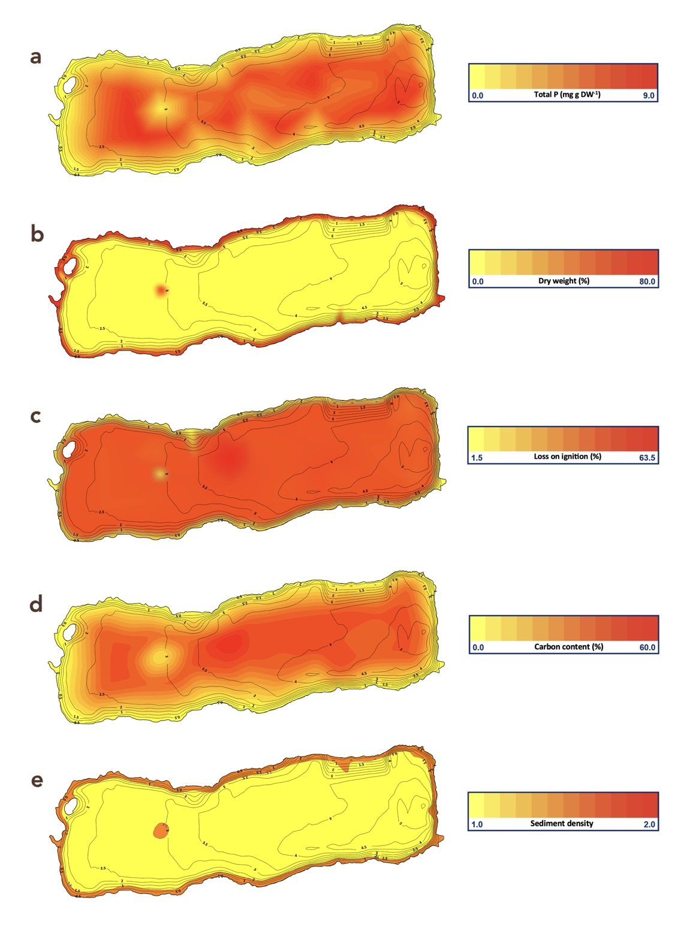

Fig. 1S Heatmaps depicting the sediment physical and chemical characteristics measured in the 0–1 cm sediment layer at the 36 sediment stations during the pre-screening of Lake Ormstrup in February 2020: Total P (mg P g DW⁻¹) (a); Dry weight (%) (b); and Loss on ignition (%) (c); Organic carbon content (%) (d); Density (mg cm⁻³) (e).
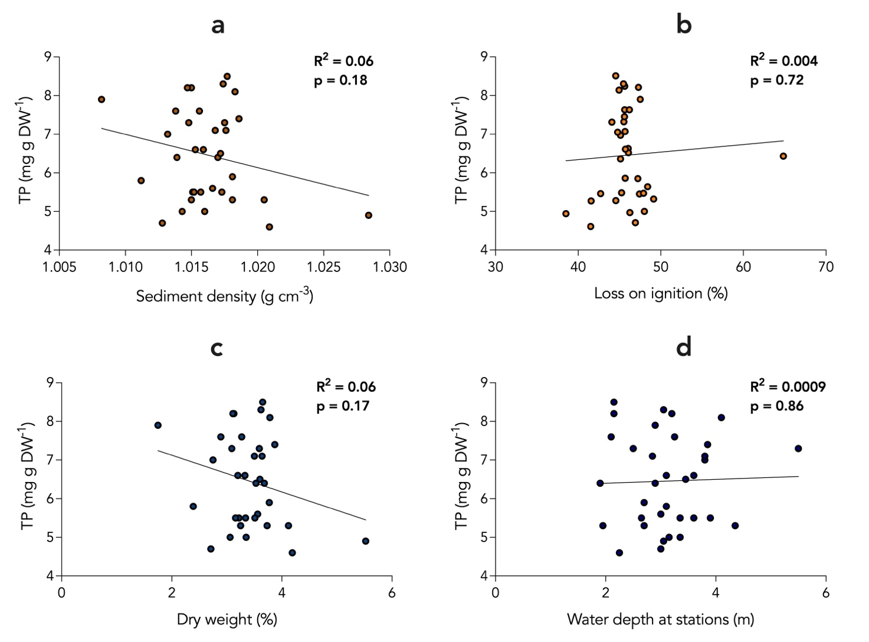
Fig. 2S Scatter plot and determination coefficient for regression analysis (p = 0.05) between sediment total phosphorus contents (mg P g DW⁻¹) and sediment density (g cm⁻³) (a), Loss on ignition (%) (b), Dry weight (%) (c), and water depth (m) (d) for 35 of the 36 stations examined as part of the initial sediment screening program in February 2020. Station 8, located at the sandy plateau in the western region, was excluded, as this station was considered an outlier due to a very high sediment density (> 1.9 g cm⁻³).

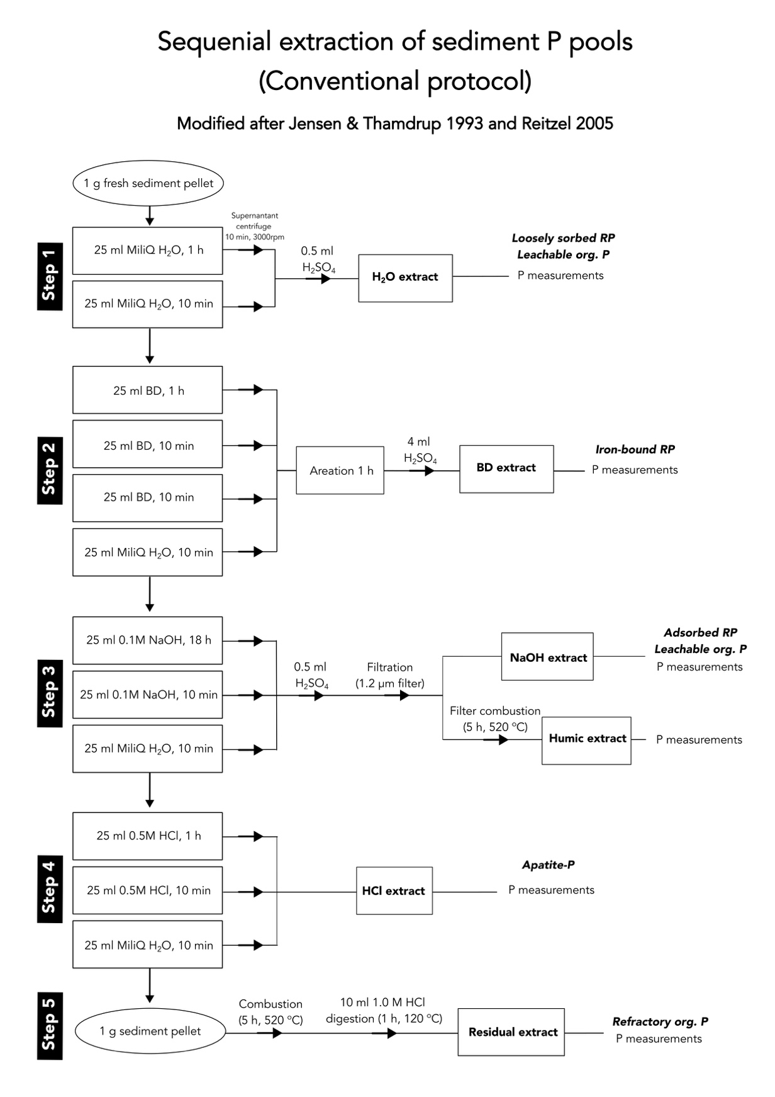

Fig. 3S Scheme showing the stepwise procedure for the conventional sequential extraction of sediment P pools. Modified from Jensen & Thamdrup (1993) and Reitzel (2005).

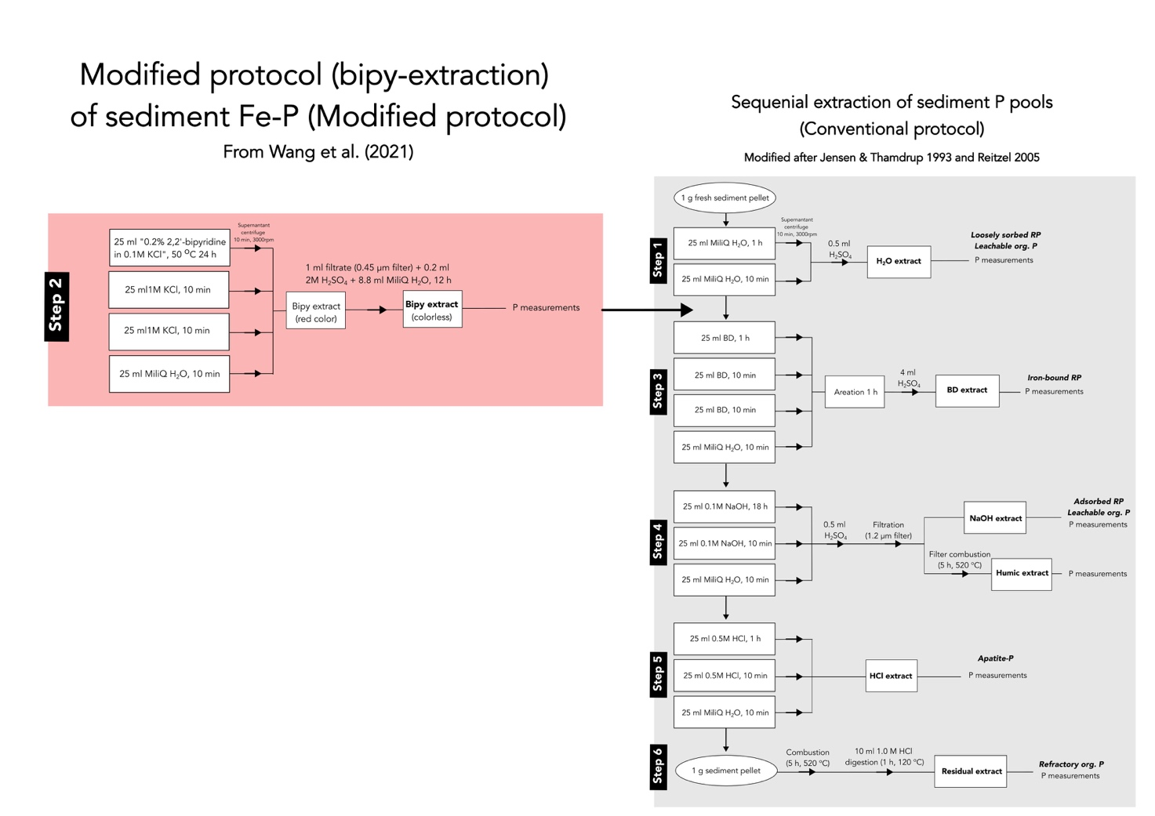
Fig. 4S Scheme showing the stepwise procedure for conducting the modified sequential extraction of sediment Fe-P pools (left), which is included as a ‘Step 2’ following the H₂O extraction step within the conventional protocol (see also Fig. 3S).

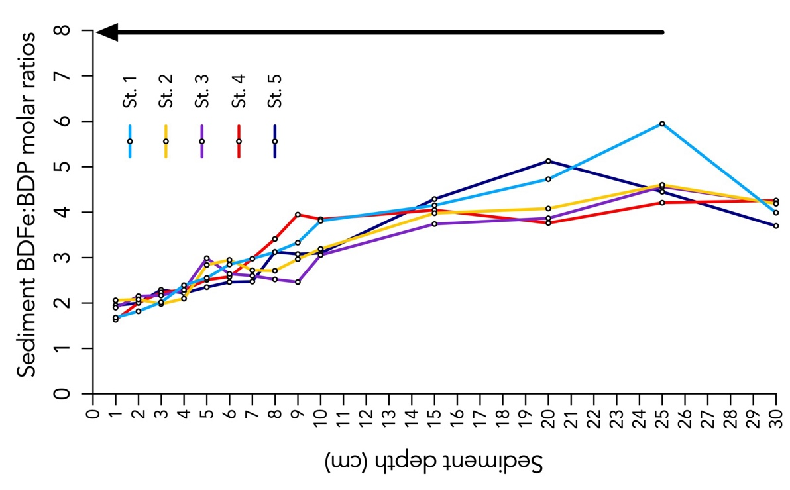

Fig. 5S The sediment molar BDFe:BDP ratios at the five stations are shown on the right with the optimal molar ratio for P binding to oxidized Fe indicated by the arrow (right).

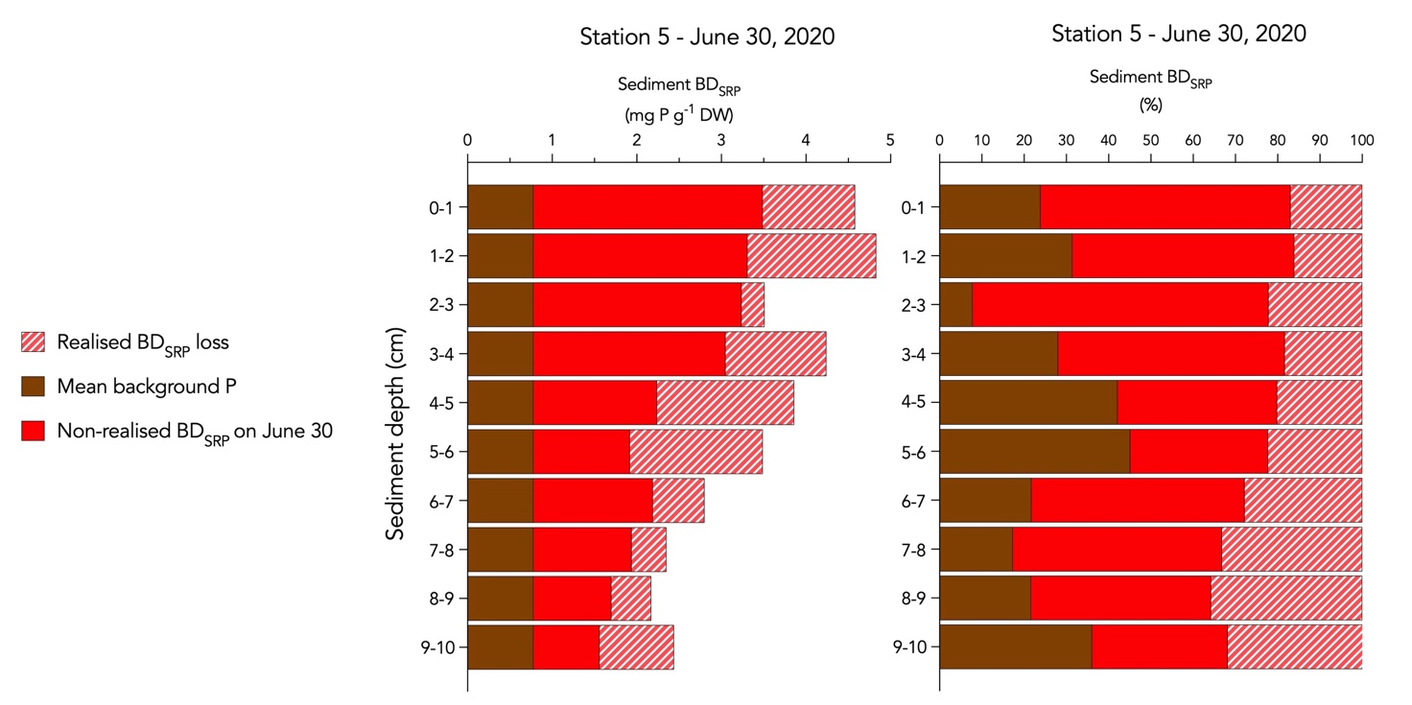
Fig. 6S The temporal changes in the sediment’s BD_{SRP} pool at station 5 (the deepest station) between May 12 and June 30, 2020. The brown bars show the mean BD_{SRP} content found in the deep sediment, considered as background P, and therefore not likely to be released. The red bars show the content of BD_{SRP,} which was left in the respective 1 cm sediment layers on day 50 (June 30) of the monitoring period. The lined bars show the BD_{SRP,} which was lost from the respective sediment layers during the 50-day period.

Table 1S. Morphometrics of the five permanent sediment stations. Water depth (m) is the water depth at the station. The designated area coverages (m²) of the five stations defined with respect to the local water depths and sediment characteristics of the sediment surface area assumed to exhibit P release to the water.
Station no. | Water depth  (m) | Designated area cover (m²) | Percentage coverage of lakebed area with P release (%)
1 | 1.75 | 19,562 | 18.0
2 | 2.65 | 24,452 | 22.5
3 | 2.65 | 21,192 | 19.5
4 | 3.2 | 24,235 | 22.3
5 | 5.5 | 3,152 | 2.9

Table 2S. Sediment physicochemical data from the surface sediment (0–1 cm) of the 36 sediment stations that were examined during the initial screening program in Lake Ormstrup in February 2020.
Station | Dry weight  (%) | Loss on Ignition  (%) | Sediment density  (g cm⁻³) | Total phosphorus  (mg g DW⁻¹)
1  2  3  4  5  6  7  8  9  10  11  12  13  14  15  16  17  18  19  20  21  22  23  24  25  26  27  28  29  30  31  32  33  34  35  36 | 3.72  -  3.50  2.88  3.13  3.65  4.19  77.6  3.08  3.34  3.67  3.24  1.74  3.68  3.49  2.71  3.55  5.51  3.62  3.35  3.20  2.39  3.26  3.11  3.22  2.75  3.05  3.59  3.33  3.51  3.15  3.63  3.59  3.87  3.77  4.11 | 45  -  45  46  46  45  42  1  46  47  46  49  48  65  46  47  48  39  45  46  46  47  46  47  48  45  48  46  46  43  45  45  44  46  45  42 | 1.018  -  1.017  1.014  1.015  1.018  1.021  1.909  1.015  1.016  1.018  1.015  1.008  1.014  1.017  1.013  1.017  1.028  1.017  1.016  1.015  1.011  1.016  1.015  1.015  1.013  1.014  1.017  1.016  1.017  1.015  1.018  1.017  1.019  1.018  1.021 | 5.28  -  6.36  7.63  8.24  8.51  4.61  0.15  7.32  5.45  5.86  5.32  7.90  6.43  7.07  4.71  5.64  4.94  8.30  4.97  6.63  5.85  7.63  8.21  5.47  6.97  5.00  6.52  6.61  5.46  5.48  7.05  7.31  7.45  8.14  5.27

Table 3S. Sediment P budgets showing the stations-specific and total losses in potentially mobile P contents across the five sediment stations calculated as area-specific differences in P content between May 12 (Day 1) and June 30, 2020 (Day 50). Calculations were based on P loss observed within the active P depths from 0 to 10 cm. Negative values indicate a loss of P, while positive values indicate increased P content.
Depth (cm) | St. 1  (kg P) | St. 2  (kg P) | St. 3  (kg P) | St. 4  (kg P) | St. 5  (kg P) | Sum  (kg)
0–1 | -12.9 | -19.1 | -10.4 | 0.9 | -1.8
1–2 | -12.9 | -8.0 | -10.9 | 0.2 | -1.9
2–3 | -9.1 | -13.0 | -13.5 | 4.8 | -1.1
3–4 | 0.3 | -12.8 | 4.1 | -8.6 | -2.1
4–5 | -0.2 | 5.1 | -10.0 | -4.1 | -2.4
5–6 | 4.6 | 7 | -1.8 | -3.9 | -2.8
6–7 | 0.6 | -2.8 | -1.6 | 4.9 | -1.3
7–8 | -10.1 | -9.9 | -3.2 | 7.7 | -0.9
8–9 | -5.2 | -12.1 | -8.2 | 9.9 | 0.6
9–10 | -0.2 | -3.6 | -7.1 | 9.3 | -1.8
Lost pr. station area | -45.2 | -69.1 | -62.6 | 21.2 | -16.6 | -172

