Spatial patterns of sediment phosphorus contents and release in a deep clearwater lake undergoing rapid eutrophication

Supporting Information

Johann Holdt^{1*}, Andreas Reimer¹, Thomas Gonsiorczyk², Mark O. Gessner^{2,3}, Volker Thiel¹
¹Geoscience Centre of the University of Göttingen, Department of Geobiology, Göttingen, Germany
²Leibniz Institute of Freshwater Ecology and Inland Fisheries, Department of Plankton and Microbial Ecology, Stechlin, Germany
³Berlin Institute of Technology (TU Berlin), Institute of Ecology, Berlin, Germany
*Corresponding author: johann.holdt@uni-goettingen.de

ORCID ID Numbers
Johann Holdt: 0009-0000-9261-7128
Andreas Reimer:
Thomas Gonsiorczyk: 0009-0004-4726-9709
Mark O. Gessner: 0000-0003-2516-7416
Volker Thiel: 0000-0003-4758-2784

Introduction
The Supplementary Information provides additional data and figures that complement the main manuscript by illustrating spatial and temporal patterns of phosphorus dynamics in Lake Stechlin. In particular, vertical water column profiles of temperature, oxygen, and soluble reactive phosphorus (SRP) are presented for different lake basins and seasons. These profiles highlight that phosphorus accumulation in the hypolimnion is not solely attributable to sedimentary release under anoxic conditions. Instead, they demonstrate that water column remineralization of settling organic matter is also a significant source of phosphorus to deep waters. Together, these results underscore the importance of considering both sedimentary and pelagic processes in driving internal phosphorus loading, thereby refining the interpretation of eutrophication dynamics in deep clearwater lakes.

Fig. S1: Relationship between TP contents in dry matter (mg kg⁻¹) in surface sediments of Lake Stechlin (measured in June 2021) and the water depth at the sampling sites. Black dots represent the 0-2 cm sediment depth, and red bars represent the 2-5 cm sediment depth.

Fig. S2: Relationship between sedimentary TP concentration (expressed in mg L⁻¹ of fresh sediment) of the upper sediment layer (0-2 cm) and SRP porewater flux across the water-sediment interface of Lake Stechlin in October 2021
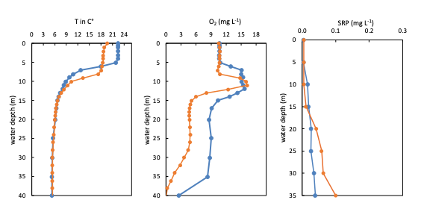
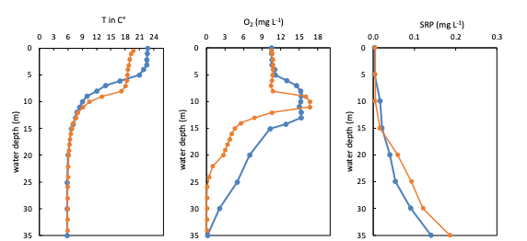
Fig. S4: Vertical profiles of temperature, oxygen concentration and SRP concentration in the water column of the west basin of Lake Stechlin on 07 July (blue lines) and 08 September (orange lines) 2021. Monitoring data for June and October (months of sediment coring) are only available in the main basin.

Fig. S3: Vertical profiles of temperature, oxygen concentration and SRP concentration in the water column of the south basin of Lake Stechlin on 07 July (blue lines) and 08 September (orange lines) 2021. Monitoring data for June and October (months of sediment coring) are only available in the main basin.

