Characterising sources and dominant cycling processes of inorganic nitrogen in a subtropical semi-urbanised catchment: Impact on harbour deoxygenation (in Biogeochemistry) – Supplementary Information
Ho Wen LO ^{1, 2}, Lishan RAN* ², Tim Sik CHAN ¹, Jiao LIU ², Henry Charles James THOMAS ¹, Qianqian YANG ², Benoit THIBODEAU* ¹
¹ Department of Earth and Environmental Sciences / School of Life Sciences, The Chinese University of Hong Kong
² Department of Geography, The University of Hong Kong
* corresponding authors
Benoit THIBODEAU: benoit.thibodeau@cuhk.edu.hk
Lishan RAN: lsran@hku.hk

This document provides supplementary information in relation to the article titled “Characterising sources and dominant cycling processes of inorganic nitrogen in a subtropical semi-urbanised catchment: Impact on harbour deoxygenation”. Part 1 of the document includes Tables S1 and S2, which present detailed results for the statistical tests conducted. Table S3 outlines the physico-chemical properties of the river water on the dates of sampling. Figures S1 to S6 that follow present data obtained at each site during each sampling occasion. These were the data employed in the statistical analyses described in the main text. Part 2 of the document shows in detail how various key numbers mentioned in the main text are computed.

Part 1: Supplementary tables and figures

Table S1: Results of Kruskal-Wallis tests on the various response variables (* indicates a statistically significant result with p < 0.05).
 | Site | Season | Month
Ammonium transport | H = 24.057  df = 3  p < 0.0001* | H = 10.204  df = 3  p = 0.0169* | H = 15.704  df = 11  p = 0.1525
Nitrite transport | H = 36.337  df = 3  p < 0.0001* | H = 1.04  df = 3  p = 0.7916 | H = 6.6199  df = 11  p = 0.829
Nitrate transport | H = 31.329  df = 3  p < 0.0001* | H = 7.7406  df = 3  p = 0.0517 | H = 13.199  df = 11  p = 0.2805
δ¹⁵N | H = 31.627  df = 3  p < 0.0001* | H = 3.5561  df = 3  p = 0.3136 | H = 9.0051  df = 11  p = 0.6214
δ¹⁸O | H = 5.4204  df = 3  p = 0.1435 | H = 3.1112  df = 3  p = 0.3748 | H = 19.652  df = 11  p = 0.05034
Fraction of sewage | H = 31.873  df = 3  p < 0.0001* | H = 3.5196  df = 3  p = 0.3182 | H = 9.0051  df = 11  p = 0.6214
Fraction of nitrification | H = 30.88  df = 3  p < 0.0001* | H = 3.5825  df = 3  p = 0.3102 | H = 8.7245  df = 11  p = 0.6473
Fraction of deposition | H = 5.4204  df = 3  p = 0.1435 | H = 3.1112  df = 3  p = 0.3748 | H = 19.652  df = 11  p = 0.05034

Table S2: Results of Dunn’s tests following Kruskal-Wallis tests with significant results.
 | Site | Season
Ammonium transport | LT01 vs. LT03:  Z = 2.8605, adjusted p = 0.0254  LT02 vs. LT03:  Z = 3.4369, adjusted p = 0.0035  LT01 vs. LT04:  Z = 3.4077, adjusted p = 0.0039  LT02 vs. LT04:  Z = 3.9842, adjusted p = 0.0004 | Summer vs. winter:  Z = 3.1377, adjusted p = 0.0102
Nitrite transport | LT01 vs. LT03:  Z = 3.2951, adjusted p = 0.0059  LT02 vs. LT03:  Z = 3.5867, adjusted p = 0.0020  LT01 vs. LT04:  Z = 4.6949, adjusted p < 0.0001  LT02 vs. LT04:  Z = 4.9865, adjusted p < 0.0001 | N/A
Nitrate transport | LT01 vs. LT03:  Z = 3.4118, adjusted p = 0.0004  LT02 vs. LT03:  Z = 3.7763, adjusted p < 0.0001  LT01 vs. LT04:  Z = 4.0679, adjusted p < 0.0001  LT02 vs. LT04:  Z = 4.4324, adjusted p < 0.0001 | N/A
δ¹⁵N | LT01 vs. LT03:  Z = 4.4470, adjusted p < 0.0001  LT02 vs. LT03:  Z = 3.5284, adjusted p = 0.0025  LT01 vs. LT04:  Z = 4.3158, adjusted p < 0.0001  LT02 vs. LT04:  Z = 3.3972, adjusted p = 0.0041 | N/A
Fraction of sewage | LT01 vs. LT03:  Z = 4.4470, adjusted p < 0.0001  LT02 vs. LT03:  Z = 3.5139, adjusted p = 0.0026  LT01 vs. LT04:  Z = 4.3595, adjusted p < 0.0001  LT02 vs. LT04:  Z = 3.4264, adjusted p = 0.0037 | N/A
Fraction of nitrification | LT01 vs. LT03:  Z = 4.6220, adjusted p < 0.0001  LT02 vs. LT03:  Z = 3.3680, adjusted p = 0.0045  LT01 vs. LT04:  Z = 4.2720, adjusted p = 0.0001  LT02 vs. LT04:  Z = 3.0181, adjusted p = 0.0153 | N/A

Table S3a: Water temperature (°C) recorded at the sampling sites throughout the study period.
Date | LT01 | LT02 | LT03 | LT04
12/12/2023 | 20.2 | 22 | 26.1 | 25.5
25/01/2024 | 11.8 | 12.9 | 13.8 | 13.5
20/02/2024 | 19.1 | 21.4 | 23.6 | 22.7
26/03/2024 | 20.7 | 24.2 | 27.9 | 25.8
16/04/2024 | 23 | 26.3 | 29.8 | 30.5
23/05/2024 | 23 | 24 | 24.9 | 24.8
20/06/2024 | 24.3 | 25.5 | 28.7 | 30.1
30/07/2024 | 24.3 | 25.2 | 27.2 | 26.5
27/08/2024 | 25.3 | 27.4 | 30.3 | 28.5
26/09/2024 | 24.1 | 25.5 | 27.7 | 26.9
31/10/2024 | 20.9 | 22.8 | 25.2 | 24.2
21/11/2024 | 18.6 | 19.2 | 21 | 20.7

Table S3b: Electrical conductivity (EC; µS cm⁻¹) recorded at the sampling sites throughout the study period.
Date | LT01 | LT02 | LT03 | LT04
12/12/2023 | 39.2 | 43.6 | 81.3 | 121.1
25/01/2024 | 40.2 | 47 | 92.6 | 140.5
20/02/2024 | 42.6 | 53 | 98.4 | 143.9
26/03/2024 | 44.9 | 53.4 | 107.9 | 156.4
16/04/2024 | 46.5 | 61.5 | 111.6 | 177.4
23/05/2024 | 42.1 | 46.5 | 92.4 | 129.1
20/06/2024 | 34.9 | 37 | 60.2 | 83.7
30/07/2024 | 29.7 | 38.9 | 66.5 | 86.3
27/08/2024 | 36.8 | 40 | 63.8 | 88.5
26/09/2024 | 34.5 | 38.3 | 62.3 | 84.6
31/10/2024 | 38.6 | 42 | 72.5 | 105.4
21/11/2024 | 36.4 | 39.7 | 76.1 | 103.3

Table S3c: pH recorded at the sampling sites throughout the study period.
Date | LT01 | LT02 | LT03 | LT04
12/12/2023 | 7.43 | 7.45 | 8.71 | 8.05
25/01/2024 | 7.21 | 7.36 | 7.83 | 7.6
20/02/2024 | 7.31 | 7.48 | 8.08 | 8.07
26/03/2024 | 7.07 | 7.31 | 8.02 | 8.34
16/04/2024 | 7.05 | 7.2 | 8.26 | 6.89
23/05/2024 | 7.06 | 7.3 | 7.85 | 7.52
20/06/2024 | 7.1 | 7.46 | 7.51 | 7.87
30/07/2024 | 7.11 | 7.34 | 7.54 | 7.62
27/08/2024 | 7.07 | 7.45 | 8.47 | 8.38
26/09/2024 | 7.08 | 7.39 | 7.65 | 7.95
31/10/2024 | 7.29 | 7.45 | 8.14 | 8.47
21/11/2024 | 7.3 | 7.35 | 7.68 | 7.46

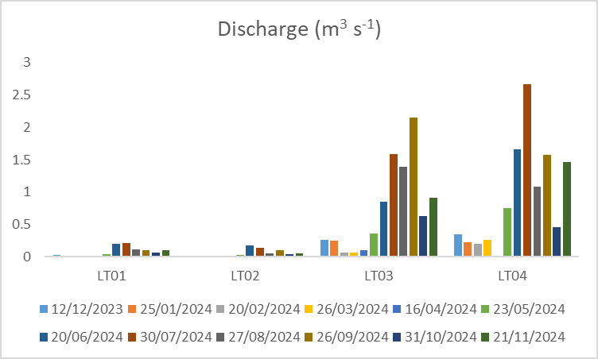
Figure S1: Discharge recorded at the sampling sites throughout the study period.
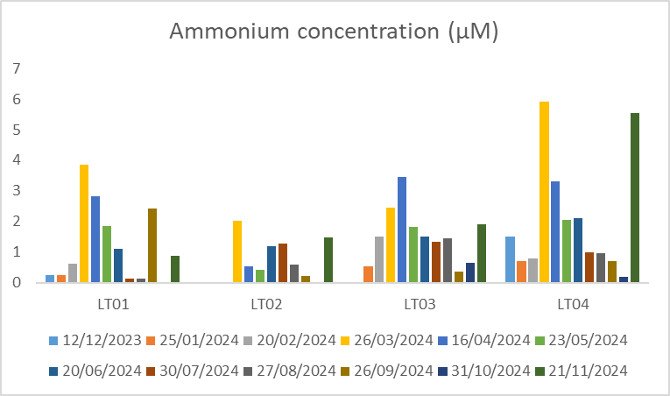
Figure S2a: Ammonium concentrations recorded at the sampling sites throughout the study period.
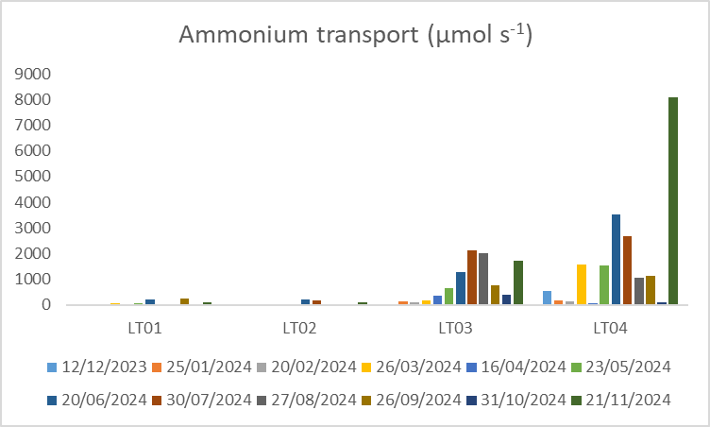
Figure S2b: Ammonium transport rates recorded at the sampling sites throughout the study period.

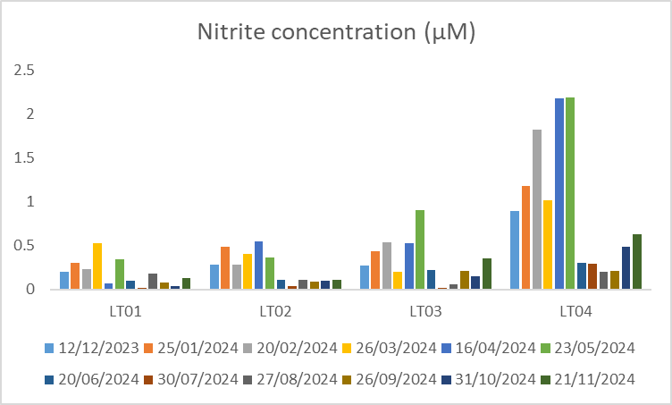
Figure S3a: Nitrite concentrations recorded at the sampling sites throughout the study period.
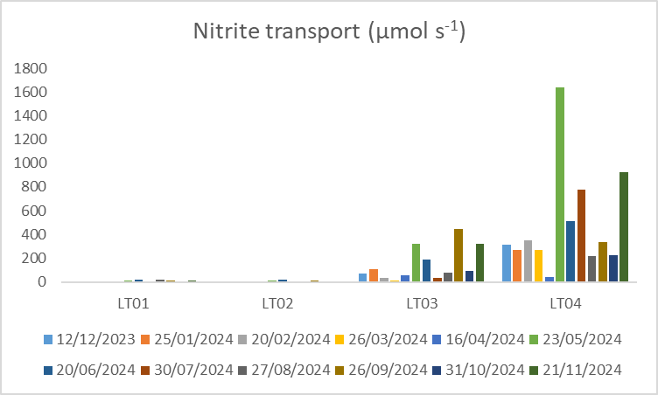
Figure S3b: Nitrite transport rates recorded at the sampling sites throughout the study period.
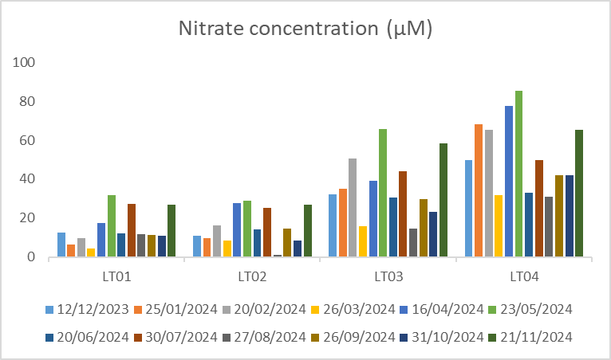
Figure S4a: Nitrate concentrations recorded at the sampling sites throughout the study period.
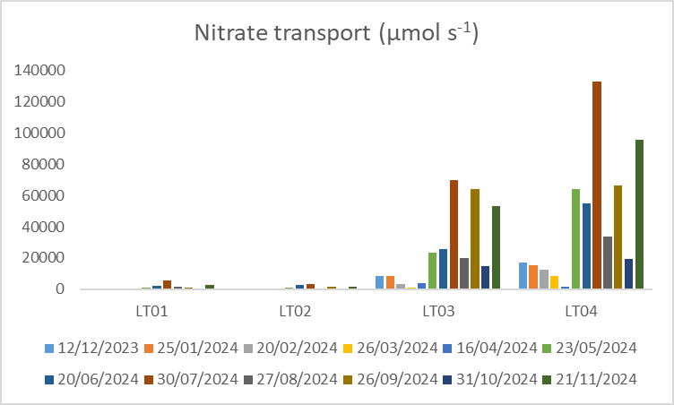
Figure S4b: Nitrate transport rates recorded at the sampling sites throughout the study period.
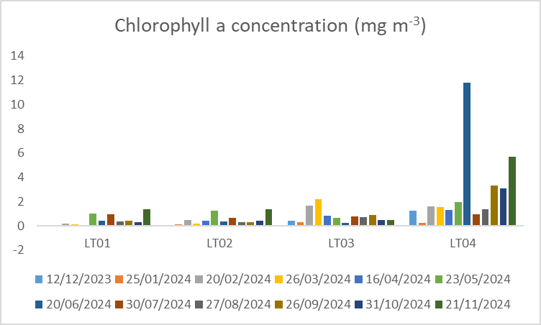
Figure S5: Chlorophyll a concentrations recorded at the sampling sites throughout the study period.
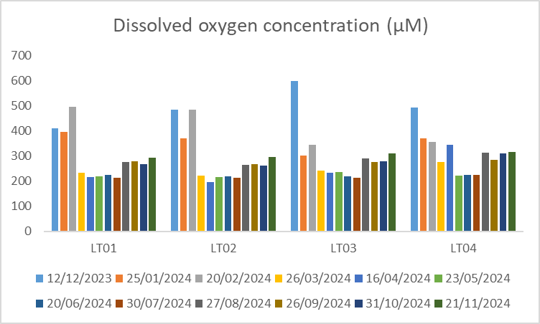
Figure S6: Dissolved oxygen (DO) concentrations recorded at the sampling sites throughout the study period.

Part 2: Calculations

Equation S1 $M=Q∙C$
Equation S2 $E=\sum_{i=1}^{12}{\left(M∙D\right)}$
- $M$: mass transport rate (of ammonium, nitrite, nitrate, or chlorophyll a), converted to d⁻¹
- $Q$: measured discharge at river outlet (LT04)
- $C$: measured concentration (of ammonium, nitrite, nitrate, or chlorophyll a)
- $E$: annual mass export (of ammonium, nitrite, nitrate, or chlorophyll a)
- $i$: month, from December 2023 ($i=1)$ to November 2024 ($i=12$)
- $D$: number of days in the $i$^{th} month

Role of assimilation in removing inorganic nitrogen (Section 4.3)
Applying Equation S2, the annual fluxes of chlorophyll a and dissolved inorganic nitrogen (ammonium + nitrite + nitrate) were found to be 107,744.7 g and 20,248,832.29 g respectively.
Multiplying the maximum carbon-to-chlorophyll mass ratio of 200 (Fanesi et al., 2016) to the annual flux of chlorophyll a, a total of 21,548,940 g of carbon was exported.
Dividing this mass by the molar mass of carbon (12 g mol⁻¹), a total of 1,795,745 mol of carbon was exported by the river.
Assuming that the Redfield mole ratio (C:N = 106:16) also applies to freshwater environments (Andersen et al., 2025), a total of 271,055.85 mol of nitrogen was exported in the form of freshwater phytoplankton.
Multiplying this to the molar mass of carbon (14 g mol⁻¹), a total of 3,794,781.89 g of nitrogen was assimilated by freshwater phytoplankton.
Dividing this mass of nitrogen by the total mass of nitrogen exported (i.e. nitrogen assimilated by phytoplankton + total dissolved inorganic nitrogen), assimilation was found to have consumed approximately 15.78% of all dissolved inorganic nitrogen.

Implications of the river for oxygen consumption in the harbour (Section 4.5)
Assuming that nitrification is governed by the following equation (Sinha & Annachhatre, 2007):
$$NH_{4}^{+}+2O_{2}→NO_{3}^{-}+H_{2}O+2H^{+}$$
Each mole of ammonium would then consume two moles of oxygen gas. The annual ammonium flux exported by Lam Tsuen River was found to be 53,945 moles (using Equations S1 and S2 but considering ammonium only and not NO_{X}). Therefore, 107,890 moles (or 3,370 g) of oxygen would be required to oxidise this ammonium annually.
Next, the annual mass of freshwater chlorophyll a exported by the river was calculated to be 107,745 g. Applying the carbon to chlorophyll a mass ratio of 135 recommended by Yu et al. (2020) for marine environments in this region, this would be equivalent to 14,545,575 g (or 1,212,131 moles) of organic carbon. Using an O₂:C ratio of 138:106 (Redfield, 1958), 1,578,058 moles (or 49,314 g) of oxygen would be consumed during the decomposition of this freshwater phytoplankton.
Finally, applying a O₂:C:N ratio of 138:106:16 (Redfield, 1958) for marine phytoplankton, the assimilation of 20,248,832.29 g (or 1,446,357 moles; annual export of Lam Tsuen River) of inorganic nitrogen would produce 9,582,116 moles of organic carbon and consume 12,474,830 moles (or 389,838 g) of oxygen during decomposition.
High biogeochemical turnover was previously documented in the harbour, with Li et al. (2014) recording a residence time of 6.5 days for organic matter. In other words, nutrient molecules released by the river generally experience more than 56 (= 365 / 6.5) assimilation-remineralisation cycles within a year. Therefore, the mass of oxygen consumed due to organic matter decomposition needs to be multiplied by 56. Overall, 3,370 g + 56 x 49,314 g + 56 x 389,838 g = 24,595,882 g (24,596 kg) of oxygen would be consumed annually due to the inputs of Lam Tsuen River.

References
Andersen, I. M., Taylor, J. M., Graeber, D., Kelly, P. T., Hoke, A. K., Robbins, C. J., & Scott, J. T. (2025). Redfield Revisited: Insights into Freshwater Seston Carbon : Nitrogen : Phosphorus Stoichiometry. Limnology and Oceanography. https://doi.org/10.1002/lno.70133
Fanesi, A., Wagner, H., Becker, A., & Wilhelm, C. (2016). Temperature Affects the Partitioning of Absorbed Light Energy in Freshwater Phytoplankton. Freshwater Biology, 61(9), 1365 – 1378.
Li, X. L., Shi, H. M., Xia, H. Y., Zhou, Y. P., & Qiu, Y. W. (2014). Seasonal Hypoxia and Its Potential Forming Mechanisms in the Mirs Bay, the Northern South China Sea. Continental Shelf Research, 80, 1 – 7.
Redfield, A. C. (1958). The Biological Control of Chemical Factors in the Environment. American Scientist, 46(3), 205 – 221.
Sinha, B., & Annachhatre, A. P. (2007). Partial Nitrification — Operational Parameters and Microorganisms Involved. Reviews in Environmental Science and Bio/Technology, 6, 285 – 313.
Yu, X., Xu, J., Long, A., Li, R., Shi, Z., & Li Q. P. (2020). Carbon-to-Chlorophyll Ratio and Carbon Content of Phytoplankton Community at the Surface in Coastal Waters Adjacent to the Zhujiang River Estuary During Summer. Acta Oceanologica Sinica, 39(2), 123 – 131.

