Supplementary Information
The potential of enhanced rock weathering for CO₂ removal and soil organic carbon storage via organo-mineral aggregation: the trade-off induced by basaltic rock particle size
Puu-Tai Yang^{1*}, Kohei Kurokawa², Atsushi Nakao², Emi Matsumura¹, Rota Wagai¹
¹ Institute for Agro-Environmental Sciences, National Agriculture and Food Research Organization, 3-1-3 Kan-nondai, Tsukuba, Ibaraki, 305-8604, Japan
² Graduate School of Life and Environmental Sciences, Kyoto Prefectural University, 1-5 Shimogamohangi-cho, Sakyo-ku, Kyoto, 606-8522, Japan
*Corresponding Author: yan.putai226@naro.go.jp, puutaiyang@gmail.com
Institute for Agro–Environmental Sciences, National Agriculture and Food Research Organization, +81 29 838 8327

List of Supplementary Texts
Text S1 Preparations and characterizations of materials
Text S2 Characterizations of leachates and microbial DNA
Text S3 The sources of pyrophosphate (PP), oxalate (OX), and dithionite-citrate (DC) extractable metal(loid)s in the samples
Text S4 The retention of elements in basaltic rock mixtures and potential mechanisms
Text S5 Comparisons of CDR potential and OM stabilization in this study with previous studies

List of Supplementary Figures
Fig. S1 Changes in the amounts of water in the basaltic rock-alone and the leaching cups and the mass losses over the six-month incubation under heavy rainfall, regular rainfall, and constant moisture. The water content was calculated from the weight difference between the wet samples and the initial dry sample. Mass losses were calculated from the dry weight of the samples measured at 75 and 175 days relative to the initial dry weight and shown as linear in between. The majority of the mass losses resulted from the decomposition of plant residue except for FB and CB. The amounts of water added were reduced over the six months according to the OM decomposition losses
Fig. S2 The amount of inorganic ions, DOC, and the estimated DIC in the leachates of fine basaltic rock (FB) and coarse basaltic rock (CB) under heavy (h) and regular (r) rainfalls. The amount of K, Na, Ca, Mg, and DOC in the artificial rainwater were shown as blue columns to indicate the contributions of background ions to the calculated DIC
Fig. S3 The amount of inorganic ions, DOC, and the estimated DIC in the weekly leachates of the quartz sand mixture (QM), fine basaltic rock mixture (FM), and coarse basaltic rock mixture (CM) under heavy (h) and regular (r) rainfalls. The amounts of K, Na, Ca, Mg, and DOC in the artificial rainwater applied each week were shown in the blue column to indicate the contributions of background ions to the calculated DIC
Fig. S4 The leachates’ pH of fine basaltic rock (FB), coarse basaltic rock (CB), quartz sand mixture (QM), fine basaltic rock mixture (FM), and coarse basaltic rock mixture (CM) under heavy (h) and regular (r) rainfalls over six months
Fig. S5 Visualization of the calculation to obtain the reactive metal(loid)s in the basaltic rock-alone and basaltic rock mixture treatments in Fig.4. For simplification, we noted the total extractable metal(loid)s in the initial mixture as “M_{BM0}”, which is used only in this figure
Fig. S6 Pyrophosphate (PP), oxalate (OX), and dithionite-citrate (DC) extractable Si, Al, Fe, and Mn (μmol g⁻¹) in each treatment before and after six-month incubation and leached metal(loid)s in six months per mass of the sample. The treatments noted were as the initial amount before the incubation (0), and after the incubation under heavy rainfall (h), regular rainfall (r), and constant moisture (c). The initial extractable metal(loid)s in the mixtures were calculated at the weighted sum of initial basaltic rock, plant residue, and quartz sand, accounting for their mass ratios
Fig. S7 Contributions of initial mixture, abiotic weathering, and biologically induced weathering in the extractable metal(loid)s from fine basaltic rock mixture (FM) and coarse basaltic rock mixture (CM) after six months (PP: pyrophosphate, OX: oxalate, DC: dithionite-citrate; h: heavy rainfall, r: regular rainfall, c: constant moisture)
Fig. S8 The DNA concentrations in the solid samples after the six-month incubation. The measurement was described in Text S2. The treatments were compared with one-way ANOVA and Tukey’s honestly significant difference test (p < 0.05). The uppercase indicates the comparisons between basaltic rocks (FB and CB) or among mixtures (QM, FM, and CM) under the same water regime. The lowercase indicates the comparison among three water regimes within each treatment

List of Supplementary Tables
Table S1 Elemental composition of rocks expressed as oxide contents
Table S2 The pH of basaltic rocks and the mixtures before and after six-month incubation (soil: water= 1: 2.5)
Table S3 Total C, total N, and C/N ratios of the initial materials and mixtures. The data was compared with one-way ANOVA and Tukey’s honestly significant difference test (p < 0.05). The uppercase indicates the comparison among QM, FM, and CM under the same water regime, and the lowercase indicates the comparison among different water regimes within the same type of mixture
Table S4 Summary of recent papers considering enhanced rock weathering for soil organic matter stabilization

Glossary
- Enhanced rock weathering (ERW): Promoting the weathering rate of the easily weatherable primary silicates by crushing them into finer particles.
- Carbon dioxide removal (CDR): Removed CO₂ from the atmosphere. In the basaltic rock-OM mixture treatments, CO₂ source also includes microbially respired CO₂ during plant residue degradation.
- Organic matter (OM): Organic substrates coming from plant/ microbe/ animal debris. In this study, this term includes plant residue, particulate organic matter (POM; partially decomposed plant residue), dissolved organic carbon (DOC), and microbial excreted substrates and necromass.
- Plant residue: Initial fresh (potato) plant residue that has not been incubated.
- Particulate organic matter (POM): Plant residue that experiences microbial degradation.
- Mineral associated organic matter (MAOM): Organic matter that is bound to mineral phases, quantified as the OM in meso-density fraction (1.8 -2.4 g cm⁻³) by density fractionation.
- OM-mineral aggregates: The materials isolated in meso-density fraction were regarded as OM-mineral aggregates in this study because the minerals used (basaltic rock and/or quartz sand) have high density (>2.4 g cm⁻³) and organic materials (plant residue, POM, and microbial compounds) have low density (<1.8 g cm⁻³).
- Dissolved inorganic carbon (DIC): Carbonates presents in the solution phase (leachates). In this study, the DIC was estimated with charge balancing with the amount of dissolved organic carbon and cations (K, Na, Ca, Mg) under measured pH.
- Dissolved organic carbon (DOC): The non-volatile carbon in the solution phase (leachates) measured with a TOC analyzer after treated with diluted acid.
- Reactive metal(loid)s: The metal(loid)s (Si, Al, Fe, Mn) that are extractable with pyrophosphate (PP), oxalate (OX), and dithionite-citrate (DC) reagents and leached during the six-month incubation, if applicable. Under the rainfall regimes (with leaching), the reactive metal(loid)s is the sum of the cumulative amount of metal(loid)s leached during the six months and the total extractable metal(loid)s from the selective dissolution (PP + OX + DC) (i.e. extractable + leached metal(loid)s). For the basaltic rock treatments under the constant moisture regime, the reactive metal(loid)s equals to the total extractable metal(loid)s. The delta reactive metal(loid)s is their increase during the six-month incubation by accounting for the reactive metal(loid)s in the initial mixture (i.e., △extractable + leached metal(loid)s).
- C_{LF}, C_{MF}, and C_{HF}: Total carbon contents in LF, MF, and HF. Due to the low inorganic and organic C contents in HF found in this study, the C_{LF} and C_{MF} were referred to POM and MAOM, respectively.
- Abiotic and biologically induced weathering: In this study, the abiotic weathering refers to the basaltic rock weathering through acid artificial rainwater without the presence of plant residue and microbial inoculum (i.e., FB, CB). The basaltic rock- alone treatments contained trace amount of DNA that was less than 1 % of that in the mixture treatments with plant residue and microbial inoculum (i.e. QM, SM, LM). The biologically induced weathering refers to the additional basaltic rock weathering in the mixtures after subtracting the abiotic weathering in the rock-alone treatment, which includes associated changes in chemical and physical properties of the mixtures induced by the addition of plant residue and microbial inoculum.
- Basaltic rock particles: Each basaltic rock particle contains several primary minerals and therefore is heterogeneous at microscale. We decided to use the term “particles” rather than “grain” as our study focused on particle-size effects in ERW context.

Text S1 Preparations and characterizations of materials
- Characterizing initial materials
For the specific surface area measurements, samples were dried under 105 ℃ before the Brunauer-Emmett-Teller (BET) measurement (Autosorb iQ-XR, Quantachrome). The measurement was carried out with an eleven-point measurement under a 77 K bath with liquid N₂. The correlation coefficients were > 99.99 %. For the geometric surface area measurements, samples were dispersed in 6 % sodium pyrophosphate solution at a solid-to-liquid ratio of 1: 20 and mixed under 150 rpm reciprocally overnight. A suitable amount of the suspension was introduced to the particle size distribution analyzer (LA-920, HORIBA) and measured at 80 – 95 % transmission rate. The geometric surface area was calculated by dividing the measured surface area (as cm² cm⁻³) by the particle density (as g cm⁻³) determined with the pycnometer method (Blake & Hartge 1986).
To determine the mineral compositions, samples (1.0 g) were mixed with 0.25 g of corundum (Baikalox 3.0CR, Baikowski, France) and 7 mL of ethanol and ground for 10 min with an XRD-mill (XRD-Mill McCrone, Retsch, Germany) of corundum grinding elements. The mixtures were dried at room temperature and ground homogeneously to powders. The powder samples were then loaded to sample holders and measured with an XRD instrument (Miniflex600, Rigaku, Tokyo, Japan) equipped with a Cu tube (600 W), Ni-foil filter, and a one-dimensional silicon strip detector (D/teX Ultra 2). The scanning range was from 5 to 65 (°2θ) with a step size of 0.01° under the speed of 60 s per 0.6°. Details of calculations were shown in Kurokawa et al. (2024).
The element concentrations were determined with X-ray fluorescence (XRF). Two to three grams of basaltic rocks (ground to < 75 μm), plant residue (< 250 μm), and quartz sand mixed with cellulose (Avicel PH-101 (~50μm), Supelco) were prepared into 32-mm pellets under 20 tons for 30 seconds. The mass and thickness of the pellets were measured to calculate elemental concentrations. The pellets were measured using scattering fundamental parameter (FP) method with a Cartesian geometric XRF instrument (NEX-CG, Rigaku) under vacuum conditions (< 100 Pa). The instrument is equipped with a 50 kV-50 W X-ray tube, and four secondary targets were used for quantifying different elements: (1) RX9 (for Na to Ar), (2) Cu (for K to Cr), (3) Mo (for Mn to Y, and Hf to Ra), and (4) Al (for Zr to Ba). The instrument’s performance was confirmed with an MCA calibration sample before measurements.
For SEM measurements, basaltic rocks were sprinkled on carbon tape and coated with platinum-palladium for 2 minutes (MSP-1S, Magnetron Sputter, Vacuum Device Inc., Japan). The morphology of basaltic rock powders was examined with a scanning electron microscope (SU1510, Hitachi; voltage 15 kV, emission current: 76μA, vacuum pressure: < 1 Pa).
2. Microbial Inoculum preparation
The microbial inoculum was prepared from the red soil (pH= 6.17) collected from Ishigaki Island, Japan. Four grams of field moist soil was weighed into a 50-mL centrifuge tube and incubated under 28 ℃ for 8 hours. Four grams of glass beads (diameter= 4 mm) and 20 mL of Milli-Q water were added into the centrifuge tube and shaken under 150 rpm reciprocally for 30 min. The suspension was filtered through a 5-μm PTFE membrane. The collected microbial inoculum was used within one day after filtration.

Text S2 Characterizations of leachates and microbial DNA
- Determining leachates’ metal(loid)s and DOC contents
The metal(loid)s in the leachates were determined with an inductively coupled plasma optical emission spectrometer (ICP-OES) (720-OES, Agilent) under Ar carrier gas. The samples and standard solutions (XSTC-22, SPEX CertiPrep) were prepared in Milli-Q water. The dissolved organic carbon (DOC) was measured as non-purgeable organic carbon (NPOC) with a TOC analyzer equipped with a nondispersive infrared sensor (TOC-L_{CSH/CSN}, Shimazu, Japan). The standard curve was prepared with hippuric acid (Wakao special grade, Fujifilm) in Milli-Q water. Each sample or standard was mixed with 0.5 % 10.5 M H₂SO₄ solution, purged with purified air for 90 seconds (sparge gas flow= 80 mL), and fifty microliters were injected and heated under 680 ℃. Each sample was injected two to four times to meet the limitation of maximum standard deviation (< 0.1) and coefficient variation (< 2 %). The concentration of each sample was obtained by averaging the integrated peak area from two injections (maximum integration of 290 seconds). For each replicate, the concentrations were multiplied with the leachates’ weights to obtain the contents of metal(loid)s and DOC in the leachates.
- DNA contents in the samples and the estimation of microbial derived carbon from the extractable DNA
After six months, the moist samples were mixed with spatula for two minutes, and 0.40 g of the mixture was subsampled into the centrifuge tube of FastDNA Spin Kit for soil (MP Biomedicals) DNA extraction. The amount of extracted DNA was quantified with Qubit dsDNA Assay (Thermo Fisher Scientific).
While fine basaltic rock mixtures had significantly higher microbial DNA concentrations over coarse basaltic rock mixtures under heavy rainfall but not in the other water regimes (Fig. S8), the difference was, however, less than an order of magnitude. It should be noted that the DNA extraction method could not directly reflect the viability and abundance of microbes. Therefore, we assumed rather similar contributions of microbial activity in the two basaltic rock mixtures. The amount of C in microbial biomass was estimated by multiplying the DNA concentration (Fig. S8) with the conversion factor of 5, which was within the range (4 – 6) reported in previous studies (Anderson & Martens 2013; Chernysheva et al. 2023; Joergensen & Emmerling 2006). The proportion of the estimated microbial biomass C (0.0015 – 0.0113 % C in bulk) was minor compared to total carbon contents (Fig. 7) and its contribution to total C could therefore be ignored.

Text S3 The sources of pyrophosphate (PP), oxalate (OX), and dithionite-citrate (DC) extractable metal(loid)s in the samples
We conducted sequential extraction of metal(loid)s using PP to examine organic-bound metal(loid)s, and using OX and DC to examine poorly crystalline and well crystalline reactive metal(loid)s, respectively. Our results showed preferred extractabilities of metal(loid)s among the three reagents (Fig. S6). The PP solution extracted the least Si, Al, Fe, and Mn among the three extractants for all treatments. The Al and Fe extracted by PP could result from the dispersed mineral particles and organic associated metals (Rennert 2019), in which Mn³⁺ could co-exist as substitutions of Fe³⁺ in octahedral positions (Schwertmann & Cornell 2000). The origin of PP-extractable silica was less studied, but could potentially come from less crystalline mineral phases or phytoliths (Höhn et al. 2008). The acid oxalate (OX) extracted the most Al, Fe, and Mn, which can originate from poorly crystalline metal (hydr)oxides, magnetite (Poulton & Canfield 2005), olivine, and allophane (Rennert et al. 2021). While Si bound to poorly crystalline metal oxides (Sauer et al. 2006) and aluminosilicates (Rennert et al. 2021) should be co-released during OX extraction, we found that most of the extractable Si was released during the dithionite-citrate (DC) extraction. First, the solubility of amorphous silica was low under acidic to neutral conditions (Iler 1979), and thus Si in poorly crystalline minerals might be barely extracted by oxalate solution (pH= 3.0). While oxalate could promote Si dissolution from basaltic rock under pH 6 (Neaman et al. 2005), silicic acid could not complex with oxalate under low pH (4.3 – 5.0) (Poulson et al. 1997) and has a weak affinity with goethite and hematite under acidic condition (Jordan et al. 2007). Therefore, with low possibilities for dissolved Si to complex with oxalate or weakly re-adsorb onto well crystalline Fe oxides under acidic conditions, we thus speculated that the Si released during DC extraction should result from the (partial) dissolution of poorly crystalline minerals from the initial basaltic rock (i.e., amorphous mineral determined by XRD (Table 2)).
The abiotic and biologically induced weathering, especially in the coarse basaltic rock, were observed mainly as DC-extractable Si and OX-extractable Al, Fe, and Mn (Fig. S7). The results suggested the formation of low-crystallinity secondary aluminosilicates and metal (hydr)oxides considering the nature of our sequential extraction method. The formation of these secondary mineral phases is supported by the reduced leaching (increased retention) of Si, Al, Fe, and Mn from the basaltic rock mixtures (Table 3). The increased extractable Fe in the coarse basaltic rock mixtures also explained the relatively low leaching loss of Fe compared to that of the fine basaltic rock mixtures (Table 3).

Text S4 The retention of elements in basaltic rock mixtures and potential mechanisms
The ratios of ions leached from the basaltic rock mixtures relative to the theoretical value (Table 3) showed the differences in the behavior of ions leached out with and without basaltic rock-plant residue interactions. The ratio was 0.23 – 1.08 in the fine basaltic rock mixtures (FM) and 0.28 – 0.99 in the coarse basaltic rock mixtures (CM). The reduction in the leaching rate mainly occurred in the first few months (Fig. S3) corresponding to the timing of rapid decomposition of the plant residue (mass loss in Fig. S1). Among the basaltic rock mixtures, FM had lower leaching ratios than CM for Si and Al, and also for Ca, Na, and Mn but to lower extents (Table 3). Iron leaching was strongly inhibited in CM (ratio = 0.53 and 0.45) but not in FM (ratio = 0.88 and 0.98). Magnesium and K were least retained in both basaltic rock mixtures (ratio = 0.85 – 1.08).
Leaching of Si originate mainly from basaltic rocks (Fig. S3 and 3b). The lower Si leaching ratios in FM relative to CM were therefore attributable to the reduction in basaltic rock weathering rate and/or the increase in Si precipitation (Table 3). The chemical condition of the retained water in the mixtures is difficult to measure but is likely to be similar to that of leachate. Using the condition of the 4th week leachates under measured pH and atmospheric CO₂ (0.00038 atm), chemical equilibrium model, Visual MINTEQ (Gustafsson 2020), indicated the possible formation of the following secondary minerals: halloysite, imogolite, and Fe and Al hydroxides (e.g., Al(OH)₃, boehmite, gibbsite, ferrihydrite). The formation of Al-containing secondary minerals may also explain the retention of Al despite being negatively charged (Al(OH)₄⁻) under the observed alkaline conditions (Fig. S4 and Table S1). The released cations, on the other hand, would be electrostatically adsorbed onto negatively charged silicates (Kosmulski 2009) and, in the case of multivalent cations, also act as cation bridges. Calcium, which has a smaller hydrated radius (4.12 Å) than Mg (4.28 Å (Nightingale Jr 1959)), was more strongly retained than Mg in agreement with the basaltic rock leachate results (Table 3). In addition, the elevated Mg leaching caused by biological weathering was consistent with Zaharescu et al. (2019). The retention of Fe, a redox-sensitive metal, was inhibited in SM relative to CM (Table 3) as found in the basaltic rock leachates (Fig. 3b). The dissolved Fe(III) ions were mainly present as Fe(OH)₂⁺ based on the chemical equilibrium model. As its hydrated radius (4.57 Å (Nightingale Jr 1959)) is larger than that of Ca²⁺ and Mg²⁺, Fe would be a weaker competitor for adsorption sites and thus more susceptible for leaching. The leaching of Fe from the coarse basaltic rock was, however, hindered presumably due to higher porosity (larger inter-particle pores) for O₂ diffusion and subsequent oxidation/precipitation as Fe(III).

Text S5 Comparisons of CDR potential and OM stabilization in this study with previous studies
The maximum inorganic carbon removed by basaltic rock in the system without plant residue and microbial inoculum (0.03 % C as DIC from 15-g basaltic rock) and in the mixtures (0.03 % C as calcite from 30-g basaltic rock mixture under constant moisture) are equivalent to 4.5 and 9 mg C captured by 15 g of basaltic rock in six months, respectively. The values translated to the CDR potential are 0.0022 and 0.0044 t CO₂ t⁻¹ basaltic rock year⁻¹, respectively, which correspond to basaltic rock abiotic weathering and biologically induced weathering. The calculated values were comparable to that reported by Rinder and von Hagke (2021), which was 0.045 t CO₂ t⁻¹ rock (<100 μm) within ten years. Translating our result to applying 50 t ha⁻¹ of basaltic rock to the field could potentially remove 0.11 and 0.22 t CO₂ ha⁻¹ per year, which were comparable to Lewis et al. (2021)(1.3 – 8.5 t CO₂ ha⁻¹ in 15 years; size < 5 mm and BET-SSA= 1.01 – 14.54 m² g⁻¹) but much lower than Vanderkloot and Ryan (2023) (2.8 – 6.8 t CO₂ ha⁻¹ yr⁻¹; size < 500 μm). Since the easily weathered plagioclase in the basaltic rock of our study (~ 60 %) was higher than that in Vanderkloot and Ryan (2023) (16 – 50 %), the relatively low CDR potential in our study should mainly be due to the experimental condition. Vanderkloot and Ryan (2023) leached basaltic rock powder with 100 mL 15 mmol oxalate solution in carbonated DI water every 48 to 72 hours for 14 days. As our study found that more Ca and Mg were released in the first four weeks and gradually decreased with time (Fig. S2 and S3), the CO₂ removal would be higher in the short term but evened out in the long term. If applying 5 % (w/w) basaltic rock across 1.6 billion hectares of cropland globally (FAO 2023) (in 15-cm soil with bulk density of 1.6 g cm⁻³), the maximum CDR potentials by abiotic weathering (0.4 Gt CO₂ yr⁻¹) and biologically induced weathering (0.8 Gt CO₂ yr⁻¹) would be comparable to the goal of 0.5 – 2.0 Gt CO₂ yr⁻¹ reported by Beerling et al. (2020). However, the net CDR potential of our study would be lower and may even be canceled out by the energy-intensive grinding and long-distance transporting (Lewis et al. 2021; Rinder & von Hagke 2021).
On the other hand, the net OM stabilization by basaltic rock addition (as indicated by C_{MF}) was 0.33 – 0.93 % C in 30-g mixture over six months at maximum, which was equivalent to 0.099 – 0.279 g C captured by 15-g basaltic rock in the mixtures over six months (or 0.0132 – 0.0372 t C t⁻¹ basaltic rock year⁻¹). Translating our result to applying 50 t ha⁻¹ of basaltic rock to the field could potentially stabilize 0.66 – 1.86 t C ha⁻¹ year⁻¹. Applying four percent of fine basaltic rock (w/w) according to this study (divided by a factor of 12.5) would potentially increase 0.03 – 0.07 % C as mineral-associated organic carbon in six months. This value was comparable to that found in Buss et al. (2024) (treatment without wheat plants: ~ + 0.05 – 0.1 % C in six months). On the other hand, Xu et al. (2024) showed an organic C stock increase of 0.57 and 5 t ha⁻¹ in two years with 0.25 and 0.5 kg m⁻² rock additions (equivalent to 2.5 to 5 t rock ha⁻¹ and 0.1 and 0.2 % rock in soil, respectively). While their experimental condition was different (less rock powder addition, different rock type but with similar sizes), their study showed one order of magnitude higher efficiency in OM stabilization relative to our current study and Buss et al. (2024). The higher rate of OM stabilization in Xu et al. (2024) may also be attributable to (i) the continuous OM input from plants and greater activity of soil fauna as well as microbes, (ii) more rainfall promoted rock weathering and resulting binding agents, and/or (iii) higher soil clay content which could provide physical protection to OM. On the other hand, Buss et al. (2024) showed a negative effect of wheat plants in MAOM contents, highlighting the complexity of dead/ living organisms and soil properties on OM stabilization.

Supplementary figures
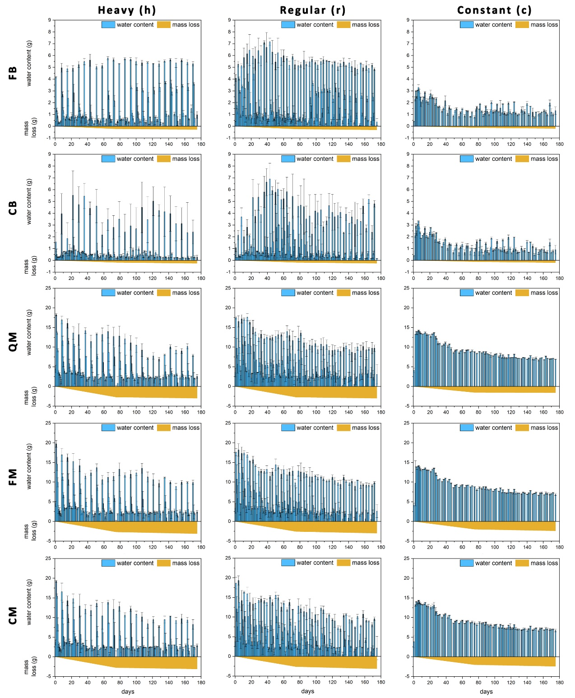
Fig. S1 Changes in the amounts of water in the basaltic rock-alone and the leaching cups and the mass losses over the six-month incubation under heavy rainfall, regular rainfall, and constant moisture. The water content was calculated from the weight difference between the wet samples and the initial dry sample. Mass losses were calculated from the dry weight of the samples measured at 75 and 175 days relative to the initial dry weight and shown as linear in between. The majority of the mass losses resulted from the decomposition of plant residue except for FB and CB. The amounts of water added were reduced over the six months according to the OM decomposition losses
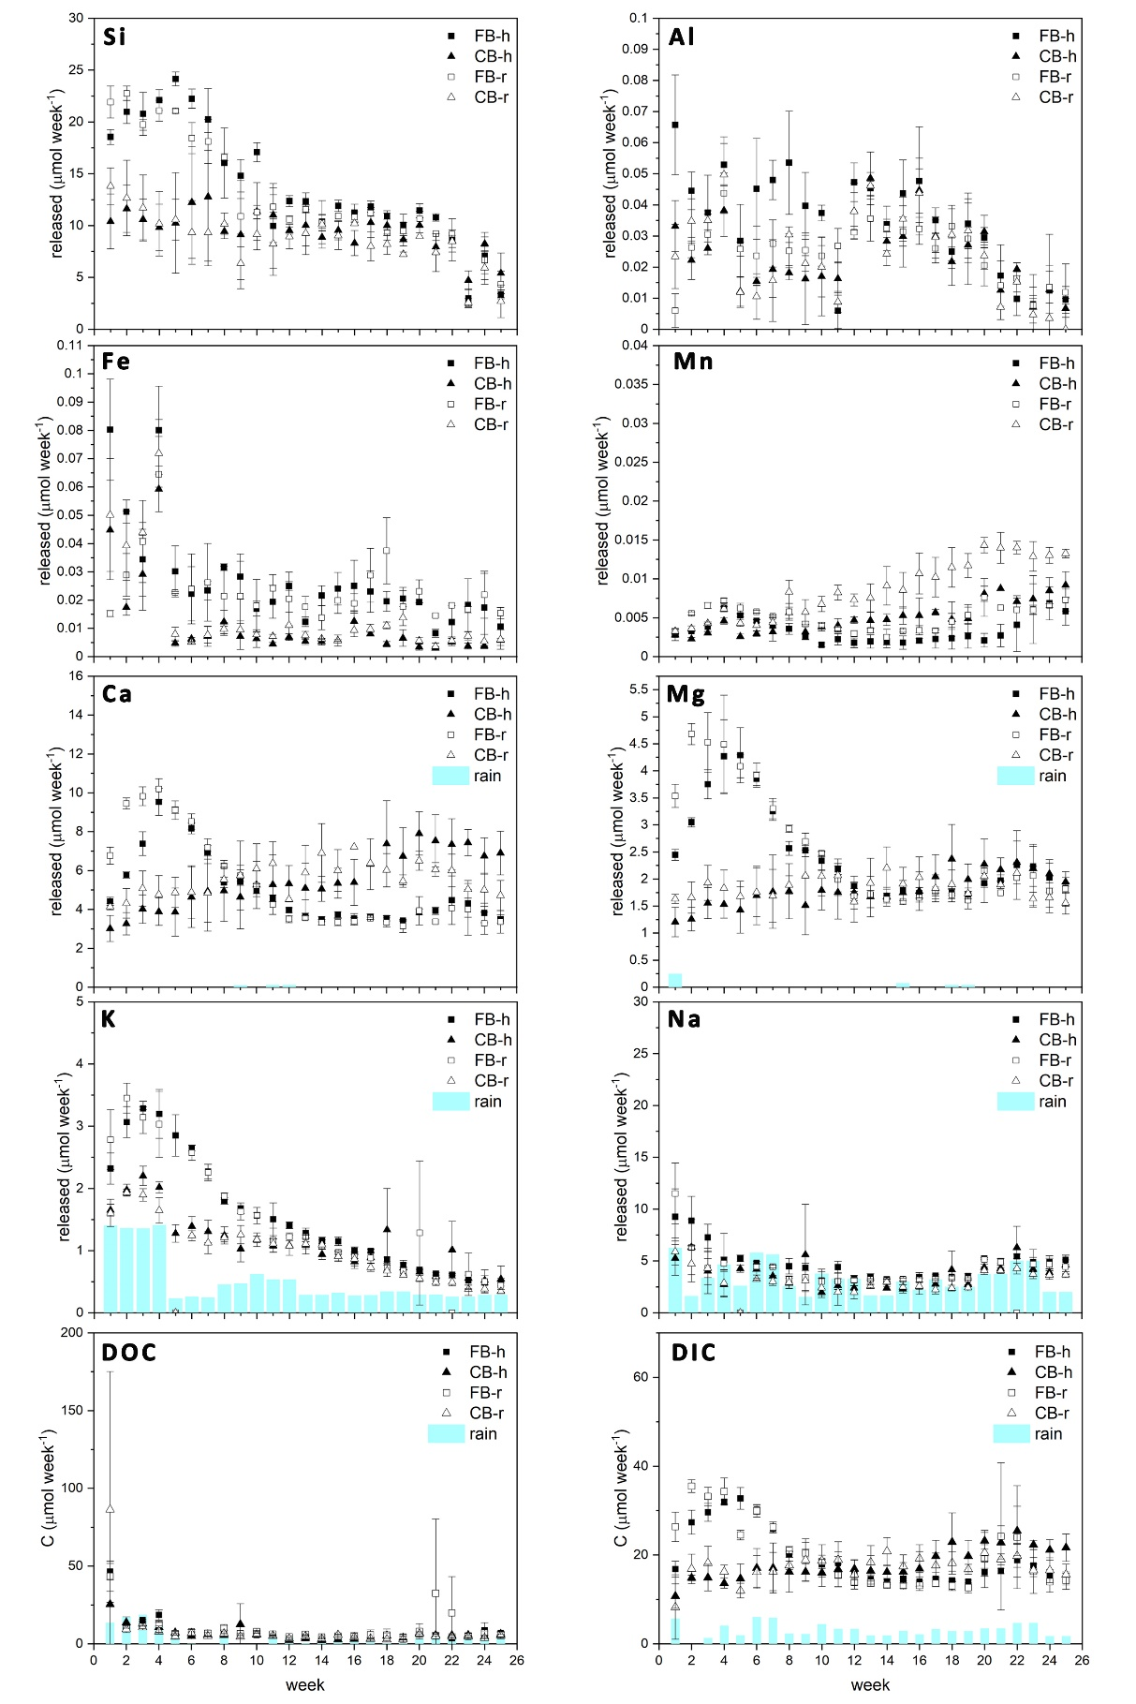
Fig. S2 The amount of inorganic ions, DOC, and the estimated DIC in the leachates of fine basaltic rock (FB) and coarse basaltic rock (CB) under heavy (h) and regular (r) rainfalls. The amount of K, Na, Ca, Mg, and DOC in the artificial rainwater were shown as blue columns to indicate the contributions of background ions to the calculated DIC
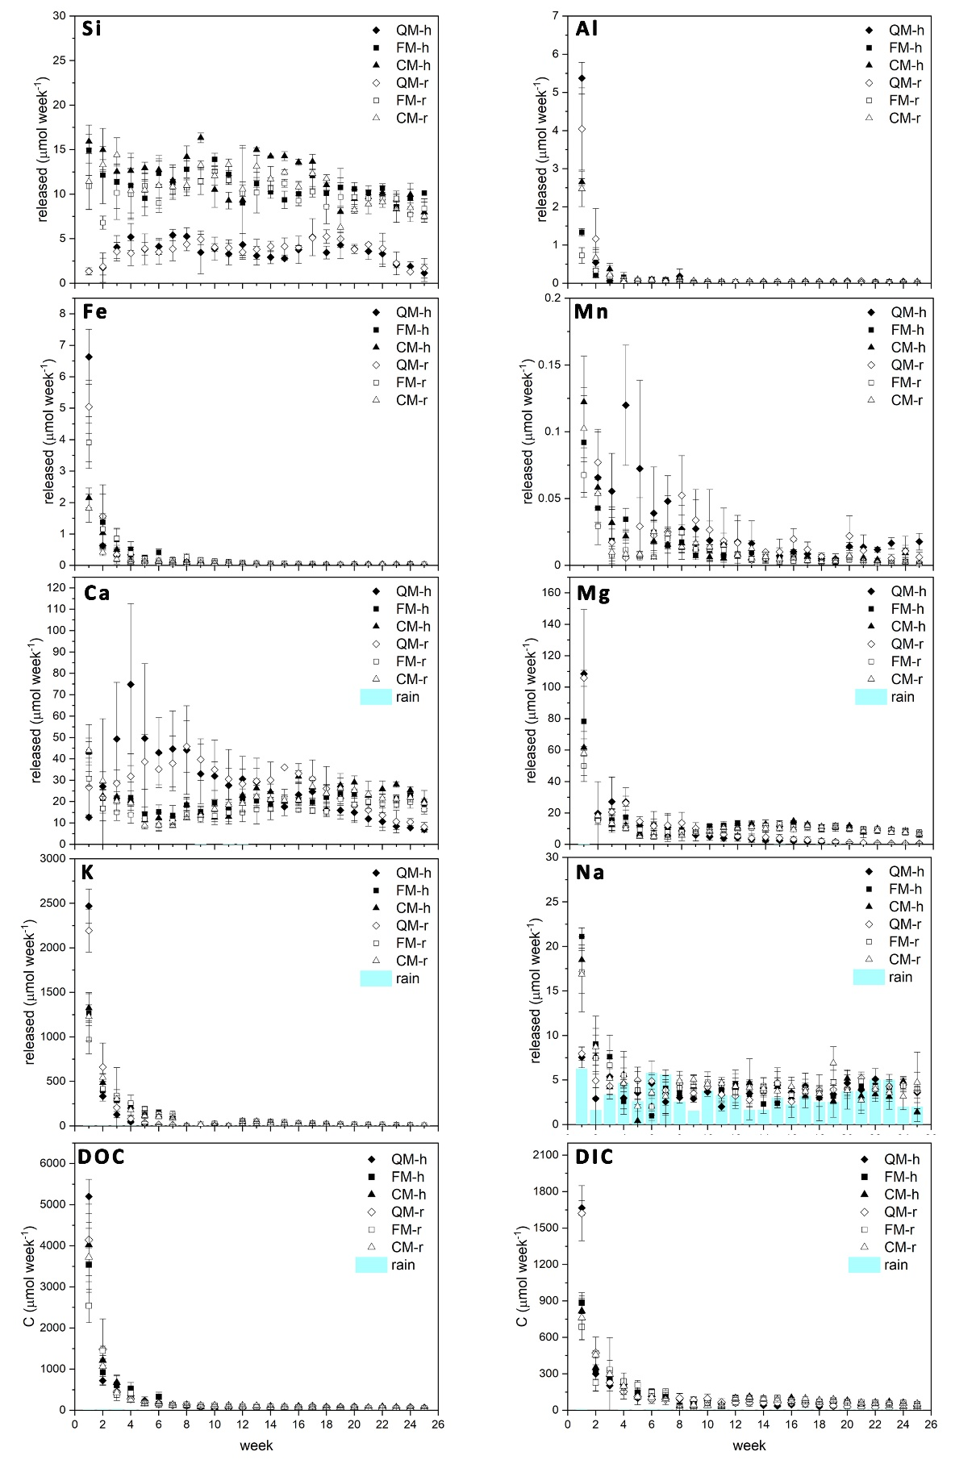
Fig. S3 The amount of inorganic ions, DOC, and the estimated DIC in the leachates of the quartz sand mixture (QM), fine basaltic rock mixture (FM), and coarse basaltic rock mixture (CM) under heavy (h) and regular (r) rainfalls. The amounts of K, Na, Ca, Mg, and DOC in the artificial rainwater applied each week were shown in the blue column to indicate the contributions of background ions to the calculated DIC
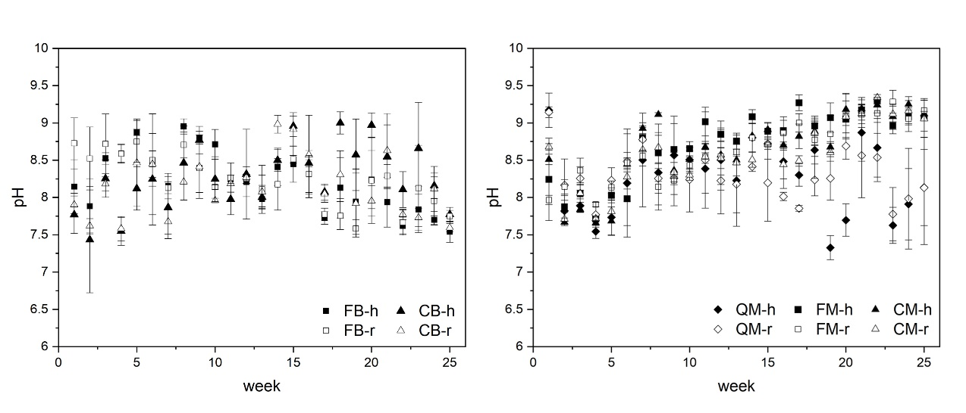
Fig. S4 The leachates’ pH of fine basaltic rock (FB), coarse basaltic rock (CB), quartz sand mixture (QM), fine basaltic rock mixture (FM), and coarse basaltic rock mixture (CM) under heavy (h) and regular (r) rainfalls over six months
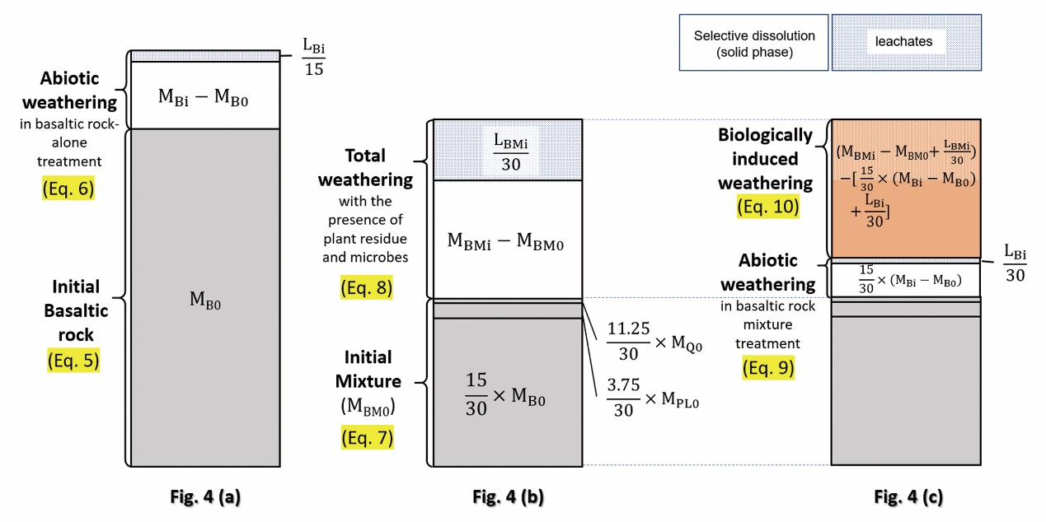
Fig. S5 Visualization of the calculation to obtain the reactive metal(loid)s in the basaltic rock-alone and basaltic rock mixture treatments in Fig.4. For simplification, we noted the total extractable metal(loid)s in the initial mixture as “M_{BM0}”, which is used only in this figure
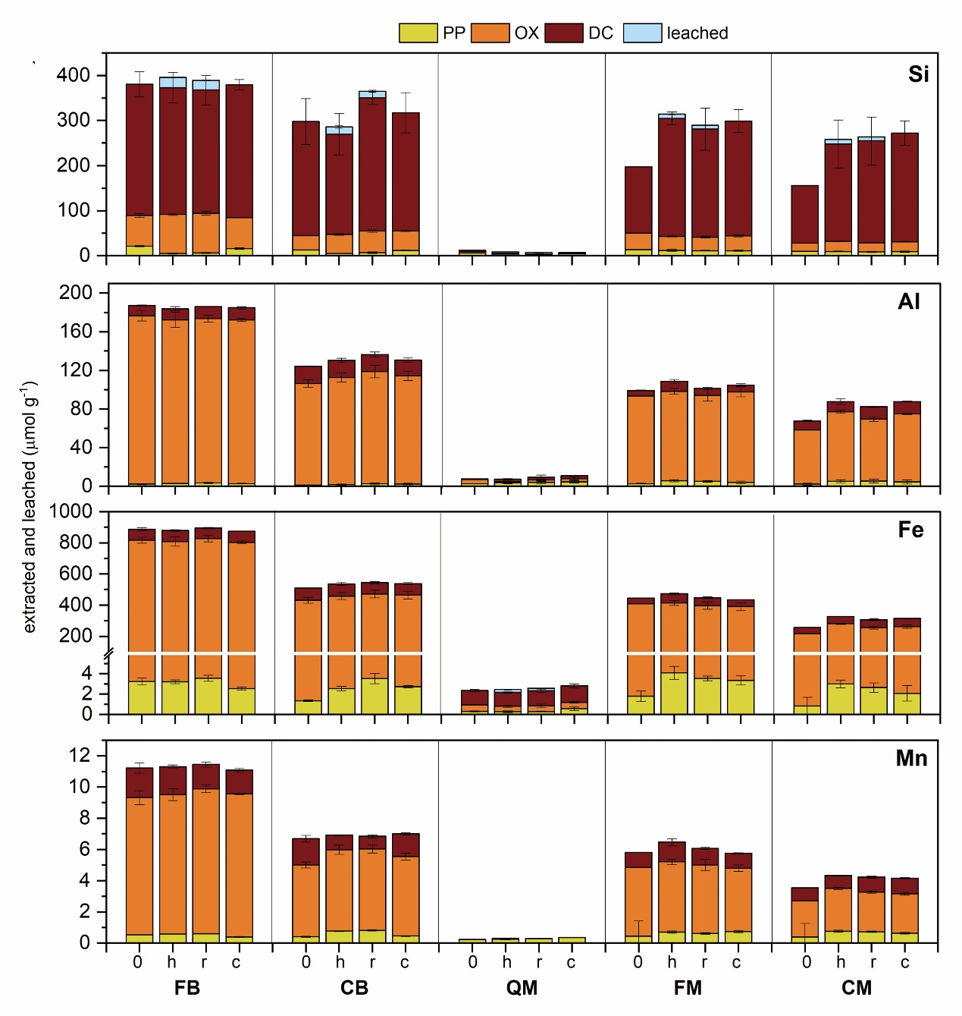
Fig. S6 Pyrophosphate (PP), oxalate (OX), and dithionite-citrate (DC) extractable Si, Al, Fe, and Mn (μmol g⁻¹) in each treatment before and after six-month incubation and leached metal(loid)s in six months per mass of the sample. The treatments noted were as the initial amount before the incubation (0), and after the incubation under heavy rainfall (h), regular rainfall (r), and constant moisture (c). The initial extractable metal(loid)s in the mixtures were calculated at the weighted sum of initial basaltic rock, plant residue, and quartz sand, accounting for their mass ratios
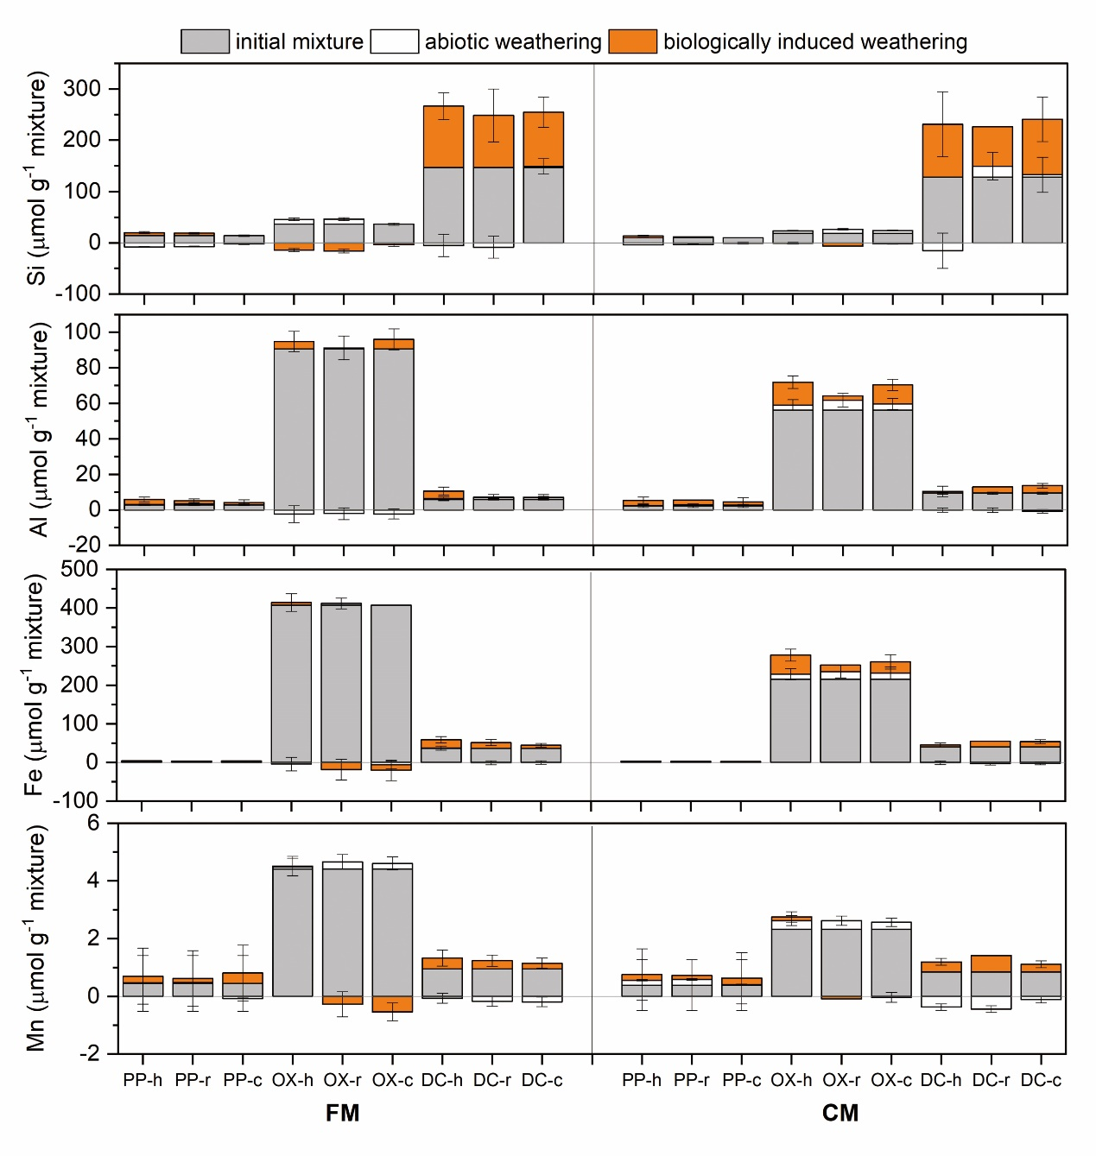
Fig. S7 Contributions of initial mixture, abiotic weathering, and biologically induced weathering in the extractable metal(loid)s from fine basaltic rock mixture (FM) and coarse basaltic rock mixture (CM) after six months (PP: pyrophosphate, OX: oxalate, DC: dithionite-citrate; h: heavy rainfall, r: regular rainfall, c: constant moisture)
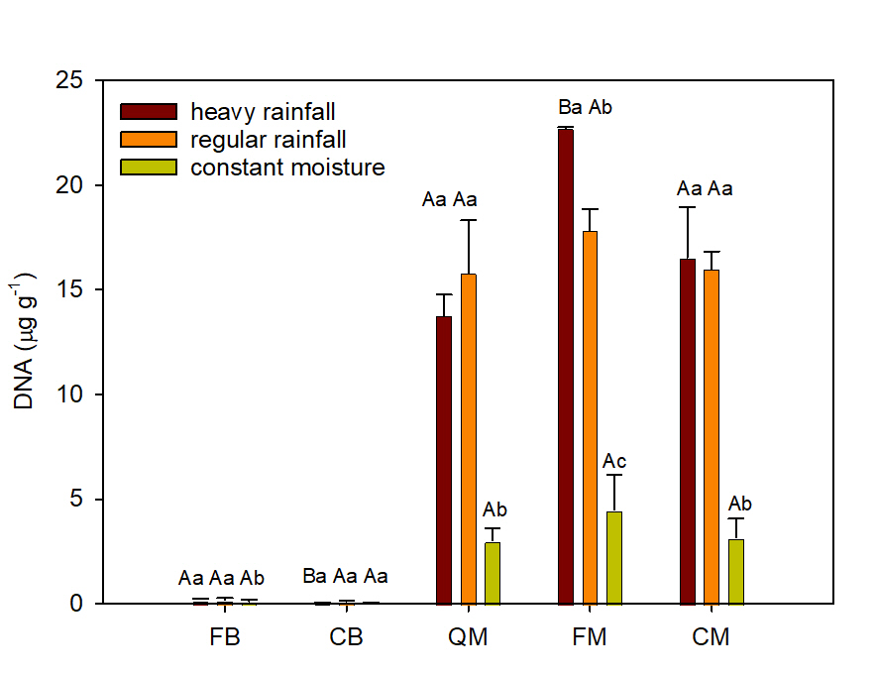
Fig. S8 The DNA concentrations in the solid samples after the six-month incubation. The measurement was described in Text S2. The treatments were compared with one-way ANOVA and Tukey’s honestly significant difference test (p < 0.05). The uppercase indicates the comparisons between basaltic rocks (FB and CB) or among mixtures (QM, FM, and CM) under the same water regime. The lowercase indicates the comparison among three water regimes within each treatment

Supplementary Tables
Table S1 Elemental composition of rocks expressed as oxide contents
elements | oxides | Original basaltic rock ª | Fine basaltic rock  (20 – 38 μm) | Coarse basaltic rock  (106 – 150 μm) | Quartz sand
elements | oxides | oxides weight (%)
Si | SiO₂ | 57.3 | 55.2 | 57.8 | 88.5
Ti | TiO₂ | 1.0 | 1.0 | 0.8 | 0.0
Al | Al₂O₃ | 16.1 | 16.4 | 16.0 | 2.9
Cr | Cr₂O₃ | 0.0 | 0.0 | 0.0 | 0.0
Fe(III)^{b} | Fe₂O₃ | 5.1 | 5.0 | 4.2 | 0.1
Fe(II)^{b} | FeO | 6.3 | 6.2 | 5.3 | 0.0
Mn | MnO | 0.2 | 0.2 | 0.2 | 0.0
Mg | MgO | 5.7 | 5.3 | 5.2 | 0.0
Ca | CaO | 8.2 | 8.5 | 8.5 | 0.6
Na | Na₂O | 2.8 | 2.7 | 2.5 | 0.7
K | K₂O | 0.5 | 0.4 | 0.5 | 0.6
recovery |  | 103.2 | 100.8 | 101.0 | 93.4
ª Basaltic rock before wet-sieving into different sizes; ^{b} The two Fe oxidation state was calculated by multiplying the Fe concentration obtained with XRF and the ratios of Fe(II) and Fe(III) obtained with Mössbauer spectroscopy, and the Fe(II):Fe(III) of the magnetite is 1:2
Table S2 The pH of basaltic rocks and the mixtures before and after six-month incubation (soil: water= 1: 2.5)
 | initial | heavy rainfall | regular rainfall | constant moisture
FB | 8.21 $±$ 0.02 | 8.00 $±$ 0.08 | 7.94 $±$ 0.04 | 8.44 $±$ 0.02
CB | 8.20 $±$ 0.02 | 8.14 $±$ 0.03 | 8.06 $±$ 0.12 | 8.56 $±$ 0.04
QM | 5.78 $±$ 0.06 | 6.26 $±$ 0.10 | 6.29 $±$ 0.09 | 10.5 $±$ 0.1
FM | 6.16 $±$ 0.01 | 7.71 $±$ 0.04 | 7.87 $±$ 0.17 | 9.85 $±$ 0.03
CM | 6.07 $±$ 0.04 | 7.64 $±$ 0.03 | 7.75 $±$ 0.14 | 9.89 $±$ 0.08

Table S3 Total C, total N, and C/N ratios of the initial materials and mixtures. The data was compared with one-way ANOVA and Tukey’s honestly significant difference test (p < 0.05). The uppercase indicates the comparison among QM, FM, and CM under the same water regime, and the lowercase indicates the comparison among different water regimes within the same type of mixture
 | C (%) | N (%) | C/N
quartz sand | 0.005 ± 0.002 | 0.006 ± 0.004 | 1.11 ± 0.59
fine basaltic rock | 0.035 ± 0.003 | 0.009 ± 0.003 | 3.99 ± 1.27
coarse basaltic rock | 0.041 ± 0.003 | 0.004 ± 0.002 | 10.7 ± 3.69
plant residue | 40.5 ± 0.5 | 1.91 ± 0.02 | 21.2 ± 0.1
QM₀ (initial) | 5.06 ± 0.06 | 0.244 ± 0.005 | 20.7 ± 0.5
heavy rainfall (QM-h) | 1.27 ± 0.39 ^{Aa} | 0.0807 ± 0.0295 ^{Aa} | 16.0 ± 2.0 ^{Ba}
regular rainfall (QM-r) | 1.30 ± 0.07 ^{Aa} | 0.0913 ± 0.0091 ^{Aa} | 14.3 ± 1.3 ^{Aa}
constant moisture (QM-c) | 2.50 ± 0.13 ^{Ab} | 0.0986 ± 0.0021 ^{Aa} | 25.4 ± 1.8 ^{Bb}
FM₀ (initial) | 5.08 ± 0.06 | 0.246 ± 0.004 | 20.6 ± 0.7
heavy rainfall (FM-h) | 1.44 ± 0.09 ^{Aa} | 0.118 ± 0.006 ^{Aa} | 12.2 ± 0.4 ^{Aa}
regular rainfall (FM-r) | 1.57 ± 0.12 ^{Ba} | 0.125 ± 0.005 ^{Ba} | 12.5 ± 1.2 ^{Aa}
constant moisture (FM-c) | 2.36 ± 0.08 ^{Ab} | 0.127 ± 0.003 ^{Ba} | 18.5 ± 0.2 ^{Ab}
CM₀ (initial) | 5.08 ± 0.06 | 0.244 ± 0.003 | 20.9 ± 1.9
heavy rainfall (CM-h) | 1.41 ± 0.23 ^{Aa} | 0.0966 ± 0.0070 ^{Aa} | 14.5 ± 1.5 ^{Abba}
regular rainfall (CM-r) | 1.27 ± 0.06 ^{Aa} | 0.108 ± 0.007 ^{Aab} | 11.8 ± 0.5 ^{Aa}
constant moisture (CM-c) | 2.38 ± 0.14 ^{Ab} | 0.122 ± 0.007 ^{Bb} | 19.6 ± 1.1 ^{Ab}

Table S4 Summary of recent papers considering enhanced rock weathering for soil organic matter stabilization
properties | description
Buss et al.(2024) | Rock addition promoted MAOM formation and aggregated OM.
Soil properties | pH (water 1:5): 5.68; texture: loamy sand (sand/silt/clay: 84.7/ 14.7/ 0.6 %); CEC: 2.3 cmol₊ kg⁻¹; TC: 0.88 %; source: Young, New South Wales, Australia.
Mineral properties | type: basaltic rock + granite; Size: < 90 μm (80% of the particle <50 μm); plagioclase/pyroxene/ amorphous/ quartz / 2:1 clay/ IC: 34.4/ 10.4/ 19.1/ 16.3/ 3.7/ 0.05 % (slightly pre-weathered); source: Victoria, Australia.
Experimental conditions | type: pot experiment (1.2 kg total); rock application: 4 % w/w (50 t ha⁻¹); period: 6 months; 18- 25/ 8-10 ℃ (day/ night); precipitation 740 or 420 mm in 6 months
Fractionation method | - For three-pool: POM: wet sieve (> 70 μm), d < 1.8 g cm⁻³ (NaI); AggOM: wet sieve (> 70 μm), d > 1.8 g cm⁻³ (NaI); MAOM: wet sieve (< 70 μm)  - For two-pool: occluded POM: 0.5 % HMP shake 18 hr (2.5 g – 30mL), sieve (> 70 μm); MAOM (< 70 μm)  - Other C: DOC (in extracted solution); SIC (soil acidification (30 % H₃PO₄) and measure released CO₂)
Change in MAOM and IC | - Relative to no rock-no plant treatment, rock addition increased AggOM (~ + 0.1 %) and MAOM (~ + 0.05 – 0.1 %).  - SIC: increased absolute 0.00005 % in 3 cm (0.005 t CO₂ ha⁻¹ at bulk density 1.2 g cm⁻³)
Main findings and proposed mechanisms | - Subsoil C < topsoil C (3 cm): loss of C through leaching was unlikely. (DOM in extracted solutions: 0.12 – 0.15 %)  - Pre-weathered secondary silicate minerals and sorb DOM immediately.  Calcium and Mg were crucial cations, relative to Fe and Al, for cation bridging and promoted formation of (a) MAOM and (b) microaggregates (70 – 200 μm) when without plant under the detected pH (6.2). (positive correlation of Ca and Mg with AggOM and MAOM).  - Effects of rock addition and water treatment on microbiome were not found.
properties | description
Xu et al. (2024) | Rock addition promoted MAOM formation and aggregated OM.
Soil properties | Oxisol; pH (1:2.5) ~ 4.9; texture: clay (~ 60 %); CEC: ~10 .5 cmol₊ kg⁻¹ (from Fig. 2); SOC: ~ 1.6 % (from Fig. 4); source: Xishuangbanna Tropical Botanical Garden, Yunnan Province, China.
Mineral properties | type: mainly wollastonite; Size: 10 – 100 μm (90% of the particle <57.5 μm; SSA= 0.3327 m² g⁻¹); Wollastonite/ xonotlite / quartz/ CaCO₃: 69.4/ 13.8/ 14.8/ 2.6 % (IC=0.312 %); source: Diaobing Mnt., Liaoning, China
Experimental conditions | type: field (rubber plantation; with foliar litter); rock application: 0.25 (low) and 0.5 (high) kg m⁻²; period: 2021 (May) – 2023 (April); average annual air temperature 21.6 ℃; mean annual precipitation (MAP) 1487 mm; climate: hot and humid (May – Oct.; 80 – 90 % of the precipitation) and cool and dry (Nov. – April)
Fractionation method | - POM: d < 1.6 g cm⁻³ NaI – sonicate; Heavy POM: d > 1.6 g cm⁻³ NaI – sonicate – wet sieve (> 53 μm); MAOM: d > 1.6 g cm⁻³ NaI – sonicate – wet sieve (< 53 μm)  - Other C: MBC (chloroform fumigation-K₂SO₄ extraction), DOC (K₂SO₄-extractable C in the non-fumigated samples), lignin phenols (CuO oxidation), necromass (amino sugars; glucosamine and muramic acid), SIC (titration)  - Size fractionation: macroaggregate (> 250 μm), microaggregate (53 – 250 μm), silt and clay (< 53 μm)
Change in MAOM and IC | - Wollastonite increased SOC (high-level; ~ + 0.05 – 0.3 %; estimated from Fig.4), MAOM (~ + 0.2 – 0.3 %; estimated from Fig.4), HCO₃⁻, MBC, necromass C, and fungal: bacterial necromass C.  - Wollastonite increased OC in macroaggregate but not in microaggregates.  - Wollastonite increased organic CDR by 0.57/ 5 t ha⁻¹ and inorganic CDR by 0.13/ 0.65 t ha⁻¹ in low/high level.
Main findings and proposed mechanisms | - Geochemical properties explained OC variations (SOC, MAOM, macroaggregate) better than biological factors.  - Rock weathering enriched soil mineral elements, especially Ca, Si, and Fe, affected the sorption, coprecipitation, and complexation of SOC, directly enhanced MAOM and indirectly promoted biological input and labile DOC.  - Macroaggregate was promoted with increased Ca, Si, Fe, and clay, which then promoted SOC accumulation.

properties | description
Sokol et al.(2024) | Rock addition reduced MAOM formation in the surface soil.
Soil properties | Three spots in Central Valley, California, USA: Yolo field: pH 6.7 – 7.5; silt loam; Mollic Xerofluvents; SOC: 0.657 %.  Merced-1 (M1) and -2 (M2): pH 7.9 – 8.2; clay loam; Typic Haplaquolls and Typic Epiaqualfs (M1 and M2); SOC: 0.9 %.
Mineral properties | type: meta-basalt, meta-andesite, minor dacite and rhyolite; Size: 102 – 107 μm; source: Specialty Granules LLC, Ione mine, Amador County, California
Experimental conditions | type: field; period: 2019 (fall) – 2021 (Nov./ Dec.)  Yolo field: rock application: 40 t ha⁻¹ (Fall 2019 and 2020); mean annual temperature (MAT) 15.6 ℃; MAP 449 mm, drip irrigation; crop: corn  M1 and M2: rock application: 40 t ha⁻¹ (Fall 2019 for M1; Fall 2019 and 2020 for M2); MAT 16.7 ℃; MAP 174 mm, furrow/ flood irrigation; crop: alfalfa (M1) and corn (2019)/ tomato (2020)/ cilantro (2021) (M2)
Fractionation method | - DOM: water-extractable (10:40 w/v; 15 min)  - POM: remaining use 5 % NaHMP (10:30 w/v; 16 hr) – sieve (> 53 μm) …acid fumigation to determine IC  - MAOM: remaining use 5 % NaHMP (10:30 w/v; 16 hr) – sieve (< 53 μm) …acid fumigation to determine IC  - Other C: active microbial biomass (substrate-induced respiration)
Change in MAOM and IC | - The POM and DOC contents were not affected by crushed rock (no increase nor decrease), while the total SOC and MAOM in the surface soil (0 – 10 cm) decreased. No net loss of total SOC, MAOM, or POM was detected.  - Rock addition increased SIC stock at 10 – 30 cm but no effect at 0 – 10 cm (increased 0.068 ± 0.023 % C in 2 years).
Main findings and proposed mechanisms | - No effect of crushed tock on microbial community composition.  - Lower accrual rate of MAOM in the surface soil (0 – 10 cm), which might be related to lower active microbial biomass and thus the transformation of POM to MAOM. But the potential mechanisms remained unclear: altered nutrient availability/ mobility with pH shift; decomposition of MAOM by subsets of microbes (rock alleviates acid retardation).
properties | description
Yan et al. (2023) | Rock addition increased soil CO₂ efflux (stimulated OC mineralization).
Soil properties | pH 4.43 – 6.42; Plinthudults; soil texture: NA; MAT: 16.5 ℃; MAP: 1200 mm; TC: 1.1 – 2.6 %; crop: paddy fields and plantation; source: Huitong Experimental Station of Forest Ecology, Hunan Province, China.
Mineral properties | type: wollastonite (contained 5 % CaCO₃); Size:≦50 μm; source: Diaobing Mnt., Liaoning, China
Experimental conditions | type: incubation (30 g dry soil); rock application rate: 10 % w/w; period: 90 days; temperature: 25 ℃; water: 60 % WHC
Fractionation method | NA  MBC: chloroform fumigation-extraction method  DOC: water extraction (1:2.5) and TOC analyzer  CO₂ efflux: closed chambers with infrared gas analyzer
Change in MAOM and IC | - The DOC, MBC increased with rock addition.  - The CO₂ efflux was positively correlated with increasing (delta) pH, DOC, and available- Si, Ca, and phosphate.
Main findings and proposed mechanisms | - Wollastonite changed soil properties and the consequent CO₂ efflux.  - Increased pH could enhance OC mineralization though (a) favor microbial activity (increased MBC) and (b) deprotonation of organic substance (increased DOC), from which the former could produce DOC.  - Silicon released from the rock could promote OC mineralization through (a) promoting OC desorption from mineral sites and (b) enhance nutrient (phosphate) release with competing adsorption sites for microbial growth, which concurrently resulted in the release of Ca.

References
Anderson T-H, Martens R (2013) DNA determinations during growth of soil microbial biomasses. Soil Biology and Biochemistry 57: 487-495. https://doi.org/10.1016/j.soilbio.2012.09.031.
Beerling DJ, Kantzas EP, Lomas MR, Wade P, Eufrasio RM, Renforth P, Sarkar B, Andrews MG, James RH, Pearce CR, Mercure J-F, Pollitt H, Holden PB, Edwards NR, Khanna M, Koh L, Quegan S, Pidgeon NF, Janssens IA, Hansen J, Banwart SA (2020) Potential for large-scale CO2 removal via enhanced rock weathering with croplands. Nature 583(7815): 242-248. https://doi.org/10.1038/s41586-020-2448-9.
Blake GR, Hartge KH (1986) Particle Density. In: Klute A (ed) Methods of soil analysis, Part 1. Physical and Mineralogical Methods. Agronomy. Soil Science Society of America, Madison, WI. p 377 - 411. https://doi.org/10.2136/sssabookser5.1.2ed.c14.
Buss W, Hasemer H, Ferguson S, Borevitz J (2024) Stabilisation of soil organic matter with rock dust partially counteracted by plants. Global Change Biology 30(1): e17052. https://doi.org/10.1111/gcb.17052.
Chernysheva EV, Fornasier F, Borisov AV (2023) Factors for conversion of the content of double-stranded DNA to carbon of soil microbial biomass. Eurasian Soil Science 56(5): 672-681. https://doi.org/10.1134/S1064229323600021.
FAO (2023) Land use statistics and indicators 2000–2021. Global, regional and country trends. In: FAOSTAT Analytical Briefs Series Rome. https://doi.org/10.4060/cc6907en.
Gustafsson J (2020) Visual MINTEQ VER. 3.1. In. p https://vminteq.com/.
Höhn A, Sommer M, Kaczorek D, Schalitz G, Breuer J (2008) Silicon fractions in Histosols and Gleysols of a temperate grassland site. Journal of Plant Nutrition and Soil Science 171(3): 409-418. https://doi.org/10.1002/jpln.200625231.
Iler RK (1979) The Chemistry of silica: Solubility, Polymerization, Colloid and Surface Properties and Biochemistry of Silica. Wiley, New York https://doi.org/10.1002/ange.19800920433.
Joergensen RG, Emmerling C (2006) Methods for evaluating human impact on soil microorganisms based on their activity, biomass, and diversity in agricultural soils. Journal of Plant Nutrition and Soil Science 169(3): 295-309. https://doi.org/10.1002/jpln.200521941.
Jordan N, Marmier N, Lomenech C, Giffaut E, Ehrhardt J-J (2007) Sorption of silicates on goethite, hematite, and magnetite: Experiments and modelling. Journal of colloid and interface science 312(2): 224-229. https://doi.org/10.1016/j.jcis.2007.03.053.
Kosmulski M (2009) Compilation of PZC and IEP of sparingly soluble metal oxides and hydroxides from literature. Advances in Colloid and Interface Science 152(1): 14−25. https://doi.org/https://doi.org/10.1016/j.cis.2009.08.003.
Kurokawa K, Azuma K, Nakao A, Suzuki A, Wakabayashi S, Fujimura S, Shinano T, Yanai J (2024) Examination of the reliability of X-ray powder diffraction analysis to determine mineral composition of soils. Soil Science Society of America Journal n/a(n/a): 1-17. https://doi.org/10.1002/saj2.20757.
Lewis AL, Sarkar B, Wade P, Kemp SJ, Hodson ME, Taylor LL, Yeong KL, Davies K, Nelson PN, Bird MI, Kantola IB, Masters MD, DeLucia E, Leake JR, Banwart SA, Beerling DJ (2021) Effects of mineralogy, chemistry and physical properties of basalts on carbon capture potential and plant-nutrient element release via enhanced weathering. Applied Geochemistry 132: 105023. https://doi.org/10.1016/j.apgeochem.2021.105023.
Neaman A, Chorover J, Brantley SL (2005) Implications of the evolution of organic acid moieties for basalt weathering over geological time. Am. J. Sci. 305(2): 147-185. https://doi.org/10.2475/ajs.305.2.147.
Nightingale Jr E (1959) Phenomenological theory of ion solvation. Effective radii of hydrated ions. The Journal of Physical Chemistry 63(9): 1381-1387. https://doi.org/10.1021/j150579a011.
Poulson SR, Drever JI, Stillings LL (1997) Aqueous Si-oxalate complexing, oxalate adsorption onto quartz, and the effect of oxalate upon quartz dissolution rates. Chemical Geology 140(1): 1-7. https://doi.org/10.1016/S0009-2541(96)00177-5.
Poulton SW, Canfield DE (2005) Development of a sequential extraction procedure for iron: implications for iron partitioning in continentally derived particulates. Chemical Geology 214(3): 209-221. https://doi.org/10.1016/j.chemgeo.2004.09.003.
Rennert T (2019) Wet-chemical extractions to characterise pedogenic Al and Fe species - a critical review. Soil Research 57(1): 1-16. https://doi.org/10.1071/sr18299.
Rennert T, Dietel J, Heilek S, Dohrmann R, Mansfeldt T (2021) Assessing poorly crystalline and mineral-organic species by extracting Al, Fe, Mn, and Si using (citrate-) ascorbate and oxalate. Geoderma 397: https://doi.org/10.1016/j.geoderma.2021.115095.
Rinder T, von Hagke C (2021) The influence of particle size on the potential of enhanced basalt weathering for carbon dioxide removal - Insights from a regional assessment. Journal of Cleaner Production 315: 128178. https://doi.org/10.1016/j.jclepro.2021.128178.
Sauer D, Saccone L, Conley DJ, Herrmann L, Sommer M (2006) Review of methodologies for extracting plant-available and amorphous Si from soils and aquatic sediments. Biogeochemistry 80(1): 89-108. https://doi.org/10.1007/s10533-005-5879-3.
Schwertmann U, Cornell RM (2000) Iron Oxides in the Laboratory: Preparation and Characterization. Wiley-VCH, Weinheim https://doi.org/10.1002/9783527613229.
Vanderkloot E, Ryan P (2023) Quantifying the effect of grain size on weathering of basaltic powders: Implications for negative emission technologies via soil carbon sequestration. Applied Geochemistry 155: 105728. https://doi.org/10.1016/j.apgeochem.2023.105728.
Xu T, Yuan Z, Vicca S, Goll DS, Li G, Lin L, Chen H, Bi B, Chen Q, Li C, Wang X, Wang C, Hao Z, Fang Y, Beerling DJ (2024) Enhanced silicate weathering accelerates forest carbon sequestration by stimulating the soil mineral carbon pump. Global Change Biology 30(8): e17464. https://doi.org/10.1111/gcb.17464.
Zaharescu DG, Burghelea CI, Dontsova K, Presler JK, Hunt EA, Domanik KJ, Amistadi MK, Sandhaus S, Munoz EN, Gaddis EE, Galey M, Vaquera-Ibarra MO, Palacios-Menendez MA, Castrejon-Martinez R, Roldan-Nicolau EC, Li KX, Maier RM, Reinhard CT, Chorover J (2019) Ecosystem-bedrock interaction changes nutrient compartmentalization during early oxidative weathering. Scientific Reports 9: 15006. https://doi.org/10.1038/s41598-019-51274-x.

