(Title)
Microbial survivability during repeated extreme dry-wet cycles determines CO₂ emissions after rewetting of dried soils in humid temperate forests

(Journal name)
Biogeochemistry

(Authors)
Masataka Nakayama^{a,b}, Yuri Suzuki^{b,c}, Yukiko Abe^{b}, Takeshi Taniguchiª, Mariko Atarashi-Andoh^{b}, Jun Koarashi^{b}, Hirohiko Nagano^{c}

ª: Arid Land Research Center, Tottori University, Tottori 680-0001, Japan
^{b}: Nuclear Science and Engineering Center, Japan Atomic Energy Agency, Tokai, Ibaraki 319-1195, Japan
^{c}: Graduate School of Science and Technology, Niigata University, Niigata 950-2181, Japan

(Corresponding Author)
Masataka Nakayama
Arid Land Research Center, Tottori University, Tottori 680-0001, Japan
Tel: +81-857-30-6356 E-mail: nakayama.masataka.32x@gmail.com

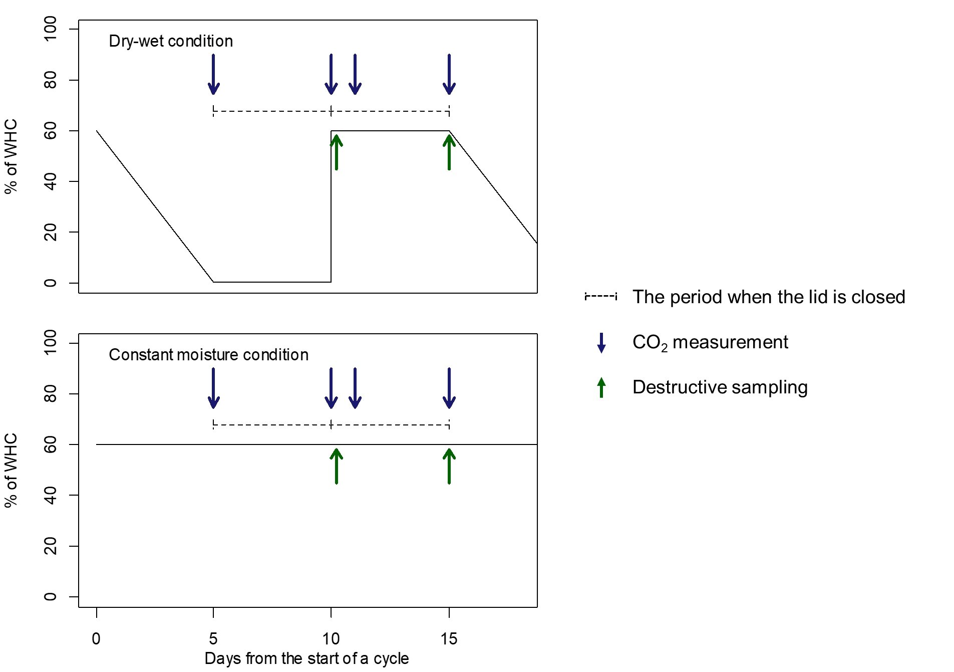
Fig. S1. Conceptual diagram of the treatments.

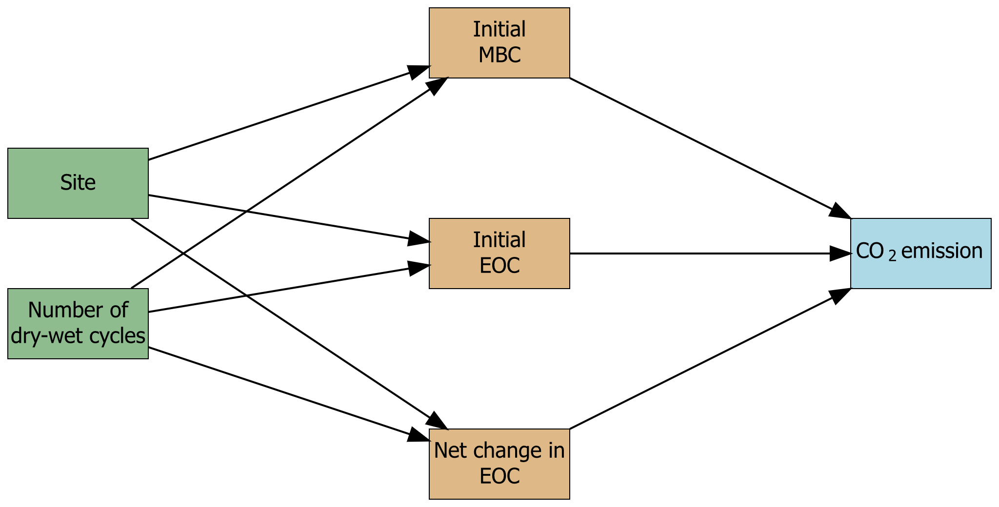
Fig. S2. Hypothetical path model. Initial MBC, Initial EOC, Net change in EOC, and CO₂ emissions represent soil microbial biomass concentrations at the start of the wet periods, soil extractable organic carbon concentrations at the start of the wet periods, net changes in the extractable organic carbon during the wet period, and cumulative CO₂ emissions from the soil during the wet period, respectively.

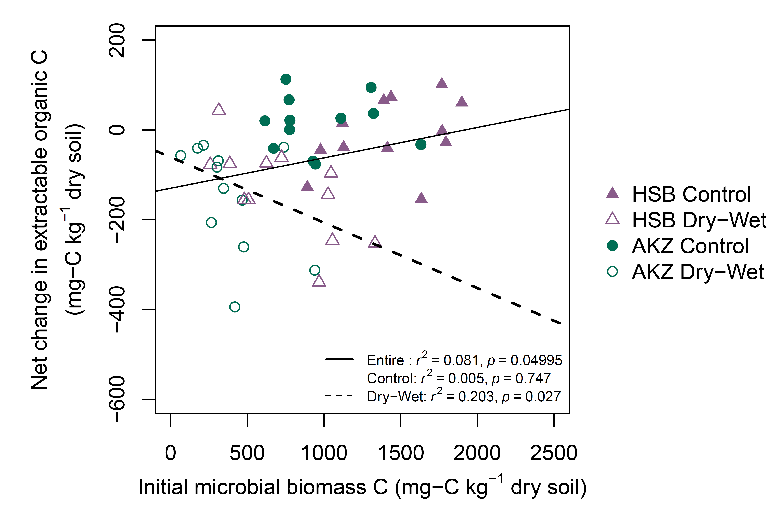
Fig. S3. Relationships between soil microbial biomass concentration (MBC) at the start of the wet periods and the net change of extractable organic carbon (EOC) during the wet periods of the first, third, and fifth dry-wet cycles. Lines represent statistically significant (p < 0.05) relationships between the variables.

