Supplementary material
Mobilized dissolved organic matter provides niche space for prokaryotes in the deep subterranean estuary of a sandy beach
Grace Abarike¹⁺, Simone Brick¹⁺, Julius Degenhardt¹, Anja Reckhardt¹, Rena Meyer^{1,2}, Bert Engelen¹, Jutta Niggemann^{1*}
¹Institute for Chemistry and Biology of the Marine Environment (ICBM), School of Mathematics and Science, Carl von Ossietzky Universität Oldenburg, Ammerländer Heerstraße 114-118, 26129 Oldenburg, Germany
² Institute for Biology and Environmental Sciences, School of Mathematics and Science, Carl von Ossietzky Universität Oldenburg, Ammerländer Heerstraße 114-118, 26129 Oldenburg, Germany
Corresponding author email: jutta.niggemann@uol.de (ORCID; 0000-0003-1237-9233)
Contents of this file
Text S1
Figures S1 – S5
Tables S1 – S3
Introduction
This supporting information includes supplemental text describing the settings for molecular formula assignment using ICBM-OCEAN (Merder et al., 2020). It also contains supplemental figures (Figure S1 to S5), showing the relative abundance of DOM compounds, salinity and oxygen saturation of the porewater, Shannon diversity, richness, evenness, and cell numbers of the sediment-attached microbial communities in the sediment cores. Table S1 shows the molecular properties of mobilizable DOM of the different sediment layers; beach sand (range; 1- 4/5 m), the tidal flat deposits (range; 5/6 -16/20m), and the deeper layers of glacio-fluvial sediments (range; 17/21-24 m). Table S2 shows the molecular properties of DOM clusters I, II and III. Table S3 shows microbial cell numbers normalized to 10⁶ that are also displayed in Figure S5.
Text S1
Mass spectra obtained from FT-ICR-MS were processed using the ICBM-OCEAN software (Merder et al., 2020). The software first applies a method detection limit (MDL) to filter out noise and retain only reliably detected peaks; in this study, the MDL was determined to be 3, based on differences observed between blank and sample spectra. A mass tolerance of 0.5 ppm was applied for both peak detection and molecular formula assignment, allowing for clear peak separation, as confirmed by Hartigan’s DIP test (p = 0). Molecular formulas were then assigned to the identified peaks based on accurate mass measurements. We chose the 'Likeliest Match' function to yield the most probable molecular formulae assignment.

Fig. S1 Relative abundance of mobilizable DOM fractions with different elemental composition of sediment cores at the dune site (Core-ML1) and high-water line (Core-ML2) at the respective sampling depths. CHO = formulas which only contain carbon, hydrogen, oxygen, CHNO = nitrogen-containing formulas, CHOS = sulfur-containing formulas, CHONS = N- and S-containing formulas

Fig. S2 Bar plots showing the relative abundance of chemical categories of mobilizable and porewater DOM taken from wells at the dune site ML1 and high-water line ML2. Categories are based on molecular formulas and were obtained with ICBM-OCEAN (Merder et al., 2020a)
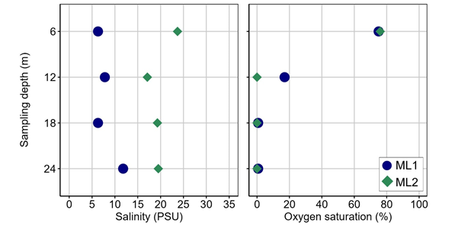

Fig. S3 Salinity and oxygen saturation of the porewater from 6, 12, 18 and 24 m depth at the dune base (ML1) and the high-water line (ML2). Data are for porewater sampled on June 2022.

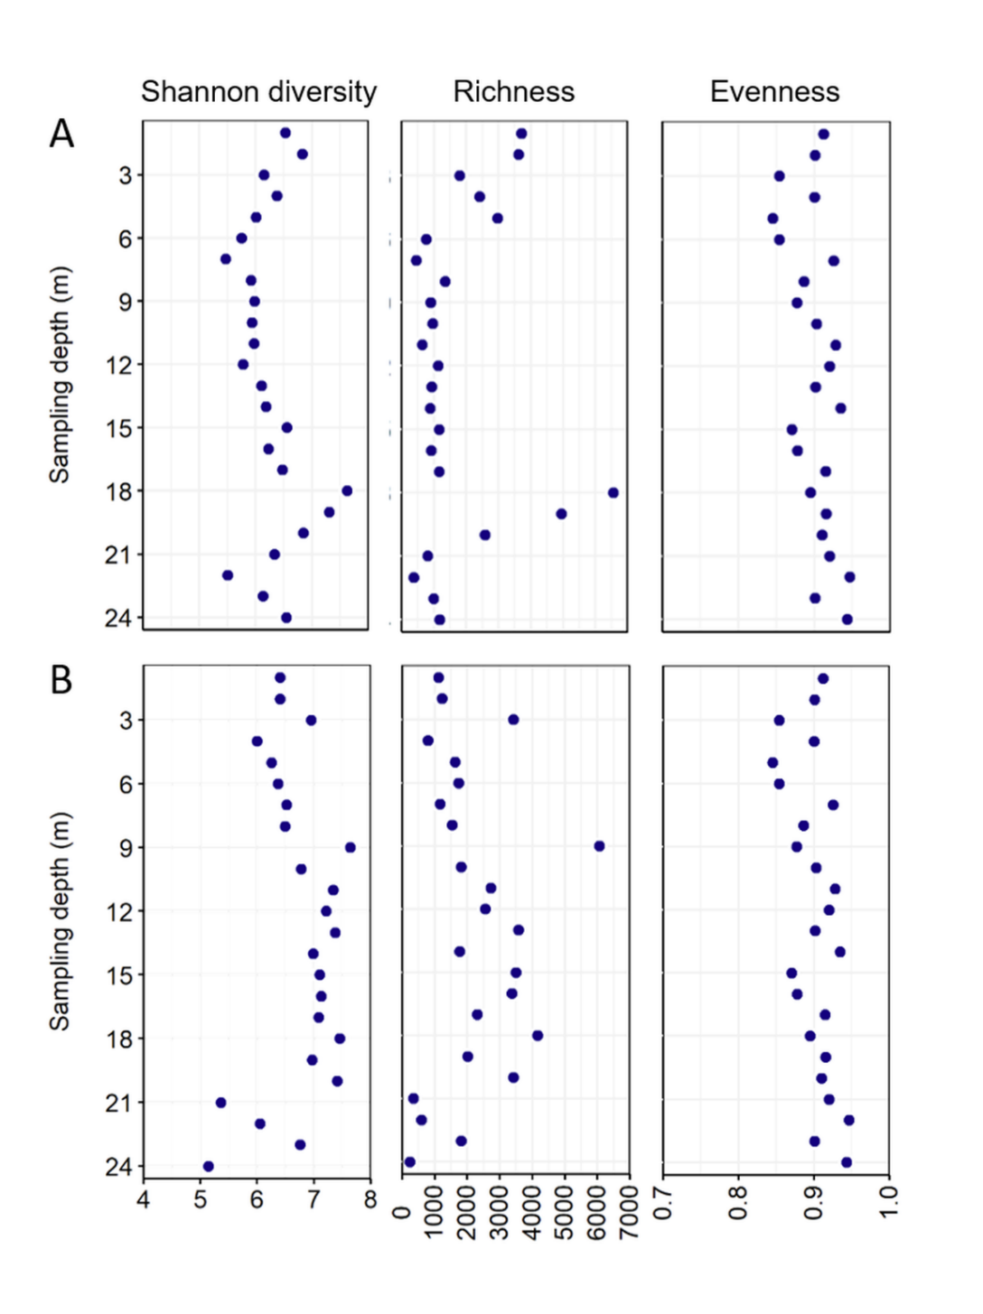
Fig. S4 Shannon diversity, richness and evenness of the sediment-attached microbial communities from the dune base (A, core-ML1) and the high-water line (B, core-ML2)

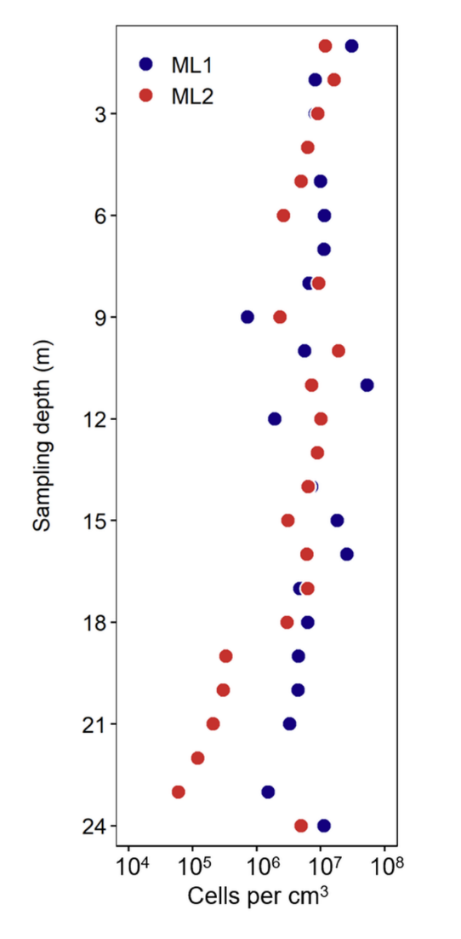
Fig. S5 Microbial cell numbers in core-ML1 (blue) and core-ML2 (red) counted with epifluorescence microscopy after staining with SybrGreen. The number of cells normalized to 10⁶ is shown in Table S3

Table S1 Mean (± SD) of weighted averages of modified aromaticity index (AI_{mod}; Koch and Dittmar, 2006), molecular lability boundary (MLB_{WL}; D’Andrilli et al., 2015), terrestrial index (I_{Terr}: Medeiros et al., 2016) and degradation index (I_{DEG}; Flerus et al. 2012) for beach sand, tidal flat, and the glacio-fluvial sediment layers at the dune site (core-ML1) and the high-water line (core-ML2). The significantly highest value of each parameter amongst the three geological layers is bold and the lowest in italics (p < 0.05). High but not statistically significant between two layers is denoted by “*”
Core-ML1 | Beach Sand  (1-5 m) | Tidal flat  (6-20 m) | Glacio-fluvial  (21-24 m)
I_{DEG} | 0.30 ± _{0.1} | 0.29 ± _{0.1} | 0.37 ± _{0.1}
I_{Terr} | 0.49± _{0.1}* | 0.42± _{0.1} | 0.52 ± _{0.0}*
AI_{mod} | 0.25 ± _{0.0}* | 0.19 ± _{0.0} | 0.24 ± _{0.1}*
MLB_{WL} | 41.9± _{7.7}* | 47.6 ± ₂₀* | 27.8 ± _{2.0}
Core-ML2 | (1-4 m) | (5-17 m) | (18-24 m)
I_{DEG} | 0.29 ± _{0.1} | 0.29 ± _{0.1} | 0.36 ± _{0.1}
I_{Terr} | 0.23 ± _{0.0} | 0.32 ± _{0.1} | 0.53 ± _{0.1}
AI_{mod} | 0.10 ± _{0.0} | 0.12 ± _{0.0} | 0.19 ± _{0.1}
MLB_{WL} | 76.8 ± ₂₀* | 71.9 ± ₂₁* | 58.1 ± ₂₉

Table S2 Mean (± SD) of weighted averages of mean mass, H/C and O/C ratios, double bond equivalent (DBE), modified aromaticity index (AI_{mod}; Koch and Dittmar 2006), relative peak intensity (%) of compounds containing heteroatoms (N and S), molecular lability boundary (MLB_{WL}; D’Andrilli et al., 2015), and terrestrial index (I_{Terr}: Medeiros et al., 2016) of the three DOM clusters (IndVal > 0.5). The significantly highest value of each parameter amongst the three clusters is bold and the lowest in italics (p < 0.05)
 | Cluster I | Cluster II | Cluster III
Indicator formulas | 359 | 168 | 586
Mean mass (w.a) | 304 _{± 25} | 393 _{± 72} | 348 _{± 58}
H/C ratio (w.a) | 1.30 _{± 0.2} | 1.60 _{± 0.1} | 1.80 _{± 0.0}
O/C ratio (w.a) | 0.36 _{± 0.0} | 0.37 _{± 0.1} | 0.29 _{± 0.0}
DBE (w.a) | 6.62 _{± 1.2} | 4.98 _{± 0.9} | 3.52 _{± 0.7}
Al_{mod} (w.a) | 0.32 _{± 0.0} | 0.10 _{± 0.0} | 0.04 _{± 0.0}
N (%) | 4.08 _{± 7.2} | 28.56 _{± 27} | 83.97 _{± 24.7}
S (%) | 8.16 _{± 6.0} | 4.58 _{± 5.2} | 1.78 _{± 5.6}
MLB_{WL} (%) | 15.12 _{± 12.5} | 81.84 _{± 11.82} | 92.51 _{± 17.94}
I_{Terr} | 0.6 _{± 0.2} | 0 | 0

Table S3 Microbial cell numbers in core-ML1 and core-ML2 counted with epifluorescence microscopy after staining with SybrGreen and normalized to 10⁶
Depth (m) | Cells/cm³ x 10⁶
Depth (m) | Core-ML1 | Core-ML2
1 | 30.8 | 11.8
2 | 8.3 | 16.2
3 | 8.3 | 9.1
4 | 6.5 | 6.3
5 | 10.0 | 5.0
6 | 11.5 | 2.7
7 | 11.4 | -
8 | 6.6 | 9.3
9 | 0.7 | 2.3
10 | 5.6 | 19.1
11 | 53.6 | 7.3
12 | 1.9 | 10.2
13 | 8.9 | 8.9
14 | 7.3 | 6.4
15 | 18.1 | 3.1
16 | 25.9 | 6.1
17 | 4.7 | 6.3
18 | 6.3 | 3.0
19 | 4.5 | 0.3
20 | 4.5 | 0.3
21 | 3.3 | 0.2
22 | 0.1 | 0.1
23 | 1.5 | 0.1
24 | 11.3 | 5.0

References for supporting information
D’Andrilli, J., Cooper, W. T., Foreman, C. M., and Marshall, A. G. (2015). An ultrahigh-resolution mass spectrometry index to estimate natural organic matter lability. Rapid Commun. Mass Spectrom. 29, 2385–2401. doi: 10.1002/rcm.7400
Koch, B. P., and Dittmar, T. (2006). From mass to structure: An aromaticity index for high‐resolution mass data of natural organic matter. Rapid Commun. mass Spectrom. 20, 926–932.
Medeiros, P. M., Seidel, M., Niggemann, J., Spencer, R. G. M., Hernes, P. J., Yager, P. L., et al. (2016). A novel molecular approach for tracing terrigenous dissolved organic matter into the deep ocean. Global Biogeochem. Cycles 30, 689–699. doi: 10.1002/2015GB005320
Merder, J., Freund, J. A., Feudel, U., Hansen, C. T., Hawkes, J. A., Jacob, B., et al. (2020a). ICBM-OCEAN: processing ultrahigh-resolution mass spectrometry data of complex molecular mixtures. Anal. Chem. 92, 6832–6838.
Merder, J., Freund, J. A., Feudel, U., Hansen, C. T., Hawkes, J. A., Jacob, B., et al. (2020b). ICBM-OCEAN: Processing Ultrahigh-Resolution Mass Spectrometry Data of Complex Molecular Mixtures. Anal. Chem. 92, 6832–6838. doi: 10.1021/acs.analchem.9b05659

