Supporting Information for

Characterizing Iron-Bound Organic Carbon in Cold Seep Sediment Cores: Impacts of Anaerobic Oxidation of Methane

Journal: Biogeochemistry
Authors: Yang Wu^{a,b}, Qianyong Liang^{a,b,*}, Huachun Liu^{c}, Jingpeng Wang^{d}, Xi Xiao^{a,b}, Yifei Dong^{a,b}, Binbin Guo^{a,b}, Xin Ni^{a,b}, Jing Zhao^{a,b}
a Guangzhou Marine Geological Survey, China Geological Survey, Guangzhou 511458 China
b National Engineering Research Center for Gas Hydrate Exploration and Development, Guangzhou 511458, China
c Guangzhou Center for Disease Control and Prevention (Guangzhou Health Supervision institute), Guangzhou 510440, China
d State Environmental Protection Key Laboratory of Water Environmental Simulation and Pollution Control, South China Institute of Environmental Science, Ministry of Ecology and Environment, Guangzhou 510535, China

*Corresponding author:
E-mail: tomlqy@163.com (Q. Liang)

This Supporting Information provides additional data supporting the main findings of the manuscript. It includes seven supplementary figures and one table documenting downcore profiles of CH₄ and corresponding δ¹³C values (Figure S1), grain-size distributions (Figure S2), total iron (Fe_{T}) levels (Figure S3), concentrations (Figure S4) and spatial distribution (Figure S5) of iron speciation, elemental correlations (Figure S6), correlations between Fe_{T} levels and grain-size components (Figure S7), and correlation between Fe_{T}, Fe speciation, and Fe_{R} (Table 1) in the studied sediments. These materials complement the results presented in the main text and enhance the transparency and robustness of the interpretations discussed.

- Figures
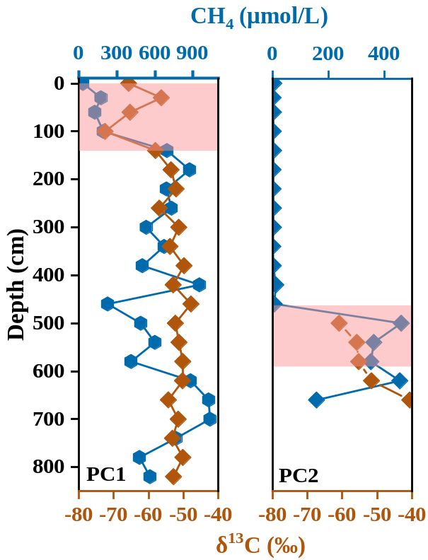
Figure S1 Downcore profiles of CH₄ and corresponding δ¹³C value in sediment from PC1 and PC2. The pink shading indicates the SMTZ occurrence area.

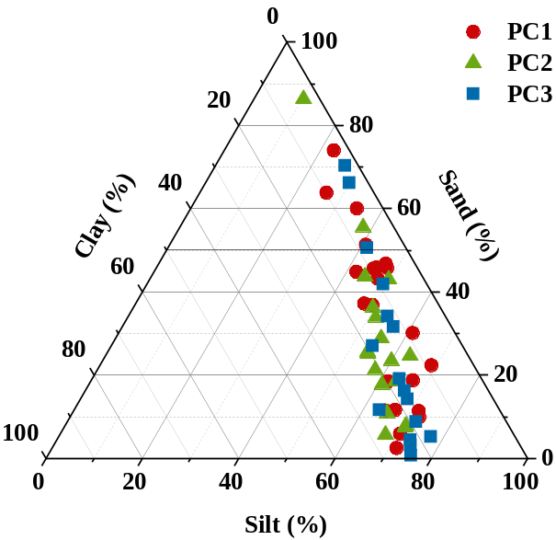
Figure S2 Ternary plot illustrating the grain size distribution of sediment samples collected from three stations.

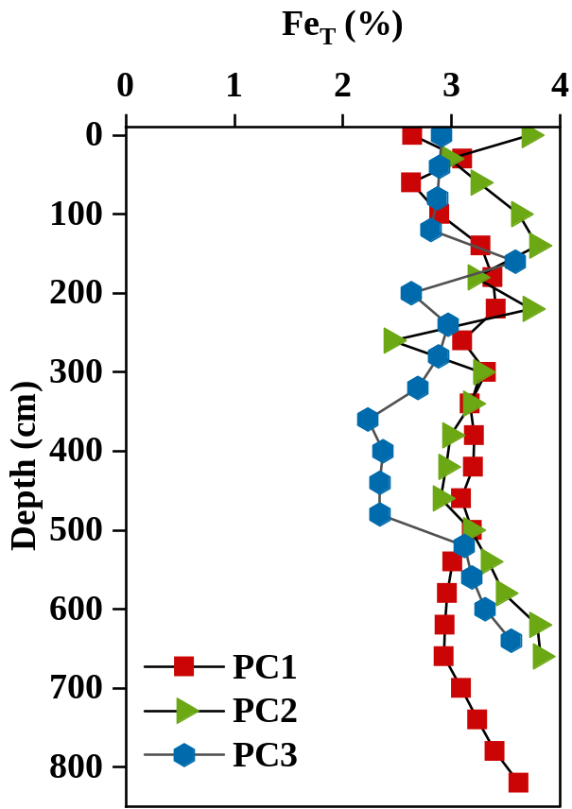
Figure S3 Levels of Fe_{T} in sediment samples collected from three stations.

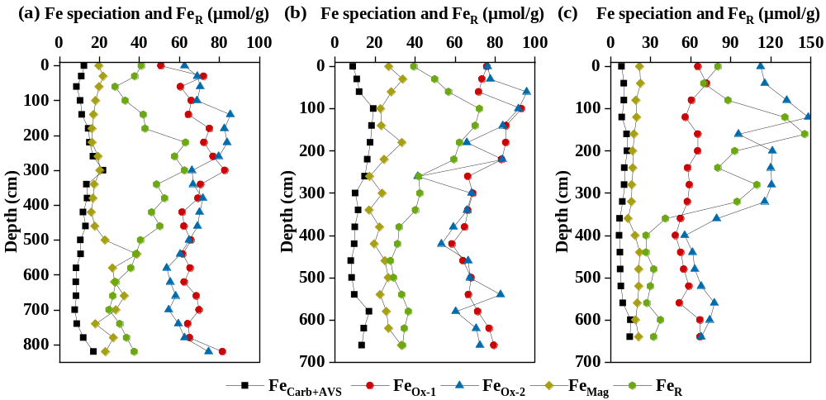
Figure S4 Concentrations of Fe speciation in sediment samples collected from stations PC1 (a), PC2 (b) and PC3 (c).

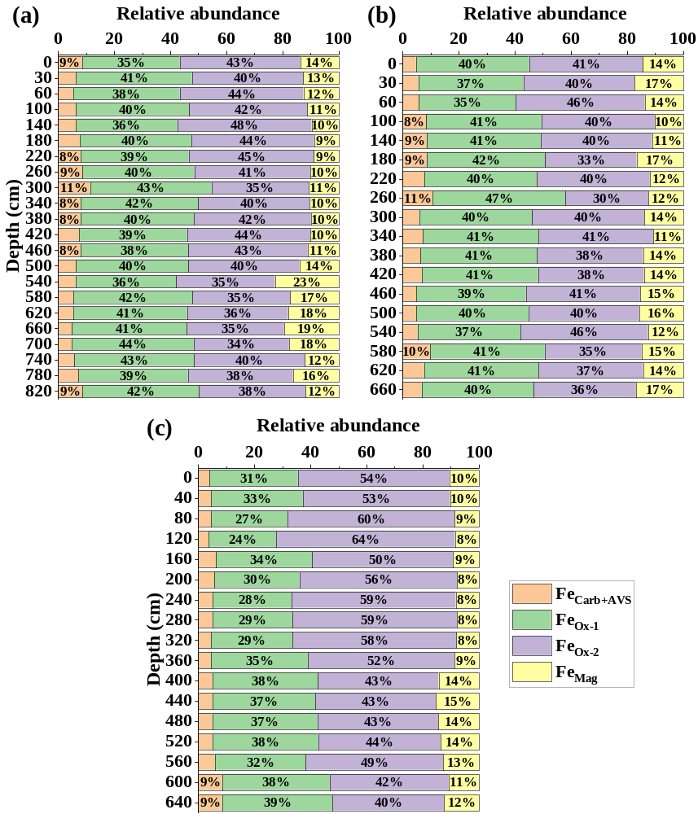
Figure S5 Spatial distribution of Fe speciation in sediment samples collected from stations PC1 (a), PC2 (b) and PC3 (c).

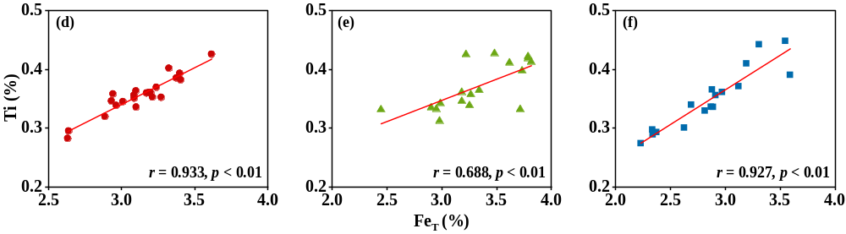
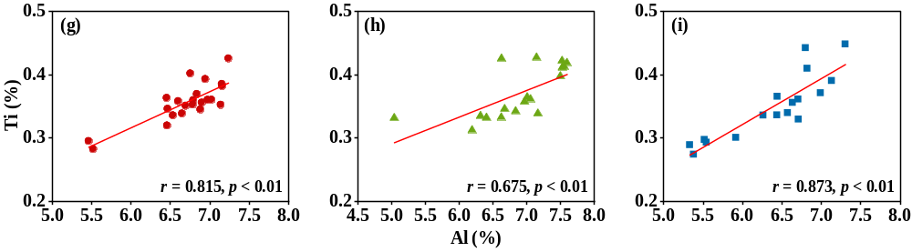
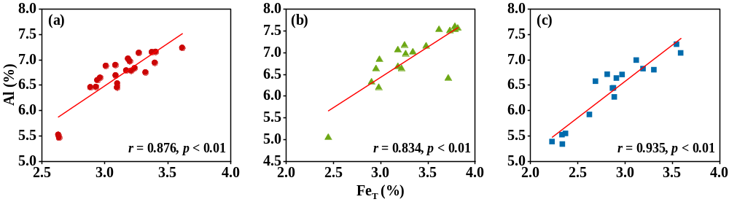
Figure S6 Elemental correlations in sediment samples across PC1 (a, d and g), PC2, (b, e and h) and PC3 (c, f and i) stations.

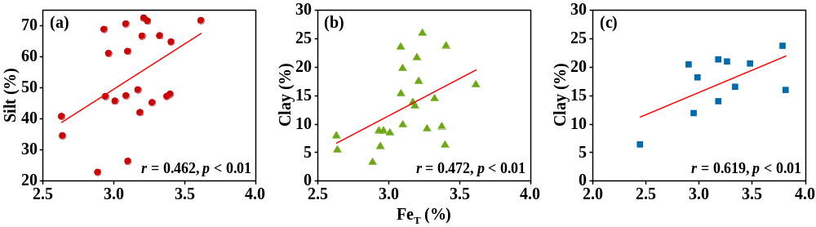
Figure S7 Correlations between Fe_{T} level and grain-size components in PC1 (a and b) and PC2 (c) sediment samples.

- Table
Table S1 The correlation between Fe_{T}, Fe speciation, and Fe_{R}.
Station | Parameter | Fe_{R} | Fe_{Carb+AVS} | Fe_{Ox-1} | Fe_{Ox-2} | Fe_{Mag}
PC1 | Fe_{T} | 0.399 | .546** | .679** | .432* | -0.212
PC1 | Fe_{R} |  | .823** | 0.407 | .591** | -.511*
PC1 | Fe_{Carb+AVS} |  |  | .661** | .545** | -0.394
PC1 | Fe_{Ox-1} |  |  |  | 0.363 | -0.121
PC1 | Fe_{Ox-2} |  |  |  |  | -.645**
PC2 | Fe_{T} | 0.321 | 0.397 | .676** | .622** | 0.33
PC2 | Fe_{R} |  | .751** | .806** | .573* | 0.141
PC2 | Fe_{Carb+AVS} |  |  | .778** | 0.2 | 0.071
PC2 | Fe_{Ox-1} |  |  |  | .588* | 0.409
PC2 | Fe_{Ox-2} |  |  |  |  | 0.351
PC3 | Fe_{T} | 0.243 | .743** | .591* | 0.085 | 0.214
PC3 | Fe_{R} |  | 0.216 | 0.330 | .821** | -0.332
PC3 | Fe_{Carb+AVS} |  |  | .729** | 0.147 | -0.037
PC3 | Fe_{Ox-1} |  |  |  | 0.327 | 0.245
PC3 | Fe_{Ox-2} |  |  |  |  | -0.243

