Supplementary Material to

Wildfire and post-fire management reshape soil microbial guilds and carbon dynamics at a boreal forest site in Sweden

Biogeochemistry

Soares M. ^{1*}, Kelly J. ², Rousk J. ¹, Kljun N.².

¹ Functional Ecology, Department of Biology, Lund University, Lund, Sweden.
² Department of Earth and Environmental Science, Lund University, Lund, Sweden.
*corresponding author: margarida.soares@biol.lu.se

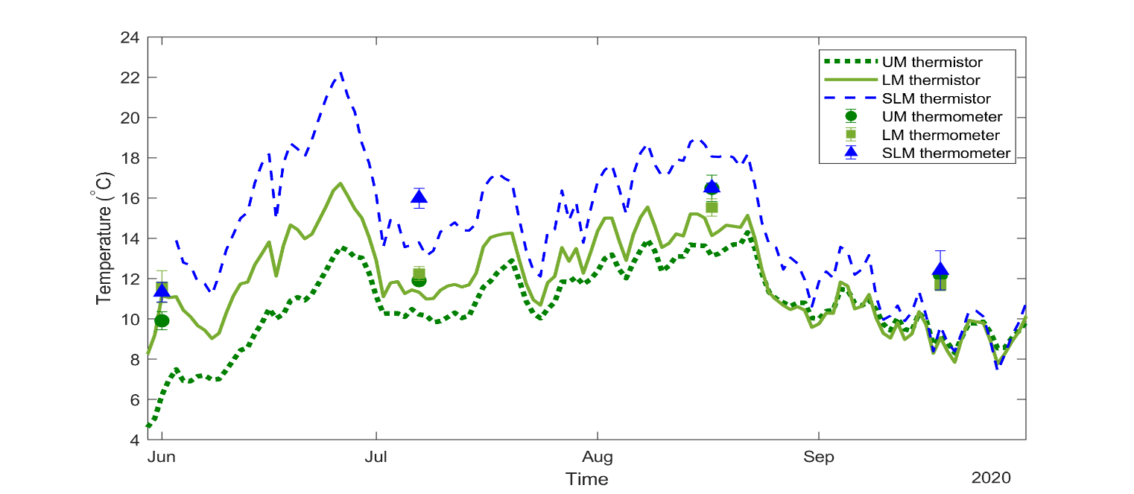

Figure S1 - Seasonal soil temperature at 3 cm depth measured from June to September 2020 for the three treatments where temperature sensors were installed (UM, LM, SLM thermistor temperature sensors; no thermistors installed at HM and SHM). Soil temperature measurements for each sampling occasion (UM, LM, SLM thermometer) are presented as symbols.

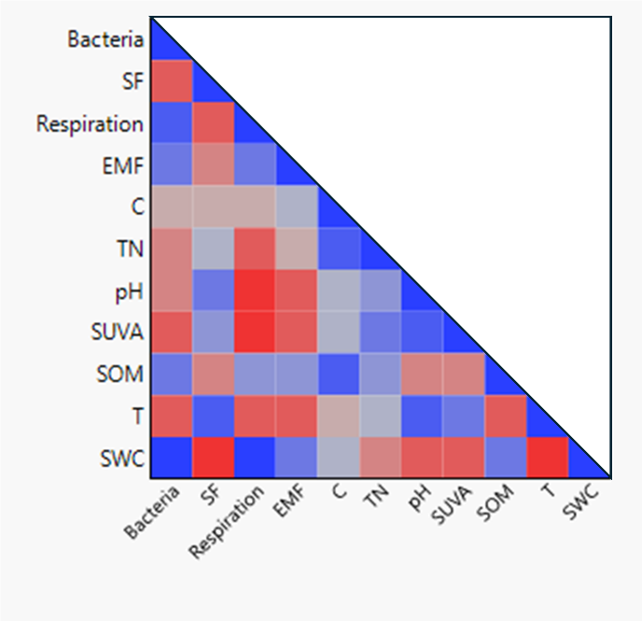
Figure S2. Pearson correlation coefficients between variables display the strength of the linear relationship. An exact linear relationship between two variables is displayed as a correlation of 1 when positive (blue) or –1 when negative (red). If there is no linear relationship, the correlation tends toward zero.
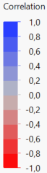
Figure S3 – Saprotrophic fungi to bacterial growth (SF:B) ratio. Results from multiple comparisons ANOVA where significant statistical values are presented in bold. Data points show mean values ± 1 SE. Treatments: Unburnt Mature (UM), High-severity Mature (HM), Low-severity Mature (LM), Salvage-logged Low-severity Mature (SLM) and Salvage-logged High-severity Mature (SHM)

Figure S4 – Seasonal (a) and cumulative (b) microbial carbon-use efficiency (CUE). Results from Multiple Comparisons ANOVA where significant statistical values are presented in bold. Data points show mean values ± 1 SE. Treatments: Unburnt Mature (UM), High-severity Mature (HM), Low-severity Mature (LM), Salvage-logged Low-severity Mature (SLM) and Salvage-logged High-severity Mature (SHM).

Table S1 – Post-fire characteristics of the sampled sites. For further details as well as measurements on diameter at breast height and tree height see Kelly et al. (2021).
 | UM | LM | HM | SLM | SHM
Site name | Unburnt Mature | Low-severity Mature | High-severity Mature | Salvage-logged Low-severity Mature | Salvage-logged High- severity Mature
Description of fire effects / Treatment | No fire | - Ground vegetation completely consumed  - Trees charred up to 2 m  - Trees survived the fire | - Ground vegetation completely consumed  - Trees killed by the fire | - Ground vegetation completely consumed  - Trees charred  - Trees survived the fire | - Ground vegetation completely consumed  -Trees killed by the fire
Post-fire management | NA | - No management  - Natural regeneration | -No management  -Natural regeneration | -All trees were salvage-logged after the wildfire  - Pinus sylvestris seeds sowed after salvage-logging | - All trees were salvage-logged after the wildfire  - Pinus sylvestris seedlings planted in 2020
Charred organic layer (mm)  mean ± se | NA | 8 ± 1 | 10 ± 0 | 11 ± 1 | 9 ± 1
Total organic layer (mm)  mean ± se | 149 ± 4 | 37 ± 2 | 25 ± 1 | 26 ± 3 | 23 ± 2
Tree age in 2018 (years) | ~ 70 | 70-90 | ~ 100 | ~ 54 | ~73

Table S2 – Soil bulk density of the organic layer measured at all sites as mean ± standard error (n = 6).

Treatment | Soil bulk density  g soil cm⁻³
Treatment | mean | se
UM | 0.21 | 0.04
LM | 0.18 | 0.02
HM | 0.19 | 0.05
SLM | 0.20 | 0.03
SHM | 0.24 | 0.02

Table S3 – Seasonal average of elemental soil composition and properties at all treatments expressed as mean ± standard error (n = 4).

Treatment | Total C (%) |  | Total N (%) |  | WS NH4+ (mg/kg) |  | WS NO3- (mg/kg) |  | Total P (mg/kg) |  | P bio (mg/kg) |  | pH |  | Conductivity |  | SUVA |  | SOM (%)
 | avg | se | avg | se | avg | se | avg | se | avg | se | avg | se | avg | se | avg | se | avg | se | avg | se
UM | 39,9 | 1,1 | 0,8 | 0,0 | 645,5 | 22,3 | 71,6 | 14,7 | 22,3 | 5,0 | 5,6 | 0,7 | 3,8 | 0,1 | 88,2 | 3,1 | 0,9 | 0,0 | 82.8 | 3.7
LM | 45,3 | 0,7 | 1,0 | 0,0 | 641,2 | 15,9 | 62,2 | 11,9 | 20,1 | 1,1 | 3,8 | 0,2 | 4,0 | 0,1 | 61,9 | 4,7 | 1,3 | 0,1 | 70.2 | 3.6
HM | 45,2 | 1,1 | 1,0 | 0,0 | 712,5 | 24,4 | 53,1 | 5,6 | 11,5 | 1,3 | 8,1 | 0,5 | 4,3 | 0,1 | 47,5 | 1,8 | 1,4 | 0,1 | 70.7 | 2.2
SLM | 41,4 | 1,3 | 0,9 | 0,0 | 582,6 | 16,5 | 67,6 | 11,0 | 7,4 | 2,6 | 5,4 | 1,3 | 4,0 | 0,1 | 44,9 | 1,7 | 1,2 | 0,0 | 65.5 | 1.9
SHM | 36,3 | 1,3 | 0,9 | 0,0 | 692,9 | 39,1 | 93,6 | 21,0 | 10,2 | 1,5 | 4,0 | 0,3 | 4,4 | 0,1 | 35,9 | 1,9 | 1,4 | 0,0 | 63.1 | 2.6

Treatment | Total C (%) |  | Total N (%) |  | WS NH₄⁺ (mg/kg) |  | WS NO₃⁻ (mg/kg) |  | Total P (mg/kg) |  | P bio (mg/kg) |  | pH |  | Conductivity |  | SUVA |  | SOM (%)
 | avg | se | avg | se | avg | se | avg | se | avg | se | avg | se | avg | se | avg | se | avg | se | avg | se
UM | 39,9 | 1,1 | 0,8 | 0,0 | 645,5 | 22,3 | 71,6 | 14,7 | 22,3 | 5,0 | 5,6 | 0,7 | 3,8 | 0,1 | 88,2 | 3,1 | 0,9 | 0,0 | 82.8 | 3.7
LM | 45,3 | 0,7 | 1,0 | 0,0 | 641,2 | 15,9 | 62,2 | 11,9 | 20,1 | 1,1 | 3,8 | 0,2 | 4,0 | 0,1 | 61,9 | 4,7 | 1,3 | 0,1 | 70.2 | 3.6
HM | 45,2 | 1,1 | 1,0 | 0,0 | 712,5 | 24,4 | 53,1 | 5,6 | 11,5 | 1,3 | 8,1 | 0,5 | 4,3 | 0,1 | 47,5 | 1,8 | 1,4 | 0,1 | 70.7 | 2.2
SLM | 41,4 | 1,3 | 0,9 | 0,0 | 582,6 | 16,5 | 67,6 | 11,0 | 7,4 | 2,6 | 5,4 | 1,3 | 4,0 | 0,1 | 44,9 | 1,7 | 1,2 | 0,0 | 65.5 | 1.9
SHM | 36,3 | 1,3 | 0,9 | 0,0 | 692,9 | 39,1 | 93,6 | 21,0 | 10,2 | 1,5 | 4,0 | 0,3 | 4,4 | 0,1 | 35,9 | 1,9 | 1,4 | 0,0 | 63.1 | 2.6

Table S4 – Matrix of Pearson correlation coefficients summarizing the strength of the linear relationships between each pair of variables.

Variables | Bacteria | SF | Respiration | EMF | TC | TN | pH | SUVA | SOM | T | SWC
Bacteria | 1 | -0.49 | 0.77 | 0.41 | -0.03 | -0.23 | -0.39 | -0.49 | 0.51 | -0.53 | 0.91
SF | -0.49 | 1 | -0.55 | -0.34 | -0.12 | 0.01 | 0.51 | 0.35 | -0.32 | 0.62 | -0.64
Respiration | 0.76 | -0.55 | 1 | 0.43 | -0.07 | -0.41 | -0.62 | -0.63 | 0.37 | -0.59 | 0.86
EMF | 0.41 | -0.34 | 0.43 | 1 | 0.15 | -0.13 | -0.40 | -0.42 | 0.31 | -0.58 | 0.47
C | -0.03 | -0.12 | -0.07 | 0.15 | 1 | 0.60 | 0.04 | 0.15 | 0.67 | -0.15 | 0.11
TN | -0.23 | 0.02 | -0.41 | -0.12 | 0.60 | 1 | 0.34 | 0.41 | 0.27 | 0.02 | -0.23
pH | -0.39 | 0.51 | -0.62 | -0.40 | 0.04 | 0.34 | 1 | 0.73 | -0.34 | 0.71 | -0.50
SUVA | -0.49 | 0.35 | -0.63 | -0.42 | 0.15 | 0.42 | 0.73 | 1 | -0.32 | 0.53 | -0.55
SOM | 0.50 | -0.32 | 0.37 | 0.31 | 0.67 | 0.27 | -0.33 | -0.32 | 1 | -0.52 | 0.60
T | -0.53 | 0.62 | -0.59 | -0.54 | -0.15 | 0.02 | 0.71 | 0.52 | -0.52 | 1 | -0.65
SWC | 0.91 | -0.64 | 0.86 | 0.48 | 0.11 | -0.23 | -0.49 | -0.55 | 0.60 | -0.65 | 1

Table S5 – Relative contribution of each of the independent variables controlling carbon use efficiency (CUE) obtained with Random Forest Modelling.
Term | Sum of Squares | Contribution (0-1)
SOM (%) | 0.29 | 0.38
SWC | 0.14 | 0.19
Temperature | 0.12 | 0.16
P bioavailable | 0.08 | 0.09
WS NH₄⁺ | 0.03 | 0.03
Total C | 0.02 | 0.03
WS NO₃⁻ | 0.02 | 0.03
SUVA | 0.02 | 0.02
Conductivity | 0.02 | 0.02
Total N | 0.01 | 0.02
pH | 0.01 | 0.01
Total P | 0.001 | 0.00

