Supplementary material

Iron focusing and sulphur-driven mineral formation regulate phosphorus sequestration in Lake Stechlin (NE Germany)

Grzegorz Scholtysik¹, Lena Heinrich^{1,6}, Helge Wolfgang Arz², Matthias Moros², Thomas Gonsiorczyk³, Volker Thiel⁴, Michael Hupfer^{1,5*}
¹Leibniz Institute of Freshwater Ecology and Inland Fisheries (IGB), Department of Ecohydrology and Biogeochemistry, Müggelseedamm 301, 12587 Berlin, Germany
²Leibniz Institute for Baltic Sea Research (IOW), Department of Marine Geology, Seestraße 15, 18119 Rostock, Germany
³Leibniz Institute of Freshwater Ecology and Inland Fisheries (IGB), Department Plankton and Microbial Ecology, Zur Alten Fischerhütte 2, 16775 Stechlin, Germany
⁴Geobiology, Geoscience Center, University of Göttingen, Goldschmidtstraße 3, 37077 Göttingen, Germany
⁵Department of Aquatic Ecology, Brandenburg Technical University Cottbus-Senftenberg, Seestraße 45, 15526 Bad Saarow, Germany
⁶University of Potsdam, Institute of Environmental Science and Geography, Karl-Liebknecht-Str. 24-25
14476 Potsdam-Golm, Germany
*Corresponding author: michael.hupfer@igb-berlin.de

The one-box model was used as an annual sulphate mass balance for Lake Stechlin, following the approach of Heinrich et al. (2022). The model treats the lake as one annually mixed reservoir and uses lake-water sulphate concentration as the state variable. Annual sulphate concentrations are controlled by external S input, hydrological export, and net sedimentary sulphate removal. Hydrological export was parameterized using the water residence time, while the stratification factor was set to 1, assuming that annual mean outflow concentrations equal annual mean lake-water concentrations. Net sulphate removal was represented by the deposition coefficient σ, defined as the ratio between sedimentary S retention and the total sulphate-S pool of the lake. Model parameters, sulphate pools, sedimentary S-retention estimates, sulphate-reduction rates, and atmospheric deposition data are provided in Tables S1–S3. The model was used to estimate the total S input required to reproduce the measured lake-water sulphate concentrations from 1970 to 2020 and to compare this input with atmospheric deposition onto the lake surface and catchment. The model provides an annual mass-balance estimate and does not resolve seasonal stratification, spatial heterogeneity, or individual sulphur transformation pathways.
Table S1 Parameters used for one-box model.
Coefficient |  | Source/Explanation
Water residence time | τ | 40 years (Holzbecher et al. 1999)¹
Net sulphate deposition | σ | Ratio of S retention in sediments to S stock (sulphate) in the entire lake (see Table S2). The S-retention of a dated sediment core was extrapolated to the entire lake.
Stratification factor | β | The value was approximated as 1, assuming the mean annual outflow concentration (epilimnetic water) equals the annual mean sulphate concentration of the lake, with negligible vertical differences

¹Holzbecher E, Nützmann G, Ginzel G (1999) Water and component mass balances in the catchment of Lake Stechlin. In: Integrated Methods in Catchment Hydrology—Tracer, Remote Sensing and New Hydrometric Techniques (Proceedings of IUGG 99 Symposium HS4, Birmingham, July 1999). IAHS Publ. 258: 37–44.

Table S2 Fluxes and pools for sulphur in Lake Stechlin.
Parameter | Value | Years | Method | Source
Sulphate lake | 31 mg SO₄²⁻ l⁻¹  10 mg S l⁻¹  228 g S m⁻²  964 × 10³ kg S lake | 2020 | IC (this study) | IGB database
Atmospheric deposition | 0.764 mg S m⁻² d⁻¹  278.9 mg S m⁻² yr⁻¹  1.18 × 10³ kg per lake area | 2008-2014 | UBA¹ | UBA¹
Sedimentation  20 m  60 m | 2.65 mg S m⁻² d⁻¹  4.65 mg S m⁻² d⁻¹ | 2009-2018  2009-2018 | Trap measurements | IGB data base
Sulphate  reduction rate | 23.4 mg S m⁻² d⁻¹ | 2009-2018 | Porewater profiles (see chapter 3.6) | this study
Retention in sediment | 8.5 mg S m⁻² d⁻¹  13.3 mg S m⁻² d⁻¹ | 1986-2017  1963-1986 | Dated sediment core 69 m | this study

¹UNECE Integrated Monitoring- Fortsetzung des Integrated Monitoring Programms an der Messstelle Neuglobsow. Report on order of the Federal Environment Agency (UBA). https://www.umweltbundesamt.de/sites/default/files/medien/370/dokumente/de02_bericht_2019.pdf

Table S3 SO₂ concentration in the air (A) and SO_{x} deposition in forested (B) and open areas (C) between 1974 and 2021. Source: UBA (Federal Environment Agency).
Year | SO₂  concentration | SO_{x}-S  Deposition  (calculated*) |  | Year | SO₂  concentration | SO_{x}-S  Deposition  (measured)
 | µg SO₂ m⁻³ | kg ha⁻¹ yr⁻¹ |  |  | µg SO₂ m⁻³ | kg ha⁻¹ yr⁻¹
 | A | B | C |  | A | B | C
1974 | 13.2 | 31.4 | 19.1 | 1998 | 1.8 | 5.6 | 3.3
1975 | 17.0 | 40.1 | 24.2 | 1999 | 1.3 | 5.2 | 3.9
1976 | 19.0 | 44.6 | 26.9 | 2000 | 1.5 | 4.2 | 3.6
1977 | 20.0 | 46.9 | 28.2 | 2001 | 1.4 | 5.8 | 3.7
1978 | 18.7 | 43.9 | 26.5 | 2002 | 1.6 | 5.1 | 3.2
1979 | 22.9 | 53.5 | 32.2 | 2003 | 1.6 | 4.0 | 2.7
1980 | 23.2 | 54.2 | 32.6 | 2004 | 1.3 | 4.3 | 2.8
1981 | 17.4 | 41.0 | 24.7 | 2005 | 1.3 |  | 2.6
1982 | 22.1 | 51.7 | 31.1 | 2006 | 1.5 | 3.4 | 2.3
1983 | 16.4 | 38.7 | 23.4 | 2007 | 0.9 | 4.7 | 3.9
1984 | 19.7 | 46.2 | 27.8 | 2008 | 1.0 | 3.2 | 2.5
1985 | 23.8 | 55.6 | 33.4 | 2009 |  | 2.8 | 2.1
1986 | 21.9 | 51.2 | 30.8 | 2010 |  | 4.0 | 3.3
1987 | 19.3 | 45.3 | 27.3 | 2011 | 0.9 | 3.1 | 2.4
1988 | 10.9 | 26.1 | 16.0 | 2012 | 0.8 | 2.7 | 2.0
1989 | 12.4 | 29.6 | 18.0 | 2013 | 0.8 | 2.7 | 2.0
1990 | 8.3 | 20.2 | 12.5 | 2014 | 0.9 | 3.4 | 2.5
1991 |  |  |  | 2015 | 0.5 | 2.0 | 1.5
1992 | 6.3 | 15.7 | 9.8 | 2016 | 0.5 | 1.7 | 1.4
1993 | 7.1 | 17.5 | 10.8 | 2017 | 0.4 | 2.8 | 2.2
1994 | 4.5 | 11.5 | 7.3 | 2018 |  | 1.9 | 1.7
1995 | 5.0 | 12.7 | 8.0 | 2019 |  | 1.9 | 1.6
1996 | 6.3 | 15.7 | 9.8 | 2020 |  | 1.7 | 1.6
1997 | 3.0 | 8.1 | 5.3 | 2021 |  | 2.0 | 1.9

*Based on the following linear correlation:
B = 1.2815 * A + 1.2812, r² = 0.632 (n = 21). C = 0.5914 * B + 0.502, r² = 0.852

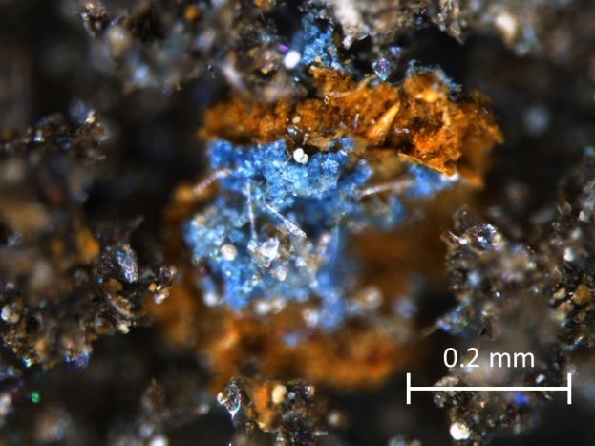
Fig. S1 Reflected-light microscopic picture of freeze-dried sediment (core from 64 m depth; 21-22 cm sediment depth). Vivianite can be easily recognized by its light blue colour, whereas putative Fe-oxyhydroxides show orange, "rust-like" colours. Vivianite crystals were only observed in sediments from > 56 m water depths where S/Fe ratios were low (approximately < 0.5).

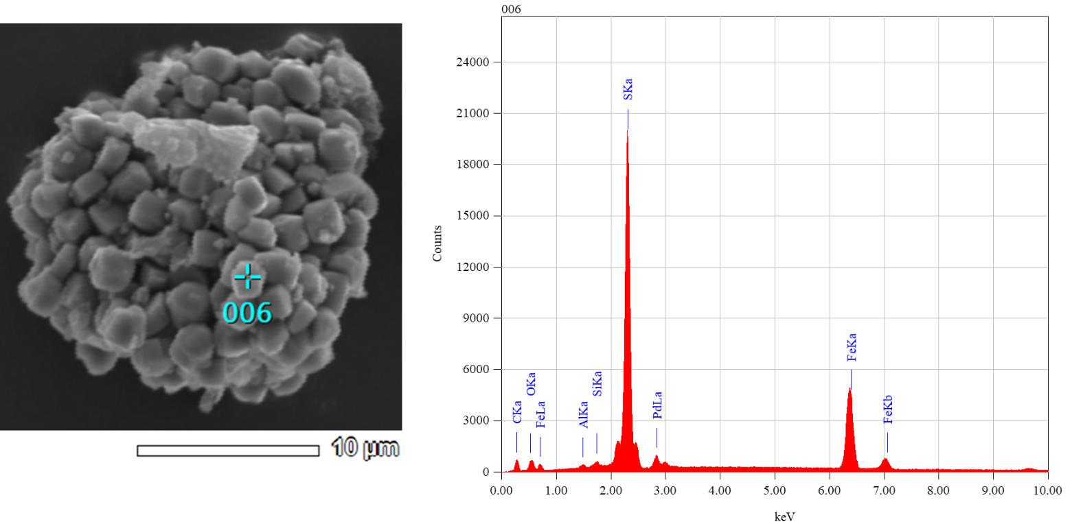
Fig. S2 SEM image and EDX spectrum of a framboidal pyrite aggregate in sediment core A from the deepest site (69.5 m water depth; 17–18 cm sediment depth). These pyrite aggregates frequently occur in sediments with high S/Fe ratios and most likely account for their elevated S contents.

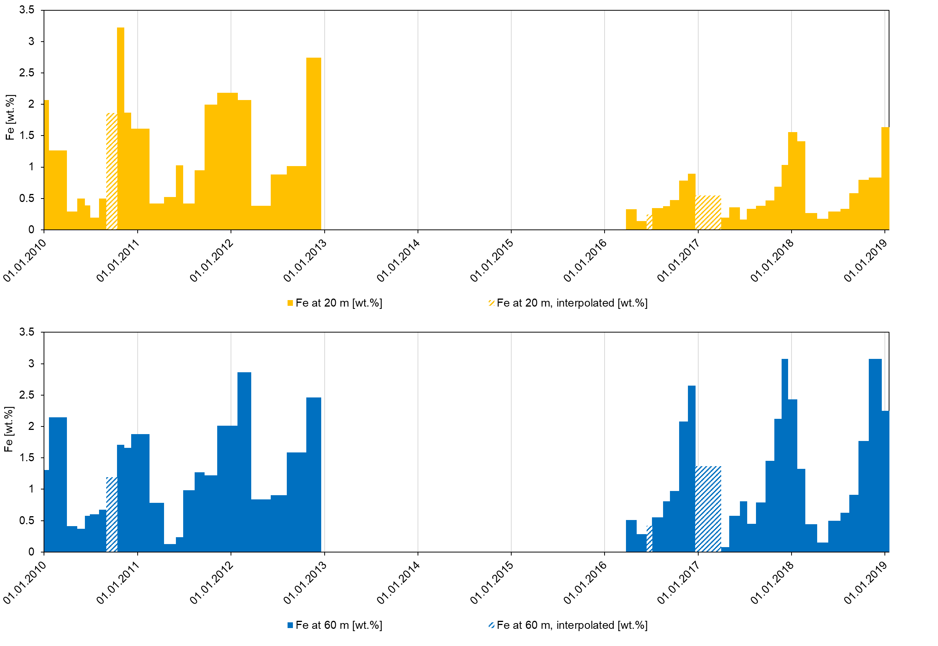
Fig. S3 Fe contents (wt. %) in material collected by sediment traps at 20 m and 60 m water depth. Similar Fe contents were observed in the deposited sediment (Figs. 2 and 4). Seasonal variations in Fe sedimentation are related to geochemical redox reactions, as also shown in Fig. 9. Most Fe is sedimented during the late summer stagnation or shortly thereafter. Hatched bars indicate periods for which annual fluxes were calculated from incomplete trap deployments/interpolated sampling intervals.

Table S4 2θ-position and relative intensities of x-ray diffractograms of sediments from depths 8.5–9.5 cm and 23.5–24.5 cm at the deepest site (69.5 m, core A). V: vivianite, A: ankerite, C: calcite, Q: quartz, P: pyrite, and S: siderite.
69.5 m, 8.5–9.5 cm |  |  |  |  | 69.5 m, 23.5–24.5 cm
Peak number | Position (2θ, ca.) | Relative intensity (%) | Label |  | Peak number | Position (2θ, ca.) | Relative intensity (%) | Label
1 | 24.6 | 10 | Q |  | 1 | 14.7 | 12 | V
2 | 26.8 | 18 | C |  | 2 | 22.6 | 10 | V
3 | 30.0 | 25 | Q |  | 3 | 25.1 | 22 | Q
4 | 33.5 | 100 | C |  | 4 | 28.4 | 18 | A
5 | 36.7 | 6 | C |  | 5 | 30.9 | 100 | Q
6 | 38.6 | 7 | P |  | 6 | 33.0 | 14 | S
7 | 42.3 | 22 | C / P |  | 7 | 34.3 | 16 | C
8 | 46.0 | 28 | C |  | 8 | 35.5 | 60 | A
9 | 49.9 | 20 | C |  | 9 | 38.1 | 12 | P
10 | 55.2 | 24 | C |  | 10 | 41.9 | 10 | Q
11 | 56.3 | 26 | C |  | 11 | 43.3 | 9 | S
12 | 58.7 | 8 | Q |  | 12 | 45.1 | 11 | Q
13 | 66.6 | 12 | P |  | 13 | 47.4 | 13 | A
14 | 71.0 | 9 | C |  | 14 | 49.1 | 9 | Q
15 | 75.8 | 10 | C |  | 15 | 51.8 | 14 | A
16 | 88.2 | 7 | C |  | 16 | 54.6 | 8 | C
 |  |  |  |  | 17 | 56.9 | 10 | Q
 |  |  |  |  | 18 | 59.2 | 12 | A
 |  |  |  |  | 19 | 65.3 | 8 | P
 |  |  |  |  | 20 | 70.1 | 11 | Q / A
 |  |  |  |  | 21 | 78.6 | 9 | A
 |  |  |  |  | 22 | 80.0 | 10 | Q

Table S5 Elements and molar S:Fe in shallower sediments (0-2 cm). These additional analyses were performed on sediments from a previously published study in order to extend the transect of this study. The exact locations of the sampling sites can be found in Holdt et al. (2025)¹.
Water depth | Sampling  Point¹ | Organic Carbon | Total P | Iron | Calcium | Sulphur | S/Fe
m |  | wt.% | mg g⁻¹ dw | mg g⁻¹ dw | mg g⁻¹ dw | mg g⁻¹ dw | molar/molar
35 | 12 | 23.31 | 2.25 | 14.7 | 74,7 | 15.8 | 1.84
25 | 13 | 21.01 | 2.16 | 15.2 | 77.1 | 16.3 | 1.84
15 | 14 | 14.43 | 1.35 | 12.8 | 57.4 | 9.0 | 1.20
5 | 15 | 1.37 | 0.40 | 2.0 | 57.9 | 0.8 | 0.71

¹Holdt KJ, Gonsiorczyk T, Reimer A, Gessner MO, Thiel V (2025) Spatial patterns of sediment phosphorus contents and release in a deep clearwater lake undergoing rapid eutrophication. Biogeochemistry 168: 83. https://doi.org/10.1007/s10533-025-01280-1

