Supplementary Material
Table S 1: Soil type and land use of the stream catchment and the direct catchment to the rewetted project area (Adhikari et al., 2013; Levin, 2022).
[ha] |  | Stream catchment |  |  |  | Direct catchment (after rewetting)
Soil type | Humic |  | 8.3 |  |  |  | 22.0
Soil type | Clayey sand |  | 19.4 |  |  |  | 54.2
Soil type | Sandy clay |  | 372.0 |  |  |  | 289.1
Soil type | Total |  | 399.7 |  |  |  | 365.3
Land use | Meadow, forest, ponds |  | 3.9 |  |  |  | 9.8
Land use | Agriculture |  | 357.0 |  |  |  | 322.2
Land use | Sealed area |  | 18.1 |  |  |  | 20.6
Land use | Other |  | 20.7 |  |  |  | 12.7
Land use | Total |  | 399.7 |  |  |  | 365.3

Table S 2: Total losses of total nitrogen (TN), nitrate-N (NO₃-N), ammonium-N (NH₄-N), total organic N (TON), total phosphorus (TP), soluble reactive phosphorus (SRP), particulate phosphorus (TP), soluble non-reactive phosphorus (SNRP), total organic carbon (TOC), and water (Runoff) from the monitored catchments surrounding the Strande Enge project area (Figure 1D). The losses were recorded for one year prior to rewetting (May 2021 – April 2022) and for two individual years after rewetting (Year 1: Jan-Dec 2023, and Year 2: Jan-Dec 2024).
[kg ha⁻¹ yr⁻¹] | Stream catchment (399.7 ha) |  |  |  | Direct catchment (365.4 ha)
 | Before  rewetting | Year 1 | Year 2 |  | Before  rewetting | Year 1 | Year 2
TN | 21.8 | 19.9 | 21.3 |  | 20.9 | 14.0 | 19.1
NO₃-N | 19.0 | 18.2 | 19.2 |  | 17.6 | 11.6 | 15.7
NH₄-N | 0.8 | 0.3 | 0.9 |  | 0.3 | 0.3 | 0.4
TON | 1.9 | 1.4 | 1.2 |  | 3.0 | 2.1 | 2.9
TP | 1.15 | 0.91 | 1.46 |  | 0.66 | 0.57 | 0.87
SRP | 0.36 | 0.56 | 0.69 |  | 0.40 | 0.39 | 0.51
PP | 0.76 | 0.33 | 0.69 |  | 0.23 | 0.15 | 0.31
SNRP | 0.04 | 0.03 | 0.08 |  | 0.03 | 0.03 | 0.05
TOC | 41.0 | 31.7 | 31.4 |  | 45.9 | 37.8 | 52.1
Runoff [mm yr⁻¹) | 394 | 438 | 480 |  | 500 | 415 | 489

Table S 3: Total loads of total nitrogen (TN), nitrate-N (NO₃-N), ammonium-N (NH₄-N), total organic N (TON), total phosphorus (TP), soluble reactive phosphorus (SRP), particulate phosphorus (TP), soluble non-reactive phosphorus (SNRP), total organic carbon (TOC), and water (Runoff) to the recipient, Søndervese, downstream of the Strande Enge project area (i.e. the combined loads from the stream catchment, the direct catchment, and the project area). The area-specific loads are normalized to the total catchment area of 780 ha (Figure 1D). The loads were recorded for one year prior to rewetting (May 2021 – April 2022) and for two individual years after rewetting (Year 1: Jan-Dec 2023, and Year 2: Jan-Dec 2024).
 | Before rewetting | Year 1 | Year 2
 | kg yr⁻¹ (kg ha⁻¹ yr⁻¹)
TN | 17,938 (23.1) | 11,204 (14.4) | 13,159 (16.9)
NO₃-N | 13,125 (16.9) | 8,732 (11.2) | 10,376 (13.3)
NH₄-N | 734 (0.9) | 270 (0.3) | 377 (0.5)
TON | 4,079 (5.2) | 2,201 (2.8) | 2,407 (3.1)
TP | 735 (0.95) | 648 (0.83) | 1,280 (1.64)
SRP | 284 (0.37) | 214 (0.27) | 134 (0.17)
PP | 420 (0.54) | 396 (0.51) | 1,065 (1.37)
SNRP | 31 (0.04) | 38 (0.05) | 81 (0.10)
TOC | 51,556 (66.4) | 38,909 (49.9) | 41,932 (53.8)
Runoff [mm yr⁻¹] | 427 | 425 | 486

Table S 4: Monthly water balances before rewetting (May 2021 – April 2022) and after rewetting (January 2023 – December 2024).”Wetland out” is the amount of water leaving the project area (before rewetting the water was pumped out of the drained area), “GW in” is groundwater inflow to the area, “Stream in” is stream discharge at the station upstream of the project area (before rewetting stream water bypassed the project area), “Pump 2” is water from an adjacent pumped area (before rewetting the pumped water bypassed the project area), “P” is precipitation, “E₀” is reference evapotranspiration, “Drains” is inflow from drains and ditches to the project area, and “Bypass” is the amount of water bypassing the project area before rewetting (Stream+Pump2+Drains).
Q [L s⁻¹] | Wetland out | GW in | Stream in | Pump 2 | Drains | P | E₀ | ∆S | Bypass
May-2021 | 5.3 | 3.0 | 34.3 | 4.2 |  | 6.5 | 3.6 |  | 59.6
Jun-2021 | 13.3 | 16.5 | 15.1 | 2.8 |  | 2.1 | 6.0 |  | 27.8
Jul-2021 | 27.8 | 30.3 | 7.9 | 0.1 |  | 2.8 | 5.8 |  | 15.9
Aug-2021 | 27.8 | 26.6 | 9.7 | 0.5 |  | 5.9 | 4.4 |  | 18.8
Sep-2021 | 27.5 | 25.0 | 12.2 | 6.1 |  | 5.6 | 2.6 |  | 22.7
Oct-2021 | 42.4 | 37.7 | 101.7 | 6.6 |  | 7.0 | 1.3 |  | 171.7
Nov-2021 | 23.9 | 20.6 | 59.9 | 9.6 |  | 4.5 | 0.5 |  | 103.1
Dec-2021 | 23.9 | 18.8 | 92.4 | 9.6 |  | 6.5 | 0.2 |  | 153.8
Jan-2022 | 20.1 | 15.9 | 78.0 | 11.4 |  | 5.5 | 0.4 |  | 131.6
Feb-2022 | 15.3 | 8.8 | 152.2 | 13.6 |  | 9.0 | 0.9 |  | 254.5
Mar-2022 | 6.2 | 8.1 | 23.1 | 2.8 |  | 0.3 | 2.6 |  | 40.8
Apr-2022 | 5.0 | 6.2 | 19.4 | 2.2 |  | 2.7 | 4.1 |  | 34.8
…
Jan-2023 | 336.3 | 35.1 | 185.7 | 19.3 | 89.0 | 8.2 | 0.4 | 0.5
Feb-2023 | 123.0 | 2.4 | 61.6 | 7.2 | 43.4 | 3.7 | 1.2 | -5.9
Mar-2023 | 130.3 | 6.9 | 67.1 | 8.2 | 44.8 | 5.7 | 1.8 | 0.5
Apr-2023 | 48.7 | 0.0 | 23.5 | 3.8 | 21.4 | 2.2 | 4.6 | -2.6
May-2023 | 13.5 | 0.0 | 8.9 | 0.9 | 10.6 | 0.7 | 6.5 | -3.9
Jun-2023 | 8.8 | 1.1 | 5.6 | 0.0 | 7.2 | 1.0 | 8.2 | -2.2
Jul-2023 | 13.9 | 1.8 | 6.0 | 0.0 | 7.2 | 7.3 | 6.2 | 2.2
Aug-2023 | 15.0 | 2.8 | 6.6 | 0.3 | 8.0 | 4.5 | 4.7 | 2.4
Sep-2023 | 40.7 | 0.0 | 21.7 | 2.7 | 19.1 | 6.7 | 3.6 | 3.0
Oct-2023 | 174.1 | 12.6 | 88.5 | 10.9 | 56.0 | 10.0 | 1.3 | 2.6
Nov-2023 | 163.4 | 7.7 | 80.7 | 14.6 | 53.9 | 5.1 | 0.5 | -1.8
Dec-2023 | 189.8 | 15.5 | 108.1 | 13.5 | 55.3 | 9.5 | 0.3 | 11.8
Jan-2024 | 246.6 | 21.3 | 131.3 | 20.2 | 64.1 | 7.4 | 0.4 | -2.7
Feb-2024 | 262.3 | 24.7 | 130.1 | 17.4 | 76.2 | 7.9 | 0.8 | -6.9
Mar-2024 | 104.0 | 1.9 | 49.5 | 10.3 | 37.9 | 3.2 | 1.6 | -2.8
Apr-2024 | 164.3 | 14.1 | 81.5 | 11.7 | 52.1 | 5.1 | 3.5 | -3.4
May-2024 | 48.9 | 3.6 | 26.9 | 5.1 | 18.9 | 3.0 | 6.5 | 2.0
Jun-2024 | 77.5 | 7.0 | 34.9 | 8.8 | 24.7 | 4.3 | 6.6 | -4.3
Jul-2024 | 79.4 | 6.9 | 39.2 | 5.3 | 28.1 | 7.2 | 5.9 | 1.3
Aug-2024 | 66.3 | 4.5 | 33.7 | 6.2 | 23.4 | 6.2 | 5.3 | 2.5
Sep-2024 | 34.2 | 0.0 | 17.5 | 4.5 | 15.3 | 4.6 | 3.6 | -0.5
Oct-2024 | 48.7 | 0.0 | 26.4 | 4.5 | 21.2 | 3.8 | 1.6 | 0.2
Nov-2024 | 80.5 | 0.0 | 41.8 | 6.8 | 34.7 | 3.9 | 0.5 | 3.5
Dec-2024 | 233.1 | 17.6 | 119.4 | 11.1 | 84.5 | 5.8 | 0.2 | 5.1

Table S 5: Monthly fluxes of TN before rewetting (May 2021 – April 2022) and after rewetting (January 2023 – December 2024).”Wetland out” is the amount of TN leaving the project area (before rewetting the water was pumped out of the drained area), “GW in” is via groundwater inflow to the area, “Stream in” is via stream discharge at the station upstream of the project area (before rewetting stream water bypassed the project area), “Pump 2” is TN from an adjacent pumped area (before rewetting the pumped water bypassed the project area), “Atm. Dep.” is atmospheric deposition, “Drains” is TN from drains and ditches to the project area, and “Bypass” is the amount of TN bypassing the project area before rewetting (Stream+Pump2+Drains).
TN [kg] | Wetland out | GW in | Stream in | Pump 2 | Drains | Atm. dep. | Bypass
May-2021 | 50.6 | 15.0 | 405.0 | 41.3 |  | 15.5 | 761.6
Jun-2021 | 187.6 | 72.0 | 142.0 | 30.5 |  | 4.9 | 285.0
Jul-2021 | 495.3 | 169.7 | 28.3 | 1.1 |  | 6.6 | 77.3
Aug-2021 | 539.4 | 168.8 | 111.2 | 8.1 |  | 14.0 | 253.0
Sep-2021 | 475.5 | 111.1 | 163.2 | 61.2 |  | 13.0 | 284.8
Oct-2021 | 449.6 | 263.5 | 1965.2 | 80.1 |  | 16.8 | 3194.4
Nov-2021 | 243.1 | 144.2 | 939.0 | 119.2 |  | 10.4 | 1585.8
Dec-2021 | 225.2 | 133.2 | 1360.9 | 125.4 |  | 15.6 | 2397.0
Jan-2022 | 176.6 | 95.4 | 1252.3 | 144.1 |  | 13.0 | 1953.7
Feb-2022 | 112.2 | 41.9 | 1850.4 | 121.8 |  | 19.3 | 3266.8
Mar-2022 | 47.6 | 51.8 | 259.6 | 25.2 |  | 0.8 | 501.4
Apr-2022 | 32.9 | 53.8 | 218.0 | 21.4 |  | 6.1 | 341.0
…
Jan-2023 | 3043.5 | 369.6 | 1639.7 | 109.4 | 1037.5 | 21.7
Feb-2023 | 921.0 | 47.4 | 464.0 | 39.0 | 438.3 | 8.8
Mar-2023 | 990.3 | 91.1 | 524.6 | 46.3 | 448.0 | 15.1
Apr-2023 | 217.5 | 11.6 | 154.4 | 20.9 | 191.3 | 5.8
May-2023 | 56.1 | 4.8 | 37.2 | 4.8 | 84.8 | 2.0
Jun-2023 | 48.7 | 19.8 | 11.4 | 0.0 | 54.3 | 2.5
Jul-2023 | 104.6 | 48.1 | 16.9 | 0.1 | 60.0 | 19.3
Aug-2023 | 112.5 | 73.5 | 22.2 | 2.4 | 69.3 | 12.0
Sep-2023 | 346.2 | 20.8 | 415.5 | 20.0 | 203.4 | 17.2
Oct-2023 | 1698.7 | 156.4 | 1899.7 | 76.8 | 713.5 | 26.7
Nov-2023 | 1737.6 | 103.1 | 1390.7 | 94.2 | 592.9 | 13.1
Dec-2023 | 1927.0 | 184.3 | 1382.8 | 87.8 | 568.9 | 25.4
Jan-2024 | 2542.5 | 233.2 | 1546.7 | 124.3 | 652.4 | 19.8
Feb-2024 | 2441.7 | 242.6 | 1383.0 | 91.3 | 729.0 | 19.6
Mar-2024 | 878.5 | 43.5 | 661.1 | 65.1 | 432.5 | 8.6
Apr-2024 | 1290.6 | 149.9 | 912.4 | 73.1 | 684.0 | 13.1
May-2024 | 397.8 | 52.8 | 314.0 | 55.3 | 221.9 | 7.9
Jun-2024 | 623.4 | 77.1 | 437.1 | 67.5 | 333.2 | 11.0
Jul-2024 | 380.4 | 81.2 | 482.5 | 46.7 | 289.0 | 19.1
Aug-2024 | 285.2 | 57.8 | 263.2 | 53.7 | 286.1 | 16.5
Sep-2024 | 121.5 | 0.3 | 137.1 | 35.1 | 189.4 | 11.8
Oct-2024 | 290.7 | 4.2 | 160.1 | 36.7 | 317.1 | 10.1
Nov-2024 | 799.9 | 36.1 | 464.7 | 52.2 | 591.9 | 10.1
Dec-2024 | 3107.1 | 184.1 | 1749.2 | 80.8 | 1308.0 | 15.5

Table S 6: Monthly fluxes of nitrate-N (NO₃-N) before rewetting (May 2021 – April 2022) and after rewetting (January 2023 – December 2024).”Wetland out” is the amount of NO₃-N leaving the project area (before rewetting the water was pumped out of the drained area), “GW in” is via groundwater inflow to the area, “Stream in” is via stream discharge at the station upstream of the project area (before rewetting stream water bypassed the project area), “Pump 2” is NO₃-N from an adjacent pumped area (before rewetting the pumped water bypassed the project area), “Atm. Dep.” is atmospheric deposition, “Drains” is NO₃-N from drains and ditches to the project area, and “Bypass” is the amount of NO₃-N bypassing the project area before rewetting (Stream+Pump2+Drains).
NO₃-N [kg] | Wetland out | GW in | Stream in | Pump 2 | Drains | Atm. dep. | Bypass
May-2021 | 32.6 | 10.3 | 385.1 | 9.8 |  | 15.5 | 707.3
Jun-2021 | 39.2 | 42.5 | 135.4 | 7.6 |  | 4.9 | 261.0
Jul-2021 | 46.1 | 88.3 | 25.1 | 0.0 |  | 6.6 | 62.4
Aug-2021 | 13.4 | 89.2 | 46.0 | 0.2 |  | 14.0 | 87.0
Sep-2021 | 25.7 | 53.9 | 123.3 | 18.8 |  | 13.0 | 206.0
Oct-2021 | 76.6 | 113.7 | 1700.9 | 37.9 |  | 16.8 | 2667.1
Nov-2021 | 71.6 | 59.7 | 832.6 | 78.6 |  | 10.4 | 1325.8
Dec-2021 | 109.6 | 78.7 | 1227.1 | 72.7 |  | 15.6 | 2174.9
Jan-2022 | 91.4 | 49.5 | 1099.0 | 77.2 |  | 13.0 | 1676.1
Feb-2022 | 64.8 | 21.2 | 1658.2 | 74.3 |  | 19.3 | 2822.2
Mar-2022 | 23.2 | 10.3 | 224.6 | 18.6 |  | 0.8 | 409.8
Apr-2022 | 11.1 | 8.9 | 152.1 | 4.0 |  | 6.1 | 119.9
…
Jan-2023 | 2501.2 | 219.3 | 1455.1 | 34.0 | 939.0 | 21.7
Feb-2023 | 736.6 | 28.1 | 407.2 | 10.9 | 396.2 | 8.8
Mar-2023 | 820.6 | 54.0 | 480.7 | 11.0 | 411.9 | 15.1
Apr-2023 | 73.3 | 6.9 | 142.2 | 2.6 | 172.6 | 5.8
May-2023 | 0.6 | 2.9 | 32.0 | 0.2 | 71.0 | 2.0
Jun-2023 | 0.4 | 11.8 | 5.0 | 0.0 | 38.6 | 2.5
Jul-2023 | 1.0 | 28.5 | 10.8 | 0.0 | 35.3 | 19.3
Aug-2023 | 2.0 | 43.6 | 15.8 | 0.0 | 49.2 | 12.0
Sep-2023 | 150.9 | 12.3 | 387.9 | 0.2 | 185.9 | 17.2
Oct-2023 | 1230.1 | 92.8 | 1778.5 | 1.6 | 659.8 | 26.7
Nov-2023 | 1472.4 | 61.2 | 1248.8 | 5.6 | 518.1 | 13.1
Dec-2023 | 1743.3 | 109.3 | 1308.0 | 9.7 | 518.6 | 25.4
Jan-2024 | 2269.8 | 138.4 | 1510.8 | 36.9 | 622.1 | 19.8
Feb-2024 | 2176.3 | 143.9 | 1295.5 | 28.0 | 688.0 | 19.6
Mar-2024 | 763.9 | 25.8 | 584.6 | 12.2 | 399.4 | 8.6
Apr-2024 | 917.2 | 88.9 | 738.9 | 6.0 | 617.5 | 13.1
May-2024 | 214.6 | 32.0 | 291.6 | 0.8 | 205.6 | 7.9
Jun-2024 | 409.8 | 47.5 | 408.3 | 0.6 | 312.6 | 11.0
Jul-2024 | 25.5 | 51.5 | 373.1 | 0.2 | 246.8 | 19.1
Aug-2024 | 24.4 | 40.6 | 223.7 | 0.4 | 247.4 | 16.5
Sep-2024 | 13.2 | 0.2 | 121.5 | 0.1 | 167.4 | 11.8
Oct-2024 | 115.3 | 3.7 | 120.2 | 0.6 | 279.9 | 10.1
Nov-2024 | 689.1 | 29.1 | 417.5 | 6.4 | 528.2 | 10.1
Dec-2024 | 2756.9 | 140.7 | 1587.6 | 19.8 | 1162.7 | 15.5

Table S 7: Monthly fluxes of ammonium-N (NH₄-N) before rewetting (May 2021 – April 2022) and after rewetting (January 2023 – December 2024).”Wetland out” is the amount of NH₄-N leaving the project area (before rewetting the water was pumped out of the drained area), “GW in” is via groundwater inflow to the area, “Stream in” is via stream discharge at the station upstream of the project area (before rewetting stream water bypassed the project area), “Pump 2” is NH₄-N from an adjacent pumped area (before rewetting the pumped water bypassed the project area), “Drains” is NH₄-N from drains and ditches to the project area, and “Bypass” is the amount of NH₄-N bypassing the project area before rewetting (Stream+Pump2+Drains).
NH₄-N [kg] | Wetland out | GW in | Stream in | Pump 2 | Drains | Bypass
May-2021 | 2.5 | 1.2 | 6.6 | 2.7 |  | 3.6
Jun-2021 | 26.9 | 4.5 | 2.5 | 0.6 |  | 4.6
Jul-2021 | 75.2 | 12.9 | 1.0 | 0.0 |  | 7.5
Aug-2021 | 93.6 | 13.4 | 41.5 | 2.5 |  | 158.0
Sep-2021 | 44.6 | 6.9 | 19.4 | 8.2 |  | 46.8
Oct-2021 | 27.6 | 11.3 | 46.2 | 3.4 |  | 42.2
Nov-2021 | 31.8 | 11.5 | 27.0 | 3.8 |  | 20.9
Dec-2021 | 27.8 | 13.7 | 103.4 | 6.6 |  | 20.5
Jan-2022 | 15.8 | 10.6 | 37.7 | 8.1 |  | 20.5
Feb-2022 | 8.5 | 5.2 | 28.2 | 4.9 |  | 32.8
Mar-2022 | 4.7 | 15.9 | 8.4 | 1.6 |  | 6.6
Apr-2022 | 3.7 | 14.8 | 4.5 | 1.9 |  | 7.4
…
Jan-2023 | 47.3 | 24.9 | 40.1 | 5.4 | 6.7
Feb-2023 | 9.3 | 3.2 | 7.4 | 1.5 | 2.7
Mar-2023 | 5.9 | 6.1 | 4.8 | 1.8 | 2.3
Apr-2023 | 6.3 | 0.8 | 3.4 | 1.2 | 1.9
May-2023 | 1.3 | 0.3 | 1.0 | 0.2 | 1.4
Jun-2023 | 1.1 | 1.3 | 0.9 | 0.0 | 7.9
Jul-2023 | 1.8 | 3.2 | 1.0 | 0.0 | 16.5
Aug-2023 | 5.6 | 5.0 | 0.8 | 0.3 | 13.1
Sep-2023 | 42.8 | 1.4 | 4.9 | 0.5 | 4.9
Oct-2023 | 60.7 | 10.5 | 16.4 | 6.7 | 4.9
Nov-2023 | 35.7 | 7.0 | 17.3 | 11.8 | 6.1
Dec-2023 | 52.7 | 12.4 | 16.0 | 12.1 | 5.1
Jan-2024 | 68.8 | 15.7 | 19.9 | 9.5 | 4.4
Feb-2024 | 53.0 | 16.4 | 24.1 | 4.7 | 5.1
Mar-2024 | 30.6 | 2.9 | 54.7 | 3.2 | 8.7
Apr-2024 | 58.9 | 10.1 | 131.0 | 5.1 | 22.6
May-2024 | 8.0 | 4.2 | 13.1 | 8.2 | 3.7
Jun-2024 | 14.0 | 6.8 | 12.9 | 5.7 | 4.1
Jul-2024 | 11.5 | 8.6 | 30.2 | 2.5 | 4.7
Aug-2024 | 18.3 | 6.5 | 6.5 | 2.3 | 4.2
Sep-2024 | 13.9 | 0.0 | 3.1 | 3.0 | 2.4
Oct-2024 | 19.6 | 0.4 | 5.3 | 6.4 | 3.8
Nov-2024 | 20.5 | 3.3 | 21.4 | 6.6 | 6.2
Dec-2024 | 59.7 | 14.6 | 51.2 | 7.5 | 29.8

Table S 8: Monthly fluxes of total organic N (TON) before rewetting (May 2021 – April 2022) and after rewetting (January 2023 – December 2024).”Wetland out” is the amount of TON leaving the project area (before rewetting the water was pumped out of the drained area), “GW in” is via groundwater inflow to the area, “Stream in” is via stream discharge at the station upstream of the project area (before rewetting stream water bypassed the project area), “Pump 2” is TON from an adjacent pumped area (before rewetting the pumped water bypassed the project area), “Drains” is TON from drains and ditches to the project area, and “Bypass” is the amount of TON bypassing the project area before rewetting (Stream+Pump2+Drains).
TON [kg] | Wetland out | GW in | Stream in | Pump 2 | Drains | Bypass
May-2021 | 15.6 | 3.6 | 13.3 | 28.8 |  | 50.7
Jun-2021 | 121.5 | 25.0 | 4.2 | 22.3 |  | 19.3
Jul-2021 | 373.9 | 68.4 | 2.1 | 1.0 |  | 7.4
Aug-2021 | 432.4 | 66.2 | 23.7 | 5.3 |  | 8.0
Sep-2021 | 405.2 | 50.3 | 20.5 | 34.2 |  | 32.0
Oct-2021 | 345.4 | 138.6 | 218.1 | 38.8 |  | 485.1
Nov-2021 | 139.7 | 73.0 | 79.3 | 36.9 |  | 239.1
Dec-2021 | 87.8 | 40.8 | 30.4 | 46.1 |  | 201.6
Jan-2022 | 69.4 | 35.3 | 115.6 | 58.8 |  | 257.2
Feb-2022 | 38.9 | 15.4 | 164.0 | 42.5 |  | 411.8
Mar-2022 | 19.7 | 25.6 | 26.6 | 5.0 |  | 85.0
Apr-2022 | 18.1 | 30.1 | 61.5 | 15.5 |  | 213.6
…
Jan-2023 | 495.0 | 125.4 | 144.4 | 70.1 | 91.8
Feb-2023 | 175.2 | 16.1 | 49.3 | 26.6 | 39.5
Mar-2023 | 163.8 | 30.9 | 39.2 | 33.6 | 33.8
Apr-2023 | 137.9 | 3.9 | 8.9 | 17.2 | 16.7
May-2023 | 54.2 | 1.6 | 4.1 | 4.4 | 12.4
Jun-2023 | 47.2 | 6.7 | 5.5 | 0.0 | 7.8
Jul-2023 | 101.8 | 16.3 | 5.1 | 0.1 | 8.2
Aug-2023 | 104.9 | 24.9 | 5.6 | 2.0 | 7.0
Sep-2023 | 152.5 | 7.1 | 22.7 | 19.3 | 12.6
Oct-2023 | 408.0 | 53.0 | 104.7 | 68.5 | 48.8
Nov-2023 | 229.4 | 35.0 | 124.6 | 76.8 | 68.8
Dec-2023 | 131.1 | 62.5 | 58.9 | 66.0 | 45.2
Jan-2024 | 203.9 | 79.1 | 16.0 | 77.8 | 25.9
Feb-2024 | 212.4 | 82.3 | 63.4 | 58.6 | 35.8
Mar-2024 | 84.0 | 14.8 | 21.9 | 49.7 | 24.4
Apr-2024 | 314.6 | 50.8 | 42.5 | 62.0 | 43.9
May-2024 | 175.2 | 16.6 | 9.3 | 46.3 | 12.6
Jun-2024 | 199.5 | 22.8 | 15.9 | 61.2 | 16.5
Jul-2024 | 343.4 | 21.1 | 79.2 | 44.0 | 37.5
Aug-2024 | 242.5 | 10.6 | 33.0 | 51.0 | 34.4
Sep-2024 | 94.4 | 0.0 | 12.5 | 32.0 | 19.7
Oct-2024 | 155.8 | 0.1 | 34.6 | 29.8 | 33.4
Nov-2024 | 90.3 | 3.8 | 25.8 | 39.2 | 57.6
Dec-2024 | 290.5 | 28.8 | 110.4 | 53.6 | 115.6

Table S 9: Monthly fluxes of total phosphorus (TP) before rewetting (May 2021 – April 2022) and after rewetting (January 2023 – December 2024).”Wetland out” is the amount of TP leaving the project area (before rewetting the water was pumped out of the drained area), “GW in” is via groundwater inflow to the area, “Stream in” is via stream discharge at the station upstream of the project area (before rewetting stream water bypassed the project area), “Pump 2” is TP from an adjacent pumped area (before rewetting the pumped water bypassed the project area), “Atm. dep.” is atmospheric deposition, “Drains” is TP from drains and ditches to the project area, and “Bypass” is the amount of TP bypassing the project area before rewetting (Stream+Pump2+Drains).
TP [kg] | Wetland out | GW in | Stream in | Pump 2 | Drains | Atm. dep. | Bypass
May-2021 | 1.18 | 0.23 | 7.13 | 4.27 |  | 0.05 | 10.05
Jun-2021 | 27.84 | 1.36 | 3.43 | 4.67 |  | 0.02 | 5.74
Jul-2021 | 67.40 | 3.24 | 1.44 | 0.26 |  | 0.02 | 5.42
Aug-2021 | 59.66 | 3.08 | 2.83 | 1.13 |  | 0.05 | 7.50
Sep-2021 | 44.66 | 3.93 | 8.80 | 15.66 |  | 0.05 | 16.05
Oct-2021 | 54.56 | 7.29 | 87.31 | 4.86 |  | 0.06 | 114.43
Nov-2021 | 17.54 | 2.99 | 22.21 | 3.51 |  | 0.04 | 70.56
Dec-2021 | 12.00 | 2.96 | 230.55 | 3.26 |  | 0.05 | 50.99
Jan-2022 | 9.06 | 2.26 | 26.46 | 4.19 |  | 0.05 | 43.21
Feb-2022 | 5.54 | 1.00 | 55.67 | 4.34 |  | 0.07 | 81.39
Mar-2022 | 2.10 | 2.00 | 6.31 | 1.10 |  | 0.00 | 14.85
Apr-2022 | 1.43 | 1.30 | 8.82 | 1.95 |  | 0.02 | 11.55
…
Jan-2023 | 213.31 | 7.39 | 131.07 | 7.00 | 31.47 | 0.08
Feb-2023 | 59.46 | 0.95 | 20.40 | 2.29 | 10.76 | 0.03
Mar-2023 | 52.10 | 1.82 | 26.81 | 3.34 | 12.83 | 0.05
Apr-2023 | 12.51 | 0.23 | 11.06 | 1.86 | 6.55 | 0.02
May-2023 | 4.49 | 0.10 | 3.82 | 0.49 | 3.97 | 0.01
Jun-2023 | 3.75 | 0.40 | 2.80 | 0.00 | 5.17 | 0.01
Jul-2023 | 11.09 | 0.96 | 2.48 | 0.01 | 7.80 | 0.07
Aug-2023 | 10.98 | 1.47 | 4.69 | 0.31 | 7.43 | 0.04
Sep-2023 | 23.77 | 0.42 | 17.63 | 4.07 | 11.02 | 0.06
Oct-2023 | 65.74 | 3.13 | 48.72 | 6.65 | 23.22 | 0.09
Nov-2023 | 74.51 | 2.06 | 41.43 | 9.28 | 26.47 | 0.05
Dec-2023 | 116.79 | 3.68 | 54.36 | 7.95 | 18.49 | 0.09
Jan-2024 | 245.43 | 4.66 | 97.04 | 7.75 | 18.16 | 0.07
Feb-2024 | 350.62 | 4.85 | 91.19 | 4.91 | 22.09 | 0.07
Mar-2024 | 169.70 | 0.87 | 37.33 | 5.23 | 21.87 | 0.03
Apr-2024 | 104.37 | 3.00 | 62.87 | 7.72 | 38.03 | 0.05
May-2024 | 36.44 | 0.92 | 19.69 | 9.41 | 5.34 | 0.03
Jun-2024 | 43.75 | 1.21 | 33.80 | 12.76 | 9.50 | 0.04
Jul-2024 | 46.15 | 0.99 | 38.64 | 9.25 | 20.29 | 0.07
Aug-2024 | 51.02 | 0.66 | 30.54 | 8.62 | 8.15 | 0.06
Sep-2024 | 32.78 | 0.00 | 12.51 | 5.64 | 5.61 | 0.04
Oct-2024 | 62.94 | 0.06 | 19.59 | 5.01 | 9.42 | 0.04
Nov-2024 | 35.92 | 0.47 | 34.50 | 7.58 | 23.15 | 0.04
Dec-2024 | 101.33 | 2.34 | 106.92 | 5.49 | 47.58 | 0.05

Table S 10: Monthly fluxes of particulate phosphorus (PP) before rewetting (May 2021 – April 2022) and after rewetting (January 2023 – December 2024).”Wetland out” is the amount of PP leaving the project area (before rewetting the water was pumped out of the drained area), “GW in” is via groundwater inflow to the area, “Stream in” is via stream discharge at the station upstream of the project area (before rewetting stream water bypassed the project area), “Pump 2” is PP from an adjacent pumped area (before rewetting the pumped water bypassed the project area), “Drains” is PP from drains and ditches to the project area, and “Bypass” is the amount of PP bypassing the project area before rewetting (Stream+Pump2+Drains).
PP [kg] | Wetland out | Stream in | Pump 2 | Drains | Bypass
May-2021 | 0.62 | 4.56 | 1.79 |  | 4.72
Jun-2021 | 21.37 | 2.42 | 2.47 |  | 3.02
Jul-2021 | 61.03 | 1.00 | 0.11 |  | 2.63
Aug-2021 | 51.11 | 1.77 | 0.73 |  | 2.95
Sep-2021 | 29.49 | 3.77 | 12.43 |  | 4.17
Oct-2021 | 34.62 | 31.88 | 2.08 |  | 28.33
Nov-2021 | 8.63 | 6.87 | 0.94 |  | 48.70
Dec-2021 | 7.06 | 215.19 | 0.94 |  | 14.49
Jan-2022 | 4.89 | 8.45 | 1.44 |  | 21.78
Feb-2022 | 3.34 | 18.21 | 2.07 |  | 50.19
Mar-2022 | 1.22 | 4.22 | 0.56 |  | 9.77
Apr-2022 | 0.88 | 5.23 | 0.87 |  | 5.30
…
Jan-2023 | 85.37 | 24.19 | 1.76 | 5.64
Feb-2023 | 46.60 | 9.31 | 0.69 | 2.21
Mar-2023 | 36.11 | 14.24 | 1.23 | 3.00
Apr-2023 | 7.49 | 7.73 | 0.64 | 1.47
May-2023 | 2.92 | 2.82 | 0.26 | 1.12
Jun-2023 | 2.88 | 2.43 | 0.00 | 1.53
Jul-2023 | 9.78 | 1.60 | 0.01 | 1.99
Aug-2023 | 9.35 | 3.52 | 0.22 | 1.98
Sep-2023 | 18.38 | 9.21 | 1.49 | 3.25
Oct-2023 | 38.74 | 11.86 | 2.09 | 4.59
Nov-2023 | 42.93 | 17.90 | 3.81 | 8.42
Dec-2023 | 95.28 | 26.02 | 3.49 | 4.90
Jan-2024 | 199.31 | 48.91 | 2.43 | 4.54
Feb-2024 | 302.69 | 32.91 | 1.28 | 5.92
Mar-2024 | 159.80 | 19.77 | 1.72 | 10.41
Apr-2024 | 80.85 | 29.35 | 2.98 | 19.24
May-2024 | 30.08 | 9.68 | 4.79 | 1.37
Jun-2024 | 33.76 | 12.19 | 4.30 | 2.42
Jul-2024 | 34.20 | 14.29 | 2.08 | 6.53
Aug-2024 | 42.90 | 14.05 | 2.40 | 1.91
Sep-2024 | 30.24 | 8.11 | 1.59 | 1.82
Oct-2024 | 60.20 | 10.26 | 1.47 | 3.20
Nov-2024 | 30.37 | 20.64 | 3.94 | 7.57
Dec-2024 | 60.69 | 56.56 | 1.93 | 18.34

Table S 11: Monthly fluxes of soluble reactive phosphorus (SRP) before rewetting (May 2021 – April 2022) and after rewetting (January 2023 – December 2024).”Wetland out” is the amount of SRP leaving the project area (before rewetting the water was pumped out of the drained area), “GW in” is via groundwater inflow to the area, “Stream in” is via stream discharge at the station upstream of the project area (before rewetting stream water bypassed the project area), “Pump 2” is SRP from an adjacent pumped area (before rewetting the pumped water bypassed the project area), “Atm. dep.” is atmospheric deposition, “Drains” is SRP from drains and ditches to the project area, and “Bypass” is the amount of SRP bypassing the project area before rewetting (Stream+Pump2+Drains).
SRP [kg] | Wetland out | GW in | Stream in | Pump 2 | Drains | Atm. dep. | Bypass
May-2021 | 0.38 | 0.20 | 2.53 | 1.98 |  | 0.05 | 4.91
Jun-2021 | 5.03 | 1.05 | 0.95 | 1.83 |  | 0.02 | 2.32
Jul-2021 | 6.09 | 2.38 | 0.38 | 0.13 |  | 0.02 | 2.45
Aug-2021 | 7.83 | 2.05 | 0.70 | 0.35 |  | 0.05 | 3.69
Sep-2021 | 13.49 | 2.97 | 4.74 | 2.57 |  | 0.05 | 11.24
Oct-2021 | 15.00 | 5.36 | 52.87 | 1.94 |  | 0.06 | 83.38
Nov-2021 | 7.42 | 2.62 | 14.43 | 2.31 |  | 0.04 | 21.05
Dec-2021 | 4.00 | 2.17 | 13.16 | 2.14 |  | 0.05 | 35.48
Jan-2022 | 2.72 | 1.52 | 15.55 | 2.00 |  | 0.05 | 18.05
Feb-2022 | 1.37 | 0.74 | 33.33 | 1.73 |  | 0.07 | 27.69
Mar-2022 | 0.67 | 1.74 | 1.94 | 0.44 |  | 0.00 | 4.70
Apr-2022 | 0.40 | 1.02 | 2.24 | 0.79 |  | 0.02 | 4.52
…
Jan-2023 | 117.72 | 5.46 | 106.40 | 3.98 | 25.28 | 0.08
Feb-2023 | 9.43 | 0.70 | 10.54 | 1.19 | 8.25 | 0.03
Mar-2023 | 8.30 | 1.35 | 10.08 | 1.38 | 9.18 | 0.05
Apr-2023 | 1.11 | 0.17 | 2.07 | 0.87 | 4.23 | 0.02
May-2023 | 0.35 | 0.07 | 0.41 | 0.13 | 2.38 | 0.01
Jun-2023 | 0.15 | 0.29 | 0.10 | 0.00 | 3.37 | 0.01
Jul-2023 | 0.18 | 0.71 | 0.52 | 0.00 | 5.21 | 0.07
Aug-2023 | 0.47 | 1.09 | 0.97 | 0.08 | 5.01 | 0.04
Sep-2023 | 2.77 | 0.31 | 7.60 | 2.20 | 7.34 | 0.06
Oct-2023 | 22.57 | 2.31 | 36.34 | 4.08 | 18.19 | 0.09
Nov-2023 | 30.29 | 1.52 | 23.53 | 4.87 | 17.65 | 0.05
Dec-2023 | 20.99 | 2.72 | 25.36 | 3.51 | 12.65 | 0.09
Jan-2024 | 43.55 | 3.44 | 39.99 | 3.92 | 12.63 | 0.07
Feb-2024 | 41.53 | 3.58 | 54.32 | 3.09 | 15.36 | 0.07
Mar-2024 | 5.26 | 0.64 | 14.40 | 2.61 | 10.43 | 0.03
Apr-2024 | 4.35 | 2.21 | 28.09 | 3.61 | 16.35 | 0.05
May-2024 | 1.26 | 0.71 | 9.09 | 4.10 | 3.88 | 0.03
Jun-2024 | 2.63 | 0.96 | 21.38 | 7.64 | 6.96 | 0.04
Jul-2024 | 3.06 | 0.86 | 21.20 | 6.39 | 13.37 | 0.07
Aug-2024 | 4.39 | 0.54 | 16.43 | 5.55 | 5.98 | 0.06
Sep-2024 | 1.52 | 0.00 | 4.27 | 3.69 | 3.74 | 0.04
Oct-2024 | 1.28 | 0.03 | 8.82 | 3.21 | 6.21 | 0.04
Nov-2024 | 4.38 | 0.30 | 13.54 | 2.74 | 14.82 | 0.04
Dec-2024 | 21.05 | 1.58 | 43.76 | 2.80 | 26.46 | 0.05

Table S 12: Monthly fluxes of soluble non-reactive phosphorus (SNRP) before rewetting (May 2021 – April 2022) and after rewetting (January 2023 – December 2024).”Wetland out” is the amount of SNRP leaving the project area (before rewetting the water was pumped out of the drained area), “GW in” is via groundwater inflow to the area, “Stream in” is via stream discharge at the station upstream of the project area (before rewetting stream water bypassed the project area), “Pump 2” is SNRP from an adjacent pumped area (before rewetting the pumped water bypassed the project area), “Drains” is SNRP from drains and ditches to the project area, and “Bypass” is the amount of SNRP bypassing the project area before rewetting (Stream+Pump2+Drains).
SNRP [kg] | Wetland out | GW in | Stream in | Pump 2 | Drains | Bypass
May-2021 | 0.18 | 0.03 | 0.04 | 0.50 |  | 0.42
Jun-2021 | 1.44 | 0.31 | 0.05 | 0.37 |  | 0.41
Jul-2021 | 0.29 | 0.86 | 0.05 | 0.01 |  | 0.34
Aug-2021 | 0.72 | 1.02 | 0.36 | 0.05 |  | 0.85
Sep-2021 | 1.68 | 0.96 | 0.30 | 0.66 |  | 0.64
Oct-2021 | 4.94 | 1.92 | 2.56 | 0.84 |  | 2.72
Nov-2021 | 1.50 | 0.37 | 0.91 | 0.26 |  | 0.81
Dec-2021 | 0.94 | 0.79 | 2.20 | 0.17 |  | 1.02
Jan-2022 | 1.45 | 0.73 | 2.46 | 0.76 |  | 3.38
Feb-2022 | 0.83 | 0.26 | 4.12 | 0.54 |  | 3.50
Mar-2022 | 0.21 | 0.26 | 0.15 | 0.10 |  | 0.39
Apr-2022 | 0.15 | 0.28 | 1.34 | 0.29 |  | 1.73
…
Jan-2023 | 10.21 | 1.93 | 0.48 | 1.26 | 0.56
Feb-2023 | 3.43 | 0.25 | 0.55 | 0.41 | 0.30
Mar-2023 | 7.69 | 0.48 | 2.49 | 0.73 | 0.64
Apr-2023 | 3.91 | 0.06 | 1.27 | 0.35 | 0.85
May-2023 | 1.22 | 0.03 | 0.58 | 0.10 | 0.47
Jun-2023 | 0.71 | 0.10 | 0.28 | 0.00 | 0.28
Jul-2023 | 1.12 | 0.25 | 0.35 | 0.00 | 0.60
Aug-2023 | 1.17 | 0.38 | 0.20 | 0.02 | 0.44
Sep-2023 | 2.61 | 0.11 | 0.82 | 0.38 | 0.43
Oct-2023 | 4.43 | 0.82 | 0.51 | 0.49 | 0.44
Nov-2023 | 1.28 | 0.54 | 0.00 | 0.60 | 0.40
Dec-2023 | 0.52 | 0.96 | 2.98 | 0.94 | 0.94
Jan-2024 | 2.57 | 1.22 | 8.15 | 1.41 | 0.99
Feb-2024 | 6.40 | 1.27 | 3.97 | 0.54 | 0.82
Mar-2024 | 4.64 | 0.23 | 3.16 | 0.90 | 1.03
Apr-2024 | 19.18 | 0.78 | 5.43 | 1.13 | 2.44
May-2024 | 5.10 | 0.22 | 0.91 | 0.53 | 0.09
Jun-2024 | 7.36 | 0.25 | 0.23 | 0.83 | 0.11
Jul-2024 | 8.89 | 0.14 | 3.16 | 0.78 | 0.38
Aug-2024 | 3.73 | 0.12 | 0.06 | 0.67 | 0.25
Sep-2024 | 1.02 | 0.00 | 0.14 | 0.36 | 0.05
Oct-2024 | 1.46 | 0.02 | 0.50 | 0.33 | 0.00
Nov-2024 | 1.17 | 0.17 | 0.31 | 0.89 | 0.76
Dec-2024 | 19.59 | 0.77 | 6.60 | 0.76 | 2.78

Table S 13: Monthly fluxes of total organic carbon (TOC) before rewetting (May 2021 – April 2022) and after rewetting (January 2023 – December 2024).”Wetland out” is the amount of TOC leaving the project area (before rewetting the water was pumped out of the drained area), “GW in” is via groundwater inflow to the area, “Stream in” is via stream discharge at the station upstream of the project area (before rewetting stream water bypassed the project area), “Pump 2” is TOC from an adjacent pumped area (before rewetting the pumped water bypassed the project area), “Drains” is TOC from drains and ditches to the project area, and “Bypass” is the amount of TOC bypassing the project area before rewetting (Stream+Pump2+Drains).
TOC [kg] | Wetland out | GW in | Stream in | Pump 2 | Drains | Bypass
May-2021 | 275 | 76 | 373 | 588 |  | 779
Jun-2021 | 1680 | 382 | 144 | 495 |  | 316
Jul-2021 | 2624 | 934 | 70 | 24 |  | 222
Aug-2021 | 2614 | 938 | 96 | 58 |  | 265
Sep-2021 | 3449 | 712 | 211 | 309 |  | 368
Oct-2021 | 6707 | 2114 | 5434 | 856 |  | 4010
Nov-2021 | 3614 | 2526 | 4930 | 1489 |  | 8885
Dec-2021 | 1696 | 737 | 1516 | 933 |  | 4268
Jan-2022 | 1568 | 546 | 1137 | 1072 |  | 1856
Feb-2022 | 900 | 230 | 1981 | 895 |  | 3036
Mar-2022 | 364 | 395 | 270 | 219 |  | 626
Apr-2022 | 292 | 365 | 245 | 324 |  | 1142
…
Jan-2023 | 9614 | 1442 | 4120 | 1237 | 1609
Feb-2023 | 3335 | 185 | 848 | 500 | 580
Mar-2023 | 3442 | 355 | 1030 | 615 | 664
Apr-2023 | 1560 | 45 | 332 | 305 | 320
May-2023 | 671 | 19 | 102 | 72 | 171
Jun-2023 | 586 | 77 | 42 | 0 | 124
Jul-2023 | 1093 | 188 | 52 | 2 | 136
Aug-2023 | 1271 | 287 | 79 | 34 | 148
Sep-2023 | 2434 | 81 | 425 | 311 | 335
Oct-2023 | 5839 | 610 | 1966 | 1106 | 1007
Nov-2023 | 4376 | 402 | 1741 | 1373 | 1091
Dec-2023 | 4687 | 719 | 1913 | 1147 | 919
Jan-2024 | 7255 | 910 | 2169 | 1438 | 884
Feb-2024 | 7655 | 946 | 2256 | 1129 | 947
Mar-2024 | 3373 | 170 | 785 | 950 | 773
Apr-2024 | 4775 | 585 | 1483 | 1160 | 1126
May-2024 | 2112 | 186 | 448 | 980 | 248
Jun-2024 | 2610 | 250 | 628 | 1128 | 344
Jul-2024 | 2536 | 221 | 742 | 793 | 465
Aug-2024 | 2136 | 147 | 615 | 890 | 315
Sep-2024 | 974 | 1 | 236 | 568 | 217
Oct-2024 | 1668 | 12 | 355 | 588 | 338
Nov-2024 | 1944 | 106 | 637 | 780 | 632
Dec-2024 | 4894 | 558 | 2204 | 994 | 1355

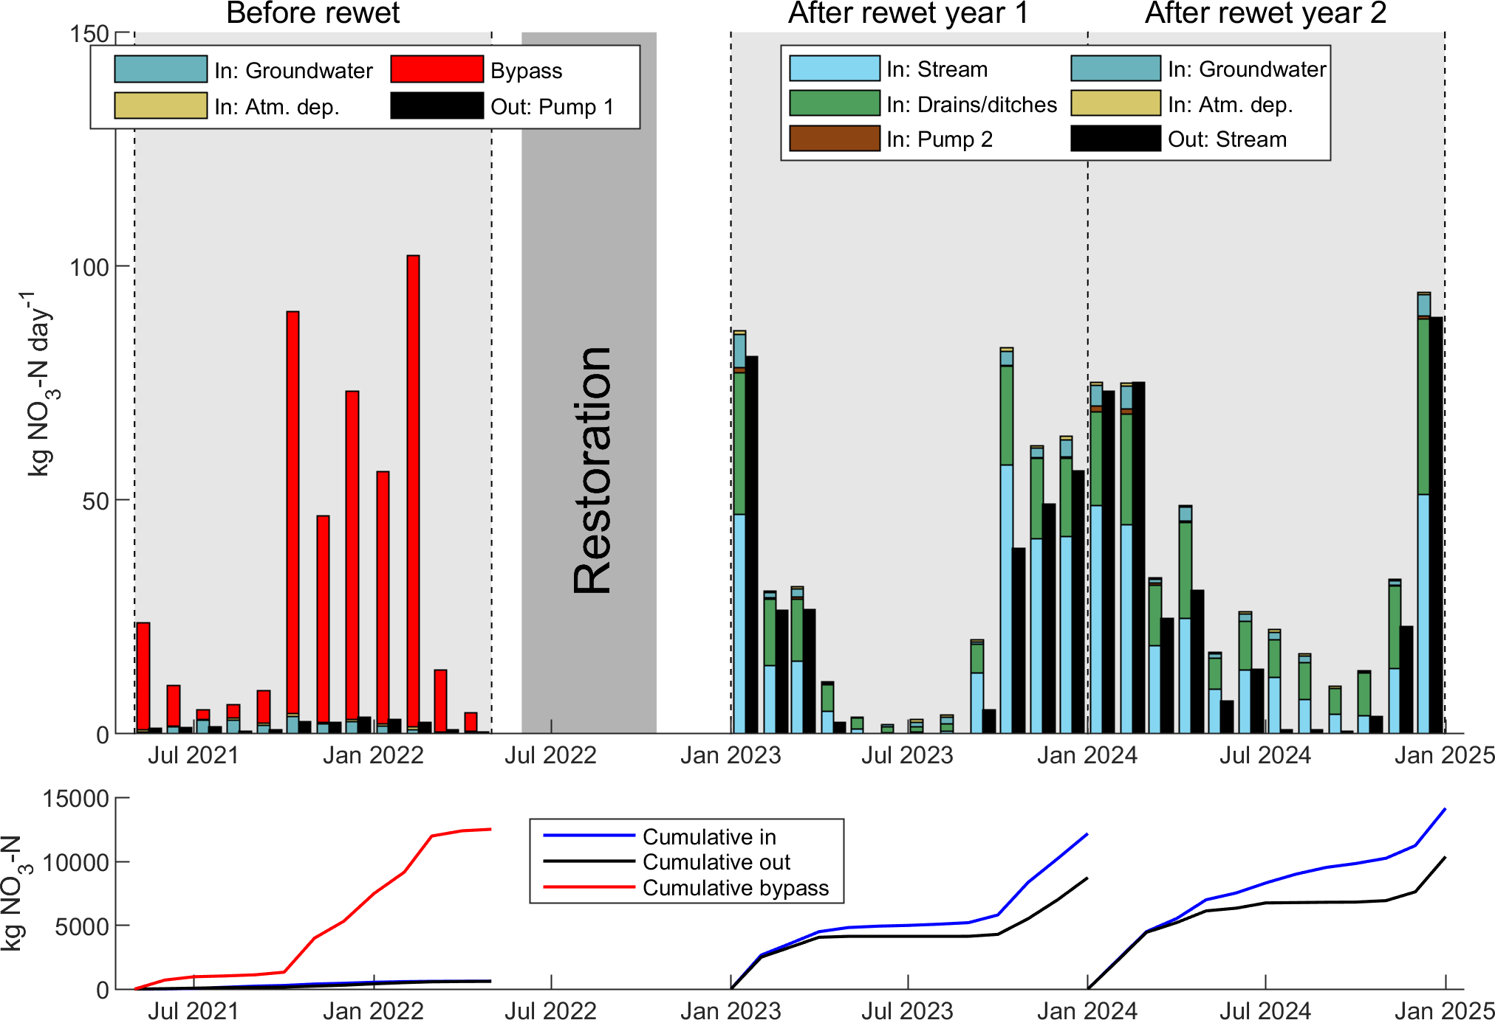
Figure S 1: Mass balance of nitrate-N (NO₃-N) before and after rewetting. Bypass is the flux in the diversion channel, which before rewetting diverted stream water and drainage water from the south of the project area directly into the recipient, Søndervese, Atm. dep. is atmospheric deposition on the project area (11.85 ha before rewetting and 14.46 ha after rewetting), and Pump 2 is water from a neighboring drained peatland, which was pumped into the rewetted project area. Nitrate-N fluxes (kg NO₃-N day⁻¹) are presented as monthly averages.
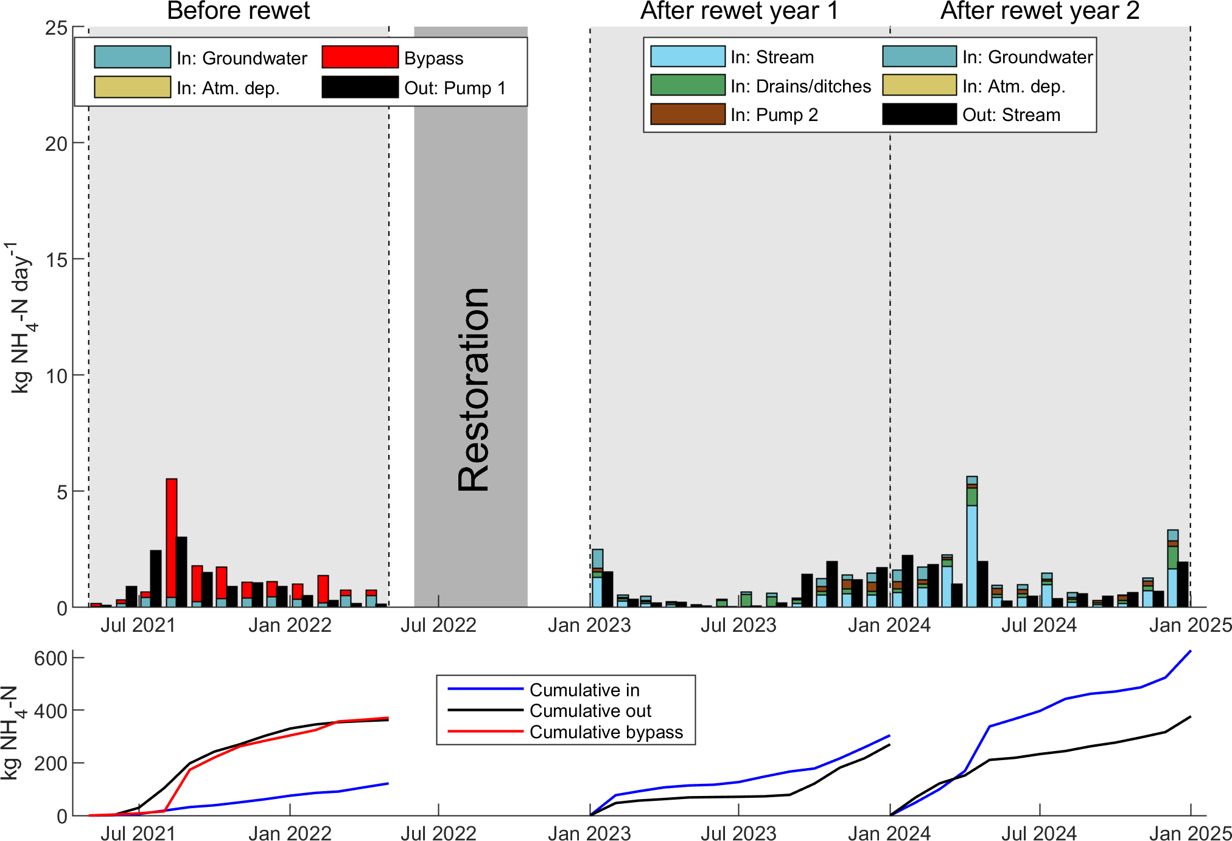
Figure S 2: Mass balance of ammonium-N (NH₄-N) before and after rewetting. Bypass is the flux in the diversion channel, which before rewetting diverted stream water and drainage water from the south of the project area directly into the recipient, Søndervese, Atm. dep. is atmospheric deposition on the project area (11.85 ha before rewetting and 14.46 ha after rewetting), and Pump 2 is water from a neighboring drained peatland, which was pumped into the rewetted project area. Ammonium-N fluxes (kg NH₄-N day⁻¹) are presented as monthly averages.

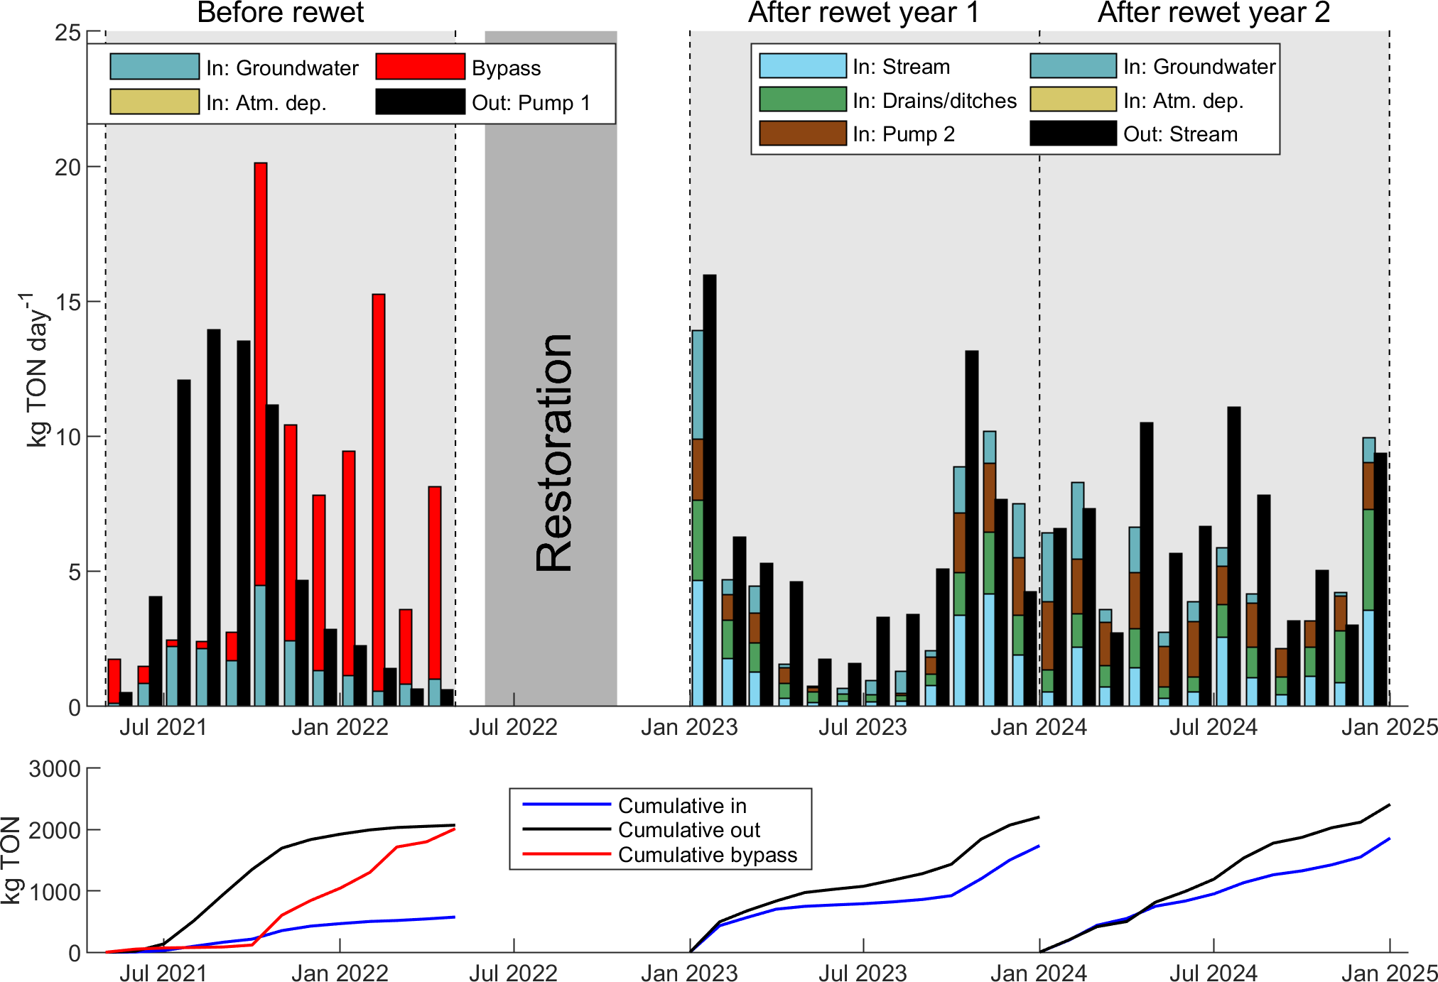
Figure S 3: Mass balance of total organic N (TON) before and after rewetting. Bypass is the flux in the diversion channel, which before rewetting diverted stream water and drainage water from the south of the project area directly into the recipient, Søndervese, Atm. dep. is atmospheric deposition on the project area (11.85 ha before rewetting and 14.46 ha after rewetting), and Pump 2 is water from a neighboring drained peatland, which was pumped into the rewetted project area. Total organic N fluxes (kg TON day⁻¹) are presented as monthly averages.
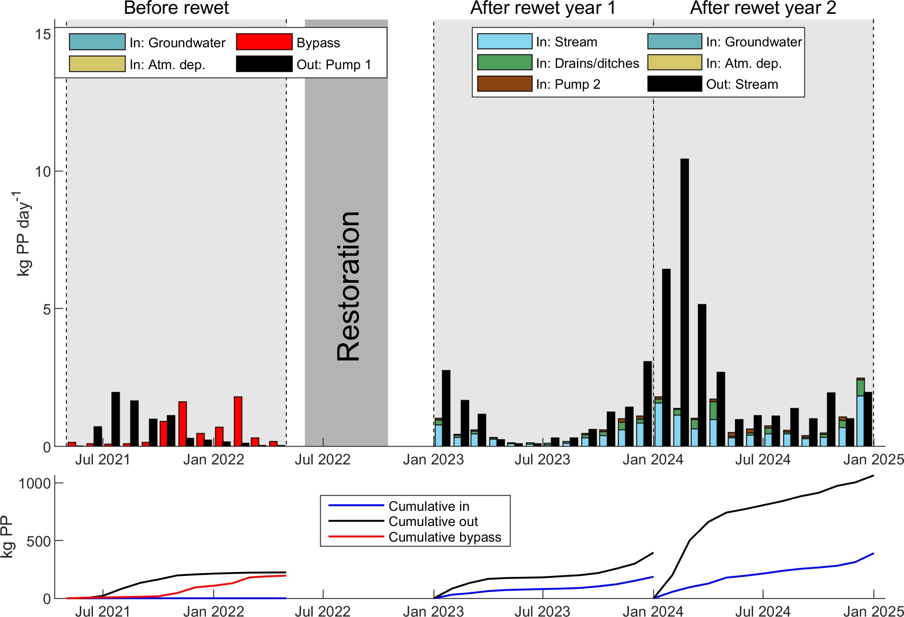
Figure S 4: Mass balance of particulate phosphorus (PP) before and after rewetting. Bypass is the flux in the diversion channel, which before rewetting diverted stream water and drainage water from the south of the project area directly into the recipient, Søndervese, Atm. dep. is atmospheric deposition on the project area (11.85 ha before rewetting and 14.46 ha after rewetting), and Pump 2 is water from a neighboring drained peatland, which was pumped into the rewetted project area. Particulate P fluxes (kg PP day⁻¹) are presented as monthly averages.
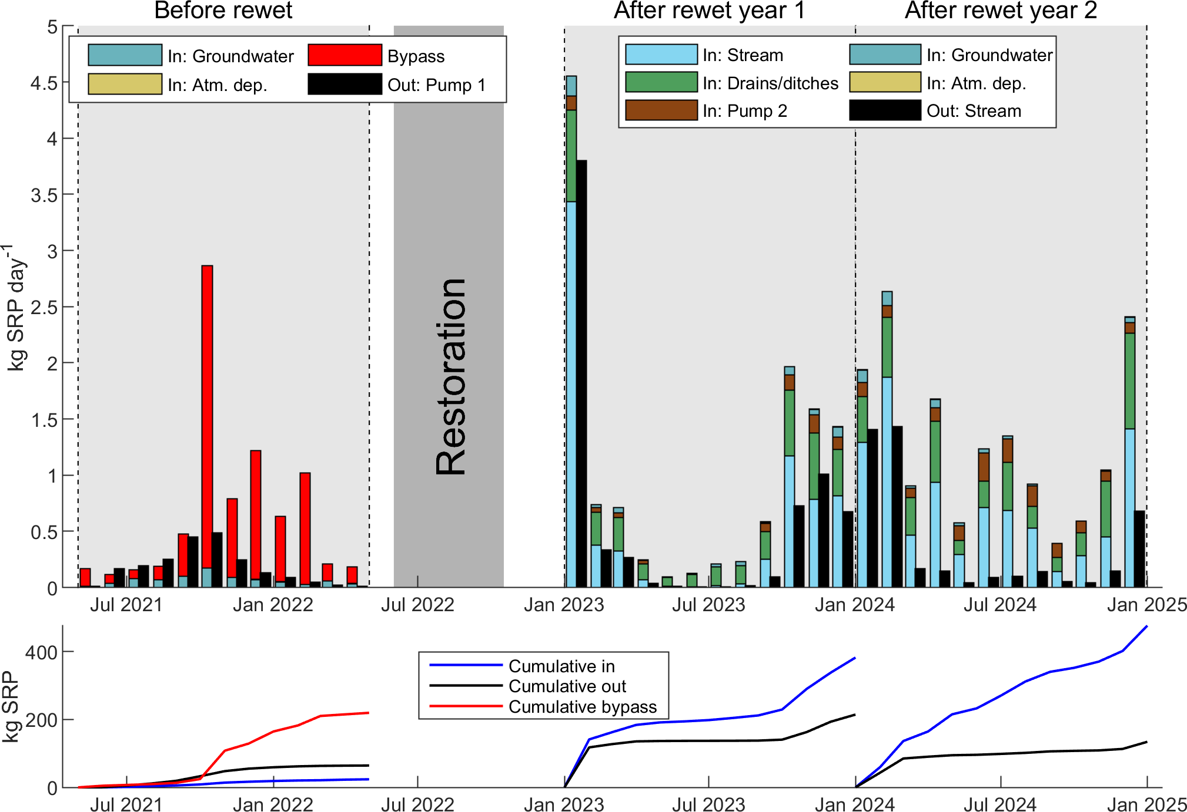
Figure S 5: Mass balance of soluble reactive phosphorus (SRP) before and after rewetting. Bypass is the flux in the diversion channel, which before rewetting diverted stream water and drainage water from the south of the project area directly into the recipient, Søndervese, Atm. dep. is atmospheric deposition on the project area (11.85 ha before rewetting and 14.46 ha after rewetting), and Pump 2 is water from a neighboring drained peatland, which was pumped into the rewetted project area. Soluble reactive P fluxes (kg SRP day⁻¹) are presented as monthly averages.
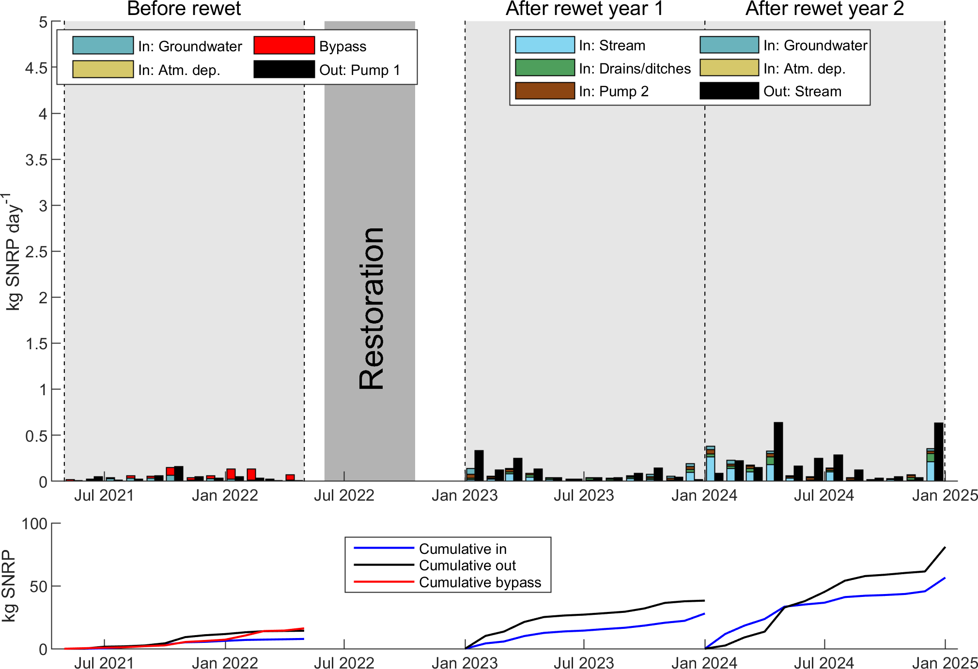
Figure S 6: Mass balance of soluble non-reactive phosphorus (SNRP) before and after rewetting. Bypass is the flux in the diversion channel, which before rewetting diverted stream water and drainage water from the south of the project area directly into the recipient, Søndervese, Atm. dep. is atmospheric deposition on the project area (11.85 ha before rewetting and 14.46 ha after rewetting), and Pump 2 is water from a neighboring drained peatland, which was pumped into the rewetted project area. Soluble non-reactive P fluxes (kg SNRP day⁻¹) are presented as monthly averages.

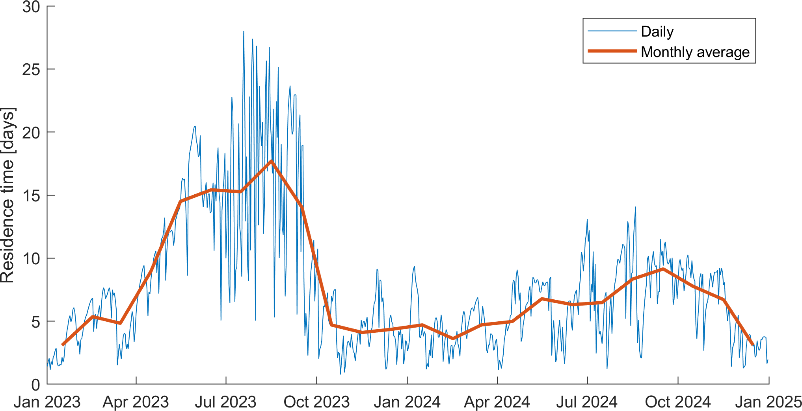
Figure S 7: Average daily (blue) and monthly (red) residence time in Lake Strande Enge after rewetting. Residence times were calculated from the lake stage measured at the lake outlet in combination with a volume-stage relationship extracted from the Danish national digital elevation model.

