Supplementary Information
Biophysical and biogeochemical controls on nitrogen fixation in cyanolichen and decaying wood
Journal: Biogeochemistry

Robert E. Heumann¹, Monica G. Turner², Cory C. Cleveland¹
¹Department of Ecosystem and Conservation Sciences, W.A. Franke College of Forestry and Conservation, University of Montana, Missoula, Montana 59812, USA
²Department of Integrative Biology, University of Wisconsin-Madison, Madison, Wisconsin 53706 USA

Corresponding author: Robert E. Heumann; robert.heumann@umontana.edu; ORCID: 0009-0001-3622-7077

Experiment x Temperature | Breakpoint (ψ) | 95% CI | Slope change at ψ | R²
Field: 1.6 °C | - | - | - | 0.83
Field: 13.5 °C | 180% | 74 – 432% | −1.60 | 0.82
Chamber: 10 °C | 98% | 41 – 234% | −1.53* | 0.81
Chamber: 30 °C | 168% | 114 – 248% | −2.90*** | 0.81
Table 1. Segmented regression model results for lichen acetylene reduction rates as a function of moisture content across temperatures in field and growth chamber experiments. Breakpoint ψ and 95% CI are back-transformed from log scale to gravimetric moisture content (% w/w). Slope change at ψ is the moisture coefficient from the segmented model, representing the change in slope at the breakpoint. No breakpoint was found in the Field: 1.6 °C lichen data. Significance of slope change: *** p < 0.001, * p < 0.05.

Niche | Exp. | Term | Degrees of freedom | Residual degrees of freedom | χ² | Residual deviance | p
Lichen | Field | Null |  | 111 | NA | 153.5 | NA
Lichen | Field | Moisture | 1 | 110 | 87.1 | 66.4 | <0.001
Lichen | Field | Temperature | 1 | 109 | 0.3 | 66.0 | 0.565
Lichen | Field | Moisture × Temperature | 1 | 108 | 1.3 | 64.8 | 0.258
Wood | Field | Null |  | 111 | NA | 153.5 | NA
Wood | Field | Moisture | 1 | 110 | 0.2 | 153.3 | 0.653
Wood | Field | Temperature | 1 | 109 | 13.2 | 140.1 | <0.001
Wood | Field | Moisture × Temperature | 1 | 108 | 8.3 | 131.8 | 0.004
Lichen | Chamber | Null |  | 110 | NA | 150.6 | NA
Lichen | Chamber | Moisture | 1 | 109 | 100.4 | 50.2 | <0.001
Lichen | Chamber | Temperature | 1 | 108 | 1.6 | 48.6 | 0.204
Lichen | Chamber | Moisture × Temperature | 1 | 107 | 0.1 | 48.5 | 0.748
Wood | Chamber | Null |  | 111 | NA | 130.2 | NA
Wood | Chamber | Moisture | 1 | 110 | 1.1 | 129.1 | 0.297
Wood | Chamber | Temperature | 1 | 109 | 36.8 | 92.3 | <0.001
Wood | Chamber | Moisture × Temperature | 1 | 108 | 0.5 | 91.8 | 0.493

Table 2: Sequential analysis of deviance (AOD) results for Binomial GLMs testing the effects of moisture and temperature on the probability of active acetylene reduction (AR) in lichens and wood across field and growth chamber experiments. Note: including nutrient treatment in zero models yielded unstable model results, thus treatment was excluded from all zero models. Significant effects (p < 0.05) are shown in bold.

Niche | Exp. | Term | Coefficient | Standard Error | Z-statistic | p
Lichen | Field | Intercept | -2.72 | 0.80 | -3.40 | 0.001
Lichen | Field | Moisture | 0.04 | 0.02 | 2.56 | 0.011
Lichen | Field | Temperature (13.5 °C) | 0.45 | 1.01 | 0.45 | 0.655
Lichen | Field | Moisture × Temperature (13.5 °C) | -0.02 | 0.02 | -0.95 | 0.341
Wood | Field | Intercept | -1.40 | 0.60 | -2.35 | 0.019
Wood | Field | Moisture | 0.00 | 0.00 | 1.90 | 0.058
Wood | Field | Temperature (13.5 °C) | 3.47 | 0.87 | 3.98 | 0.000
Wood | Field | Moisture × Temperature (13.5 °C) | -0.01 | 0.00 | -2.77 | 0.006
Lichen | Chamber | Intercept | -4.20 | 1.58 | -2.66 | 0.008
Lichen | Chamber | Moisture | 0.13 | 0.08 | 1.63 | 0.103
Lichen | Chamber | Temperature (30 °C) | 1.45 | 1.86 | 0.78 | 0.434
Lichen | Chamber | Moisture × Temperature (30 °C) | -0.03 | 0.09 | -0.30 | 0.761
Wood | Chamber | Intercept | -3.17 | 1.45 | -2.19 | 0.029
Wood | Chamber | Moisture | 0.00 | 0.01 | -0.10 | 0.921
Wood | Chamber | Temperature (30 °C) | 2.40 | 1.54 | 1.56 | 0.119
Wood | Chamber | Moisture × Temperature (30 °C) | 0.01 | 0.01 | 0.69 | 0.491

Table 3: Coefficients for Binomial GLMs testing the effects of moisture and temperature on the probability of active acetylene reduction (AR) in lichens and wood across field and growth chamber experiments. Note: including nutrient treatment in zero models yielded unstable model results, thus treatment was excluded from all zero models. Significant effects (p < 0.05) are shown in bold. Intercept refers to 0% moisture content and the lower temperature of that experiment (i.e., 1.6°C in field, 10°C in chamber experiments)

Niche | Exp. | Term | Degrees of freedom | Residual degrees of freedom | χ² | Residual deviance | p
Lichen | Field | NULL | NA | 62 | NA | 162.8 | NA
Lichen | Field | Moisture | 1 | 61 | 7.1 | 155.0 | 0.011
Lichen | Field | Temperature | 1 | 60 | 44.5 | 106.5 | <0.001
Lichen | Field | Treatment | 3 | 57 | 2.2 | 99.2 | 0.096
Lichen | Field | Moisture x Temperature | 1 | 56 | 0.0 | 99.2 | 0.837
Lichen | Field | Moisture x Treatment | 3 | 53 | 2.9 | 89.7 | 0.044
Lichen | Field | Temperature x Treatment | 3 | 50 | 1.1 | 86.1 | 0.364
Lichen | Field | Moisture x Temperature x Treatment | 3 | 47 | 1.6 | 80.9 | 0.206
Wood | Field | NULL | NA | 62 | NA | 206.5 | NA
Wood | Field | Moisture | 1 | 61 | 18.9 | 172.8 | <0.001
Wood | Field | Temperature | 1 | 60 | 29.3 | 120.4 | <0.001
Wood | Field | Treatment | 3 | 57 | 2.1 | 109.0 | 0.110
Wood | Field | Moisture x Temperature | 1 | 56 | 1.6 | 106.1 | 0.214
Wood | Field | Moisture x Treatment | 3 | 53 | 3.1 | 89.5 | 0.036
Wood | Field | Temperature x Treatment | 3 | 50 | 0.7 | 86.0 | 0.589
Wood | Field | Moisture x Temperature x Treatment | 3 | 47 | 0.3 | 84.4 | 0.829
Lichen | Chamber | NULL | NA | 64 | NA | 195.3 | NA
Lichen | Chamber | Moisture | 1 | 63 | 0.9 | 194.1 | 0.346
Lichen | Chamber | Temperature | 1 | 62 | 19.3 | 170.2 | <0.001
Lichen | Chamber | Treatment | 3 | 59 | 1.5 | 164.4 | 0.216
Lichen | Chamber | Moisture x Temperature | 1 | 58 | 0.0 | 164.4 | 0.914
Lichen | Chamber | Moisture x Treatment | 3 | 55 | 4.3 | 148.5 | 0.009
Lichen | Chamber | Temperature x Treatment | 3 | 52 | 0.7 | 145.9 | 0.544
Lichen | Chamber | Moisture x Temperature x Treatment | 3 | 49 | 0.2 | 145.2 | 0.914
Wood | Chamber | NULL | NA | 29 | NA | 50.6 | NA
Wood | Chamber | Moisture | 1 | 28 | 1.6 | 48.7 | 0.220
Wood | Chamber | Treatment | 3 | 25 | 1.7 | 42.6 | 0.188
Wood | Chamber | Moisture x Treatment | 3 | 22 | 0.5 | 40.8 | 0.684

Table 4: Sequential analysis of deviance (AOD) results for Gamma GLMs testing the effects of moisture, temperature and nutrient treatment (treatment) on active (non-zero) AR rates in lichens and wood across field and growth chamber experiments. Note: Including temperature in the Wood-Chamber model yielded unstable results because only 2 of 56 samples were active in the 10° C chamber. Significant effects (p < 0.05) are shown in bold.

Niche | Exp. | Term | Coeff. | Std. Error | Z-statistic | p
Lichen | Field | Intercept | 3.02 | 0.86 | 3.51 | 0.001
Lichen | Field | Moisture | 0.00 | 0.00 | -0.54 | 0.592
Lichen | Field | Temperature (13.5°C) | 0.95 | 1.19 | 0.79 | 0.431
Lichen | Field | Treatment: +P | -3.30 | 1.04 | -3.18 | 0.003
Lichen | Field | Treatment: control | 1.22 | 1.19 | 1.03 | 0.308
Lichen | Field | Treatment: P+ N+ | -1.01 | 1.40 | -0.72 | 0.473
Lichen | Field | Moisture x Temperature (13.5°C) | 0.00 | 0.00 | 0.94 | 0.352
Lichen | Field | Moisture x Treatment: +P | 0.01 | 0.00 | 3.69 | 0.001
Lichen | Field | Moisture x Treatment: control | 0.00 | 0.00 | -0.31 | 0.755
Lichen | Field | Moisture x Treatment: P+ N+ | 0.01 | 0.01 | 0.99 | 0.329
Lichen | Field | Temperature (13.5°C) x Treatment: +P | 2.84 | 1.61 | 1.77 | 0.084
Lichen | Field | Temperature (13.5°C) x Treatment: control | -2.82 | 1.61 | -1.75 | 0.087
Lichen | Field | Temperature (13.5°C) x Treatment: P+ N+ | 1.31 | 2.03 | 0.64 | 0.522
Lichen | Field | Moisture x Temperature (13.5°C) x Treatment: +P | -0.01 | 0.01 | -1.39 | 0.172
Lichen | Field | Moisture x Temperature (13.5°C) x Treatment: control | 0.02 | 0.01 | 2.08 | 0.043
Lichen | Field | Moisture x Temperature (13.5°C) x Treatment: P+ N+ | -0.01 | 0.01 | -0.91 | 0.366
Wood | Field | Intercept | -3.81 | 1.50 | -2.55 | 0.014
Wood | Field | Moisture | 0.00 | 0.01 | 0.13 | 0.897
Wood | Field | Temperature (13.5°C) | 4.29 | 1.73 | 2.48 | 0.017
Wood | Field | Treatment: +P | 1.63 | 1.84 | 0.88 | 0.381
Wood | Field | Treatment: control | -1.32 | 1.89 | -0.70 | 0.488
Wood | Field | Treatment: P+ N+ | 1.95 | 2.52 | 0.77 | 0.445
Wood | Field | Moisture x Temperature (13.5°C) | 0.00 | 0.01 | -0.69 | 0.493
Wood | Field | Moisture x Treatment: +P | -0.01 | 0.01 | -0.83 | 0.411
Wood | Field | Moisture x Treatment: control | 0.00 | 0.01 | 0.56 | 0.580
Wood | Field | Moisture x Treatment: P+ N+ | -0.01 | 0.01 | -0.80 | 0.429
Wood | Field | Temperature (13.5°C) x Treatment: +P | -0.98 | 2.14 | -0.46 | 0.649
Wood | Field | Temperature (13.5°C) x Treatment: control | -0.98 | 2.18 | -0.45 | 0.656
Wood | Field | Temperature (13.5°C) x Treatment: P+ N+ | -4.75 | 3.16 | -1.50 | 0.140
Wood | Field | Moisture x Temperature (13.5°C) x Treatment: +P | 0.00 | 0.01 | -0.08 | 0.936
Wood | Field | Moisture x Temperature (13.5°C) x Treatment: control | 0.00 | 0.01 | 0.40 | 0.694
Wood | Field | Moisture x Temperature (13.5°C) x Treatment: P+ N+ | 0.01 | 0.01 | 0.95 | 0.345
Lichen | Chamber | Intercept | 5.57 | 1.86 | 2.99 | 0.004
Lichen | Chamber | Moisture | -0.01 | 0.01 | -1.13 | 0.263
Lichen | Chamber | Temperature (30°C) | -0.08 | 1.97 | -0.04 | 0.968
Lichen | Chamber | Treatment:+P | -2.53 | 1.95 | -1.30 | 0.199
Lichen | Chamber | Treatment: control | -2.58 | 2.04 | -1.27 | 0.211
Lichen | Chamber | Treatment: P+ N+ | -4.77 | 2.35 | -2.03 | 0.047
Lichen | Chamber | Moisture x Temperature (30°C) | 0.01 | 0.01 | 0.70 | 0.485
Lichen | Chamber | Moisture x Treatment: +P | 0.01 | 0.01 | 1.51 | 0.137
Lichen | Chamber | Moisture x Treatment: control | 0.01 | 0.01 | 1.54 | 0.130
Lichen | Chamber | Moisture x Treatment: P+ N+ | 0.02 | 0.01 | 1.76 | 0.085
Lichen | Chamber | Temperature (30°C) x Treatment: +P | 0.97 | 2.17 | 0.44 | 0.659
Lichen | Chamber | Temperature (30°C) x Treatment: control | -0.31 | 2.22 | -0.14 | 0.890
Lichen | Chamber | Temperature (30°C) x Treatment: P+ N+ | 2.40 | 2.51 | 0.96 | 0.343
Lichen | Chamber | Moisture x Temperature (30°C) x Treatment: +P | 0.00 | 0.01 | -0.09 | 0.926
Lichen | Chamber | Moisture x Temperature (30°C) x Treatment: control | 0.00 | 0.01 | 0.40 | 0.693
Lichen | Chamber | Moisture x Temperature (30°C) x Treatment: P+ N+ | -0.01 | 0.01 | -0.65 | 0.517
Wood | Chamber | Intercept | -4.26 | 0.85 | -5.01 | <0.001
Wood | Chamber | Moisture | 0.01 | 0.00 | 1.72 | 0.100
Wood | Chamber | Treatment: +P | 2.73 | 1.21 | 2.26 | 0.034
Wood | Chamber | Treatment: control | 1.41 | 1.24 | 1.14 | 0.268
Wood | Chamber | Treatment: P+ N+ | 1.00 | 2.19 | 0.46 | 0.654
Wood | Chamber | Moisture x Treatment: +P | -0.01 | 0.01 | -1.51 | 0.145
Wood | Chamber | Moisture x Treatment: control | 0.00 | 0.01 | -0.61 | 0.546
Wood | Chamber | Moisture x Treatment: P+N+ | -0.01 | 0.02 | -0.51 | 0.614

Table 5: Coefficients from Gamma GLMs testing the effects of moisture, temperature and nutrient treatment (treatment) on active (non-zero) AR rates in lichens and wood across field and growth chamber experiments. Note: Including temperature in the Wood/Chamber model yielded unstable results because only 2 of 56 samples were active in the 10°C chamber. Significant effects (p < 0.05) are shown in bold.

Niche | Exp. | Term | Degrees of freedom | Residual degrees of freedom | χ² | Residual deviance | p
Lichen | Field | Null | NA | 233 | NA | 314.5 | NA
Lichen | Field | Moisture | 1 | 232 | 122.0 | 192.0 | <0.001
Lichen | Field | Temperature | 5 | 227 | 31.1 | 160.9 | <0.001
Lichen | Field | Moisture × Temperature | 5 | 222 | 16.3 | 144.6 | 0.006
Wood | Field | Null | NA | 230 | NA | 308.9 | NA
Wood | Field | Moisture | 1 | 229 | 48.3 | 260.6 | <0.001
Wood | Field | Temperature | 5 | 224 | 68.2 | 192.4 | <0.001
Wood | Field | Moisture × Temperature | 5 | 219 | 8.8 | 183.6 | 0.119
Lichen | Chamber | Null | NA | 188 | NA | 262.0 | NA
Lichen | Chamber | Moisture | 1 | 187 | 68.0 | 194.0 | <0.001
Lichen | Chamber | Temperature | 5 | 182 | 43.9 | 150.1 | <0.001
Lichen | Chamber | Moisture × Temperature | 5 | 177 | 26.0 | 124.2 | <0.001
Wood | Chamber | Null | NA | 335 | NA | 415.8 | NA
Wood | Chamber | Moisture | 1 | 334 | 3.9 | 411.9 | 0.049
Wood | Chamber | Temperature | 5 | 329 | 81.4 | 330.6 | <0.001
Wood | Chamber | Moisture × Temperature | 5 | 324 | 5.6 | 324.9 | 0.344

Table 6: Sequential analysis of deviance (AOD) results for Binomial GLMs testing the effects of moisture and temperature active (non-zero) vs. inactive AR rates in lichens and wood across field and growth chamber experiments. Results are based on analysis of combined data from this study and Heumann et al. (2025). Significant effects (p < 0.05) are shown in bold.

Niche | Exp. | Term | Coefficient | Standard Error | Z-statistic | p
Lichen | Field | Intercept | -10.15 | 1.86 | -5.47 | <0.001
Lichen | Field | Moisture | 2.50 | 0.46 | 5.48 | <0.001
Lichen | Field | Temperature | 0.41 | 0.12 | 3.56 | <0.001
Lichen | Field | Moisture × Temperature | -0.10 | 0.03 | -3.38 | <0.001
Wood | Field | Intercept | -4.80 | 1.75 | -2.74 | 0.006
Wood | Field | Moisture | 0.79 | 0.33 | 2.36 | 0.018
Wood | Field | Temperature | 0.05 | 0.12 | 0.45 | 0.656
Wood | Field | Moisture × Temperature | 0.01 | 0.02 | 0.46 | 0.647
Lichen | Chamber | Intercept | -8.37 | 2.06 | -4.06 | <0.001
Lichen | Chamber | Moisture | 1.94 | 0.48 | 4.02 | <0.001
Lichen | Chamber | Temperature | 0.15 | 0.08 | 1.78 | 0.076
Lichen | Chamber | Moisture × Temperature | -0.03 | 0.02 | -1.52 | 0.130
Wood | Chamber | Intercept | 0.19 | 2.01 | 0.09 | 0.926
Wood | Chamber | Moisture | -0.49 | 0.40 | -1.22 | 0.223
Wood | Chamber | Temperature | -0.15 | 0.09 | -1.65 | 0.099
Wood | Chamber | Moisture × Temperature | 0.04 | 0.02 | 2.44 | 0.015

Table 7: Coefficient results for Binomial GLMs testing the effects of moisture and temperature on active (non-zero) vs. inactive AR rates in lichens and wood across field and growth chamber experiments. Results are based on analysis of combined data from this study and Heumann et al. (2025). Significant effects (p < 0.05) are shown in bold.

Niche | Exp. | Term | Degrees of freedom | Residual degrees of freedom | χ² | Residual deviance | p
Lichen | Field | Null | NA | 92 | NA | 155.0 | NA
Lichen | Field | Moisture | 1 | 91 | 27.4 | 136.0 | <0.001
Lichen | Field | Temperature | 4 | 87 | 11.3 | 106.0 | <0.001
Lichen | Field | Moisture × Temperature | 4 | 83 | 6.52 | 89.0 | <0.001
Wood | Field | Null | NA | 89 | NA | 191.0 | NA
Wood | Field | Moisture | 1 | 88 | 9.34 | 177.0 | 0.003
Wood | Field | Temperature | 3 | 85 | 12.4 | 123.0 | <0.001
Wood | Field | Moisture × Temperature | 3 | 82 | 1.45 | 116.0 | 0.235
Lichen | Chamber | Null | NA | 95 | NA | 133.0 | NA
Lichen | Chamber | Moisture | 1 | 94 | 33.9 | 108.0 | <0.001
Lichen | Chamber | Temperature | 5 | 89 | 2.71 | 97.6 | 0.025
Lichen | Chamber | Moisture × Temperature | 5 | 84 | 1.1 | 93.5 | 0.365
Wood | Chamber | Null | NA | 103 | NA | 164.0 | NA
Wood | Chamber | Moisture | 1 | 102 | 0.051 | 164.0 | 0.822
Wood | Chamber | Temperature | 5 | 97 | 9.36 | 119.0 | <0.001
Wood | Chamber | Moisture × Temperature | 5 | 92 | 2.52 | 107.0 | 0.035

Table 8: Sequential analysis of deviance (AOD) results for Gamma GLMs testing the effects of moisture and temperature on active (non-zero) AR rates in lichens and wood across field and growth chamber experiments. Results are based on analysis of combined data from this study and Heumann et al. (2025). Significant effects (p < 0.05) are shown in bold.

Niche | Exp. | Term | Coefficient | Standard Error | Z-statistic | p
Lichen | Field | (Intercept) | -5.64 | 0.71 | -7.99 | <0.001
Lichen | Field | Moisture | 1.19 | 0.14 | 8.60 | <0.001
Lichen | Field | Temperature | 0.30 | 0.05 | 6.61 | <0.001
Lichen | Field | Moisture × Temperature | -0.05 | 0.01 | -5.06 | <0.001
Wood | Field | (Intercept) | -1.97 | 2.61 | -0.76 | 0.451
Wood | Field | Moisture | -0.32 | 0.48 | -0.66 | 0.509
Wood | Field | Temperature | 0.13 | 0.22 | 0.58 | 0.564
Wood | Field | Moisture × Temperature | 0.01 | 0.04 | 0.18 | 0.860
Lichen | Chamber | (Intercept) | -1.36 | 1.19 | -1.15 | 0.254
Lichen | Chamber | Moisture | 0.43 | 0.24 | 1.78 | 0.079
Lichen | Chamber | Temperature | -0.05 | 0.05 | -1.11 | 0.271
Lichen | Chamber | Moisture × Temperature | 0.01 | 0.01 | 1.33 | 0.185
Wood | Chamber | (Intercept) | -7.22 | 2.69 | -2.69 | 0.008
Wood | Chamber | Moisture | 0.84 | 0.54 | 1.56 | 0.122
Wood | Chamber | Temperature | 0.25 | 0.11 | 2.23 | 0.028
Wood | Chamber | Moisture × Temperature | -0.04 | 0.02 | -1.77 | 0.081
Table 9: Coefficient results for Gamma GLMs testing the effects of moisture and temperature on active (non-zero) AR rates in lichens and wood across experiments in the entire combined dataset of this study and Heumann et al. (2025). Significant effects (p < 0.05) are shown in bold.

Niche | Breakpoint (ψ) | 95% CI | Slope change at ψ | R²
Lichen (~moisture) | 203.6 | 132.0 – 290.4 | - 0.003 | 0.83
Wood (~temperature) | - | - | - | 0.15
Table 10. Segmented regression model results for lichen acetylene reduction rates as a function of moisture content and wood acetylene reduction rates as a function of temperature from combined dataset. Breakpoint ψ and 95% CI are back-transformed from log scale to gravimetric moisture content (% w/w). Slope change at ψ is the coefficient from the segmented model, representing the change in slope at the breakpoint. No temperature (or moisture) breakpoint was found in the wood data. Significance of slope change: *** p < 0.001, * p < 0.05.

Fig. 1
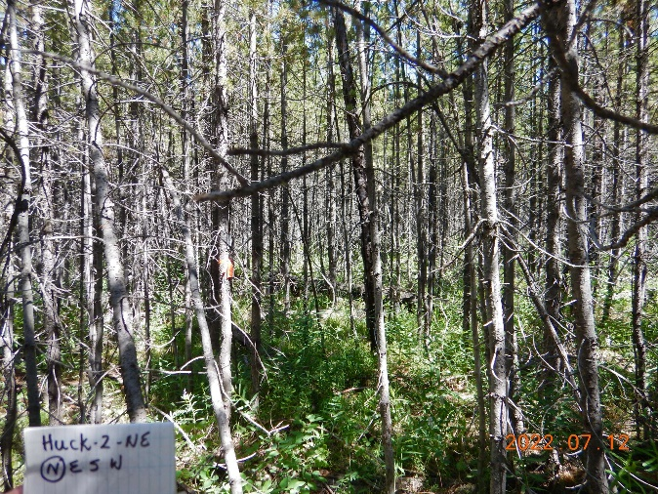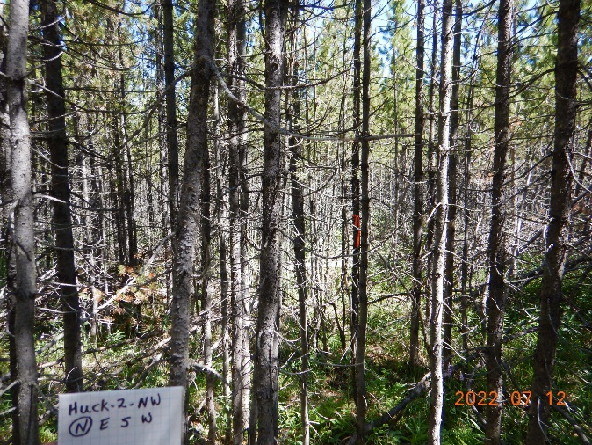
Fig. 1 North facing view of our 50 kg N (+N) treatment plot (left panel) and our control plots (right panel) to demonstrate above ground characteristics in the experimental plots. Images were taken immediately before the first N treatment in 2022. Samples for this study were collected in 2024. No major changes to plot structure (e.g., from disturbance) in any of our plots occurred over those two years.

Fig. 2
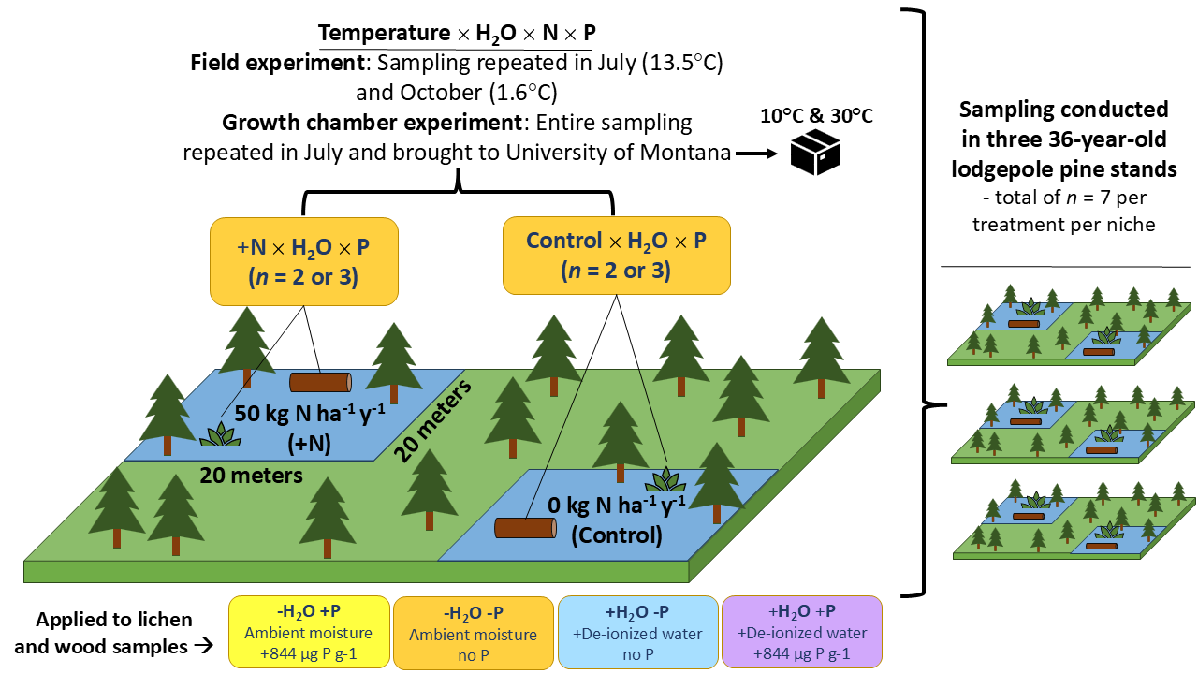
Fig. 2 Experimental design schematic for the field experiment and sample collection for the growth chamber experiment across three lodgepole pine dominated forest blocks in Grand Teton National Park. The main block shows the experimental plots (20 x 20 m; 50 kg N and Control) from which samples of lichen and decaying wood were collected. Once collected in the field, samples from both plots were treated with water and P as described in the bottom row of the diagram for both field and growth chamber experiments. Acetylene reduction assays (ARAs) were conducted in the field on samples collected in July and October. For the growth chamber experiment, ARAs were conducted on field-collected samples in temperature-controlled chambers at the University of Montana.
Fig. 3
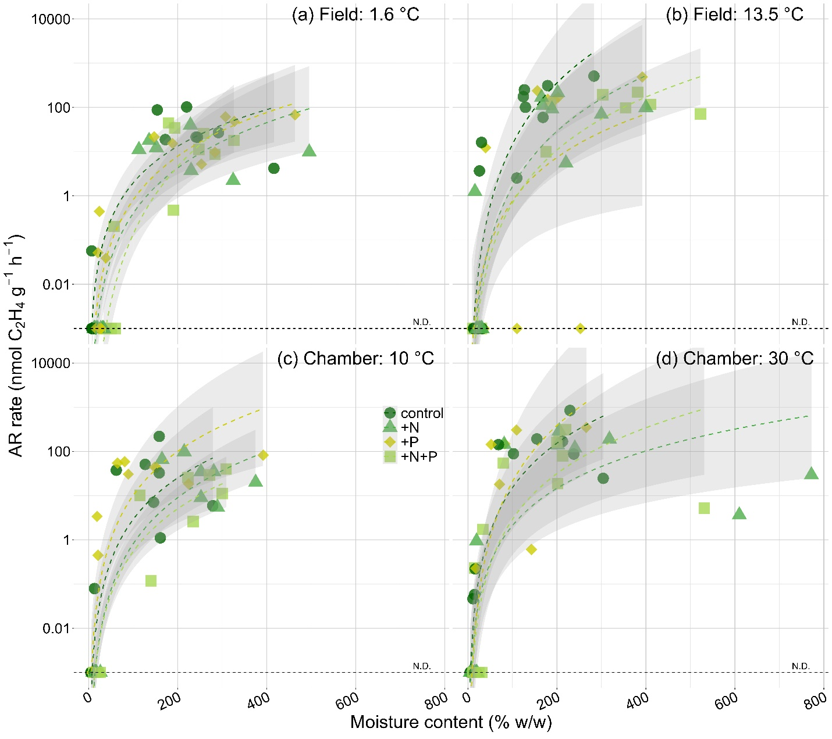
Fig. 3 Acetylene reduction (AR) rates among lichen samples in the field (a and b) and growth chamber (c and d) experiments (n = 14). Field temperatures represent 24-hour means. Different colors and symbols depict different nutrient treatments (see legend in panel c). Phosphorus fertilization had no effect on AR rates (data not shown). Rates are shown on a log10 scale. Samples with no detected AR rates (N.D.) are plotted across the bottom of the y-axes (Detection limit = 0.001 nmol C₂H₄ g⁻¹ h⁻¹). Trendline and gray confidence intervals (95%) represent modeled outputs from lichen GLMs by nutrient treatment (SI: Table 2-5)
Fig. 4

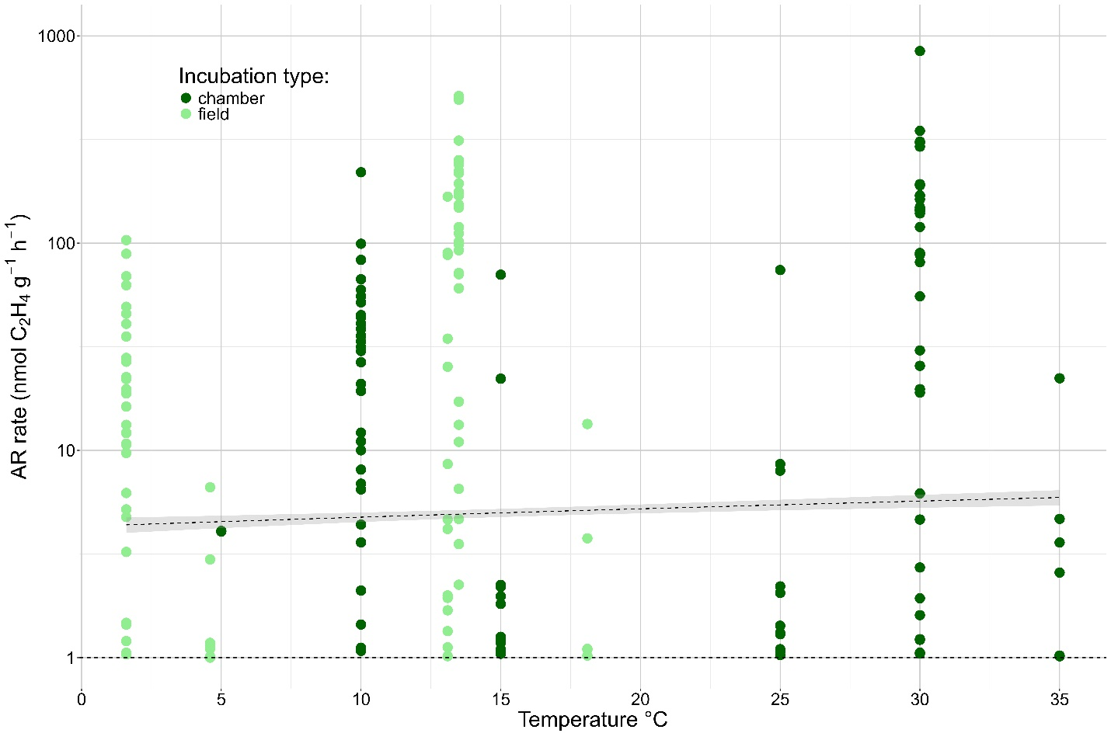
Fig. 4 Scatter plot of active lichen AR rate data from this study and Heumann et al. (2025). Dots represent individual lichen rates and colors represent different date from field incubations (light green) or growth chamber experiments (dark green). Note the log scales on y axis. The trend line represents a fitted Gamma GLM with log link function and the gray shading represents a 95% confidence interval.

