Supporting Information for
Investigating the persistence of iron-bound phosphorus in lake sediment under sulfidic conditions
Biogeochemistry
Harm van Kuppevelt^{1,2}*, Michael Hupfer^{1,2}, Kasper Reitzel³, Marta Lidia Sudo⁴, Ugo Marzocchi^{4,5}

¹ Department of Ecohydrology and Biogeochemistry, Leibniz Institute of Freshwater Ecology and Inland Fisheries, Müggelseedamm 301, 12587 Berlin, Germany
² Brandenburg University of Technology Cottbus-Senftenberg, Platz der Deutschen Einheit 1, 03046 Cottbus, Germany
³ Department of Biology, University of Southern Denmark, Campusvej 55, 5230 Odense M, Denmark
⁴ Center for Electromicrobiology (CEM), Department of Biology, Aarhus University, Ny Munkegade 114, 8000 Aarhus C, Denmark
⁵ Center for Water Technology (WATEC), Department of Biology, Aarhus University, Ny Munkegade 114, 8000 Aarhus C, Denmark

* Corresponding author: Harm van Kuppevelt (h.vankuppevelt@has.nl)
Keywords: Vivianite; Internal phosphorus loading; Lake restoration; Sulfate reduction; Phosphorus mobilization; Iron-bound phosphorus

Introduction
This Supplementary Information (SI) provides the datasets, methodological detail, and additional analyses that support the results reported in the main article. It follows the structure of the manuscript, with a Methods section and a Results section.
The Methods section reports two items referenced from the main text: the water chemistry of Langer See, the source lake for the study sediment, based on monthly monitoring from January 2022 to May 2023 (Table S1); and the full set of parameters and boundary conditions used to derive sediment oxygen consumption rates from the porewater oxygen microsensor profiles (Table S2).
The Results section presents four supporting datasets. Sequential extraction data from the anoxic pre-incubation (Fig. S1) document the conversion of iron (oxyhydr)oxide-bound phosphorus to vivianite that produced the enriched starting sediment. Dissolved oxygen microsensor profiles (Fig. S2) and the derived oxygen penetration depths (Table S3) show that a stable, thin oxic zone was maintained at the sediment surface throughout the 96-day incubation and did not differ between treatments. Solid-phase elemental profiles measured by inductively coupled plasma optical emission spectroscopy (ICP-OES; Fig. S3) resolve the depth distribution of phosphorus, sulfur, iron, manganese, and magnesium at 19 and 96 days.
Together, these materials substantiate three points made in the main article: that the pre-incubation produced a reproducible, vivianite-enriched sediment; that oxic conditions at the sediment–water interface were stable and comparable between treatments; and that sulfide accumulation under elevated sulfate coincided with a loss of solid-phase phosphorus, most strongly within the sulfidic zone.

Methods

Water chemistry of Langer See (Table S1)
Surface water samples were collected monthly from Langer See between January 2022 and May 2023 (n = 19). Samples were analyzed for the parameters listed in Table S1. Prior to analysis, samples were filtered through 0.45 µm membranes for dissolved constituents. Soluble reactive phosphorus (SRP), ammonium (NH₄⁺), and nitrate plus nitrite (NO₂⁻ + NO₃⁻) were measured photometrically by segmented flow analysis (Skalar Scan++, Skalar Analytical B.V.) following the respective DIN EN ISO standards. Total phosphorus (TP) was determined by the same method after digesting unfiltered water with 5% K₂S₂O₈ for 2 h at 120 °C. Total organic carbon (TOC), total inorganic carbon (TIC), and total nitrogen (TN) were measured in filtered samples by infrared spectrometry after high-temperature oxidation (TOC/TN analyzer, Shimadzu, Japan). Anion concentrations (Cl⁻, SO₄²⁻) were determined by ion chromatography (Metrohm Compact IC) with a conductivity detector (DIN EN ISO 10304-1), using samples filtered through 0.2 µm membranes. Major elemental concentrations were measured by ICP-OES (Thermo Fisher iCAP 7400, Thermo Fisher Scientific Inc., Waltham, MA, USA)).

Table S1: Measured surface water composition of Langer See over the period January 2022 to May 2023. Total phosphorus (TP) content was measured photometrically after digestion, and the concentration of soluble reactive phosphorus (SRP) ammonium (NH⁴⁺), nitrite (NO₂⁻) and nitrate (NO₃⁻) was measured photometrically directly using a segmented flow analyzer. Total organic carbon (TOC), total nitrogen (TN) and total inorganic carbon (TIC) were measured with a multi-analyzer. Chloride (Cl⁻) and sulfate (SO₄²⁻) were determined by ion chromatography. Optical emission spectroscopy was used to measure the element concentrations. The yearly average composition was calculated and used in the main publication.
Sampling date |  | TP |  | SRP | NH⁴⁺ | NO₂⁻ | NO₃⁻ |  | TOC | TN | TIC |  | Cl⁻ | SO₄²⁻ |  | Al | B | Ca | Cu | Fe | K | Mg | Mn | Na | P | S | Si | Zn
Sampling date |  | µgP/L |  | µgP/L | mgN/L | mgN/L | mgN/L |  | mgC/L | mgN/L | mgC/L |  | mg/L | mgS/L |  | mg/L | mg/L | mg/L | mg/L | mg/L | mg/L | mg/L | mg/L | mg/L | mg/L | mg/L | mg/L | mg/L
10/01/22 |  | 193 |  | 64 | 0,28 | 0,01 | 0,45 |  | 8,1 | 1,2 | 28,9 |  | 62 | 81 |  | <0,01 | 0,04 | 72,9 | <0,01 | <0,01 | 6,97 | 9,71 | 0,02 | 40,1 | 0,08 | 25,7 | 4,94 | <0,01
08/02/22 |  | 94 |  | 6 | 0,03 | <0.005 | 0,21 |  | 9,7 | 1,2 | 28,1 |  | 62 | 75 |  | <0,01 | 0,03 | 66,9 | <0,01 | <0,01 | 6,63 | 8,69 | <0,01 | 36,9 | 0,017 | 24,1 | 2,40 | <0,01
14/03/22 |  | 25 |  | 4 | 0,04 | <0.005 | 0,04 |  | 9,1 | 1,0 | 25,9 |  | 55 | 97 |  | 0,01 | 0,04 | 74,4 | <0,01 | 0,01 | 6,70 | 9,73 | 0,02 | 35,4 | 0,013 | 34,8 | 0,51 | <0,01
12/04/22 |  | 44 |  | 3 | 0,03 | <0.005 | 0,01 |  | 9,2 | 0,8 | 24,0 |  | 56 | 93 |  | <0,01 | 0,03 | 68,2 | <0,01 | <0,01 | 6,94 | 8,94 | 0,01 | 35,2 | 0,01 | 32,0 | <0,1 | <0,01
10/05/22 |  | 50 |  | <3 | <0.01 | <0.005 | 0,02 |  | 8,7 | 0,8 | 28,2 |  | 52 | 102 |  | 0,01 | 0,04 | 77,6 | <0,01 | <0,01 | 7,94 | 8,94 | 0,03 | 36,5 | 0,015 | 35,4 | 0,90 | <0,01
08/06/22 |  | n.d. |  | 25 | 0,10 | <0.005 | 0,01 |  | 9,8 | 0,9 | 30,0 |  | 50 | 111 |  | 0,01 | 0,04 | 79,3 | <0,01 | <0,01 | 6,50 | 10,2 | 0,15 | 31,4 | 0,046 | 37,3 | 1,60 | <0,01
05/07/22 |  | n.d. |  | 6 | 0,04 | <0.005 | 0,01 |  | 9,7 | 1,0 | 29,3 |  | 50 | 128 |  | 0,01 | 0,05 | 81,0 | <0,01 | <0,01 | 6,23 | 10,8 | 0,11 | 30,6 | 0,023 | 41,5 | 4,11 | 0,02
09/08/22 |  | n.d. |  | <3 | 0,11 | <0.005 | <0.01 |  | 14,5 | 1,9 | 14,4 |  | 45 | 133 |  | <0,01 | 0,05 | 62,1 | <0,01 | <0,01 | 6,25 | 11,3 | 0,13 | 30,1 | 0,012 | 46,1 | 5,79 | <0,01
08/09/22 |  | 119 |  | 4 | 0,06 | <0.005 | <0.01 |  | 13,2 | 1,6 | 18,3 |  | 42 | 160 |  | <0,02 | 0,05 | 73,2 | <0,01 | <0,01 | 6,27 | 12,8 | 0,07 | 30,4 | 0,027 | 53,1 | 6,68 | <0,01
11/10/22 |  | 138 |  | <3 | 0,19 | <0.005 | 0,02 |  | 17,1 | 1,6 | 21,0 |  | 43 | 162 |  | <0,02 | 0,05 | 81,4 | <0,01 | <0,01 | 6,13 | 13,1 | 0,11 | 30,2 | 0,014 | 53,5 | 7,12 | 0,02
09/11/22 |  | 109 |  | 29 | 0,20 | <0.005 | 0,03 |  | 10,2 | 1,5 | 24,0 |  | 46 | 153 |  | <0,02 | 0,04 | 77,1 | <0,01 | <0,01 | 6,09 | 12,7 | 0,04 | 31,3 | 0,037 | 49,6 | 7,10 | <0,01
06/12/22 |  | 64 |  | 16 | 0,27 | <0.005 | 0,14 |  | 8,6 | 1,2 | 26,6 |  | 48 | 157 |  | <0,02 | 0,04 | 79,1 | <0,01 | <0,01 | 6,06 | 12,4 | 0,04 | 30,8 | 0,028 | 48,6 | 6,49 | <0,01
04/01/23 |  | 69 |  | 8 | 0,21 | <0.005 | 0,2 |  | 8,3 | 1,2 | 26,6 |  | 51 | 121 |  | <0,02 | 0,04 | 73,0 | <0,01 | <0,01 | 6,22 | 11,1 | <0,01 | 33,4 | 0,025 | 40,0 | 4,95 | <0,01
22/02/23 |  | 69 |  | 7 | 0,07 | 0,01 | 0,28 |  | 10,3 | 1,5 | 26,0 |  | 60 | 81 |  | <0,02 | 0,03 | 63,8 | <0,01 | <0,01 | 6,57 | 9,21 | <0,01 | 37,8 | 0,018 | 27,7 | 3,18 | <0,01
08/03/23 |  | 65 |  | 4 | 0,02 | <0.005 | <0.01 |  | 10,8 | 1,1 | 23,9 |  | 63 | 81 |  | <0,02 | 0,04 | 63,3 | <0,01 | <0,01 | 6,72 | 9,49 | <0,01 | 36,9 | 0,014 | 28,2 | 1,39 | <0,01
04/04/23 |  | 73 |  | 3 | 0,09 | <0.005 | 0,01 |  | 10,8 | 1,1 | 21,8 |  | 64 | 74 |  | <0,02 | 0,03 | 57,1 | <0,01 | <0,01 | 6,42 | 8,74 | 0,02 | 39,9 | 0,015 | 24,3 | <0,1 | <0,01
17/04/23 |  | 61 |  | 4 | 0,04 | <0.005 | <0.01 |  | 9,3 | 0,9 | 24,2 |  | 61 | 74 |  | <0,02 | 0,03 | 61,4 | <0,01 | <0,01 | 6,43 | 8,79 | 0,01 | 38,2 | 0,016 | 25,0 | <0,1 | <0,01
09/05/23 |  | 22 |  | 4 | 0,05 | <0.005 | <0.01 |  | 11,5 | 1,1 | 26,9 |  | 61 | 87 |  | <0,02 | 0,04 | 68,5 | <0,01 | <0,01 | 6,75 | 9,59 | 0,01 | 37,4 | 0,017 | 29,5 | <0,1 | 0,01
mean |  | 72 |  | 8 | 0,08 | 0,01 | 0,05 |  | 10,3 | 1,2 | 24,5 |  | 53 | 105 |  | <0,01 | 0,04 | 70,7 | <0,01 | <0,01 | 6,53 | 10,24 | 0,03 | 34,4 | 0,020 | 35,1 | 2,40 | <0.01

Oxygen consumption rate calculations (Table S2)
Oxygen consumption rates were derived from porewater O₂ microsensor profiles using the numerical finite-difference method of Berg et al. (1998). Porosity values used to calculate sediment diffusivity were derived from dry weight (DW) measurements of sliced sediment as φ = 1 − DW. Bioirrigation was assumed to be negligible. Diffusion constants were taken from Schulz & Zabel (2000). The parameters and boundary conditions used in the model are listed in Table S2.
Table S2. Parameters and boundary conditions used for oxygen consumption rate calculations (Berg et al. 1998).
Parameter | Value | Description
Top of calculation domain (cm) | −0.1 | Depth at top boundary (above SWI)
Bottom of calculation domain (cm) | 0.68 | Depth at bottom boundary
Max. number of zones | 12 | Maximum equally spaced zones (1–12)
Boundary condition type | 1 | Type 1: top = concentration, bottom = concentration
Top boundary condition | 100 | O₂ concentration at top (% saturation)
Bottom boundary condition | 0 | O₂ concentration at bottom (% saturation)
Diffusivity in water, D (cm² s⁻¹) | 1.91 × 10⁻⁵ | Temperature-dependent value from Schulz & Zabel (2000)
Sediment diffusivity expression | Ds = φ × D | Expression type 1; φ = porosity derived from DW measurements
O₂ concentration in water column | 100 | Normalized (% saturation)
Min. production rate | −1.0 × 10²⁰ | Lower bound for optimization
Max. production rate | 1.0 × 10²⁰ | Upper bound for optimization
Max. deviation for acceptance (%) | 0.001 | Tolerance for accepting calculated minimum
F-statistic significance level | 0.01 | Level of significance for zone selection

Results

Pre-incubation (Figs. S1)
The Fe-P amendment substantially increased extractable P in the BD-P fraction. Sequential extraction data from the pre-incubation period showed a progressive shift from BD-P to NaOH-SRP over 42 days, consistent with the transformation of FeOx-bound P to vivianite (Heinrich et al. 2020; Fig. S1). After 42 days, 52% of the initial BD-TP pool had been converted to NaOH-SRP.
This conversion is slightly lower than the 72% reported by Heinrich et al. (2020) using the same Langer See sediment under closely analogous conditions (Fig. S4). Despite this difference in conversion efficiency, both studies show the same qualitative pattern: a rapid initial sink-switch during the first ~20–30 days that decelerates thereafter, with BD-P and NaOH-SRP fractions stabilizing at broadly similar absolute concentrations by the end of the pre-incubation. The modest quantitative difference likely reflects inter-annual variability in sediment chemistry between the July 2019 and May 2023 sampling campaigns, including possible differences in organic matter content, microbial community composition, or the FeOx precursor reactivity. The overall agreement in trajectory and magnitude confirms the reproducibility of the Fe-P amendment method and supports the consistency of vivianite formation in Langer See sediment across independent experiments.
The Fe-P amendment also altered the elemental composition of the sediment, increasing Fe and P content while slightly reducing LOI relative to the unamended control. This produced a compositional gradient in the sediment cores used in the subsequent oxic incubation, with the highest metal and P concentrations in the upper amended layer.
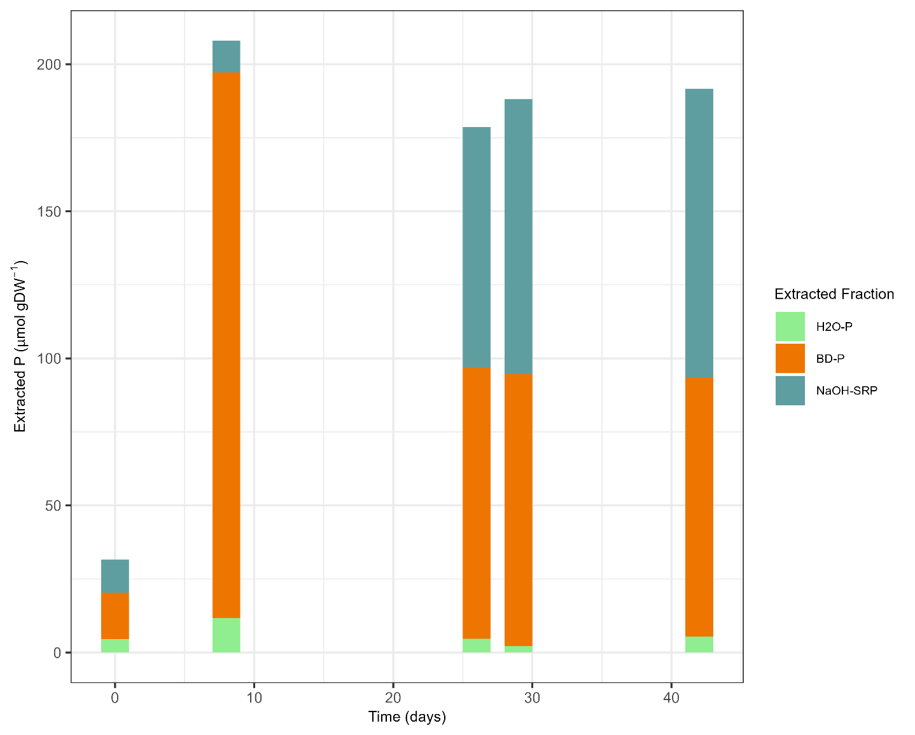
Fig. S1. Sequential extraction data during the anoxic pre-incubation of Fe-P amended sediment (this study). The FeOx-P loaded in the BD-P fraction at day 0 progressively shifts to the NaOH-SRP fraction over 42 days, reflecting the transformation of FeOx-bound P to redox-stable vivianite.

Oxygen profiles (Fig. S2)
Dissolved oxygen depth profiles measured by microsensor showed a stable oxygen gradient confined to the uppermost sediment layer throughout the 96-day incubation (Fig. S2). The gradient established within the first day of the experiment and did not change significantly between timepoints or between treatments, indicating consistent oxic conditions at the sediment–water interface across all cores.
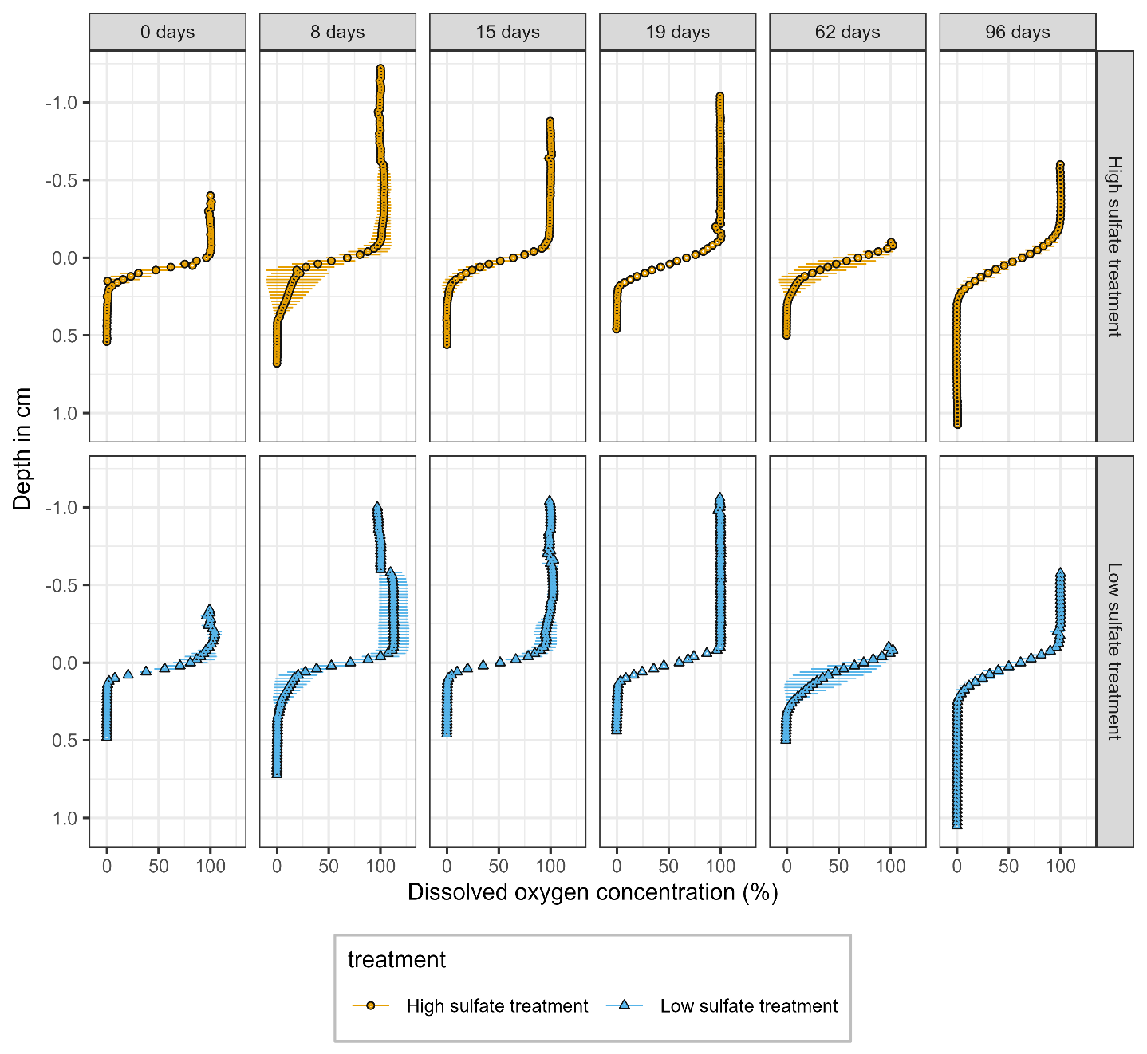
Fig. S2. Dissolved oxygen profiles in the sediment porewater and overlying water column at different timepoints during the sulfate incubation. The oxygen gradient, confined to the top <0.3 cm of sediment, remained stable throughout the experiment and was similar between the high and low sulfate treatments.
Table S3. Depth below which the oxygen concentration is less than 1%, as measure for oxygen penetration and thus the oxic zone.
Day | 0 | 8 | 15 | 19 | 62 | 96
Treatment | Oxygen penetration depth (DO > 1%) in mm
High sulfate | 1.70 ± 0.81 | 1.95 ± 1.56 | 2.23 ± 0.50 | 1.80 ± 0.57 | 1.96 ± 0.26 | 2.17 ± 0.80
Low sulfate | 1.15 ± 0.44 | 2.15 ± 1.17 | 1.08 ± 0.23 | 1.6 | 2.32 ± 0.48 | 2.08 ± 0.34

Elemental composition profiles (Fig. S3)
Elemental profiles of the solid-phase sediment (Fig. S3) were obtained by ICP-OES following aqua regia digestion of freeze-dried sediment slices. Concentrations of Mg, Mn, and Fe did not differ significantly between treatments, but all three decreased at 1.2–2.4 cm depth after 96 days compared to day 19. The most pronounced treatment-related changes were observed in P and S: P was depleted and S was enriched in the top 3 cm of the high sulfate treatment, with this difference becoming more pronounced by day 96. Total extracted sulfur (Sᵉˣᵗʳ = AVS + CRS) was on average 81 μmol S g⁻¹ DW lower than the sulfur measured after aqua regia digestion (Sᵉᴵᶢ). The difference (Sᵉᴵᶢ − Sᵉˣᵗʳ) was negatively correlated with S content (r = −0.84, p = 0.002) and negative in the most S-enriched slices, suggesting the presence of S phases not captured by the cold distillation extraction.
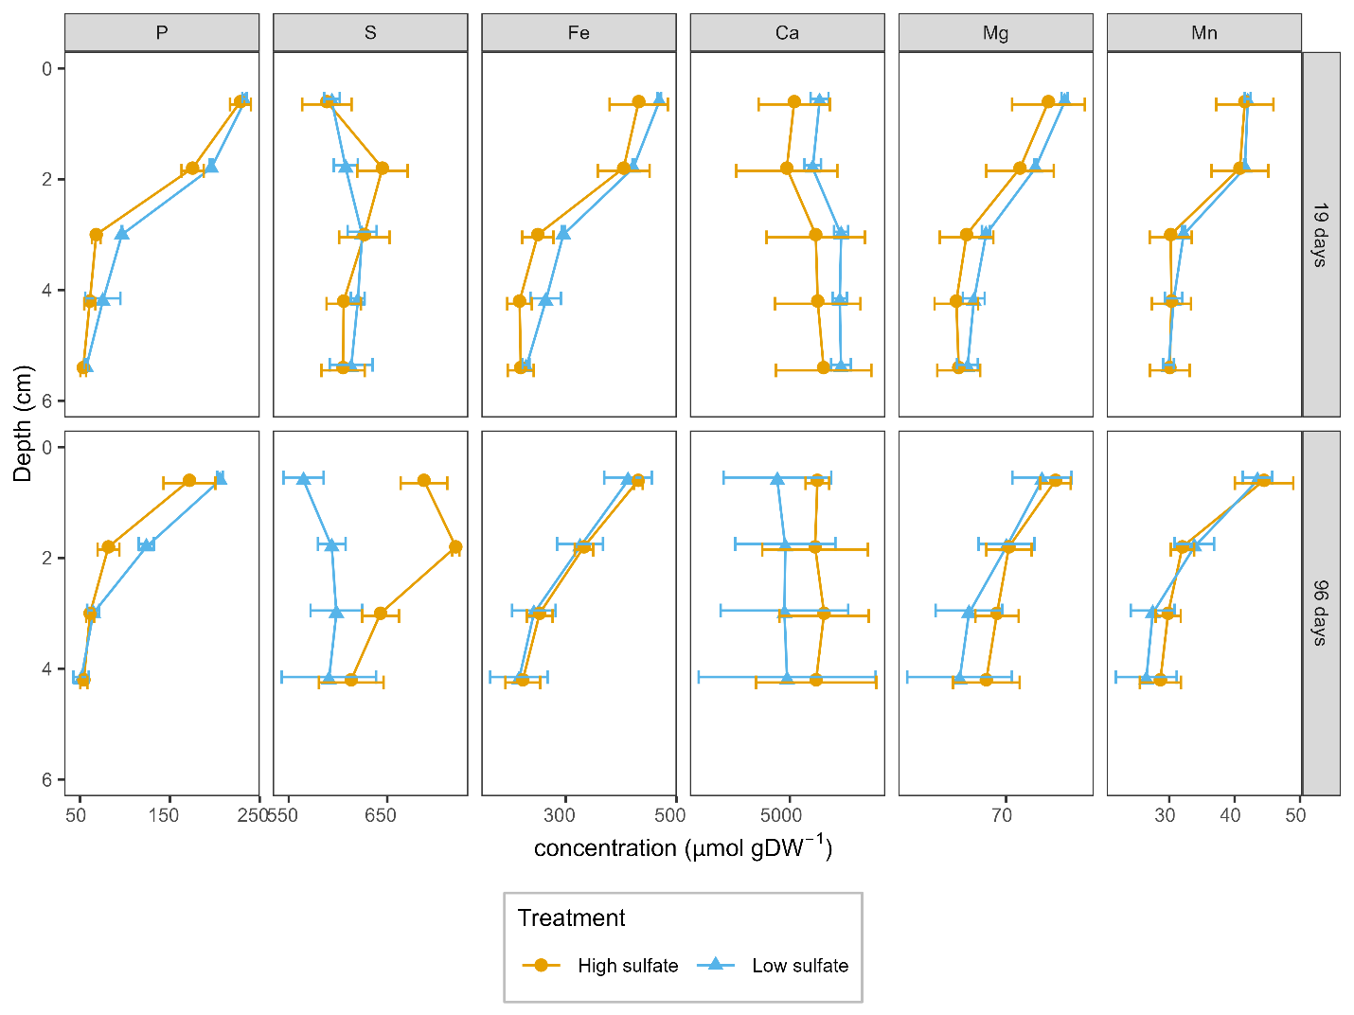
Fig. S3. Elemental composition profiles of the solid-phase sediment at 19 and 96 days after the start of the incubation. Concentrations of Mg, Mn, and Fe did not differ significantly between treatments but decreased at 1.2–2.4 cm depth after 96 days. P and S showed the largest treatment-related differences, with P depletion and S enrichment in the top 3 cm of the high sulfate treatment, most pronounced at day 96.

