Supporting Information

Anticancer effects against Colorectal Cancer Models of chloro(triethylphosphine)gold(I) Encapsulated in PLGA-PEG Nanoparticles

Alessio Menconi,^{[a]} Tiziano Marzo,^{*[b]} Lara Massai,^{[c]} Alessandro Pratesi,^{[d]} Mirko Severi,^{[c]} Giulia Petroni,^{[a]} Lorenzo Antonuzzo,^{[e]} Luigi Messori,^{[c]} Serena Pillozzi,^{*[a,f]#} Damiano Cirri^{*[d]#}

[a] A. Menconi, Dr. G. Petroni, Dr. S. Pillozzi, Department of Experimental and Clinical Medicine, University of Florence, Viale G.B. Morgagni 50, 50134 Firenze, Italy. E-mail: serena.pillozzi@unifi.it
[b] Dr. T. Marzo orcid.org/0000-0002-2567-3637, Department of Pharmacy, University of Pisa, Via Bonanno Pisano 6, 56126, Pisa, Italy. E-mail: tiziano.marzo@unipi.it
[c] Prof. L. Messori orcid.org/0000-0002-9490-8014, Dr. L. Massai orcid.org/0000-0003-0765-1802, Laboratory of Metals in Medicine (MetMed), Department of Chemistry “U. Schiff”, University of Florence, Via della Lastruccia 3, 50019 Sesto Fiorentino, Italy.
[d] Dr. A. Pratesi orcid.org/0000-0002-9553-9943, Dr. D. Cirri orcid.org/0000-0001-9175-9562, Department of Chemistry and Industrial chemistry (DCCI), University of Pisa, Via G. Moruzzi 13, 56124, Pisa, Italy. E-mail: damiano.cirri@dcci.unipi.it
[e] Dr. L. Antonuzzo, S.C. Oncologia Medica 1, Azienda Ospedaliero-Universitaria Careggi, Florence, Italy.
[f] Dr. S. Pillozzi, DI.V.A.L Toscana S.R.L., Via Madonna del Piano, 6, 50019 Sesto Fiorentino, Italy. E-mail: serena.pillozzi@unifi.it
# These authors equally contributed

Index
¹HNMR spectrum 2
DLS measurements 2
Spectroscopic properties 3
Et₃PAuCl retention 4

¹HNMR spectrum

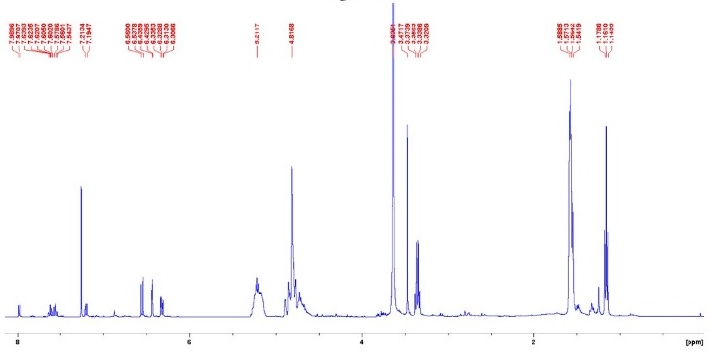

Figure S1. ¹HNMR spectrum of RhB-C=O-PLGA-C=O-NH-PEG-COOH.

DLS measurements

Batch | PDI | Size (nm)
1 | 0.17 | 87
2 | 0.17 | 72
3 | 0.17 | 71
4 | 0.22 | 52
5 | 0.27 | 55
6 | 0.23 | 74
7 | 0.18 | 66

Table S1. DLS measurements used for determining size and PDI index of nanoparticles.

Spectroscopic properties
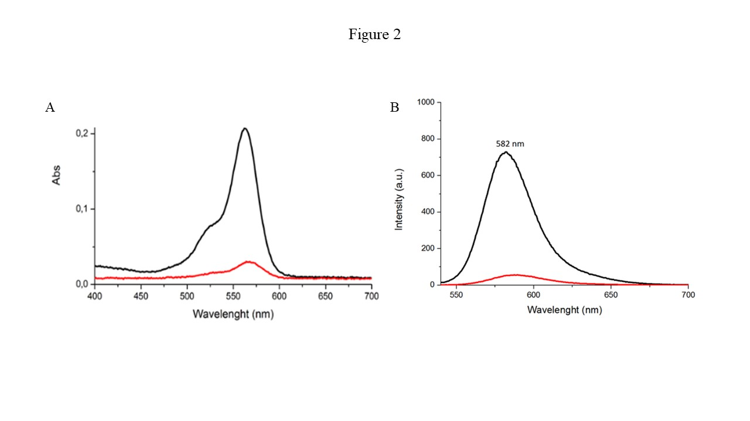
Figure S2. Spectroscopic properties of PLGA-PEG nanoparticles loaded with Et₃PAuCl. A: Comparison of absorbance profiles recorded on the solution of nanoparticles (black line) and filtered solution (red line). B: Comparison of fluorescence profiles recorded on the solution of nanoparticles (black line) and filtered solution (red line). Spectra were recorded using the same samples of absorbance analysis after an eight-fold dilution with MilliQ water.

Et₃PAuCl retention

Batch | [Gold] (μg/L) | [Released Gold] (μg/L) | Gold retention (%)
1 | 7777.3 | 555.4 | 92.9
2 | 7836.2 | 485.1 | 93.8
3 | 7982.4 | 694.9 | 91.4

Table S2. Determination of the retained amount of Et₃PAuCl after 24 h at 25° C.

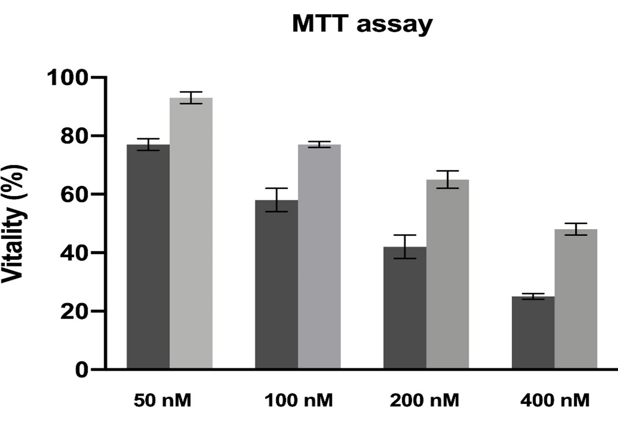

Figure S3. IC₅₀ evaluation of Et₃PAuCl (dark grey) and its encapsulated form (light grey) on HCT-116. Determination performed through MTT assay.

