Supplemental material:
CntP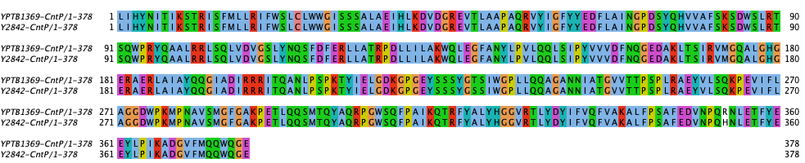
CntQ
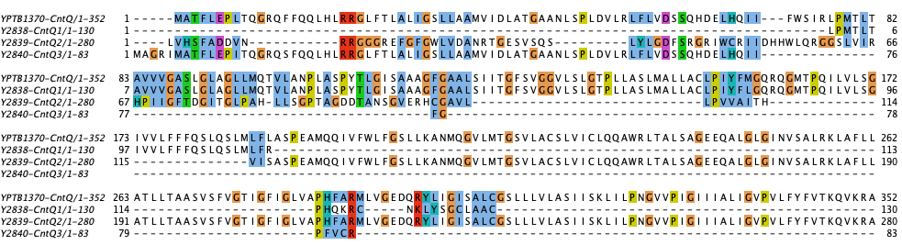
CntR
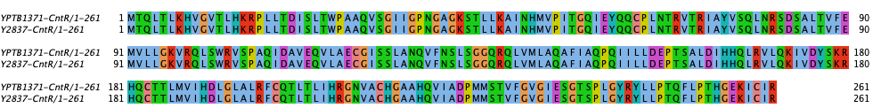
CntL
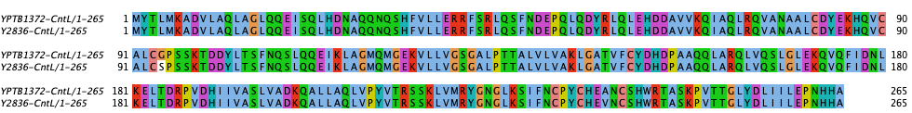CntM
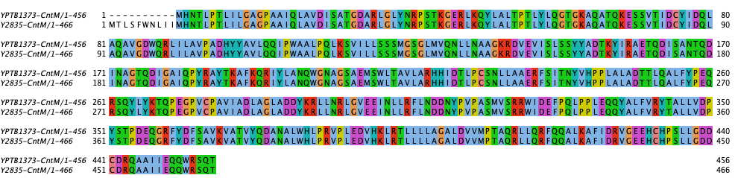
CntI
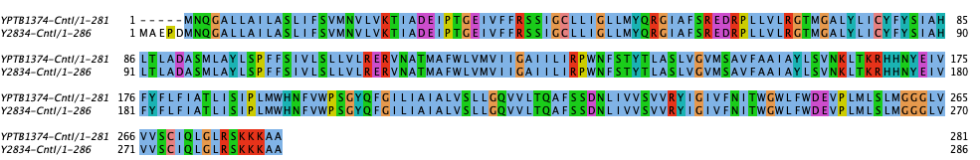

Supplementary Figure 1. Sequence conservation between the different predicted cnt genes in Y. pestis and Y. pseudotuberculosis.
Supplementary Figure 2. AlphaFold3 models of a CntQ monomer from Y. pseudotuberculosis (YPTB1370; left) and Y. pestis (YP2838-40; right). The models are coloured according to the quality of the prediction, except for the right panel, which shows the position of the three peptides and the location of their N- and C-terminus. The approximate position of the membrane is shown in grey.
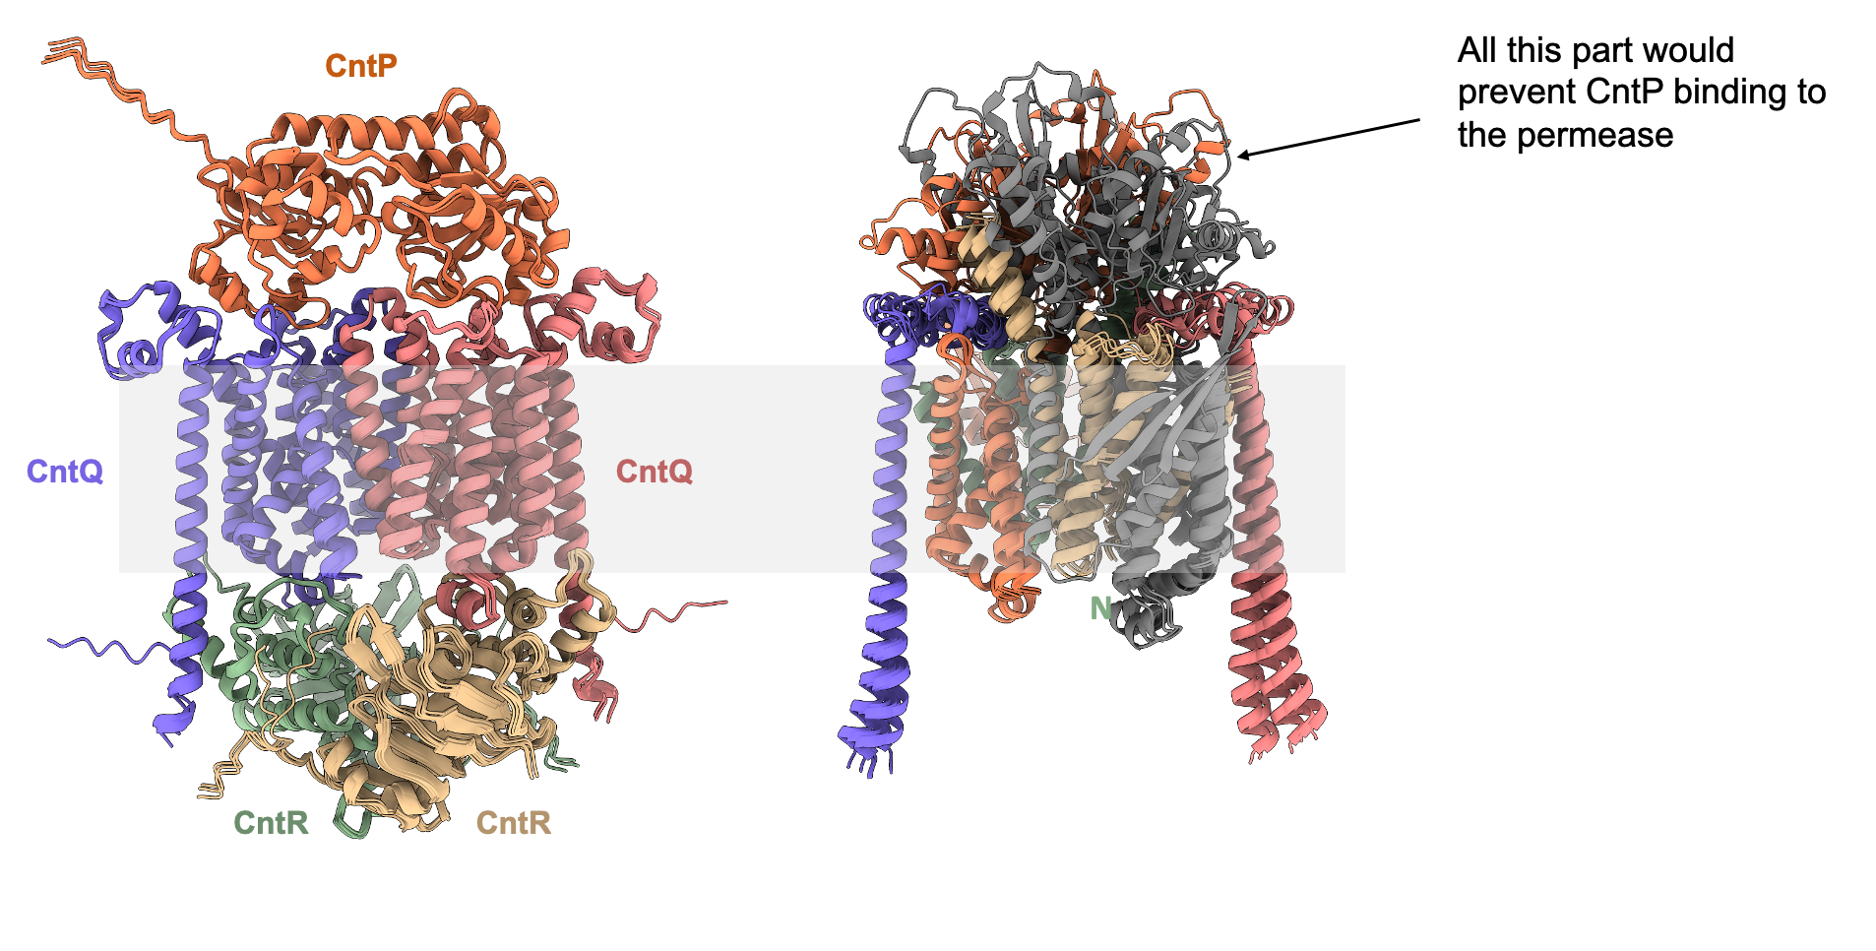
Supplementary Figure 3. AlphaFold3 models of the CntPQ₂R₂ from Y. pseudotuberculosis (left ; ipTM = 0.81 pTM = 0.84) and the CntQ₂ from Y. pestis (right ; ipTM = 0.61 pTM = 0.61). Although there would be enough space for interaction with the ATPase CntR in the cytoplasm, the space used for recognition of CntP in the periplasm is occupied by additional peptide parts that have no counterpart in Y. pseudotuberculosis, therefore leading to our central hypothesis that the three peptides produced by Y. pestis (Y2838-40), even if produced, are likely non-functional.

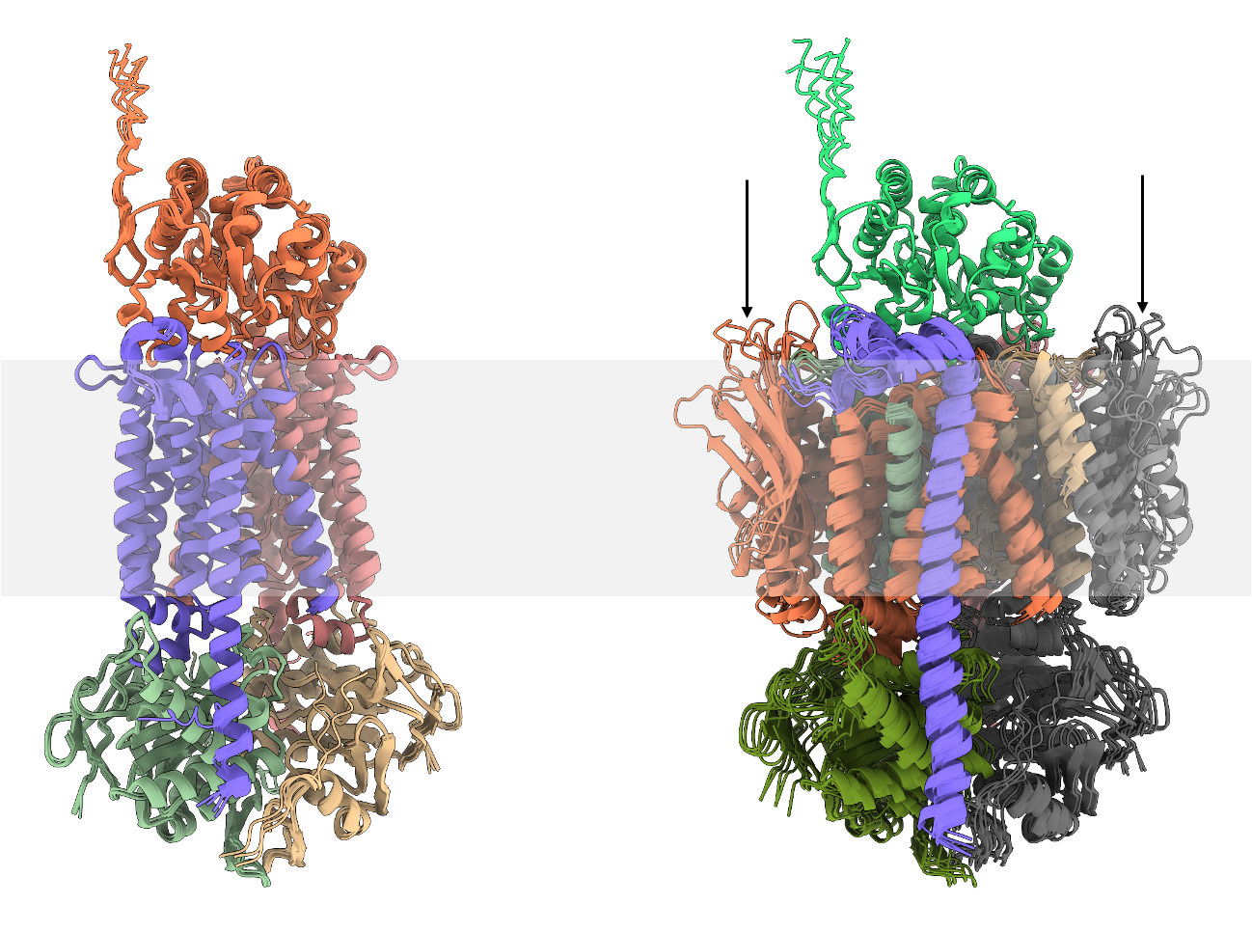
Supplementary Figure 4. AlphaFold3 models of the CntPQ₂R₂ from Y. pseudotuberculosis (left; ipTM = 0.81 pTM = 0.84) and the equivalent from Y. pestis (right; ipTM = 0.65 pTM = 0.65). With regard to Y. pestis, the modelling with CntP indicates that the parts that have no equivalent in Y. pseudotuberculosis now folds in the membrane (arrows), most probably because the model forces CntP binding. However, if stable, this part should fold in the periplamic space, which should therefore prevent either membrane insertion of CntQ or CntP binding to CntQ, anyway likely impairing its function.
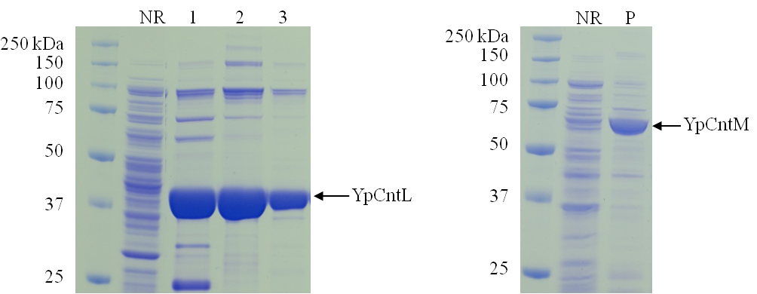
Supplementary Figure 5: SDS-PAGE gels illustrating the purifications of YpCntL (left) and YpCntM (right) using HisTrap columns. NR corresponds to the flow-through fraction, 1, 2 and 3 to the different eluted fractions, and P to the eluted fraction of CntM.
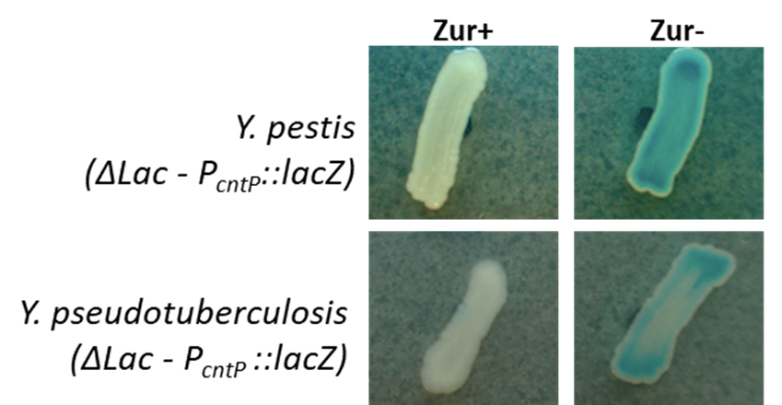
Supplementary Figure 6. Zur-dependent repression of the cnt operon in Y. pestis and Y. pseudotuberculosis. Y. pestis and Y. pseudotuberculosis ΔlacZ strains, either expressing (+) or lacking (-) Zur, carried a chromosomal fusion between the cnt operon promoter (P_{cntP}) and the E. coli lacZ reporter gene. Promoter activity was assessed by β-galactosidase activity, visualized as blue coloration on LB agar plates supplemented with X-gal.

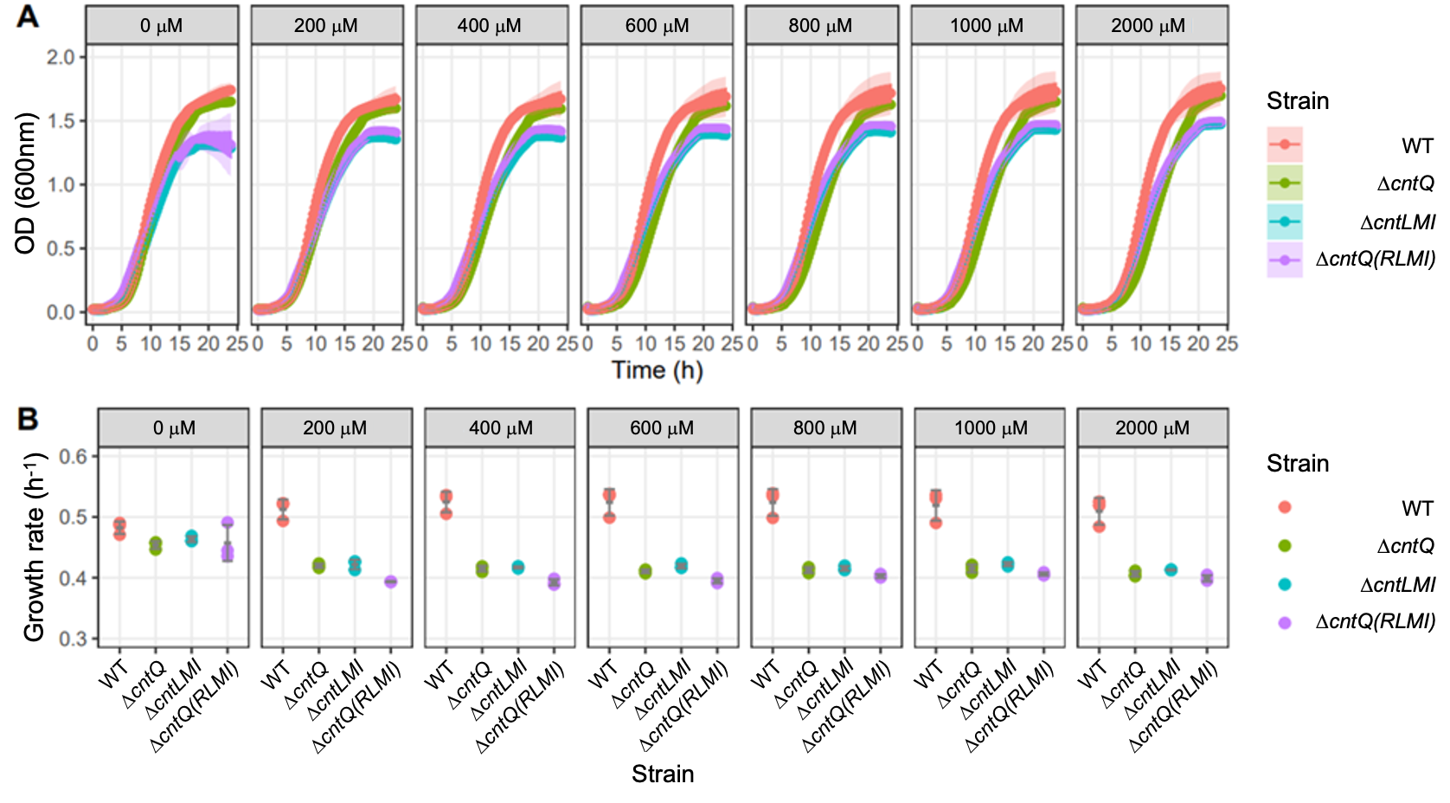
Supplementary Figure 7: Growth curves (A) and inferred growth rates (B) of Y. pseudotuberculosis cultivated in TMH without or with increasing concentration of EDTA. In A, the data represent the means and the confidence intervals (95%) calculated from three biological replicates. In B, the data from these three biological replicates are shown as individual points associated with their mean and standard deviation (in grey).

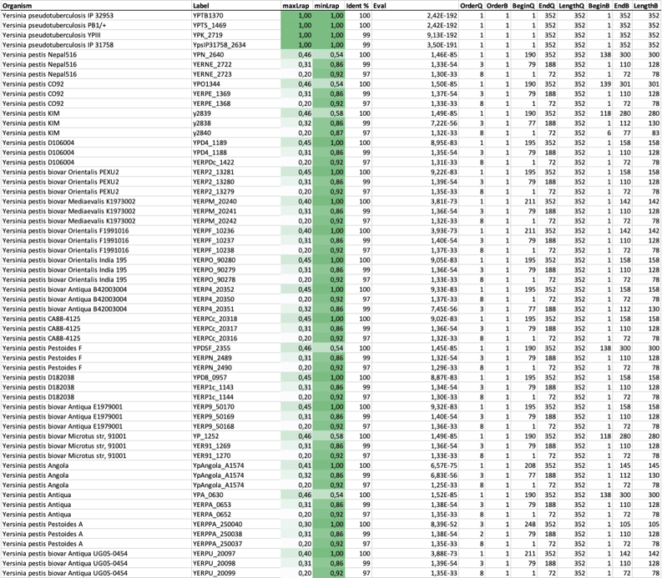
Supplementary Table 1. Pseudogenization of the cntQ permease is conserved in Y. pestis strains. List of orfs predicted in sequenced Y. pseudotuberculosis and Y. pestis strains at the cntQ position. maxLrap and minLrap denote respectively the length (expressed as a percentage of the gene) that is conserved, taking YPTB1370 as a reference (Query). BeginQ and EndQ refer to portions of sequence that is conserved on YPTB1370, taking YPTB1370 (Query) as a reference. BeginB and EndB refer to portions of sequence that is conserved in a given sequence (Bait), using YPTB1370 as a reference.
Supplementary Table 2. Bacterial strains and plasmids used in this study
Strain name in the text |  | Description
Yersinia pseudotuberculosis
Y. pseudotuberculosis WT |  | Y. pseudotuberculosis IP32777
Y. pseudotuberculosis ΔlacZ P_{cntP}::lacZ (Zur+) |  | IP32777 ΔlacZ P_{cntP}::lacZ  chromosomal lacZ reporter fusion with cnt promoter
Y. pseudotuberculosis ΔlacZ P_{cntP}::lacZ (Zur-) |  | IP32777 ΔlacZ Δzur P_{cntP}::lacZ  zur deletion and lacZ reporter fusion with cnt promoter
Y. pseudotuberculosis ΔcntLMI |  | IP32777 ΔcntLMI-FRT  unlabeled deletion of cntLMI
Y. pseudotuberculosis ΔcntQ(RLMI) |  | IP32777 ΔcntQ::Km1447  cntQ deletion and insertion of a kanamycin resistance cassette abolishing cntRLMI expression
Y. pseudotuberculosis ΔcntQ |  | IP32777 ΔcntQ-FRT  unlabeled deletion of cntQ, no polar effect on cntRLMI downstream genes
Y. pseudotuberculosis ΔcntQ(RLMI) complemented |  | IP32777 ΔcntQ::Km1447 mini-Tn7-Zeo2::cntPQRLMI  Strain complemented by the insertion of cntPQRLMI
Yersinia pestis
Y. pestis WT |  | Y. pestis KIM6+
Y. pestis ΔcntLMI |  | KIM6+ ΔcntLMI::Tp1087  cntLMI deletion and insertion of a trimethoprim (Tp) resistance cassette
Y. pestis ΔcntQ(RLMI) |  | KIM6+ ΔcntQ::Km1447  cntQ deletion and insertion of a kanamycin resistance cassette abolishing cntRLMI expression
Y. pestis ΔlacZ P_{cntP}::lacZ (Zur+) |  | KIM6+ ΔlacZ P_{cntP}::lacZ  chromosomal lacZ reporter fusion with cnt promoter
Y. pestis ΔlacZ P_{cntP}::lacZ (Zur-) |  | KIM6+ ΔlacZ Δzur P_{cntP}::lacZ  zur deletion and lacZ reporter fusion with cnt promoter
Y. pestis ΔcntQ(RLMI) ΔybtX |  | KIM6+ ΔcntQ::Km1447 ΔybtX::TpNP  ybtX deletion and insertion of a Tp resistance cassette without polar effect on downstream ybt genes
Y. pestis ΔcntLMI ΔznuCB |  | KIM6+ ΔcntLMI::Tp1087 ΔznuCB::Km4  Deletion of znuCB and insertion of a kanamycin resistance cassette
Y. pestis ΔcntQ(RLMI) ΔybtX ΔznuCB |  | KIM6+ ΔcntQ::Km1447 ΔybtX::TpNP ΔznuCB::Sm1315  Deletion of znuCB and inserting a streptomycin resistance cassette
Plasmids
Name | Description |  | Reference
pACYC177 | Suicide plasmid used as a template to generate pEP699 by ExoCET cloning. |  | (Rose 1988)
pDS132 | Suicide plasmid, CmR. |  | (Philippe et al. 2004)
pFLP3 | Encodes FLP recombinase to excise FRT flanked cassettes. |  | (Choi et al. 2005)
pKD4 | Source of KmR cassette, Km flanked by FRT sites. |  | (Datsenko and Wanner 2000)
pEP620 | lacZ reporter suicide plasmid bearing P_{cnt} from Y. pestis, KmR |  | This work
pEP681 | pDS132:: DcntQ::Km1447, CmR KmR |  | This work
pEP692 | pDS132::DcntLMI::Tp1087, CmR TpR |  | This work
pEP696 | lacZ reporter suicide plasmid bearing Pcnt from Y. pseudotuberculosis, derived from pEP848, KmR |  | This work
pEP699 | p15A-Ap::cntPQRLMI, obtained by ExoCET cloning of the Y. pseudotuberculosis cnt operon, AmpR |  | This work
pEP701 | pUC18R6K-miniTn7-Zeo2-cntPQRLMI, bears the Y. pseudotuberculosis cnt operon, AmpR ZeoR |  | This work
pEP848 | lacZ reporter suicide plasmid, KmR |  | EP collection
pEP1046 | pUC18R6K-miniTn7-Zeo2, used to clone the Y. pseudotuberculosis cnt operon,  AmpR ZeoR |  | GenBank MH614591
pEP1087 | Source of TpR cassette flanked by FRT sites |  | (Bibi-Triki et al. 2014)
pEP1315 | Source of SmR cassette flanked by FRT sites |  | GenBank MH626523
pEP1436 | Plasmid used for Red recombination in Y. pestis |  | (Dewitte et al. 2020)
pEP1447 | Source of Km1447 cassette flanked by FRT sites, in this plasmid the Km resistance gene is oriented opposite to that in pEP1446 |  | EP collection

Supplementary Table 3. Composition of the TMH medium
Compound | Final concentration (mM)
DL-Ala | 2.5
L-Ile | 1
L-Val | 1
L-Leu | 1
L-Phe | 1
L-Tyr | 1
L-Thr | 5
L-Arg | 1
L-Pro | 5
L-Glu | 5
L-Lys | 1
Gly | 5
L-His | 1
L-Asp | 2
L-Ser | 5
L-Trp | 0.1
L-Asn | 2.5
L-Gln | 10
L-Met | 1
Sodium thiosulfate | 2.5
KH₂PO₄ | 2.5
Citric acid | 10
NH₄Cl | 10
MnCl₂ | 0.01
FeCl₂ | 0.1
MgCl₂ | 20
HEPES | 25
Thiamine (vit. b2) | 0.0003
Panthotenic acid (vit. b5) | 0.0004
Biotine (vit. b8) | 0.0002
Potassium gluconate | 10

Supplementary Table 4. Metal concentrations in TMH medium. Metal concentration as determined by ICP-AES (Bdl: below detection level).
Metal | Concentration (μM)
Mn | 6.3
Fe | 62.5
Zn | Bdl
Cu | Bdl
Ni | Bdl
Co | Bdl

Supplementary References
Bibi-Triki S, Li de la Sierra-Gallay I, Lazar N, et al (2014) Functional and Structural Analysis of HicA3-HicB3, a Novel Toxin-Antitoxin System of Yersinia pestis. Journal of Bacteriology 196:3712–3723. https://doi.org/10.1128/JB.01932-14
Choi K-H, Gaynor JB, White KG, et al (2005) A Tn7-based broad-range bacterial cloning and expression system. Nat Methods 2:443–448. https://doi.org/10.1038/nmeth765
Datsenko KA, Wanner BL (2000) One-step inactivation of chromosomal genes in Escherichia coli K-12 using PCR products. Proceedings of the National Academy of Sciences 97:6640–6645. https://doi.org/10.1073/pnas.120163297
Dewitte A, Bouvenot T, Pierre F, et al (2020) A refined model of how Yersinia pestis produces a transmissible infection in its flea vector. PLOS Pathogens 16:e1008440. https://doi.org/10.1371/journal.ppat.1008440
Philippe N, Alcaraz J-P, Coursange E, et al (2004) Improvement of pCVD442, a suicide plasmid for gene allele exchange in bacteria. Plasmid 51:246–255. https://doi.org/10.1016/j.plasmid.2004.02.003
Rose RE (1988) The nucleotide sequence of pACYC177. Nucleic Acids Research 16:356. https://doi.org/10.1093/nar/16.1.356

