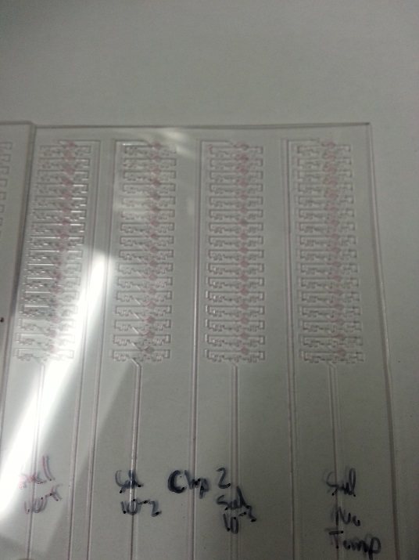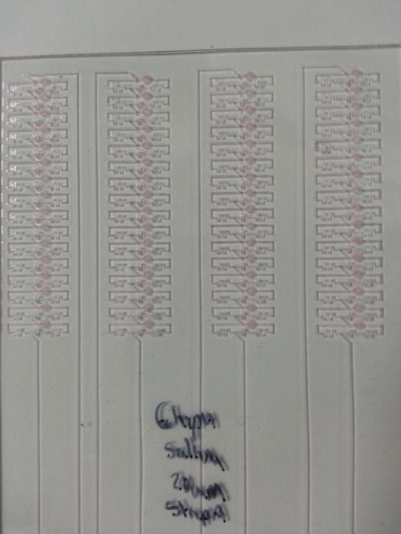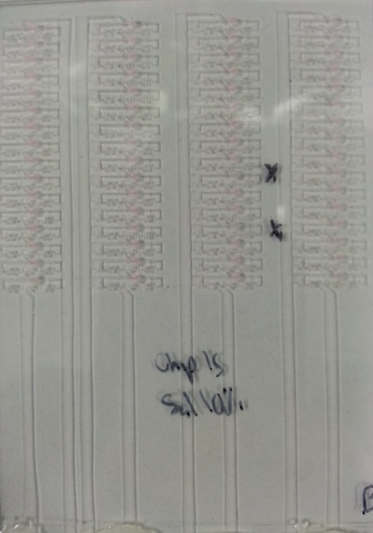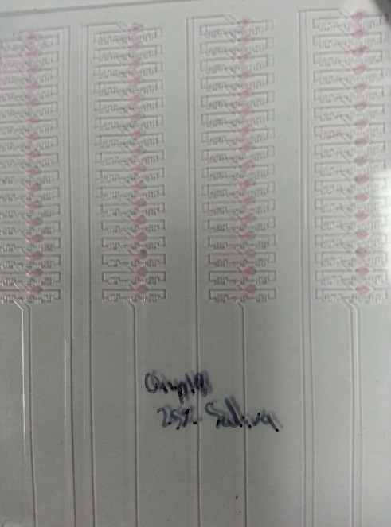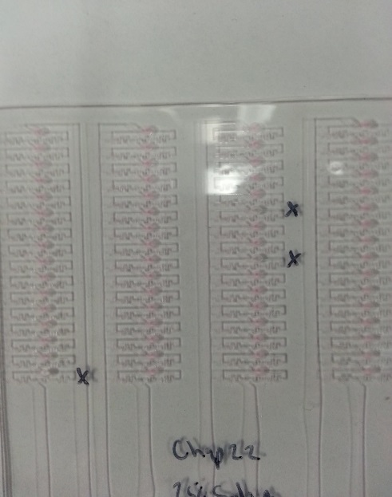
10% saliva rep 1,2,3
25% saliva rep 1,2
Fig S6. Pictures of cards loaded with varying concentrations of saliva in the amplification reaction. Wells that did not load properly are marked with a yellow circle. Overall, 315 out of 320 wells loaded properly when tested with saliva samples.

